Phytochelatin Synthase de-regulation in M. polymorpha indicates cadmium detoxification as its primary ancestral function in land plants and provides a novel visual bioindicator for detection of this metal in the environment

Mingai Li^{1#}, Martina Leso^{1,2}, Matteo Buti³, Erika Bellini⁴, Daniela Bertoldi⁵, Alessandro Saba⁶, Roberto Larcher⁵, Luigi Sanità di Toppi⁴, Claudio Varotto^{1#}
¹ Biodiversity, Ecology and Environment Area, Research and Innovation Centre, Fondazione Edmund Mach, via Mach 1, 38098, San Michele all’Adige, Trento, Italy
² Department of Plant Biology, Linnean Center for Plant Biology, Swedish University of Agricultural Sciences, Almas allé 5, 756 51, Uppsala, Sweden.
³ Department of Agriculture, Food, Environment and Forestry, University of Florence, Florence, Italy
⁴ Dipartimento di Biologia, Università di Pisa, via Luca Ghini 13, 56126, Pisa, Italy
⁵ Technology Transfer Centre, Experiment and Technological Services Department, Fondazione Edmund Mach, via Mach 1, 38098, San Michele all’Adige, Trento, Italy
⁶ Dipartimento di Patologia Chirurgica, Medica, Molecolare e dell’Area Critica, Università di Pisa, via Roma 67, 56126, Pisa, Italy

# Author for correspondence.
Mingai Li, Biodiversity, Ecology and Environment Area, Research and Innovation Centre, Fondazione Edmund Mach. Via Edmund Mach, 1 - 38098 San Michele all’Adige, Trento, Italy. E-mail: mingai.li@fmach.it
Claudio Varotto, Biodiversity, Ecology and Environment Area, Research and Innovation Centre, Fondazione Edmund Mach. Via Edmund Mach, 1 - 38098 San Michele all’Adige, Trento, Italy. E-mail: claudio.varotto@fmach.it

Running title: Marchantia mutants as bioindicators of Cd pollution
Abstract
Bryophytes are a large group of nonvascular plants commonly used as bioindicators of metal and metalloid pollution. However, very little is known about the bryophyte genes responsible for metal(loid) detoxification, a knowledge that could provide novel tools for environmental monitoring applications.
By genetic transformation and genome editing, in this study we obtained lines of the model bryophyte Marchantia polymorpha with de-regulated activity of the Phytochelatin Synthase (MpPCS) enzyme, responsible for the biosynthesis of metal(loid) chelators phytochelatins (PCn). Lack of PCn causes hypersensitivity to cadmium but has only subtle effects on excess of other highly toxic metals and the metalloid arsenic in M. polymorpha. Besides, our results indicate that MpPCS has a minor role in the maintenance of essential metals like zinc.
As liverworts are sister to vascular plants, these results imply that the primary ancestral function of PCS genes in the common ancestor of all land plants most likely was the detoxification of the non-essential cadmium ion. Hypersensitivity to cadmium further suggests that the Mppcs mutants could become useful bioindicators to specifically detect environmental contaminations of cadmium through direct visual assessment of plant growth and pigmentation.

Key words: Phytochelatin synthase, Marchantia polymorpha, cadmium, visual bioindicator, heavy metals, CRISPR/cas9 genome editing, overexpression.

Introduction: 1402
M&M: 1695
Results: 1858
Legends: 2262; Suppl legends: 464
Discussion: 1354
References:

Introduction
Metals and metalloids are natural components of the Earth's crust, and some essential metal(loid) elements are fundamental nutrients for proper growth of plants and animals [1]. However, supraoptimal concentration of many metal and metalloid elements, commonly referred to as heavy metals but from here on referred to as potentially toxic elements (PTEs; [2]), can display high levels of toxicity for most living organisms [3](Clemens 2019). Unlike organic compounds which can be degraded by microorganisms, in fact, PTEs are not degradable, and thus accumulate in the environment and eventually integrate into the food chain. Especially some non-essential metals and metalloids such as Cd²⁺, As³⁺, and Pb²⁺ are toxic even in trace amounts and can severely affect plant growth and yield [4](Clemens and Ma, 2016). While the environmental pollution derived from PTEs is currently in large part generated by anthropogenic activities such as mining, intensive applications of fertilizers, vehicle emissions and industrial development [5](Ghori et al., 2019), the ability of plants to detoxify PTEs resulting from natural processes of rock weathering is an ancient and widespread trait in plants [6](Fasani et al. 2022 Plants). To cope with various kinds of PTE contamination in their growing environments, plants have evolved a diverse array of strategies for toxicity control like sequestration, exclusion, speciation and chelation [7].
Phytochelatins (PCn) are one of the essential intracellular chelators of PTEs that prevent their toxic accumulation in the cytoplasm in a range of organisms [8](Grill et al., 1989). They are short cysteine-containing polypeptides that are activated by several metal and metalloid elements with whom they form complexes which are actively sequestered and safely stored into the vacuole by specific ATP-binding cassette (ABC) transporter proteins [9,10](e.g., Song et al., 2010; Song et al., 2014). PCn are constitutively synthesized from glutathione (GSH) and related thiols through γ-glutamylcysteine transpeptidation by the enzyme phytochelatin synthase (PCS). Phytochelatin synthases are present in distantly related organisms such as diatoms, nematodes, fission yeast, fungi, and plants [11](Rea et al., 2004). While in cyanobacteria PCS usually encompass a single N-terminal domain [12](Tsuji et al., 2004), two distinct domains, designated as N- and C-terminus, are present in plant PCSs studied so far [13](Cobett and Goldsbrough, 2002). The N-terminus is highly conserved across different species, and contains three amino acids (Cys56, His162, and Asp180 in A. thaliana), that are fundamental for enzymatic activity. On the other hand, the C-terminus is quite divergent and proposed to be responsible for sensing a wide range of metal and metalloid ions [14](Ruotolo et al., 2004). By analyzing a set of truncations in the C-terminal domain of Arabidopsis AtPCS1 in the fission yeast S. pombe, specific protein regions responsible for Zn- and As-dependent PCn formation were identified [15,16](Kühnlenz et al., 2016; Uraguchi et al., 2018). Moreover, two twin-cysteine motifs in the C-terminus of MpPCS in M. polymorpha have been proposed to inhibit enzyme overactivation in the presence of PTE metals [17](Li et al., 2020).
Since the publication of the seminal studies reporting PCS discovery more than two decades ago [18–20](Ha et al., 1999; Clemens et al. 1999; Vatamaniuk et al. 1999), many orthologous PCS genes from different plant species across the plant kingdom have been identified and characterized (e.g., [21–24]Ramos et al., 2008; Liu et al., 2011; Chen et al., 2015; Fan et al 2018). Overexpression in heterologous plant models of PCS genes has been used as a convenient mean to infer PCS relevance in PTE detoxification, but this approach resulted in somehow contradictory results. For example, overexpression in Arabidopsis of a PCS gene (BnPCS1) from the bast fiber crop ramie (Boehmeria nivea) led to a dramatically increased Cd²⁺ tolerance, resulting in biomass increase and oxidative stress reduction compared with Col-0 wild-type plants [25](Zhu et al., 2021). By contrast, transgenic plants overexpressing AtPCS1 in Arabidopsis displayed enhanced Cd²⁺ sensitivity accompanied by a higher accumulation of PCn [26](Lee et al., 2003). Similarly, overexpression of AtPCS1 in indian mustard Brassica juncea tolerated Cd²⁺ exposure only in the transgenic lines with moderate expression level [27](Gasic & Korban 2007), and in tobacco it caused Cd hypersensitivity without increasing the level of PCn [28](Wojas et al. 2008). These differences seem to be linked to relatively small variations in primary protein sequence, as three recently diverged PCS genes (AdPCS1, AdPCS2 and AdPCS3) from the bioenergy crop Arundo donax resulted in either enhanced (AdPCS2 and AdPCS3) or decreased (AdPCS1) sensitivity to PTEs once overexpressed in Arabidopsis Col-0 wild-type plants [29](Li et al., 2019). Despite the relevance of these and analogous studies (e.g., [28,30]Wojas et al., 2008; Brunetti et al., 2011), PCn-mediated PTE detoxification regulation may thus be too finely tuned in different plant species for its comprehensive elucidation through overexpression approaches in heterologous systems alone.
The use of PCS knockout mutants has indeed provided important insights into the functional relevance of the enzyme in PTE detoxification. Till now, PCS knockout mutants from just two plant species (Arabidopsis thaliana and Oryza sativa), both angiosperms, have been identified and functionally characterized [18,31–33](Howden et al., 1995; Ha et al., 1999; Hayashi et al., 2017; Uraguchi et al., 2017). Of the two PCS paralogs (AtPCS1 and AtPCS2) present in Arabidopsis, AtPCS1 is considered to play a major role in the PTE detoxification because of the hypersensitivity to PTEs exhibited by AtPCS1 knockout mutant cad1-3. The AtPCS2 paralog, albeit functional, could only partially rescue the AtPCS1 knockout mutant cad1-3 [34](Kühnlenz et al., 2014). Therefore, most Arabidopsis studies were focused on AtPCS1, showing that cad1-3 is extremely sensitive to As and Cd, but less so to Zn, Pb, Ag, Cu and Hg [18,35,36](Ha et al., 1999; Tennstedt 2009; Fischer et al. 2014). By contrast, both PCS paralogs present in this rice (OsPCS1 and OsPCS2 following the nomenclature of [33] Uraguchi et al., 2017) are functionally relevant in PTE detoxification, although the two enzymes show different intensities of activation by As and Cd [32](Hayashi et al., 2017). In vivo, the OsPCS1 mutation enhanced the sensitivity to As and Cd while increasing As and decreasing Cd accumulation in rice grains [33](Uraguchi et al., 2017). Also the OsPCS2 mutant exhibited high As accumulation in grains, indicating that both OsPCS1 and OsPCS2 play important roles to reduce toxic As accumulation in rice grains [32](Hayashi et al., 2017).
Although the PC-mediated detoxification of PTEs has been firmly established as the fundamental detoxification mechanism in angiosperms, the functional relevance of this pathway in bryophytes, a monophyletic group comprising hornworts, liverworts and mosses which constitute a lineage sister to all tracheophytes [37](Harris et al., 2020), started to be addressed only recently. While clear biochemical evidence of PCS activity in hornworts and especially liverworts has been obtained [38,39](Petraglia et al. 2014; Bellini, Betti, 2021), only one species of moss investigated so far (Sphagnum palustre) showed sustained PCn production [38](Petraglia et al. 2014). However, homology searches revealed no PCS gene in either the congeneric species with fully sequenced genomes S. fallax and S. magellanicum or in any other moss genome present in public databases (Li and Varotto, unpublished results), indicating that other metabolic pathways likely play major roles in metal detoxification in mosses. This view is further supported by the fact that the highly cadmium-tolerant moss Leptodictyum riparium produces only trace amounts of PCn [40](Bellini et al. 2020 The Moss Leptodictyum riparium Counteracts Severe). Recently, the single-copy PCS gene present in the genome of M. polymorpha has been isolated and functionally characterized by overexpression in heterologous systems, demonstrating that it is enzymatically active and able to complement the Arabidopsis knock-out cad1-3 mutant [17](Li et al., 2020). However, in the lack of stable M. polymorpha PCS knockouts, the outstanding questions of whether PCn-mediated detoxification plays in liverworts a role as pivotal as that in angiosperms and its relative relevance with respect to other detoxification pathways have remained unanswered. This is particularly relevant considering the relevance of bryophytes as bioindicators of metal and metalloid pollution [6](Fasani et al. 2022), as the elucidation of the genes responsible for the detoxification of the different PTEs could provide standardized genotypes for environmental monitoring applications.
Thus, in the present study, Mppcs loss of function mutants were generated through CRISPR/cas9 mediated genome-editing at two independent target sites and, in addition, MpPCS was overexpressed in M. polymorpha. The detailed molecular genetics, biochemical and physiological characterization of both loss- and gain-of-function lines provided evidence that MpPCS plays an essential role in the detoxification of Cd, but not of As or other divalent metal cations in M. polymorpha, indicating that tolerance to Cd is a plesiomorphic and major function of PCS in all land plants. The potential of the Mppcs mutants as sensitive biological indicators of Cd contamination in the environment is discussed.
Materials and methods
Plant materials and growing conditions and PTE treatments
The reference genetic background used in this study is M. polymorpha L. Cam2 (UK Cambridge-2 wild type) female gametophytes, from which four independent Mppcs knockout mutant alleles from two different sgRNAs (Mppcs-1-6^{ge}, Mppcs-1-16^{ge}, Mppcs-2-16^{ge} and Mppcs-2-28^{ge}), and two independent transgenic lines overexpressing MpPCS (MpPCS-ox-3 and MpPCS-ox-7) were obtained as described in the next section. M. polymorpha was generally grown in a growth chamber in a half strength Murashige and Skoog (MS) medium with 1% sucrose and 1% phytoagar under long-day photoperiod (16h light/8h dark) at 21°C with a light intensity of 60 µmol m⁻² s⁻¹.
For biomass analyses upon PTE treatments in M. polymorpha, fresh gemmae from wild-type Cam2, four knockout mutants (Mppcs-1-6^{ge}, Mppcs-1-16^{ge}, Mppcs-2-16^{ge} and Mppcs-2-28^{ge}) and two overexpression lines (MpPCS-ox-3 and MpPCS-ox-7) were grown in 1/10 hydroponic solid medium as previously described [16](Uraguchi et al., 2018) either without or with addition of 3 and 5 µM CdSO₄ or 300 and 400 µM ZnSO₄ for two weeks.
For thiol-peptide and elemental analyses, the gemmae from four different genotypes (Mppcs-1-16^{ge}, Mppcs-2-16^{ge}, MpPCS-ox-3 and MpPCS-ox-7) were grown as previously described [16](Uraguchi et al., 2018) for ten days and transferred into the fresh media or fresh media supplemented with either 20 µM CdSO₄ or 400 µM ZnSO₄. After a three-day treatment, around 100 mg of each sample were harvested for thiol-peptide analyses which were snap frozen in liquid nitrogen and stored at -80 °C till use. Additionally, around 40 mg dry weight of each sample were harvested for elemental analyses and kept at 55°C in an oven for 72 hr.
For transcriptomic assay, wild-type Cam2 and knockout mutant Mppcs-2-16^{ge} plants were grown for ten days in 1/10 hydroponic solid medium, and about 100mg for each of three biological replicates for each sample were harvested, snap frozen in liquid nitrogen and stored at -80 °C till use for RNA-Seq analyses.
Plasmid construction and plant transformation
For the construction of plasmids used for genome-editing, the annealed double-stranded oligonucleotides (see Supplementary Table S1) derived from selected target sites were ligated into the pMpGE_En03 vector linearized by BsaI restriction enzyme digestion. The resulting plasmid containing the gRNA cassette was recombined into the destination vector pMpGE010 through LR reaction using the LR Clonase II Enzyme Mix (Invitrogen).
For overexpression of MpPCS in M. polymorpha, MpPCS coding sequence was amplified using primers MpPCS_For and MpPCS_Rev as previously described [17](Li et al., 2020) with Phusion High Fidelity DNA Polymerase (Thermo Scientific). The resulting amplicon was cloned into pENTR/D-TOPO vector (Invitrogen) and recombined into the destination vector pMpGWB103 [41] using LR clonase II Enzyme Mix (Invitrogen). All constructs described above were verified by bidirectional Sanger sequencing using a 96-capillary 3730xl DNA Analyzer (Thermo Fisher Scientific).
All constructs were transformed by electroporation into Agrobacterium tumefaciens strain GV3101-pMP90RK. The resulting Agrobacterium strains were used for transformation of M. polymorpha genome as previously described [42]. T1 transgenic plants growing on half-strength solid Gambourg B5 medium containing 10 mg/l hygromycin were selected and a single G1 gemma derived from each T1 line was grown to generate G2 gemmae which were used for further downstream work.
Genotyping of CRISPR mutations
Genomic DNA was isolated from thallus harboring the CRISPR/Cas9 constructs by a modified CTAB-based method [43](Aboul-Maaty and Abdel-Sadek Oraby, 2019) and used for PCR amplification of the target regions within MpPCS. The PCR reactions were carried out using the primers listed in Supplementary Table S1 and Phusion High-Fidelity DNA polymerase (Thermo Fisher Scientific). The PCR products were purified using the NucleoSpin Gel and PCR Clean-up kit (Macherey Nagel) and sequenced using BigDye v.3.1 chemistry in a 96 capillary 3730xl DNA analyzer (Thermo Fisher Scientific). Sequence alignment was performed in Bioedit (Version 7.2) to identify sequence polymorphisms in the target sites compared with that of wild-type MpPCS. G2 or later generation plants from two independent isogenic mutant lines were sequenced again for confirmation and used for all downstream work.
Lipid peroxidation analyses
10-day-old plants of different genotypes growing in 1/10 hydroponic medium were transferred into the fresh medium without or with 20 µM CdSO₄/400 µM ZnSO₄. After three- or seven-day treatment, around 100 mg of plant materials were collected in liquid nitrogen and stored at -80°C. Lipid peroxidation of the samples was estimated by malondialdehyde (MDA) production using the thiobarbituric acid (TBA) method [44](Hodges et al., 1999).
Chlorophyll content analyses
10-day-old plants of different genotypes growing in the same condition as for lipid peroxidation analysis were treated without or with 20 µM CdSO₄/400 µM ZnSO₄ for one week, after which 100 mg of plant materials for each sample were harvested, frozen in liquid nitrogen and ground into powder with Tissue Lyser (Qiagen). The samples were extracted with 80% acetone and then centrifuged at 10,000 × g for 10 min at 4°C. The supernatant was collected and subsequently absorbance was determined at 646.6, 663.6 and 750 nm. The chlorophyll content was calculated as reported by [45]Porra (2002).
Ion leakage assay
10-day-old Cam2 wild-type plants and individuals from two independent Mppcs knockout mutant alleles (Mppcs-1-16^{ge} and Mppcs-2-16^{ge}) grown in 1/10 hydroponic solid medium were transferred into either fresh medium or medium supplemented individually with different concentrations of heavy metals (Ag⁺, As³⁺, Cd²⁺, Pb²⁺, Cu²⁺, Fe²⁺, Ni²⁺, and Zn²⁺), and grown in the same condition for additional 2, 3, 4, 5, 6 and 7 days. At least 30 plantlets for each sample were harvested at each time point, transferred into a glass test tube containing 7 ml of deionized water, shaken gently at room temperature for 2.5 h and used for conductivity measurement with a CyberScan CON 1500 Conductivity meter (Thermo Scientific). The samples were then autoclaved, and the conductivity was measured again at room temperature. The electrolyte leakage was calculated as the ratio of the conductivity before autoclaving to that after autoclaving.
Total RNA extraction, cDNA synthesis and rt-PCR analyses
Around 100 mg of frozen plant material (whole gametophytes) was used for RNA extraction with the Spectrum Plant Total RNA Kit (Sigma-Aldrich) according to the manufacturer’s instructions. Amplification-grade DNaseI (Sigma-Aldrich) treatment, evaluation of integrity and quality of total RNA and cDNA synthesis were carried out as previously described [46](Poli et al., 2017). Semi-quantitative rt-PCR for overexpressing MpPCS transgenic lines was carried out using the MpACT gene as a reference [47](Saint-Marcoux 2015). Primer sequences are listed in Supplementary Table S1.
RNA-Seq library construction, sequencing and data analyses
1.0 µg total RNA was isolated from Mppcs-2^{ge-16} mutant and Cam2 wild-type whole-gametophytes (three biological replicates for each genotype) using the method mentioned above and used for RNA-Seq libraries construction. Libraries were prepared with NEBNext® Ultra™ RNA Library Prep Kit (New England BioLab) by integrating Illumina unique dual index adapters (Illumina) and sequenced with a NovaSeq 6000 at Novogene (Cambridge Science Park, UK), generating 150-bp paired-end reads at a minimal depth of 13 Gbp per library.
After assessing the raw reads quality with FastQC v0.11.9 [48], Trimmomatic v0.39 [49] was used to trim the adapters sequences and to remove the low-quality reads. The filtered RNA reads were mapped to M. polymorpha v1 reference genome assembly [50] using HiSat2 v2.2.1 tool [51]. Read counts were generated from alignment files with the featureCounts v 1.6.0 software [52] with default parameters, basing on ‘exon’ feature and ‘transcript_id’ meta-feature of M. polymorpha v1.49 annotation file retrieved from the EnsemblPlants website (http://plants.ensembl.org/).
Differential expression (DE) analyses were carried out using Bioconductor EdgeR v3.30.3 [53] in the R environment. EdgeR was used to: (i) filter out the non-expressed or poorly expressed transcripts (a transcript was considered “active” if the value of reads per million mapped to that gene was >1 in at least two libraries), (ii) normalize the RNA libraries, and (iii) do the differential expression analysis with the likelihood ratio test. The Log2 Fold Change (LFC) of each transcript expression between two samples was calculated with EdgeR, whose computing approach fits a negative binomial generalized linear model (GLM) to the read counts for each transcript. The transcripts with a resulting false discovery rate (FDR) smaller than 0.05 and LFC lower than -1 or higher than 1 were considered as differentially expressed. Only DE transcripts corresponding to gene models confirmed in M. polymorpha subsp. ruderalis MpTak1_v6.1 were retained for further analyses [54](Montgomery SA, Tanizawa Y, Galik B, et al. 2020. Chromatin organization in early land plants reveals an ancestral association between H3K27me3, transposons, and constitutive heterochromatin. Current Biology 30, 573–588.e7). GO enrichment of DE transcripts was carried out with ShinyGO v2.76 [55](Ge et al. Bioinformatics, Volume 36, Issue 8, 15 April 2020, Pages 2628–2629, https://doi.org/10.1093/bioinformatics/btz931) using pathway sizes between 2-2000 genes and P-values from the hypergeometric test corrected for multiple testing by False Discovery Rate (FDR). FDR cutoff was set to 0.05 and pathways sharing ≥ 95% of genes were represented only by the most significant pathway. Barplots were generated to display the Fold Enrichment for the single GO terms, defined as the percentage of DEG genes belonging to a pathway, divided by the corresponding percentage in the background, i.e. all the genes transcribed in either the Cam2 or the Mppcs-2-16^{ge} mutant under the experimental conditions described above.
Thiol-peptides analyses
Thiol-peptides analyses and quantification for M. polymorpha wild-type plants, Mppcs knockout mutants and MpPCS overexpressing transgenic lines were conducted as formerly described [56](Bellini et al., 2019). An AB Sciex Analyst version 1.6.3 software was utilized for system control, data acquisition and processing.
Elemental analyses
For elemental analyses of M. polymorpha wild-type plants, Mppcs knockout mutants and overexpressing MpPCS transgenic lines, dried plant materials were acid digested with ultrapure nitric acid (67-69%, Carlo Erba, Milan, Italy). Elemental concentrations in the samples were carried out with an inductively coupled mass spectrometer (ICP-MS, Agilent 7800, Agilent Technologies, Tokyo, Japan) equipped with quartz micromist nebulizer and an octopole collision cell (He mode) used to minimize polyatomic interference during Zn analysis.
Statistical analyses
Data with one independent factor were analyzed using One-way ANOVA analysis. Tukey’s multiple comparison and least significant difference (LSD) tests were used to identify significant differences. Differences were considered significant if P ≤ 0.05 in the two-sided test. Compact letter display was used to summarize the differences among means. All analyses were run in R version 4.0.0 (2020. 04.24; [57]) using the scripts provided in [58]. All experiments were performed with at least n = 3 biological replicates.
Results
Identification of Mppcs knockout mutants and selection of overexpressing MpPCS lines
A prerequisite to demonstrate MpPCS biological function in vivo and elucidate the relative relevance of the PCn pathway in bryophytes is to obtain MpPCS stable knockouts in M. polymorpha. Therefore, CRISPR/cas9 mediated genome-editing was applied to target MpPCS in two different positions at the N-terminal of the protein (Fig. 1A). G2 generation transformants were genotyped and a total of four independent lines harboring mutations in the MpPCS gene were identified. Two of them (lines Mppcs-1-6^{ge} and Mppcs-1-16^{ge}) were mutated in the first target site and had one base pair (bp) insertion and 1bp deletion, respectively. The other two lines (Mppcs-2-16^{ge} and Mppcs-2-28^{ge}) had mutations in the second target site of MpPCS with a 153bp insertion/3bp deletion and a 1bp deletion, respectively (Fig. 1B). All these mutations were predicted to cause truncated proteins resulting from frameshifts and premature stop codons (Fig. 1B). To evaluate the impact of the mutations on MpPCS mRNA stability, semi-quantitative rt-PCR was performed with 14-day-old mutant and wild-type plants. The result showed that MpPCS mRNA was present in all mutant lines. The expression levels of the two mutant lines in the first target site were very similar to wild-type Cam2 plants, while those of the two lines in the second target site were slightly lower compared with that of Cam2 (Supplementary Fig. S1).
In addition to knockout lines, a total of 14 independent G2 generation M. polymorpha transgenic lines overexpressing MpPCS were obtained and analyzed by semi-quantitative rt-PCR, confirming that the transgene was integrated and expressed in all the lines (Supplementary Fig. S2). The two transgenic lines with highest transgene expression, MpPCS-ox-3 and MpPCS-ox-7, were selected to carry out all further experiments.
Both lack and increase of MpPCS activity result in Cd²⁺ but not Zn²⁺ hypersensitivity
In angiosperms, PCS mutations impair the detoxification of a wide range of PTE in both monocot and dicot plant species [18,31–33](Howden et al., 1995; Ha et al., 1999; Hayashi et al., 2017; Uraguchi et al., 2017). To investigate the in vivo role of MpPCS in the regulation of PTE detoxification, we characterized the responsiveness upon PTE treatment of the four Mppcs mutants compared with Cam2 wild-type plants. From a previous study in heterologous systems, it was inferred that MpPCS likely plays important roles in Cd²⁺ and Zn²⁺ tolerance [17](Li et al., 2020). Thus, 10-day-old Mppcs mutants and Cam2 wild-type plants were subjected to 5 or 8 µM Cd²⁺ and 80 or 150 µM Zn²⁺ treatment for 15 days. All mutant lines were hypersensitive to Cd²⁺, displaying dramatically reduced growth and strong chlorosis, while Cam2 wild-type plants were still green and grew slightly larger than untreated plants. No phenotypic differences were observed between untreated mutant lines and Cam2 plants (Fig. 2A and B). On the contrary, no significant differences in biomass were detected between any of the mutants and Cam2 plants under 80 µM Zn²⁺ treatment. A significant reduction in biomass compared to Cam2 was detected only in the two lines harboring mutations in the first target site (Mppcs-1-6^{ge} and Mppcs-1-16^{ge}) when they were treated with 150 µM Zn²⁺, while no differences in biomass between the two mutant lines in the second target site and Cam2 plants were observed (Fig. 2C and D).
Due to the consistent phenotypic responses upon metal treatment mentioned above for both lines in each target site, only one mutated line in each target site (Mppcs-1-16^{ge} and Mppcs-2-16^{ge}) was selected for further downstream analyses.
Also in the case of overexpression lines, growth in media supplemented with 5 µM or 8 µM Cd²⁺ for 15 days resulted in chlorosis and a significant reduction in the biomass accumulation of both transgenic lines compared with Cam2 wild-type plants. In control condition, no phenotypic and biomass differences among genotypes were identified (Fig. 3A and 3B). On the other hand, treatments with 80 µM or 150 µM Zn²⁺ resulted in no significant differences in biomass (Fig. 3C and 3D).
Given the moderate effects on the biomass of only the knockout mutants at 150 µM Zn²⁺, to assess chlorosis we measured the total chlorophyll contents in mutant, overexpressor and Cam2 plants subjected to a seven-day treatment either with 20 µM Cd²⁺ or with 400 µM Zn²⁺. The chlorophyll amounts were strongly reduced in both mutants treated with Cd²⁺, but surprisingly they were significantly higher in both mutants upon Zn²⁺ treatment. No significant differences were observed in chlorophyll amounts in all tested genotypes in control condition (Fig. 4). Similarly, the chlorophyll contents in transgenic lines were very significantly lower under Cd²⁺ treatment and very significantly higher under Zn²⁺ treatment compared with Cam2 (Fig. 4).
Taken together, these results indicate that deregulation of MpPCS activity by both knockout and overexpression of MpPCS cause hypersensitivity to Cd²⁺ but not to Zn²⁺.
Deregulation of MpPCS activity affects the intracellular levels of thiol-peptides, enhancing accumulation of Cd but not Zn
PCn are synthesized by PCS using GSH as substrate in the presence of PTE [8](Grill et al., 1989). Thus, GSH and PCn amounts were analyzed in mutants, overexpressors and Cam2 plants after three-day treatments either with 20 µM Cd²⁺ or with 400 µM Zn²⁺.
Under control condition similar amounts of GSH were detected in both knockout mutants and Cam2 wild-type plants (top-left pane in Fig. 5). However, the amount of GSH was significantly higher in both knockout lines under Cd²⁺ treatment (middle-left pane in Fig. 5) and, in the case of Zn²⁺ treatment, one mutant (Mppcs-1-16^{ge}) had a significant higher amount and the other one (Mppcs-2-16^{ge}) had a significant lower amount of GSH relative to Cam2 plants (bottom-left pane in Fig. 5). Furthermore, no PCn production was detectable in both mutant lines either under control or under heavy metal treatments, while PCn production in Cam2 wild-type plants was increased upon metal treatments relative to that of the control condition (right side panes in Fig. 5).
For the overexpressors in control condition, the amounts of GSH did not differ from those in Cam2 (top-left pane in Fig. 5), but both transgenic lines produced significantly more PCn than Cam2 (top-right pane in Fig. 5). Under Cd²⁺ treatment, significantly lower amounts of both GSH and PCn were generated in transgenic lines compared with Cam2 (middle-right and middle-right panes in Fig. 5, respectively). In the case of Zn²⁺ treatment, significantly lower amounts of GSH were identified in transgenic lines relative to Cam2 (bottom-left pane in Fig. 5), while PCn production in the transgenic lines was slightly lower than that of Cam2 (bottom-right pane in Fig. 5).
As both GSH and PCn can chelate divalent cations [59](Hernandez et al., 2015), Mppcs mutants, MpPCS overexpressors and Cam2 plants were treated with Cd²⁺ and Zn²⁺ and the accumulation of both metals in thalli was examined. As expected, only traces of Cd²⁺ were detected in all genotypes under control condition, but after treatment both Mppcs mutants as well as MpPCS overexpressors accumulated significantly higher Cd²⁺ amounts compared with Cam2 plants (Fig. 6A). Zn²⁺ accumulation did not significantly differ among genotypes (Fig. 6B).
Only cadmium among several metal/metalloids affects membrane oxidation and stability in Mppcs loss of function mutants
In angiosperms, several divalent metal ions can cause oxidative damage to membranes [59](Hernadez et al., 2015). Therefore, the oxidative stress status was initially estimated by measurements of MDA (malondialdehyde) concentration in 10-day-old mutants and Cam2 plants exposed to 20 µM Cd²⁺ or 400 µM Zn²⁺ for either three or seven days. There were no significant changes between mutants and Cam2 under both metal treatments for three days (Fig. 7A), but significantly increased MDA concentrations in both mutants compared with Cam2 were detected after seven-day Cd²⁺ exposure (Fig. 7B). No differences existed among genotypes under control condition and for the seven-day Zn²⁺ treatment (Fig. 7A and 7B).
Electrolyte leakage test has been widely used to evaluate the cell membrane damage in plant tissues induced by stress injuries [60](Demidchik et al. 2014). To estimate the role of MpPCS in the responses to various PTEs, time course analyses of electrolyte leakage were performed in 10-day-old Cam2 and Mppcs mutants (Mppcs-1-16^{ge} and Mppcs-2-16^{ge}) subjected to treatments with eight different PTEs (Fig. 8). The results indicated that only in the case of Cd²⁺ treatment the ion leakage from day 5 till day 7 continuously increased in both mutant lines and was significantly higher compared with wild-type Cam2 plants, which maintained the same leakage level from day 2 till day 7. In the case of Cu²⁺ and Ni²⁺ treatments, a continuous leakage increase was observed, but it affected similarly Cam2 and the two Mppcs mutants. With all the other heavy metal treatments, Cam2 and both mutant lines showed similar leakage patterns, and no dramatic differences were detected through the entire time course.
For three of the PTE tested (As³⁺, Zn²⁺ and Cd²⁺), a detailed assessment of electrolyte leakage at increasingly higher PTE concentrations was carried out at the seventh day of treatment (Fig. 9). In the case of As³⁺ treatment, electrolyte leakage of Cam2 and Mppcs mutants generally had a very similar trend at all concentrations of As³⁺ tested, with only one of the mutant lines showing significant differences with respect to Cam2 at two concentrations of As³⁺ (400 and 800 µM) (Fig. 9A). In the case of Cd²⁺, electrolyte leakage of the Mppcs mutants was much higher than that of Cam2 plants at all different concentrations Cd²⁺ tested (Fig. 9B). For Zn²⁺, both mutant lines and Cam2 exhibited a comparable pattern of leakage through the entire range of metal concentrations, with the exception of very significant differences for both lines at 500 and 600 µM Zn²⁺ (Fig. 9C).
Knockout of MpPCS affects the transcription of ROS detoxification and extracellular region genes in unstressed M. polymorpha gametophytes
To assess whether the knockout of MpPCS affects the transcription of M. polymorpha nuclear genes in unstressed condition even in the lack of macroscopic phenotypes, the Mppcs-2-16^{ge} mutant and Cam2 whole transcriptomes were sequenced and compared. The resulting RNA-Seq reads have been deposited in the ArrayExpress database at EMBL-EBI (www.ebi.ac. uk/arrayexpress) under accession number E-MTAB-11885. Overall, the number of resulting paired reads ranged from 44 to 58 million across the 6 libraries and, after filtering out the adapters and the low-quality sequences, 97.74%±0.26% of the initial reads were retained for further analysis (Supplementary Table 2). For each RNA library, 93.83%±1.33% of the reads aligned to the Marcanthia polymorpha reference genome assembly, and the number of reads mapping to each predicted transcript was calculated (Supplementary Table 2). Analysis of GO enrichment of differentially expressed transcripts revealed a total of 102 terms significantly enriched in the Mppcs-2-16^{ge} mutant compared to Cam2 (Supplementary Table 3). Among the 69 Biological Process domain GOs, the most significantly enriched are those related to responses to oxidative stress and detoxification of hydrogen peroxide and related reactive oxygen species (Fig. 10A; Supplementary Table 3). Additional clusters of enriched Biological Process domain GOs are related to phenylpropanoid (cinnamic acid) biosynthesis, chitin degradation and defense response, metal cation transport (Supplementary Table 3 and Supplementary Fig. 3). The most significantly enriched of the 34 Molecular Function domain GOs are those related to peroxidase activity, manganese ion binding / reservoir activity, metal ion binding and acyltransferase activity (Fig. 10B; Supplementary Table 3). Other enriched Biological Process GO clusters are related to phenylalanine ammonia-lyase activity, chitinase activity and chlorophyll metabolism (Supplementary Table 3 and Supplementary Fig. 4). The 4 GO terms associated to the Cellular Component domain refer all to the extracellular region and, in particular, to apoplast and cell wall (Fig. 10C; Supplementary Table 3 and Supplementary Fig. 5).

Discussion
Previous biochemical and physiological studies found compelling evidence of widespread PCn production indicative of PCS-like activity in two of the three bryophyte lineages, namely hornworts and especially liverworts [38](Petraglia et al. 2014). However, the functional relevance and metal specificity of this pathway in PTE detoxification in planta remained to be determined, also considering that PCn seem to be largely dispensable or totally absent in many mosses. Leveraging on the recent identification and partial characterization of the first bryophyte PCS gene in the model liverwort M. polymorpha [17](Li et al. 2020), in this study we took a reverse genetics approach to functionally characterize the effects that MpPCS loss-of-function and gain-of-function have in vivo on metal tolerance. We found that de-regulation of PCS activity has several aspects in common between the liverwort M. polymorpha and angiosperms, but also some notable differences. Like in many angiosperm species, both PCS mutant and overexpressing lines were hypersensitive to Cd²⁺ and displayed arrested growth and strong decrease in chlorophyll content (Fig. 2-4). The somehow counterintuitive result in PCS overexpressing lines has been previously attributed to toxicity caused by an increased PCn/GSH ratio [26](Lee et al. 2003). This view, however, has been later challenged in light of the broad spectrum of phenotypes observed in different combinations of PCS source/recipient species for overexpression (e.g. [23–25,28,61–63]Wojas et al. 2008; Zhu et al. 2021 doi: 10.3389/fpls.2021.639189; Zhang et al. 2018; Park et al. 2019 doi:10.1111/plb.12991; Chen et al. 2015 DOI 10.1007/s11240-015-0710-x; Fan et al. 2018 https://doi.org/10.1016/j.gene.2017.12.042; Su et al. 2020 https://doi.org/10.1016/j.plaphy.2020.08.012). In M. polymorpha we found that the PCS overexpressing lines had strongly decreased amounts of both GSH and PCn compared to the WT following Cd²⁺ treatment (Fig. 5), which most closely matches the phenotype observed in tobacco overexpressing AtPCS1 [28](Wojas et al. 2008). It has been hypothesized that the concomitant decreases of GSH and PCn may result from degradation catalyzed by the peptidase activity of PCS, and thus that hypersensitivity could be a direct consequence of the reduced Cd complexation capacity due to PCn depletion in the cytosol [64](Wojas et al. 2010). In general, in M. polymorpha, this model consistently explains the phenotype of both MpPCS overexpressors as well as of knockout mutants, which completely lack PCn, and thus accumulate their precursor, GSH, to higher amounts than WT plants (Fig. 5). Although GSH can chelate Cd, its affinity towards this toxic metal is significantly lower than that of PCn [65](Watly et al., 2021). This explains why even doubling of the GSH amount is not sufficient to protect the M. polymorpha mutants from Cd hypersensitivity, as confirmed by their significantly higher lipid peroxidation relative to Cam 2 WT (Fig. 8).
While AtPCS1 is activated by a wide range of metal and metalloid ions [66–68](Grill et al., 1987; Vatamaniuk et al., 2000; Oven et al., 2002), Arabidopsis cad1-3 mutant sensitivity has been demonstrated only for some of them, namely As, Cd, Ag, Zn, Pb, Hg and Cu [15,18,36,69](Ha et al. 1999; Gong et al. 2003; Fischer et al. 2014; Kühnlenz et al., 2016). The highest sensitivity of Arabidopsis cad1-3 is towards As (~10-20 times increase in sensitivity compared with WT; [18]Ha et al. 1999) and Cd (~3 times increase; [70]Howden and Cobbett 1992), suggesting that the primary role of PCS1 in this species is the detoxification of these two PTEs. In M. polymorpha Mppcs mutants, by contrast, ion leakage assays upon treatments with a range of different metals displayed clear evidence for sensitivity only to Cd, while notably lacked enhanced sensitivity towards As (Fig. 8-9). Genes coding for ACR3, an ancient bacterial-like As³⁺ transporter playing fundamental roles in As detoxification, are present in mosses, lycophytes, ferns, and gymnosperms, while they are missing in angiosperms [71](Indriolo et al. 2010). A putative ACR3 homologue is also present in the M. polymorpha genome (Li and Varotto, unpublished data) and in the fern Pteris vittata, where both As detoxification pathways co-exist and have been functionally characterized, ACR3 has been demonstrated to play a much more relevant role than PCS in As detoxification [71,72](Zhao et al. 2003; Indriolo et al. 2010). Taken together, thus, our results indicate that the ancestral primary function of PCS may have probably been that of detoxifying Cd, but that, with the loss of ACR3 during angiosperm evolution, the enzyme acquired also a major role in the detoxification of As. Different lines of evidence, however, suggest that MpPCS is also involved in the homeostasis of essential ion metals in addition to its primary role in detoxifying non-essential Cd. Although without significantly impacting growth, ROS production and membrane stability (Fig. 2, 3, 6-9), Zn treatment, in fact, perturbed GSH as well as PCn levels in roughly the same direction of Cd treatment, although to a much lower extent (Fig 5), in line with the lower toxicity of Zn compared with Cd [18](Ha et al. 1999). Zn excess also caused an increase in the total chlorophyll content (Fig. 4), a phenotype that has not been observed in angiosperms with altered PCS activity [35,73](Tennstedt et al. 2009; Wang et al. 2022). Taken together, these results indicate that, in M. polymorpha, PCS activity perturbation leads to a partial imbalance in homeostasis of the essential Zn ion in agreement, although to a much lower degree, with the increased sensitivity to Zn Arabidopsis cad1-3 mutants [15,35](Tennstedt et al., 2009; Kühnlenz et al., 2016). Consistently, even in the absence of any metal treatment, the transcriptome of the mutant is highly enriched in GO terms related to detoxification of ROS stress and metal ion binding (Fig. 10, Suppl. Fig. S3-S4), suggesting that lack of PCn increases the background levels of metal-dependent oxidative stress. Thus, the fact that many ROS detoxifying enzymes use manganese (Mn) as a co-factor [74](Alejandro et al. 2020) likely explains enrichment of GO terms related to binding of this metal ion rather than to a direct involvement of PCn in its homeostasis, as PCS loss of activity in the cad1-3 mutant did not lead to increased Mn sensitivity [70](Howden and Cobbett 1992). On the other hand, enrichment of several GO terms related to the extracellular region and phenylpropanoid biosynthesis is consistent with the metabolomic changes that characterize the cad1-3 mutant in Arabidopsis [75](De Benedictis et al. 2018). The enrichment of GOs related to chitin degradation and defense response further suggests that the moonlighting function recently uncovered for AtPCS1 in the extracellular defense against fungal pathogens may be conserved in M. polymorpha [76](Hematy et al. 2020). On the other hand, the enrichment of GO terms related to the extracellular region indicates that the cell wall and apoplastic space may partially contribute to metal toxicity avoidance in M. polymorpha, which could explain the unexpected increased Cd content of the Mppcs mutant plants compared to WT (Fig. 6). However, while in mosses cell walls and extracellular plasma membrane surfaces are the major players in the mechanisms of metal toxicity avoidance thanks to their capacity to bind large amounts of metal ions [40,77](Stankovic et al. 2018; Bellini et al. 2020), our results point out that in M. polymorpha the PCS-mediated intracellular detoxification may be more relevant. Further studies will be therefore required to test the role of PCS in the modification of the extracellular region of M. polymorpha cells in relation to biotic stress resistance and avoidance of metal ion toxicity.
Many studies have demonstrated the suitability of different bryophyte species (reviewed in [6,78]Alam 2018; Fasani et al. 2022), including M. polymorpha (e.g., [79–81]Samecka-Cymerman et al. 1997; Sharma 2007; Ares et al. 2018), as environmental bioindicators of metal pollution. However, common environmental monitoring methods based on transplantation to polluted areas of metal-tolerant bryophyte species are not specific for Cd detection, that requires a further analytical step for the quantification of the metal in the plant tissues [82](Govindapyari et al. 2010). By contrast the use of both M. polymorpha WT and Mppcs mutants transplanted in moss bags to polluted sites would provide a highly specific, low cost and visually screenable bioindicator of Cd contamination. Depending on the country, the development of a field-deployable version of such a bioindicator could first require, or anyway be simplified by, the obtainment of non-transgenic Mppcs mutants. This could be accomplished ex-novo either by chemical or physical mutagenesis (already established for M. polymorpha; [83]Sakai et al. 2016) or by DNA-free genome editing techniques (still to be established in M. polymorpha; [84]He et al. 2022). Otherwise, for countries where the T-DNA-free progeny of backcrosses with the WT untransformed parental would fulfill the environmental safety requirements on genome-edited organisms [85](Pixley et al. 2022), non-transgenic lines derived from those obtained in this study and validated by whole genome sequencing could be deployed as a highly specific, low-cost, visual Cd bioindicator. This could be the first of a series of new pollution-sensitive M. polymorpha indicator lines to become part of the growing bryophyte bioindicator toolbox, in addition to the existing species already in use to monitor metal pollution in the environment [6](Fasani et al. 2022).
Conclusions
While it has been known for some time that liverworts produce PCn, until now no demonstration of their in vivo relevance and precise role had been possible. The identification of M. polymorpha lines with de-regulated PCS activity carried out in this work with a functional genetics approach allowed for the first time to demonstrate that, like in angiosperms, lack of PCn causes hypersensitivity to Cd but has only barely detectable effects on excess of other metal ions and the metalloid As in liverworts. As liverworts are sister to vascular plants, this further implies that the primary ancestral function of PCS genes in the common ancestor of all land plants most likely was the detoxification of the non-essential Cd ion. Besides, our results indicate that MpPCS has a minor role in the maintenance of essential metals like zinc, while its possible involvement in biotic stress tolerance will be object of further studies. The availability of genome edited lines displaying a high sensitivity to Cd further suggests that Mppcs mutants could soon become useful bioindicators to specifically detect environmental contaminations of this toxic metal through a simple visual assessment of plant growth and pigmentation.

CRediT authorship contribution statement
Mingai Li: Conceptualization, Validation, Formal analysis, Investigation, Writing - Original Draft, Writing - Review & Editing, Visualization, Supervision, Project administration. Martina Leso: Investigation, Writing - Review & Editing. Matteo Buti: Formal analysis, Writing - Review & Editing. Erika Bellini: Formal analysis, Investigation, Writing - Review & Editing. Daniela Bertoldi: Formal analysis, Investigation, Writing - Review & Editing. Alessandro Saba: Resources, Writing - Review & Editing. Roberto Larcher: Resources, Writing - Review & Editing, Supervision. Luigi Sanità di Toppi: Resources, Writing - Review & Editing, Supervision. Claudio Varotto: Conceptualization, Validation, Formal analysis, Resources, Writing - Original Draft, Writing - Review & Editing, Visualization, Supervision, Project administration, Funding acquisition.

Declaration of Competing Interest
The authors declare that they have no known competing financial interests or personal relationships that could have appeared to influence the work reported in this paper.

Acknowledgments
The authors would like to thank Enrico Barbaro for lab technical support. This work was supported by the Autonomous Province of Trento (core funding to the Ecogenomics Unit).

REFERENCES
[1] S. Clemens, S. Eroglu, L. Grillet, T. Nozoye, Editorial: Metal Transport in Plants, Frontiers in Plant Science. 12 (2021). https://www.frontiersin.org/article/10.3389/fpls.2021.644960 (accessed June 27, 2022).
[2] O. Pourret, J.-C. Bollinger, A. Hursthouse, Heavy metal: a misused term?, Acta Geochim. 40 (2021) 466–471. https://doi.org/10.1007/s11631-021-00468-0.
[3] S. Clemens, Metal ligands in micronutrient acquisition and homeostasis, Plant Cell and Environment. 42 (2019) 2902–2912. https://doi.org/10.1111/pce.13627.
[4] S. Clemens, J.F. Ma, Toxic Heavy Metal and Metalloid Accumulation in Crop Plants and Foods, Annu. Rev. Plant Biol. 67 (2016) 489–512. https://doi.org/10.1146/annurev-arplant-043015-112301.
[5] N.-H. Ghori, T. Ghori, M.Q. Hayat, S.R. Imadi, A. Gul, V. Altay, M. Ozturk, Heavy metal stress and responses in plants, Int. J. Environ. Sci. Technol. 16 (2019) 1807–1828. https://doi.org/10.1007/s13762-019-02215-8.
[6] E. Fasani, M. Li, C. Varotto, A. Furini, G. DalCorso, Metal Detoxification in Land Plants: From Bryophytes to Vascular Plants. STATE of the Art and Opportunities, Plants. 11 (2022) 237. https://doi.org/10.3390/plants11030237.
[7] P.I. Angulo-Bejarano, J. Puente-Rivera, R. Cruz-Ortega, Metal and Metalloid Toxicity in Plants: An Overview on Molecular Aspects, Plants. 10 (2021) 635. https://doi.org/10.3390/plants10040635.
[8] E. Grill, S. Loffler, E.-L. Winnacker, M.H. Zenk, Phytochelatins, the heavy-metal-binding peptides of plants, are synthesized from glutathione by a specific -glutamylcysteine dipeptidyl transpeptidase (phytochelatin synthase), Proceedings of the National Academy of Sciences. 86 (1989) 6838–6842. https://doi.org/10.1073/pnas.86.18.6838.
[9] W.Y. Song, J. Park, D.G. Mendoza-Cózatl, M. Suter-Grotemeyer, D. Shima, S. Hörtensteiner, M. Geisler, B. Weder, P.A. Rea, D. Rentsch, J.I. Schroeder, Y. Lee, E. Martinoia, Arsenic tolerance in Arabidopsis is mediated by two ABCC-type phytochelatin transporters, Proceedings of the National Academy of Sciences of the United States of America. 107 (2010) 21187–21192. https://doi.org/10.1073/pnas.1013964107.
[10] W.Y. Song, D.G. Mendoza-Cózatl, Y. Lee, J.I. Schroeder, S.N. Ahn, H.S. Lee, T. Wicker, E. Martinoia, Phytochelatin-metal(loid) transport into vacuoles shows different substrate preferences in barley and Arabidopsis, Plant, Cell and Environment. 37 (2014) 1192–1201. https://doi.org/10.1111/pce.12227.
[11] P.A. Rea, O.K. Vatamaniuk, D.J. Rigden, Weeds, worms, and more: papain’s long-lost cousin, Plant Physiology. 136 (2004) 2463–2474. https://doi.org/10.1104/pp.104.048579.LONG-CHAIN.
[12] N. Tsuji, S. Nishikori, O. Iwabe, K. Shiraki, H. Miyasaka, M. Takagi, K. Hirata, K. Miyamoto, Characterization of phytochelatin synthase-like protein encoded by alr0975 from a prokaryote, Nostoc sp. PCC 7120, Biochemical and Biophysical Research Communications. 315 (2004) 751–755. https://doi.org/10.1016/j.bbrc.2004.01.122.
[13] C. Cobbett, P. Goldsbrough, Phytochelatins and metallothioneins: roles in heavy metal detoxification and homeostasis, Annu Rev Plant Biol. 53 (2002) 159–182. https://doi.org/10.1146/annurev.arplant.53.100301.135154.
[14] R. Ruotolo, A. Peracchi, A. Bolchi, G. Infusini, A. Amoresano, S. Ottonello, Domain organization of phytochelatin synthase. Functional properties of truncated enzyme species identified by limited proteolysis, Journal of Biological Chemistry. 279 (2004) 14686–14693. https://doi.org/10.1074/jbc.M314325200.
[15] T. Kühnlenz, C. Hofmann, S. Uraguchi, H. Schmidt, S. Schempp, M. Weber, B. Lahner, D.E. Salt, S. Clemens, Phytochelatin synthesis promotes leaf Zn accumulation of Arabidopsis thaliana plants grown in soil with adequate Zn supply and is essential for survival on Zn-contaminated soil, Plant and Cell Physiology. 57 (2016) 2342–2352. https://doi.org/10.1093/pcp/pcw148.
[16] S. Uraguchi, Y. Sone, Y. Ohta, N. Ohkama-Ohtsu, C. Hofmann, N. Hess, R. Nakamura, Y. Takanezawa, S. Clemens, M. Kiyono, Identification of C-terminal Regions in Arabidopsis thaliana Phytochelatin Synthase 1 Specifically Involved in Activation by Arsenite, Plant and Cell Physiology. 59 (2018) 500–509. https://doi.org/10.1093/pcp/pcx204.
[17] M. Li, E. Barbaro, E. Bellini, A. Saba, L.S. di Toppi, C. Varotto, Ancestral function of the phytochelatin synthase C-terminal domain in inhibition of heavy metal-mediated enzyme overactivation, Journal of Experimental Botany. 71 (2020) 6655–6669. https://doi.org/10.1093/jxb/eraa386.
[18] S.B. Ha, A.P. Smith, R. Howden, W.M. Dietrich, S. Bugg, M.J. O’Connell, P.B. Goldsbrough, C.S. Cobbett, Phytochelatin synthase genes from Arabidopsis and the yeast Schizosaccharomyces pombe, Plant Cell. 11 (1999) 1153–1163. https://doi.org/10.1105/tpc.11.6.1153.
[19] S. Clemens, E.J. Kim, D. Neumann, J.I. Schroeder, Tolerance to toxic metals by a gene family of phytochelatin synthases from plants and yeast, EMBO Journal. 18 (1999) 3325–3333. https://doi.org/10.1093/emboj/18.12.3325.
[20] O.K. Vatamaniuk, S. Mari, Y.P. Lu, P.A. Rea, AtPCS1, a phytochelatin synthase from Arabidopsis: Isolation and in vitro reconstitution, Proceedings of the National Academy of Sciences of the United States of America. 96 (1999) 7110–7115. https://doi.org/10.1073/pnas.96.12.7110.
[21] J. Ramos, L. Naya, M. Gay, J. Abián, M. Becana, Functional characterization of an unusual phytochelatin synthase, LjPCS3, of Lotus japonicus, Plant Physiology. 148 (2008) 536–545. https://doi.org/10.1104/pp.108.121715.
[22] G.Y. Liu, Y.X. Zhang, T.Y. Chai, Phytochelatin synthase of Thlaspi caerulescens enhanced tolerance and accumulation of heavy metals when expressed in yeast and tobacco, Plant Cell Reports. 30 (2011) 1067–1076. https://doi.org/10.1007/s00299-011-1013-2.
[23] Y. Chen, Y. Liu, Y. Ding, X. Wang, J. Xu, Overexpression of PtPCS enhances cadmium tolerance and cadmium accumulation in tobacco, Plant Cell Tiss Organ Cult. 121 (2015) 389–396. https://doi.org/10.1007/s11240-015-0710-x.
[24] W. Fan, Q. Guo, C.Y. Liu, X. Liu, M. Zhang, D. Long, Z. Xiang, A. Zhao, Two mulberry phytochelatin synthase genes confer zinc/cadmium tolerance and accumulation in transgenic Arabidopsis and tobacco, Gene. 645 (2018) 95–104. https://doi.org/10.1016/j.gene.2017.12.042.
[25] S. Zhu, W. Shi, Y. Jie, Overexpression of BnPCS1, a Novel Phytochelatin Synthase Gene From Ramie (Boehmeria nivea), Enhanced Cd Tolerance, Accumulation, and Translocation in Arabidopsis thaliana, Front. Plant Sci. 12 (2021) 639189. https://doi.org/10.3389/fpls.2021.639189.
[26] S. Lee, J.S. Moon, T.S. Ko, D. Petros, P.B. Goldsbrough, S.S. Korban, Overexpression of Arabidopsis phytochelatin synthase paradoxically leads to hypersensitivity to cadmium stress, Plant Physiology. 131 (2003) 656–663. https://doi.org/10.1104/pp.014118.
[27] K. Gasic, S.S. Korban, Transgenic Indian mustard (Brassica juncea) plants expressing an Arabidopsis phytochelatin synthase (AtPCS1) exhibit enhanced As and Cd tolerance, Plant Molecular Biology. 64 (2007) 361–369. https://doi.org/10.1007/s11103-007-9158-7.
[28] S. Wojas, S. Clemens, J. Hennig, A. Skłodowska, E. Kopera, H. Schat, W. Bal, D.M. Antosiewicz, Overexpression of phytochelatin synthase in tobacco: Distinctive effects of AtPCS1 and CePCS genes on plant response to cadmium, Journal of Experimental Botany. 59 (2008) 2205–2219. https://doi.org/10.1093/jxb/ern092.
[29] M. Li, L. Stragliati, E. Bellini, A. Ricci, A. Saba, L. Sanità Di Toppi, C. Varotto, H. Küpper, Evolution and functional differentiation of recently diverged phytochelatin synthase genes from Arundo donax L., Journal of Experimental Botany. 70 (2019) 5391–5405. https://doi.org/10.1093/jxb/erz266.
[30] P. Brunetti, L. Zanella, A. Proia, A. De Paolis, G. Falasca, M.M. Altamura, L. Sanit Di Toppi, P. Costantino, M. Cardarelli, Cadmium tolerance and phytochelatin content of Arabidopsis seedlings over-expressing the phytochelatin synthase gene AtPCS1, Journal of Experimental Botany. 62 (2011) 5509–5519. https://doi.org/10.1093/jxb/err228.
[31] R. Howden, P.B. Goldsbrough, C.R. Andersen, C.S. Cobbett, Cadmium-sensitive, cad1 mutants of Arabidopsis thaliana are phytochelatin deficient, Plant Physiology. 107 (1995) 1059–1066. https://doi.org/10.1104/pp.107.4.1059.
[32] S. Hayashi, M. Kuramata, T. Abe, H. Takagi, K. Ozawa, S. Ishikawa, Phytochelatin synthase OsPCS1 plays a crucial role in reducing arsenic levels in rice grains, Plant J. 91 (2017) 840–848. https://doi.org/10.1111/tpj.13612.
[33] S. Uraguchi, N. Tanaka, C. Hofmann, K. Abiko, N. Ohkama-Ohtsu, M. Weber, T. Kamiya, Y. Sone, R. Nakamura, Y. Takanezawa, M. Kiyono, T. Fujiwara, S. Clemens, Phytochelatin synthase has contrasting effects on cadmium and arsenic accumulation in rice grains, Plant and Cell Physiology. 58 (2017) 1730–1742. https://doi.org/10.1093/pcp/pcx114.
[34] T. Kühnlenz, H. Schmidt, S. Uraguchi, S. Clemens, Arabidopsis thaliana phytochelatin synthase 2 is constitutively active in vivo and can rescue the growth defect of the PCS1-deficient cad1-3 mutant on Cd-contaminated soil, Journal of Experimental Botany. 65 (2014) 4241–4253. https://doi.org/10.1093/jxb/eru195.
[35] P. Tennstedt, D. Peisker, C. Böttcher, A. Trampczynska, S. Clemens, Phytochelatin synthesis is essential for the detoxification of excess zinc and contributes significantly to the accumulation of zinc, Plant Physiology. 149 (2009) 938–948. https://doi.org/10.1104/pp.108.127472.
[36] S. Fischer, T. Kühnlenz, M. Thieme, H. Schmidt, S. Clemens, Analysis of Plant Pb Tolerance at Realistic Submicromolar Concentrations Demonstrates the Role of Phytochelatin Synthesis for Pb Detoxification, Environ. Sci. Technol. 48 (2014) 7552–7559. https://doi.org/10.1021/es405234p.
[37] B.J. Harris, C.J. Harrison, A.M. Hetherington, T.A. Williams, Phylogenomic Evidence for the Monophyly of Bryophytes and the Reductive Evolution of Stomata, Current Biology. 30 (2020) 2001-2012.e2. https://doi.org/10.1016/j.cub.2020.03.048.
[38] A. Petraglia, M. De Benedictis, F. Degola, G. Pastore, M. Calcagno, R. Ruotolo, A. Mengoni, L.S. Di Toppi, The capability to synthesize phytochelatins and the presence of constitutive and functional phytochelatin synthases are ancestral (plesiomorphic) characters for basal land plants, Journal of Experimental Botany. 65 (2014) 1153–1163. https://doi.org/10.1093/jxb/ert472.
[39] E. Bellini, C. Betti, L. Sanità di Toppi, Responses to Cadmium in Early-Diverging Streptophytes (Charophytes and Bryophytes): Current Views and Potential Applications, Plants. 10 (2021) 770. https://doi.org/10.3390/plants10040770.
[40] E. Bellini, V. Maresca, C. Betti, M.R. Castiglione, D. Fontanini, A. Capocchi, C. Sorce, M. Borsò, L. Bruno, S. Sorbo, A. Basile, L.S. Di Toppi, The moss Leptodictyum riparium counteracts severe cadmium stress by activation of glutathione transferase and phytochelatin synthase, but slightly by phytochelatins, International Journal of Molecular Sciences. 21 (2020). https://doi.org/10.3390/ijms21051583.
[41] K. Ishizaki, R. Nishihama, M. Ueda, K. Inoue, S. Ishida, Y. Nishimura, T. Shikanai, T. Kohchi, Development of gateway binary vector series with four different selection markers for the liverwort marchantia polymorpha, PLoS ONE. 10 (2015) 1–13. https://doi.org/10.1371/journal.pone.0138876.
[42] A. Kubota, K. Ishizaki, M. Hosaka, T. Kohchi, Efficient Agrobacterium-mediated transformation of the liverwort Marchantia polymorpha using regenerating thalli, Bioscience, Biotechnology and Biochemistry. 77 (2013) 167–172. https://doi.org/10.1271/bbb.120700.
[43] N.A.-F. Aboul-Maaty, H.A.-S. Oraby, Extraction of high-quality genomic DNA from different plant orders applying a modified CTAB-based method, Bulletin of the National Research Centre. 43 (2019) 25. https://doi.org/10.1186/s42269-019-0066-1.
[44] D.M. Hodges, J.M. DeLong, C.F. Forney, R.K. Prange, Improving the thiobarbituric acid-reactive-substances assay for estimating lipid peroxidation in plant tissues containing anthocyanin and other interfering compounds, Planta. 207 (1999) 604–611. https://doi.org/10.1007/s004250050524.
[45] R.J. Porra, The chequered history of the development and use of simultaneous equations for the accurate determination of chlorophylls a and b, Photosynthesis Research. 73 (2002) 149–156. https://doi.org/10.1023/A:1020470224740.
[46] M. Poli, S. Salvi, M. Li, C. Varotto, Selection of reference genes suitable for normalization of qPCR data under abiotic stresses in bioenergy crop Arundo donax L., Scientific Reports. 7 (2017) 1–11. https://doi.org/10.1038/s41598-017-11019-0.
[47] D. Saint-Marcoux, H. Proust, L. Dolan, J.A. Langdale, Identification of Reference Genes for Real-Time Quantitative PCR Experiments in the Liverwort Marchantia polymorpha, PLOS ONE. 10 (2015) e0118678. https://doi.org/10.1371/journal.pone.0118678.
[48] S. Andrews, Babraham Bioinformatics - FastQC A Quality Control tool for High Throughput Sequence Data, (2010). Available online at: http://www.bioinformatics.babraham.ac.uk/projects/fastqc
[49] A.M. Bolger, M. Lohse, B. Usadel, Trimmomatic: A flexible trimmer for Illumina sequence data, Bioinformatics. 30 (2014) 2114–2120. https://doi.org/10.1093/bioinformatics/btu170.
[50] J.L. Bowman, T. Kohchi, K.T. Yamato, J. Jenkins, S. Shu, K. Ishizaki, S. Yamaoka, R. Nishihama, Y. Nakamura, F. Berger, C. Adam, S.S. Aki, F. Althoff, T. Araki, M.A. Arteaga-Vazquez, S. Balasubrmanian, K. Barry, D. Bauer, C.R. Boehm, L. Briginshaw, J. Caballero-Perez, B. Catarino, F. Chen, S. Chiyoda, M. Chovatia, K.M. Davies, M. Delmans, T. Demura, T. Dierschke, L. Dolan, A.E. Dorantes-Acosta, D.M. Eklund, S.N. Florent, E. Flores-Sandoval, A. Fujiyama, H. Fukuzawa, B. Galik, D. Grimanelli, J. Grimwood, U. Grossniklaus, T. Hamada, J. Haseloff, A.J. Hetherington, A. Higo, Y. Hirakawa, H.N. Hundley, Y. Ikeda, K. Inoue, S. ichiro Inoue, S. Ishida, Q. Jia, M. Kakita, T. Kanazawa, Y. Kawai, T. Kawashima, M. Kennedy, K. Kinose, T. Kinoshita, Y. Kohara, E. Koide, K. Komatsu, S. Kopischke, M. Kubo, J. Kyozuka, U. Lagercrantz, S.S. Lin, E. Lindquist, A.M. Lipzen, C.W. Lu, E. De Luna, R.A. Martienssen, N. Minamino, M. Mizutani, M. Mizutani, N. Mochizuki, I. Monte, R. Mosher, H. Nagasaki, H. Nakagami, S. Naramoto, K. Nishitani, M. Ohtani, T. Okamoto, M. Okumura, J. Phillips, B. Pollak, A. Reinders, M. Rövekamp, R. Sano, S. Sawa, M.W. Schmid, M. Shirakawa, R. Solano, A. Spunde, N. Suetsugu, S. Sugano, A. Sugiyama, R. Sun, Y. Suzuki, M. Takenaka, D. Takezawa, H. Tomogane, M. Tsuzuki, T. Ueda, M. Umeda, J.M. Ward, Y. Watanabe, K. Yazaki, R. Yokoyama, Y. Yoshitake, I. Yotsui, S. Zachgo, J. Schmutz, Insights into Land Plant Evolution Garnered from the Marchantia polymorpha Genome, Cell. 171 (2017) 287-304.e15. https://doi.org/10.1016/j.cell.2017.09.030.
[51] D. Kim, J.M. Paggi, C. Park, C. Bennett, S.L. Salzberg, Graph-based genome alignment and genotyping with HISAT2 and HISAT-genotype, Nature Biotechnology. 37 (2019) 907–915. https://doi.org/10.1038/s41587-019-0201-4.
[52] Y. Liao, G.K. Smyth, W. Shi, featureCounts: an efficient general purpose program for assigning sequence reads to genomic features, Bioinformatics. 30 (2014) 923–930. https://doi.org/10.1093/bioinformatics/btt656.
[53] M.D. Robinson, D.J. McCarthy, G.K. Smyth, edgeR: a Bioconductor package for differential expression analysis of digital gene expression data, Bioinformatics. 26 (2010) 139–140. https://doi.org/10.1093/bioinformatics/btp616.
[54] S.A. Montgomery, Y. Tanizawa, B. Galik, N. Wang, T. Ito, T. Mochizuki, S. Akimcheva, J.L. Bowman, V. Cognat, L. Maréchal-Drouard, H. Ekker, S.-F. Hong, T. Kohchi, S.-S. Lin, L.-Y.D. Liu, Y. Nakamura, L.R. Valeeva, E.V. Shakirov, D.E. Shippen, W.-L. Wei, M. Yagura, S. Yamaoka, K.T. Yamato, C. Liu, F. Berger, Chromatin Organization in Early Land Plants Reveals an Ancestral Association between H3K27me3, Transposons, and Constitutive Heterochromatin, Current Biology. 30 (2020) 573-588.e7. https://doi.org/10.1016/j.cub.2019.12.015.
[55] S.X. Ge, D. Jung, R. Yao, ShinyGO: a graphical gene-set enrichment tool for animals and plants, Bioinformatics. 36 (2020) 2628–2629. https://doi.org/10.1093/bioinformatics/btz931.
[56] E. Bellini, M. Borsò, C. Betti, L. Bruno, A. Andreucci, M. Ruffini Castiglione, A. Saba, L. Sanità di Toppi, Characterization and quantification of thiol-peptides in Arabidopsis thaliana using combined dilution and high sensitivity HPLC-ESI-MS-MS, Phytochemistry. 164 (2019) 215–222. https://doi.org/10.1016/j.phytochem.2019.05.007.
[57] R Core Team, R: A Language and Environment for Statistical Computing, (2020).
[58] S.S. Mangiafico, An R companion for the handbook of biological statistics, Available: Rcompanion. Org/Documents/RCompanionBioStatistics. Pdf.(January 2016). (2015).
[59] L.E. Hernández, J. Sobrino-Plata, M.B. Montero-Palmero, S. Carrasco-Gil, M.L. Flores-Cáceres, C. Ortega-Villasante, C. Escobar, Contribution of glutathione to the control of cellular redox homeostasis under toxic metal and metalloid stress, J Exp Bot. 66 (2015) 2901–2911. https://doi.org/10.1093/jxb/erv063.
[60] V. Demidchik, D. Straltsova, S.S. Medvedev, G.A. Pozhvanov, A. Sokolik, V. Yurin, Stress-induced electrolyte leakage: the role of K+-permeable channels and involvement in programmed cell death and metabolic adjustment, Journal of Experimental Botany. 65 (2014) 1259–1270. https://doi.org/10.1093/jxb/eru004.
[61] X. Zhang, H. Rui, F. Zhang, Z. Hu, Y. Xia, Z. Shen, Overexpression of a functional vicia sativa PCS1 homolog increases cadmium tolerance and phytochelatins synthesis in Arabidopsis, Frontiers in Plant Science. 9 (2018) 1–12. https://doi.org/10.3389/fpls.2018.00107.
[62] H.C. Park, J.E. Hwang, Y. Jiang, Y.J. Kim, S.H. Kim, X.C. Nguyen, C.Y. Kim, W.S. Chung, Functional characterisation of two phytochelatin synthases in rice ( Oryza sativa cv. Milyang 117) that respond to cadmium stress, Plant Biol J. 21 (2019) 854–861. https://doi.org/10.1111/plb.12991.
[63] H. Su, T. Zou, R. Lin, J. Zheng, S. Jian, M. Zhang, Characterization of a phytochelatin synthase gene from Ipomoea pes-caprae involved in cadmium tolerance and accumulation in yeast and plants, Plant Physiology and Biochemistry. 155 (2020) 743–755. https://doi.org/10.1016/j.plaphy.2020.08.012.
[64] S. Wojas, A. Ruszczyńska, E. Bulska, S. Clemens, M. Antosiewicz Danuta, The role of subcellular distribution of cadmium and phytochelatins in the generation of distinct phenotypes of AtPCS1- and CePCS3-expressing tobacco, Journal of Plant Physiology. 167 (2010) 981–988. https://doi.org/10.1016/j.jplph.2010.02.010.
[65] J. Wątły, M. Łuczkowski, M. Padjasek, A. Krężel, Phytochelatins as a Dynamic System for Cd(II) Buffering from the Micro- to Femtomolar Range, Inorg. Chem. 60 (2021) 4657–4675. https://doi.org/10.1021/acs.inorgchem.0c03639.
[66] E. Grill, E.L. Winnacker, M.H. Zenk, Phytochelatins, a class of heavy-metal-binding peptides from plants, are functionally analogous to metallothioneins, Proceedings of the National Academy of Sciences of the United States of America. 84 (1987) 439–443. https://doi.org/10.1073/pnas.84.2.439.
[67] O.K. Vatamaniuk, S. Mari, Y.P. Lu, P.A. Rea, Mechanism of heavy metal ion activation of phytochelatin (PC) synthase. Blocked thiols are sufficient for PC synthase-catalyzed transpeptidation of glutathione and related thiol peptides, Journal of Biological Chemistry. 275 (2000) 31451–31459. https://doi.org/10.1074/jbc.M002997200.
[68] M. Oven, J.E. Page, M.H. Zenk, T.M. Kutchan, Molecular characterization of the homo-phytochelatin synthase of soybean Glycine max: relation to phytochelatin synthase, J Biol Chem. 277 (2002) 4747–4754. https://doi.org/10.1074/jbc.M108254200.
[69] J.-M. Gong, D.A. Lee, J.I. Schroeder, Long-distance root-to-shoot transport of phytochelatins and cadmium in Arabidopsis, Proc. Natl. Acad. Sci. U.S.A. 100 (2003) 10118–10123. https://doi.org/10.1073/pnas.1734072100.
[70] R. Howden, C.S. Cobbett, Cadmium-Sensitive Mutants of Arabidopsis thaliana, Plant Physiol. 100 (1992) 100–107. https://doi.org/10.1104/pp.100.1.100.
[71] E. Indriolo, G.N. Na, D. Ellis, D.E. Salt, J.A. Banks, A vacuolar arsenite transporter necessary for arsenic tolerance in the arsenic hyperaccumulating fern pteris vittata is missing in flowering plants, Plant Cell. 22 (2010) 2045–2057. https://doi.org/10.1105/tpc.109.069773.
[72] F.J. Zhao, J.R. Wang, J.H.A. Barker, H. Schat, P.M. Bleeker, S.P. McGrath, The role of phytochelatins in arsenic tolerance in the hyperaccumulator Pteris vittata, New Phytologist. 159 (2003) 403–410. https://doi.org/10.1046/j.1469-8137.2003.00784.x.
[73] Y. Wang, Y. Kang, W. Yu, S.M. Lyi, H.W. Choi, E. Xiao, L. Li, D.F. Klessig, J. Liu, AtTIP2;2 facilitates resistance to zinc toxicity via promoting zinc immobilization in the root and limiting root-to-shoot zinc translocation in Arabidopsis thaliana, Ecotoxicology and Environmental Safety. 233 (2022) 113333. https://doi.org/10.1016/j.ecoenv.2022.113333.
[74] S. Alejandro, S. Höller, B. Meier, E. Peiter, Manganese in Plants: From Acquisition to Subcellular Allocation, Front. Plant Sci. 11 (2020) 300. https://doi.org/10.3389/fpls.2020.00300.
[75] M. De Benedictis, C. Brunetti, E.K. Brauer, A. Andreucci, S.C. Popescu, M. Commisso, F. Guzzo, A. Sofo, M. Ruffini Castiglione, O.K. Vatamaniuk, L. Sanità di Toppi, The Arabidopsis thaliana knockout mutant for phytochelatin synthase1 (cad1-3) is defective in callose deposition, bacterial pathogen defense and auxin content, but shows an increased stem lignification, Frontiers in Plant Science. 9 (2018) 1–14. https://doi.org/10.3389/fpls.2018.00019.
[76] K. Hématy, M. Lim, C. Cherk, M. Piślewska-Bednarek, C. Sanchez-Rodriguez, M. Stein, R. Fuchs, C. Klapprodt, V. Lipka, A. Molina, E. Grill, P. Schulze-Lefert, P. Bednarek, S. Somerville, Moonlighting Function of Phytochelatin Synthase1 in Extracellular Defense against Fungal Pathogens, Plant Physiol. 182 (2020) 1920–1932. https://doi.org/10.1104/pp.19.01393.
[77] J.D. Stanković, A.D. Sabovljević, M.S. Sabovljević, Bryophytes and heavy metals: A review, Acta Botanica Croatica. 77 (2018) 109–118. https://doi.org/10.2478/botcro-2018-0014.
[78] A. Alam, Bryomonitoring of Environmental Pollution, in: S. Vats (Ed.), Biotic and Abiotic Stress Tolerance in Plants, Springer Singapore, Singapore, 2018: pp. 349–366. https://doi.org/10.1007/978-981-10-9029-5_13.
[79] A. Samecka-Cymerman, A. Marczonek, A.J. Kempers, Bioindication of heavy metals in soil by liverworts, Archives of Environmental Contamination and Toxicology. 33 (1997) 162–171. https://doi.org/10.1007/s002449900238.
[80] S. Sharma, Marchantia polymorpha L.: A Bioaccumulator, Aerobiologia. 23 (2007) 181–187. https://doi.org/10.1007/s10453-007-9062-2.
[81] Á. Ares, M. Itouga, Y. Kato, H. Sakakibara, Differential Metal Tolerance and Accumulation Patterns of Cd, Cu, Pb and Zn in the Liverwort Marchantia polymorpha L., Bulletin of Environmental Contamination and Toxicology. 100 (2018) 444–450. https://doi.org/10.1007/s00128-017-2241-0.
[82] H. Govindapyari, M. Leleeka, M. Nivedita, P. Uniyal, Bryophytes: indicators and monitoring agents of pollution, NeBIO. 1 (2010) 35–41.
[83] S. Sakai, C. Hirata, Y. Sakai, Y. Kazama, T. Abe, K. Ishizaki, Isolation of morphological mutants in a bryophyte model Marchantia polymorpha using heavy-ion mutagenesis, RIKEN Accelerator Progress Report. 53 (2019) 203.
[84] Y. He, M. Mudgett, Y. Zhao, Advances in gene editing without residual transgenes in plants, Plant Physiology. 188 (2022) 1757–1768. https://doi.org/10.1093/plphys/kiab574.
[85] K.V. Pixley, J.B. Falck-Zepeda, R.L. Paarlberg, P.W.B. Phillips, I.H. Slamet-Loedin, K.S. Dhugga, H. Campos, N. Gutterson, Genome-edited crops for improved food security of smallholder farmers, Nat Genet. 54 (2022) 364–367. https://doi.org/10.1038/s41588-022-01046-7.

Fig.1. Schematic representation of the genome-editing locations targeted in MpPCS genomic locus and summary of the mutations. (A) the red arrowheads indicate the target sites, with target 1 in the first exon and target 2 in the fourth one. Black rectangles represent exons and light grey lines introns. (B) The wild-type MpPCS DNA sequence is shown with the PAM sequence highlighted in red, the target sequence is underlined and the symbol “//” stands for sequence omission. Under the DNA sequence is reported the encoded amino acid sequence. The two numbers above the sequence indicate the positions of the first and last base pairs in the full-length cDNA, respectively. Two independent mutant sequences are summarized for each target site, Mppcs-1-6^{ge} and Mppcs-1-16^{ge} for target 1 mutation and Mppcs-2-16^{ge} and Mppcs-2-28^{ge} for target 2. Dashes indicate deletions and sequences in blue insertions.
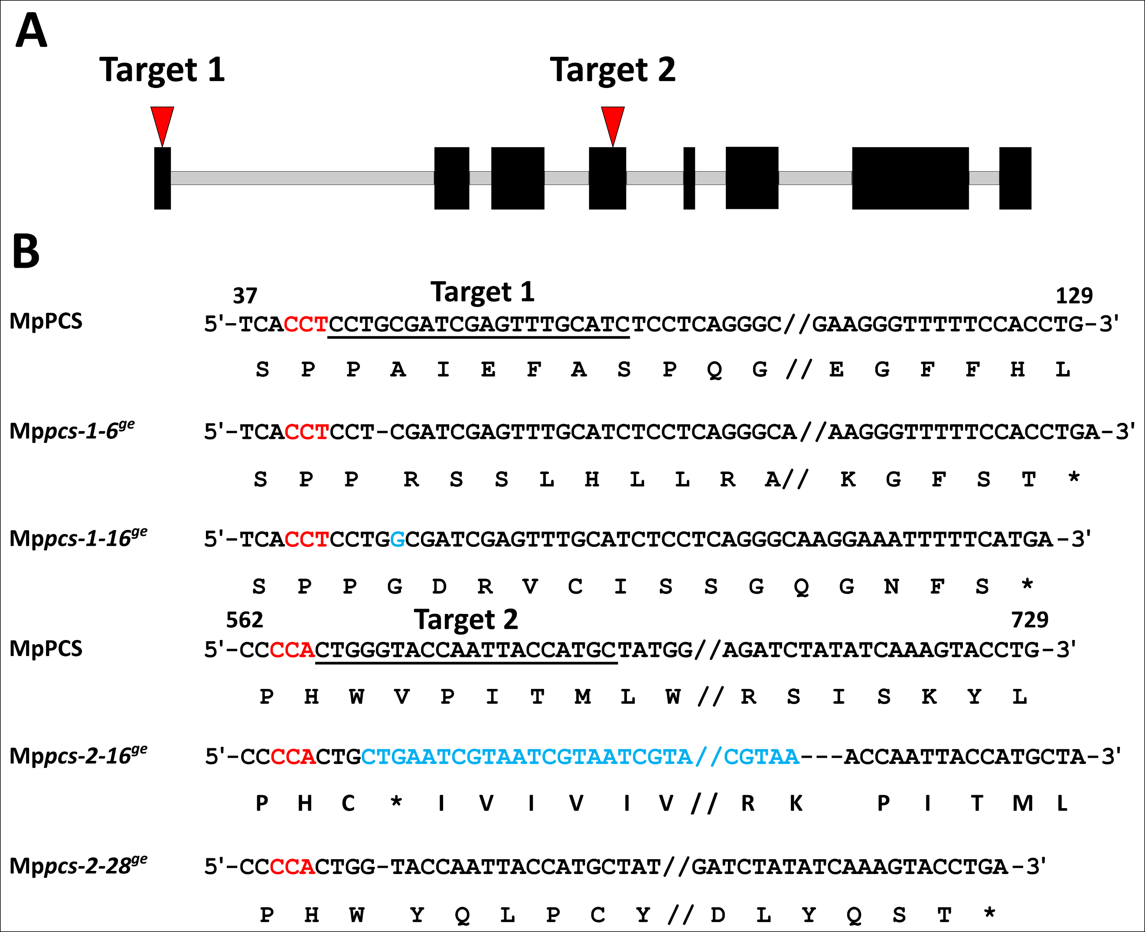

Fig. 2. Phenotype and biomass measurement of Mppcs knockout mutants compared with Cam2 wild-type plants under control and heavy metal treatments. (A) Representative phenotypic variation of plants treated with different concentrations of CdSO₄ and (B) corresponding biomass quantification; (C) Phenotypes of plants treated with different concentrations of ZnSO₄ and (D) corresponding biomass analyses. The scale bars indicate 10 mm. Vertical bars in the graphics represent standard deviation (n = 5 biological replicates), two stars stand for statistically significant difference from the corresponding Cam2 (Student's t-test, P < 0.01).
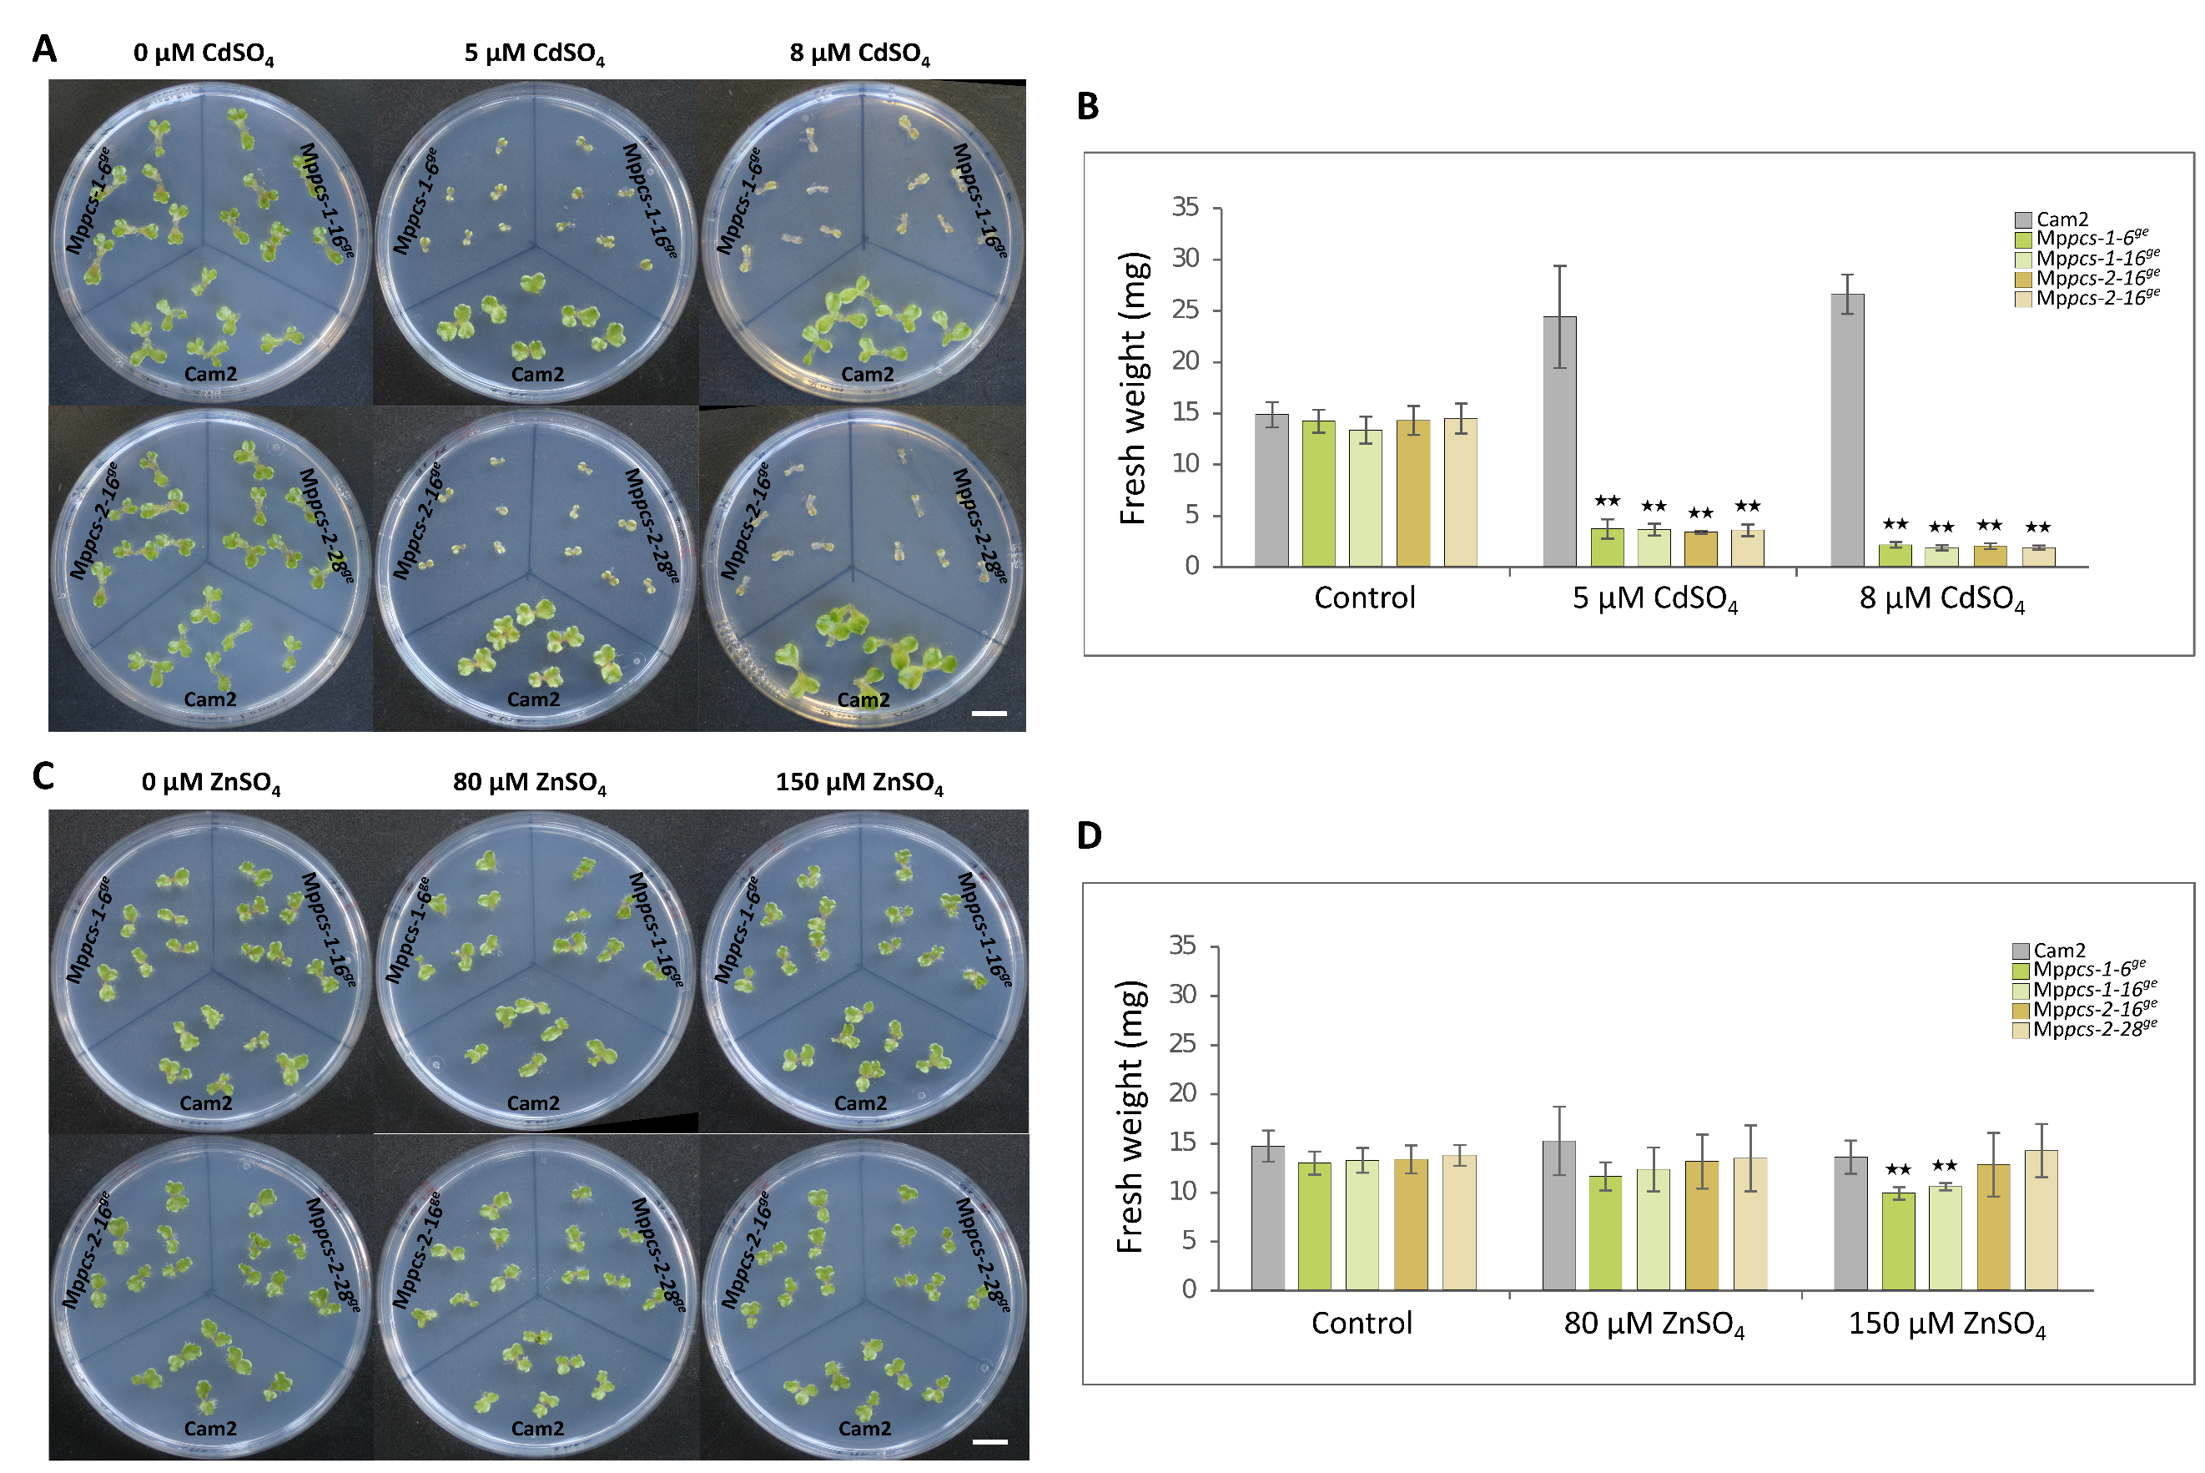

Fig. 3. Phenotypes and biomass analyses of two selected transgenic lines overexpressing MpPCS in M. polymorpha compared with Cam2 wild-type plants under control and metal treatments. (A) Phenotypic variation under different concentrations of CdSO₄ treatment and (B) corresponding biomass quantification; (C) phenotypes of plants subjected to different concentrations of ZnSO₄ and (D) corresponding biomass. The scale bar indicates 10 mm. Vertical bars in the graphs represent standard deviation (n = 5 biological replicates), two stars indicate significant difference from the corresponding Cam2 (Student's t-test, P < 0.01).
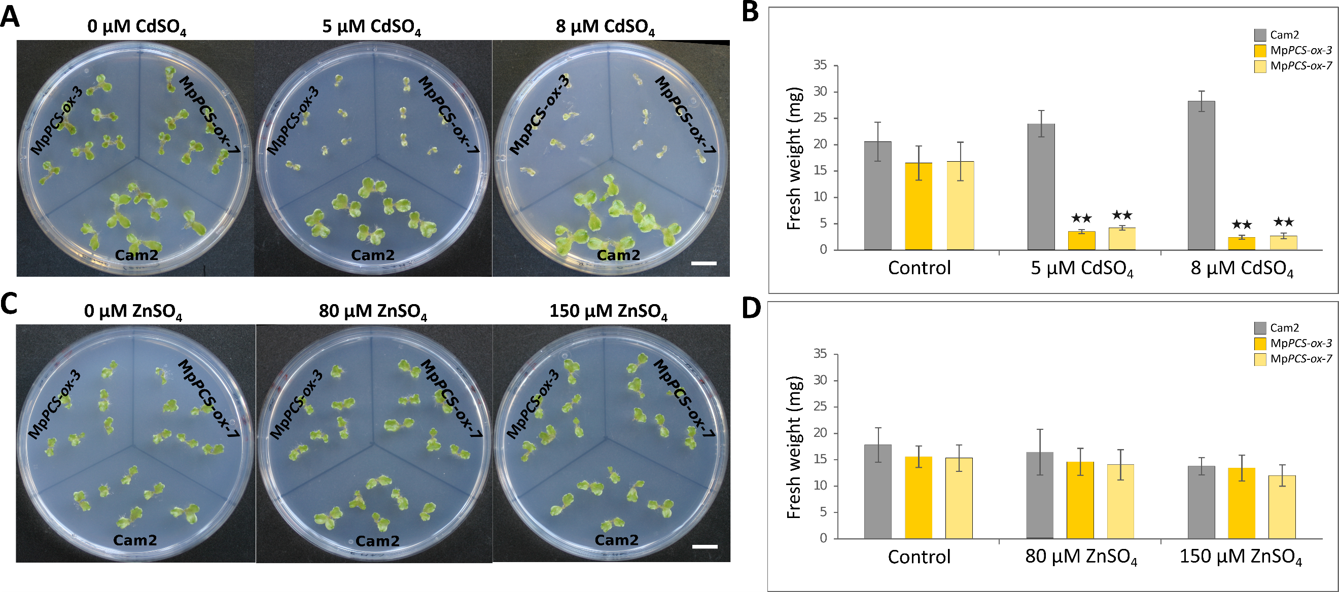

Fig. 4. Chlorophyll contents of 10-day-old Cam2 wild-type plants and MpPCS knockout mutants in M. polymorpha under control and 20 µM CdSO₄ or 400 µM ZnSO₄ treatment for one week. Bars indicate standard deviation (n = 4 biological replicates), two stars represent significant difference from the corresponding Cam2 (Student's t-test, P < 0.01).
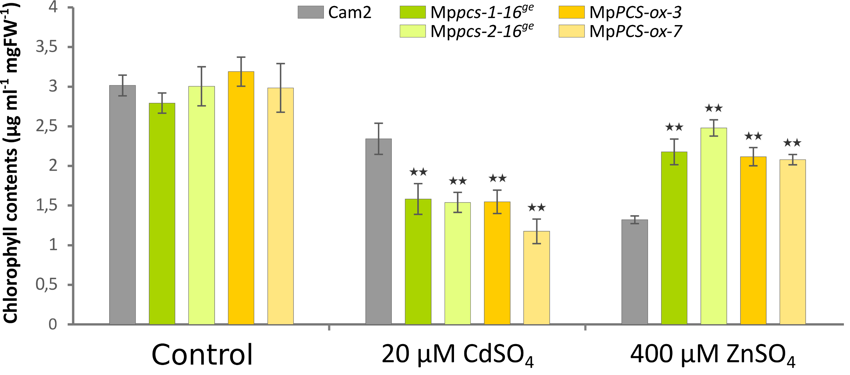

Fig. 5. Thiol-peptide quantification of 10-day-old Cam2 wild-type plants, MpPCS knockout mutants and transgenic lines overexpressing MpPCS in M. polymorpha under control and 20 µM CdSO₄ or 400 µM ZnSO₄ treatment for three days. Bars indicate standard error (n = 4 biological replicates), stars represent significant difference from the corresponding Cam2 (Student's t-test, P < 0.05).
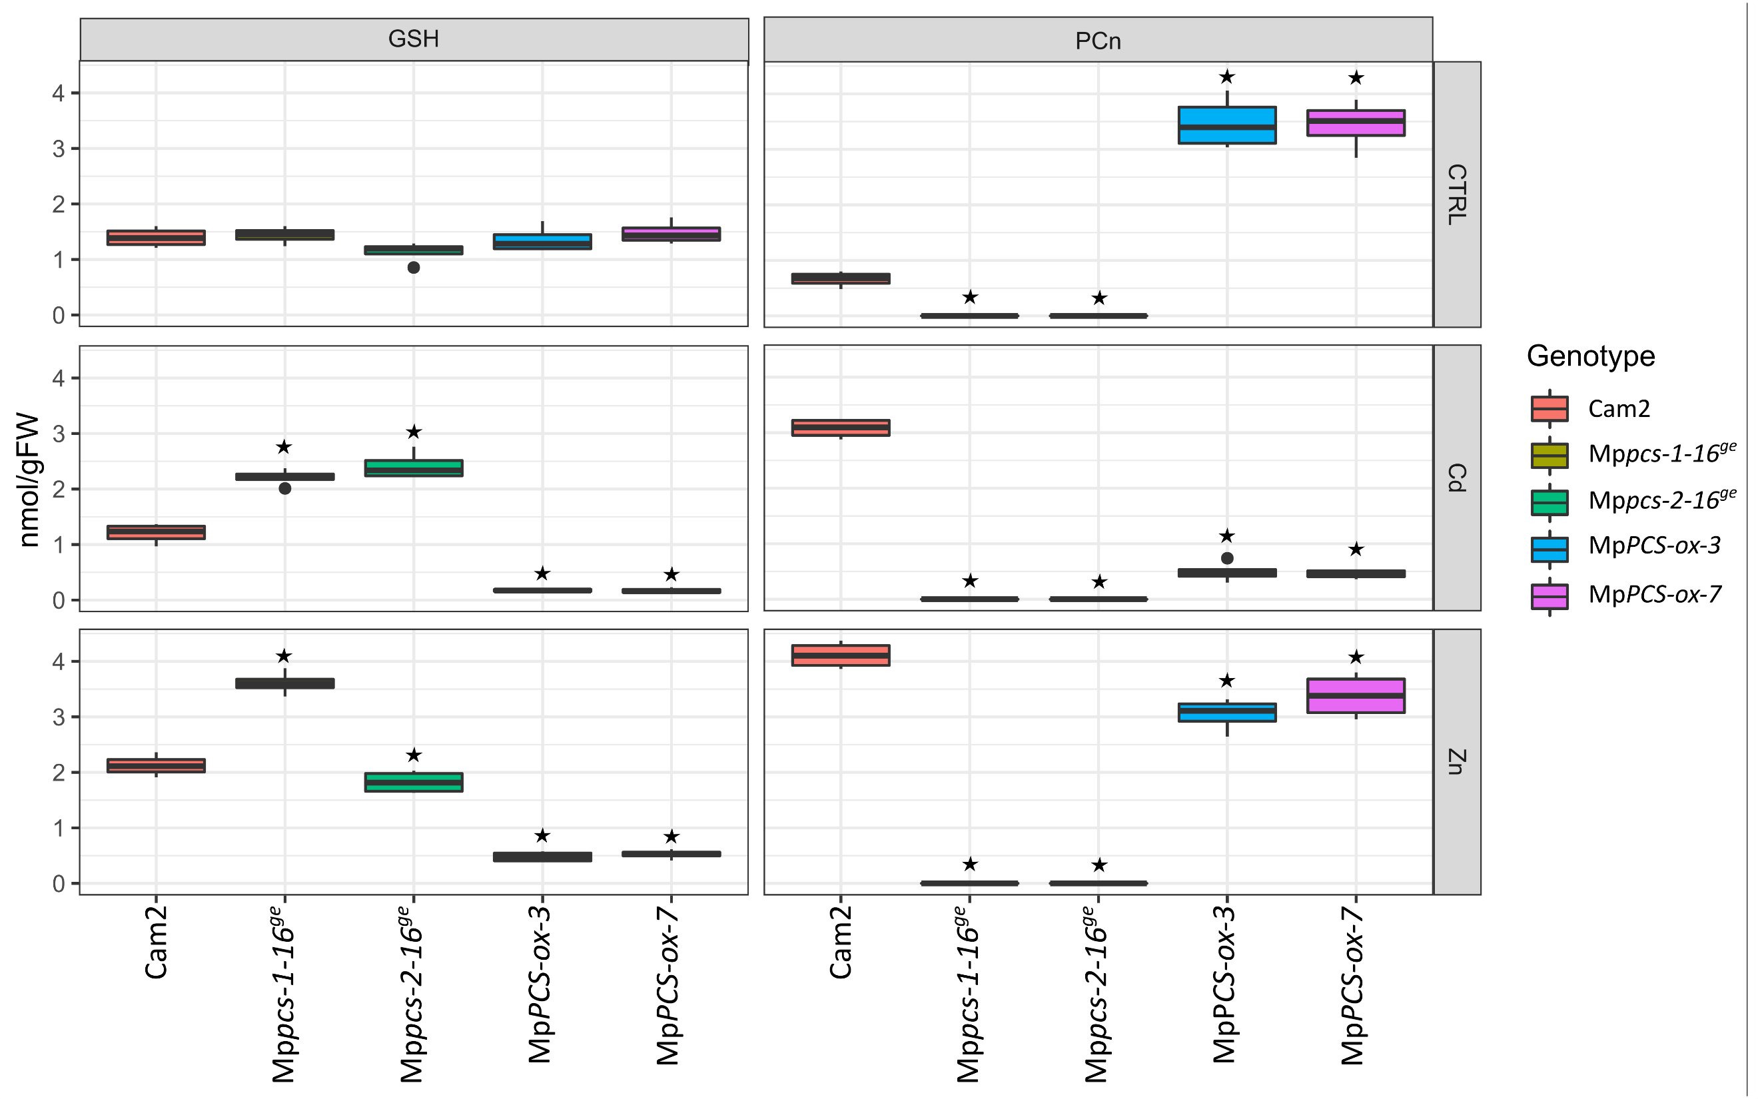

Fig. 6. Cd and Zn contents of 10-day-old Cam2 wild-type plants, Mppcs mutants and transgenic lines overexpressing MpPCS in M. polymorpha under control and 20 µM CdSO₄ or 400 µM ZnSO₄ treatment for three days. Bars indicate standard deviation (n = 4 biological replicates), stars represent significant difference from the corresponding Cam2 (Student's t-test, P < 0.05).
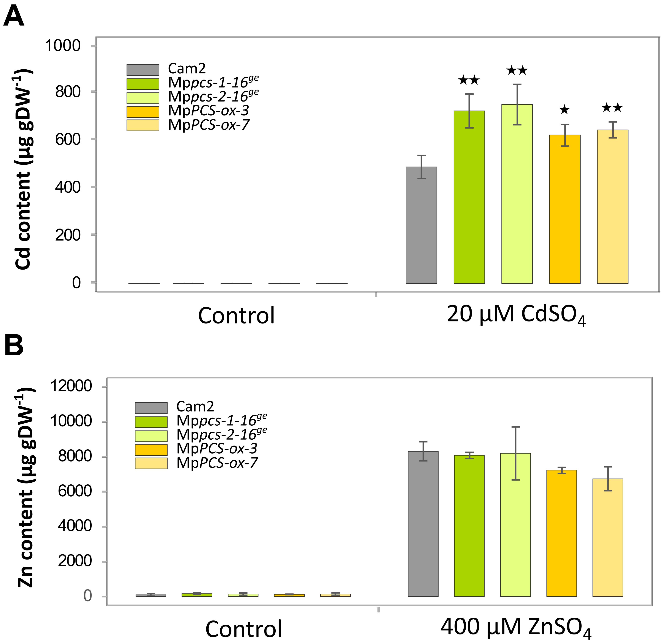

Fig. 7. MDA measurement of lipid peroxidation for 10-day-old Cam2 wild-type plants and MpPCS knockout mutants in M. polymorpha treated without or with 20 µM CdSO₄ or 400 µM ZnSO₄ for 3 days (A) and seven days (B). Bars indicate standard deviation (n = 4 biological replicates), two stars indicate significant difference from the corresponding Cam2 (Student's t-test, P < 0.01).
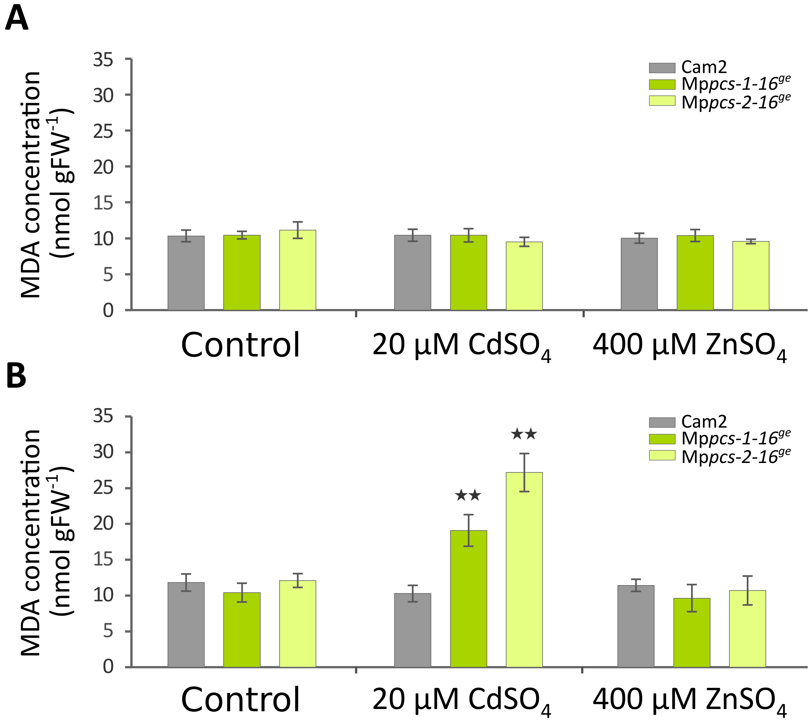

Fig. 8. Time course analyses of electrolyte leakage for 10-day-old Cam2 wild-type plants and MpPCS knockout mutants in M. polymorpha subjected to different heavy metal treatments. The electrolyte leakage under control condition on different days from day 2 to day 7 is shown in (A), under silver nitrate (Ag⁺) treatment indicated in (B), sodium (meta)arsenite (As³⁺) in (C), cadmium sulfate (Cd²⁺) in (D), lead nitrate (Pb²⁺) in (E), copper sulfate pentahydrate (Cu²⁺) in (F), ferrous chloride (Fe²⁺) in (G), nickel chloride hexahydrate (Ni²⁺) in (H), and zinc sulfate heptahydrate (Zn²⁺) in (I). At least four biological replicates were applied for each time point in all the analyses. Each star represents statistical differences of one of the mutants from Cam2 using Student's t-test with Bonferroni correction.
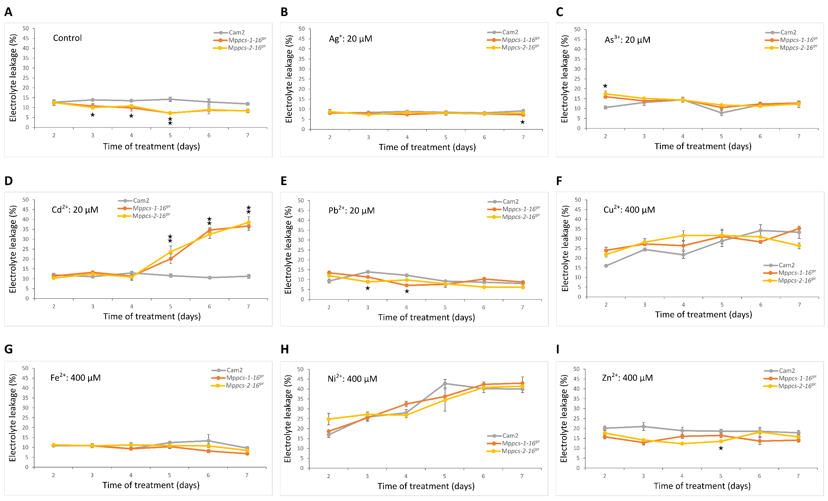

Fig. 9. Electrolyte leakage of 10-day-old Cam2 wild-type plants and MpPCS knockout mutants in M. polymorpha exposed for seven days to different concentrations of sodium (meta)arsenite (As³⁺) are shown in (A), cadmium sulfate (Cd²⁺) in (B), and zinc sulfate heptahydrate (Zn²⁺) in (C). At least four biological replicates were applied for each time point in all the analyses. Each star represents statistical differences of one of the mutants from Cam2 using Student's t-test with Bonferroni correction.

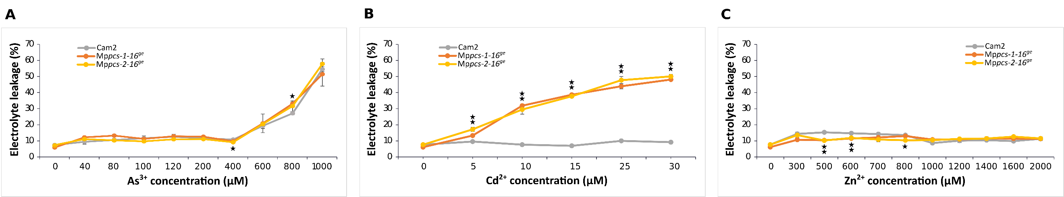

Fig. 10. Enriched GO terms of DEGs between the Mppcs-2-16^{ge} mutant and Cam2. Barplots show the Fold Enrichment of A) Biological Process, B) Molecular Function, C) Cellular Component GO terms sorted in decreasing order of the corrected enrichment probability (expressed as -Log10(FDR), i.e. the opposite of the base-10 logarithm of the enrichment probability corrected for multiple testing by False Discovery Rate).
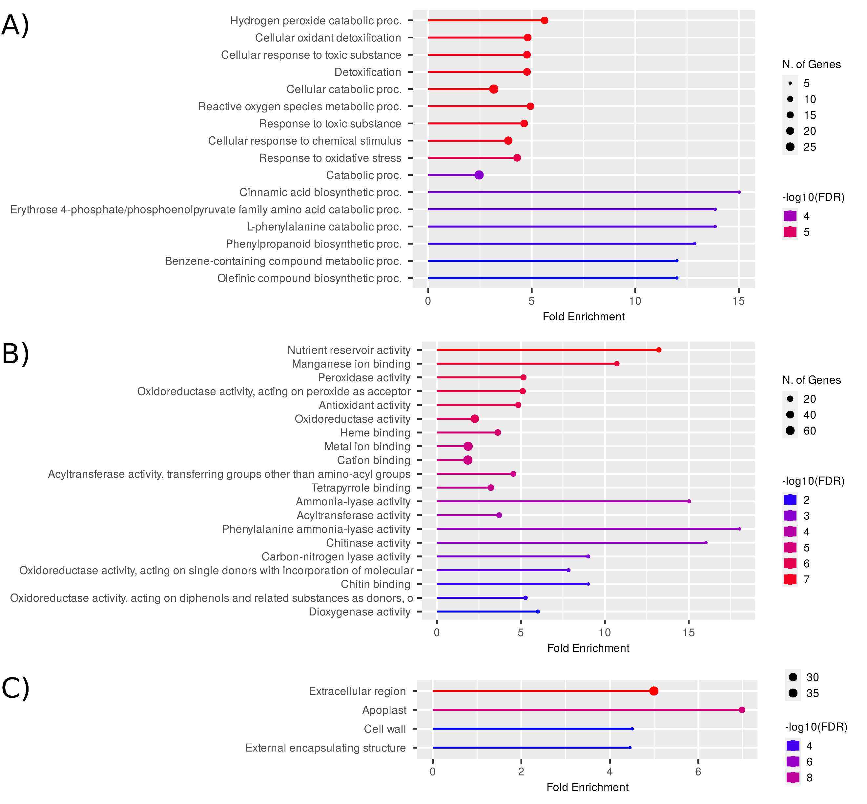

SUPPLEMENTARY FIGURE/TABLES LEGENDS
Supplementary Fig. S1. Transcription levels of MpPCS and MpACT genes in two-week-old Cam2 wild-type and four independent knockout mutant lines.
Supplementary Fig. S2. Expression patterns of MpPCS overexpression lines of G2 generation in M. polymorpha.
Supplementary Fig. S3 Enrichment of Biological Process GO terms in genes differentially expressed between the Mppcs-1-16^{ge} mutant and Cam2 WT M. polymorpha. A) Barplot of the Fold Enrichment of GO terms sorted in decreasing order of the corrected enrichment probability (expressed as -Log10(FDR), i.e. the opposite of the logarithm in base 10 of the enrichment probability corrected for multiple testing by False Discovery Rate). B) Hierarchical tree summarizing significantly enriched GO terms reported in A). Bigger dots at the end of branches correspond to more significant FDR values (printed in front of the terms). Terms sharing more genes are grouped together. The full names of each GO term correspond to those in Supplementary Table 3.
Supplementary Fig. S4 Enrichment of Molecular Function GO terms in genes differentially expressed between the Mppcs-1-16^{ge} mutant and Cam2 WT M. polymorpha. A) Barplot of the Fold Enrichment of GO terms sorted in decreasing order of the corrected enrichment probability (expressed as -Log10(FDR), i.e. the opposite of the logarithm in base 10 of the enrichment probability corrected for multiple testing by Benjamini-Hochberg False Discovery Rate). B) Hierarchical tree summarizing significantly enriched GO terms reported in A). Bigger dots at the end of branches correspond to more significant FDR values (printed in front of the terms). Terms sharing more genes are grouped together. The full names of each GO term correspond to those in Supplementary Table 3.
Supplementary Fig. S5 Enrichment of Cellular Component GO terms in genes differentially expressed between the Mppcs-1-16^{ge} mutant and Cam2 WT M. polymorpha. A) Barplot of the Fold Enrichment of GO terms sorted in decreasing order of the corrected enrichment probability (expressed as -Log10(FDR), i.e. the opposite of the logarithm in base 10 of the enrichment probability corrected for multiple testing by Benjamini-Hochberg False Discovery Rate). B) Hierarchical tree summarizing significantly enriched GO terms reported in A). Bigger dots at the end of branches correspond to more significant FDR values (printed in front of the terms). Terms sharing more genes are grouped together. The full names of each GO term correspond to those in Supplementary Table 3.

Supplementary Table S1. List of primers used in this study.
Supplementary Table S2. RNA-Seq summary statistics. For the 6 RNA-seq libraries, we reported the number of raw reads pairs and the statistics of filtering (number of survived paired reads, survival rate), aligning to reference genome (aligned concordantly 1 time, aligned concordantly >1 times, aligned discordantly 1 time, aligned singularly 1 time, aligned singularly >1 time, overall alignment rate) and assigning to annotated transcripts (total fragments, fragments assigned to transcripts, assigning rate).
Supplementary Table S3. GO term enrichment. Enrichment of Biological Process, Molecular Function and Cellular Component GO terms in genes differentially expressed between the Mppcs-1-16^{ge} mutant and Cam2 WT M. polymorpha. The transcript IDs for each group of GO terms are provided.

