An on-site teaching laboratory in a village damaged
by the 2009 Abruzzo earthquake

Linda Giresini^{*1}, Mauro Sassu²
linda.giresini@unipi.it¹, msassu@unica.it¹
¹ DESTEC, Dipartimento di ingegneria dell’Energia, dei Sistemi, del Territorio e delle Costruzioni, School of Engineering, Pisa, Italy
² DICAAR - Dipartimento di ingegneria civile, ambientale e architettura, University of Cagliari

Abstract: This paper illustrates a two-year program of summer internships that involved forty students from the School of Engineering of the University of Pisa during 2010 and 2011. The activity consisted in a systematic survey of damages occurred in a small village after the 2009 Abruzzo earthquake and in the preparation of documents addressed to a reconstruction plan. The historical center of San Pio delle Camere (1000 inhabitants) was fully surveyed, including about 140 hypogeal sites. Each student spent at least one month in these activities, funded by specific study grants provided by the Italian Tuscany Region. Teams of two-three students performed well-defined work packages, led by a tutor, who established roles and functions. At the end of each day, the students discussed the progress made preparing a weekly report. Moreover, preliminary structural analyses were carried out to assess the seismic vulnerability of some relevant buildings, fully available to the students. The main results were published in a book presented in a workshop. Most of the results were used to set up the official reconstruction plan of the village. During this on-site laboratory, the students could experience the effects of that destructive earthquake on the population, visiting also the damaged surrounding towns and seeing with their own eyes many cases of structural collapse.

Introduction
After the 2009 Abruzzo earthquake, the Tuscany region funded a two-year program of summer internships in one of the towns damaged by the main seismic shock, San Pio delle Camere (Figure 1). During the summer of the years 2010 and 2011, about forty student from the University of Pisa were involved in activities of survey, monitoring and analysis on buildings of this village. Each student participated for four weeks in the areas struck by the earthquake, taking advantage of the opportunity of an open-air teaching laboratory. Indeed, this was an important educational occasion for students to see live the behavior of constructions under seismic actions, and how an erroneous structural conception can lead to relevant disasters. The students could face issues typical of existing masonry buildings and of particular historical structures, hypogean sites, called “Camere” (from which the town name derives). The teams classified over a hundred aggregates, recognizing the buildings types that better performed over the shock and those that were affected by collapses.

During the internship several inspections took place in some nearby small cities (Paganica, Onna, Barisciano, San Demetrio nei Vestini, Fossa etc., Figure 2) and the historic center of L’Aquila. In addition, the students participated to surveys to live see interventions of retrofitting after earthquake, such as temporary houses, temporary schools, new buildings with seismic isolators. The students interacted with the inhabitants, the authorities and the technical offices, acquiring a socioeconomic knowledge of the site. They experienced the difficulties faced by the local authorities in the survey of seismic damages and in programming a reconstruction plan. It is worthy to notice the extremely positive results obtained with such an experience: the great number and type of collapses occurred in the buildings, the close relationships with the inhabitants, the close connections with the colleagues represented a relevant human and professional experience for both the students and the tutors that led them.

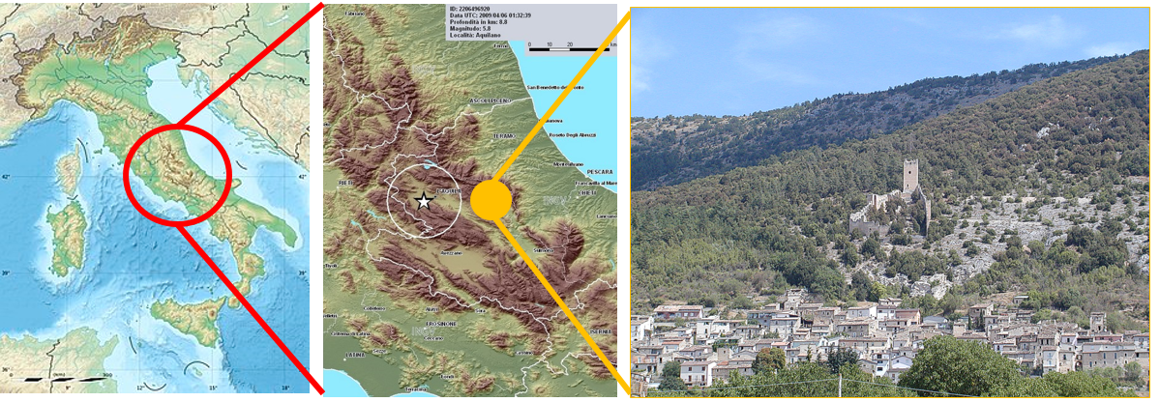
Figure 1 San Pio delle Camere village: the on-site teaching laboratory for students
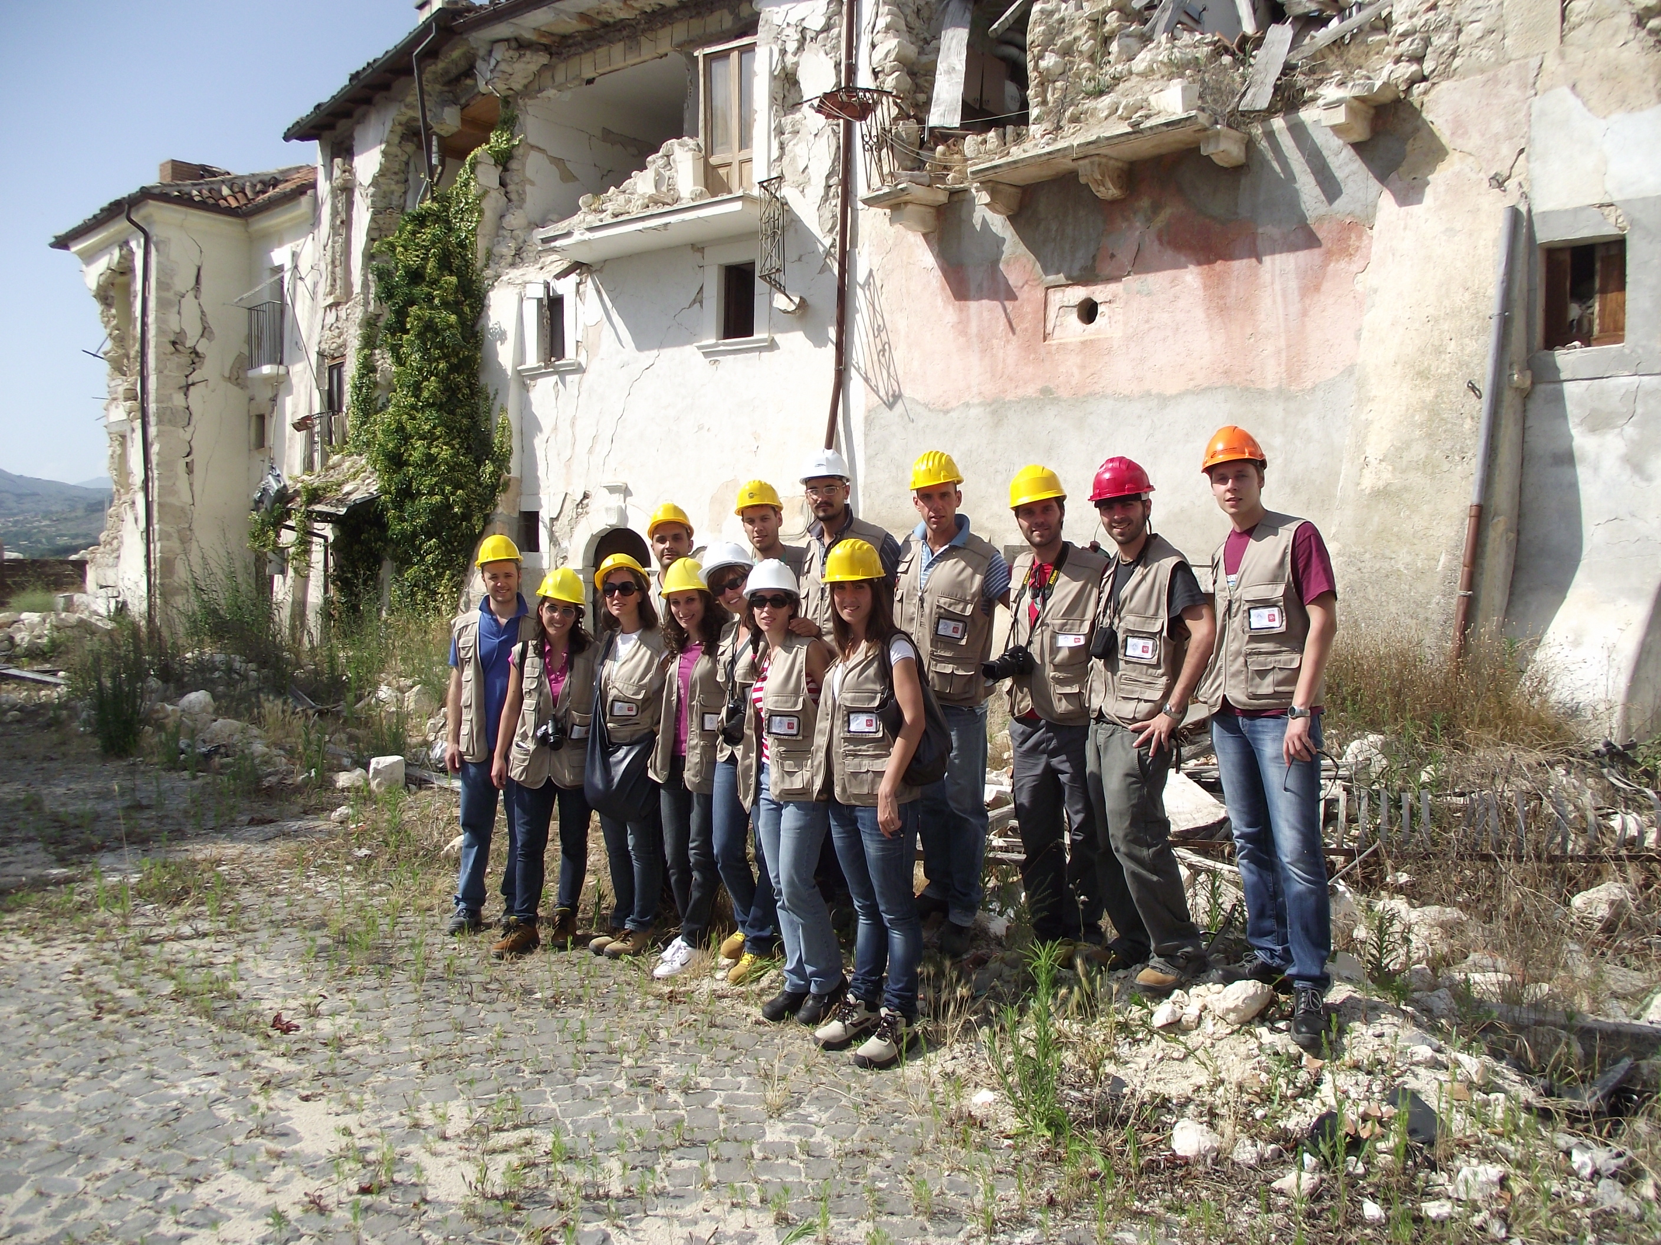
Figure 2 Part of the forty students selected for the internship during a survey

The damages of the 2009 Abruzzo earthquake
In the night of April, 6th, 2009, a main shock rated 5.9 on the Richter scale (M6.3) occurred in the Abruzzo Italian Region. This shock caused devastation, with 286 deaths and 1173 injured. San Pio delle Camere, 25 km far away from the epicenter, was made of 2-3 storey masonry buildings, built according to the schemes B-C of Figure 3a due to the ground natural slope. A considerable amount of houses in the city centre were of the so-called “Profferlo” type (Ceradini, 2003): an external staircase and a multifunctional house (Figure 3b). The basement was often used for storage or as farm recovery, while the others floors were used for residential purposes. The newest part of the village, mainly made of r.c. buildings, basically had not been damaged.
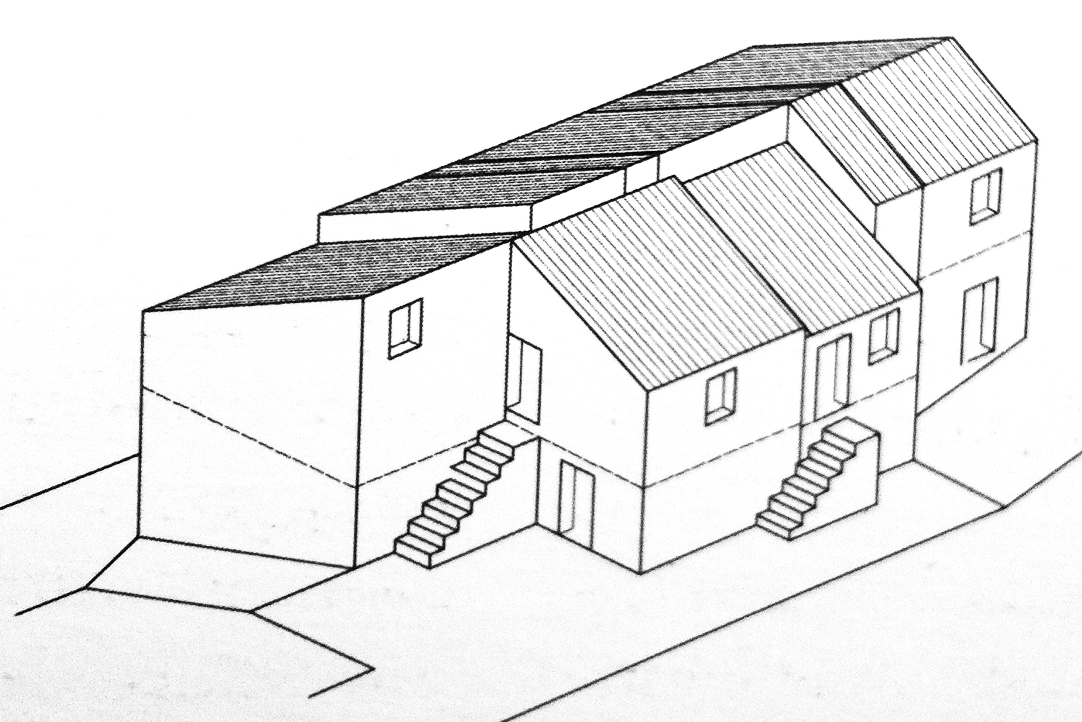
(a) (b)
Figure 3 Buildings location in case of ground natural slope (Ceradini, 2003) (a); “Profferlo” house typical scheme (Ceradini, 2003) (b).
The damages due to the earthquake showed the relevant role of the soil seismic amplification: similar buildings, located at the same distance from the epicenter but with different soil characteristics, had shown strongly different damages. While San Pio delle Camere – built over rock - was not heavily damaged by the earthquake, the nearby town, Castelnuovo, was affected by a significant seismic shock amplification. The San Pio subsoil is characterized by a carbonate bedrock overlaid by breccias in the upper part of the village and alternative layers of continental drifts of silts and clay in the lower part (Andreini et al 2012). The area nearby San Pio is built over an alluvial soil. Thus, the need of analyzing in detail the seismic micro-zonation arose to better address the interest of future housing projects. In particular, the greater damages occurred in buildings with irregular masonry, weak mortar and floors such as vaults or with low connected beams.
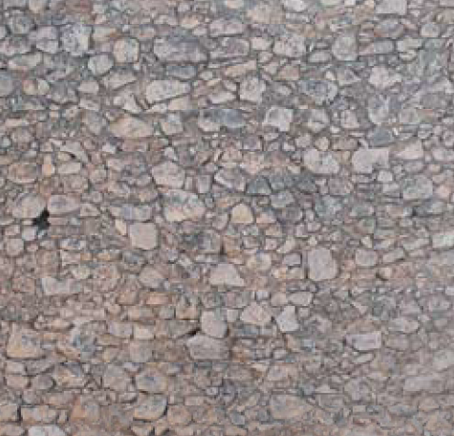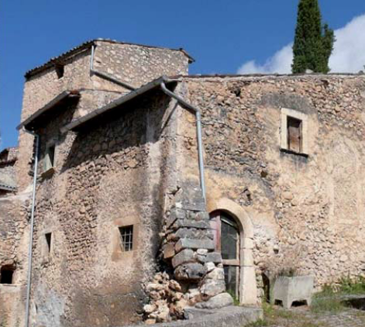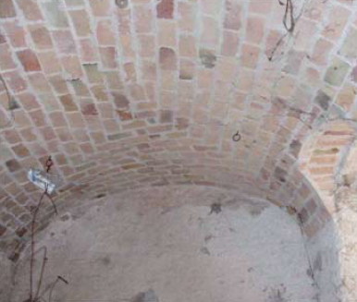
(a) (b) (c)
Figure 4 Old masonry texture (a); typical house in the city centre (b); masonry vault.
Masonry of poor quality was mainly made of small size stones with irregular shape (Figure 4a,b), without headers or transversal connections. Local mechanisms of out-of-plane rigid block modes and collapse of external leafs were detected (Andreini et al. 2014). Other relevant damages influenced heavy roofs in clay and r.c. diaphragms, besides flexible roofs such as vaults (Figure 4c). More extensive failures were surveyed in some buildings with hypogeal cavities, as illustrated in the next paragraphs. The buildings less damaged where those with masonry made of concrete blocks masonry, good quality mortar, steel ties and light timber roofs.

Teaching and learning activities

The internship framework
A crucial aspect of the internship was related to its organization: the selected forty students, twenty for every year, were divided in eight teams with a time schedule well defined for properly covering the working period (Figure 5).

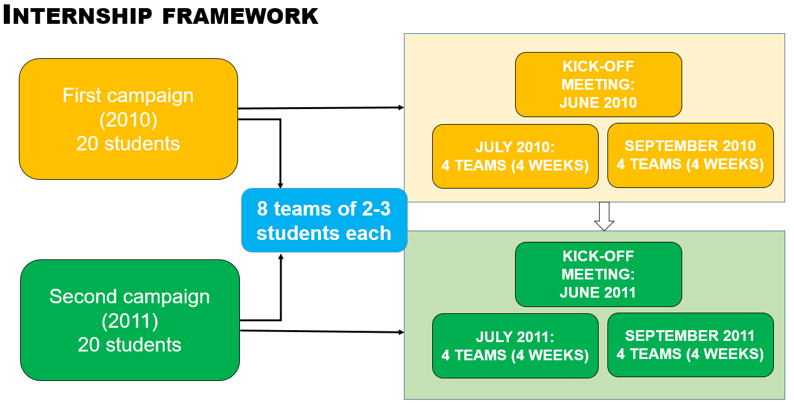
Figure 5 Internship framework
The work groups were constantly supported by teams of tutors, research assistants and PhD students, under the guidance of one author.
The activity program mainly involved two steps: the survey of structural aggregates and a careful survey of earthquake damages, starting from the analysis of previously compiled forms designed by the Civil Protection Department. This analysis allowed to classify in each aggregate the typologies of damages and the safety level. Collateral activities, such as inspections in the nearby damaged areas, alto took place (Figure 6).
A book (Sassu, 2011) and conferences were the result of those activities. The participants were directly engaged in the dissemination of results; indeed, each team prepared a specific chapter of the book under the guidance of team tutors.

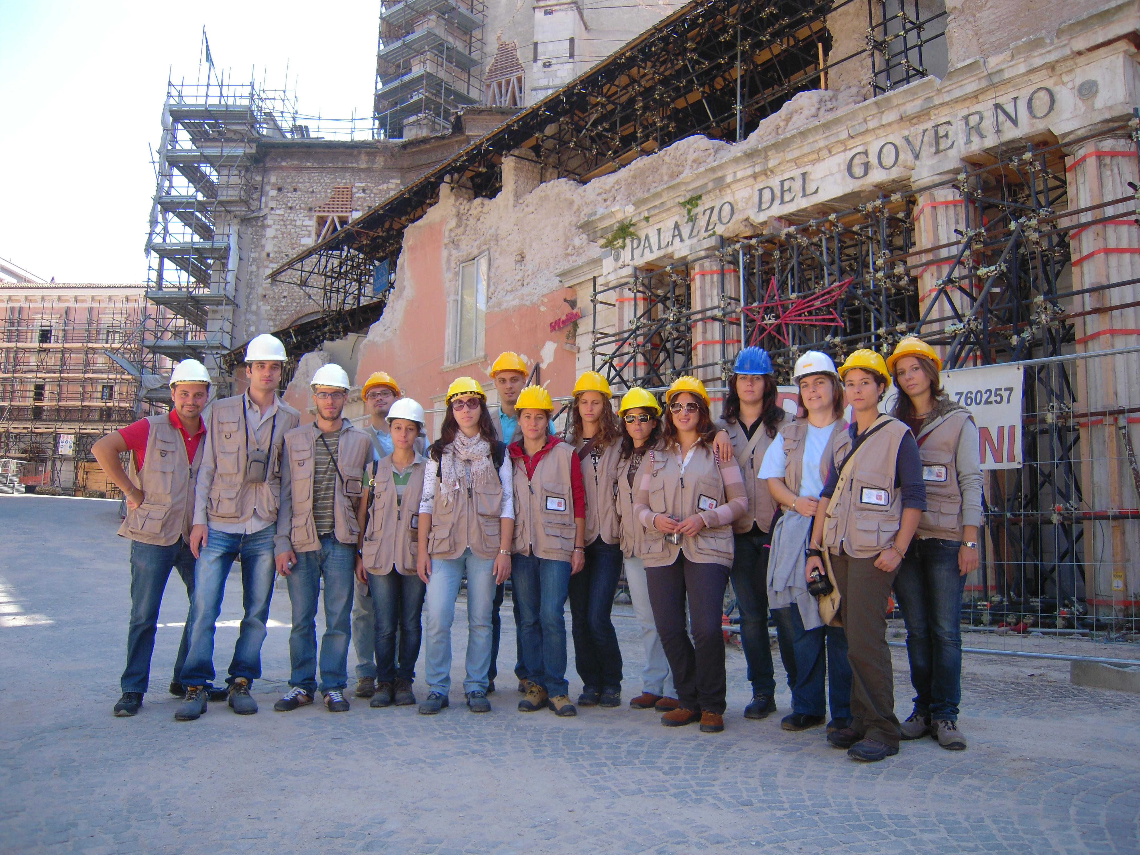
Figure 6 Inspection in L’Aquila with a group of students

First campaign: survey and classification of damages

Structural aggregates, survey of damages and form-based assessment
The activity program started in Summer 2010 with the survey of structural aggregates, composed by “structural units” (S.U.) and “units of minimum intervention” (U.M.I.). The U.M.I.s were defined as minimum sets of S.U., structurally independent components of aggregates, to reinforcement activities. By identifying the S.U., the students could put in practice the concepts of independent structure. Moreover, they could also reflect about an optimization of structural interventions from a technical and economic point of view, through the analysis of the U.M.I.s.
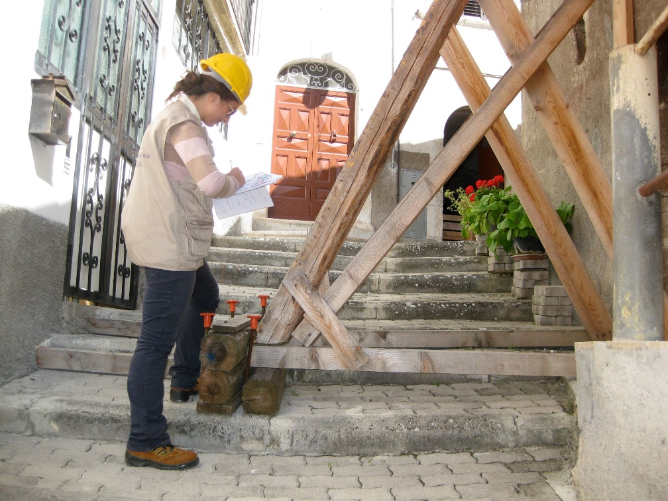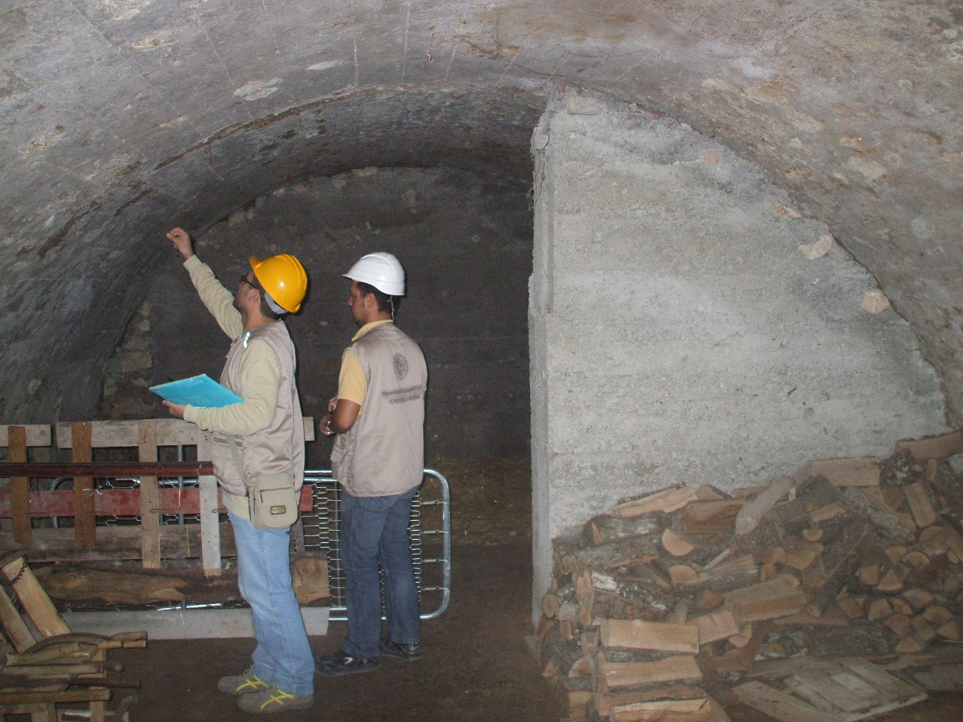
(a) (b)
Figure 7 Students surveying structural features and damages of a building (a) and an hypogeal structure (b)
The students spent the first two-three weeks of the first campaign in a systematic survey of damages, most of them light or moderate cracks in masonry buildings of the historic center, as discussed in the previous paragraph (Figure 7). The main consolidation activities before and after earthquake had also been classified: the use of steel tie-rods, r.c. plating plates, curbs, metal beams were recurring but with different effectiveness in function of the type of building, soil and construction in accordance with the best practice. They also made inspections in the newer part of the town, with r.c. buildings not sensitively damaged, due to the lower soil amplification. The students could relate the damages of masonry buildings to its poor quality, both in terms of material and construction technique. Moreover, improper retrofitting techniques had been adopted before the earthquake, worsening a potentially dangerous building status. The students realized that (i) erroneous interventions could worsen a situation and that (ii) the use of simple anti-seismic devices, such as steel tie-rods or regular masonry, could strongly improve the building response under dynamic actions. Indeed, the buildings with those elements showed less pronounced out-of-plane modes and performed much better without significant cracks. For what concerns point (i), it should be pointed out that the team tutors systematically explained why some interventions, e.g. the substitution of a timber diaphragms with an r.c. floor, could aggravate the building response in case of a seismic shock. In this way the building dynamic features could vary such a way that the overall structural stiffness reduces and the seismic action is amplified.
Some historic buildings, such as the San Pietro Celestino Church, were judged unusable due to the collapse of the bell tower and an incipient overturning of the main façade. Other cases were also declared unusable for the external risk caused by adjacent buildings.

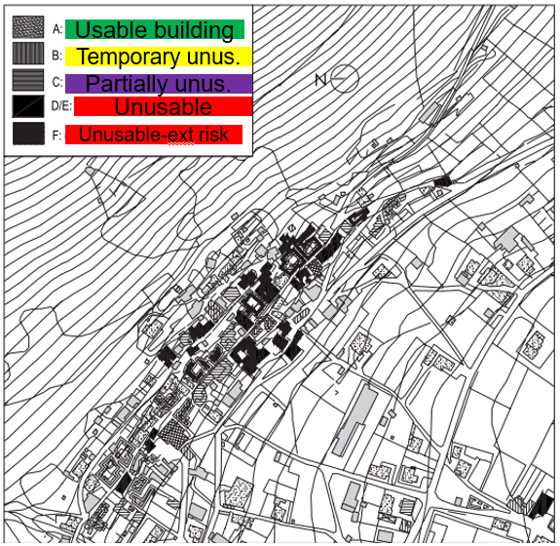
Figure 8 Classification of structural aggregates depending on their hazard level
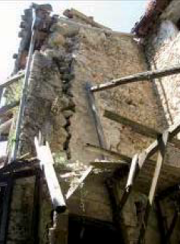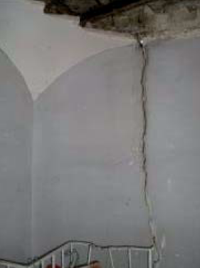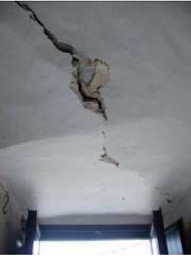
(a) (b) (c)
Figure 9 Masonry façade overturning (a); partial vault collapse (b); deep vault crack due to shear action.
After this phase, the students analyzed the forms previously compiled by technicians right after the earthquakes.
These forms (called AEDES, Agibilità e Danno nell’Emergenza Sismica = Usability and Damage in Seismic Emergency, Baggio et al. 2007), contain data regarding site and structural properties, the damage level of structural and non-structural elements, qualitative information concerning soil and foundations. The forms also consider external risk due to other constructions, the mean vulnerability level and the indication of some short term countermeasures (e.g. temporary scaffolding, supports) to promptly reduce risk in the post-earthquake phase. The students could infer from these forms, made available by the local authorities, a map of the damages and therefore the vulnerability useful for an assessment of a seismic amplification (Figure 8). It is worthy to notice the extremely educational value of this experience for the students of verifying with their own eyes all these aspects related to the survey of damages.

Hypogeal structures
San Pio delle Camere is characterised by horizontal underground chambers or hypogeal structures (Camere, in Italian, Figure 3) excavated under the buildings in the rock or in the sedimentary colluviums. This structural feature was very interesting to be considered by the students, which had the possibility of understanding its role on the structural behaviour of whole aggregates. In particular, two teams of students systematically classified over 150 hypogeal structures, identifying three main typologies of chambers:
- Type 1: the cave is made of three components: one under the building, generally a plastered clay bricks barrel vault, a second one right behind the first one, excavated, covered by a barrel vault with irregular stones, and a third one usually large and high (Figure 11a);
- Type 2: as Type 1, but without the second component: behind the building a large and high chamber is directly excavated in the ground, with natural recesses and secondary rooms (Figure 11b);;
- Type 3: multilevel chambers of types 1 and 2. This typology is the most frequent, due to the numerous construction activities during the decades. In this case, the chambers can reach up to 30 meters of depth. Sometimes, reinforcement arches are built under other structures, but misaligned with respect to the upper walls (Figure 11c).
An example of façade with entrance to the hypogeal structures is shown in Figure 11d.

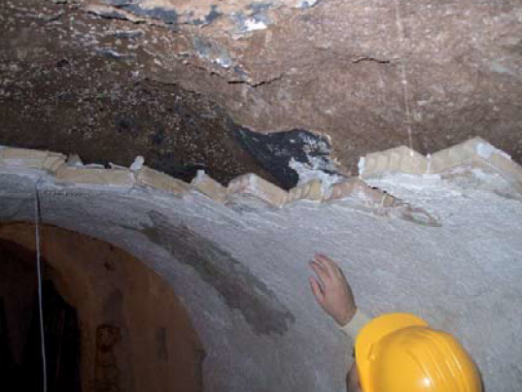  (a) | 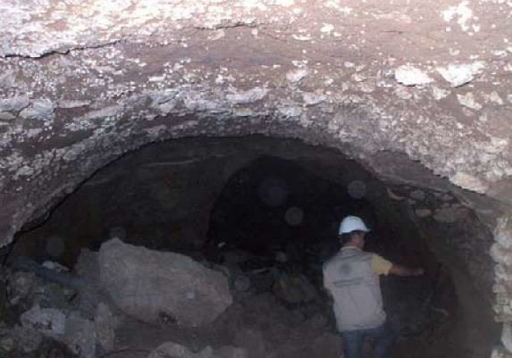  (b)
Figure 10 Qualitative survey of the hypogeal structures: assessment of the structural status (a); material and humidity level (b).
The first team analysed the main structural characteristics of these chambers, such as the soil type and the humidity level (Figure 10a, b). Clay alluvium of red colour was mainly identified, with discrete cohesion and compact.
For the lack of instrumentation, the survey was performed in qualitative but systematic way, significant for general information. The students could associate these features to the structural behaviour, characterised by some (although not relevant) tensile material strength and plastic behaviour.

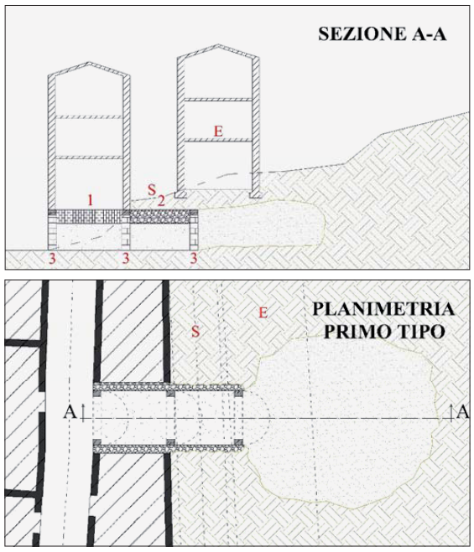  (a) | 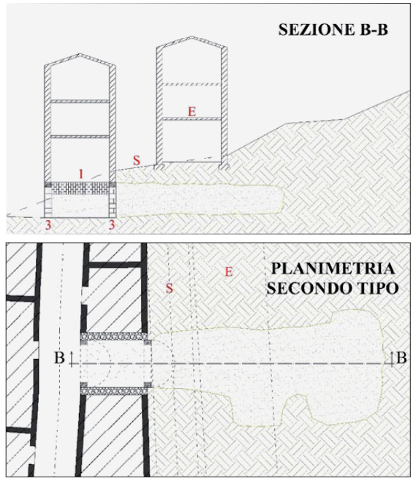  (b)
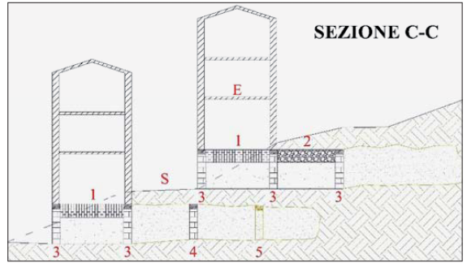
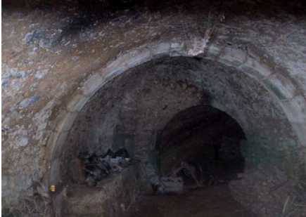
(c)
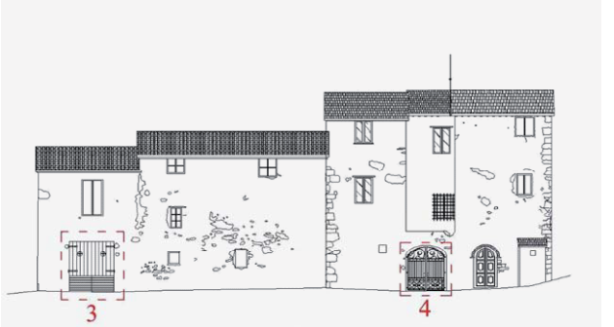
(d)
Figure 11 Technical survey of the hypogeal structures: type 1 (a); type 2 (b); type 3 (c); example of façade with entrance to chambers (d).
Through visual inspection and collection of information by the owners, the humidity level seen in many chambers sensitively rose up after the earthquake. Indeed, before it the chambers were more or less dry or slightly humid. In many surveys, the material was wet to the touch and plastic. In fewer cases, leak of water was seen. Failures in the water supply network or small cracks in the soil due to the ground motion likely caused them. For this reason, some covering collapsed here and there.
Moreover, the students analysed static and technical issues related to the chambers. They investigated the kinds of loads acting on the chambers, identifying several types of loads: concentrated (due to columns), uniformly distributed (walls), non-uniformly distributed (arches). In many cases, they could observe consolidations structures adopted, based on the load type: continuous walls to
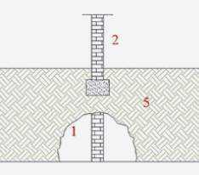  (a) | 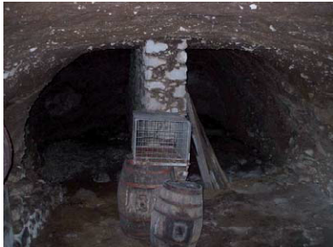  (b)
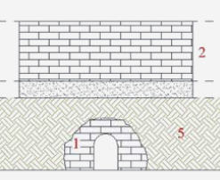  (c) | 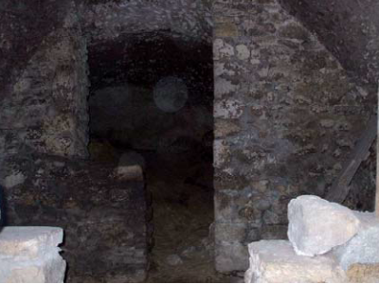  (d)
Figure 12 Schematization of loads and reinforcement structures: continuous wall (a, b); transverse arch (c,d).
counteract the load of the upper wall #2 (Figure 12a) with a longitudinal wall (Figure 12b). Another reinforcements technique was given by a transverse arch balancing the load due to a continuous wall in transverse direction (Figure 12c,d).
The second team of students proposed practical data sheets to classify the hypogeal structures (Figure 13). The data sheet is made of eight sections: (I) identification data (address, owners name) and level of inspection; (II) geometrical data and coating, distinguishing the type of chamber; (III) the soil type; (IV) the general status of the structure (water, humidity level, collapses); (V) features of the building over the hypogeal structure considered; (VI) usability level provided by the AEDES forms, previously described and a final judgement of the structural condition, with five levels of damage; (VII) pictures, technical drawing and relevant notes, such the presence of failures, water leakage, etc.

Second campaign: analysis of real data and proposals of consolidation activities
The second campaign, performed in Summer 2011, involved other twenty students. Their work was related to the elaboration of the data collected in 2010, completing several surveys of masonry aggregates and hypogeal structures, and to structural analyses on buildings. In this section, the Authors describe the type of analyses performed on selected case studies, to increase the awareness of students on their professional role once graduated.

Local seismic analyses
The tutors selected some relevant case studies among the buildings surveyed in San Pio delle Camere village. The selection criterion was related to the amount of information available for each case and to the strategic importance of the building for the municipality.
The teams of students had to calculate the maximum static horizontal actions capable of initiate the mechanism. In this sense they had to collect information about the geometry of the macro-element and about the loads (masonry specific weights, floor loads, possible actions due to arches, etc). This was believed to be a straightforward tool for civil engineering students for understanding the relevance of simple calculations to get a first but significant information about the safety level of the macro-element, due to the higher vulnerability of out-of-plane modes with respect to in-plane modes.

Vulnerability index and risk index assessment
From the information available about the survey made in the first campaign, the students assessed the vulnerability index corresponding to selected buildings. In particular, a form-based approach, through a data sheet made available by the Marche Region (Figure 15), was adopted.
In it, the students had to specify some structural parameters (material, regular/irregular building, foundation, floors and roof types, presence of good connections between floors and vertical structural elements). The scores associated to these parameters allowed to calculate a scaled vulnerability index and, from this, a capacity peak ground acceleration, capable of causing structural failure. The combination of capacity peak ground acceleration and demand peak ground acceleration gave the index risk of the building.
The vulnerability index was calculated for the S.U., the U.M.I. and the aggregates. This way, the students gained confidence with the huge amount of data collected in the previous campaign and processed them to compile a scale of priority useful for local authorities.

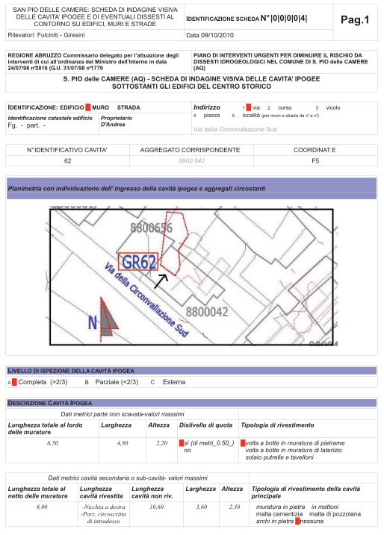
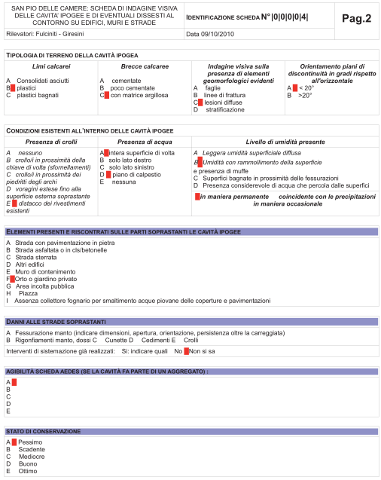
Figure 13 Data sheet proposed by the team of students for the classification of the hypogeal structures
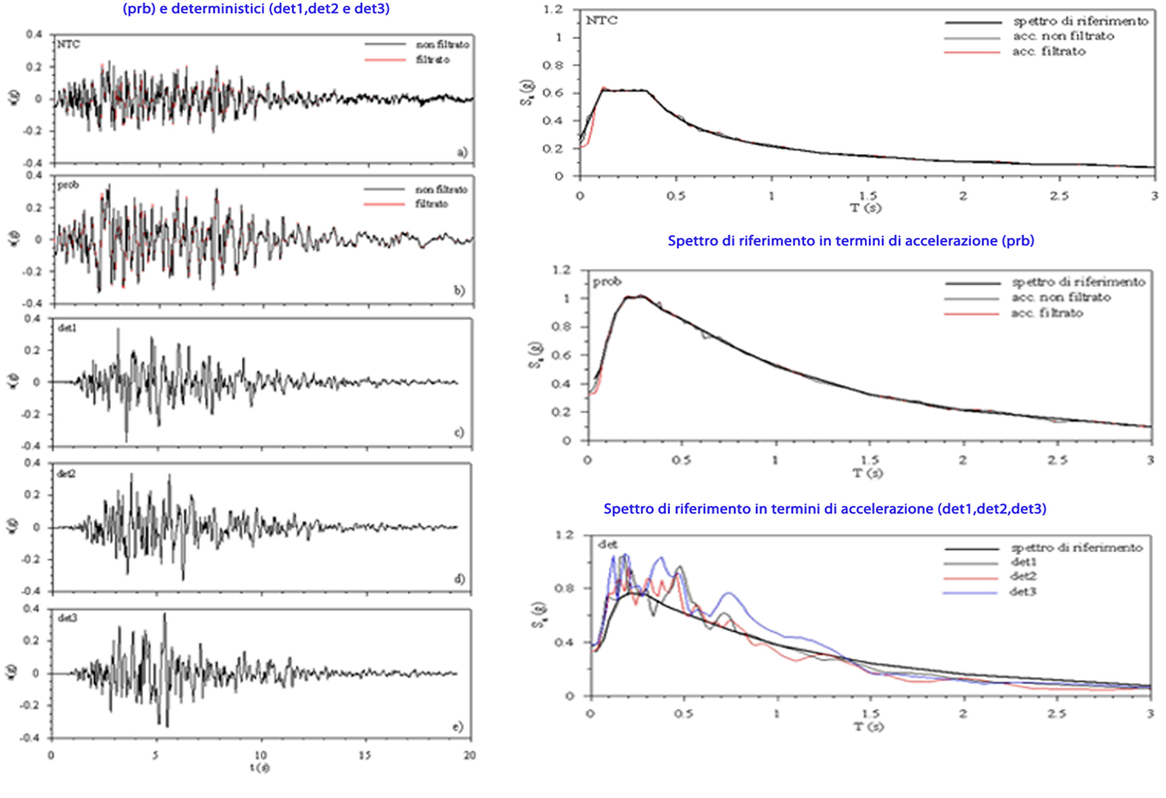
Figure 14 Determination of response spectra corresponding to the main seismic shock record and comparison with the response spectrum provided by the Italian Standards

Global seismic analyses
The last step of the campaign, performed by three teams, was the structural analysis of selected case studies, such as schools and other strategic buildings. Simple linear dynamic analyses with computer-based programs were carried out (Figure 16). For this purpose, the students dealt with the computation of the response spectra corresponding to the main seismic shock record. Moreover, this was compared to that provided by the Italian Standards [1] and the students saw that it was underestimated. In this manner, the students could put in practice, as in an actual professional activity, their knowledge about seismic analysis directly on site, having a deeper perception of the issue.

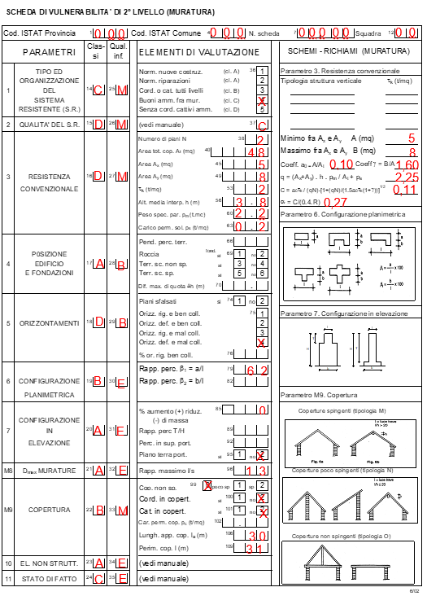
Figure 15 Example of 2nd level form for the calculation of the vulnerability index made by the students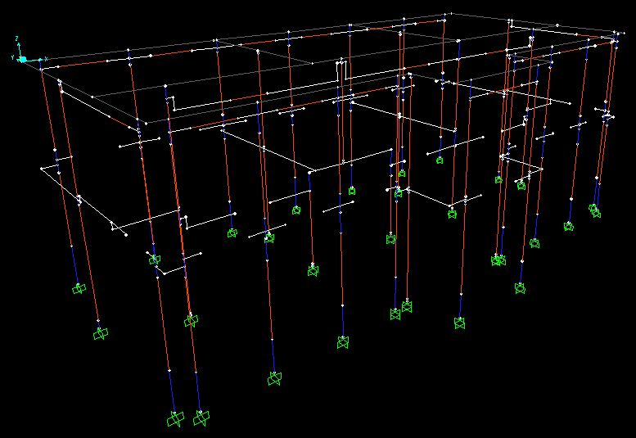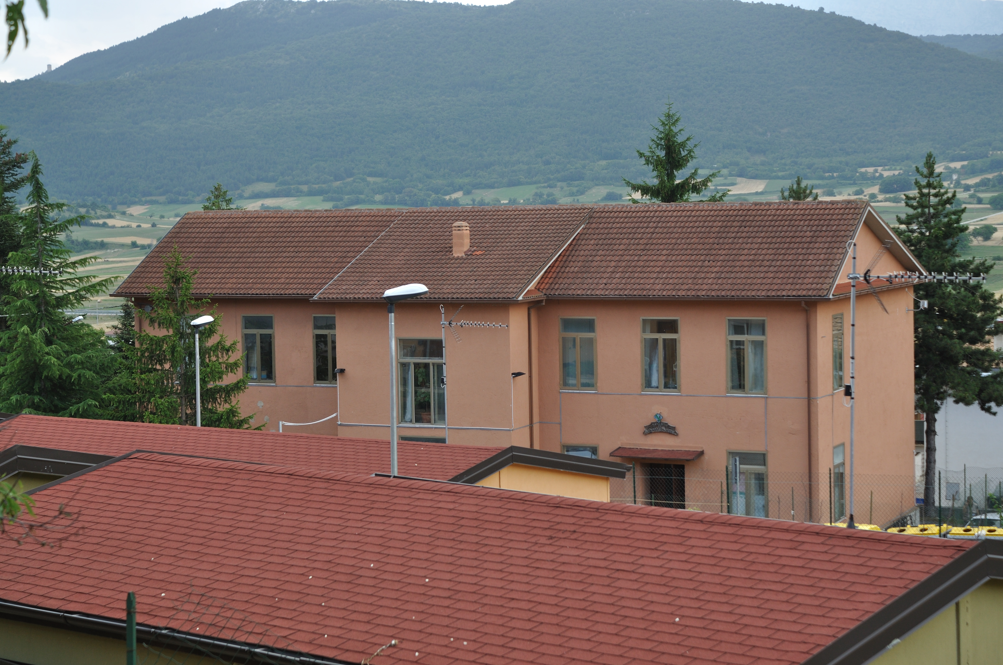
Figure 16 Finite element model (a) of a frame type structure (municipality, b) made by one team of students

Conclusions
This contribution illustrated the activities performed during two internships funded by the Tuscany Region for civil engineering students. The San Pio delle Camere village, damaged by the 2009 Abruzzo earthquake, was fully surveyed in 2010-2011 by forty students divided in teams of two-three students each. They stayed in the village for about four weeks each one. The activities of surveying and analysis have been of extremely high value from a professional and human point of view, giving to the students the opportunity to see with their own eyes the consequences of design errors and of improper consolidation techniques. The experience also strengthened their tendency to empathy and their capability of communicating with local authorities and inhabitants, in a complex context.

Acknowledgements
Special thanks to all the students and tutors that participated to the two campaigns of 2010-2011, the RELUIS Consortium for the support and the Tuscany Region that funded the internships.

References
Andreini, A., De Falco, A. & Sassu, M. (2012) Damage mechanisms in masonry buildings and peak ground acceleration during the 2009 earthquake in Abruzzo (Italy). Proceedings of SAHC: 8th International Conference on Structural Analysis of Historical Constructions, Wrocklaw (Lourenco, Modena, Roca eds.), pp. 1755-1764.
Andreini M, De Falco A, Sassu M (2012). Damage mechanisms as seismic transducers in historic centres: the example of San Pio delle Camere after 2009 earthquake in Abruzzo (Italy). In: 15th WCEE. Lisboa:15th WCEE, Lisbon, Portugal, 24-28 September, 2012
Andreini M., De Falco A., Formisano A., Giresini L., Sassu M. (2014) Historic centre of San Pio delle Camere under 2009 Abruzzo earthquake (Italy): survey campaign and seismic vulnerability estimation, Proceedings of PROHITECH: 2nd International Conference on the Protection of Historical Constructions, Antalya, Turkey, 1, pp. 445-451.
Baggio C, Bernardini A, Colozza R, Corazza L, Della Bella M, Di Pasquale G, Dolce M, Goretti A, Msrtinelli A, Orsini G, Papa F, Zuccaro G (2007) Field manual for post-earthquake damage and safety assessment and short term countermeasures (AeDES). In: Pinto AV, Taucer F (eds) European Commission—Joint Research Centre—Institute for the Protection and Security of the Citizen, EUR 22868 EN-2007
Ceradini V. (2003) Codice di pratica per la sicurezza e la conservazione degli insediamenti storici dell’Area Grecanica. Gangemi, Roma. In Italian.
Sassu M. (2011), (Eds) “Studies and surveys on the seismic risk of the historic centre of San Pio delle Camere (AQ)” Pisa, ETS Editions, ISBN: 9788846730770, pp. 298, 2011-In Italian.
M. Sassu, E. Bonannini, V. Cutini, A. De Falco, M. Andreini, L. Giresini, M. L., Puppio, Il piano di ricostruzione di San Pio delle Camere (AQ), edizioni ETS, ISBN: 978-884674281-0, Pisa, 2015.

.

