Minimum tillage mitigated soil N₂O emissions and maximized crop yield in faba bean in a Mediterranean environment

Iride Volpi ª, Daniele Antichi ^{b}, Per Lennart Ambus ^{c}, Enrico Bonari ª, Nicoletta Nassi o Di Nasso ª, Simona Bosco ª.

ª Institute of Life Sciences, Scuola Superiore Sant'Anna, Pisa, Italy
Corresponding author: i.volpi@santannapisa.it, Via Santa Cecilia, n. 3, 56127, Pisa, Italy.
^{b} Department of Agriculture, Food and Environment, University of Pisa, Italy
^{c} Department of Geosciences and Natural Resource Management, University of Copenhagen, Denmark

Key words: reduced tillage, ¹⁵N natural abundance, N₂ biological fixation, N balance, crop residues, legumes

Abstract
Besides improving soil properties and N availability, N₂-fixing crops may also mitigate soil N₂O emissions, by reducing N fertilizer requirements. That said, the N released in their root exudates and through the decomposition of their residues may increase N₂O emissions. Agricultural practices like tillage that affect soil parameters are known to influence the processes that lead to N₂O production. However, the combined effect of the tillage system used and the crop type being cultivated on soil N₂O emissions remains unclear, especially in a Mediterranean climate.
A two-year study was carried out on a faba bean (Vicia faba L. var. minor Beck) crop as part of a long-term tillage experiment (> 20 years) in a Mediterranean environment. We evaluated the effects of two tillage systems, ploughing (P) and minimum tillage (MT), on the following parameters: N₂O emissions, grain yield, N assimilated in plant biomass and biological N₂ fixation. Our results showed grain yield to be higher in MT than P in the first year and roughly similar in the second. Moreover, cumulative N₂O emissions were lower in MT than P in both years (up to -80%). Indeed, MT was identified in our environment as a sustainable means of achieving N₂O emissions mitigation while also maximizing grain yield. Furthermore, the percentage of N derived from N₂ fixation (Ndfa%) in plants stood at 80% on average, affected by tillage only in the second year, with higher values in P than MT. Moreover, a positive relationship between N₂ fixation and N₂O emissions was reported, particularly in P, and during the fallow period.

1 Introduction
Nitrous oxide (N₂O) is one of the most important non-CO₂ greenhouse gases, and agriculture is its largest anthropogenic source, with most of these emissions coming from agricultural soils (Reay et al., 2012). It is well known that N₂O emissions from agricultural soils result mainly from biological nitrification and denitrification processes; also that said emissions are directly increased by nitrogen fertilization (Skiba and Rees, 2014; Stehfest and Bouwman, 2006). In addition to N fertilization, legume crops may also contribute significantly to N inputs at both field and farm scales, given their ability to fix atmospheric N₂, in symbiosis with the soil bacteria rhizobia. Therefore, any non-N₂-fixing crops in a rotation may benefit from the inclusion of legumes and the improved soil N availability, soil properties and disease resistance they afford (Peoples et al., 2009). Moreover, compared to N-fertilized cereals, legumes may allow for a 35-60% reduction in the use of fossil fuels when grown as pure standing crops, and a 12-34% reduction when included in crop rotations, mainly due to the lower N fertilizer requirements for the following catch crops and lower use of agrichemicals (Jensen et al., 2012).
On the other hand, N₂-fixing crops may increase soil N₂O emissions through various processes such as N₂O production by N₂-fixing bacteria and the degradation of N-rich root exudates or crop residues (Rochette and Janzen, 2005). However, it was previously reported that N₂ fixation in itself is not directly responsible for N₂O emissions (Carter and Ambus, 2006; Rochette and Janzen, 2005). Indeed the Intergovernmental Panel on Climate Change (IPCC) removed the contribution of biological N₂ fixation to the N₂O emissions estimate from its guidelines in 2006. So N₂O emissions in legume cultivation may occur during the crop growing period, mainly due to the decaying root nodules or N root exudates, most likely as plant N demand begins to decrease at the later stages of crop growth (Uchida et al., 2013; Yang and Cai, 2005). Furthermore, some authors reported that N₂O emissions from legume cultivation mainly occurred post-harvest due to the decomposition of root nodules and crop residues, considering that the application of residues with low C/N may encourage mineralization in soil (Baggs et al., 2000; Toma and Hatano, 2007).
Besides the stimulatory effect of N input on soil N₂O emissions, soil parameters such as aeration, water content, temperature, pH and C availability may influence the biological processes leading to N₂O emissions (Freibauer and Kaltschmitt, 2003; Hénault et al., 2012). Therefore, agricultural practices that affect soil parameters, such as tillage, may also indirectly influence N₂O production processes. Many studies concluded that reduced tillage may provide benefits in terms of soil erosion protection, soil moisture conservation, cost reduction, carbon sequestration and possible greenhouse gas emissions mitigation (Holland, 2004; Six et al., 2004; Paustian et al., 1997). However, the role of tillage depth on soil N₂O emissions is still uncertain, since tillage depth may exert different influences on interrelated factors such as aggregate stability, drainage, total N and soil organic carbon. Indeed, studies have reported higher (MacKenzie et al., 1998; Rochette, 2008), lower (Halvorson et al., 2010; Mutegi et al., 2010) and similar (Abdalla et al., 2010; Tellez-Rio et al., 2015) N₂O emissions in reduced tillage (no-till or minimum tillage) scenarios, compared to conventional tillage. The different effects of tillage on N₂O emissions are mainly related to soil texture, climate and the duration of the period over which reduced tillage has been practised (Van Kessel et al., 2013).
The effect of tillage on N₂O emissions may be different in N-fertilized crops than in non-fertilized legumes, especially in terms of residue incorporation into the soil, since a deeper tillage depth may increase the mineralization of residues, and even more when the residues are characterized by a low C/N ratio (Van Den Bossche et al., 2009). Further studies are needed, as the effect on soil N₂O emissions of the interaction between the tillage system and crop type is surrounded in uncertainty, an uncertainty that is compounded in the Mediterranean context due to a lack of studies.
Additionally, tillage intensity may affect grain yield and N₂ fixation in legume crops. It was previously reported that reduced tillage may decrease the available N through a slowdown of mineralization and nitrification, and that this may stimulate N demand and N₂ fixation in legume crops (Van Kessel and Hartley, 2000).
Among the legumes that may be included into a crop rotation in a Mediterranean environment is the faba bean (Vicia faba L. var. minor Beck), a legume primarily used as animal feed in grain form. However, as yet little information is available about the response of faba bean yield and N₂ fixation to different tillage systems (Lestingi et al., 2011; Giambalvo et al., 2012); even less is available about the soil N₂O emissions associated with its cultivation.
The objectives of this study, carried out in central Italy, as part of a long-term experiment were: i) to assess the effect of different soil tillage practices (ploughing and minimum tillage) on soil N₂O emissions, crop yield, plant N assimilation and N₂ fixation in faba bean cultivated under Mediterranean conditions; ii) to highlight the potential differences in daily N₂O flux between the crop growing and the fallow periods, and; iii) to evaluate if the incorporation of crop residues and the N₂ fixation may be drivers for N₂O emission production.

2 Material and methods

2.1 Site description and experimental set-up
The experiment was carried out in central Italy in the coastal plain of Pisa (43° 40' N Lat; 10° 19' E Long; 1 m a.s.l and 0% slope), at the “Enrico Avanzi” Centre for Agro-Environmental Research of the University of Pisa. The climate is typically Mediterranean, characterized by a long-term (1986-2013) average annual rainfall of about 900 mm and a mean annual temperature of 15°C. According to the long-term data, the coldest month is January (mean air temperature of 7°C), while the highest mean air temperature occurs in August (24°C). For its part, rainfall is higher in spring and autumn, with the highest values recorded from September to December (480 mm).
The soil is a silty clay loam derived from alluvial sediments and classiﬁed as a Typic Haplustert based on the USDA soil taxonomy (Soil Survey Staff, 2014) (Table 1). The soil water table depth is around 35 cm at the end of winter and 110 cm at the end of the summer.
The study was conducted on a faba bean (Vicia faba L. var. minor Beck. cv Vesuvio) crop, included in a six-year crop rotation established in autumn 1992 at the “Enrico Avanzi” research centre with the aim of studying the long-term effects of conventional vs integrated management systems on crop productivity (CIMAS, or Conventional vs Integrated Management Systems comparison) (Lechenet et al., 2016; Nassi o Di Nasso, 2011).
The field campaign presented in this study ran from February 2014 to September 2015. From 1992 until the start of this field campaign, the conventional system was characterized by conventional tillage practices and high fertilization rates, varying according to the different crops in the rotation, while reduced tillage practices and N fertilizer rates were applied within the integrated management system. In February 2014, the crops included in the rotation were: sunflower (Helianthus annuus L.), hybrid sorghum (var. Hannibal), faba bean (Vicia faba L. var. minor Beck.), rapeseed (Brassica napus L.), clover (Trifolium alexandrinum L.) and durum wheat (Triticum durum Desf.). The crop rotation was performed over a period of six years, with all crops being present each year, moved on an annual basis sequentially along the six fields dedicated to the rotation. Accordingly, in the second year of this study the faba bean crop was sown in a field next to where it was sown in the first year.
The factor studied was the intensity of the primary tillage with two levels: minimum tillage (MT), performed via disk harrow at a depth of 10 cm, and; mouldboard ploughing (P), performed at a depth of 30 cm. There were four replicates. The experimental unit consisted of 30 m² (5 m x 6 m) plot. P was performed in the fields originally assigned to the conventional system in CIMAS, while MT was carried out in the fields assigned to the integrated management system.
For both MT and P, the seed bed was prepared via double harrowing and the last of the two harrowing was performed about one week before sowing. On this occasion, phosphate fertilization was carried out by applying 70 kg P₂O₅ ha⁻¹ as a triple superphosphate. The sowing rate was 30 seeds per m⁻². Weeding, irrigation and pest control were not necessary at any point during the study period. N fertilization was not been carried out at any stage of faba bean cultivation.
Harvest was performed at grain maturity, and crop residues were shredded and left in the field. Table 2 reports the dates on which the main agricultural practices were carried out in the two fields for both tillage levels.

2.2 Crop sampling and analysis
The phenology of the faba bean was monitored and determined using the extended BBCH (Biologische Bundesanstalt, Bundessortenamt and Chemical industry) scale (Lancashire et al., 1991).
The dominant phenological phase was considered representative for the whole field, and said phase was assigned when it was reached by more than 70% of the plants.
At harvest, faba bean biomass was sampled to assess crop productivity and nitrogen assimilated by plants (N amount in plant biomass), as well as to collect samples for the estimation of nitrogen fixation through the ¹⁵N natural abundance technique. Two sub-replicates of 0.5 m² were sampled from each plot, including both the above and below-ground biomass of the faba bean plants and weeds, and excluding border plants at the perimeters of the harvested area. In each sub-replicate, below-ground biomass was sampled by digging at a depth of 25 cm. The faba bean plants and weeds collected in each sampling area were separated into two different paper bags, since non-N₂-fixing weeds were used as reference plants for the natural abundance method. The faba bean plants were then separated into grain, husks, roots, stalks and leaves. All harvested plant samples were oven-dried until constant weight for 24-48 hours at 60°C.
Since at crop maturity the majority of the leaves had been shed, the final dry weight of the leaves at harvest was estimated through the ratio between the dry weight of the stalks and leaves measured in a sampling campaign one month before harvest.
The harvest index (HI) was also calculated according to equation (1).

$$HI (\%)=\left[\frac{dry grain}{total aboveground biomass}\right] ×100 (1)$$

For the subsequent calculation of N concentration and N₂ fixation, all oven-dried plant samples were ground using a mill equipped with a 500 µm mesh. The total nitrogen content and isotopic ratio of ¹⁵N/¹⁴N was measured in the plant material by Dumas combustion (1020 °C) on an elemental analyser (Flash 2000, Thermo Scientific, Bremen, Germany) coupled in continuous flow mode to a Delta V Advantage isotope ratio mass spectrometer (Thermo Scientific). Approximately 2 mg of dried and homogenized material were weighed into tin combustion cups for the elemental analysis. Peach leaf material (NIST 1547; National Institute of Standards and Technology, Gaithersburg, MD, USA) was used for elemental analyser mass calibration and quality assessment of isotopic analysis. The working standard for isotope ratio determination was commercial N₂ calibrated against ¹⁵N/¹⁴N certified ammonium sulfate (IAEA, Vienna, Austria).
The sample ¹⁵N/¹⁴N isotope ratio ($R_{Sa}$) was compared to the ratio in the primary standard ($R_{Std}$), and expressed by the delta notation:
$$δ (‰)=\frac{R_{Sa}-R_{Std}}{R_{Std}} ×1000 (2)$$
where the primary standard for nitrogen is atmospheric air.
Total N assimilated in above-ground faba bean biomass was calculated as the sum of N amount in each biomass fraction, calculated as the product of N concentration and biomass weight. Moreover, the amount of N assimilated to produce a unit of grain yield was calculated by dividing the total N assimilated by dry grain yield.

2.3 Nitrogen fixation estimation
The nitrogen derived from biological fixation was estimated through the quantification of the ¹⁵N natural abundance (δ¹⁵N) in the faba bean plants and the non-N₂-fixing weeds grown in the same plot (reference plants). The percentage of N found in the plants deriving from N₂ fixation ($\%Ndfa$) was calculated using equation (3) by Shearer and Kohl (1986):

$$\%Ndfa=\left[\frac{δ^{ 15}N_{reference plant}-δ^{ 15}N_{fixing plant}}{δ^{ 15}N_{reference plant}-β}\right] ×100 (3)$$

where $β$ is the $δ^{15}N$ of legume grown in a N-free medium. We used $β$= -0.6, calculated for the whole plant by Nebiyu et al. (2014) as the average of six varieties of faba bean. The amount of N₂ fixed with respect to the total N assimilated by the plant ($plant assimilated N$) was calculated as in equation (4):

$$N_{2}fixed \left(kg {ha}^{-1}\right)=\left(\frac{\% Ndfa}{100}\right) ×plant assimilated N \left(kg {ha}^{-1}\right) (4)$$

The N uptaken by plants from soil ($N soil$) was calculated using equation (5):
$$N soil \left(kg {ha}^{-1}\right)=plant assimilated N \left(kg{ ha}^{-1}\right)-N_{2}fixed \left(kg{ ha}^{-1}\right) \left(5\right)$$

The N returned to the soil by the legume crop due to N₂ fixation ($N balance$) was calculated through the balance between the N₂ fixed and the N removed from the field with grain harvest ($grain N$) (6):

$$N balance \left(kg {ha}^{-1}\right)=N_{2}fixed \left(kg{ ha}^{-1}\right)-grain N\left(kg{ ha}^{-1}\right) \left(6\right)$$

2.4 Soil nitrous oxide emissions monitoring
The monitoring of soil N₂O emissions was performed over two years of faba bean cultivation, including two growing seasons and two fallow periods. The first monitoring year started on 18 February 2014 and ended on 8 October 2014, while the second started on 5 December 2014 and ended on 21 September 2015. The N₂O monitoring frequency was bi-weekly, intensified to about twice a week for five days following the primary tillage for rapeseed in order to detect the potential peaks of N₂O emitted after the incorporation of faba bean residues into the soil.
N₂O emissions from there soil were measured through the through-flow non-steady state chamber technique (Livingston and Hutchinson, 1995) using a mobile instrument developed within the LIFE+ “Improved flux Prototypes for N₂O emission reduction from Agriculture” (IPNOA) project (www.ipnoa.eu) by West Systems Srl (Florence, Italy). It consists of a light tracked vehicle that can be operated by remote control, equipped with an ultraportable greenhouse gas analyser (UGGA) to measure carbon dioxide (CO₂), methane (CH₄) and water vapour, and a N₂O, carbon monoxide (CO) and water vapour detector that uses off-axis integrated cavity output spectroscopy (ICOS), both provided by Los Gatos Research (LGR) Inc. (Mountain View, CA, USA). Output gas concentrations are given with a scan rate of 1 s. Measured data were recorded using a smartphone connected via Bluetooth®. The technical details of the instrument and its validation are reported by Bosco et al. (2015) and Laville et al. (2015). A PVC collar (15 cm height, 30 cm ø) was inserted permanently at a soil depth of 5 cm in each plot. The collars were mounted within plant rows, and plants within the collar were left uncut in order to minimize the differences in soil water content, soil temperature and soil nitrogen dynamics between the conditions inside and outside of the collar. To perform the N₂O flux measurement, a movable steel chamber (10 cm height, 30 cm ø) was connected to the detector through a tube (20 m long, 4 mm ø). The chamber was equipped with an internal fan to guarantee the homogeneity of the gas concentration and a rubber seal to avoid air leaks. In order to match crop growth, stackable PVC extensions (15, 30, 45 cm) were installed between the collar and the chamber, just before measurement, in order to adjust the height of the collar to the height of the crop over the crop growing period.
Daily N₂O flux was calculated from the slope of the linear increment of the gas concentration within the chamber plus collar volume during chamber deployment time (2-3 minutes), taking into consideration the mean daily atmospheric pressure, mean daily temperature and the volume/area ratio of the chamber as reported by Laville et al. (2011). Measurements were conducted in the morning (i.e. between 9:00 and 10:00 a.m.) a time period when soil N₂O flux and air temperature are most likely to be near to their the daily means (Alves at al., 2012).
When plants were present within the chamber, their biovolume was not subtracted from the headspace volume of the chamber plus extensions, it having been demonstrated that this does not affect flux calculation (Volpi et al., 2015).

2.5 Ancillary measurements
Daily mean air temperature, atmospheric pressure and rainfall were recorded from the closest weather station, located on a grassland less than 500 m from the experimental trial.
Furthermore at each N₂O sampling day, soil temperature and volumetric water content were measured close to each collar at the same time as to the flux was measured, using a dielectric probe (Decagon Devices GS3) inserted into the soil to a depth of 5 cm and linked to the instrument via a Bluetooth® connection. Soil water content values were used to calculate the water filled pore space (WFPS) using equation (8) and (9). Bulk density was measured using the soil core method and considering a particle density of 2.65 g cm⁻³.
$$Total porosity \left(\%\right)=\frac{1-bulk density}{2.65} ×100 (8)$$

$$WFPS \left(\%\right)=\frac{volumetric water content}{total porosity} ×100 (9)$$
To study the soil mineral nitrogen dynamic, the soil was sampled a maximum of once a month, and approximately once a week after tillage for crop residues incorporation. Three soil cores per plot were collected from the 0-20 cm soil layer to constitute one sample. Samples were frozen at -20°C. Before the analysis, each soil sample was thawed at ambient temperature and later, a 12 g subsample of moist soil was extracted with 1M KCl using a 1:10 soil:extractant ratio and 30 min shaking time. NO₃-N concentrations were determined using ultraviolet spectrophotometry (Goldman and Jacobs, 1961). NH₄-N concentrations were determined photometrically using the Spectroquant® Ammonium-test kit by Merck KGaA (Darmstadt, Germany). Soil mineral N content was calculated based on N sample concentration considering soil dry weight.

2.6 Calculation and statistical analysis
Statistical analysis was performed with R software (R Core Team, 2016), considering statistical differences as significant for p<0.05. First, N₂O data were checked for outliers among replicates within each sampling day using the R “outliers” package of the Grubbs’ test (Komsta, 2015). This test is able to identify when a value is significantly different from the others within a group. Cumulative emissions were calculated for the whole monitoring period, including the crop growing and fallow periods, by linear interpolation between two adjacent sampling dates and the numerical integration of the function over time, assuming that fluxes changed linearly between sampling days. N₂O data were log transformed, as residuals deviated strongly from normal distribution. To allow for log-transformation, considering the presence of negative values of daily N₂O flux, N₂O fluxes were translated before transformation as: $N_{2}O flux+0.1-min{ (N}_{2}O flux)$where $min{ (N}_{2}O flux)$was the minimum value in the dataset.
Then, linear mixed-effect models were used to analyse the effect of the treatments on: crop yield, N assimilated in plant biomass, % Ndfa, N₂ fixed, N derived from soil and N balance, monitored soil parameters, and daily and cumulative N₂O emissions. The R package used for the linear mixed model was “lme4” (Bates et al., 2014). The significance of factors and their interaction was determined using the R “LMERConvenienceFunctions” package (Tremblay and Ransijn, 2015). In particular, to analyse crop yield, N assimilated by plants, N₂ fixation parameters and cumulative N₂O emissions, the year and tillage levels were both considered as fixed factors. In order to analyse differences in the mean daily N₂O flux between the crop growing and fallow periods, the fixed factors included tillage and phase (crop growing season or fallow period). The replicate was considered as random effect in all the models. Moreover, to analyse the measured soil parameters, the same statistical approach was used, in this case considering as random effect both the replicate and sampling day. If a significant effect was identified for one or more of the fixed factors, Tukey's HSD post hoc test was used to reveal differences among treatments. Since significant effects of year or significant interaction between year and the other fixed factors occurred, the data have been presented separately for each year.
Furthermore, the difference between the two tillage levels in terms of daily N₂O flux was also analysed within each monitoring day through one-way ANOVA and Tukey's HSD post hoc test.
Meanwhile, the redundancy analysis (RDA) performed using the R “vegan” package (Oksanen et al., 2016) was used to assess the relationship with the following environmental variables for the two tillage systems: mean daily N₂O flux in the crop growing period (Crop_N₂O flux), mean N₂O daily flux in the fallow period (Fallow_N₂O flux), cumulative N₂O emissions over the whole monitoring period (Cumulative_N₂O), percentage of N derived from N₂ fixation (Ndfa_percent), amount of N from N₂ fixation (Ndfa_N), grain yield (dry_grain), weight of plant residues after harvest (dry_residues), N amount in plant residues (N_residues), N balance (N_balance) and N derived from the soil (N_from_soil).

3 Results

3.1 Meteorological conditions and crop phenology
Rainfall between sowing the faba bean plants and the end of the monitoring campaign was 1090 mm in the first year and 1030 mm in the second (Figure 1). Rainfall in the crop growing period was 810 mm in the first year and 780 mm in the second. The majority of the rainfall in the first year occurred in January (363 mm) and July (194 mm), while in the second year it fell mostly in November (289 mm) and August (232 mm). The driest month in the first year was August (9 mm), while in the second year July (3 mm) was the driest. Mean air temperature from sowing to harvest was about 13°C in both years. The highest mean monthly temperature was recorded in July in both years, equal to 22°C and 26°C in the first and second years, respectively. The coldest month was December in the first year (8°C) and January in the second (8°C).
Regarding the phenological stages of the crop, no differences were observed between the two tillage levels. High soil humidity in the first year meant sowing was delayed by one month. Fruit development, ripening and senescence occurred about two weeks later, and the vegetative stage of the faba bean was longer, in the second year than in the first year (Figure 1).

3.2 Faba bean dry matter and nitrogen yields
Averaged over the two tillage systems, total above-ground biomass of the faba bean in the first year was 13.8 ±0.7 t ha⁻¹, significantly higher than the 9.7 ±0.9 t ha⁻¹ recorded in the second year (p<0.01). The components of the biomass that contributed to the inter-annual variability were grain (1st year: 4.2 ±0.3 t ha⁻¹, 2nd year: 2.2 ±0.2 t ha⁻¹), pods (1st year: 1.6 ±0.1 t ha⁻¹, 2nd year: 0.9 ±0.1 t ha⁻¹) and leaves (1st year: 2.7 ±0.2 t ha⁻¹, 2nd year: 1.9 ±0.2 t ha⁻¹) (Figure 2).
The effect of the tillage system on faba bean above-ground biomass was different in the two years (Figure 2). In the first year, both the total above-ground biomass and its components, with the exception of pods, were significantly higher in MT than P (p<0.05) (Figure 2a). Grain yield was higher in MT (4.8 ±0.4 t ha⁻¹) than in P (3.7 ±0.03 t ha⁻¹). Meanwhile, in the second year, total above-ground biomass, pod weight and grain yield were similar between the two tillage systems, while the vegetative components (stalks and leaves) were significantly higher in P than in MT (p<0.05) (Figure 2b). Indeed, the harvest index (HI) in the first year was the same for the two tillage systems (on average 31%), while in the second year the HI for P (16%) was significantly lower than that for MT (32%) (p<0.001).
N concentration in the various fractions of faba bean biomass was generally unaffected by either year or tillage system. An exception to this was recorded for N concentration in grain, which was significantly higher (p<0.01) in the second year (4.4%) than in first (4.0%). Another exception was N concentration in leaves in the first year, which was significantly higher (p<0.05) in MT (3.0%) than in P (2.8%).
Furthermore, as with total above-ground biomass, the total N assimilated in plants was also significantly higher in the first year (323 ±23 kg N ha⁻¹) than in the second (213 ±21 kg N ha⁻¹) (p<0.01). The inter-annual variability of total N assimilated by the faba bean plants was mainly due to the higher N in the grain (1st year: 170 ±14 kg N ha⁻¹, 2nd year: 99 ±12 kg N ha⁻¹) and the pods (1st year: 27 ±1 kg N ha⁻¹, 2nd year: 18 ±4 kg N ha⁻¹).
As observed for above-ground biomass, the effect of the tillage system on the amount of N assimilated by the faba bean plants was different in the two years (Figure 3). In fact, total N assimilated in the first year and the N assimilated in each biomass component, with the exception of pods, was higher in MT than in P (Figure 3a). By contrast, there was no difference in the second year in total assimilated N between the two tillage systems, with exception of the N in stalks, which was higher in P than in MT (p<0.05) (Figure 3b).

3.3 Biological nitrogen fixation in faba beans
The percentage of N in faba beans derived from the atmosphere (%Ndfa), the total amount of fixed N₂ and the contribution of the faba beans to the soil N pool, as measured by the N balance method, were significantly higher in the first year than in the second (Table 3). The effect of the tillage intensity was different in the two years: specifically, %Ndfa values ranged between 63% and 89% and were unaffected by tillage intensity in the first year, while in the second, higher %Ndfa was recorded in P than in MT (p<0.05). The amount of fixed N₂ ranged between 148 kg N ha⁻¹ and 331 kg N ha⁻¹ and was significantly higher in MT than in P in the first year (p<0.05), while no differences were recorded between the two tillage levels in the second year. Furthermore, the nitrogen uptaken from soil was not significantly different in the two years, ranging between 44 kg N ha⁻¹ and 88 kg N ha⁻¹, though it was significantly affected by tillage intensity, with higher values recorded in MT than in P in both years (p<0.01). The N balance ranged between 130 kg N ha⁻¹ and 30 kg N ha⁻¹ and was significantly affected by tillage intensity in the second year, with higher values recorded in P than in MT (p<0.05).
The $δ^{15}N$ of each biomass fraction of the faba beans and reference plants (non-leguminous weeds) are reported in “Supplementary material” (Table S1).

3.4 Soil parameters, daily N₂O flux and cumulative N₂O emissions
Water filled pore space (WFPS) showed no differences between P and MT, while average WFPS values were higher in the second year than in the first (Figure 4a). In the first year the highest WFPS was recorded at the beginning of October 2014 (70%) and the lowest at the end of May 2014 (4%), while in the second year the highest values were recorded from December 2014 to March 2015 (70-90%) and the lowest at the end of July 2015 (10-20%).
Soil temperature in the first year was similar between the two tillage systems, while in the second year it was higher in MT than P (Figure 4a). In the first year, the lowest soil temperature was recorded at the beginning of the field campaign, in February 2014 (17°C), with the temperature then increasing constantly until reaching the maximum value recorded at the beginning of September 2014 (30-35°C). By contrast, in the second year the lowest value was recorded at the beginning of January 2015 (12°C) and the highest at the beginning of August 2015 (39°C).
Soil ammonium concentration on average was significantly higher in the first year (2.1 ±0.3 mg N kg⁻¹) than in the second (1.2 ±0.2 mg N kg⁻¹), observing no differences between the two tillage systems (Figure 4b). Soil nitrate concentration showed no differences between P and MT in the first year, while in the second year it was higher in P (5.2 ±1.1mg N kg⁻¹) than in MT (1.9 ±0.2 mg N kg⁻¹) (Figure 4b).
Mean daily N₂O flux was significantly higher in the first year (8.4 ±2.2 g N₂O-N ha⁻¹ day⁻¹) than in the second (2.1 ±0.4 g N₂O-N ha⁻¹ day⁻¹) (p<0.001). Moreover, the daily N₂O flux was significantly different between the two tillage systems for nine of the 17 total monitoring days in the first year and for eight of the 23 monitoring days in the second year, with N₂O recorded in P being significantly higher than in MT (Figure 4c). The highest peaks in N₂O emissions (from 19 to 50 g N₂O-N ha⁻¹ day⁻¹) were recorded in the first year, from March to April, and on the three monitoring days after the incorporation of faba bean residues into the soil (mid-September to the beginning of October).
In both years, mean daily N₂O flux showed no differences between the faba bean growing season (from sowing to harvest) and the fallow period, while it was significantly higher in P than in MT. Table 4 shows the effect of tillage system on mean daily N₂O flux over the whole two-year monitoring period. Cumulative N₂O emissions calculated over the whole monitoring period were significantly higher in the first year (1945 ±601 g N₂O-N ha⁻¹) than in the second (601 ±125 g N₂O-N ha⁻¹) (p<0.001), and they were higher in P than in MT in both years (Table 4).

3.5 Multivariate analysis of faba bean biomass, N assimilated in plants, N₂ fixation and N₂O emissions
The biplot (Figure 5) shows the results of the RDA analyzing the possible relationships between the biomass of faba bean residues and N assimilated in plants, grain yield, symbiotic N₂ fixation, N₂O flux during the crop growing season and fallow period, and cumulative N₂O emissions over the whole monitoring period as response variables (RVs), considering the tillage system as an environmental variable (EV).
The significance of the overall RDA tested through 999 permutations showed that the relationship between the RVs and EV was significant (p<0.05), indicating that tillage system was significantly corelated with the variables studied through the RDA. The first two axes of the RDA biplot explain 60% of total variance, while the EV explains 20% of total variance.
The biplot clearly confirms that in MT, especially in the second year, the contribution of the N uptaken from soil (N_from_soil) was greater and the percentage of N in faba bean plants derived from N₂ fixation (Ndfa_percent) was lower than in P. N₂O emissions were higher in P and a positive relationship was observed between N₂O emissions, the biomass of faba bean residues and the percentage of N derived from symbiotic N₂ fixation (Ndfa_percent), especially n terms of mean daily N₂O flux during fallow period in P. Furthermore, the amount of fixed N can be positively corelated with grain yield.

4 Discussion
In this study, we assessed the effect of conventional and minimum tillage on faba bean yield, N assimilated in biomass, N₂ fixation and N₂O emissions from soil. This allowed the identification of the best tillage techniques in terms of the tradeoff between the mitigation of soil N₂O emissions and faba bean grain production. Moreover, potential differences in mean daily N₂O flux during the faba bean growing and fallow periods were examined. Additionally, the effect of tillage intensity on N₂ fixation, and the relationship between N₂ fixation and N₂O emissions were also discussed.
With regard to grain yield, the main results highlighted that reduced tillage practices, i.e. minimum tillage (MT), may be applied successfully to faba bean, as also reported by other authors for Mediterranean climate in both V. faba and V. faba var. minor (De Giorgio and Formaro, 2004; Giambalvo et al., 2012; Lestingi et al., 2011). In fact, dry grain yield in MT was 30% higher than ploughing (P) in the first year and 44% higher in the second, although the difference between P and MT in the second year was not statistically significant. Moreover, dry grain yields measured in our experiment (on average 3.2 t ha⁻¹) were within the range measured by Ruisi et al. (2012) (1.7-4.0 t ha⁻¹) for Southern Italy which, unlike in our study, did not find any differences between faba bean plants cultivated under conventional or minimum tillage. Similarly, no differences in crop yield were found by Lopez-Bellido et al. (2006) in a long term experiment carried out in Southern Spain comparing conventional and no tillage in a wheat-faba bean rotation.
In our experiment, grain yield was twofold higher in the first year than in the second, which may be due to a better synchronization between rainfall and crop water requirements in the first year. In fact, in the first year the highest monthly rainfall occurred in January during the phenological stage of leaf development and the formation of side shoots. By constrast, in the second year the wettest month was November, with around 200 mm of rainfall occurring in the first ten days after sowing. Indeed, it has been previously reported that inter-annual variability in faba bean yield is due mainly to suboptimal environmental conditions (Lestingi et al., 2011). In particular, the harvest index (HI) of faba bean in MT was the same over the two years, while in P the HI was lower in second year due to the higher weight of vegetative components in the whole biomass. The higher stalk biomass measured in P as compared to MT in the second year pointed a better crop development, maybe due to a higher drainage capacity of soil in P than MT that might have avoided the negative effect of the abundant rainfall occurred just after faba bean sowing (Celik and Ersahin, 2011). In fact, considering the high percentage of silt in soil (>40%) favoring soil compaction, P may have increased soil macroporosity in the short-term leading to a better drainage than in MT (Carter, 1988).
However, grain yield was lower in P than MT, possibly because fruit development was prevented by stem lodging occurred in April 2015 after strong wind storms. Stem lodging occurred only in P, possibly due to the higher biomass of stalks in P than in MT, which probably resulted in taller plants in P than in MT. Indeed, a positive correlation between plant height and stem lodging has been reported by other authors (Navabi et al., 2006; Shi et al., 2016).
Furthermore, the amount of N assimilated in the biomass of faba beans was influenced by year and tillage system in the same way as biomass weight, so differences were not generally related to changes in N concentration.
Our results confirm the weak effect of the tillage system on biological N₂ fixation reported by other authors (Ruisi et al., 2012; López-Bellido et al., 2006), with significantly higher %Ndfa in P than MT in the second year only. By contrast, Van Kessel and Hartley (2000), in a review paper, reported that reduced tillage may decrease the soil availability of mineral N and so enhance symbiotic N₂ fixation. Similarly, Giambalvo et al. (2012) reported higher %Ndfa in no-till than in conventional tillage in a 15-year field experiment in Southern Italy. They suggested that the higher N₂ fixation in no-till might have been related to higher yield and consequent higher N demand than in conventional tillage. However, in our study, even in the first year when grain yield in MT was higher than in P, %Ndfa showed no differences between the two tillage levels, but the higher N demand in MT was compensated by a higher amount of N caught from soil.
The average value of %Ndfa (about 80%) measured in our experiment was in the range reported by People et al. (2009) for faba beans in Europe (60-92%), and similar to the %Ndfa measured by López-Bellido et al. (2011) (89%, on average) and Ruisi et al. (2012) (85%, on average).
The tillage system only affected the N added to the system by the legume crop due to N₂ fixation (N balance) in the second year, with higher values recorded in P than in MT, due to the exceptionally low HI under P.
N balances in our experiment (30-130 kg N ha⁻¹) were higher than those reported by López-Bellido et al. (2006) (9-43 kg N ha⁻¹) in vertisol soils in a Mediterranean climate. They were lower than the values reported by Rochester et al. (1998) (270 kg N ha⁻¹) in northern New South Wales (Australia), which also included the contribution of below-ground residues.
The main results on N₂O emissions highlighted that both daily N₂O fluxes and cumulative emissions were: i) vastly different between the two years, with cumulative emissions being about three times higher in the first year than in the second; ii) higher in P than in MT. Furthermore, daily N₂O fluxes were not different between the crop growing and fallow periods in either year.
The differences that we measured in daily N₂O flux between the two tillage systems resulted in significantly lower cumulative N₂O emissions in MT than in P, specifically around 78% lower in the first year and 61% lower in the second.
In our study, N₂O emissions in P were higher than in MT after the incorporation of the residues of faba bean in soil in both years, and in addiction for almost all of the monitoring days from April to June in the first year. The latter result contrasts with that found by other authors who report that emissions during the crop growing period are more likely to occur at the ripening stage, when roots activity, and N₂ fixation tends to decrease (Uchida et al., 2013; Yang and Cai, 2005). It was previously assessed that N₂O emissions recorded during the growing period of legumes may occur due to root nodule decomposition, or to the release of N in root exudates, since there is only limited evidence that N₂ fixation may be a direct source to N₂O production (Carter and Ambus, 2006; Rochette et al., 2004; Zhong et al., 2009). In our experiment, high N₂O emissions recorded in P during the first faba bean growing season may be also a consequence of the incorporation in soil of the residues of sorghum that preceded faba bean. Indeed, in P the biomass of sorghum harvested before faba bean sowing was higher in 2013 (13 t ha⁻¹) than in 2014 (7 t ha⁻¹), while in MT the difference between 2013 (16 t ha⁻¹) and 2014 (13 t ha⁻¹) was smaller (data not published). The incorporation of crop residues of sorghum or faba bean itself in soil, provoked higher N₂O emissions in P than in MT, even with a similar amount of sorghum residues as in first year, probably because P favored the mineralization of crop residues as reported by Van Den Bossche et al. (2009). Similarly, Mutegi et al. (2010) reported higher emissions following the incorporation of crop residues for conventional tillage as compared to reduced tillage in a loamy sand soil in Denmark.
N₂O peaks after the incorporation in soil of faba bean residues were higher in first year than in second in both the tillage systems. It has previously been reported that residues with low C/N ratios, such as legume residues, could be easily mineralized and stimulate peaks of N₂O emissions (Baggs et al. 2000; Toma and Hatano, 2007). Indeed, in the first year, soil mineral N concentration increased following the incorporation of crop residues (from about 2 mg N kg⁻¹ up to 10 mg N kg⁻¹) and the peak N₂O emissions (>30 g N₂O-N ha⁻¹ day⁻¹) occurred at WFPS >60%, making it reasonable to assume that this peak was due to denitrification (Laville et al., 2011).
Moreover, another explanation to the higher N₂O emissions in P than MT could be the different amount of N uptaken from soil by faba bean plants in the different tillage systems. Indeed, the N uptaken from soil in MT was higher than in P, suggesting that the N in soil available for nitrification or denitrification may have been lower in MT, reducing consequently N₂O emissions. However, this was not confirmed by data on soil mineral N content, since we only found differences in nitrate concentrations in second year, with higher values in P than MT. However, in our study, a closer examination of the relationships between soil parameters and N₂O flux was not possible, due to the occasional lack of simultaneous measurements between soil mineral N and N₂O emissions, as well as the non-continuous N₂O flux measurements that may have excluded peak events (Bai et al., 2014; Barton et al., 2015).
Many studies have reported lower N₂O emissions from legumes than from N-fertilized systems, or similar N₂O emissions between legumes and bare soil (Barton et al. 2011; Jensen et al., 2012). In our study, cumulative N₂O emissions measured for the two successive periods (200 days in first year and 275 days in second year) were higher in first year and lower in second than the average annual values (700 g N-N₂O per ha⁻¹ year) reported in the review made by Aguilera et al. (2013) of legume crops in a Mediterranean environment. Moreover, values recorded in MT were in line with cumulative N₂O emissions measured in the same area for ploughed squarrosum clover (Trifolium squarrosum Savi) in the 2013-14 growing season and fallow period (i.e. 480 g N₂O-N ha⁻¹ for 280 days), even if on clover N₂O emissions monitoring was stopped before tillage for residue incorporation (Volpi et al., 2016). Meanwhile, N₂O emissions measured for ploughed faba beans were approximately twice those measured for N-fertilized durum wheat in the same crop rotation and years, while N₂O emissions from faba beans under MT were markedly lower in the first year and similar in the second year compared to the N₂O emissions measured in N-fertilized wheat (data not published). This highlights that under specific conditions N₂O emissions in a leguminous crop may be comparable to or even higher than N₂O emissions in N-fertilized crops. Guardia et al. (2016), in a sandy loam soil in Spain, reported higher N₂O emissions from legumes (vetch) than from cereals (barley) when the tillage system used was either P or MT, but similar emissions between the two crops in a no-till system.
On the whole, MT proved to be more efficient than P in terms of N utilization. In fact, we argue that plants under MT were less reliant upon N₂ fixation, as they were more able to catch N from soil, as presented in the RDA biplot (Fig. 5). Furthermore, N losses through N₂O emissions were clearly lower in MT than in P, without negatively impacting on grain yield. Moreover, the RDA revealed positive relationships between N₂O emissions, in particular mean daily N₂O flux in the fallow period in P, on the one hand, and the amount of residues, the N added to soil by N₂ fixation and %Ndfa, on the other. This evidence confirms that crop residue management plays a crucial role in mitigating N₂O emissions from legume-based cropping systems (Uchida et al., 2013; Rochette and Janzen, 2005), even if this should be better evaluate with field experiments at crop rotation scale.

5 Conclusions
This study presents, to our knowledge for the first time, observations on soil N₂O emissions over two successive years from faba beans cultivated in a Mediterranean environment, including both the crop growing and fallow periods. In addition, the effect of tillage intensity on faba bean yield, N assimilated in crop biomass, N₂O emissions and N₂ fixation were also studied.
Faba bean grain yield was different between the two years, in response to environmental conditions, while the differences in N₂O emissions between the two years in ploughing were probably mainly due to the different amount of residues of the previous crop incorporated in soil. However, the main results highlight that minimum tillage is more suitable than ploughing in this environment, both to maximize faba bean grain yield and to reduce cumulative N₂O emissions by up to 80%.
Furthermore, average % Ndfa stood at 80% and the contribution of faba bean N₂ fixation to the soil N pool was high, at up to 130 kg N ha⁻¹. A redundancy analysis revealed a positive relationship between N₂ fixation and N₂O emissions, particularly in ploughing and for the N₂O emitted during the fallow period, highlighting the need to identify best practices for crop residue management in order to mitigate N₂O emissions. Further experiments are therefore needed i) to test the effect of alternative residue management practices on soil N₂O emissions in legume crops and ii) to evaluate the effect of residues incorporation at crop rotation scale. It could be also recommended to study in long-term crop rotation experiments how the soil microbial composition might be affected by agricultural practices and environmental conditions, and thus leading to possible variations in soil N₂O emissions.

Acknowledgements
This research received funding under the European Commision’s LIFE financial instrument within the framework of the LIFE+IPNOA "Improved flux Prototypes for N₂O emission reduction from Agriculture" (LIFE/11 ENV/IT/302, www.ipnoa.eu) project.
The authors would also like to thank Santis Analytical Italia S.r.l. for proving us with the tin combustion cups for the elemental analysis. Furthermore, we would like to acknowledge Cristiano Tozzini, Fabio Taccini and the staff at the “Enrico Avanzi” Centre for Agro-Environmental Research of the University of Pisa, who managed the field trials and provided technical support throughout.

Supplementary Material
Table 1S. $δ^{15}N$ of each biomass fraction for the faba beans and reference plants in the two tillage systems (P: ploughing, MT: minimum tillage) over the two years.

 |  | Faba bean |  |  |  |  | Reference plants
Year | Tillage | δ¹⁵N roots | δ¹⁵N grain | δ¹⁵N pods | δ¹⁵N leaves | δ¹⁵N stalks | δ¹⁵N roots | δ¹⁵N  above-ground biomass
1st | MT | 0.76±0.31 | 1.27±0.19 | -0.41±0.23 | 0.48±0.39 | 0.12±0.36 | 6.48±0.59 | 9.33±2.10
1st | P | 0.82±0.33 | 1.39±0.20 | -0.34±0.17 | 0.60±0.20 | -0.07±0.26 | 13.82±2.82 | 14.08±3.34
2nd | MT | -0.25±0.09 | 0.66±0.04 | -1.03±0.21 | -0.09±0.07 | -1.01±0.09 | 1.22±0.13 | 1.60±0.23
2nd | P | 0.16±0.17 | 1.48±0.32 | -0.67±0.18 | 0.62±0.37 | -0.54±0.10 | 5.54±0.83 | 5.19±0.32

References
Abdalla, M., Jones, M., Ambus, P., Williams, M., 2010. Emissions of nitrous oxide from Irish arable soils: effects of tillage and reduced N input. Nutr. Cycl. Agroecosystems. 86, 53–65.
Aguilera, E., Lassaletta, L., Sanz-Cobena, A., Garnier, J., Vallejo, A., 2013. The potential of organic fertilizers and water management to reduce N₂O emissions in Mediterranean climate cropping systems. A review. Agric. Ecosyst. Environ. 164, 32–52.
Alves, B.J.R., Smith, K.A., Flores, R.A., Cardoso, A.S., Oliveira, W.R.D., Jantalia, C.P., Urquiaga, S., Boddey, R.M., 2012. Selection of the most suitable sampling time for static chambers for the estimation of daily mean N₂O flux from soils. Soil Biol. Biochem. 46, 129–135.
Baggs, E.M., Rees, R.M., Smith, K.A., Vinten, A.J.A., 2000. Nitrous oxide emission from soils after incorporating crop residues. Soil Use Manage. 16, 82–87.
Bai, E., Li, W., Li, S., Sun, J., Peng, B., Dai, W., Jiang, P., Han, S., 2014. Pulse increase of soil N₂O emission in response to N addition in a temperate forest on Mt Changbai, northeast China. PLoS One. 9: e102765.
Barton, L., Butterbach-Bahl, K., Kiese, R., Murphy, D.V., 2011. Nitrous oxide fluxes from a grain-legume crop (narrow-leafed lupin) grown in a semiarid climate. Glob. Chang. Biol. 17, 1153–1166.
Barton, L., Wolf, B., Rowlings, D., Scheer, C., Kiese, R., Grace, P., Stefanova, K., Butterbach-Bahl, K., 2015. Sampling frequency affects estimates of annual nitrous oxide fluxes. Sci. Rep. 5, 15912.
Bates, D., Maechler, M., Bolker, B., Walker, S., Christensen, R.H.B., Singmann, H., Dai, B., 2014. Linear mixed-effects models using Eigen and S4. R package version 1.1-7. Available from: http://CRAN.R-project.org/package=lme4.
Bosco, S., Volpi, I., Nassi o Di Nasso, N., Triana, F., Roncucci, N., Tozzini, C., Villani, R., Laville, P., Neri, S., Mattei, F., Virgili, G., Nuvoli, S., Fabbrini, L., Bonari, E., 2015. LIFE+IPNOA mobile prototype for the monitoring of soil N₂O emissions from arable crops: first-year results on durum wheat. Ital J Agron 10:669.
Carter, M.R., 1988. Temporal variability of soil macroporosity in a fine sandy loam under mouldboard ploughing and direct drilling. Soil Tillage Res. 12, 37–51.
Carter, M.S. and Ambus, P., 2006. Biologically fixed N₂ as a source for N₂O production in a grass-clover mixture, measured by ¹⁵N₂,” Nutr. Cycl. Agroecosystems. 74, 13–26.
Celik, I., Ersahin, S., 2011. Evaluation of tillage influence on infiltration characteristics in a clay soil. J. Food, Agric. Environ. 9, 653–658.
De Giorgio, D. and Fornaro, F., 2004. Tillage systems for a sustainable growth of broad bean (Vicia faba L., major) in a semiarid region of Southern Italy. ISCO 2004 - 13th International Soil Conservation Organisation Conference – Brisbane, July 2004 Conserving Soil and Water for Society: Sharing Solutions. 934, 1–4.
Freibauer, A. and Kaltschmitt, M., 2003. Controls and models for estimating direct nitrous oxide emissions from temperate and sub-boreal agricultural mineral soils in Europe. Biogeochemistry. 1, 93–115.
Guardia, G., Tellez-Rio, A., García-Marco, S., Martin-Lammerding, D., Tenorio, J. L., Ibáñez, M. Á., & Vallejo, A. (2016). Effect of tillage and crop (cereal versus legume) on greenhouse gas emissions and Global Warming Potential in a non-irrigated Mediterranean field. Agriculture, Ecosystems & Environment, 221, 187–197. http://doi.org/10.1016/j.agee.2016.01.047
Halvorson, A.D., Del Grosso, S.J., Alluvione, F., 2010. Tillage and Inorganic Nitrogen Source Effects on Nitrous Oxide Emissions from Irrigated Cropping Systems. Soil Sci. Soc. Am. J. 74, 436.
Hénault, C., Grossel, A., Mary, B., Roussel, M., Léonard, J., 2012. Nitrous Oxide Emission by Agricultural Soils: A Review of Spatial and Temporal Variability for Mitigation. Pedosphere. 22, 426–433.
Högberg, P., 1997. Tansley Review No. 95. ¹⁵N Natural Abundance in Soil-Plant Systems. New Phytol. 137, 179-203.
Holland, J.M., 2004. The environmental consequences of adopting conservation tillage in Europe: Reviewing the evidence. Agric. Ecosyst. Environ. 103, 1–25.
Jensen, E.S., Peoples, M.B., Boddey, R.M., Gresshoff, P.M., Henrik, H.N., Alves, B.J.R., Morrison, M.J., 2012. Legumes for mitigation of climate change and the provision of feedstock for biofuels and biorefineries. Agron. Sustain. Dev. 32, 329–364.
Lancashire, P.D., Bleiholder, H., Langeluddecke, P., Stauss, R., Den Boom, T., Weber, E., Witzen-Berger, A., 1991. An uniform decimal code for growth stages of crops and weeds. Ann. Appl. Biol. 119, 561–601.
Laville, P., Lehuger, S., Loubet, B., Chaumartin, F., Cellier, P., 2011. Effect of management, climate and soil conditions on N₂O and NO emissions from an arable crop rotation using high temporal resolution measurements. Agric. For. Meteorol. 151, 228–240.
Laville, P., Neri, S., Continanza, D., Vero, L.F., Bosco, S., Virgili, G., 2015. Cross-Validation of a Mobile N₂O Flux Prototype (IPNOA) Using Micrometeorological and Chamber Methods. Journal of Energy and Power Engineering. 9, 375–385.
Lechenet, M., Deytieux, V., Antichi, D., Aubertot, J.N., Bàrberi, P., Bertrand, M., Cellier, V., Charles, R., Colnenne-David, C., Dachbrodt-Saaydeh, S., Debaeke, P., Doré, T., Farcy, P., Fernandez-Quintanilla, C., Grandeau, G., Hawes, C., Jouy, L., Justes, E., Kierzek, R., Kudsk, P., Lamichhane, J.R., Lescourret, F., Mazzoncini, M., Melander, B., Messéan, A., Moonen, A.C., Newton, A.C., Nolot, J.M., Panozzo, S., Retaureau, P., Sattin, M., Schwarz, J., Toqué, C., Vasileiadis, V.P., Munier-Jolain, N., 2017. Diversity of methodologies to experiment Integrated Pest Management in arable cropping systems: Analysis and reflections based on a European network. Eur J of Agron. 83, 86–99.
Lestingi, A., Bovera, F., De Giorgio, D., Ventrella, D., 2011. Effect of tillage system on seed yield , chemical composition and nutritive value of horse bean (Vicia faba L. minor) grown under Mediterranean conditions. Journal of Food, Agriculture & Environment. 9, 228-235.
Livingston, G.P. and Hutchinson G.L., 1995. Enclosure-based measurement of trace gas exchange: applications and sources of error. In: Matson PA, Harriss RC (Eds.), Biogenic Trace Gases: Measuring Emissions from Soil and Water. Blackwell Science, Cambridge. 14–50.
López-Bellido, L., López-Bellido, R.J., Redondo, R., Benítez, J., 2006. Faba bean nitrogen fixation in a wheat-based rotation under rainfed Mediterranean conditions: Effect of tillage system. F. Crop. Res. 98, 253–260.
López-Bellido, R.J., López-Bellido, L., Benítez-Vega, J., Muñoz-Romero, V., López-Bellido, F.J., Redondo, R., 2011. Chickpea and faba bean nitrogen fixation in a Mediterranean rainfed Vertisol: Effect of the tillage system. Eur. J. Agron. 34, 222–230.
MacKenzie, A.F., Fan, M.X., Cadrin, F., 1998. Nitrous oxide emission in three years as affected by tillage, corn-soybean-alfalfa rotations, and nitrogen fertilization. J Environ Qual. 27, 698–703.
Mutegi, J.K., Munkholm, L.J., Petersen, B.M., Hansen, E.M., Petersen, S.O., 2010. Nitrous oxide emissions and controls as influenced by tillage and crop residue management strategy. Soil Biol. Biochem. 42, 1701–1711.
Nassi o Di Nasso, N., Bosco, S., Di Bene, C., Coli, A., Mazzoncini, M., Bonari, E., 2011. Energy efficiency in long-term Mediterranean cropping systems with different management intensities. Energy. 36, 1924–1930.
Navabi, A., Iqbal, M., Strenzke, K., Spaner, D., 2006. The relationship between lodging and plant height in a diverse wheat population. Can. J. Plant Sci. 86, 723–726.
Nebiyu, A., Huygens, D., Upadhayay, H.R., Diels, J., Boeckx, P., 2014. Importance of correct B value determination to quantify biological N₂ fixation and N balances of faba beans (Vicia faba L.) via ¹⁵N natural abundance. Biol. Fertil. Soils. 50, 517–525.
Oksanen, J., Guillame Blanchet, F., Friendly, M., Kindt, R., Legendre, P., McGlinn, D., Minchin, P.R., O'Hara, R.B., Simpson, G.L,. Solymos, P., Stevens, M.H.H., Szoecs, E., Wagner, H., 2016. Ordination methods, diversity analysis and other functions for community and vegetation ecologists,” R package version 2.4-1. Available from: https://cran.r-project.org/web/packages/vegan/index.html.
Paustian, K., Andrén, O., Janzen, H.H., Lal, R., Smith, P., Tian, G., Tiessen, H., Van Noordwijk, M., Woomer, P.L., 1997,. Agricultural soils as a sink to mitigate CO₂ emissions. Soil Use Manag. 13, 230–244.
Peoples, M.B., Brockwell, J., Herridge, D.F., Rochester, I.J., Alves, B.J.R., Urquiaga, S., Boddey, R.M., Dakora, F.D., Bhattarai, S., Maskey, S.L., Sampet, C., Rerkasem, B., Khan, D.F., Hauggaard-Nielsen, H., Jensen, E.S., 2009. The contributions of nitrogen-fixing crop legumes to the productivity of agricultural systems. Symbiosis. 48, 1–17.
Reay, D.S., Davidson, E.A., Smith, K.A., Smith, P., Melillo, J.M., Dentener, F., Crutzen, P.J., 2012. Global agriculture and nitrous oxide emissions. Nat. Clim. Chang. 2, 410–416.
Rochester, I.J., Peoples, M.B., Constable, G.A., Gault, R.R., 1998. Faba beans and other legumes add nitrogen to irritated cotton cropping systems. Aust. J. Exp. Agric. 38, 253–260.
Rochette, P. and Janzen H.H., 2005. Towards a revised coefficient for estimating N₂O emissions from legumes. Nutr. Cycl. Agroecosystems. 73, 171–179.
Rochette P., 2008. No-till only increases N₂O emissions in poorly-aerated soils. Soil Tillage Res. 101, 97–100.
Rochette, P., Angers, D.A., Bélanger, G., Chantigny, M.H., Prévost, D., Lévesque, G., 2004. Emissions of N₂O from Alfalfa and Soybean Crops in Eastern Canada. Soil Sci. Soc. Am. J. 68, 493–506.
Ruisi, P., Giambalvo, D., Di Miceli, G., Frenda, A.S., Saia, S., Amato, G., 2012. Tillage effects on yield and nitrogen fixation of legumes in Mediterranean conditions. Agron. J. 104, 1459–1466.
Shearer, G. and Kohl, D.H., 1986. N₂-fixation in field settings: estimations based on natural ¹⁵N abundance. Funct Plant Biol. 13, 699–756.
Shi, D.Y., Li, Y.H., Zhang, J.W., Liu, P., Zhao, B., Dong, S.T., 2016. Effects of plant density and nitrogen rate on lodging-related stalk traits of summer maize. Plant Soil Environ. 62, 299–306.
Six, J., Ogle, S.M., Breidt, F.J., Conant, R.T., Mosiers, A.R., Paustian, K., 2004. The potential to mitigate global warming with no-tillage management is only realized when practiced in the long term. Glob. Chang. Biol. 10, 155–160.
Skiba, U. and Rees, R.M., 2014. Nitrous oxide, climate change and agriculture. CAB Rev. Perspect. Agric. Vet. Sci. Nutr. Nat. Resour. 9.
Soil Survey Staff, 2014. Keys to Soil Taxonomy, 12th ed. USDA-Natural Resources Conservation Service, Washington DC.
Stehfest, E. and Bouwman, L., 2006. N₂O and NO emission from agricultural fields and soils under natural vegetation: summarizing available measurement data and modeling of global annual emissions. Nutr. Cycl. Agroecosystems. 74, 207–228.
Tellez-Rio, A., García-Marco, S., Navas, M., López-Solanilla, E., Tenorio, J.L., Vallejo, A., 2015. N₂O and CH₄ emissions from a fallow-wheat rotation with low N input in conservation and conventional tillage under a Mediterranean agroecosystem. Sci. Total Environ. 508, 85–94.
Toma, Y. and Hatano, R., 2007. Effect of crop residue C:N ratio on N₂O emissions from Gray Lowland soil in Mikasa, Hokkaido, Japan. Soil Sci. Plant Nutr. 53, 198–205.
Tremblay, A. and Ransijn, J., 2015. LMERConvenienceFunctions: Model Selection and Post-hoc Analysis for (G)LMER Models. R package version 2.1. Available from: https://CRAN.R-project.org/package=LMERConvenienceFunctions.
Uchida, Y. and Akiyama, H., 2013. Mitigation of postharvest nitrous oxide emissions from soybean ecosystems: a review. Soil Sci. Plant Nutr. 59, 477–487.
Van Den Bossche, A., De Bolle, S., De Neve, S., Hofman, G., 2009. Effect of tillage intensity on N mineralization of different crop residues in a temperate climate. Soil Tillage Res. 103, 316–324.
Van Kessel, C. and Hartley, C., 2000. Agricultural management of grain legumes: Has it led to an increase in nitrogen fixation? F. Crop. Res. 65, 165–181.
Van Kessel, C., Venterea, R., Six, J., Adviento-Borbe, M.A., Linquist, B., van Groenigen, K.J., 2013. Climate, duration, and N placement determine N₂O emissions in reduced tillage systems: a meta-analysis. Glob. Chang. Biol. 19, 33–44.
Volpi, I., Bosco, S., Triana, F., Laville, P., Nassi o Di Nasso, N., Bonari, E., 2015. Soil gas flux calculation from chamber measurements: the influence of faba bean (Vicia faba L. var. minor) volume on headspace volume. Proceedings of: Potsdam Greenhouse Gas Workshop From Natural to Urban Systems 19 - 23 October 2015.
Volpi, I., Bosco, S., Nassi o Di Nasso, N., Triana, F., Roncucci, N., Laville, P., Neri, S., Virgili, G., Bonari, E., 2016. Nitrous oxide emissions from clover in the Mediterranean environment. Ital. J. Agron. 11, 133.
Zhong, Z., Lemke, R.L., Nelson, L.M., 2009. Nitrous oxide emissions associated with nitrogen fixation by grain legumes. Soil Biol. Biochem. 41, 2283–2291.

Tables

Table 1. Soil characteristics in the top layer (0-20 cm) in the two tillage systems (MT: minimum tillage, P: ploughing) over the two years.

Parameter | Unit | 1st year |  | 2nd year
 |  | P | MT | P | MT
Sand (2 mm – 0.05 mm) | g kg⁻¹ | 179 | 215 | 188 | 194
Silt (0.05 mm – 0.002 mm) | g kg⁻¹ | 486 | 498 | 425 | 466
Clay (< 0.002 mm) | g kg⁻¹ | 336 | 287 | 387 | 340
pH | 1:1 w/v | 7.9 | 8.1 | 8.0 | 8.1
Organic matter (Walkley-Black) | g kg⁻¹ | 17.8 | 17.8 | 20.0 | 19.0
Total N (Kjeldahl) | g kg⁻¹ | 1.3 | 1.2 | 1.4 | 1.2
Available P (Olsen) | mg kg⁻¹ | 31.3 | 30.3 | 35.5 | 19.4
Exchangeable K (BaCl₂) | mg kg⁻¹ | 203.2 | 150.2 | 271.3 | 184.8
C/N |  | 8.2 | 8.6 | 8.6 | 9.2
Bulk density | g cm⁻³ | 1.23 | 1.25 | 1.20 | 1.22

Table 2. Dates in which the main agricultural practices were carried out in the field trial.

Agricultural practices | 1st year | 2nd year
Primary tillage | 19 Nov 2013 | 29 Oct 2014
Sowing | 12 Dec 2013 | 04 Nov 2014
Harvest | 30 Jun 2014 | 25 Jun 2015
Tillage after harvest* | 03 Sep 2014 | 04 Sep 2015

*Refers to soil tillage for the following crop which in our experiment was rapeseed

Table 3. Ndfa (%), N₂ fixed (kg N ha⁻¹), N uptakenfrom soil (kg N ha⁻¹) and N balance (kg N ha⁻¹) in the two tillage systems (MT: minimum tillage, P: ploughing) over the two years. Different letters represent significant differences in treatments resulting from the post-hoc test: capital letters refer to differences between years, while lower-case letters refer to differences between tillage systems within each year. Values are mean±SE, n=4 for the factor tillage and n=8 for the factor year. Significance was as follows: n.s. is not significant; * is significant at the p≤0.05 level; ** is significant at p≤0.01 level; *** is significant at p≤0.001 level.

Year | Tillage levels | Ndfa (%) |  | N₂ fixed  (kg N ha⁻¹) |  |  | N uptaken from soil  (kg N ha⁻¹) |  |  | N balance  (kg N ha⁻¹)
1st |  | 86 ±2 | A | 284 ±20 | A |  | 45 ±8 |  |  | 114 ±10 | A
 | MT | 84 ±3 |  | 331 ±19 | a |  | 60 ±11 | a |  | 130 ±13
 | P | 88 ±3 |  | 237 ±11 | b |  | 30 ±7 | b |  | 98 ±13
 | Significance | n.s. |  | * |  |  | ** |  |  | n.s.
2nd |  | 72 ±4 | B | 164 ±18 | B |  | 66 ±12 |  |  | 66 ±18 | B
 | MT | 63 ±4 | b | 148 ±20 |  |  | 88 ±16 | a |  | 30 ± 16 | b
 | P | 80 ±1 | a | 181 ±31 |  |  | 44 ±8 | b |  | 102 ±18 | a
 | Significance | * |  | n.s. |  |  | ** |  |  | *
Significance |  | ** |  | ** |  |  | n.s. |  |  | *

Table 4. Mean daily N₂O flux (g N₂O-N ha⁻¹) and cumulative N₂O emissions (g N₂O-N ha⁻¹) in the two tillage systems (MT: minimum tillage, P: ploughing) over the two years. Different letters represent significant differences between treatments within each year, resulting from the post-hoc test, n=4 mean±SE. Significance was as follows: n.s. is not significant; * is significant at the p≤0.05 level; ** is significant at p≤0.01 level; *** is significant at p≤0.001 level.
Tillage | Mean daily N₂O flux  (g N₂O-N ha⁻¹ day⁻¹) |  | Cumulative N₂O emissions  (g N₂O-N ha⁻¹)
 | 1st year | 2nd year | 1st year | 2nd year
MT | 3.0 ±0.3 b | 1.2 ±0.1 b | 691 ±62 b | 340 ±20 b
P | 14.0 ±2.0 a | 3.0 ±0.6 a | 3198 ±452 a | 863 ±165 a
Significance | *** | *** | *** | *

Figure captions

Figure 1. Monthly cumulative rainfall (mm), monthly mean air temperature (°C) and phenological stages of the faba beans from sowing to the end of N₂O monitoring in a) the first-year field campaign (from December to October) and b) in the second-year year field campaign (from November to September).

Figure 2. Effect of the tillage system (MT: minimum tillage, P: ploughing) on the dry weight of all faba bean above-ground components at harvest in the first (a) and second (b) years. Letters refer to significant differences in total biomass among the two tillage systems within each year. Significance was as follows: n.s. is not significant; * is significant at the p≤0.05 level; ** is significant at p≤0.01 level; *** is significant at p≤0.001 level.

Figure 3. Effect of the tillage system (MT: minimum tillage, P: ploughing) on the amount of N assimilated in all faba bean above-ground components at harvest in the first (a) and second (b) years. Letters refer to significant differences in total N assimilated among the two tillage systems within each year. Significance was as follows: n.s. is not significant; * is significant at the p≤0.05 level; ** is significant at p≤0.01 level; *** is significant at p≤0.001 level.

Figure 4. Pattern of a) soil water filled pore space (WFPS, %) and soil temperature (°C), b) nitrate (NO₃-N) and ammonium (NH₄-N) concentration in soil (mg N kg⁻¹) and N₂O daily flux (g N₂O-N ha⁻¹) in the two tillage systems (MT: minimum tillage, P: ploughing) in the first (18 Feb 2014 - 08 Oct 2014) and second years (05 Dec 2014 - 21 Sep 2015). In 4d) solid arrows denote faba bean harvest, while dashed arrows denote the tillage for the following crop. Significant differences in daily N₂O flux between P and MT were as follows: * is significant at the p≤0.05 level; ** is significant at p≤0.01 level; *** is significant at p≤0.001 level.

Figure 5. Biplot of redundancy analysis (RDA). Response variables were: mean daily N₂O flux in the crop growing period (Crop_N₂O flux), mean daily N₂O flux in the fallow period (Fallow_N₂O flux) (g N₂O-N ha⁻¹ day⁻¹), cumulative N₂O emissions over the whole monitoring period (Cumulative_N₂O) (g N₂O-N ha⁻¹), percentage of N derived from N₂ fixation (Ndfa_percent), amount of N from N₂ fixation (Ndfa_N) (kg N ha⁻¹), dry grain yield (dry_grain) (t ha⁻¹), dry biomass of plant residues after harvest (t ha⁻¹) (dry_residues), N amount in plant residues (N_residues) (kg N ha⁻¹), contribution of N₂ fixation to the N pool (N_balance) (kg N ha⁻¹), and N derived from soil (N_from_soil) (kg N ha⁻¹). Environmental variables were tillage levels: ploughing (TILL_P) and minimum tillage (TILL_MT).

Figures

Figure 1.

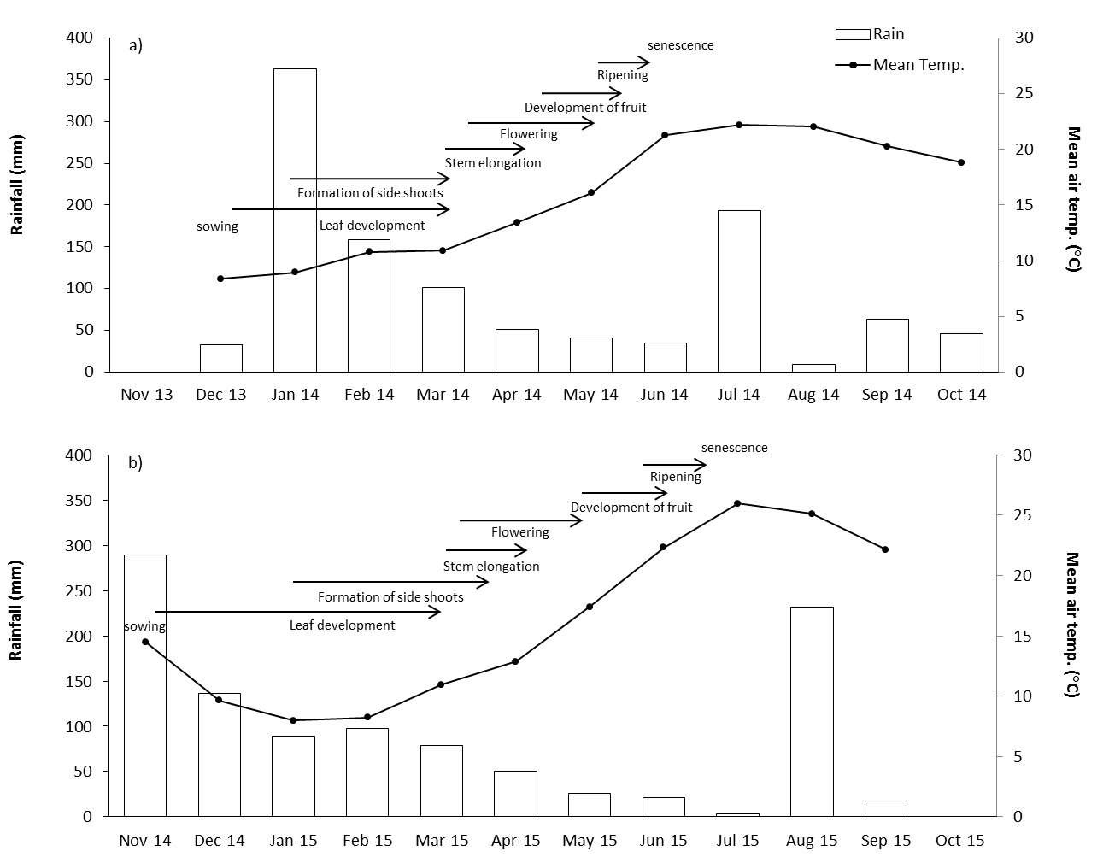

Figure 2.

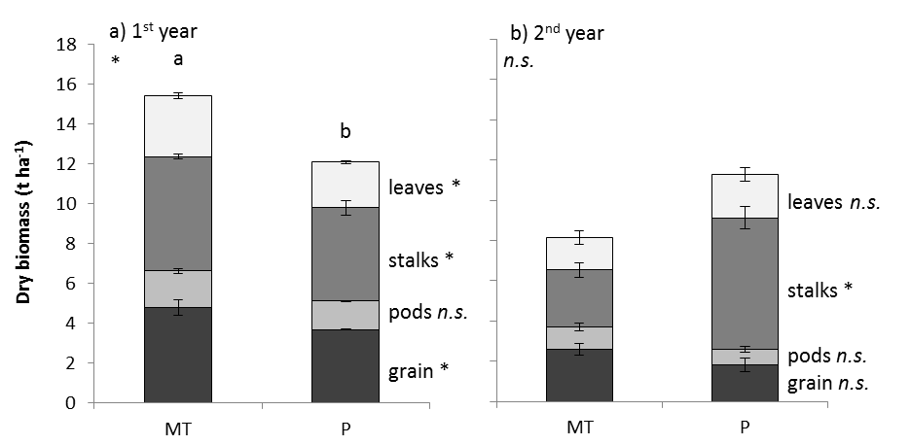

Figure 3.

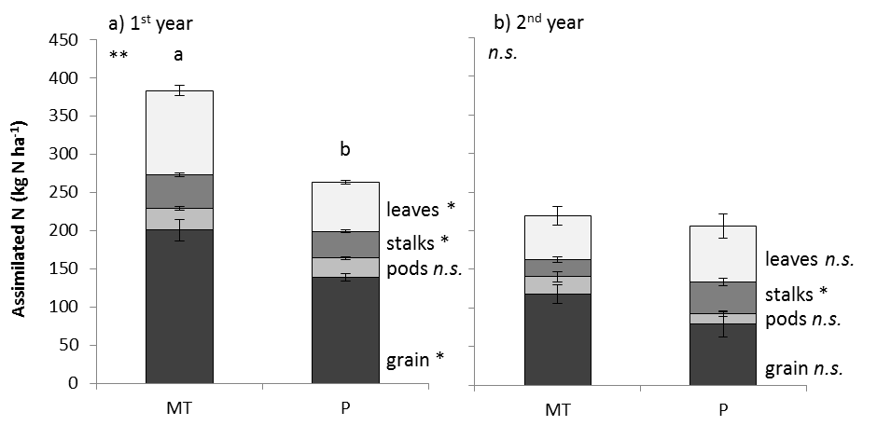

Figure 4.

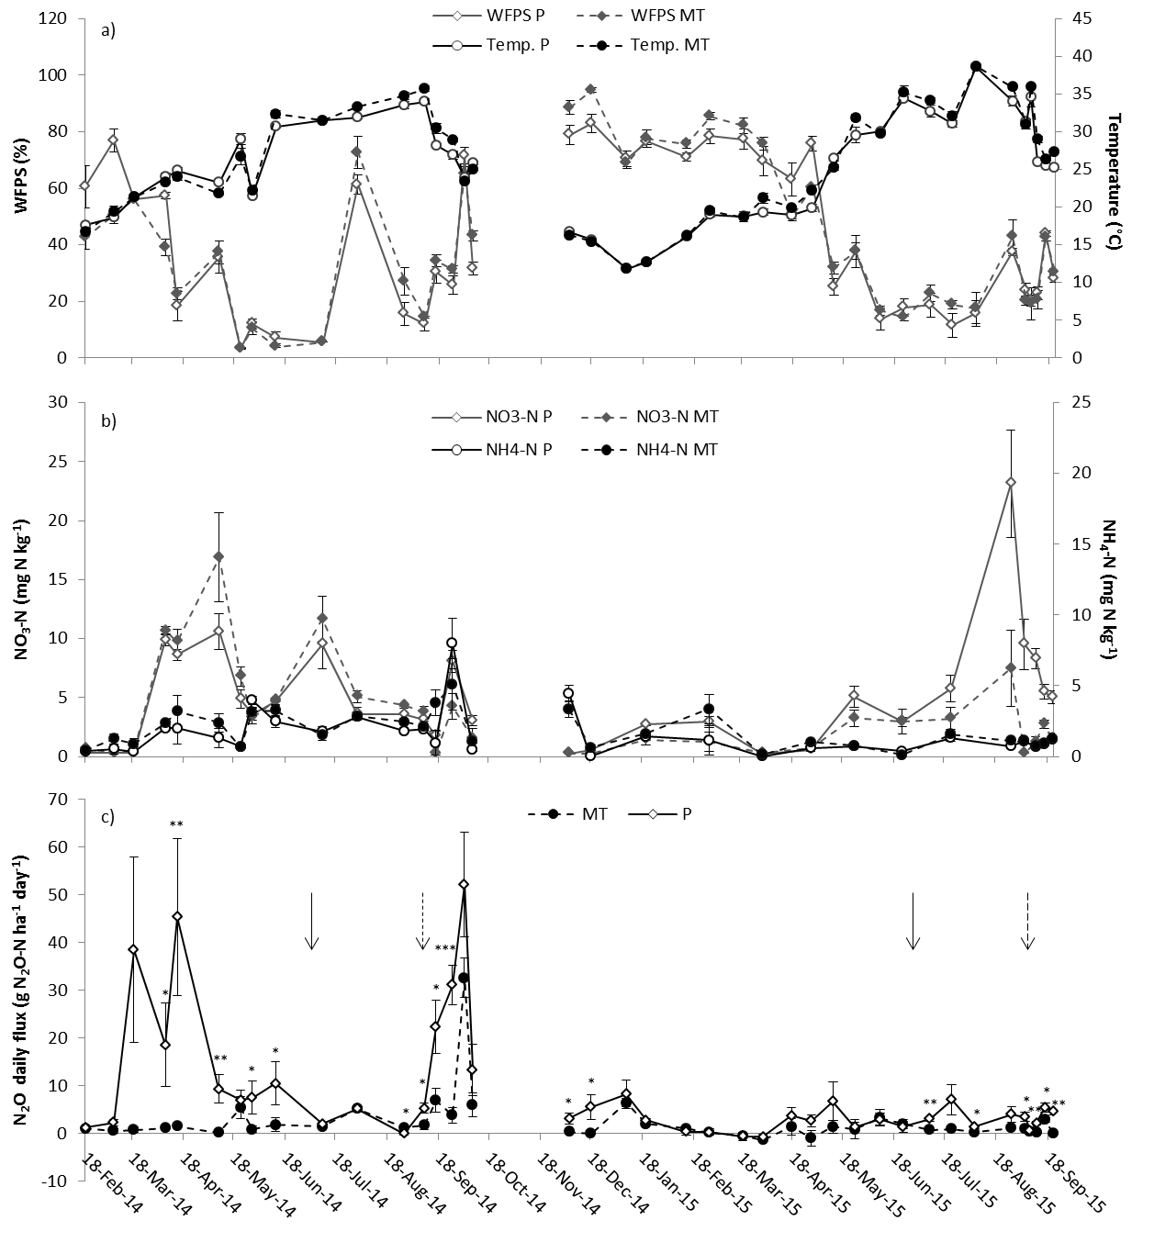

Figure 5.

