Ruptured mycotic aneurysm after intravesical instillation for bladder tumor
Authors:
Raffaella Berchiolli,
Davide M. Mocellin,
Michele Marconi,
Francesca Tomei,
Irene Bargellini,
Roberta Zanca,
Paola Erba,
Mauro Ferrari,
¹ Vascular Surgery Unit, Azienda Ospedaliero Universitaria Pisana, Pisa, Italy
² Interventional Radiology Unit, Azienda Ospedaliero Universitaria Pisana, Pisa, Italy
³ Nuclear Medicine, Department of Translational Research and New Technology in Medicine, University of Pisa, Pisa, Italy

Corresponding author:
Michele Marconi.
E-mail: michemarconi@gmail.com
Vascular Surgery Unit, Azienda Ospedaliero Universitaria Pisana.
Via Paradisa, 2. Pisa. 56124. Italy.
Phone number 00393287648533
Abstract
Introduction Intravesical instillation of Bacillus Calmette-Guérin (BCG) is an effective, widely used treatment for patient affected by in-situ bladder cancer. Major complications are quite uncommon, but a systemic dissemination of the attenuated strain of Mycobacteryum bovis (MB) is possible. Few cases of aortic rupture caused by M. bovis infection are described in Literature.
Case report A 70-year–old male, treated three months before with BCG instillation, presented to the emergency department because of a ruptured abdominal aortic aneurysm. Patient was hemodynamically stable, with a “hostile” abdomen. Thus, an Endologix AFX endograft was deployed. During post-operatory period, blood inflammatory markers increased, suspicious of a graft infection. SPECT/CT scan showed aortic increased uptake. Antibiotic therapy was continued but, some days after, patient presented hematemesis and CT scan showed an aorto-enteric fistula. In emergency, the infected graft and aneurysm were removed, enteric fistula closed and an axillo-bifemoral bypass performed. Patient died 25 days after EVAR explant.
Discussion Despite the high suspicion of mycotic aortic aneurysm and graft infection by MB, there is no proof of this theory cause of absence of any positive culture test. MB is a slow growing bacteria and specific culture tests are required in order to identify it; indeed, all our blood and intraoperative samples were positive to other bacteria, probably contaminant ones.
Conclusions Mycotic aneurysm is an extremely rare complication of intravesical BCG therapy, but it must be taken into consideration in patients with rapidly growing aortic aneurysms or rupture of a normal aorta, who have been previously submitted to this kind of instillation.

Keywords: mycotic aneurysm, intravesical administration, endovascular procedures

Introduction
Bacillus Calmette-Guérin (BCG) is a live attenuated strain of Mycobacteryum bovis (MB), part of Mycobacterium Tubercolosis complex, and it is an effective treatment for patients with stage T1 grade 3 bladder tumors, when applied topically by intravesical instillation. The instillation causes a local inflammatory reaction which can destroy non-muscle invasive cancer cells. Despite it being an effective and non-invasive treatment, it is not risk-free. The complication rate of this therapy is very low, but few cases of systemic infection and multi-organ bacteria dissemination has been reported [1]. One of the most dangerous infection sites is the abdominal aorta where Mycobacterium proliferation can create a weakening of the arterial wall with a progressive but fast dilation of the aorta up to its spontaneous rupture [1].

Case report
A 70-year–old male, affected by hypertension, hyperlipidemia and ischemic heart disease, presented to the emergency department with a history of lumbar pain radiating bilaterally to the back lasting from about one week. Patient history showed subsequent transurethral resections (10 and 5 months before) and intravesical BCG therapy (3 months before) as treatment for bladder transitional cell carcinoma. Two months apart, due to biopsy proven residual high degree transitional papillary cell carcinoma, the patient was subsequently treated with robot-assisted radical cystectomy followed by urostomy.
Abdominal computed tomographic (CT) scan was performed, revealing a ruptured abdominal aortic aneurysm (RAAA) greater than 45mm in size (Figure 1). The patient was hemodynamically stable.
Due to the “hostile” abdomen and the favorable anatomy, the patient was submitted to endovascular aneurysm repair (EVAR) (BA25-90/120-30 AFX, Endologix Inc., Irvine, CA, USA) through a bilateral groin cutdown approach. After surgery the patient was transferred to the Vascular Surgery ward. The comparative assessment of a previous CT scan which has been performed at the time of the radical cystectomy and which was not available at the time of emergency admission revealed a normal aorta (Figure 2). The possibility of aortic iatrogenic lesions during the pelvic lymphadenectomy was excluded by the referring urologist.
After an initial postoperative period with complete pain relief, blood tests showed a progressive increased of inflammatory markers in the absence of fever. Positive blood and urine cultures for Staphylococcus aureus were found; therefore, antibiotic therapy with cefazolin was initiated with the clinical suspicious of graft infection. ^{99m}Tc-HMPAO-WBC SPECT/CT was performed, revealing a significant radiopharmaceutical uptake at the level of abdominal aorta, suggesting infection (Figure 3). After few days, new onset of fever and abdominal pain occurred with significant increase of WBC counts. Ten days after the surgery, patient presented hematemesis and hemodynamic shock. Urgent CT scan revealed free air bubbles in the abdomen, thus suspecting the presence of aorto-enteric fistula (Figure 4). Urgent laparotomy was performed confirming the aorto-enteric fistula at the level of duodenum with the exposition of the endograft (Figure 5). After suprarenal clamping, the endograft was easily removed due to its characteristics (no proximal hook and anatomical fixation) and sent for culture (Figure 6). Because of the evident signs of infection, the proximal aortic stump was sutured just below the origin of renal arteries with a double layer of 2/0 non-absorbable sutures (PROLENE® Polypropylene Suture, Ethicon, Somerville, NJ, USA). Distally the aorta was sutured at the level of its bifurcation. Proximal aortic stump was covered with a large omental flap. The duodenum lesion was repaired with 3/0 absorbable suture (PDS® II, polydioxanone suture, Ethicon, Somerville, NJ, USA). Finally, a left axillo-bifemoral bypass was performed (Axillo-bifemoral Equi-flo Gelsoft, Vascutek Ltd, Scotland, UK).
The early postoperative period was complicated by critical colic ischemia, requiring total colectomy. Graft, aortic wall and thrombus cultures were positive for Enterococcus Faecium, Saccaromices Celevisie, Candida Glabrata and antimicrobial therapy was modified accordingly. Interestingly, MB was not isolated because a specific culture was been explicitly requested. Patient passed away 25 days after EVAR explant.

Discussion
Intravesical BCG instillation therapy is the treatment of choice for early stage transitional cell bladder cancer with reported cure rates of 70% [2]. Although it is a well-tolerated treatment, systemic reactions, such as fever, malaise, hepatitis and pneumonia have been described [2,3]. Vascular complications, such as mycotic aneurysms occur in less than 1% of cases [4]. In literature, less than 30 cases are reported of MB related mycotic aneurysms are reported [5,6]. The presence of a mycotic aneurysms similarly to other complications of intravesical BCG therapy, is a late event appearing up to five years after BCG instillation during patients’ follow-up [6]. Fifty percent of mycotic aneurysms secondary to BCG instillation ruptured and required emergency surgery [7-8].
However, considering the widespread utilization of BCG instillation for the treatment of early stage bladder cancer, the incidence of mycotic aneurysms after BCG instillation may be currently underestimated [9]. This might be related to the very difficult diagnosis due to the fact that identification of MB requires specific culture methods. Therefore, physicians must be aware of this possible complication.
Once BCG mycotic aneurysms have been identified, well-defined guidelines for its management are still lacking. Harding et al. suggested performing an extra-anatomical bypass as a standard management of BCG-related primary aortic infection [3]. In the case we are presenting, EVAR was performed because of recent open abdominal surgery, the favorable aortic anatomy and the lack of evidence of possible infectious etiology of the aneurysm. Antimicrobial treatment based on the isolated strain was not successful in limiting the infection burden. In the hypothesis of the MB-etiology a specific antitubercular therapy could have provided better results. However, since all the analyses performed were not able to demonstrate the MB infection these are just hypothesis. Nonetheless, on the basis of the patient’s history, the rapidity of the aneurysm growth, and the clinical evolution with local and systemic complications MB infection is highly suspected.

Conclusion
Mycotic aneurysm is an extremely rare but life-threatening complication of intravesical BCG therapy. Despite its rarity, urologists and vascular surgeons should be aware of the risk of vascular complications related to this therapy. An accurate and prompt diagnosis could address towards the most adequate treatment.

References
- Wolf YG, Wolf DG, Higginbottom PA, Dilley RB. Infection of a ruptured aortic aneurysm and an aortic graft with bacille Calmette-Guérin after intravesical administration for bladder cancer. J Vasc Surg. 1995;22:80-4.
- Gao CQ, Mithani R, Leya J, Dawravoo L, Bhatia A, Antoine J, et al. Granulomatous hepatitis, choroiditis and aortoduodenal ﬁstula complicating intravesical bacillus Calmette–Guérin therapy: case report. BMC Infectious Diseases 2011;11:260.
- Hearding GEJ, Lawer DK. Ruptured mycotic abdominal aortic aneurysm secondary to Mycobacterium Bovis after intravesical treatment with bacillus Celemette-Guérin. J Vasc Surg 2007; 46:131-4.
- Pittman M, Sakai L, Craig R, Joehl R, Milner R. Primary aortoenteric fistula following disseminated bacillus Calmette-Guérin infection: a case report. Vascular. 2012;20(4):221-4
- Holmes BJ, LaRue RW, Black III JH, Dionne K, Parrish NM, Melia MT. Mycotic aortic aneurysm due to intravesical BCG immunotherapy: Clinical manifestations and diagnostic challenges. Int J Mycob 2014; 3:60-65.
- Coddington ND, Sandberg JK, Yang C, Sehn JK, Kim EH, Strope SA. Mycotic Aneurysm after Bacillus Calmette-Guérin Treatment: Case Report and Review of the Literature. Case Rep Urol. 2017;2017:4508583
- Roylance A, Mosley J, Jameel M, Sylvan A, Walker V. Aorto-enteric fistula developmente secondary to mycotic abdominal aortic aneurysm following intravescial bacillus Calmette-Gierun (BCG) treatment for transitional cell carcinoma of the bladder. Int J Surg case reports 2013;4:88-90
- Scarcello E, Ferrari M, Rossi G, Berchiolli R, Adami D, Romagnani F, et al. A new preoperative predictor of outcome in ruptured abdominal aortic aneurysms: the time before shock (TBS). Ann Vasc Surg. 2010 Apr;24(3):315-20.
- Mizoguchi H, Iida O, Dohi T, Tomoda K, Kimura H, Inoue K, et al. Abdominal Aortic aneurismal and endovascular device infection with iliopsoas abscess caused by Mycobacterium Bovis as a complication of intravesical Bacillus Calmette-Guèrin therapy. Ann Vasc Surg 2013; 27: 1186.e1-1186.e5

Figure legends
Figure 1 - CT angiography shows the presence of a ruptured infrarenal abdominal aortic 45 mm in size.
Figure 2 - CT angiography performed a few months before demonstrates that the abdominal aorta is normal in size.
Figure 3 - 99mTc-HMPAO WBC whole body images at 30 mins after the radiopharmaceutical administration (A), planar spot view images in antero-posterior projection on the abdominal area (B) at 30 mins (upper panel), 6 hrs. (middle panel) 20 hrs. (lower panel) and SPECT/CT (C, upper panel coronal view from left to right emission, non-ceCT and superimposed SPECT/CT), trans axial superimposed SPECT/CT at different level (C left), superimposed sagittal (C middle) and superimposed coronal (C right) showing progressive increased radiopharmaceutical uptake at the site of the aneurysm extending anteriorly to the contiguous bowel wall as clearly showed by the SPECT/CT images. Of interest, despite endovascular repair of the abdominal aortic aneurysm images was performed 4 days before the scintigraphy, no effect on the image quality was determined and the image correctly identify the site and extend of infection.
Figure 4 - CT angiography shows patency of the endograft, with air bubbles in the aneurysm sac and an evidence of a large fistula between the aorta and the duodenum.
Figure 5 - Intraoperative view of the aortoduodenal fistula.
Figure 6 - Removed endograft with evident signs of infection.

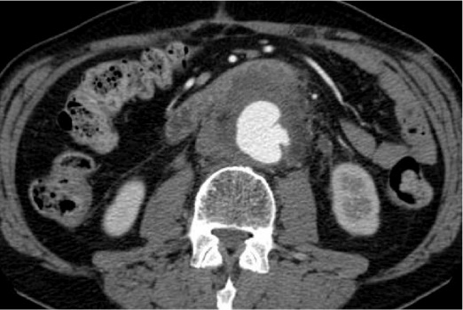
Fig 1

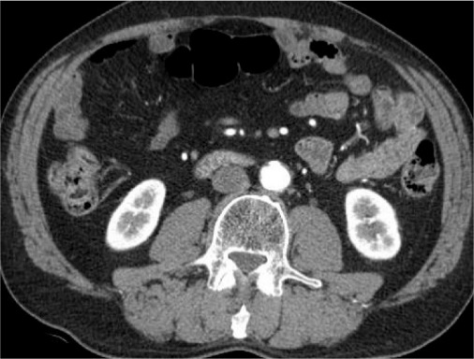

Fig 2

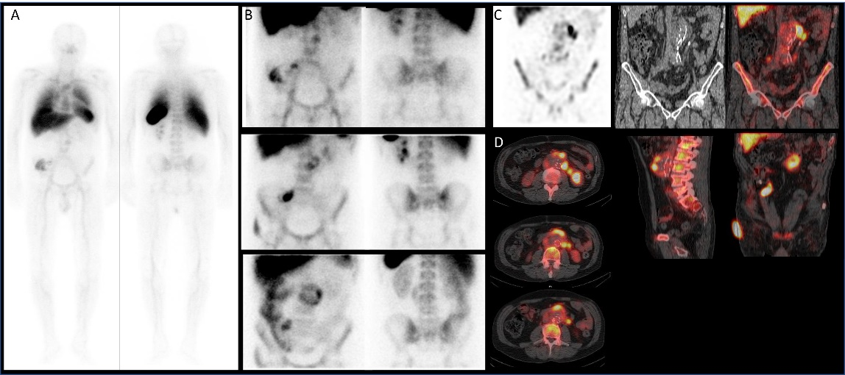
Fig 3

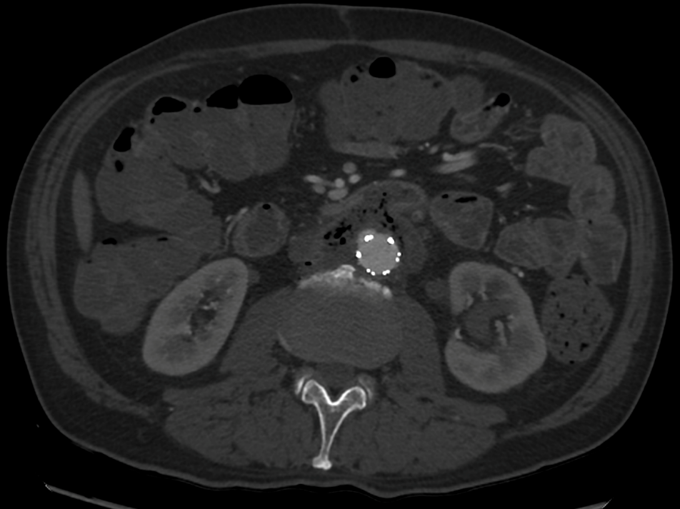

Fig 4

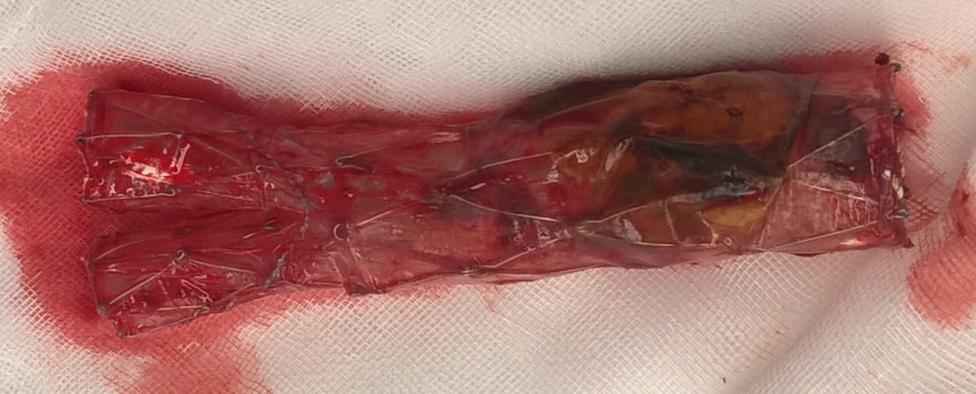

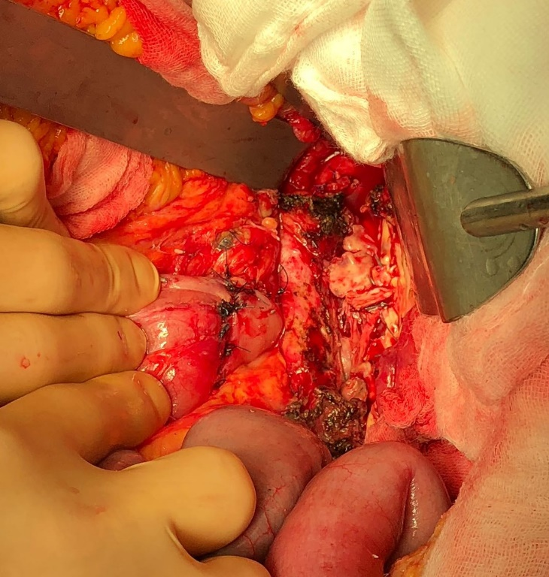
Fig 5

Fig 6

