(Long Title) Morphology of the Homo naledi femora from Lesedi
(Short Title) Femora of Homo naledi from Lesedi

Christopher S. Walker,^{1,2,3,}* Zachary D. Cofran,^{4,3} Mark Grabowski,⁵ Damiano Marchi,^{6,3} Rebecca W. Cook,^{1,2}, Steven E. Churchill,² Kimberleigh A. Tommy,^{7,3} Zachary Throckmorton,^{8,3} Ann H. Ross,⁹ John Hawks,^{10,3} Gabriel S. Yapuncich,^{1,2} Adam P. Van Arsdale,¹¹ Frederika I. Rentzeperis,¹² Lee R. Berger,³ Jeremy M. DeSilva^{12,3}

¹Department of Molecular Biomedical Sciences, College of Veterinary Medicine, North Carolina State University, Raleigh, North Carolina, USA.
²Department of Evolutionary Anthropology, Duke University, Durham, North Carolina, USA.
³Evolutionary Studies Institute, University of the Witwatersrand, Johannesburg, South Africa.
⁴Anthropology Department, Vassar College, Poughkeepsie, New York, USA.
⁵Research Centre in Evolutionary Anthropology and Palaeoecology, School of Natural Sciences and Psychology, Liverpool John Moores University, Liverpool, United Kingdom.
⁶Department of Biology, University of Pisa, Pisa, Italy.
⁷Human Variation and Identification Research Unit, School of Anatomical Sciences,
University of the Witwatersrand, Johannesburg, South Africa.
⁸Department of Anatomy, Arkansas College of Osteopathic Medicine, Fort Smith, Arkansas, USA.
⁹Department of Biological Sciences, North Carolina State University, Raleigh, North Carolina, USA.
¹⁰Department of Anthropology, University of Wisconsin, Madison, Wisconsin, USA.
¹¹Department of Anthropology, Wellesley College, Wellesley, MA, USA.
¹²Department of Anthropology, Dartmouth College, Hanover, New Hampshire, USA.

*Correspondence
Email: christopher_walker@ncsu.edu (C.S.W.)

KEYWORDS: Rising Star, thigh, bipedal locomotion, hominin

ABSTRACT

Objectives: The femoral remains recovered from the Lesedi Chamber are among the most complete South African fossil hominin femora discovered to date and offer new and valuable insights into the anatomy and variation of the bone in Homo naledi. While the femur is one of the best represented postcranial elements in the H. naledi assemblage from the Dinaledi Chamber, the fragmentary and commingled nature of the Dinaledi femoral remains has impeded the assessment of this element in its complete state.

Materials and Methods: Here we analyze and provide descriptions of three new relatively well-preserved femoral specimens of H. naledi from the Lesedi Chamber: U.W. 102a-001, U.W. 102a-003, and U.W. 102a-004. These femora are quantitatively and qualitatively compared to multiple extinct hominin femoral specimens, extant hominid taxa, and, where possible, each other.

Results: The Lesedi femora are morphologically similar to the Dinaledi femora for all overlapping regions, with differences limited to few traits of presently unknown significance. The Lesedi distal femur and mid-diaphysis preserve anatomy previously unidentified or unconfirmed in the species, including an anteroposteriorly expanded midshaft and anteriorly expanded patellar surface. The hypothesis that the Lesedi femoral sample may represent two individuals is supported.

Discussion: The Lesedi femora increase the range of variation of femoral morphology in H. naledi. Newly described features of the diaphysis and distal femur are either taxonomically uninformative or Homo-like. Overall, these three new femora are consistent with previous functional interpretations of the H. naledi lower limb as belonging to a species adapted for long distance walking and, possibly, running.

KEYWORDS: Rising Star, thigh, bipedal locomotion, hominin

1 INTRODUCTION

To date, 1681 fossil elements attributed to Homo naledi have been reported from the Rising Star cave system (Berger et al., 2015; Hawks et al., 2017), including 32 femoral elements. Twenty-nine of these femoral elements recovered from the Dinaledi Chamber have been described previously (Berger et al., 2015; Marchi et al., 2017). The Dinaledi femora, dated to between 335 and 236 kya (Dirks et al., 2017), evince a mosaic of primitive (Australopithecus-like), shared derived (Homo-like), and autapomorphic features. Their long, superoinferiorly tall, and anteroposteriorly compressed femoral necks, that are anteverted relative to platymeric proximal diaphyses, and thick diaphyseal cortices are Australopithecus-like in nature (Marchi et al., 2017). Prominent and posteriorly positioned gluteal tuberosities and well-defined lineae asperae are among the distinctly Homo-like traits of the Dinaledi femora (Marchi et al., 2017). Notably, a mediolaterally-elongated depression on the superior aspect of the neck and two associated parallel ridges of bone are unique to H. naledi (Marchi et al., 2017). In combination with the rest of the Dinaledi lower limb material, the femoral morphology is compatible with a fully bipedal gait (Marchi et al., 2017). Beyond this, the adaptive and evolutionary significance of the unique suite of femoral features of H. naledi is currently unknown.
Here we describe three femoral elements recently recovered from the Lesedi Chamber of the Rising Star cave system and attributed to H. naledi (Hawks et al., 2017): U.W. 102a-001, U.W. 102a-003, and U.W. 102a-004 (figure 1). Through comparative analysis, we demonstrate that the Lesedi distal femur and mid-diaphysis reveal a largely Homo-like suite of features which contrast with the more anatomically mosaic proximal end.

2 MATERIALS AND METHODS

2.1 Comparative Sample

The comparative samples used in analyses herein include femora from three extant species (Homo sapiens, Pan troglodytes, and Gorilla gorilla) and fossil femora attributed to multiple taxa, including Australopithecus africanus, Australopithecus afarensis, Australopithecus sediba, robust Australopithecus (Paranthropus) spp., Homo erectus sensu lato (with Early Pleistocene Homo sp. indet.), Homo heidelbergensis (with Middle Pleistocene Homo sp. indet.), and Homo naledi from Dinaledi. Details, including sample sizes, composition, origins, and individual fossil identification codes can be found in table 1.

2.2 Measurements and Data Collection

Measurements of the femur used in this study (figure 2) include maximum superoinferior (SI) head diameter (FHD), minimum SI neck diameter (height; NH; taken orthogonal to the long axis of the neck), anteroposterior (AP) neck diameter (breadth; NB; taken orthogonal to NH), neck-shaft angle (NSA), neck length (NL; maximum length from the lateral-most edge of the femoral head to the intertrochanteric crest), subtrochanteric mediolateral (ML) diameter (SML; maximum ML diameter of the proximal diaphysis taken just distal to the level of the lesser trochanter), subtrochanteric AP diameter (SAP; taken orthogonal to SML), and femoral neck anteversion angle (FNA). To evaluate femoral neck and subtrochanteric shape (or platymeric index), ratios of neck and subtrochanteric diameters were calculated as follows: neck shape = (neck AP/SI * 100); platymeric index = (subtrochanteric AP/ML * 100). All linear measurements were taken using digital calipers on original specimens or high quality casts by study authors unless otherwise noted. NSA (defined here as the angle between the longitudinal axis of the femoral neck and the longitudinal axis of the femoral shaft) was taken with a handheld goniometer on the anterior aspect of the specimen, while FNA (defined here as the angle between the longitudinal axis of the femoral neck and the sagittal plane) was taken following Marchi et al. (2017; see pp. 3-4 and figures 1-2). Femoral neck shape was also qualitatively evaluated via assessment of periosteal contours (or external outline) of cross-sections (transverse plane; perpendicular to the long axis of the femoral neck) at the neck-shaft junction. Femora were surface scanned using an Artec Spider blue light scanner (100µm resolution, 30µm accuracy) and cross-sections were digitally extracted using Geomagic Design X (3D Systems).

2.3 Reconstructions and Measurement Estimations

Damage to the head and neck of U.W. 102a-001 precludes an accurate measurement of both FHD and NB on this specimen. The head is heavily abraded on nearly all surfaces and the anterosuperior aspect of the neck is broken, such that at least one measurement point falls on exposed trabeculae (see fossil descriptions for further details). To facilitate comparisons with Dinaledi and other fossil hominin femora, using Geomagic Design X (3D Systems), we digitally estimated FHD and reconstructed the missing periosteal border of the anterior neck of U.W. 102a-001 to estimate NB.

Reconstruction of the anterior femoral neck (figure 3) focused specifically on the level of NH, since it is at this level that NB is taken (orthogonal to NH). Transverse sections (cross-sections) were digitally extracted from the U.W. 102a-001 3D mesh at 1 mm intervals along the entire length of the femoral neck. The cross-section at the level of NH (i.e. the section of interest; SOI) was identified using physical landmarks and confirmed with a digital measurement of NH matching the instrumentally determined value (24.4 mm). Adjacent sections were stacked on the SOI to evaluate overlapping and non-overlapping regions of preserved cortical bone. One section, 2 mm lateral to the SOI, preserved more of the anteroinferior periosteal contour than the SOI and curvature of this portion was consistent with the preserved, connecting section of the SOI contour. Accordingly, the portion of partially-overlapping periosteal border from the adjacent section was merged with the SOI. To estimate the rest of the missing contour, the SOI was compared to corresponding sections in the Dinaledi femoral sample. While no Dinaledi femoral neck transverse section closely matched U.W. 102a-001 in overall shape, one – U.W. 101-398 – possessed an anterior/anterosuperior border that seamlessly adjoined the broken borders of the SOI anterior contour, when it was scaled to match U.W. 102a-001 in size, mirrored, and slightly rotated. This section of U.W. 101-398 was cut and placed on the SOI creating a composite cross-section. The composite section was then stitched and re-measured, yielding an estimated AP diameter (NB) of 17.5 mm.

Estimation of U.W. 102a-001 FHD utilized a sphere-fitting technique incorporating preserved subchondral surfaces (figure 4; cf., Hammond et al., 2013; Plavcan et al., 2014; Ward et al., 2015). This procedure was undertaken in Geomagic Design X (3D Systems) using the sphere-fitting function, which applies a best-fit sphere to selected surfaces. The preserved subchondral areas were identified on a 3D mesh of the specimen, by both inspecting a 3D print and creating a curvature map in Amira 6.4 (Thermofisher Scientific). U.W. 102a-001 preserves three subchondral surfaces: one roughly rectangular patch measuring 196 mm² located on the posterior aspect of the head (figure 4), and two smaller and more irregularly-shaped patches adjacent (one inferomedial and one superolateral) to the large patch (figure S 1). Care was taken to select only smooth subchondral surface and to avoid areas of breakage. Spheres were fitted to all preserved subchondral surfaces (estimated FHD 36.4 mm) and to only the largest and most precisely defined patch (estimated FHD 35.5 mm). Hereafter, we consider the average diameter of these two reconstructions, 36.0 mm, as the estimated FHD for U.W. 102a-001.

In order to assess the error of this estimated FHD, we compared empirical and sphere-fitted diameters (cf. Hammond et al., 2013) in a subset of our comparative sample, focusing solely on the femoral heads of H. sapiens (n = 28, mixed-sex, from UT) and fossil hominins (n = 10; A.L. 288-1, KNM-ER 1481, KNM-ER 1503, SK 82, SK 97, StW 99, KNM-WT 15000, Berg Aukas, Kabwe E689, Kabwe E907). Comparative specimens were digitized using the same equipment used to acquire Lesedi femoral 3D meshes (Artec Spider blue light scanner), and spheres were fitted following the same procedures and software used to reconstruct U.W. 102a-001. Because of the irregular shape and somewhat ambiguous positioning of the preserved subchondral surfaces of U.W. 102a-001, it is difficult to isolate a clearly homologous surface on individuals within the comparative samples. Therefore, for each comparative specimen, we tried to replicate the size and position of only the largest subchondral patch on U.W. 102a-001. Each individual was measured three times, and the average value was then compared to empirical superoinferior FHD using least squares regression in R software (R Core Team, 2018). Empirical FHD was used as the dependent variable since this is the value to be predicted. We assessed the performance of the sphere estimates with three measures: residual standard error (RSE) and the coefficient of determination (R²) from the linear model, and percent prediction error (PPE). RSE and R² were automatically calculated as part of the regression analysis in R. PPE was calculated as the absolute difference between empirical FHD and sphere-fitted FHD, divided by empirical FHD; this is “PPE2” of Hammond et al. (2013). Regressions and PPE were calculated separately for H. sapiens only, fossil hominins only, and the combined human and fossil hominin sample (tables 2 and 3).

2.4 Discriminant Function Analysis

A linear discriminant function analysis (DFA) was used to assess broad morphological affinities and differences of the Lesedi proximal femur relative to other hominin groups. U.W. 102a-001 was entered as an unknown alongside H. sapiens (n = 58, mixed-sex, from UM and PMAE), Australopithecus, fossil Homo, and H. naledi from Dinaledi. This DFA (calculated in IBM SPSS Statistics Version 20) is an amended version of the DFA presented in Marchi et al. (2017) and includes five linear metrics (FHD, NB, SAP, SML, and NL) which were size-adjusted by dividing each variable by the geometric mean of all five metrics (Mosimann, 1970; Richmond & Jungers, 2008). To evaluate the performance of the DFA with respect to group classification accuracy, cross-validation tests were performed (IBM SPSS Statistics Version 20).

2.5 Bilateral Asymmetry

Hawks et al. (2017) argued that a minimum of two adult individuals are present within the Lesedi Chamber assemblage based on mandibular and dental remains. The two proximal femoral elements, U.W. 102a-001 and U.W. 102a-003, are morphologically different from one another in ways that suggest they may not be antimeres, and therefore Hawks et al. (2017) accepted that these specimens may represent two different adult individuals, albeit two individuals with similarly sized femora. Here, we test the hypothesis that the size variation between these two specimens is consistent with bilateral asymmetry within a single adult individual. To quantitatively assess this, U.W. 102a-001 and U.W. 102a-003 were evaluated in the context of 51 mixed-sex modern human femoral left/right pairs (from UM). Though hip biomechanics may differ between species, influencing subtrochanteric dimensions differently, H. sapiens are the best available extant proxy to examine bilateral asymmetry in an extinct biped like H. naledi. First, variation (% difference) between U.W. 102a-001 and U.W. 102a-003 subtrochanteric dimensions was compared to bilateral asymmetry in the modern human sample. Secondly, we used exact randomization sampling methods (Sokal & Rohlf, 1995; Manly, 2006) to determine the probability of drawing two femora as different (with respect to subtrochanteric dimensions) as U.W. 102a-001 and U.W. 102a-003 from a mixed human sample (all possible left/right pairings). This approach was used because exact randomization sampling allows for probability computations with small sample sizes and is free of the assumption that data are normally distributed (Richmond & Jungers, 1995; Manly, 2006).

3 RESULTS

3.1 Descriptions

U.W. 102a-001 (figure 5) is a proximal right femur measuring 163.8 mm SI from the superior aspect of the eroded femoral head to a jagged break in the diaphysis, distally. Only a small portion of the posterior subchondral surface of the femoral head is preserved, but it is badly eroded on the superior, inferior, and (especially) anterior aspects. The preserved SI height of the femoral head is 30.4 mm and the estimated SI diameter is 36.0 mm (see section 3.2). The anterosuperior neck is broken and missing, with partially sediment infilled trabecular bone exposed from the anterior head, medially, to the base of the greater trochanter, laterally. The intact portion of the anteroinferior neck is smooth, showing no clear sign of an intertrochanteric line. The inferior and posterior aspects of the neck are well-preserved. An indistinct obturator externus groove is present, running inferomedial to superolateral near the midpoint of the posterior neck. Some cortical bone is preserved on the most superior aspect of the neck, which allows for minimum SI neck height (24.4 mm) to be measured with reasonable accuracy. The AP width of the neck (orthogonal to SI) measures 16.1 mm, but the anterior point of this measurement is on exposed trabeculae and is, thus, an underestimate. The anteroposterior neck width is estimated to be 17.5 mm (see section 3.2). The neck is 33.9 mm long from the most lateral aspect of the head (at the head-neck border) to the small remnant of the intertrochanteric crest. The greater trochanter is broken and missing, with the exception of a small portion of its distolateral surface. A pit, possibly for the attachment of the conjoined tendon of obturator internus and the gemelli, is present on the most lateral aspect of the preserved superoposterior neck, but it is small and not notably mediolaterally expanded. Above this pit, there is a weakly defined mediolateral-oriented bony pillar which is consistent with the inferoposterior pillar described for the Dinaledi femora (Marchi et al., 2017). The combination of damage to the greater trochanter and femoral neck preclude assessment of the superoanterior neck pillar, which is found in all femora of H. naledi from Dinaledi (Marchi et al., 2017). The lesser trochanter is sheared off at its base, exposing a 15.1 mm SI by 15.9 mm ML patch of trabecular bone. Immediately superior to the lesser trochanter is an approximately 2.5 mm diameter hole positioned superoinferiorly, boring deep to the lesser trochanter. The diaphysis is, overall, well-preserved, though there is notable and pervasive longitudinally-oriented cracking (consistent with postmortem drying) and other superficial damage. At the level of the lesser trochanter, just inferior to the missing greater trochanter on the lateral shaft, is a pronounced, anteroposteriorly-oriented defect measuring 10.6 mm by 2.3 mm. Distal to this defect on the lateral diaphysis is an irregularly-shaped shallow depression in the cortical bone that is sediment infilled. Adjacent to this depression, on the lateral, anterolateral, and posterolateral diaphysis, are multiple smaller shallow pits of varying shape. Numerous small striations, oriented perpendicular to the long axis of the shaft, are evident across the diaphysis, but are particularly prevalent on the anterior surface. The subtrochanteric mediolateral diameter measures 28.1 mm. The subtrochanteric anteroposterior diameter measures 20.8 mm. The linea aspera is palpable, but very weakly-developed. The pectineal line is almost undetectable, presenting as a smooth, small ridge descending from the inferior corner of the lesser trochanter, flattening as it extends distally. The gluteal tuberosity is more pronounced, posteriorly positioned, and forms a slight third trochanter proximally. The diaphysis is irregularly fractured (approximately 80 mm distal to the inferior border of the lesser trochanter) such that the lateral aspect of the shaft extends approximately 18 mm distal to the fracture plane through the anterior, posterior, and medial diaphysis. The edges of the broken diaphysis are jagged and lighter in color than the surrounding bone, consistent with post-depositional or postmortem fractures. The anterior surface of the distal diaphysis, abutting the fracture, shows cortical bone flaking. Cortical thickness at the distal break is 7.8 mm medially, 7.4 mm laterally, 7.3 mm posteriorly, and 7.3 mm anteriorly (thickest posteromedially = 8.9 mm). External diaphyseal dimensions just proximal to the shaft break are 23.2 mm ML by 20.7 mm AP. Superficially, the anterior surface of the diaphysis is, overall, smoother than the posterior surface. The color of the specimen ranges from very light brown to dark brown, with small and patchy iron oxide (red) and manganese oxyhydroxide (black) stains present throughout.

U.W. 102a-003 (figure 6) and U.W. 102a-004 (figure 7) are two left femoral elements preserving 148.7 mm SI from the level of the lesser trochanter to near midshaft (U.W. 102a-003) and 182.5 mm SI from near midshaft to the distal extent of the intercondylar fossa (U.W. 102a-004). The two elements conjoin at the lateral diaphysis (Hawks et al., 2017), but there are notable differences in patina, edge wear, and breakage patterns between the distal end of U.W. 102a-003 and the proximal end of U.W. 102a-004 and the elements have no points of contact posteriorly, medially, or anteriorly.

The femoral head, neck, greater trochanter, and associated structures of U.W. 102a-003 are missing due to an oblique fracture through the lesser trochanter that extends proximolaterally to the most proximal diaphysis, exposing underlying trabecular bone. The subtrochanteric diaphyseal dimensions are 25.2 mm ML by 20.9 mm AP. The gluteal line is indistinct. The pectineal line and linea aspera are rugose. While the linea aspera does form a small crest, there is only a very weak pilaster. Slight sagittal plane curvature (anteroposterior bowing) of the diaphysis is evident in the medial and lateral views. Numerous longitudinally-oriented cracks, consistent with postmortem drying, are present on all aspects of the diaphysis, but are most prominent on the anterior surface and penetrate deepest at the distal end of the specimen. A particularly notable fissure on the posterior diaphysis runs adjacent to the linea aspera, extending from level of the inferior aspect of the lesser trochanter to the distal diaphyseal breakage. Short striations, oriented perpendicular to the long axis of the shaft, are concentrated on the lateral aspect of the diaphysis. The anterior aspect of the diaphysis exhibits multiple large, amorphous, black stains, consistent with manganese oxyhydroxide. The coloration of the distal end of the specimen is lighter (off white) than the rest of the specimen (light brown/brown). The diaphysis terminates at an oblique break, approximately 112 mm distal to the inferior border of the lesser trochanter. At the level of the break, the diaphysis is elliptical in cross section, with the major axis of the ellipse running from anterolateral to posteromedial. The cortical bone at the distal break is thick, measuring 8.7 mm at its thickest portion (posteromedial), 7.5 mm medially, 7.5 mm laterally, 8.0 mm posteriorly, and 6.7 mm anteriorly (estimated due to superficial damage on the distal anterior shaft).

The proximal end of the U.W. 102a-004 diaphysis is jagged and deformed. Some of the broken edges show the white internal structure of the bone. Proximally, a sizeable, irregularly-shaped, fragment is missing from the lateral aspect of the diaphysis. Altogether, this pattern of damage and coloration is consistent with a post-depositional fracture. Numerous short, wide, transversely-oriented lacerations are present on the posterior aspect of the element. As on U.W. 102a-003, there are numerous fine cracks, running longitudinally, primarily on the anterior, medial, and lateral diaphyseal surfaces. The continuation of the linea aspera from U.W. 102a-003 is visible to its distal extent. The lateral supracondylar line is palpable, but poorly developed, while the medial supracondylar line is barely detectable. Anteriorly, there is a very well-developed, concave sustrochlear hollow filled with several foramina. The patellar groove is smooth, convex SI, and concave ML. The lateral condyle is broken anteroposteriorly, through the lateral lip, and is largely missing, exposing a 38.2 mm AP by 33.3 mm SI section of trabecular bone. The medial condyle is broken obliquely, also exposing trabecular bone. Though the condyles are broken, remnants of the medial and lateral patellar lips are sufficient to show a markedly anterior projecting lateral lip (relative to both the medial lip and patellar groove). The partial intercondylar notch measures 16.3 mm ML and contains a well-developed pit posterolaterally for the anterior cruciate ligament.

Additional details about the preservation of U.W. 102a-001, -003, and -004, specifically, and the Lesedi fossil assemblage, generally, can be found in Hawks et al. (2017; pp. 30-32, 40-42, and supplementary file 5).

3.2 Reconstructions and Measurement Estimations

Estimates of FHD and NB, derived from reconstructions of the damaged U.W. 102a-001 femoral head and anterior neck, are 36.0 mm and 17.5 mm, respectively.

Overall, the results of our error analyses indicate that our sphere-fitting method produces reasonably accurate estimates of empirical FHD in modern humans and fossil hominins (figure 8, tables 2 and 3). The regression slopes less than 1.0 indicate that the sphere-fitted diameters tend to slightly overestimate true FHD (e.g., estimates falling to the right of the dashed isometry lines in figure 8). Interestingly, many fossil hominins, especially at larger sizes, appear to have larger FHDs than predicted for H. sapiens of the same sphere size, possibly indicating differences in femoral head shape (i.e., sphericity), between these groups. Regardless, both H. sapiens and fossil hominin regression lines cross or exceed the isometry line at the sphere size predicted for U.W. 102a-001, implying that its estimated FHD of 36.0 mm may even be a slight underestimate.

Mean percent prediction error is low in both fossil hominin (2.8%) and H. sapiens (3.4%) groups (table 3). Moreover, 83% of all fitted spheres are within 5% of the empirical value. Contrastingly, the mean PPEs of spheres derived from small areas (single regions) of the acetabular lunate surface, analyzed in Hammond et al. (2013), are much higher, ranging between 32.3% and 64.3% within Hominidae (PPEs are within the lower end of this range when considering anthropoids more broadly). Thus, while a small area of the acetabular lunate surface is insufficient to accurately predict acetabular size, a small area of the posterior subchondral surface of the femur head does appear to be sufficient to accurately estimate FHD among hominins.

With respect to the femoral neck and our estimate of NB, given that our U.W. 102a-001 neck reconstruction utilized a largely qualitative methodology that cannot be uniformly applied to other hominin femoral neck reconstructions, error could not be assessed. Accordingly, the accuracy of our NB estimation is unknown, however, when the typical shape of the H. naledi femoral neck is considered, we believe it likely that the U.W. 102a-001 NB estimate presented here represents the maximum reasonable value for this measure. All Dinaledi femora exhibit a flattened anterior border at and near mid-neck. As reconstructed, the anterior border of U.W. 102a-001 is gently convex, exhibiting a degree of curvature comparable to that of its posterior border and greater than that of the Dinaledi femora. A larger estimated AP diameter than that presented here would indicate an atypically shaped (for H. naledi) convex anterior border, that morphologically contrasts the shape observed in adjacent, preserved portions of the U.W. 102a-001 femoral neck. As such, while we cannot entirely dismiss the possibility of an anomalously convex anterior border of the U.W. 102a-001 mid-neck, we consider it improbable, and conservatively propose that the true neck breadth of the specimen is, most likely, between the estimated value of 17.5 mm and the preserved value of 16.1 mm (a known underestimate).

3.3 Comparative Anatomy

Overall, the three femoral elements from the Lesedi chamber are morphologically consistent with the femoral remains from the Dinaledi chamber (Berger et al., 2015; Marchi et al., 2017), and expand the range of variation observed in the Dinaledi sample. The neck dimensions, neck shape, neck length, subtrochanteric dimensions, platymeric index, and degree of femoral anteversion of U.W. 102a-001 and (for a subset of these measures) U.W. 102a-003 fall within the range of the Dinaledi femora, and commonly within one standard deviation of the Dinaledi mean, for each respective metric (table 4; figures S2-S9). The neck-shaft angle of U.W. 102a-001 is 120°, placing it just under 2° greater than the Dinaledi maximum. The suite of Lesedi femur values is most consistent with the Dinaledi femora among comparative hominin femora.

Discriminant function analysis plots U.W. 102a-001 within the bounds of the convex hull formed by H. naledi specimens from Dinaledi (figure 9). The highest posterior probability for group membership for U.W. 102a-001 is H. naledi; the second highest group posterior probability is Australopithecus (table S1). Though 81% of H. sapiens are correctly classified, only 42.9% of australopiths and none of the four fossil Homo specimens are correctly classified (table S2). Overall, 69.4% of cross-validated grouped cases are correctly classified. U.W. 102a-001 is differentiated from H. sapiens along function 1 and is intermediate to fossil Homo and Australopithecus along function 2. All fossil hominin specimens in the DFA are largely separated from H. sapiens along function 1, which accounts for 81.9% of the variance. Anteroposterior neck breadth and neck length are the primary driving factors, with specimens possessing longer and AP compressed necks located on the right. Fossil hominin groups are differentiated from each other along function 2, accounting for 16.6% of the variance. Again, neck length factors prominently (in the positive direction) along with subtrochanteric anteroposterior diameter (in the negative direction). Notably, three of the H. naledi femora included in the DFA (U.W. 102a-001, U.W. 101-002, and U.W. 101-1391) are within the range of human variation. Moreover, though U.W. 102a-001 is within the boundaries of the H. naledi convex hull, it resides nearest SK 97 (A. robustus), along with Dinaledi specimen U.W. 101-002 and two modern humans.

The Lesedi femur U.W. 102a-001 differs from the Dinaledi femora with respect to some features of the neck. The most unique trait of the Dinaledi proximal femora is a mediolaterally expanded groove on the superior surface of the neck, possibly for the attachment of internal obturator and gemelli muscles, associated with two adjacent mediolaterally-oriented pillars (one positioned superoanteriorly and one positioned inferoposteriorly; Marchi et al., 2017). Damage to the region of the neck that would bear the superoanterior pillar prevents evaluation of this structure on U.W. 102a-001. An inferoposteriorly positioned pillar, however, is preserved on U.W. 102a-001. (figures 10 and S10). Though the pervasive damage abutting the pillar precludes an unequivocal assessment of pillar expression, compared to the Dinaledi femora, the U.W. 102a-001 inferoposterior pillar appears less defined. U.W. 102a-001 also differs from the Dinaledi femora (and a variety of other hominin taxa) by the concavity of its posterior surface and the squareness/flatness of its inferior surface, particularly at and near the neck-shaft junction (figure 11). Some degree of posterior neck concavity is present in the Dinaledi femora (especially U.W. 101-002 and U.W. 101-398), but this concavity is much more pronounced in U.W. 102a-001. Similarly, other hominin femora (including StW 99, A.L. 333-3, and A.L. 333-95) have flattened inferior femoral necks near the neck-shaft junction, but none are as expanded as that of U.W. 102a-001. The Dinaledi femora have largely narrow, rounded, convex inferior necks, though U.W. 101-398 does exhibit some degree of flattening. The significance of this femoral neck morphological variation between U.W. 102a-001 and the Dinaledi femora, however, is presently unknown. Accordingly, while we highlight these traits, further work is necessary to determine if any of the noted variation is functionally and/or evolutionary meaningful.

Some features not entirely preserved in the Dinaledi femora are more clearly evident in the Lesedi femoral sample. Chief among these are the anteriorly projecting lateral lip and sustrochlear hollow of U.W. 102a-004 distal femur (figure S11). Both features were suspected to be present in the Dinaledi femora, but no distal femoral fragment in the Dinaledi assemblage was complete enough to unambiguously confirm the existence of a sustrochlear hollow or degree of lateral lip projection (Marchi et al., 2017). U.W. 102a-004 preserves much more of the lateral lip than the Dinaledi archetype for the feature, immature specimen U.W. 101-1120, substantiating the evidence for an anteriorly projecting lateral lip in H. naledi (Marchi et al., 2017). Lateral lip projection, functionally helping to prevent dislocation of the patella during bipedal locomotion, is present in both Australopithecus and Homo femora, but with varying degrees of prominence (Clark, 1947; Heiple & Lovejoy, 1971; Aiello & Dean, 1990; DeSilva et al., 2013). Due to damage on the condyles of U.W. 102a-004, lateral lip projection can only be assessed qualitatively, and appears less pronounced than in A. sediba, comparable to H. sapiens, and more pronounced than most specimens of A afarensis and A. africanus (including TM 1513, A.L. 334-4, and A.L. 129-1) and some specimens attributed to Homo (like KNM-ER 1472). Additionally, the patellar surface in U.W. 102a-004 is anteriorly expanded, a feature that could not be evaluated in U.W. 101-1120 and may be related to the prominent lateral lip (Lovejoy, 2007).

No femur in the Dinaledi assemblage is as complete as the U.W. 102a-003/U.W. 102a-004 rejoined left femur, allowing for improved estimations of total length and evaluation of midshaft dimensions. Hawks et al. (2017) estimated the total length of the femur to be 375 mm. If this value is accurate, the dimensions of the diaphysis at midshaft are approximately 23 mm AP by 21 mm ML; accordingly, the femur is marked by an AP expanded diaphysis at midshaft (pilasteric index = 1.09). Notably, even if the total length of the composite femur is estimated incorrectly, the Lesedi femur is still almost certainly marked by an AP expanded diaphysis at midshaft, as the AP dimensions of the diaphysis exceed ML dimensions for much of the shaft. This differentiates H. naledi from most early Pleistocene Homo femora, which possess ML expanded midshafts, and aligns U.W. 102a-003/-004 with a minority of fossil Homo femora, including KNM-ER 5881 (which, coincidentally, has identical midshaft proportions to U.W. 102a-003/004), D3160, D4167, and OH 62, each of which have pilasteric indices (midshaft AP/ML) greater than 1 (Ruff, 1995; Ward et al., 2015).

3.4 Bilateral Asymmetry

Our evaluation of the morphological variation between U.W. 102a-001 and U.W. 102a-003 supports the hypothesis that these bones may come from two different individuals. First, the entheses of U.W. 102a-001 are considerably less developed than those of U.W. 102a-003. This includes a reduced linea aspera and pectineal line in U.W. 102a-001 (right) compared to U.W. 102a-003 (left). Second, though the lesser trochanters of both specimens are damaged, the remnants reveal a contrasting morphology between U.W. 102a-001 and -003, particularly with respect to the angle formed at the medial borders (Hawks et al., 2017). Third, while the anteroposterior subtrochanteric dimensions of the two proximal femora are comparable (0.5% difference), the mediolateral diameter of U.W. 102a-001 (28.1 mm) is 10.9% larger than the same dimension in U.W. 102a-003 (25.2 mm). Relative to a sample of 51 modern human femora, the Lesedi pairing is exceedingly asymmetrical with respect to ML diameter. Only a single human included in the study exhibits greater subtrochanteric diaphyseal asymmetry (12.6%) than the two Lesedi proximal femora, and this variation is between AP measures. The maximum human ML asymmetry in the sample is 7.3%. Results of exact randomization sampling reveal that Lesedi femora ML variation falls at the 72nd percentile (where a lower percentile corresponds to a higher sampling probability) of all sampled H. sapiens pairings (figure S12; n = 2601). Accordingly, even in a moderate-sized sample of mixed-sex humans, the probability of pairing two femora as different as U.W. 102a-001 and -003 is fairly low. Importantly, the H. sapiens test sample did not include any individuals with obvious abnormalities, so these results cannot evaluate the likelihood of marked bilateral asymmetry in an individual with pathologies that may affect subtrochanteric dimensions (i.e. by influencing gait). That caveat aside, it appears unlikely (though not impossible) that U.W. 102a-001 and U.W. 102a-003 (along with the associated U.W. 102a-004) came from the same individual.

4 DISCUSSION

The Dinaledi Chamber sample of H. naledi is impressively morphologically uniform (Berger et al., 2015; Garvin et al., 2017) and the Lesedi Chamber sample can mostly be encompassed within that low level of variability (Hawks et al., 2017). Nevertheless, the Lesedi femora do slightly expand the range of variation within H. naledi, particularly with respect to some qualitative features, including a potentially reduced inferoposterior neck pillar, a flattened inferior neck, and a weakly developed linea aspera in U.W. 102a-001. We hypothesize that these differences are consistent with normal variation within a slightly enlarged sample of H. naledi. Results of the DFA support this general assessment and, additionally, reflect the morphological affinities of the H. naledi proximal femora to those from other taxa. While the H. naledi femoral neck is relatively long, like early members of the genus Homo, absolute femoral neck length largely overlaps with members of Australopithecus. Ward et al. (2015) note a clear distinction between Homo and Australopithecus femoral neck shape indices (neck AP/SI diameter), with members of the latter genus exhibiting far greater AP compression (lower ratios) of the neck than members of the former. In their comparative fossil sample, D4167 (early H. erectus or H. georgicus) was the only Homo specimen to fall in the range of australopiths (Ward et al., 2015). Like D4167, all H. naledi femora found to date have decidedly australopith-like neck shape indices (Marchi et al., 2017). These primitive aspects of the proximal femur diverge from the morphological pattern observed on much of the rest of the H. naledi femur.

The femur is one of the most numerous postcranial elements recovered from the Dinaledi chamber, but no complete (or near complete) mature femora have, thus far, been identified from that locality. The distal femur is particularly poorly represented in the Dinaledi assemblage. U.W. 102a-004 is the most complete distal femur of H. naledi currently known, preserving a sustrochlear hollow and projecting lateral lip, previously speculated (Marchi et al., 2017), but now confirmed. Moreover, together U.W. 102a-003 and -004 represent the most complete mature femur of H. naledi, allowing for more accurate estimation of length (375 mm) and midshaft proportions (AP expanded). Each of these new findings carry some functional and/or taxonomic implications. The presence of a sustrochlear hollow has been taken as evidence of the capability of full knee extension (Tardieu, 2010). While this feature is evident in A. sediba and a number of fossils attributed to the genus Homo (see supplementary materials of Ward et al., 2015), the presence of a sustrochlear hollow and the capacity for full knee extension in A. afarensis is disputed (Tardieu, 2010; DeSilva et al., 2013). A distinct sustrochlear hollow on U.W. 102a-004 confirms the more preliminary identification of this feature on U.W. 101-545 and suggests that H. naledi was indeed capable of full knee extension. The presence of a distinct, anteriorly projecting lateral lip in H. naledi is not surprising given that this trait exists in most Plio-Pleistocene hominins (Heiple & Lovejoy, 1971; Lovejoy, 2007; DeSilva et al., 2013), but the prominence of the feature, comparable to H. sapiens and exceeded only by A. sediba, is notable. A prominent lateral lip serves to resist lateral dislocation of the patella during bipedal locomotion (related to a high femoral bicondylar angle and the action of m. quadriceps femoris) (Heiple & Lovejoy, 1971). The potentially associated (Lovejoy, 2007) anteriorly expanded patellar surface of U.W. 102a-004 is also important, because this feature is distinctive of the genus Homo and increases the mechanical advantage of m. quadriceps femoris (Lovejoy, 2007; DeSilva et al., 2013).

The finding of an AP expanded midshaft (pilasteric index = 1.09) in the conjoined U.W. 102a-003/-004 left femur is particularly notable. Homo naledi femora are similar to many early Homo femora in having weak pilasters, thick cortices, and relatively long necks (Ruff, 1995; Ward et al., 2015; Marchi et al., 2017). Homo naledi, however, appears to diverge from the typical early Homo midshaft shape pattern. Most early Homo femora and all African H. erectus femora are marked by ML expanded diaphyseal midshafts, while only a handful of Early Pleistocene Homo femora (namely KNM-ER 5881 and OH 62 [early Homo, possibly H. habilis], D3160 and D4167 [early H. erectus or H. georgicus], and Trinil I [H. erectus; though the age of the fossil is uncertain (Bartsiokas & Day, 1993; Day & Molleson, 1973; Ruff, 1995)]) are like U.W. 102a-003/-004 in having AP expanded midshafts (Kennedy, 1983; Ruff, 1995; Ward et al., 2015). Ruff (1995) explained ML wide midshaft diaphyses as part of a suite of pelvic and femoral features, including a long femoral neck and wide biacetabular dimensions, that contribute to high ML bending moments in the proximal diaphysis. The lack of an ML expanded diaphysis in H. naledi and the smaller bodied early Homo (e.g. OH 62, KNM-ER 5881, D3160, D416) and presence in larger early Homo specimens (e.g. KNM-ER 1481, KNM-ER 1472) supports this model, as body mass impacts bending moments of the femoral shaft. Ruff (1995) also linked the reduced expression of pilasters in early Homo to ML diaphyseal expansion. In the case of KNM-ER 5881 and OH 62, the reverse is indeed true, with their AP expanded midshafts accompanying pronounced pilasters (Ward et al., 2015). Partial support for the hypothesis that body size in early Homo impacts proximal femur morphology comes from the comparable (to H. naledi) suite of traits – including a long femoral neck and AP expanded midshaft – found in the diminutive LB1 (H. floresiensis), though the LB1 pilasteric index is slightly lower (1.02) and it has no pilaster (Jungers et al., 2009).

The Dinaledi H. naledi assemblage was deposited between 335,000 and 236,000 years ago (Dirks et al., 2017). The Lesedi Chamber assemblage remains undated, but its morphological similarity to the Dinaledi sample may suggest it derives from a similar geological age (Hawks et al., 2017). This age does not impact the phylogenetic placement of H. naledi, but it may reveal a blind spot in previous comparisons of morphologically primitive species of Homo. While an AP expanded midshaft is somewhat surprising in a species with so many affinities to Early Pleistocene samples attributed to Homo, the Dinaledi (and presumably Lesedi) remains are from the Middle Pleistocene. In this context, the H. naledi diaphyseal morphology is unremarkable, as most later Homo species, including H. sapiens, have high pilasteric indices (greater than 1) (Kennedy, 1984; Aiello & Dean, 1990; Grine, Jungers, Tobias, & Pearson, 1995; Trinkaus & Ruff, 1999). Accordingly, proximate causes of shared diaphyseal midshaft morphology may differ between early (ca. 1.8-1.9 mya) femora, like KNM-ER 5881 and OH 62, and more recent ones, like those of H. naledi, H. floresiensis (Sutikna et al., 2016), and the Trinil femora (Kennedy, 1983; Ruff, Puymerail, Macchiarelli, Sipla, & Ciochon, 2015).

Overall, the results presented here support the functional interpretation of the H. naledi lower limb as belonging to a species adapted for long distance walking and, perhaps, running (Marchi et al., 2017). The significance of the unique femoral traits (e.g., superior neck pillars), however, remains unclear, as does the significance of any of the subtle morphological differences between otherwise metrically comparable Lesedi and Dinaledi femoral samples. While these features may be functionally relevant and differences between assemblages may be consistent with normal variation, future work is necessary to further investigate and specifically test these hypotheses.

Data accessibility: Three-dimensional surface renderings of U.W. 102a-001 (https://doi.org/10.17602/M2/M26233), U.W. 102a-003, and U.W. 102a-004 (https://doi.org/10.17602/M2/M26235) are freely available for download from MorphoSource (http://morphosource.org; [Boyer, Gunnell, Kaufman, & McGeary, 2016]). The original fossils are available for study by researchers upon application to the Evolutionary Studies Institute at the University of the Witwatersrand, where they are curated.

Competing interests: The authors have no competing interests to declare.

Author contributions: C. S. W., MG, SEC, and J. M. D. conceived the project. J. H. and L. R. B. administered the project. C. S. W., K.A.T., A. H. R., S. E. C., and J. M. D. described the fossils. C. S. W. made the figures. J. M. D. performed the discriminant function analysis. C. S. W., M. G. , D. M., Z. D. C., A. P. V., and J. M. D. provided comparative data. All authors participated in the interpretation of results. C. S. W. wrote the paper with contributions from all authors.

Acknowledgments: We thank the National Geographic Society and the National Research Foundation of South Africa for significantly funding the recovery and study of the remains from Rising Star. We are grateful to those who facilitated the collection of our comparative data: B. Billings, J. Chupasko, G. Grupe, Y. Haile-Selassie, K. Isler, L. Jellema, E. Langenegger, O. Lovejoy, E. Mbua, M. Morgan, D. Pilbeam, S. Potze, O. Röhrer-Ertl, E. Westwig, B. Zipfel. We thank K. Schroepfer and A. Harvey for assistance in the development and creation of figures. We appreciate I. Thompson and K. Walker for their aid in editing parts of the manuscript. We would also like to thank the University of the Witwatersrand and the Evolutionary Studies Institute for curating the material and hosting some authors and B. De Klerk for her help in coordinating visits

Funding: North Carolina State University (C. S. W.), Dartmouth College (J. M. D.), Wisconsin Alumni Research Foundation (J. H.), Vilas Trust (J. H.), Fulbright Scholar Program (J. H.), National Geographic Society (L. R. B.), National Research Foundation (L. R. B.; Bernhard Zipfel), Gauteng Provincial Government (L. R. B.), Palaeontological Scientific Trust (L. R. B.), Lyda Hill Foundation (L. R. B.).

REFERENCES
3D Systems. Geomagic Design X [Computer software]. Rock Hill, SC.
Aiello, L. C., & Dean, C. (1990). An Introduction to Human Evolutionary Anatomy. Academic Press. https://doi.org/10.1007/BF02547638
Auerbach, B. M., & Ruff, C. B. (2004). Human body mass estimation: A comparison of “morphometric” and “mechanical” methods. American Journal of Physical Anthropology, 125, 331–342. https://doi.org/10.1002/ajpa.20032
Bartsiokas, A., & Day, M. H. (1993). Electron probe energy dispersive X-ray microanalysis (EDXA) in the investigation of fossil bone: the case of Java man. Proceedings of the Royal Society B: Biological Sciences, 252, 115–123. https://doi.org/10.1098/rspb.1993.0054
Berger, L. R., Hawks, J., de Ruiter, D. J., Churchill, S. E., Schmid, P., Delezene, L. K., … Zipfel, B. (2015). Homo naledi, a new species of the genus Homo from the Dinaledi Chamber, South Africa. eLife, 4, e24232. https://doi.org/10.7554/eLife.09560
Boyer, D. M., Gunnell, G. F., Kaufman, S., & McGeary, T. M. (2016). Morphosource: Archiving and sharing 3-D digital specimen data. The Paleontological Society Papers, 22, 157–181. https://doi.org/10.1017/scs.2017.13
Clark, W. (1947). Observations on the anatomy of the fossil Australopithecinae. Journal of Anatomy, 81, 300–333. https://doi.org/10.1002/ar.1091200107
Day, M., & Molleson, T. (1973). The trinil femora. In M. Day (Ed.), Human Evolution. — Symp. Soc. Study Hum. Biol., Vol. 11 (pp. 127–154). London: Taylor and Francis.
https://doi.org/10.1016/j.jhevol.2016.04.008
DeSilva, J. M., Holt, K. G., Churchill, S. E., Carlson, K. J., Walker, C. S., Zipfel, B., & Berger, L. R. (2013). The lower limb and mechanics of walking in Australopithecus sediba. Science, 340, 1232999. https://doi.org/10.1126/science.1232999
Dirks, P. H. G. M., Roberts, E. M., Hilbert-Wolf, H., Kramers, J. D., Hawks, J., Dosseto, A., … Berger, L. R. (2017). The age of Homo naledi and associated sediments in the Rising Star Cave, South Africa. eLife, 6, e24231. https://doi.org/10.7554/eLife.24231
Domínguez-Rodrigo, M., Pickering, T. R., Baquedano, E., Mabulla, A., Mark, D. F., Musiba, C.,
… Arriaza, M. C. (2013). First partial skeleton of a 1.34-million-year-old Paranthropus boisei from Bed II, Olduvai Gorge, Tanzania. PLoS ONE, 8. https://doi.org/10.1371/journal.pone.0080347
Garvin, H. M., Elliott, M. C., Delezene, L. K., Hawks, J., Churchill, S. E., Berger, L. R., & Holliday, T. W. (2017). Body size, brain size, and sexual dimorphism in Homo naledi from the Dinaledi Chamber. Journal of Human Evolution, 111, 119–138. https://doi.org/10.1016/j.jhevol.2017.06.010
Gilbert, W. H. (2008). Daka member hominid postcranial remains. In W. Gilbert & B. Asfaw (Eds.), Homo erectus: Pleistocene evidence from the Middle Awash, Ethiopia, Vol. 1. (pp. 372–396). Berkeley: University of California Press.
Grabowski, M., Hatala, K. G., Jungers, W. L., & Richmond, B. G. (2015). Body mass estimates of hominin fossils and the evolution of human body size. Journal of Human Evolution, 85, 75–93. https://doi.org/10.1016/j.jhevol.2015.05.005
Grine, F. E., Jungers, W. L., Tobias, P. V., & Pearson, O. M. (1995). Fossil Homo femur from Berg Aukas, Northern Namibia. American Journal of Physical Anthropology, 97, 151–185. https://doi.org/10.1002/ajpa.1330970207
Haeusler, M., & McHenry, H. M. (2004). Body proportions of Homo habilis reviewed. Journal of Human Evolution, 46, 433–465. https://doi.org/10.1016/j.jhevol.2004.01.004
Haile-Selassie, Y., Latimer, B. M., Alene, M., Deino, A. L., Gibert, L., Melillo, S. M., … Lovejoy, C. O. (2010). An early Australopithecus afarensis postcranium from Woranso-Mille, Ethiopia. Proceedings of the National Academy of Sciences, 107, 12121–12126. https://doi.org/10.1073/pnas.1004527107
Hammond, A. S., Plavcan, J. M., & Ward, C. V. (2013). Precision and accuracy of acetabular size measures in fragmentary hominin pelves obtained using sphere-fitting techniques. American Journal of Physical Anthropology, 150, 565–578. https://doi.org/10.1002/ajpa.22228
Harcourt-Smith, W., Throckmorton, Z., Congdon, K. A., Zipfel, B., Deane, A. S., Drapeau, M. S. M., … DeSilva, J. M. (2015). The foot of Homo naledi. Nature Communications, 6, 8432. https://doi.org/10.1038/ncomms9432
Hawks, J., Elliott, M. C., Schmid, P., Churchill, S. E., de Ruiter, D. J., Roberts, E. M., … Berger, L. R. (2017). New fossil remains of Homo naledi from the Lesedi Chamber, South Africa. eLife, 6, e24232. https://doi.org/10.7554/eLife.24232
Heiple, K. G., & Lovejoy, C. O. (1971). The distal femoral anatomy of Australopithecus. American Journal of Physical Anthropology, 35, 75–84. https://doi.org/10.1002/ajpa.1330350109
Johanson, D. C., Lovejoy, C. O., Kimbel, W. H., White, T. D., Ward, S. C., Bush, M. E., … Coppens, Y. (1982). Morphology of the Pliocene partial hominid skeleton (A.L. 288‐1) from the Hadar formation, Ethiopia. American Journal of Physical Anthropology, 57, 403–451. https://doi.org/10.1002/ajpa.1330570403
Jungers, W. L. (1988). Relative joint size and hominoid locomotor adaptations with implications for the evolution of hominid bipedalism. Journal of Human Evolution, 17, 247–265. https://doi.org/10.1016/0047-2484(88)90056-5
Jungers, W. L., Larson, S. G., Harcourt-Smith, W., Morwood, M. J., Sutikna, T., Due Awe, R., & Djubiantono, T. (2009). Descriptions of the lower limb skeleton of Homo floresiensis. Journal of Human Evolution, 57, 538–554. https://doi.org/10.1016/j.jhevol.2008.08.014
Kennedy, G. E. (1983). A morphometric and taxonomic assessment of a hominine femur from the lower member, Koobi Fora, Lake Turkana. American Journal of Physical Anthropology, 61, 429–436. https://doi.org/10.1002/ajpa.1330610405
Kennedy, G. E. (1984). The emergence of Homo sapiens: The post-cranial evidence. Man, 19, 94–110. https://doi.org/10.2307/2803226
Lordkipanidze, D., Jashashvili, T., Vekua, A., De León, M. S. P., Zollikofer, C. P. E., Rightmire, G. P., … Rook, L. (2007). Postcranial evidence from early Homo from Dmanisi, Georgia. Nature, 449, 305–310. https://doi.org/10.1038/nature06134
Lovejoy, C. O. (2007). The natural history of human gait and posture. Part 3. The knee. Gait and Posture, 25, 325–341. https://doi.org/10.1016/j.gaitpost.2006.05.001
Lovejoy, C. O., & Johanson, D. C. (1982). Hominid lower limb bones recovered from the Hadar formation: 1974-1977 collections. American Journal of Physical Anthropology, 57, 97–133.
Lovejoy, C.O., Meindl, R. S., Ohman, J. C., Heiple, K. G., & White, T. D. (2002). The Maka femur and its bearing on the antiquity of human walking: Applying contemporary concepts of morphogenesis to the human fossil record. American Journal of Physical Anthropology, 119, 97–133. https://doi.org/10.1002/ajpa.10111
Manly, B. F. J. (2006). Randomization, Bootstrap, and Monte Carlo Methods in Biology (3rd ed.). CRC Press.
Marchi, D., Walker, C. S., Wei, P., Holliday, T. W., Churchill, S. E., Berger, L. R., & DeSilva, J. M. (2017). The thigh and leg of Homo naledi. Journal of Human Evolution, 104, 174–204. https://doi.org/10.1016/j.jhevol.2016.09.005
McHenry, H. M. (1988). New estimates of body weight in early hominids and their significance to encephalization and megadontia in “robust” Australopithecines. In F. E. Grine (Ed.), Evolutionary History of the “Robust” Australopithecines (pp. 133–148). New York: Aldine de Gruyter.
McHenry, H. M., & Corruccini, R. S. (1978). The femur in early human evolution. American Journal of Physical Anthropology, 49, 473–488. https://doi.org/10.1002/ajpa.1330490407
Morwood, M. J., Brown, P., Jatmiko, Sutikna, T., Saptomo, E. W., Westaway, K. E., … Djubiantono, T. (2005). Further evidence for small-bodied hominins from the Late Pleistocene of Flores, Indonesia. Nature, 437, 1012–1017. https://doi.org/10.1038/nature04022
Mosimann, J. E. (1970). Size allometry: Size and shape variables with characterizations of the lognormal and generalized gamma distributions. Journal of the American Statistical Association, 65, 930–945. https://doi.org/10.1080/01621459.1970.10481136
Partridge, T. C., Granger, D. E., Caffee, M. W., & Clarke, R. J. (2003). Lower Pliocene hominid remains from Sterkfontein. Science, 300, 607–612. https://doi.org/10.1126/science.1081651
Pickering, T. R., Heaton, J. L., Clarke, R. J., Sutton, M. B., Brain, C. K., & Kuman, K. (2012). New hominid fossils from Member 1 of the Swartkrans formation, South Africa. Journal of Human Evolution, 62, 618–628. https://doi.org/10.1016/j.jhevol.2012.02.003
Pickford, M., Senut, B., Gommery, D., & Treil, J. (2002). Bipedalism in Orrorin tugenensis revealed by its femora. Comptes Rendus Palevol, 1, 191–203. https://doi.org/10.1016/S1631-0683(02)00028-3
Plavcan, J. M., Hammond, A. S., & Ward, C. V. (2014). Brief communication: Calculating
hominin and nonhuman anthropoid femoral head diameter from acetabular size. American Journal of Physical Anthropology, 155(3), 469–475. https://doi.org/10.1002/ajpa.22591
R Core Team (2018). R: A language and environment for statistical computing. R Foundation for Statistical Computing, Vienna, Austria. URL https://www.R-project.org/.
Reed, K. E., Kitching, J. W., Grine, F. E., Jungers, W. L., & Sokoloff, L. (1993). Proximal femur of Australopithecus africanus from member 4, Makapansgat, South Africa. American Journal of Physical Anthropology, 92, 1–15. https://doi.org/10.1002/ajpa.1330920102Richmond, B. G., & Jungers, W. L. (1995). Size variation and sexual dimorphism in Australopithecus afarensis and living hominoids. Journal of Human Evolution. 29, 229-245. https://doi.org/10.1006/jhev.1995.1058
Richmond, B. G., & Jungers, W. L. (2008). Orrorin tugenensis femoral morphology and the evolution of hominin bipedalism. Science, 319, 1662–1665. https://doi.org/10.1126/science.1154197
Roff, D. (1995). The estimation of genetic correlations from phenotypic correlations: A test of Cheverud’s conjecture. Heredity, 74, 481–490. https://doi.org/10.1038/hdy.1995.68
Ruff, C. B. (1995). Biomechanics of the hip and birth in early Homo. American Journal of Physical Anthropology, 98, 527–574. https://doi.org/10.1002/ajpa.1330980412
Ruff, C. B. (2010). Body size and body shape in early hominins - implications of the Gona Pelvis. Journal of Human Evolution, 58, 166–178. https://doi.org/10.1016/j.jhevol.2009.10.003
Ruff, C. B., McHenry, H. M., & Thackeray, J. F. (1999). Cross-sectional morphology of the SK 82 and 97 proximal femora. American Journal of Physical Anthropology, 109, 509–521. https://doi.org/10.1002/(SICI)1096-8644(199908)109:4<509::AID-AJPA7>3.0.CO;2-X
Ruff, C. B., Puymerail, L., Macchiarelli, R., Sipla, J., & Ciochon, R. L. (2015). Structure and composition of the Trinil femora: Functional and taxonomic implications. Journal of Human Evolution, 80, 147–158. https://doi.org/10.1016/j.jhevol.2014.12.004
Sokal, R. R., & Rohlf, F. J. (1995). Biometry. (W.H. Freeman and Company, Ed.) (3rd ed.)
Sutikna, T., Tocheri, M. W., Morwood, M. J., Saptomo, E. W., Jatmiko, Awe Due, R., … Roberts, R. G. (2016). Revised stratigraphy and chronology for Homo floresiensis at Liang Bua in Indonesia. Nature, 532, 366–369. https://doi.org/10.1038/nature17179
Tardieu, C. (2010). Development of the human hind limb and its importance for the evolution of bipedalism. Evolutionary Anthropology: Issues, News, and Reviews, 19, 174–186. https://doi.org/10.1002/evan.20276
ThermoFisher Scientific. Amira 6.4 [Computer software].
Trinkaus, E., & Ruff, C. B. (1999). Diaphyseal cross-sectional geometry of Near Eastern Middle Paleolithic humans: The femur. Journal of Archaeological Science, 26, 409–424. https://doi.org/10.1006/jasc.1998.0343
VanSickle, C., Cofran, Z. D., Garcia-Martinez, D., Williams, S. A., Churchill, S. E., Berger, L. R., & Hawks, J. (2017). Homo naledi pelvic remains from the Dinaledi Chamber, South Africa. Journal of Human Evolution. In Press. https://doi.org/10.1002/ajpa.20032
Walker, A., & Leakey, R. (1993). The postcranial bones. In A. Walker & R. Leakey (Eds.), The Nariokotome Homo erectus skeleton (pp. 95–160). Harvard University Press. https://doi.org/10.1016/0169-5347(94)90164-3
Ward, C. V., Feibel, C. S., Hammond, A. S., Leakey, L. N., Moffett, E. A., Plavcan, J. M., … Leakey, M. G. (2015). Associated ilium and femur from Koobi Fora, Kenya, and postcranial diversity in early Homo. Journal of Human Evolution, 81, 48–67. https://doi.org/10.1016/j.jhevol.2015.01.005
Ward, C. V., Kimbel, W. H., Harmon, E. H., & Johanson, D. C. (2012). New postcranial fossils of Australopithecus afarensis from Hadar, Ethiopia (1990-2007). Journal of Human Evolution, 63, 1–51. https://doi.org/10.1016/j.jhevol.2011.11.012

Figure 1: Posterior view of the three femoral fragments of H. naledi from the Lesedi Chamber. Partial left femur (image left) comprised of U.W. 102a-003 (proximal) and U.W. 102a-004 (distal). Partial right femur (image right) represented by U.W. 102a-001. Scale bar = 5 cm

Figure 2: Measurements of the femur. Maximum superoinferior head diameter (FHD), minimum superoinferior neck diameter (height; NH), anteroposterior neck diameter (breadth; NB), neck-shaft angle (NSA), neck length (NL), subtrochanteric mediolateral diameter (SML), subtrochanteric anteroposterior diameter (SAP; not pictured; taken orthogonal to SML), and femoral neck anteversion angle (FNA).
Figure 3: Transverse sections of the U.W. 102a-001 and U.W. 101-398 femoral necks at the level of minimum superoinferior neck diameter. The missing periosteal border the anterior neck of U.W. 102a-001, at the level of interest, was reconstructed using a combination of patterning on an equivalent section from Dinaledi specimen U.W. 101-398 and a proximate U.W. 102a-001 transverse neck section. The solid white lines define areas of preserved cortical bone/periosteal borders. The dotted white line represents the area of breakage (exposed trabeculae). The solid orange line is a periosteal border segment reconstructed by overlaying a transverse neck section from U.W. 102a-001 taken 2 mm lateral to the section of interest, for which the contours of each section match anteroinferiorly. The split yellow line represents a periosteal border created by overlaying a mirrored, scaled, and slightly rotated U.W. 101-398, adjusted to accommodate minute variation in the curvature of preserved periosteal border of U.W. 102a-001, both anterosuperiorly and anteroinferiorly.

Figure 4: U.W. 102a-001 femoral head sphere-fitting. 3D mesh of U.W. 102a-001 in posterior view. (A) The largest continuous patch of preserved subchondral is highlighted in orange. (B) Sphere (yellow) fitted to the highlighted surface.

Figure 5: Partial right proximal femur U.W. 102a-001. Scale bar = 2 cm

Figure 6: Partial left proximal femur U.W. 102a-003. Scale bar = 2.5 cm

Figure 7: Partial left distal femur U.W. 102a-004. Scale bar = 2.5 cm

Figure 8: Empirical superoinferior head diameter (FHD; mm) plotted against fitted sphere (estimated) diameter (mm) in H. sapiens and fossil hominins. The solid lines depict least squares regressions. The dashed line represents isometry (y = x or estimated = empirical). Red dots and lines represent H. sapiens. Black dots and lines represent fossil hominins. The vertical blue line represents the average sphere-fit diameter for U.W. 102a-001.

Figure 9: Discriminant function analysis of the hominin proximal femur. The associated table lists incorporated measurements, structure matrix, and Wilks’ lambda and significance values. Groups: H. sapiens (solid black circles; gray convex hull), Australopithecus (squares; yellow convex hull), Fossil Homo (gray circles; green convex hull), H. naledi from Dinaledi (small solid red stars; red convex hull). Lesedi femur specimen U.W. 102a-001 (large unfilled red star) falls within the boundaries of the Dinaledi and H. sapiens convex hulls.

Figure 10: Comparison of U.W. 101-002 (H. naledi from Dinaledi) and U.W. 102a-001 (H. naledi from Lesedi) superior neck pillars in an oblique superoposterior view. The dashed blue line corresponds to a superoanterior pillar. The solid red lines correspond to inferoposterior pillars. U.W. 102a-001 preserves an inferoposterior pillar, like all Dinaledi femora preserving the region, however, presence of a superoanterior pillar cannot be assessed due to breakage.

Figure 11: Comparison of U.W. 101-002 (H. naledi from Dinaledi) and U.W. 102a-001 (H. naledi from Lesedi) transverse neck sections from the neck-shaft junction. 3D meshes of both specimens are shown in a posterior view. Transverse neck sections are gray with preserved periosteal borders colored light brown and damaged areas colored red. Note the more pronounced flattening of the inferior neck (transverse section bottom) and concavity of the posterior neck (transverse section right) in U.W. 102a-001 relative to U.W. 101-002.

Table 1: Comparative sample composition, sizes, origins, and individual fossil identification codes.
Taxon | N (or fossil specimen ID)
Homo sapiens | 295 (fromª: PMAE, KSU, DC, NMNH, UI, TU, CMNH, DU, UT, NCSU, UM)
Pan troglodytes | 42 (fromª: MCZ, NMNH, CMNH, TU)
Gorilla gorilla | 47 (fromª: MCZ, NMNH, CMNH, TU)
Australopithecus afarensis | A.L. 128-1^{b}, A.L.152-2^{c}, A.L.211-1^{d}, A.L. 288-1 ^{b,c,e}, A.L. 333-3^{c,d} A.L.333-95 ^{b,c,d}, A.L.333-131^{d}, A.L.827-1^{c}, MAK-VP 1/1^{f}, A.L. 333-142^{c}, A.L. 333w-40^{g}, KSD-VP-1/1^{h}
Australopithecus africanus | MLD 17^{i}, MLD 25^{j}, MLD 46^{k}, Sts 14 ^{b,j}, StW 25^{b}, StW 31^{i}, StW 99^{b}, StW 179^{b}, StW 300^{i}, StW 311^{b,l}, StW 361^{b}, StW 392^{b}, StW 403^{b}, StW 431^{j}, StW 443^{l}, StW 479^{b}, StW 501^{b}, StW 522^{b}, StW 527^{b}, StW 598^{m}
Robust Australopithecus (Paranthropus) spp. | SK 14024^{b}, SK 3121^{b}, SK 3155B^{j}, SK 50^{j}, SK 82^{b}, SK 97^{b}, SKW 19^{b}, SKX 3121^{b}, SWT1/LB-2^{n}, TM 1605^{j}, OH 20^{b}, OH 80-12º, KNM-ER 1500d^{b}, KNM-ER 1503^{b}, KNM-ER 1505^{b}
Australopithecus sediba | U.W. 88-51 (MH2)^{b}, U.W. 88-4,5,39 (MH1)^{b}
Homo erectus (ergaster) & Homo sp. indet. (Early Pleistocene) | BOU-VP-1/75^{p}, BOU-VP-19/63^{p}, BSN49/P2^{q}, D4167^{q,r}, D3901^{q}, KNM-WT 15000 ^{b,s}, KNM-ER 736^{b}, KNM-ER 737^{b}, KNM-ER 803A^{b}, KNM-ER 1472^{b}, KNM-ER 1475^{b}, KNM-ER 1481^{b}, KNM-ER 1808^{b}, KNM-ER 3228^{k}, KNM-ER 5880A^{b}, KNM-ER 5881^{b}, OH 28^{b}, OH 34^{t}, OH 62^{b}
Homo naledi | U.W. 101-002^{b}, U.W. 101-003^{b}, U.W. 101-012^{b}, U.W. 101-018^{b}, U.W. 101-143^{b}, U.W. 101-215^{b}, U.W. 101-268^{b}, U.W. 101-271^{b}, U.W. 101-341^{b}, U.W. 101-398^{b}, U.W. 101-421^{b}, U.W. 101-545^{b}, U.W. 101-857^{b}, U.W. 101-898^{b}, U.W. 101-1136^{b}, U.W. 101-1284^{b}, U.W. 101-1300^{b}, U.W. 101-1391^{b}, U.W. 101-1434^{b}, U.W. 101-1475^{b}, U.W. 101-1482^{b}
Homo heidelbergensis (rhodesiensis) & Homo sp. indet. (Middle Pleistocene) | Berg Aukas^{b}, KNM-ER 999^{b}, Kabwe E689^{u} Kabwe E907^{u}
ª Institutions: PMAE = Merida and Mistihalj populations, Harvard Peabody Museum of Archaeology and Ethnology; KSU = Kent State University Libben Paleoindian collection, DC: Dart Collection, University of the Witwatersrand ; NMNH = National Museum of Natural History (Smithsonian Institution) Terry Collection; UI = Department of Anthropology, University of Iowa; TU = Department of Anthropology, Tulane University; ; CMNH = Cleveland Museum of Natural History; MCZ = Harvard Museum of Comparative Zoology; DU = Duke University; UT = University of Tennessee Dr. William M. Bass Collection; NCSU = North Carolina State University Forensic Analysis Lab Collection; UM = University of Michigan Anthropology Teaching Collection (unknown provenance).
^{b} Data collected from original fossils or high quality casts by a study author or associated researcher.
^{c} Data from Ward et al. 2012; ^{d} Data from Lovejoy et al. 1982; ^{e} Data from Johanson et al. 1982; ^{f} Data from Lovejoy et al. 2002; ^{g} Data from McHenry 1988; ^{h} Data from Haile-Selassie et al. 2010; ^{i} Data from Jungers 1988; ^{j} Data from Plavcan et al. 2014; ^{k} Data from Reed et al. 1993; ^{l} Data from McHenry 1992; ^{m} Data from Partridge et al. 2003; ^{n} Data from Pickering et al. 2012; º Data from Domínguez-Rodrigo et al. 2013; ^{p} Data from Gilbert 2008; ^{q} Data from Ruff 2010; ^{r} Data from Lordkipanidze et al. 2007; ^{s} Data from Walker and Leakey 1993; ^{t} Data from Haeusler and McHenry 2004; ^{u} Data from Grine et al. 1995.

Table 2: Regression results comparing empirical vs. fitted sphere FHD for H. sapiens and fossil hominins.
SI Diameter | Intercept | Slope | RSE | R² | Lesedi Mean Estimate
H. sapiens | 5.28772 | 0.85929 | 1.310 | 0.9167 | 36.308089
Std error | 2.40082 | 0.05079
t-value | 2.202 | 16.917
P value | 0.0367 | 1.50E-15
Fossil Hominins | 3.19334 | 0.93196 | 1.537 | 0.9818 | 36.7439
Std error | 2.20116 | 0.05174
t-value | 1.451 | 18.012
P value | 0.197 | 1.88E-06
All | 4.6639 | 0.8773 | 1.414 | 0.9521 | 36.2467
Std error | 1.56054 | 0.03374
t-value | 2.989 | 26.005
P value | 0.00517 | < 2E-16

Table 3: Estimated FHD for U.W. 102a-001 using mean prediction errors for H. sapiens and fossil hominins.

Sample | Mean PPE (%) | Lesedi sphere estimate (mm) | Min. estimated diameter (mm) | Max. estimated diameter (mm)
H. sapiens | 3.4 | 36.0 | 34.8 | 37.2
Fossil Hominins | 3.1 | 36.0 | 34.9 | 37.1
All | 3.3 | 36.0 | 34.8 | 37.2

Table 4: Comparative Proximal Femur Metrics
Specimen/Species/  Group | Head SI (mm) | Neck SI (mm) | Neck AP (mm) | Neck shape  (AP/SI) x 100 | Neck-shaft angle (degrees) | Neck length† (mm) | Subtroch. AP (mm) | Subtroch. ML (mm) | Platymeric index | Neck length/subtrochanteric dimensions‡
U.W. 102a-001 | 36.0¶ | 24.4 | 17.5¶ | 71.7 | 120.0 | 33.9 | 20.8 | 28.1 | 74.0 | 1.40
U.W. 102a-003 |  | - | - | - | - | - | 20.9 | 25.2 | 82.9 | -
Homo naledi  (Dinaledi)§ | 35.5 ± 0.4  35.2-35.8  (n = 2) | 23.3 ± 1.8  21.7-25.8  (n = 4) | 16.4 ± 1.1  15.0-17.5  (n = 4) | 70.7 ± 7.0  65.5-80.6  (n = 4) | 117.3 ± 1.4  115.7-118.2  (n = 3) | 31.1 ± 3.1  27.4-34.3  (n = 4) | 18.8 ± 1.8  15.4-21.6  (n = 11) | 25.0 ± 3.7  19.1-31.4  (n = 11) | 75.7 ± 6.8  64.8-87.1  (n = 11) | 1.4 ± 0.2  1.3-1.6  (n = 3)
Gorilla gorilla | 45.5 ± 5.6  36.5-54.7  (n = 47) | 31.3 ± 4.0  24.2-39.1  (n = 47) | 25.5 ± 3.7  17.1-33.0  (n = 47) | 81.3 ± 4.7  70.6-92.6  (n = 47) | 119.0 ± 4.3  111.6-127.3  (n = 20) | 32 ± 6.2  21.6-48.9  (n = 47) | 31.9 ± 4.0  24.7-39.3  (n = 47) | 38.3 ± 4.8  29.3-45.9  (n = 47) | 83.2 ± 4.0  76.5-93.8  (n = 47) | 0.9 ± 0.2  0.5-1.4  (n = 47)
Pan  troglodytes | 33.5 ± 2.1  23.7-37.4  (n = 42) | 23.4 ± 1.9  19.7-27.6  (n = 42) | 20.0 ± 1.3  17.9-22.8  (n = 42) | 85.9 ± 5.1  76.7-95.7  (n = 42) | 124.1 ± 4.6  115.0-130.9  (n = 20) | 27.3 ± 4.3  20.2-40  (n = 42) | 23.4 ± 1.4  20.6-26.2  (n = 42) | 27.7 ± 1.9  23.7-32.4  (n = 42) | 85.0 ± 5.5  71.1-95.5  (n = 42) | 1.1 ± 0.2  0.8-1.8  (n = 42)
Homo sapiens | 43.0 ± 4.3  32.1-52.4  (n = 195) | 31.5 ± 3.6  23.7-40.8  (n = 170) | 25.9 ± 3.4  17.2-34.0  (n = 170) | 82.4 ± 5.9  63.9-104.3  (n = 170) | 124.4 ± 3.8  114.0-132.0  (n = 100) | 33.4 ± 4.0  23.5-42.8  (n = 83) | 25.7 ± 2.6  19.7-32.8  (n = 195) | 31.9 ± 3  23.4-39.3  (n = 195) | 80.8 ± 6.8  56.1-96.6  (n = 195) | 1.2 ± 0.1  0.9-1.5  (n = 83)
Australopithecus afarensisπ | 35.9 ± 4.9  28.6-40.2  (n = 5) | 25.1 ± 3.3  21.4-29.8  (n = 5) | 19.5 ± 3.3  15.7-24.9  (n = 6) | 78.8 ± 3.9  73.4-83.6  (n = 5) | 121.8 ± 3.6  117.0-125.0  (n = 5) | 30.6 ± 10.0  23.5-37.7  (n = 2) | 23.0 ± 5.1  16.9-30.6  (n = 11) | 30.2 ± 5.2  23.5-38.9  (n = 11) | 75.8 ± 5.9  66.4-88.4  (n = 11) | 1.1 ± 0.0  1.1-1.1  (n = 2)
Australopithecus africanus∞ | 33.1 ± 2.7  29.1-37.6  (n = 18) | 23.8 ± 2.5  20.1-27.3  (n = 11) | 17.0 ± 2.3  13.4-21.3  (n = 9) | 70.3 ± 7.0  59.8-78.0  (n = 9) | 120.7 ± 3.1  118.0-124.0  (n = 3) | 32.2 ± 14.1  22.2-42.1  (n = 2) | 18.1  (n = 1) | 22.4  (n = 1) | 80.8  (n = 1) | -
Robust Australopithecus  (Paranthropus)λ | 33.9 ± 3.9  28.6-41.3  (n = 12) | 25.6 ± 3.9  19.1-33.0  (n = 10) | 17.1 ± 1.5  15.0-19.5  (n = 10) | 67.7 ± 8.1  55.5-83.8  (n = 10) | 116.8 ± 2.8  114.0-120.0  (n = 4) | 36.6 ± 5.0  31.2-43.1  (n = 4) | 23.6 ± 1.4  22.4-26.0  (n = 6) | 30.7 ± 2.4  26.3-33.0  (n = 6) | 77.2 ± 5.4  71.5-85.2  (n = 6) | 1.3 ± 0.2  1.1-1.6  (n = 4)
Australopithecus sediba✩ | 32.9 ± 0.2  32.7-33.0  (n = 2) | 22.9 ± 0.6  22.4-23.3  (n = 2) | 16.9 ± 0.4  16.6-17.1  (n = 2) | 73.8 ± 0.5  73.4-74.1  (n = 2) | 112.5  (n = 1) | 28.9  (n = 1) | 20.3  (n = 1) | 26.4  (n = 1) | 76.9  (n = 1) | 1.3  (n = 1)
Early Pleistocene African/Georgian Homo⸾ | 40.9 ± 4.5  32.6-46.0  (n = 9) | 28.2 ± 2.8  24-32.1  (n = 7) | 21.2 ± 3.7  13.2-25.5  (n = 8) | 79.8 ± 5.8  68.3-85.9  (n = 7) | 119.3 ± 8.1  110.0-125.0  (n = 3) | 38.0 ± 5.9  32.8-46.3  (n = 4) | 24.4 ± 3.4  17.4-30.0  (n = 14) | 33.1 ± 6.5  20.1-40.0  (n = 14) | 75.1 ± 9.1  62.3-96.5  (n = 14) | 1.4 ± 0.3  1.2-1.6  (n = 4)
Middle Pleistocene African Homo◊ | 50.4 ± 7.9  44.8-56.0  (n = 2) | 41.4  (n = 1) | 39.3  (n = 1) | 84.6 ± 8.9  79.0-94.9  (n = 3) | 135.0  (n = 1) | 38.8 ± 2.3  37.2-40.4  (n = 2) | 32.4 ± 3.4  30-34.8  (n = 2) | 40.8 ± 0.07  40.7-40.8  (n = 2) | 79.5 ± 8.5  73.5-85.5  (n = 2) | 1.1 ± 0.1  1.0-1.2  (n = 2)
Linear measurements are in mm, areas in mm², angular measurements are in degrees. Measurements are represented by mean ± std.dev., range , and sample size;
† Neck length from intertrochanteric crest to the lateral edge of the head; ‡ Neck length standardized by the subtrochanteric dimensions √(AP×ML); ¶ Estimate. See section 3.2

§ U.W. 101-002, U.W. 101-018, U.W. 101-271, U.W. 101-398, U.W. 101-421, U.W. 101-1136, U.W. 101-1300, U.W. 101-1391, U.W. 101-1434, U.W. 101-1475, U.W. 101-1482; π A.L. 128-1, A.L. 152-2, A.L. 211-1, A.L. 288-1, A.L. 333-131, A.L. 333-142, A.L. 333-3, A.L. 333-95, A.L. 333w-40, A.L. 827-1, KSD-VP-1/1, MAK-VP-1/1; ∞ MLD 17, MLD 25, MLD 46, Sts 14, StW 179, StW 25, StW 300, StW 31, StW 311, StW 99, StW 361, StW 392, StW 403, StW 431, StW 443, StW 479, StW 501, StW 522, StW 527, StW 598; λ SK 14024, SK 3121, SK 3155B, SK 50, SK 82, SK 97, SKT1/LB-2, SKW 19, SKX 3121, TM 1605, OH 20, OH 80-12, KNM-ER 1500d, KNM-ER 1503, KNM-ER 1505; ✩ U.W.88-51 (MH2), U.W. 88-4,5,39 (MH1); ⸾BOU-VP-1/75, BOU-VP-19/63, BSN49/P2, D4167, D3901, KNM-WT 15000, KNM-ER 736, KNM-ER 737, KNM-ER 803A, KNM-ER 1472, KNM-ER 1475, KNM-ER 1481, KNM-ER 1808, KNM-ER 3228, KNM-ER 5880A, KNM-ER 5881, OH 28, OH 34, OH 62; ◊ Berg Aukas, KNM-ER 999, Kabwe E689 & E907

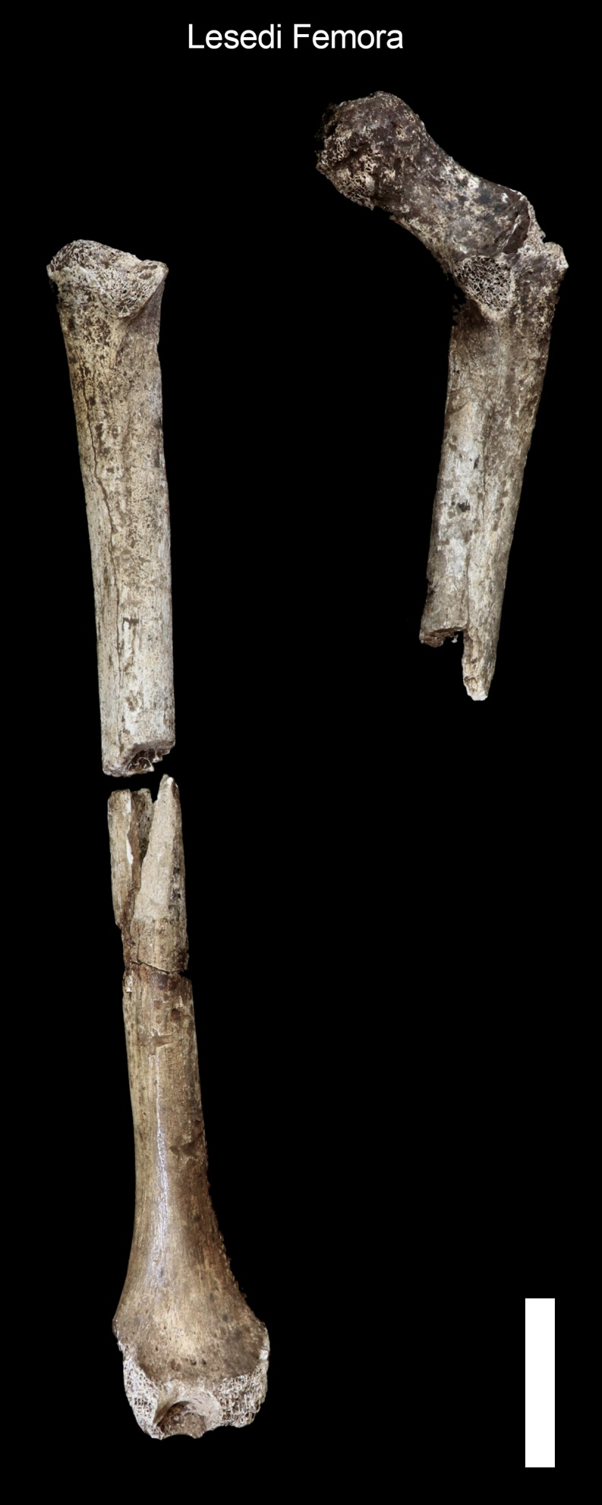

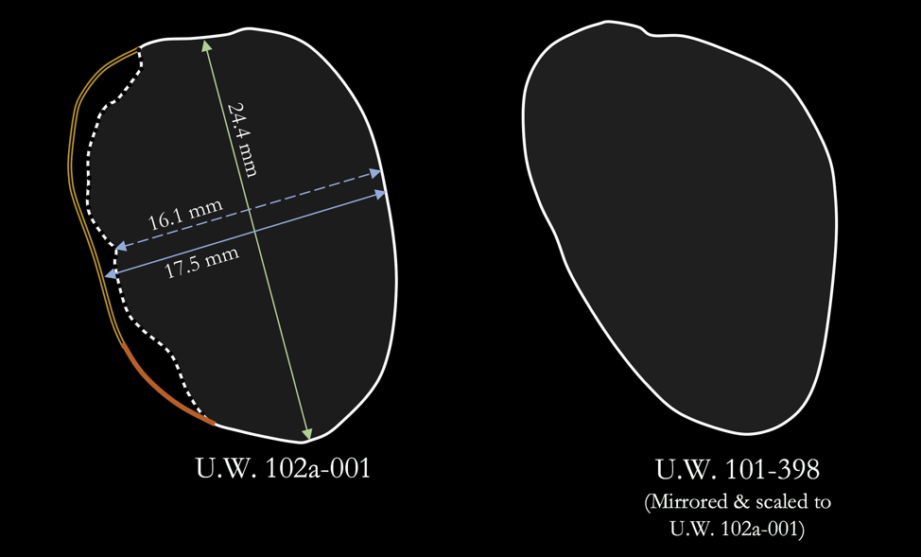

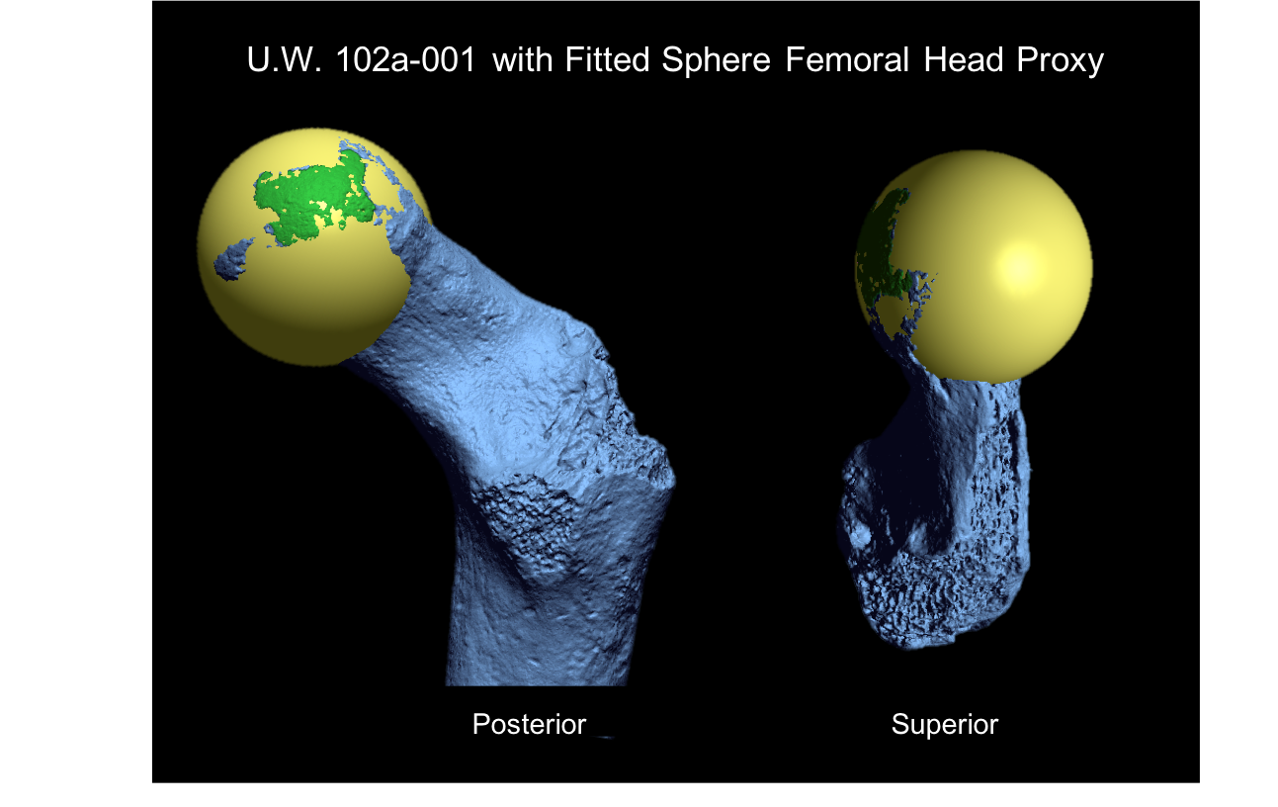

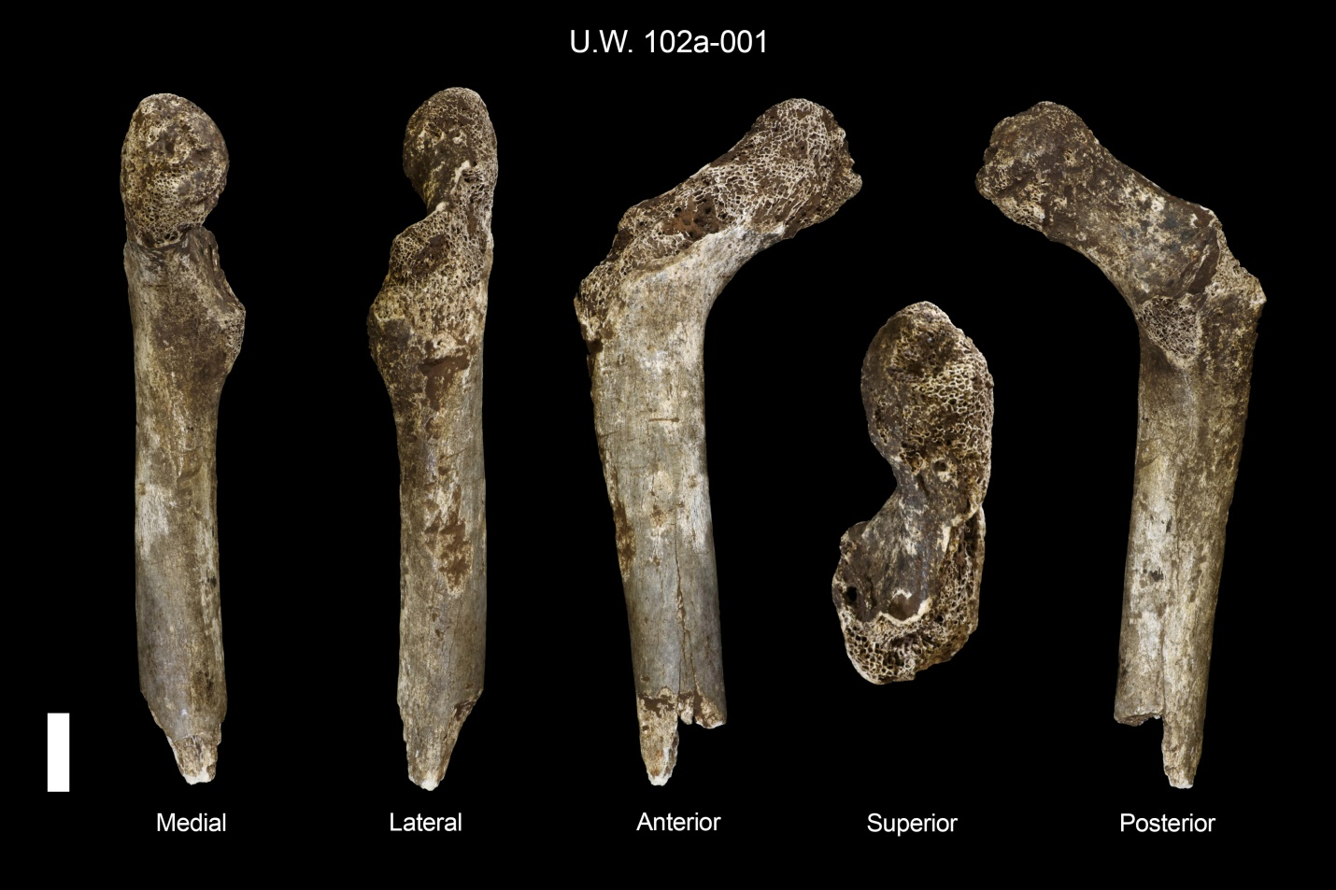

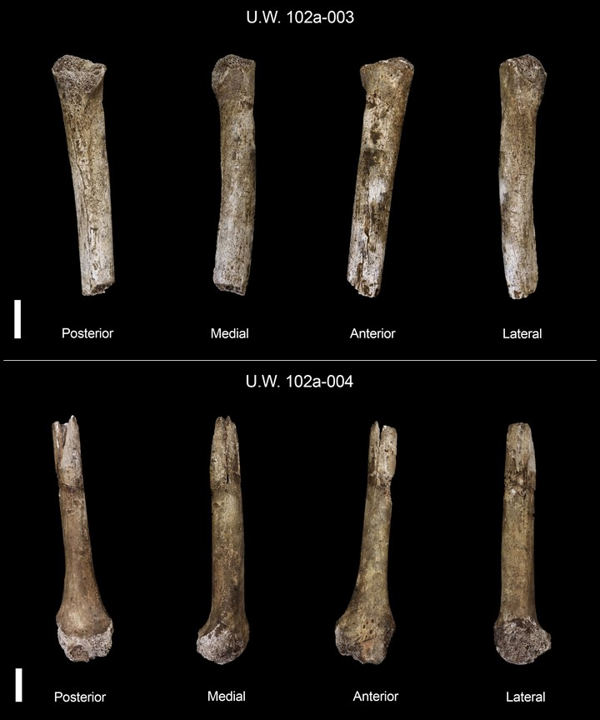

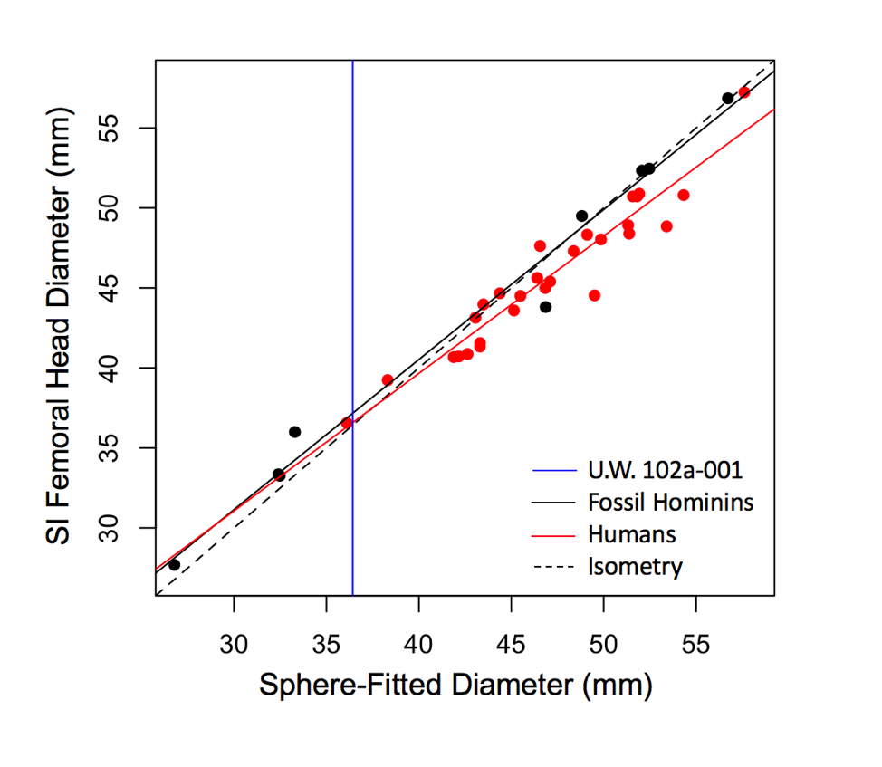

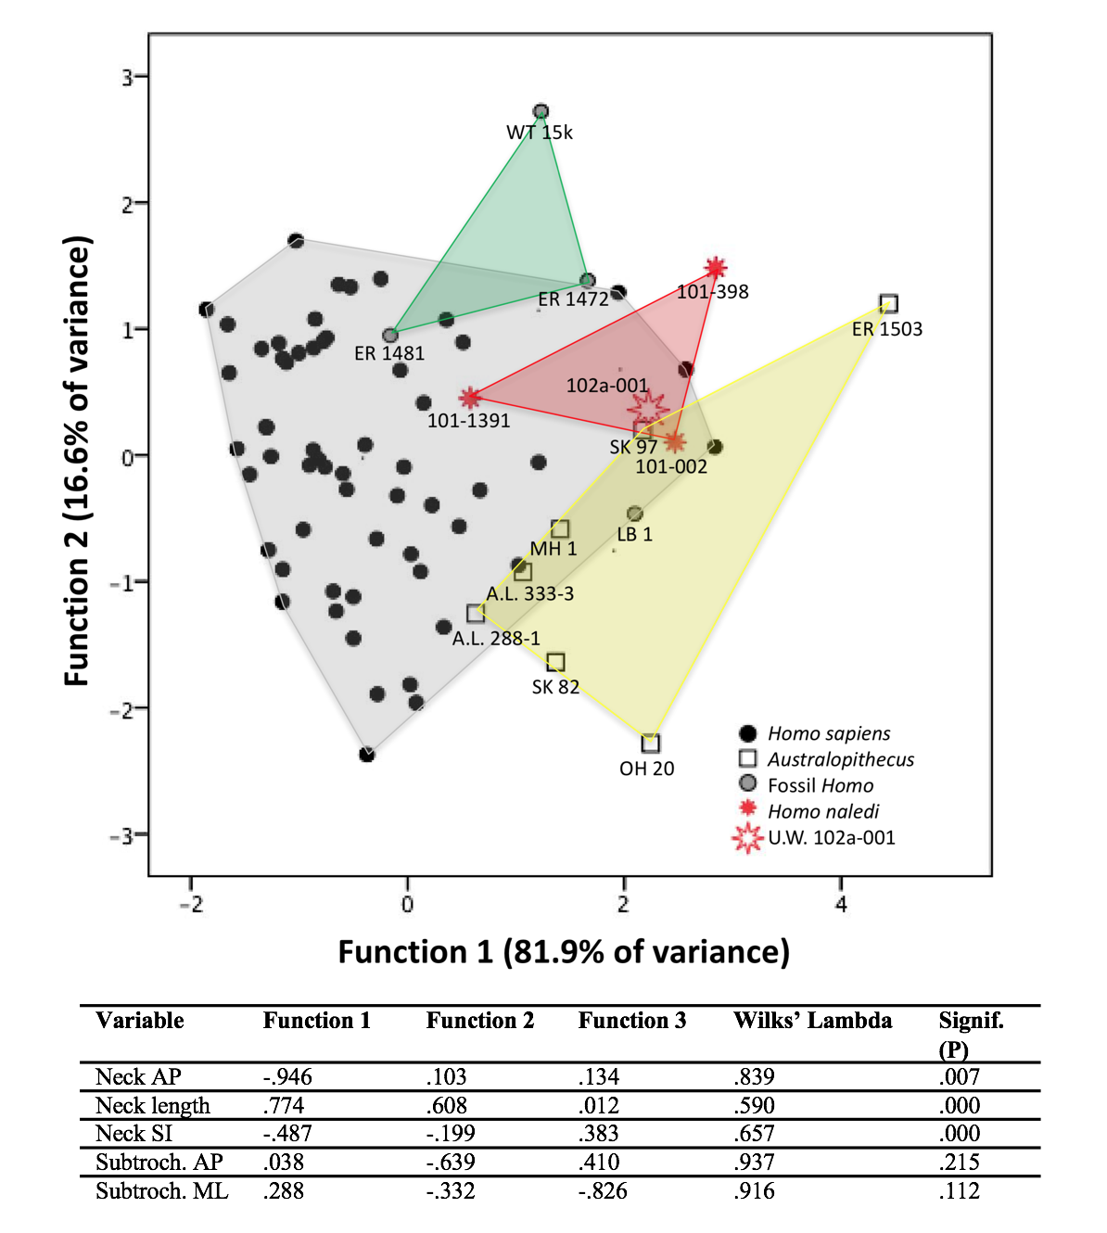

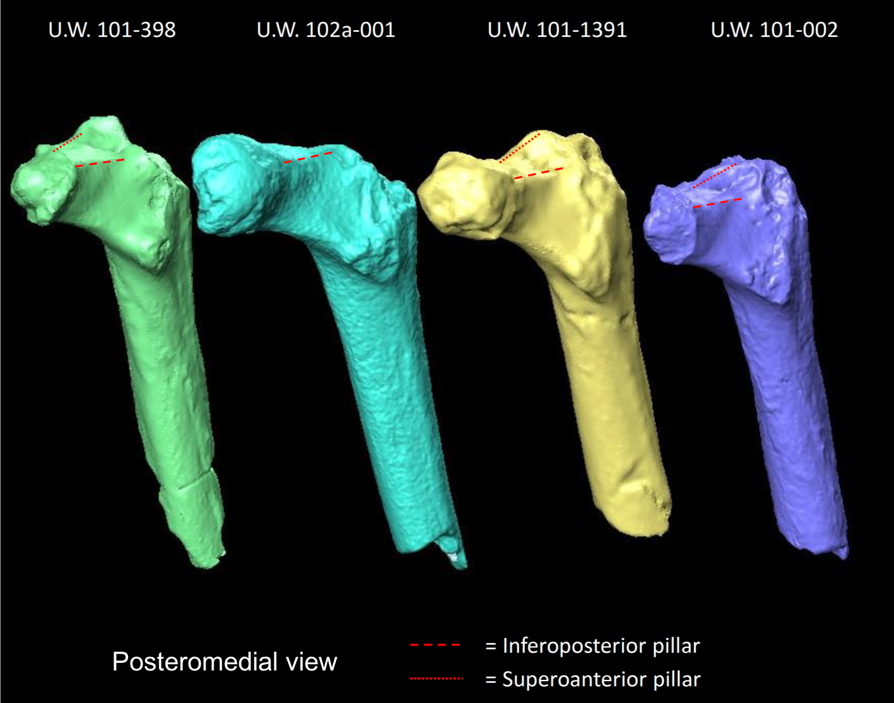

Electronic Supplementary Materials
Morphology of the Homo naledi femora from Lesedi

ESM Section 1: Reconstruction & Measurement Estimations – U.W. 102a-001 femoral head sphere-fitting

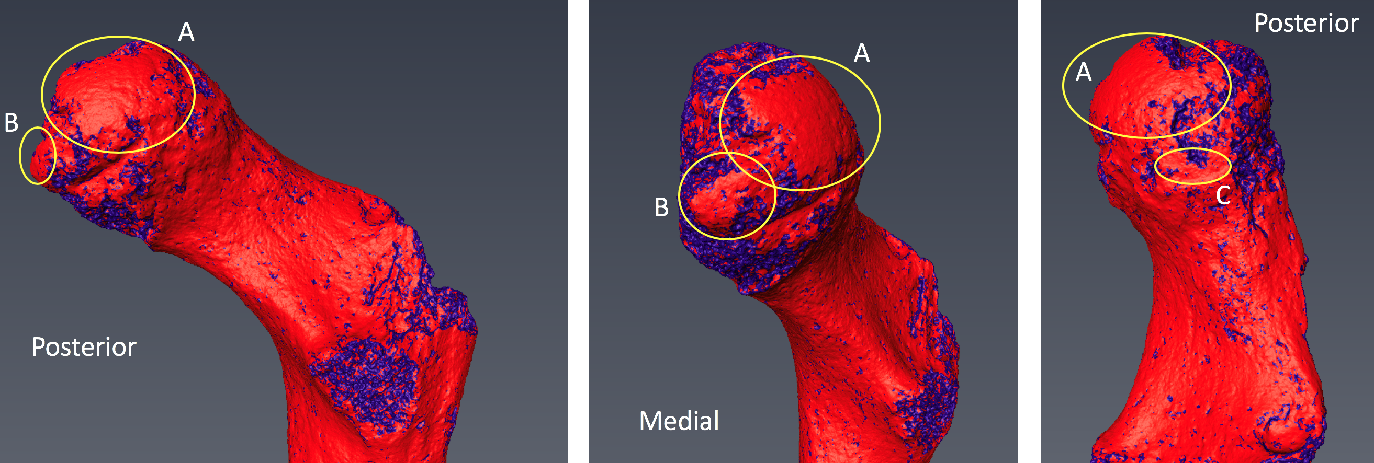
Figure S1: Curvature map created in Amira 6.4, to identify subchondral surface. Red corresponds to low curvature (e.g., better-preserved surface); blue corresponds to high curvature (e.g., trabecular bone and breaks). Mapping helps identify the presence of a relatively large area of subchondral surface (A), as well as two smaller patches (B and C).

ESM Section 2: Comparative Anatomy – Boxplots of comparative proximal femur metrics.

Key

G.g. - Gorilla gorilla
P.t. - Pan troglodytes
H.s. - Homo sapiens
A.afa - Australopithecus afarensis
A.afr - Australopithecus africanus
R.A. - Robust Australopithecus (Paranthropus)
A.s. - Australopithecus sediba
E.P. - Early Pleistocene African/ Georgian Homo
M.P. - Middle Pleistocene African Homo
H.n (D) - Homo naledi (Dinaledi)
H.n (L) - Homo naledi (Lesedi)

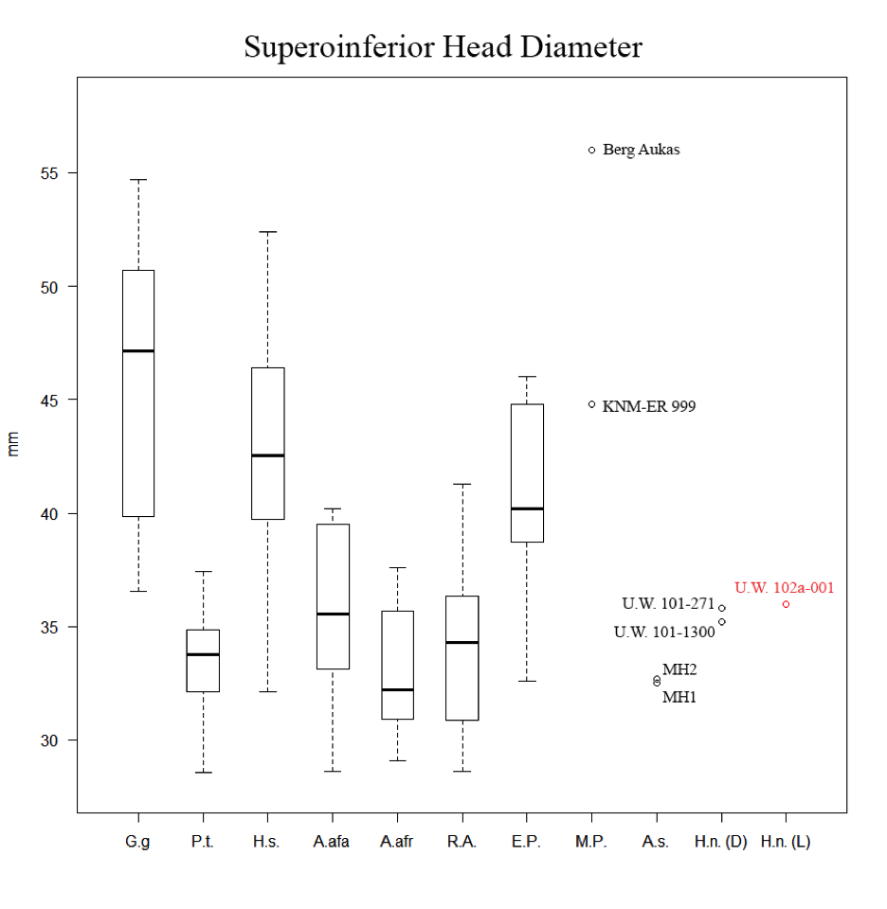
Figure S2: Superoinferior head diameter (FHD) boxplots for extinct and extant hominid taxa. Boxes include 25–75% quartiles with a mean line; whiskers extend to maximum and minimum values < 1.5 times interquartile range.

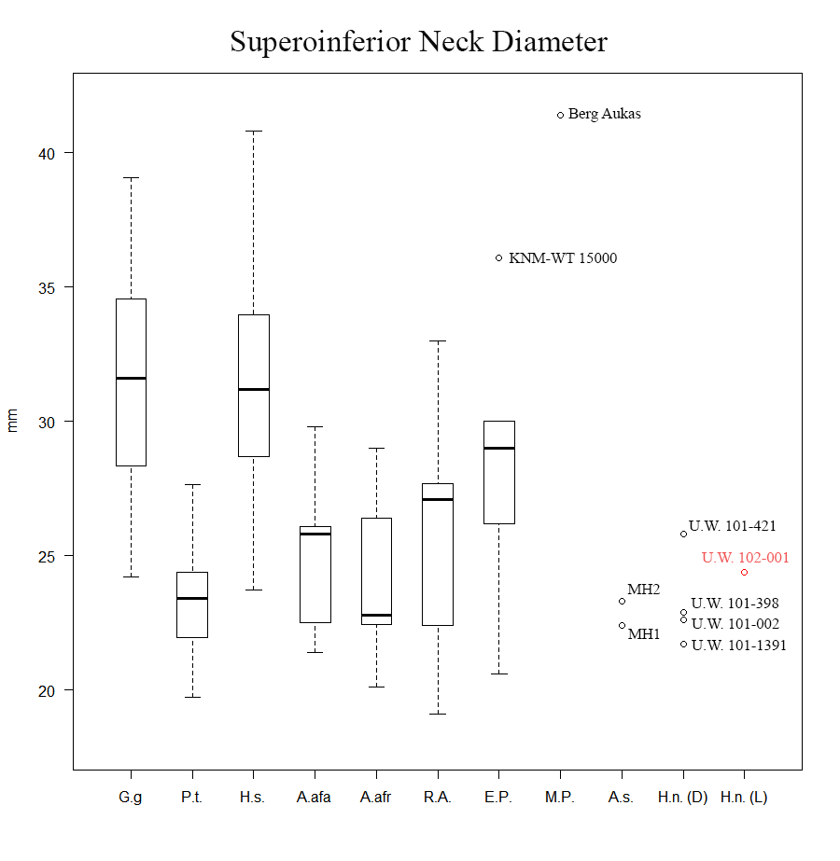
Figure S3: Superoinferior neck diameter (NH) boxplots for extinct and extant hominid taxa. Boxes include 25–75% quartiles with a mean line; whiskers extend to maximum and minimum values < 1.5 times interquartile range.

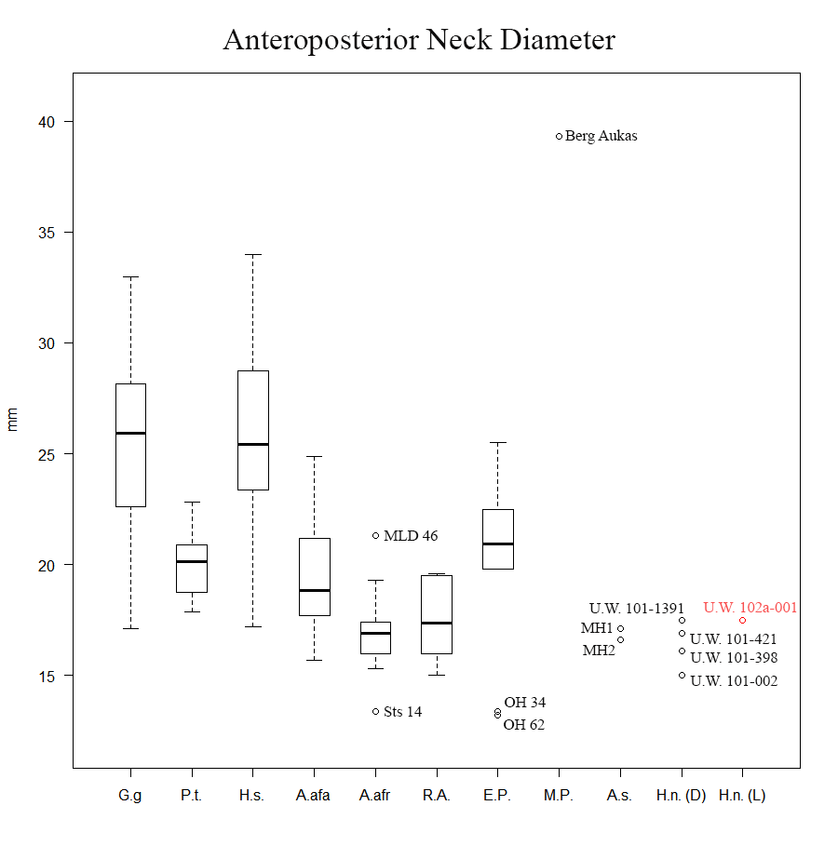
Figure S4: Anteroposterior neck diameter (NB) boxplots for extinct and extant hominid taxa. Boxes include 25–75% quartiles with a mean line; whiskers extend to maximum and minimum values < 1.5 times interquartile range.

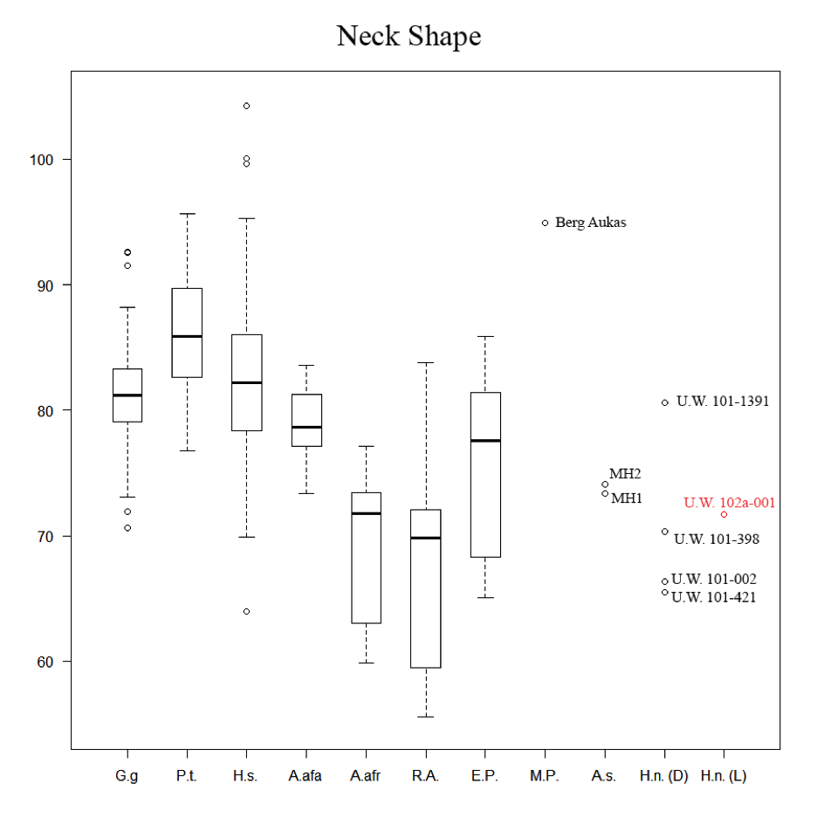
Figure S5: Neck shape (NB/NH x 100) boxplots for extinct and extant hominid taxa. Boxes include 25–75% quartiles with a mean line; whiskers extend to maximum and minimum values < 1.5 times interquartile range.

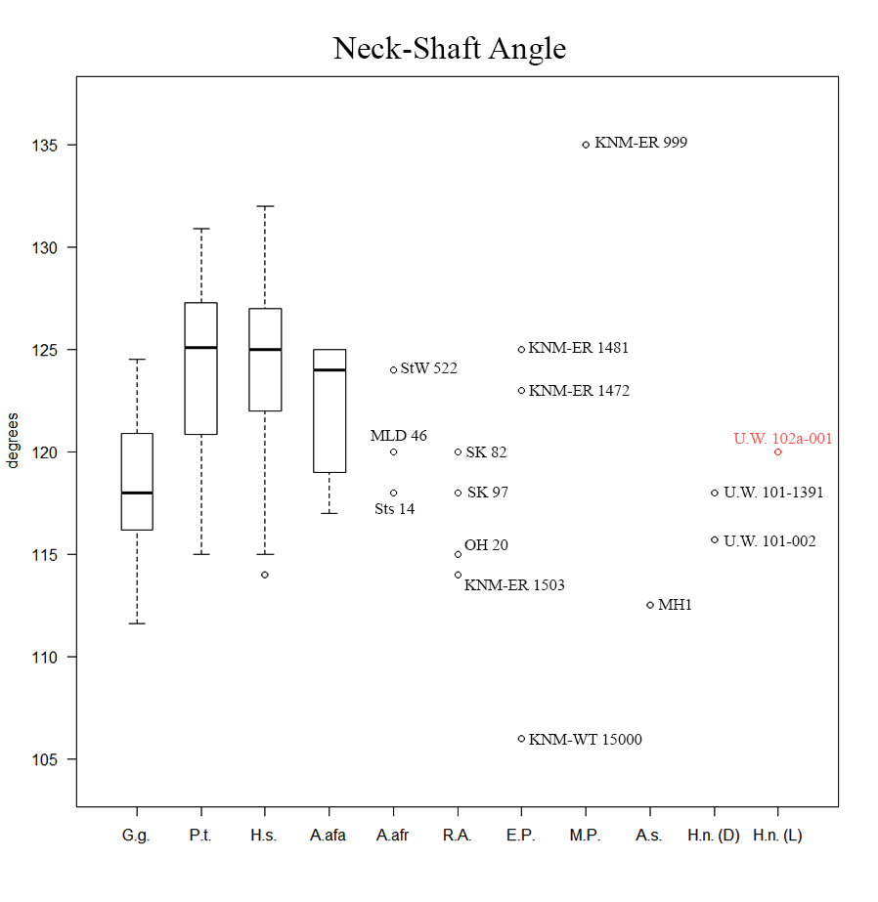
Figure S6: Neck-shaft angle (NSA) boxplots for extinct and extant hominid taxa. Boxes include 25–75% quartiles with a mean line; whiskers extend to maximum and minimum values < 1.5 times interquartile range.

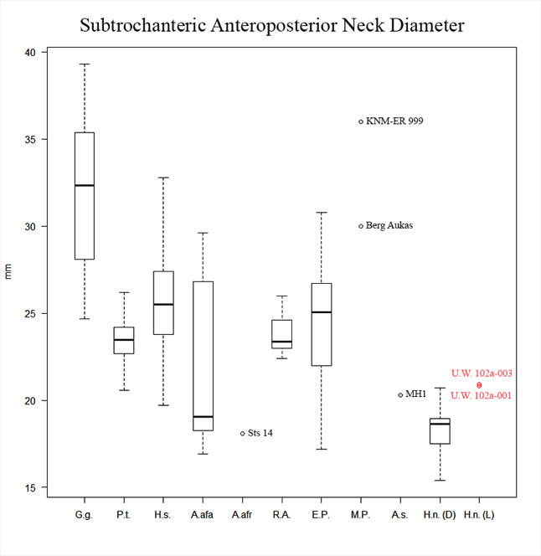
Figure S7: Subtrochanteric anteroposterior diameter (SAP) boxplots for extinct and extant hominid taxa. Boxes include 25–75% quartiles with a mean line; whiskers extend to maximum and minimum values < 1.5 times interquartile range.

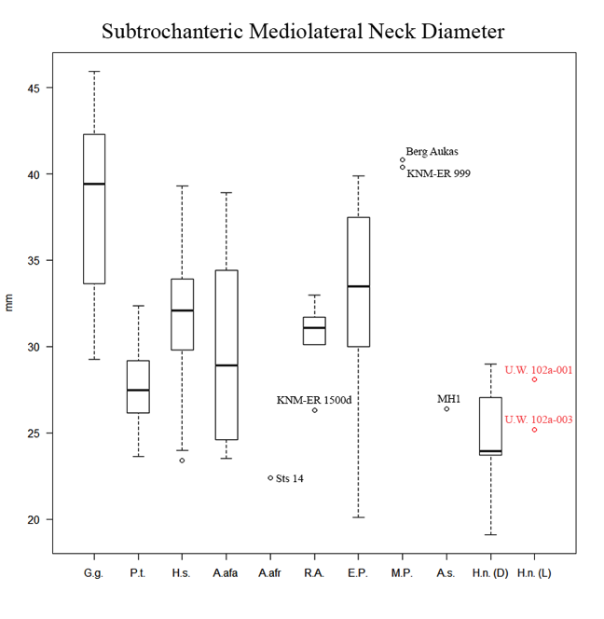
Figure S8: Subtrochanteric mediolateral diameter (SML) boxplots for extinct and extant hominid taxa. Boxes include 25–75% quartiles with a mean line; whiskers extend to maximum and minimum values < 1.5 times interquartile range.

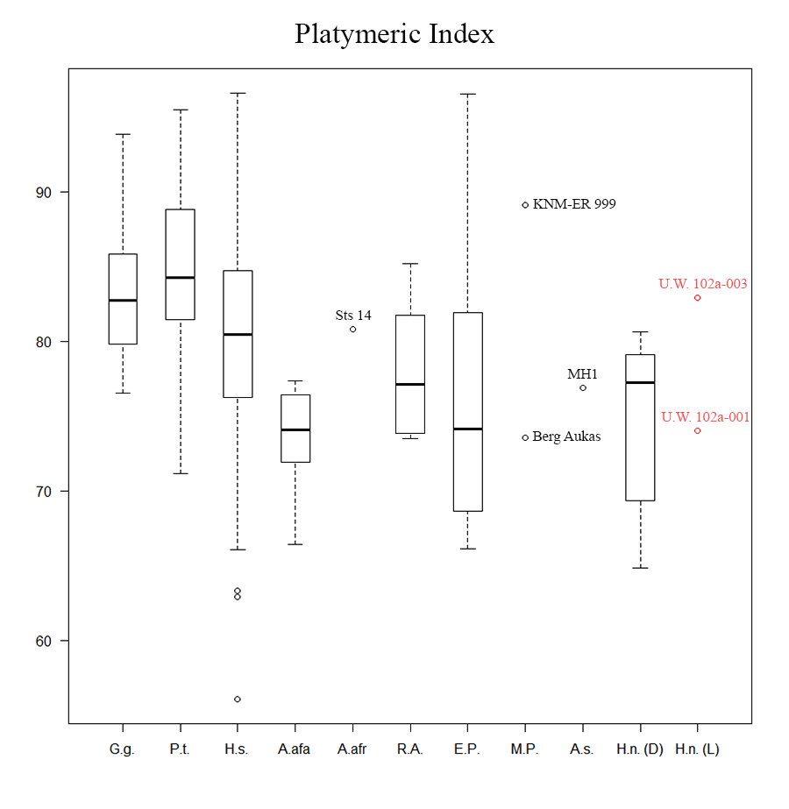
Figure S9: Platymeric index (SAP/SML x 100) boxplots for extinct and extant hominid taxa. Boxes include 25–75% quartiles with a mean line; whiskers extend to maximum and minimum values < 1.5 times interquartile range.

ESM Section 3: Comparative Anatomy – Discriminant function analysis tables.

Table S1: Posterior-probabilities for group membership of U.W. 102a-001.

Group membership | Taxon | P (G=g|D=d) | Mahalanobis distance to centroid
Highest | Homo naledi | .407 | .861
2nd highest | Australopithecus | .304 | 1.441

Table S2: Discriminant function analysis cross-validation results.
 | Homo sapiens | Australopithecus | Fossil Homo | Homo naledi
Homo sapiens | 81% | 5.2% | 5.2% | 8.6%
Australopithecus | 28.6% | 42.9% | 0% | 28.6%
Fossil Homo | 25% | 25% | 0% | 50%
Homo naledi | 0% | 33.3% | 66.7% | 0%

ESM Section 4: Comparative Anatomy Figures

Figure S10: Transverse sections of the femoral neck at the neck-shaft junction. IP = inferoposterior pillar. SA = superoanterior pillar. The Dinaledi femora all possess two distinct, mediolaterally-oriented pillars on the superior aspect of the neck, visible in these transverse sections. In U.W. 102a-001, the region in which the superoanterior would be located is damaged, prohibiting trait identification, however, an inferoposterior pillar is present. Also note the general shape of the inferior (transverse sections bottom) and posterior (transverse sections right) neck in all specimens. The U.W. 102a-001 neck cross-section is relatively broad and flat inferiorly and concave posteriorly.

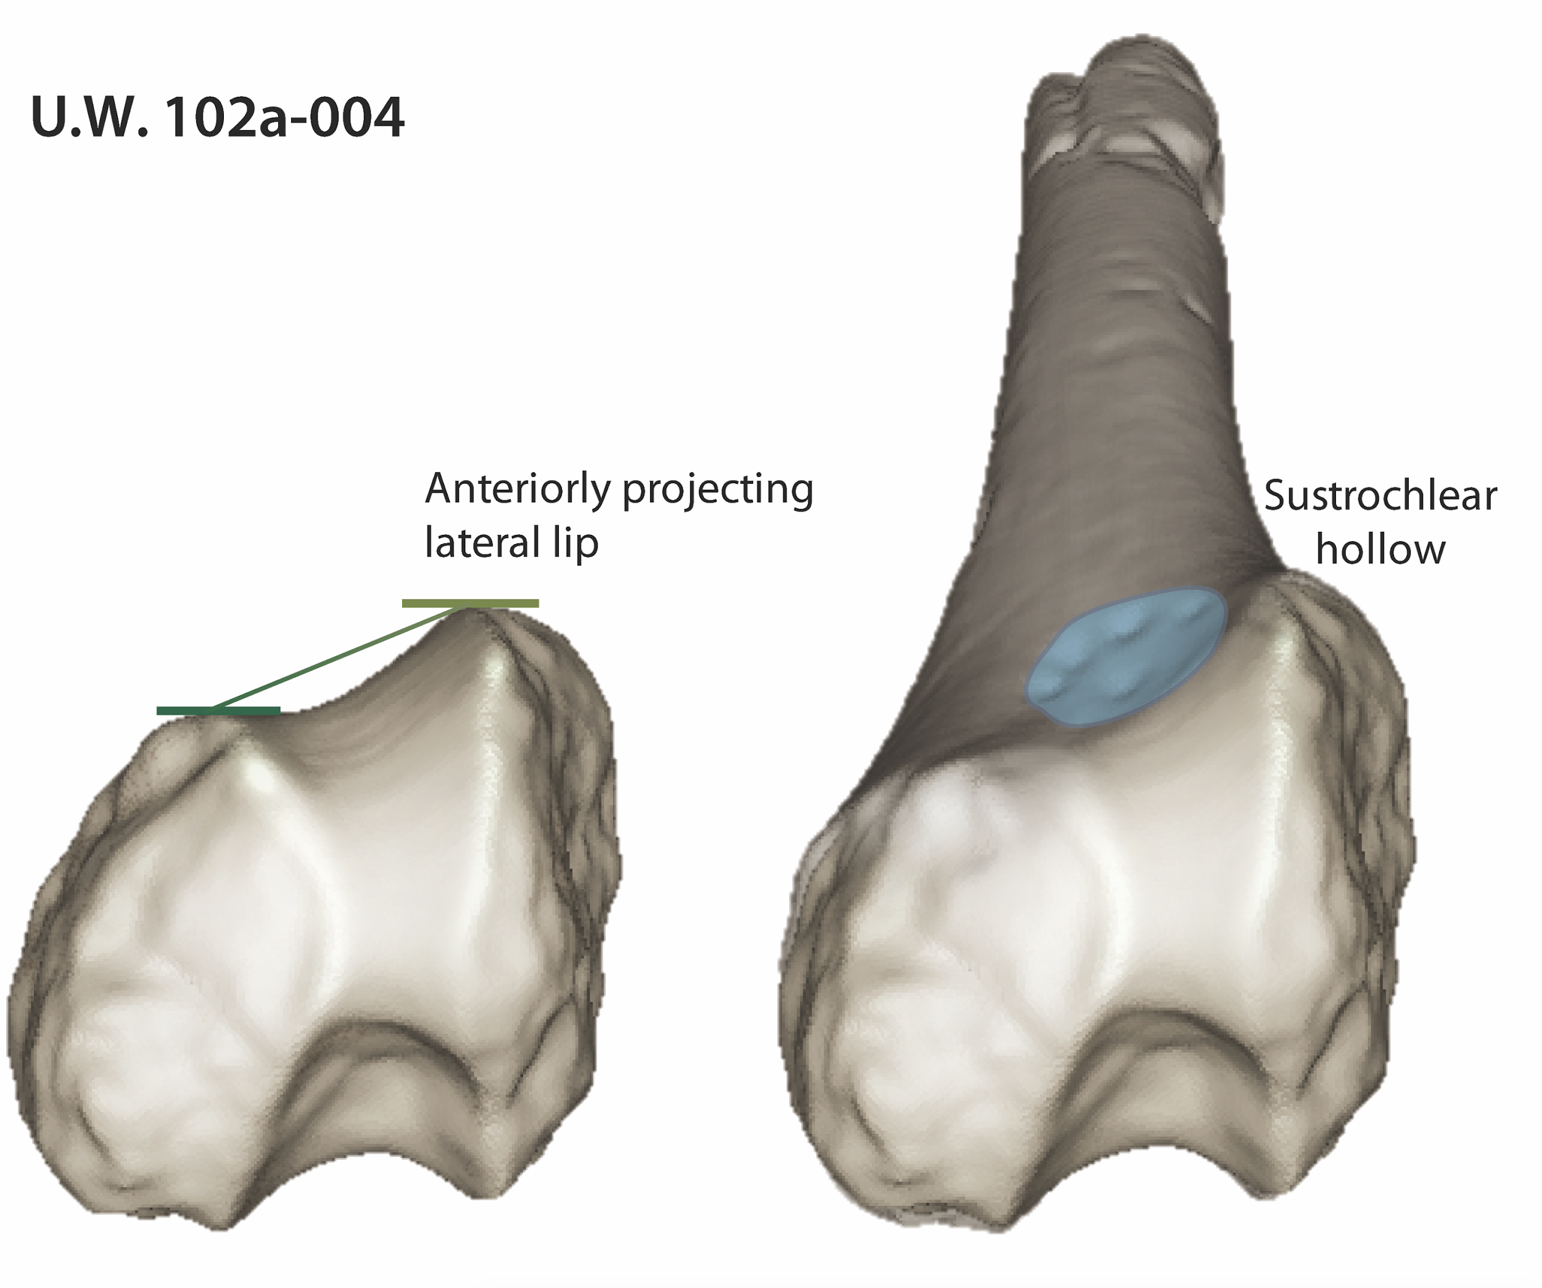
Figure S11: U.W. 102a-004 in inferior (left) and inferoanterior (right) views. Left: Damage to the femoral condyles prevents accurate quantification of lateral lip projection, but it appears quite pronounced. Right: There is a clear depression on the inferoanterior femoral diaphysis, just proximal to the patellar groove, known as the sustrochlear hollow. The presence of this trait has been taken as evidence of the full knee extension capability (see main text).

ESM Section 5: Bilateral Asymmetry Results – Exact Randomization Sampling Frequency

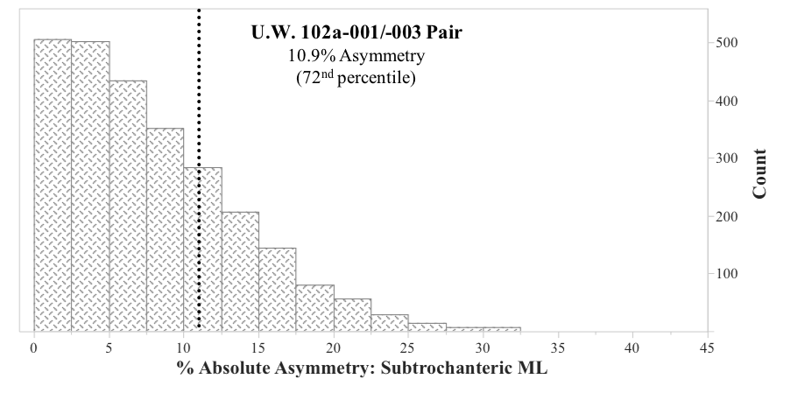
Figure S12: Exact randomization sampling frequencies for mediolateral subtrochanteric diameter (SML) asymmetry in a mixed-sexed human sample (n = 51 individuals & 2601 combinations). The degree of SML asymmetry between U.W. 102a-001 and -003 (10.9%; vertical dotted line) falls at the 72nd percentile of sampled human pairings.

