40-year Shoreline Evolution in Italy: Critical Challenges in River Delta Regions
Luppichini Marco^{a,*} and Bini Monica^{a,b,c}
ª Department of Earth Sciences, University of Pisa, Via S. Maria, 52, 56126 Pisa, Italy; marco.luppichini@dst.unipi.it; monica.bini@unipi.it
^{b} CIRSEC Centro Interdipartimentale Di Ricerca Per Lo Studio Degli Effetti del Cambiamento Climatico Dell’Università Di Pisa, Via del Borghetto 80, 56124 Pisa, Italy
^{c} Istituto Nazionale Di Geofísica E Vulcanologia (INGV), Via Vigna Murata 605, 00143 Rome, Italy
*corresponding author

Abstract
Current global warming is causing a variation of different phenomena such as storm surges, sea level rise, and rainfall distribution, with possible consequences for the sandy coast areas. Over the last century, like a great part of the Mediterranean, Italy has been affected by a decrease in total yearly rainfall and by an increase in the occurrence of rapid and intense events. This has induced a change in rainfall distribution and, consequently, a potential impact on the environmental evolution. Our work uses the software CoastSat to investigate the past evolution of the sandy coastlines of Italy, with a particular focus on the period 1984-2024. Criticality was found in the river deltas, for which significant results were obtained: 66% of the 40 major rivers are currently experiencing coastal erosion; over 75% of these rivers have a hydrographic side affected by erosion. If we exclude the areas with a presence of coastal defences, 100% of the major rivers are affected by erosion. Our study highlights that river deltas in the Mediterranean area are particularly vulnerable to climate change when compared to the average behaviour of the area.
Keywords: coastline evolution; river deltas; Italy; time series analysis; coastal adaptation.

Introduction
Global warming, driven by increasing greenhouse gas concentrations, is causing significant global impacts, including the loss and degradation of coastal areas. Coastal zones are crucial ecosystems and habitats, as well as home to large human populations and critical economic infrastructures. The impact of climate change on coastal regions depends on several factors, which act both independently and together, heightening the risk of coastal erosion, flooding, biodiversity loss, and infrastructure damage. Sea-level rise is considered one of the most significant physical effects of global warming and a primary cause of coastal area loss (Church et al., 2013; IPCC, 2023). This increase in sea-level directly threatens coastal ecosystems and human communities, especially in low-lying regions like deltas, coral islands, and coastal plains. The warming ocean surface waters have a direct impact on the intensity and frequency of extreme weather events such as hurricanes and tropical cyclones (Knutson et al., 2010). Storm surges associated with these events can cause widespread and destructive coastal flooding. Such events do not only threaten coastal populations and infrastructures, but they also accelerate erosion processes, alter coastal morphology, and reduce the resilience of an area to future storm inundations (Woodruff et al., 2013). Climate change is altering global precipitation patterns, with varying impacts on coastal areas. In some regions, extreme precipitations are expected to increase, possibly enhancing the risk of both riverine and coastal flooding (Trenberth, 2011). The Mediterranean, in particular, is recording an important variation of the hydrological cycles, with an increase in rainfall intensity (Luppichini et al., 2023; Tramblay & Somot, 2018; Zittis et al., 2021) and at the same time with a decrease in rainfall amounts (Brogli et al., 2019; Deitch et al., 2017). These phenomena, combined with temperature increase (Giannakopoulos et al., 2009; Pastor et al., 2020), induce a surge in drought risk for several areas of the Mediterranean (An et al., 2023; Baronetti et al., 2022; Cancelliere & Rossi, 2003; Polemio & Casarano, 2004; Sousa et al., 2011). An alteration of the hydrological cycle can have a cascading effect on several natural environments. The sandy coastal areas are strongly linked to the climate and to the capacity of the rivers to transport sediments (Besset et al., 2019; Billi & Fazzini, 2017; Luppichini et al., 2024). A change in the hydrological cycle can induce important variations in the trend pattern of these environments, which are also amplified by human activities. Coastal areas and river deltas are important for human socio-economic activities and ecosystems (Anfuso et al., 2011; Anthony, 2018; Anthony et al., 2014). Monitoring and safeguarding these environments are fundamental challenges in the context of climate change. In these scenarios, Italy is a key area because it is centrally located in the Mediterranean sea and exhibits significant climatic variability due to the presence of major mountain ranges (Fratianni & Acquaotta, 2017). In the last century, the Italian rivers have presented a decrease in sediment transport resulting from a variation of rainfall distribution (Luppichini et al., 2024; Zanchettin et al., 2008) and of human activities, contributing to changes in land cover and dams (Surian et al., 2009; Surian & Rinaldi, 2004). Coastal erosion is an issue that affects the entire Italian territory (Celata & Gioia, 2024). Several studies have highlighted trends of erosion and progradation along the Italian coast. For example, in areas near the Arno and Serchio rivers, the trend has been that of erosion with values around 2-3 m/year over the past 40 years (Besset et al., 2017, 2019; Bini et al., 2008; Cappucci et al., 2020). The area of the Ombrone River shows erosion rates as high as 5-6 m/year (Cipriani et al., 2013). In the Adriatic coast, erosion around the Trigno and Biferno rivers is about 2.7-2.9 m/year, with an increase between 1992-2004 up to 3.5-4.0 m/year (Rosskopf et al., 2018). Similar erosion trends have been observed in Sicily, with rates around 3 m/year for the Simeto River (Laksono et al., 2022). Shoreline erosion along the Calabrian coasts is driven by both natural factors and escalating anthropogenic pressures, with significant advancements observed in recent and short-term time periods (Foti et al., 2022). In the last 100 years, the coastal plain of the Sele River has experienced a period of shoreline retreat, mainly due to human activities such as land reclamation, dam construction, and urbanization, which have reduced sediment delivery to the coast. However, since 1984, the coastline has remained relatively stable, with the exception of the river mouth area, which has continued to experience erosion (Alberico et al., 2012).
Unfortunately, a uniform monitoring system for the Italian sandy beaches and river deltas is currently lacking.
Coastal areas can be monitored using different tools and techniques such as cartographies (Guariglia et al., 2006), aerial images (Bini et al., 2008), differential GPS (Jang et al., 2016), drones (Gonçalves & Henriques, 2015; Luppichini et al., 2020; Turner et al., 2016), satellite images (Mantas et al., 2013; Vos, Harley, et al., 2019; Vos, Splinter, et al., 2019). Cartography allows to extract the longest time series by investigating long patterns and variabilities. Nevertheless, the frequency of production of high-resolution cartography does not permit to analyse in detail the variations over time;in some cases it can only provide the main patterns and general trends. More precise techniques, such as differential GPS and drones, yield high resolutions and collect high frequency data, even at specific times. For example, they are able to analyze the effects of a storm surge by acquiring data before and after the event. However, the relatively short duration of the time series available represents a limit of these techniques, as they have only been used in favourable cases in the past 10 years. The procedures based on satellite images make it possible to cover large areas with high frequency and to obtain homogenous results , with no limits imposed by administrative boundaries. Furthermore, since the acquisition of satellite images began over 40 years ago, we now have access to long-time series, which have allowed to investigate extended temporal patterns up to the present day.
In this study we use satellite data to investigate the past trends of the sandy coasts of Italy (Figure 1) in the period 1984-2024, using the software CoastSat (Vos, Splinter, et al., 2019). The trend analysis is conducted along transects located every 100 m. We wish to focus our attention on the river deltas and to understand whether there is a displacement from the general patterns.
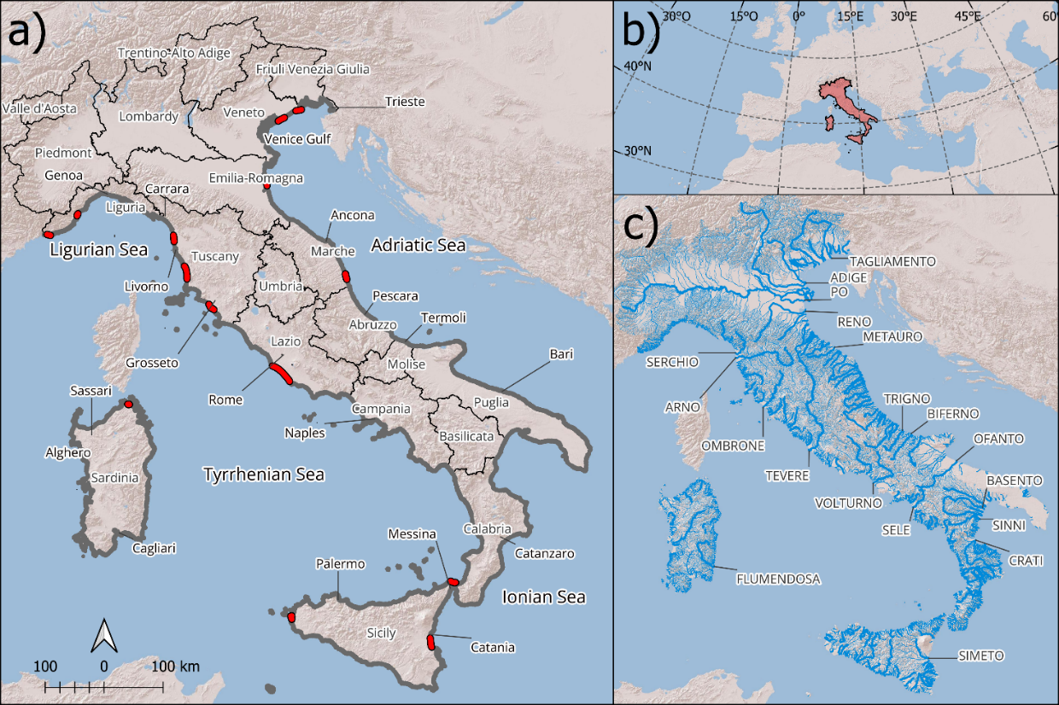
Figure 1 Study area: a) the grey line indicates the coastline investigated. The red lines indicate the coastal segments selected for manual digitalization of the shoreline from aerial photographs for validation of the results; b) the geographic position of the study area in the Mediterranean; c) hydrographic network of Italy. The thick blue lines represent the main rivers.

Materials and Methods
This work, based on the application of the CoastSat software (Vos, Splinter, et al., 2019), allows to obtain the shoreline position analysis of multispectral satellite images, . The Python library software, applied to the entire Italian coast, is used to extract the shoreline positions by analysing the satellite images acquired by Landasat campaigns (Landasat 5, Landasat 7, and Landasat 8). The CoastSat software is built on the Google Earth Engine platform (https://earthengine.google.com/) and leverages its repository, along with the corresponding Application Programming Interface (API), to analyze data—in this case, from the LandSat satellite mission. The data are georeferenced with a Root Mean Square Error (RMSE) below 12 meters and are considered suitable for time series analyses (https://earthengine.google.com). Since 1984, the Landsat dataset has allowed to obtain very long time series in the field of remote sensing. The software is applied to each satellite image with a cloud coverage of less than 5%, reducing the probability of issues linked to the presence of clouds and making it possible to manage a great number of images. The shoreline extracted in this step is analysed along transects located on sandy and pebble beaches (about 3,624 km). The geospatial information derives from a dataset of the Istituto Superiore per la Protezione e la Ricerca Ambientale (ISPRA; https://data.europa.eu/data/datasets/ispra_rm-01fasciacostiera_sdt?locale=it). The transects are orthogonal to the coast with a length of 500 m, located every 100 m and oriented from sea to land. We also distinguish the transects in the proximity (in a radius of 500 m) of anthropic coastal buildings such as harbours, groynes, etc., using the information obtained from a dataset provided by the “Istituto Superiore per la Protezione e la Ricerca Ambientale” (ISPRA) and updated on 29 November 2020 (https://data.europa.eu/data/datasets/ispra_rm-01fasciacostiera_sdt?locale=it). In this way, the analysis described below is conducted by investigating the transects with a possible direct influence of the human pressures and transects with no coastal defence structures.
For each transect, we derive a time series of distances from the first point of the transect ( located on the sea) and the intersection points between the transect and the shorelines. In this way, when the distance increases the transect is affected by erosion; instead, when the distance decreases the transect tends to advance. A filter of the data is necessary to exclude errors in some of the shorelines. As suggested by Vos et al. (2019), we exclude shorelines that exhibit a change greater than 50 m along the transect from one date to the next one. Given the high temporal density of the data, such a significant variation in shoreline position between consecutive dates is unlikely to occur naturally. Therefore, these cases are considered errors of image analysis. Transects with fewer than 20 shorelines are excluded from the analysis to avoid cases for which statistical reliability may be insufficient.
The linear trend for each time series derives from Linregress, a method used by the Python library Scipy (Virtanen et al., 2020). This method calculates a linear least-squares regression for two sets of measurements and provides the p-value for a hypothesis test whose null hypothesis is that the slope is zero, according to the Wald Test with t-distribution of the test statistics (https://docs.scipy.org/doc/scipy/reference/generated/scipy.stats.linregress.html). We assume that the trend is significant with a p-value < 0.05, while it is considered non-significant with a p-value ≥ 0.05.
Validation of the results obtained by CoastSat processing is crucial. For this reason, we digitalized the shoreline position in 15 localities (about 200 km of coast; red lines in Figure 1) by using five aerial photograph samples covering the entire peninsula in the years 1988, 1996, 2000, 2006, and 2012. For these shorelines, we extracted the trends along the transects, repeating the same procedure applied to the CoastSat products. Extraction of the linear trends of the shoreline from the CoastSat outcomes for the same period of the aerial photographs makes it possible to perform a statistical comparison between the time series derived from the different datasets and, importantly, from those obtained by manual and automatic procedures.
To analyse seasonal variability in shoreline positions, we classified the data into four seasons: winter (DJF), spring (MAM), summer (JJA), and autumn (SON). We first applied the Kruskal-Wallis test for each transect to assess whether significant differences existed among the seasonal shoreline positions. Where the Kruskal-Wallis test indicated significant differences ($p<0.05$), we performed post-hoc pairwise comparisons (Tukey's Honest Significant Difference) to identify specific pairs of seasons exhibiting significant differences. This approach allowed us to evaluate and quantify seasonal patterns in shoreline dynamics across the transects. The statistical tests are applied using kruskal and pairwise_tukeyhsd functions of the Python Library Statsmodels.

Focus on the river deltas
In this work, we analyse in detail the variation of the delta rivers, which are vulnerable zones because of several pressures such as changes in sediment balance and anthropic activities (Anthony, 2018; Anthony et al., 2014; Besset et al., 2017, 2019). On the basis of a dataset of the hydrographic network subdivided into various categories such as rivers, torrents, channels, etc., we selected the transects running along the river deltas for around 10 km (Table 1). We distinguished the transects on the hydrographic right and left to identify the different behaviours of the two sides of the deltas. We also defined three categories to identify the watercourses, according to their erosion patterns. The "Average" category includes watercourses where the average transect slope indicates a predominant erosion. The "Always" category covers watercourses where both hydrographic sides consistently exhibit erosion. Lastly, the "Mixed" category refers to watercourses where either the left or the right hydrographic side is affected by erosion.
Table 1 List of the rivers and large rivers (*) investigated
Rivers
Abatemarco | Cecina* | Gela | Oliva | Sile*
Acate O Dirillo | Cedrino | Grande | Ombrone* | Silis
Adige* | Centa | Grande O Imera Settentrionale | Osa | Simeto*
Agri* | Cento Acque | Ippari | Osento | Sinello
Albegna | Cesano | Irminio | Padrogiano | Sinni*
Alcantara | Chienti* | Irno | Palma | Sisto
Alento | Coghinas | Jato | Pecora | Soleo
Alento | Corace | La Lama | Pescara* | Solofrone
Alli | Cornia | Lama Di Lenne | Petrace | Tacina
Amato | Crati* | Lambro | Picentino | Tagliamento*
Anapo | Crocchio | Lamone* | Platani* | Tara
Ancinale | Cuba | Lao | Po* | Tavollo
Angitola | Di Chinisia | Lentini | Pollina | Tellaro
Arena | Di Noto | Liscia | Potenza* | Temo
Arielli | Di Zappulla | Magazzolo | Reno* | Tenna*
Arno* | Drago | Magra Ligure | Roia | Testene
Arrone | Entella | Marecchia* | Rosmarino | Tevere*
Aso | Esaro | Mesima | Rubicone | Torbido
Astura | Esino* | Metauro* | S. Leonardo | Torbido
Baiata | Ete Vivo | Mignone | S. Michele | Tordino
Basento* | Ferro | Milicia | S. Stefano | Torto
Belice | Ficarazzi | Mingardo | Saline | Trigno*
Biferno* | Fine | Misa | Salinello | Trionto
Birgi | Fiora* | Modione | Salso* | Tronto*
Bradano* | Fiumi Uniti | Musone | Sangro* | Tusciano
Bruna | Flumendosa* | Naro | Sarno | Uso
Bussento | Foglia* | Neto* | Savio* | Verdura
Carboj | Foro | Nica' | Savoca | Volturno*
Cassibile O Cava Grande | Fortore* | Noce | Savuto | Vomano
Catocastro | Freddo | Nocella | Sele* | Zaffaria
Cavone | Garigliano* | Ofanto* | Serchio*

Results
The coastline investigated is about 3,624 km discretized into 34,215 valid transects (excluding those with less than 20 valid shorelines) distributed more or less every 100 m along the coastline. The CoastSat software has been used since 1984 to investigate the Landsat images. Figure 2 reports the statistics of the distance time series for the investigated transects. The great part of the time series ranges from 1984 to 2024 (investigated for approximately 40 years, with very small variability).Many shorelines have been involved to extract the linear trend: a median value of 311 with a standard 123 deviation (Figure 2). In areas where satellite campaigns capture overlapping images (between one swath and the next), a significantly higher amount of data is recorded, approximately double compared to other regions. This overlap explains the variability in the number of images collected, which is an inherent characteristic of the satellite imaging process. The linear trends distributed in several years were calculated over a large amount of data, making it possible to obtain a robust statistic.
The procedure of results validation was carried out using the dataset of aerial photographs, where the shoreline position was drawn manually. The analysis conducted on about 200 km of coast resulted in a study involving 1761 transects (about 6% of the total coastal area). The linear trends obtained with the two methodologies were very similar; Pearson’s coefficient of correlation was 0.90 and the p-value was < 0.05 (Figure 3), with a mean absolute error (MAE) of about 0.62 m/year Different sources of error influence the two methodologies. The manual methodology is subject to user dependency and to the subjective interpretation of shoreline positions, while the automatic methodology is affected by systematic errors and by the resolution of the analysed data. Manual editing of extensive coastal areas is highly time-consuming but the comparison of these two methodologies is crucial to evaluate the results obtained in previous studies.
The linear trends are reported in Figure 4 and in Table 2. Figure 4a shows all the transects and diagrams for the macro areas. Figure 4b shows only the results for areas with no coastal defences within a radius of 500 m. The diagrams report the significant positive (sP), not-significant positive (nsP), significant negative (sN) and not-significant negative (nsN) trends. In the Ligurian Sea, 17% (21% considering the transects more distant than 500 m from coastal defences) of the transects have sP trends; 6% (7%) have nsP trends; 69% (61%) have sN trends; and 9% (11%) have nsN trends.
In the north Tyrrhenian Sea, 21% (20%) of the transects have sP trends; 8% (8%) have nsP trends; 62% (62%) have sN trends; and 9% (10%) have nsN trends. In the south Tyrrhenian Sea, 40% (40%) of the transects have sP trends; 11% (12%) have nsP trends; 37% (35%) have sN trends; and 12% (12%) have nsN trends. In the Sardinian Sea 30% (31%) of the transects have sP trends; 18% (18%) have nsP trends; 33% (31%) have sN trends; and 19% (19%) have nsN trends.
In the Ionian Sea, 42% (42%) of the transects have sP trends; 8% (8%) have nsP trends; 42% (43%) have sN trends; and 8% (7%) have nsN trends.
In the Adriatic Sea, 22% (24%) of the transects have sP trends; 6% (6%) have nsP trends; 65% (63%) have sN trends; and 7% (7%) have nsN trends. Considering the entire peninsula, about 31% of the transects are characterized by erosion (sP trend) and they reach 41% if we consider all the positive trends.
Southern Italy and Sardinia have a higher percentage of erosion transects with an increase in erosion areas from north to south and a consequent decrease in the advancement and stable areas.
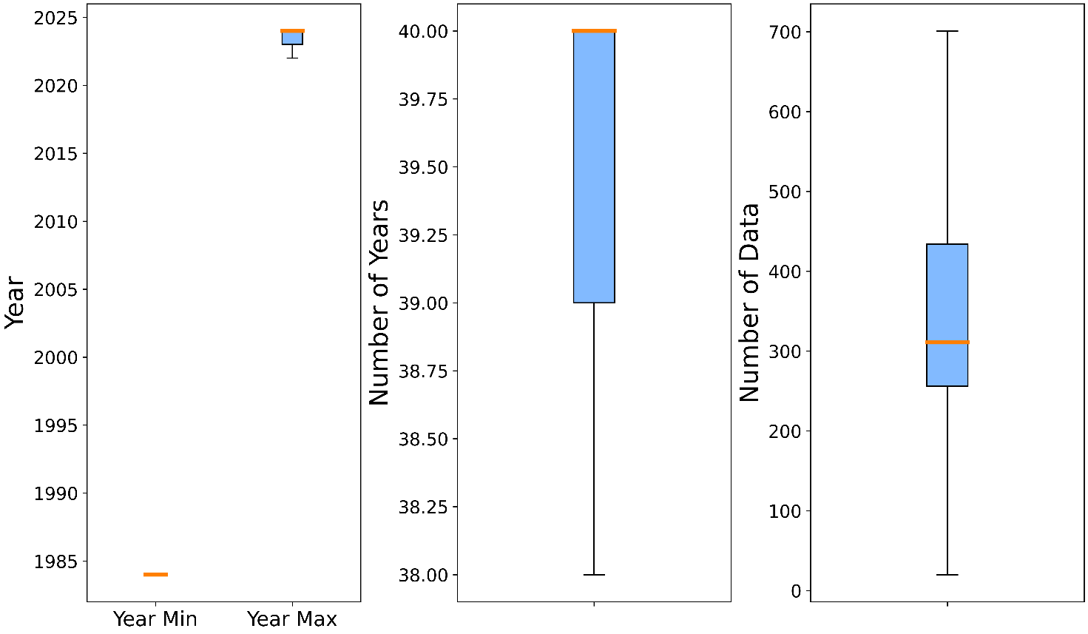
Figure 2 Characteristics of the transect time series used to calculate the linear trends. From left to right: distribution of the minimal years and maximum years of the time series; distribution of the number of years derived from the difference between maximum year and minimum year; distribution of the amount of data used to calculate the trends. The boxes represent the interval between the 25th and 75th percentiles (Q1 and Q3). IQR is the interquartile range Q3-Q1. The upper whisker will extend to the last datum lower than Q3 + 1.5 × IQR. Similarly, the lower whisker will reach the first datum higher than Q1–1.5 × IQR. The orange line represents the median.
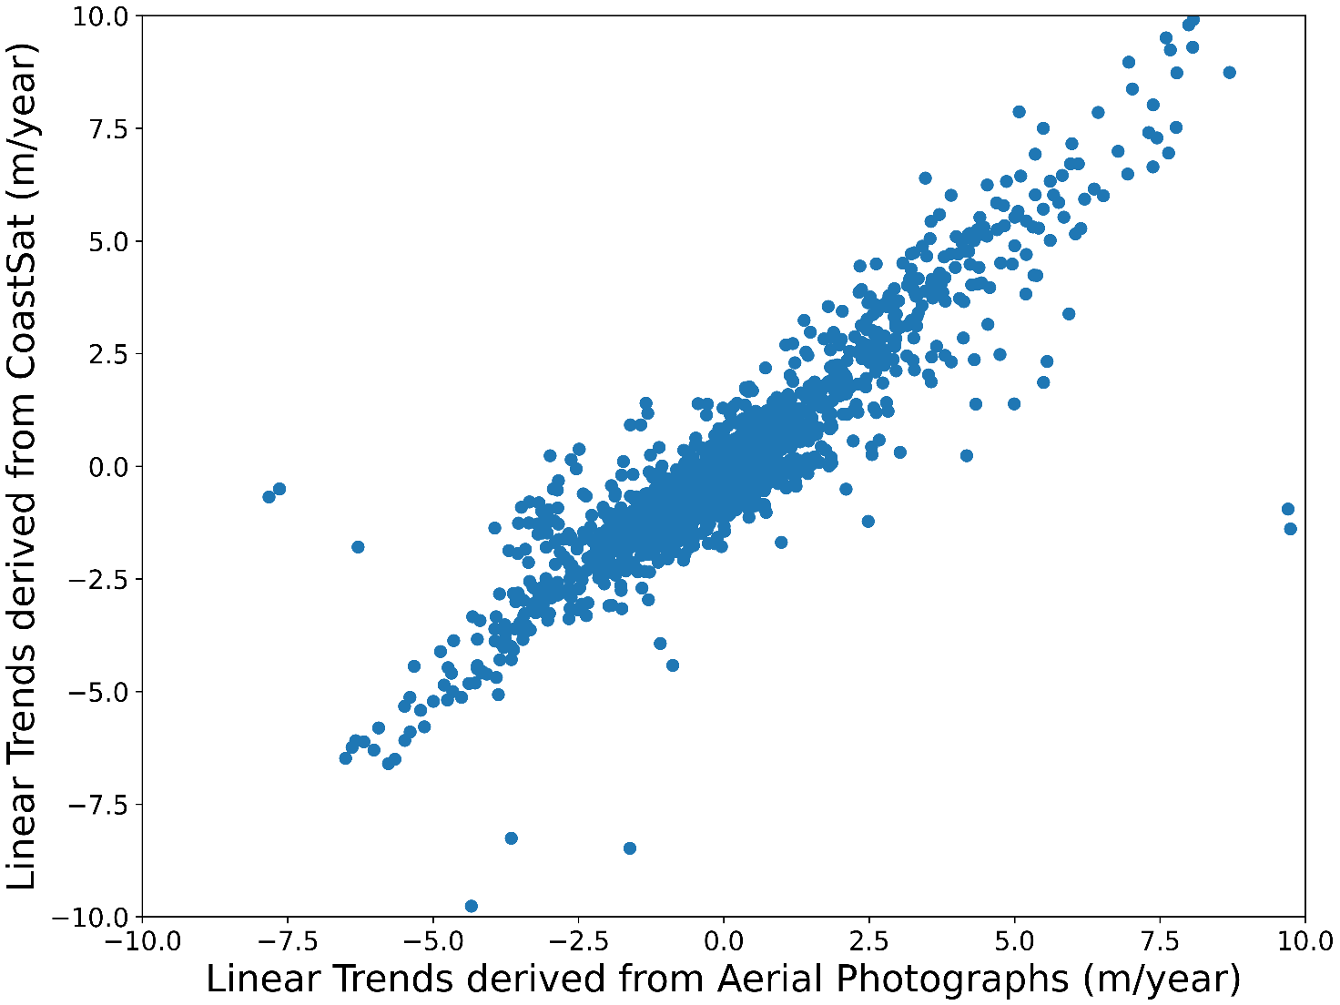
Figure 3 Relation between the linear trends (of 1761 transects) derived from aerial photograph analysis and the application of CoastSat software to the Landsat datasets considered.

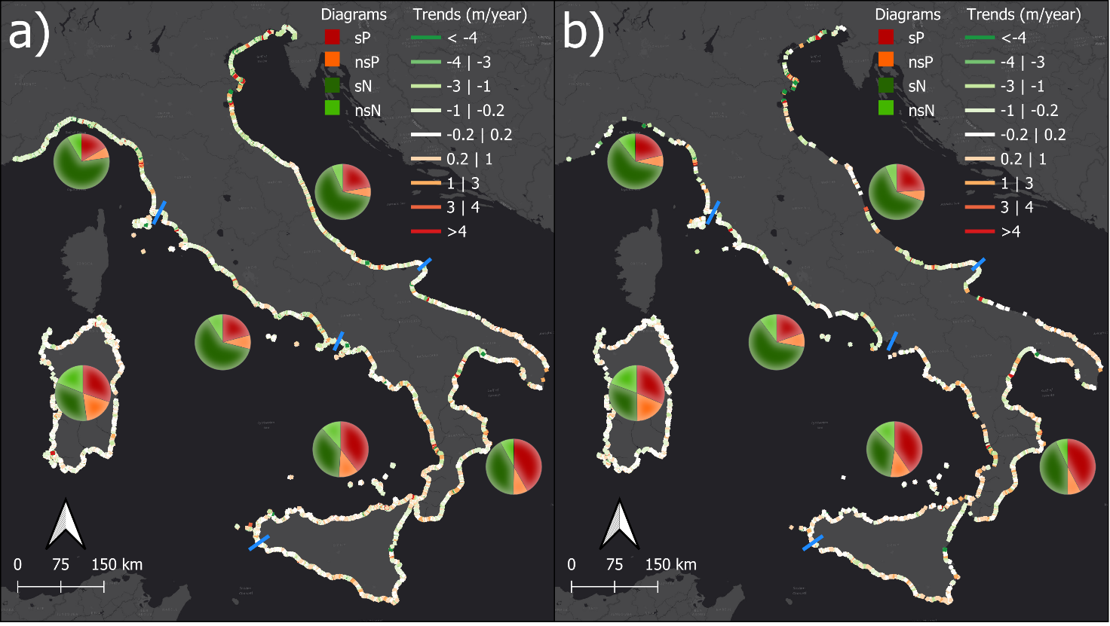
Figure 4 Linear trends calculated along the transects: a) entire dataset; b) transects further than 500 m from coastal defences. The blue lines indicate the boundaries of the macro areas where the results are summarized in the pie charts: significant positive (sP), not-significant positive (nsP), significant negative (sN), and not-significant negative (nsN) trends.

Table 2 Percentage of transects categorized in different linear trends: significant positive (sP), not-significant positive (nsP), significant negative (sN), and not-significant negative (nsN) trends.
 | All Datasets (%) |  |  |  | No Coastal Defence Structures (%)
Area | sP | sN | nsP | nsN | sP | sN | nsP | nsN
Ligurian Sea | 17 | 69 | 6 | 9 | 21 | 61 | 7 | 11
Northern Tyrrhenian Sea | 21 | 62 | 8 | 9 | 20 | 62 | 8 | 10
Sardinia | 30 | 33 | 18 | 19 | 31 | 31 | 18 | 19
Southern Italy | 40 | 37 | 11 | 12 | 40 | 35 | 12 | 12
Ionian Sea | 42 | 42 | 8 | 8 | 42 | 43 | 8 | 7
Adriatic Sea | 22 | 65 | 6 | 7 | 24 | 63 | 6 | 7

Figure 5 is an example designed to illustrate the results of this study, highlighting how the high density of transects (one every 100 m) allows for precise descriptions of coastal segments. This level of detail enables the analysis of highly accurate coastal dynamics, providing a clear understanding of spatial and temporal variations through detailed temporal analyses. Such an approach makes it possible to identify local phenomena of erosion and accretion, even in complex coastal contexts. Around the Tagliamento River (Figure 5a), a clear distinction is observed between the stability of the northern bank (left side of the river) and the evident erosive trend of the southern bank (right side of the river), which transitions into accretion further away from the river mouth. In the Po River delta (Figure 5b), the complexity of the hydrographic network is reflected in a marked alternation of erosive and accretional areas, characteristic of a dynamic deltaic system. The area between the right bank of the Arno River and the left bank of the Serchio River (Figure 5c) exhibits high rates of erosion along its entire extent. To the north of the Biferno River (Figure 5d), the right bank shows strong erosive rates that progressively decrease with distance from the mouth, transitioning into stable or slightly accretional areas, while to the south of the Trigno River, high erosion rates are observed again. In the Sele River area (Figure 5e), variation rates are lower than those of other areas; however, the region is still characterized by a predominantly erosive pattern on both banks. Finally, the area around the Sinni River (Figure 5f) shows high erosion rates on both banks, which gradually decrease with distance from the river, eventually transitioning into accretional zones. These observations emphasize how coastal dynamics are closely linked to fluvial sedimentation and local hydrographic characteristics, highlighting the complexity of interactions between fluvial and marine environments.
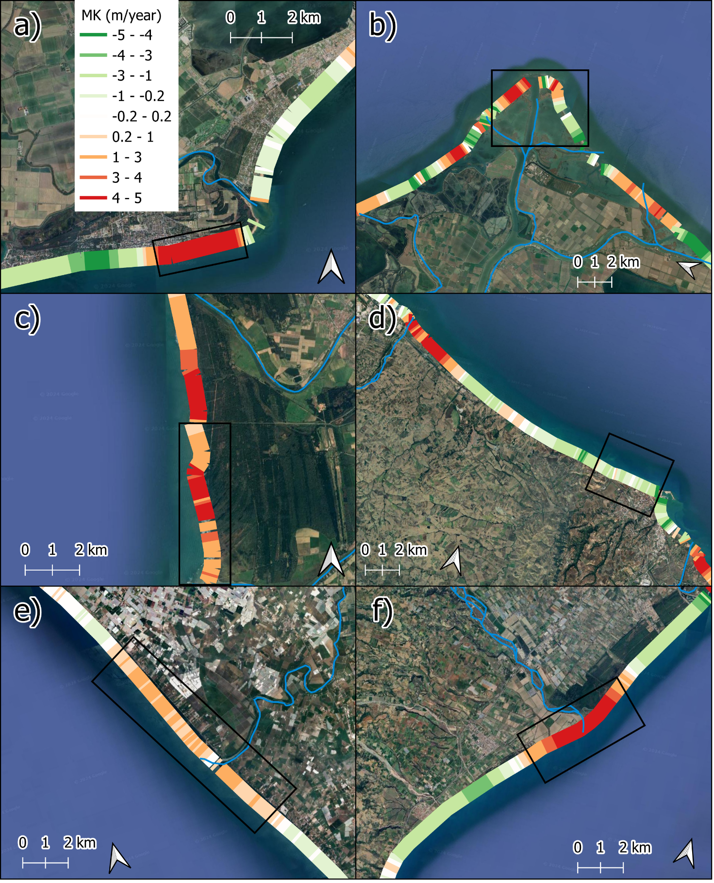
Figure 5 Focus on specific areas from northern to southern Italy: a) Tagliamento River, B) Po River; c) Arno River d) Northern Termoli; e) Sele River; f) Sinni River. The black rectagles indicate the transects analyzed in Figure 6

Figure 6 illustrates the temporal trends of a group of transects selected for each area represented in Figure 5 (transects marked by black rectangles). The figure highlights the high temporal resolution of the data available for a detailed analysis of trend variations, including those influenced by infrastructure works, watershed modifications, and climatic changes. The analysis reveals the distinct trends characterizing the areas, as well as the periods of higher or lower spatial variability. For instance, in the case of the Sinni River, the period between 1995 and 2005 exhibits lower variability (with a narrower confidence interval) compared to the preceding and succeeding periods. Similarly, in the Po River area, variability significantly increases after 2005 compared that of the earlier period. Additionally, for the Arno River and the Northern Termoli area, a notable trend variation is observed around 2010. These insights, when examined in greater detail and on a site-specific basis, provide valuable information about the temporal evolution of the coastline.
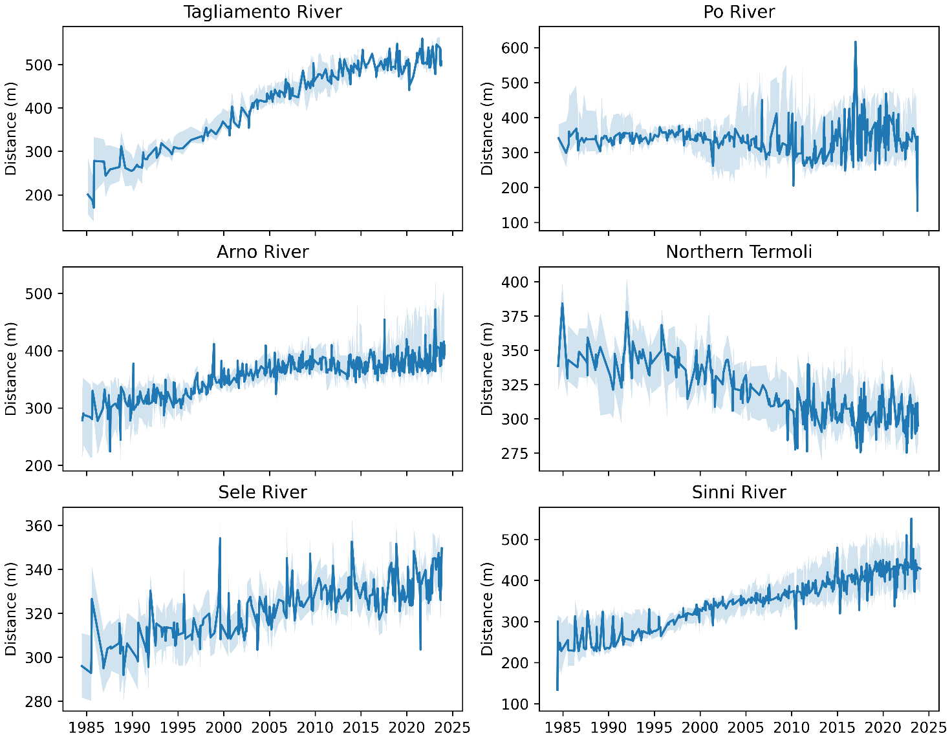
Figure 6 Time series analysis of the transects outlined by the black rectangles in Figure 5: the blue line represents the median value, while the light-blue shaded area indicates the 50% confidence interval.
The Kruskal-Wallis test revealed that 19,574 transects, corresponding to 58% of the total analyzed, show significant seasonal differences in means. Tukey's Honest Significant Difference (HSD) test was then applied to identify specifically which season pairs showed these significant differences. The results of these analyses are presented in Figures 7 and 8.
The analysis clearly shows that the winter season (DJF, December-January-February) exhibits the largest negative differences compared to the other seasons, especially when compared to the summer. This result indicates that winter is generally the period of greatest accretion on Italian beaches, while summer is characterized by more pronounced erosions. However, this general pattern is not uniform all across Italy. Figure 8 highlights significant regional differences. Specifically, the Ligurian region and the Gulf of Taranto show an opposite pattern, where winter is associated with erosive phases, while summer is the period of greatest accretion.
These regional variations suggest that local factors such as coastal configuration, dynamics of marine currents, and prevailing weather conditions play a key role in shaping the seasonal dynamics of beach accretion and erosion. These findings emphasize the importance of considering regionalized approaches in the analysis and management of coastal zones.
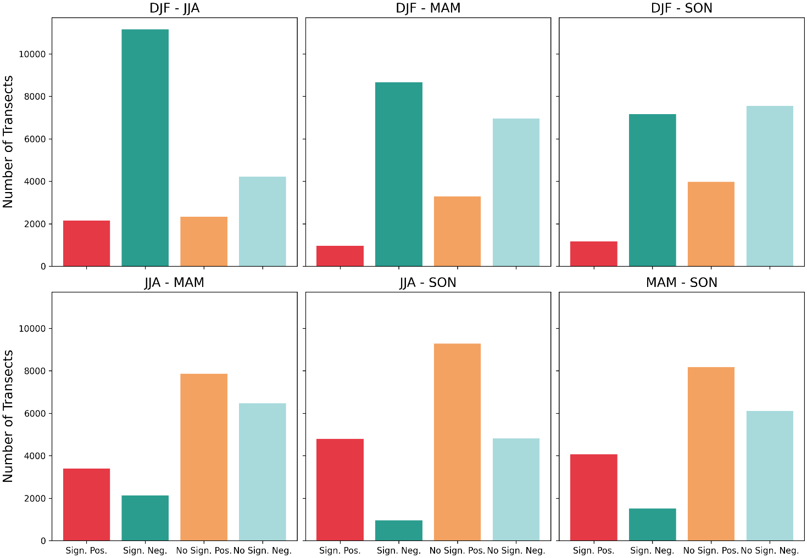
Figure 7 Tukey's Honest Significant Difference test to identify seasonal patterns distinguishing in significant positive (Sign. Pos.) results, significant negative (Sign. Neg.) results, not significant positive ( No Sign. Pos.) results and not significant negative (No Sign. Neg.) results. The comparison is for the seasons December-January-February (DJF); March-April-May (MAM); June-July-August (JJA); September-October-November (SON).
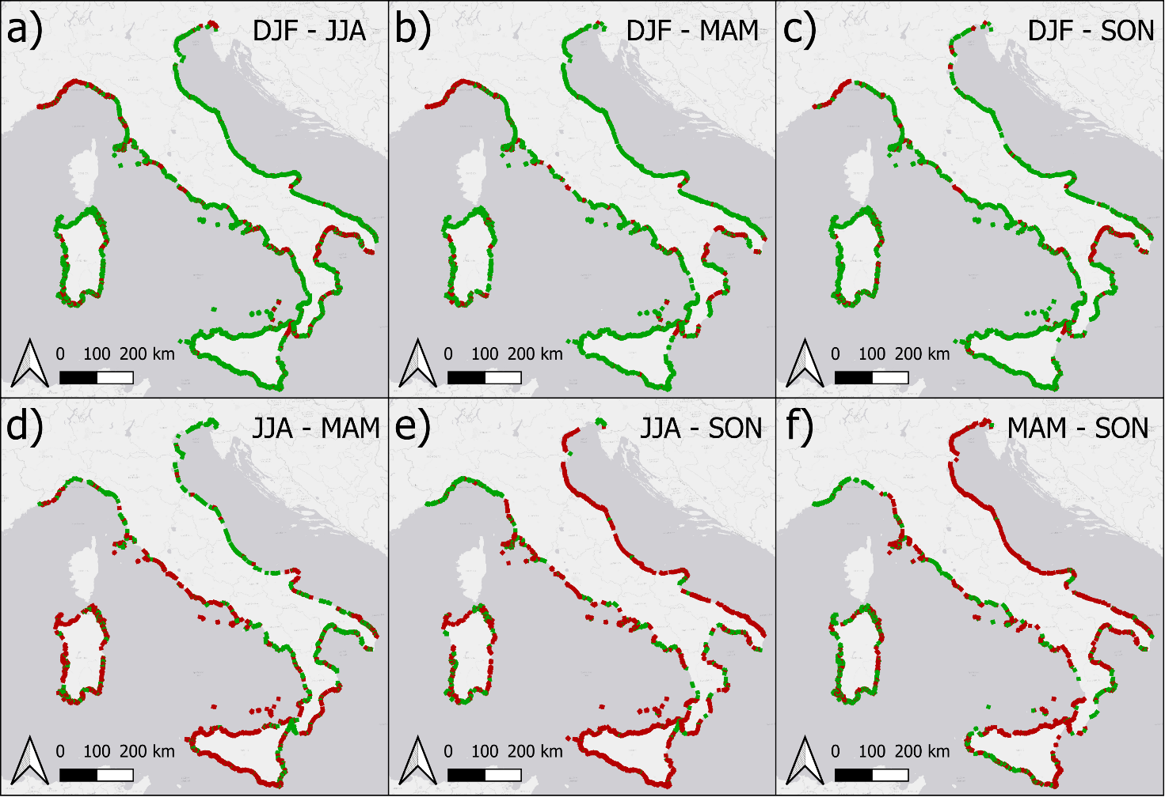
Figure 8 Red transects indicate significant positive results, and green transects indicate significant negative results of Tukey's Honest Significant Difference test. The comparison is for the seasons December-January-February (DJF); March-April-May (MAM); June-July-August (JJA); September-October-November (SON).

River Delta Focus
In this paragraph, we focus on the beaches situated near the watercourse deltas. An approximate 35% of the beaches about 10 km from all the watercourses are affected by erosion and, if we exclude the transects near coastal defences, this percentage rises to about 45% (Figure 9a). With the exception of the small watercourses, focusing on the larger rivers, the percentage increases to about 67%. These results suggest that the primary evolutionary pattern for two out of three major Italian rivers is erosion (Figure 9a).
More than 25% of watercourses are affected by erosion on either hydrographic side, increasing to about 33% in the rivers and large rivers (Figure 9b). The percentage of watercourses characterised by a mixed pattern of the two hydrographic sides is about 32% (Figure 9c); therefore, around 43% of all watercourses have both hydrographic sides in advancement. However, approximately 40% of the large rivers exhibit a mixed pattern (Figure 9c). When combined with the 33% of the large rivers affected by erosion (Figure 9b), it becomes evident that about 73% of the large rivers experience erosion on at least one hydrographic side. This scenario is even worse if we focus on the areas with no coastal defences. In this case, more than 75% of watercourses are characterized by a mixed pattern. Excluding the areas with coastal defences, every large river is affected by erosion (20% always; 80% mixed) and only 5% of the rivers present an accretion pattern on both hydrographic sides.
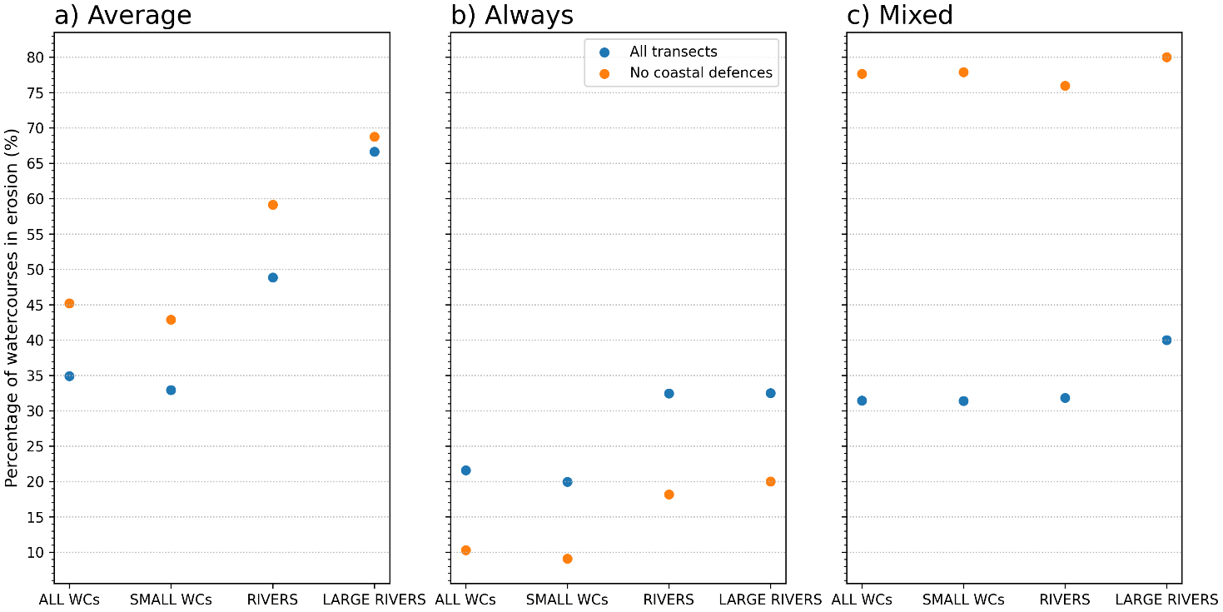
Figure 9 Percentage of the watercourse (WC) deltas affected by erosion, distinguishing between small watercourses (SMALL WCs), rivers, and large rivers (longer than 100 km): a) main pattern between right and left hydrographic sides; b) right and left hydrographic sides in erosion; c) right or left hydrographic side in erosion. The blue points indicate the analysis conducted on all transects; the orange points indicate the analysis of the transects more than 500 m far from coastal defences.
Geographically, we can identify some important patterns in the spatial distribution of the erosion/advancement trend for the rivers (Figure 10). Figure 10 shows the trends for the deltaic region of all rivers (Figure 10a,b) and only large rivers (Figure 10c,d). Moreover, the figure shows trend analysis of the transects considering all transects (Figure 10a,c) and the transects not near coastal defences (Figure 10b,d). The north Adriatic Sea is characterized by several rivers displaying advancement trends (Figure 10a). If we exclude the transects affected by the influence of coastal defences (Figure 10b), several rivers are excluded from this analysis owing to the absence of human activities. Therefore, a strong influence of human strategies and activities can limit the erosion trends and, consequently, change the patterns of this area. Another important area is southern Italy, where we found a general erosion pattern. In particular, the rivers and large rivers of Basilicata are all affected by erosion. Even in the region of Calabria the main pattern is that of the loss of beach areas.
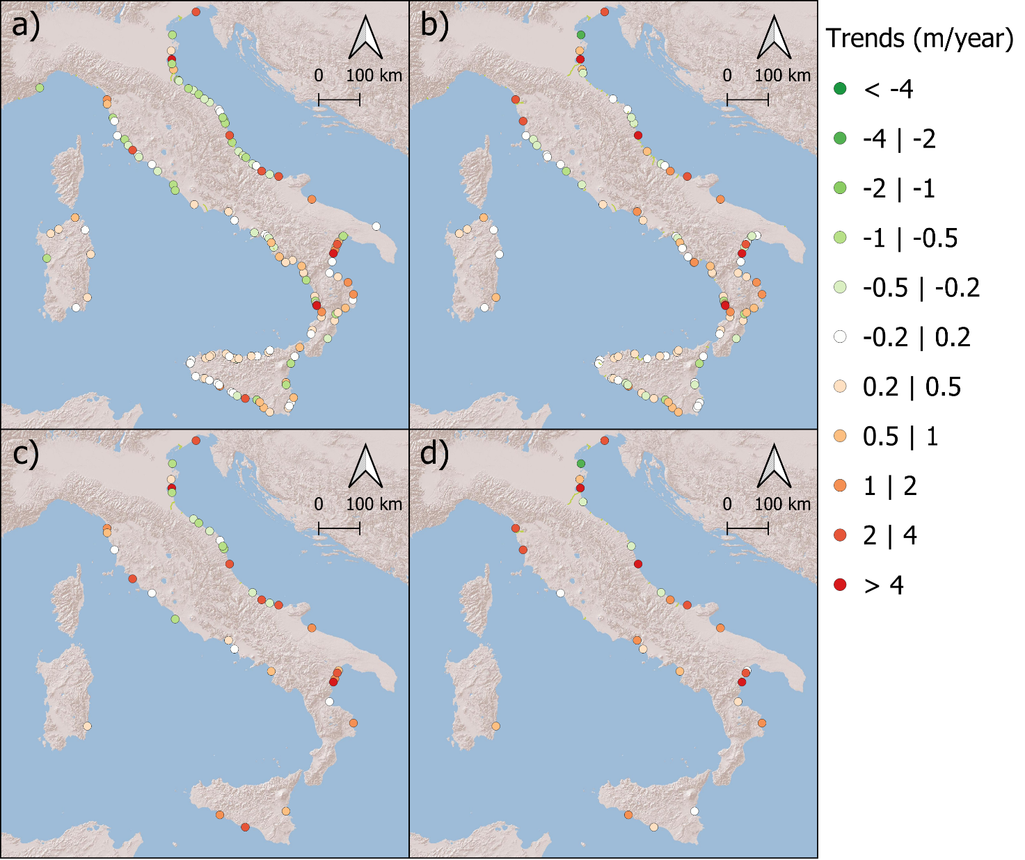
Figure 10 Geographic map of the erosion/advancement trends for the rivers (a,b) and large rivers (c,d), analysing the areas with all transects (a,c) and transects at a distance higher than 500 m from coastal defences (b, d).

Discussion
The Italian coast is characterized by great variability with several zones affected by a loss of area (also with trends higher than 5 m/year) and other zones characterized by accretion. However, our results indicate that in the areas close to the rivers and large rivers the main pattern is that of beach erosion. The coastal area between the Magra River and Leghorn is affected by an alternation of progradation and erosion in relation to the harbours and the river mouths (Anfuso et al., 2011; Pratellesi et al., 2018). The Serchio and Arno river deltas in the Ligurian Sea are affected by erosion with a trend of about 2-3 m/year over the last 40 years, in agreement with previous studies based on the use of cartographies (Besset et al., 2017, 2019; Bini et al., 2008, 2021). In this respect, Bini et al. (2021) demonstrated the important role of the coastal defences of the river mouths in terms of sediment dispersal along the coast, with the consequent production of erosion phenomena in some areas.
The Ombrone River delta is affected by a great erosion trend with peaks of erosion of also 5-6 m/year, in agreement with previous works (Besset et al., 2017, 2019; Cipriani et al., 2013). The authors highlight that the main cause of coastal erosion in the Maremma Regional Park is a combination of natural and anthropogenic factors. In particular, the reduced supply of river sediments resulting from the construction of dams and other hydraulic works along rivers is one of the main causes of erosion (Frangipane & Paris, 1994; Rinaldi, 2003).
This work studies the erosion patterns of several river deltas also in the Adriatic Sea. For example, the 25 km coastal area around the city of Termoli, in the proximity of the Trigno and Biferno rivers, is affected by an erosion of about 2.7-2.9 m/year, with an increase in the period 1992-2004 until reaching trends of about 3.5-4.0 m/year (Rosskopf et al., 2018). In this area we found an erosion of about 4 m/year, in perfect agreement with the results obtained in previous work.
In Basilicata, the Sinni River delta is affected by great erosion with values also higher than 10 m/year, in agreement with previous works (Aiello et al., 2013).
The coastal area near the Simeto River, the main river of Sicily, is affected by erosion with values of about 3 m/year in the period 1972-2022 (Laksono et al., 2022), in agreement with the trend identified in this work. For this area, our work agrees with a previous work, which identified a progradation of the southern area of the Catania harbour, with values of about 5 m/year (Laksono et al., 2022).
The Alghero Bay in Sardinia is characterized by great variability with a transition from progradation zones (3 m/year) to erosion zones (1.2 m/year), in complete agreement with the bibliography of Manca et al., (2013), where the same pattern (with peaks of progradation of about 3 m/year and peaks of erosion of about 1.2 m/year) is demonstrated.
In the past century the Mediterranean has been marked by a drastic reduction in rainfall and river flows, linked to global warming trends (Bertola et al., 2019; Blöschl et al., 2019, 2020; Deitch et al., 2017; Hall et al., 2014). This trend is also evident in Italian rivers, where there is a strong correlation between rainfall and flow rates. Owing to a general decrease in precipitation frequency, river flows have diminished (Luppichini et al., 2024; Zanchettin et al., 2008). The reduction of Mediterranean precipitations is attributed to increased atmospheric and sea temperatures, which shift the cyclonic areas of the North Atlantic and Mediterranean seas (Börgel et al., 2020), leading to the formation of high-pressure systems at the studied latitudes and consequently of reduced flow rates and sediment transport (Billi & Fazzini, 2017). The strong correlations identified between precipitation and flow time series with the North Atlantic Oscillation Index confirm the influence of North Atlantic atmospheric patterns on the climatology of the study area (Brandimarte et al., 2011; Ferrari et al., 2013; Luppichini et al., 2021, 2022; Vergni & Chiaudani, 2015). In this climatic context, Italian rivers have undergone geomorphological changes (Billi & Rinaldi, 1997; Dufour et al., 2015; Rinaldi, 2003; Rinaldi et al., 2015; Surian et al., 2009; Surian & Rinaldi, 2004) and modifications in the river deltas (Besset et al., 2017, 2019) since the early 1900s. This phenomenon is primarily attributed to intensified human activities, in particular between 1950 and 1990, a period of peak industrial activity in several Italian plains (Felice et al., 2013). The interplay between climatic and anthropogenic factors has led to the scenario highlighted in this study, where nearly all the Italian rivers are affected by coastal erosion.

Conclusions
This work has provided a comprehensive analysis of coastal erosion in Italy through several key contributions:
- It has established a nationally homogeneous database, meticulously extracted using the same methodology for the entire area;
- It has conducted trend analyses to identify the areas at major risk of coastal erosion;
- A seasonality in coastal dynamics was identified, with winter being accretionary and summer erosive, except for some areas such as Liguria and the Gulf of Taranto.
- Particular attention has been placed on the beaches in the proximity of river courses, which have revealed high levels of vulnerability;
- Our findings indicate that approximately two-thirds of the 40 major rivers in Italy are currently experiencing coastal erosion. Over 75% of these rivers have a hydrographic side affected by coastal erosion, a value that reaches 100% if we exclude the areas with coastal defences.
The aim of this work is to highlight that coastal erosion characterizes the entire Italian territory. The climatic trend of recent centuries as well as human activities have influenced river deltas, leading to the conditions we are currently experiencing. This study shows that river deltas are a climate change "hotspot," in other words, they are areas in which the effects of global warming are particularly visible. On account of this heightened exposure, river deltas are particularly vulnerable to future climate variations.

Funding
This research was funded by the CUP F54J16000020001 project “Autorità di Bacino Distrettuale dell’Appennino Settentrionale - Misure di prevenzione tese a supportare ed ottimizzare la pianificazione di gestione, la programmazione e realizzazione degli interventi di cui al PGRA” (Leader M. Bini).

Data availability
The data are published in the Mendeley Data Repository: Luppichini, Marco (2024), “40-year Shoreline Evolution in Italy: Critical Challenges in River Delta Regions”, Mendeley Data, V1, doi: 10.17632/fscfbtpg7h.1

References
Aiello, A., Canora, F., Pasquariello, G., & Spilotro, G. (2013). Shoreline variations and coastal dynamics: A space–time data analysis of the Jonian littoral, Italy. Estuarine, Coastal and Shelf Science, 129, 124–135. https://doi.org/https://doi.org/10.1016/j.ecss.2013.06.012
Alberico, I., Amato, V., Aucelli, P., Paola, G., Pappone, G., & Rosskopf, C. (2012). Historical and recent changes of the Sele River coastal plain (Southern Italy): natural variations and human pressures. Rendiconti Lincei, 23, 3–12. https://doi.org/10.1007/s12210-011-0156-y
An, W., Xu, C., Marković, S. B., Sun, S., Sun, Y., Gavrilov, M. B., Govedar, Z., Hao, Q., & Guo, Z. (2023). Anthropogenic warming has exacerbated droughts in southern Europe since the 1850s. Communications Earth & Environment, 4(1). https://doi.org/10.1038/s43247-023-00907-1
Anfuso, G., Pranzini, E., & Vitale, G. (2011). An integrated approach to coastal erosion problems in northern Tuscany (Italy): Littoral morphological evolution and cell distribution. Geomorphology, 129(3), 204–214. https://doi.org/https://doi.org/10.1016/j.geomorph.2011.01.023
Anthony, E. J. (2018). Sand and gravel supply from rivers to coasts: A review from a Mediterranean perspective. Atti Della Societa Toscana Di Scienze Naturali, Memorie Serie A, 125, 13–33.
Anthony, E. J., Marriner, N., & Morhange, C. (2014). Human influence and the changing geomorphology of Mediterranean deltas and coasts over the last 6000years: From progradation to destruction phase? Earth-Science Reviews, 139, 336–361. https://doi.org/https://doi.org/10.1016/j.earscirev.2014.10.003
Baronetti, A., Dubreuil, V., Provenzale, A., & Fratianni, S. (2022). Future droughts in northern Italy: high-resolution projections using EURO-CORDEX and MED-CORDEX ensembles. Climatic Change, 172(3), 22. https://doi.org/10.1007/s10584-022-03370-7
Bertola, M., Viglione, A., Hall, J., & Blöschl, G. (2019). Flood trends in Europe: are changes in small and big floods different? Hydrology and Earth System Sciences Discussions, 1–23. https://doi.org/10.5194/hess-2019-523
Besset, M., Anthony, E. J., & Bouchette, F. (2019). Multi-decadal variations in delta shorelines and their relationship to river sediment supply: An assessment and review. Earth-Science Reviews, 193(November 2018), 199–219. https://doi.org/10.1016/j.earscirev.2019.04.018
Besset, M., Anthony, E. J., & Sabatier, F. (2017). River delta shoreline reworking and erosion in the Mediterranean and Black Seas: The potential roles of fluvial sediment starvation and other factors. Elementa Science of the Anthropocene, 5. https://doi.org/10.1525/elementa.139
Billi, P., & Fazzini, M. (2017). Global change and river flow in Italy. Global and Planetary Change, 155(July), 234–246. https://doi.org/https://doi.org/10.1016/j.gloplacha.2017.07.008
Billi, P., & Rinaldi, M. (1997). Human impact on sediment yield and channel dynamics in the Arno River (central Italy). IAHS-AISH Publication, 245.
Bini, M., Casarosa, N., & Luppichini, M. (2021). Exploring the relationship between river discharge and coastal erosion: An integrated approach applied to the pisa coastal plain (italy). Remote Sensing, 13(2). https://doi.org/10.3390/rs13020226
Bini, M., Casarosa, N., & Ribolini, A. (2008). L’evoluzione diacronica della linea di riva del litorale Pisano (1938-2004) sulla base del confront di immagini aeree georeferenziate. Atti Della Societa Toscana Di Scienze Naturali, Memorie Serie A, 113(January 2008), 1–12.
Blöschl, G., Hall, J., Viglione, A., Perdigão, R. A. P., Parajka, J., Merz, B., Lun, D., Arheimer, B., Aronica, G. T., Bilibashi, A., Boháč, M., Bonacci, O., Borga, M., Čanjevac, I., Castellarin, A., Chirico, G. B., Claps, P., Frolova, N., Ganora, D., … Živković, N. (2019). Changing climate both increases and decreases European river floods. Nature, 573(7772), 108–111. https://doi.org/10.1038/s41586-019-1495-6
Blöschl, G., Kiss, A., Viglione, A., Barriendos, M., Böhm, O., Brázdil, R., Coeur, D., Demarée, G., Llasat, M. C., Macdonald, N., Retsö, D., Roald, L., Schmocker-Fackel, P., Amorim, I., Bělínová, M., Benito, G., Bertolin, C., Camuffo, D., Cornel, D., … Wetter, O. (2020). Current European flood-rich period exceptional compared with past 500 years. Nature, 583(7817), 560–566. https://doi.org/10.1038/s41586-020-2478-3
Börgel, F., Frauen, C., Neumann, T., & Meier, H. E. M. (2020). The Atlantic Multidecadal Oscillation controls the impact of the North Atlantic Oscillation on North European climate. Environmental Research Letters, 15(10).
Brandimarte, L., Di Baldassarre, G., Bruni, G., D’Odorico, P., Montanari, A., D’Odorico, P., & Montanari, A. (2011). Relation Between the North-Atlantic Oscillation and Hydroclimatic Conditions in Mediterranean Areas. Water Resources Management, 25(5), 1269–1279. https://doi.org/10.1007/s11269-010-9742-5
Brogli, R., Sørland, S. L., Kröner, N., & Schär, C. (2019). Causes of future Mediterranean precipitation decline depend on the season. Environmental Research Letters, 14(11), 114017. https://doi.org/10.1088/1748-9326/ab4438
Cancelliere, A., & Rossi, G. (2003). Droughts in Sicily and Comparison of Identified Droughts in Mediterranean Regions (pp. 103–122). https://doi.org/10.1007/978-94-010-0129-8_7
Cappucci, S., Bertoni, D., Cipriani, L. E., Boninsegni, G., & Sarti, G. (2020). Assessment of the Anthropogenic Sediment Budget of a Littoral Cell System (Northern Tuscany, Italy). Water, 12(11), 3240. https://doi.org/10.3390/w12113240
Celata, F., & Gioia, E. (2024). Resist or retreat? Beach erosion and the climate crisis in Italy: Scenarios, impacts and challenges. Applied Geography, 169, 103335. https://doi.org/https://doi.org/10.1016/j.apgeog.2024.103335
Church, J. A., Clark, P. U., Cazenave, A., Gregory, J. M., Jevrejeva, S., Levermann, A., Merrifield, M. A., Milne, G. A., Nerem, R. S., Nunn, P. D., Payne, A. J., Pfeffer, W. T., Stammer, D., & Unnikrishnan, A. S. (2013). Sea Level Change.
Cipriani, L. E., Pranzini, E., Vitale, G., & Wetzel, L. (2013). Adaptation to beach erosion at Maremma regional park (Tuscany, Italy). Geo-Eco-Marina, 19, 65–76.
Deitch, M. J., Sapundjieff, M. J., & Feirer, S. T. (2017). Characterizing Precipitation Variability and Trends in the World’s Mediterranean-Climate Areas. Water, 9(4). https://doi.org/10.3390/w9040259
Dufour, S., Rinaldi, M., Piégay, H., & Michalon, A. (2015). How do river dynamics and human influences affect the landscape pattern of fluvial corridors? Lessons from the Magra River, Central-Northern Italy. Landscape and Urban Planning, 134, 107–118. https://doi.org/10.1016/j.landurbplan.2014.10.007
Felice, E., Vecchi, G., Vecchi Università di Roma, G., & Vergata, T. (2013). Italy’s Growth and Decline, 1861-2011 Italy’s Growth and Decline (Vol. 11, Issue 293).
Ferrari, E., Caloiero, T., & Coscarelli, R. (2013). Influence of the North Atlantic Oscillation on winter rainfall in Calabria (southern Italy). Theoretical and Applied Climatology, 114(3), 479–494. https://doi.org/10.1007/s00704-013-0856-6
Foti, G., Barbaro, G., Barillà, G. C., Mancuso, P., & Puntorieri, P. (2022). Shoreline Evolutionary Trends Along Calabrian Coasts: Causes and Classification. Frontiers in Marine Science, 9. https://doi.org/10.3389/fmars.2022.846914
Frangipane, A., & Paris, E. (1994). Long-term variability of sediment transport in the Ombrone River basin (Italy) (Issue 224). IAHS Publ. https://www.researchgate.net/publication/252793594
Fratianni, S., & Acquaotta, F. (2017). The Climate of Italy. In M. Soldati & M. Marchetti (Eds.), Landscapes and Landforms of Italy (pp. 29–38). Springer International Publishing. https://doi.org/10.1007/978-3-319-26194-2_4
Giannakopoulos, C., Le Sager, P., Bindi, M., Moriondo, M., Kostopoulou, E., & Goodess, C. M. (2009). Climatic changes and associated impacts in the Mediterranean resulting from a 2 °C global warming. Global and Planetary Change, 68(3), 209–224. https://doi.org/https://doi.org/10.1016/j.gloplacha.2009.06.001
Gonçalves, J. A., & Henriques, R. (2015). UAV photogrammetry for topographic monitoring of coastal areas. ISPRS Journal of Photogrammetry and Remote Sensing, 104, 101–111. https://doi.org/https://doi.org/10.1016/j.isprsjprs.2015.02.009
Guariglia, A., Buonamassa, A., Losurdo, A., Saladino, R., Trivigno, M., Zaccagnino, A., & Colangelo, A. (2006). A multisource approach for coastline mapping and identification of shoreline changes. Annals of Geophysics, 49. https://doi.org/10.4401/AG-3155
Hall, J., Arheimer, B., Borga, M., Brázdil, R., Claps, P., Kiss, A., Kjeldsen, T. R., Kriaučiūnienė, J., Kundzewicz, Z. W., Lang, M., Llasat, M. C., Macdonald, N., McIntyre, N., Mediero, L., Merz, B., Merz, R., Molnar, P., Montanari, A., Neuhold, C., … Blöschl, G. (2014). Understanding flood regime changes in Europe: A state-of-the-art assessment. Hydrology and Earth System Sciences, 18(7), 2735–2772. https://doi.org/10.5194/hess-18-2735-2014
IPCC. (2023). IPCC, 2023: Climate Change 2023: Synthesis Report. Contribution of Working Groups I, II and III to the Sixth Assessment Report of the Intergovernmental Panel on Climate Change [Core Writing Team, H. Lee and J. Romero (eds.)]. IPCC, Geneva, Switzerland. (P. Arias, M. Bustamante, I. Elgizouli, G. Flato, M. Howden, C. Méndez-Vallejo, J. J. Pereira, R. Pichs-Madruga, S. K. Rose, Y. Saheb, R. Sánchez Rodríguez, D. Ürge-Vorsatz, C. Xiao, N. Yassaa, J. Romero, J. Kim, E. F. Haites, Y. Jung, R. Stavins, … C. Péan, Eds.). https://doi.org/10.59327/IPCC/AR6-9789291691647
Jang, W., Park, H., Seo, K., & Kim, Y. (2016). Analysis of Positioning Accuracy Using Multi Differential GNSS in Coast and Port Area of South Korea. Journal of Coastal Research, 75(sp1), 1337–1341. https://doi.org/10.2112/SI75-268.1
Knutson, T. R., McBride, J. L., Chan, J., Emanuel, K., Holland, G., Landsea, C., Held, I., Kossin, J. P., Srivastava, A. K., & Sugi, M. (2010). Tropical cyclones and climate change. Nature Geoscience, 3(3), 157–163. https://doi.org/10.1038/ngeo779
Laksono, F. A. T., Borzì, L., Distefano, S., Di Stefano, A., & Kovács, J. (2022). Shoreline Prediction Modelling as a Base Tool for Coastal Management: The Catania Plain Case Study (Italy). Journal of Marine Science and Engineering, 10(12). https://doi.org/10.3390/jmse10121988
Luppichini, M., Barsanti, M., Giannecchini, R., & Bini, M. (2021). Statistical relationships between large-scale circulation patterns and local-scale effects: NAO and rainfall regime in a key area of the Mediterranean basin. Atmospheric Research, 248, 105270. http://www.sciencedirect.com/science/article/pii/S0169809520312072
Luppichini, M., Bini, M., Barsanti, M., Giannecchini, R., & Zanchetta, G. (2022). Seasonal rainfall trends of a key Mediterranean area in relation to large-scale atmospheric circulation: How does current global change affect the rainfall regime? Journal of Hydrology, 612, 128233. https://doi.org/https://doi.org/10.1016/j.jhydrol.2022.128233
Luppichini, M., Bini, M., Giannecchini, R., & Zanchetta, G. (2023). High-resolution spatial analysis of temperature influence on the rainfall regime and extreme precipitation events in north-central Italy. Science of The Total Environment, 880, 163368. https://doi.org/https://doi.org/10.1016/j.scitotenv.2023.163368
Luppichini, M., Bini, M., Paterni, M., Berton, A., & Merlino, S. (2020). A new beach topography-based method for shoreline identification. Water (Switzerland), 12(11), 1–11. https://doi.org/10.3390/w12113110
Luppichini, M., Lazzarotti, M., & Bini, M. (2024). Climate change as main driver of centennial decline in river sediment transport across the Mediterranean region. Journal of Hydrology, 636, 131266. https://doi.org/https://doi.org/10.1016/j.jhydrol.2024.131266
Manca, E., Pascucci, V., Deluca, M., Cossu, A., & Andreucci, S. (2013). Shoreline evolution related to coastal development of a managed beach in Alghero, Sardinia, Italy. Ocean & Coastal Management, 85, 65–76. https://doi.org/https://doi.org/10.1016/j.ocecoaman.2013.09.008
Mantas, V. M., Pereira, A. J. S. C., Neto, J., Patrício, J., & Marques, J. C. (2013). Monitoring estuarine water quality using satellite imagery. The Mondego river estuary (Portugal) as a case study. Ocean & Coastal Management, 72, 13–21. https://doi.org/https://doi.org/10.1016/j.ocecoaman.2011.06.013
Pastor, F., Valiente, J. A., & Khodayar, S. (2020). A warming Mediterranean: 38 years of increasing sea surface temperature. Remote Sensing, 12(17). https://doi.org/10.3390/RS12172687
Polemio, M., & Casarano, D. (2004). Rainfall and drought in southern Italy (1821-2001). In IAHS-AISH Publication (pp. 217–227).
Pratellesi, M., Ciavola, P., Ivaldi, Roberta., Anthony, E. J., & Armaroli, C. (2018). River-mouth geomorphological changes over 130 years (1882–2014) in a small Mediterranean delta: Is the Magra delta reverting to an estuary? Marine Geology, 403, 215–224. https://doi.org/https://doi.org/10.1016/j.margeo.2018.06.003
Rinaldi, M. (2003). Recent channel adjustments in alluvial rivers of Tuscany, Central Italy. Earth Surface Processes and Landforms, 28(6), 587–608. https://doi.org/10.1002/esp.464
Rinaldi, M., Teruggi, L. B., Colombo, F., & Groppelli, B. (2015). Trajectories of channel adjustments of the toce river (Northern italy). In Engineering Geology for Society and Territory - Volume 3: River Basins, Reservoir Sedimentation and Water Resources (pp. 309–311). https://doi.org/10.1007/978-3-319-09054-2_64
Rosskopf, C. M., Di Paola, G., Atkinson, D. E., Rodríguez, G., & Walker, I. J. (2018). Recent shoreline evolution and beach erosion along the central Adriatic coast of Italy: the case of Molise region. Journal of Coastal Conservation, 22(5), 879–895. https://doi.org/10.1007/s11852-017-0550-4
Sousa, P. M., Trigo, R. M., Aizpurua, P., Nieto, R., Gimeno, L., & Garcia-Herrera, R. (2011). Trends and extremes of drought indices throughout the 20th century in the Mediterranean. Natural Hazards and Earth System Sciences, 11(1), 33–51. https://doi.org/10.5194/nhess-11-33-2011
Surian, N., & Rinaldi, M. (2004). Channel adjustments in response to human alteration of sediment fluxes: examples from Italian rivers. IAHS Publication, 288, 276–282.
Surian, N., Rinaldi, M., Pellegrini, L., Audisio, C., Maraga, F., Teruggi, L., Turitto, O., & Ziliani, L. (2009). Channel adjustments in northern and central Italy over the last 200 years. Special Paper of the Geological Society of America, 451, 83–95. https://doi.org/10.1130/2009.2451(05)
Tramblay, Y., & Somot, S. (2018). Future evolution of extreme precipitation in the Mediterranean. Climatic Change, 151(2), 289–302. https://doi.org/10.1007/s10584-018-2300-5
Trenberth, K. E. (2011). Changes in precipitation with climate change. Climate Research, 47(1–2), 123–138. https://www.int-res.com/abstracts/cr/v47/n1-2/p123-138/
Turner, I. L., Harley, M. D., & Drummond, C. D. (2016). UAVs for coastal surveying. Coastal Engineering, 114, 19–24. https://doi.org/https://doi.org/10.1016/j.coastaleng.2016.03.011
Vergni, L., & Chiaudani, A. (2015). Relationship between the NAO index and some indices of extreme precipitation in the Abruzzo Region. http://climatedataguide.ucar.edu/guidance/hurrell-north-
Virtanen, P., Gommers, R., Oliphant, T. E., Haberland, M., Reddy, T., Cournapeau, D., Burovski, E., Peterson, P., Weckesser, W., Bright, J., van der Walt, S. J., Brett, M., Wilson, J., Millman, K. J., Mayorov, N., Nelson, A. R. J., Jones, E., Kern, R., Larson, E., … Contributors, S. 1. 0. (2020). SciPy 1.0: Fundamental Algorithms for Scientific Computing in Python. Nature Methods, 17, 261–272. https://doi.org/10.1038/s41592-019-0686-2
Vos, K., Harley, M. D., Splinter, K. D., Simmons, J. A., & Turner, I. L. (2019). Sub-annual to multi-decadal shoreline variability from publicly available satellite imagery. Coastal Engineering, 150(April), 160–174. https://doi.org/10.1016/j.coastaleng.2019.04.004
Vos, K., Splinter, K. D., Harley, M. D., Simmons, J. A., & Turner, I. L. (2019). CoastSat: A Google Earth Engine-enabled Python toolkit to extract shorelines from publicly available satellite imagery. Environmental Modelling and Software, 122, 104528. https://doi.org/10.1016/j.envsoft.2019.104528
Woodruff, J. D., Irish, J. L., & Camargo, S. J. (2013). Coastal flooding by tropical cyclones and sea-level rise. Nature, 504(7478), 44–52. https://doi.org/10.1038/nature12855
Zanchettin, D., Traverso, P., & Tomasino, M. (2008). Po River discharges: a preliminary analysis of a 200-year time series. Climatic Change, 89(3), 411–433. https://doi.org/10.1007/s10584-008-9395-z
Zittis, G., Bruggeman, A., & Lelieveld, J. (2021). Revisiting future extreme precipitation trends in the Mediterranean. Weather and Climate Extremes, 34, 100380. https://doi.org/https://doi.org/10.1016/j.wace.2021.100380

