Inorganic Chemistry

Stoichiometry Controlled Assembly of Lanthanide Molecular Complexes of the heteroditopic divergent ligand 4’-(4-pyridil)-2,2’:6’,2”-terpyridine N-oxide in hypodentate or bridging coordination modes. Structural, Magnetic and Photoluminescence studies.

Lorenzo Fioravanti,‡ Luca Bellucci,§† Lidia Armelao,§†¡ Gregorio Bottaro,† Fabio Marchetti,‡ Francesco Pineider‡, Giordano Poneti, # Simona Samaritani,‡ Luca Labella,‡ †*
‡Dipartimento di Chimica e Chimica Industriale and CIRCC, Università di Pisa, via Giuseppe Moruzzi 13, I-56124
§Dipartimento di Scienze Chimiche, Università di Padova, via Marzolo 1,I-35131
†CNR ICMATE and INSTM, Dipartimento di Scienze Chimiche, Università di Padova, via Marzolo 1,I-35131
¡Dipartimento di Scienze Chimiche e Tecnologie dei Materiali (DSCTM), Consiglio Nazionale delle Ricerche, Piazzale A. Moro 7, 00185 Roma, Italy
#Instituto de Química, Universidade Federal do Rio de Janeiro, Avenida Athos da Silveira Ramos, 149, Centro de Tecnologia – Cidade Universitária, 21941-909, Rio de Janeiro, Brazil

Abstract

Mononuclear rare-earth tris β-diketonato complexes RE(tta)₃dme (RE = Y, 1; La, 2; Dy, 3; Eu, 4; Htta = 2-thenoylacetone; dme = 1,2-dimethoxyethane) react cleanly at room temperature in a 1 to 1 molar ratio with the heteroditopic divergent ligand 4’-(4-pyridil)-2,2’:6’,2”-terpyridine N-oxide (pyterpyNO) to yield RE₂(tta)₆(pyterpyNO)_{n} where n = 2 for RE= Y, 5; Dy, 6; Eu, 7, and n=3 for RE=La 8. The crystal structure of 5 revealed a dinuclear compound with two pyterpyNO bridging through the oxygen atom in a hypodentate mode leaving uncoordinated the terpyridine moieties. Using a metal:pyterpyNO molar ratio of 2 for RE= Y, 9; Dy, 10; Eu, 11 it was possible to isolate the molecular complexes RE₄(tta)₁₂(pyterpyNO)₂ whilst using a molar ratio of 2.5 the product La₅(tta)₁₂(pyterpyNO)₃ 12 can be obtained. ⁸⁹Y-NMR spectroscopy revealed two different yttrium centers at room temperature for 9. An X-ray diffraction study of 10 showed a symmetrical tetranuclear structure resulting from the coordination of two Dy(tta)₃ fragments to the two hypodentate terpyridines of the dinuclear unit and presenting two different coordination sites for metals with coordination numbers 8 and 9. Magnetic studies on 6 and 10 revealed the presence of an antiferromagnetic interaction between the two Dy(III) bound by the NO bridges. These compounds displayed a slow relaxing magnetization through Orbach (6) and Raman (10) processes in the absence of an applied magnetic field, whose rate increased upon application of a 1 kOe field. 7 and 11 showed a bright red emission typical of Eu³⁺. The two complexes have similar emission properties mainly determined by the employed β-diketonato ligands.

Introduction
The rational design and synthesis of heterometallic molecular or extended structure compounds relies on suitable connectors showing functional units with different affinity for different metal centres. Several heterometallic d-f coordination polymers (CPs) have been prepared by self-assembling reactions between a mixture of metal ions (usually oxides or nitrates) and organic ligands containing different donor atoms (mostly N O donors) able of a selective binding to different metal ions. A minor change in the organic linker can induce a structural variation of the final coordination structure, of the architecture of new coordination polymers (CPs) and a fine control of their properties such as gas storage and separation,^{1,2} luminescence,^{3–5} catalysis,^{6,7} and magnetism.^{8,9} Particularly, organic linkers can efficiently control the spatial organization and the metal to metal distance, a relevant issue in the study of the luminescence or magnetic properties of lanthanide compounds. Attention to multifunctional organic ligands is continuously growing in the literature and the full understanding of their coordination chemistry can afford low nuclearity molecular complexes carrying hypodentate ligands, potentially utilizable as building blocks able to guarantee a better control of the synthesis.^{10–15}
Indeed, chemically induced coupling of different molecular units has been shown to be a very powerful tool for the modulation of the magnetic properties of the final adducts. Single Molecule Magnets (SMMs) are coordination compounds with slow relaxing magnetic moment, arising from a preferential direction of magnetization, with no three-dimensional magnetic order.^{16,17} Lanthanide ions, due to their largely unquenched orbital moment, giving rise to highly anisotropic paramagnetic ground states, have been widely used for the development of SMMs.¹⁸ One of the most relevant contributions that ditopic organic ligands introduced to the field of molecular magnetism is the possibility to prepare the so called Single Chain Magnets (SCM), monodimensional coordination polymers featuring significant intrachain magnetic interaction among anisotropic spin bearers, but negligible interaction among the different chains, able to present opening of magnetic hysteresis loop at cryogenic temperatures.¹⁹ Moreover, the use of divergent organic ligands has been envisaged as promising for the preparation of ordered structures of SMMs with modulable magnetic properties,^{20,21}and heterotopic ligands has been used to couple SMM units in mono-^{22–24} or three-dimensional²⁵coordination polymeric networks. Moving to discrete molecular entities, a coordination chemistry bottom-up approach has been used to induce a weak magnetic bias between different paramagnetic centers in SMMs, slowing down their dynamics²⁶, to prepare polymetallic grids²⁷, to increase the number of addressable states in molecular candidates as qbits²⁸ or in a molecular switch, allowing to move from two to three available states within a single molecular entity.²⁹
Concerning the ligand sensitized emission of Ln³⁺ ions, most of the literature is focused on i) discrete systems based on molecular complexes mainly containing only one lanthanide cation, and ii) extended systems as lanthanide Coordination Polymers (CPs) and lanthanide Metal-Organic Frameworks (LOFs).
To exploit and tune the emission properties of polynuclear compounds, CPs, and LOFs containing two or more lanthanide ions, the control of Ln³⁺ distribution in the different available coordination sites is fundamental. Given the very similar chemistry of the f-block ions, the statistical occupation of the accessible coordination sites is often obtained, thus losing control of the ion-ion interactions as for examples Energy Transfer processes or ion-ion cross relaxations phenomena.^{30,31} These interactions, together with the charge transfer transitions, are often fundamental in determining the emission and functional properties of these compounds and are not trivial to rationalize if the spatial composition (SC)^{32,33,34} is not univocally defined. For these reasons, it is necessary to develop synthetic protocols that allow the fine control of SC. In this framework, we decided to follow a stepwise process by using divergent N-oxides ligand.
In our previous work we showed that heterocyclic N-oxide ligands as pyrazine N-oxide, or 4,4’bipyridine N-oxide (bipyMO) react with neutral lanthanide tris β-diketonato Eu(β-diketonate)₃ fragments stabilizing homodinuclear molecular compounds Eu₂(β-diketonate)₆(N-oxide)_{y} (β-diketonate = thenoyltrifluoroacetonate, dibenzoylmethanate, benzoyltrifluoroacetonate, hexafluoroacetylacetonate; y = 2 or 3).^{35–37.}Heterotopic ligands in these molecular compounds behave as O-donor bridging and hypodentate ligands mantaining an uncoordinated nitrogen donor functionality. Luminescence studies has established the effect of the β-diketonato and N-oxide ligands on the thermometric properties of the obtained compounds, that are determined by the presence of two nonradiative deactivation channels, back energy transfer from Eu³⁺ to the ligand triplet levels and ligand to metal charge transfer (LMCT), the latter being strongly influenced by the N-oxide ligands.
Furthermore, self-assembled heterometallic d-f compounds, [Zn(hfac)₂Eu(hfac)₃(bipyMO)₂]_{n} and [Co(hfac)₂Dy(hfac)₃(bipyMO)₂]_{n,} have been prepared exploiting the divergent heterotopic 4,4’bipyridine N-oxide ligand. Magnetic and luminescence studies have been carried out on the ordered 1D CPs resulting from a large difference of affinity for O or N atoms of lanthanide and 3d metal centers.²³ In this context, it appeared interesting to evaluate how the nature of the rigid heterotopic ligand could influence the identity and the magnetic and luminescence properties of the product of its reaction with neutral lanthanide tris diketonato fragments Ln(β-diketonate)₃.
A terpyridyl unit is often used in the design of new organic linkers for the relatively easy synthesis and functionalization, for the strong bond with d transition metals and for the interesting redox, photoluminescent and magnetic properties.^{38–46} The divergent ligand 4’-(4’’’-pyridyl)-2:2’,6’:2’’-terpyridine (pyterpy) is well known in literature, forming a large number of molecular and extended structure compounds for d metals,^{47–52} but a limited number of examples for lanthanide metals.^{53–55} Furthermore, very little attention has been paid in the literature on the analogue N-oxidated ligand, 4’-(4’’’-pyridyl-N-oxide)-2:2’,6’:2’’-terpyridine (pyterpyNO) Scheme 1, a single paper reports the synthesis of a mononuclear iron(II) complex, [Fe(pyterpyNO)₂](BF₄)₂, where the metal is coordinated only to the terpyridine unit.⁵⁶ Nevertheless, this rigid aromatic ligand with two different binding sites is expected to have a rich coordination chemistry, to be able to control the selective and spontaneous organization of molecular units into ordered structures and to be potentially useful for the synthesis of heterometallic complexes, a hot topic in the development of polynuclear molecular materials based on lanthanide systems,⁵⁷ as previously shown for the analogous 4,4’bipyridine N-oxide ligand.^{23,35–37}

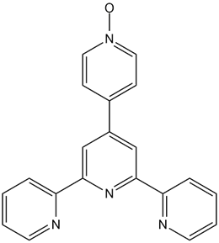
Scheme 1. 4’-(4’’’-pyridyl-N-oxide)-2:2’,6’:2’’-terpyridine (pyterpyNO).

In this work, we show that pyterpyNO can bridge two rare earth centers in a hypodentate mode through the oxygen atom. A careful control of the stoichiometry in the reaction of pyterpyNO with RE(tta)₃dme affords complexes with two different molecular compositions, adding new members to the family of polynuclear lanthanide compounds connected through N-oxide bridges.^{23,35,36,}The characterization of the products has been carried out, where appropriate, through NMR, single crystal X-ray diffraction, magnetic and photoluminescent studies. Our results introduce the pyterpyNO ligand as a new synthon to prepare polynuclear functional materials based on lanthanide ions, whose nuclearity and structure may be controlled in a rational manner.

Result and Discussion
Dinuclear complexes. Mononuclear RE(tta)₃(dme) (RE= Y (1), La (2), Dy (3), Eu (4); Htta=1,1,1-trifluoro-3-(2-thenoyl)-acetone; dme=1,2-dimethoxyethane) precursors have been easily prepared in good yields, following a synthetic route previously reported for Y(hfac)₃(dme),⁵⁸ (Hhfac = hexafluoroacetylacetone) see supplementary information. Air stable crystalline products, quite soluble in most organic solvents, have been fully characterized. The crystal structures of compounds 3 (Dy) and 4 (Eu) are shown in Figure S1.
PyterpyNO cleanly reacts at room temperature with the diketonato precursor RE(tta)₃(dme) in molar ratio 1:1 (RE = Y, Dy, Eu) yielding a toluene soluble product. For all compounds, elemental analyses were consistent with the product of a dme substitution reaction, RE(tta)₃(pyterpyNO). The IR spectra of the recovered products 5 (Y), 6 (Dy) and 7 (Eu) (Figure S2a) are almost completely superimposable suggesting a similar molecular identity. Suitable crystals for X-ray diffraction have been obtained by slow evaporation of a deuterated chloroform solution of the yttrium compound. A single-crystal diffraction analysis revealed the dinuclear complex Y₂(tta)₆(pyterpyNO)₂ .2 CDCl₃, 5 CDCl₃, where two pyterpyNO ligands are bridging two metal centers through the oxygen atom and the terpyridine fragments are not involved in the metal coordination (Figure 1). The molecule is centrosymmetric and the coordination around yttrium atoms is approximately described by a triangular dodecahedron (according to the results obtained with the SHAPE software, reported in Table S2). Coordination through an oxygen atom is preferred with respect to the coordination of the terpyridine unit that is expected to be stabilized by a strong chelate effect. Simple steric arguments do not provide a convincing explanation of the outcome, since a coordination number 9 is common for lanthanides.⁵⁹ The hypodentate coordination mode suggests that the oxygen atom of the N-oxide moiety is a strong donor for rare earth centers. Previous findings, with different divergent heterotopic (N, O) ligands (as 4,4’-bipyridile N-oxide or pyrazine N-oxide) showing uncoordinated nitrogen atoms in their lanthanide β-diketonato complexes, are here confirmed and a well-defined reactivity result established. Crystals collapse on drying and also on standing in air.
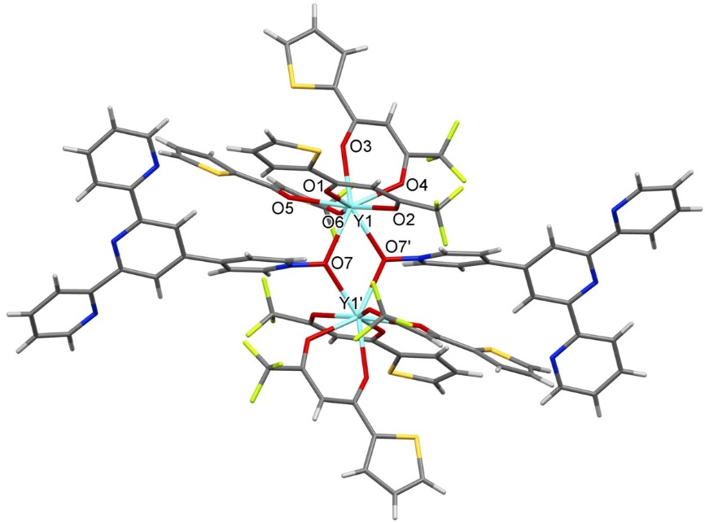
Figure 1. Molecular structure for 5. Only the most populated positions of the disordered CF₃ groups have been represented. ' = 1 − x, 1 − y, 1 − z.

For the diamagnetic yttrium, 5, NMR studies (¹H, ¹³C, ¹⁹F and ⁸⁹Y-NMR) have been carried out (Figure 2a). ¹H spectra show a single set of quaterpyridine signals. Significantly, the signal due to the hydrogen close to the terpyridine unit, hydrogen 11 in Figure 2a at 8.79 ppm, is not greatly shifted with respect to the chemical shift of the free ligand at 8.75 ppm while hydrogen 5, close to the N-oxide moiety, moves from 8.35 to 9.34 ppm upon coordination. Fluorine atoms of the tta ligands are all equivalent in the ¹⁹F-NMR and a single signal at 31.5 ppm is present in the ⁸⁹Y-NMR, a chemical shift not much different from that found for 1, 32.8 ppm, that is octacoordinated with all oxygen donors.

Figure 2. a) ¹H, ¹⁹F and ⁸⁹Y NMR spectra of 5 and b) ¹H, ¹⁹F and NMR of 8.
La(tta)₃(dme) reacted as well with pyterpyNO in toluene at room temperature, although with an important difference respect to europium, dysprosium, and yttrium analogues. Analytical and spectroscopic (NMR in Figure 2b) data suggest the formation of a dinuclear complex of compositions [La(tta)₃]₂(pyterpyNO)₃ (8). As for the yttrium derivative, a single set of the pyterpyNO signals is present and a significative shift of the hydrogen 5, close to the N-oxide moiety, is observed for compound 8. Differently from the yttrium derivative 5, in 8 the integral ratio of hydrogen atoms suggests a tta/pyterpyNO molar ratio of 6/3. These results can be rationalized considering that the larger ionic radius of lanthanum ions can afford the presence of three bridging pyterpyNO ligands instead of two as discussed above for yttrium, europium, and dysprosium. The lanthanum complex 8 has three uncoordinated terpyridine units of three hypodentate pyterpyNO ligands. Despite several crystallization attempts, no suitable single crystal has been obtained for a X-ray diffraction study in order to establish the crystal and molecular structure in the solid state.

Tetra- and pentanuclear complexes. PyterpyNO reacts as well with RE(tta)₃(dme) (RE= Y, Dy, Eu) in molar ratio 1:2 yielding a single highly soluble complex, of composition [RE(tta)₃]₄(pyterpyNO)₂ (IR, Figure S2b; elemental analysis). Structural studies on the dysprosium derivative, carried out through X-ray single crystal diffraction, have confirmed what suggested by analytical data: here the heterotopic divergent ligand has a bridging coordination mode. A tetranuclear centrosymmetric molecule with two non-equivalent metals has been characterized for [Dy(tta)₃]₄(pyterpyNO)₂ (Figure 3). Two metals in a central position (CN = 8, approximately described by a triangular dodecahedron, see Table S2) are coordinated by 6 oxygen atoms of three tta and by 2 oxygen atoms of two bridging pyterpyNO while two metals in a lateral position (CN = 9, three-capped trigonal prism, Table S2) are coordinated by 6 oxygen atoms of three tta and by 3 nitrogen atoms of a chelate terpyridine fragment. Crystals collapse on drying and also on standing in air.
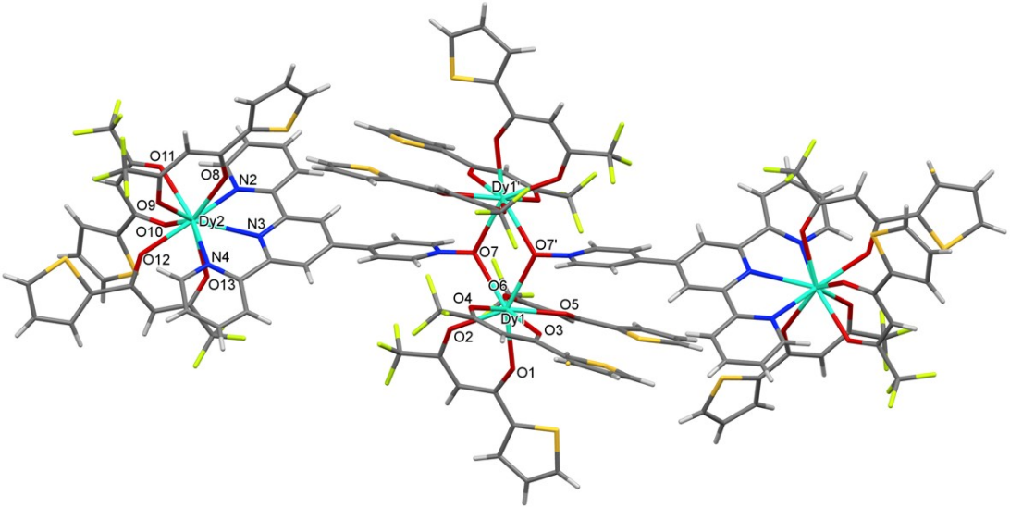
Figure 3. Molecular structure of 10. Only the more populated positions of the disordered CF₃ groups have been represented. ' = 2 − x, 1 − y, 1 − z.
NMR characterization has been carried out for RE = Y, Figure 4a. Also in this case only a single set of quaterpyridine signals is present in the ¹H-NMR spectrum of 9, with hydrogen 11 moving from 8.79 to 9.68 ppm as expected for coordination of the terpyridine unit to yttrium while hydrogen 5 only slightly changing its chemical shift. Significantly, two different sets of signals for tta ligands are present in ¹H-NMR, a result that is consistent with two non-equivalent metal centers as revealed by ⁸⁹Y-NMR spectroscopy (signals at 13.9 and 31.4 ppm) and by two different fluorine signals in the ¹⁹F-NMR.
La(tta)₃(dme) reacted with pyterpyNO in toluene at room temperature in a molar ratio five to three to yield a pentanuclear complex of composition [La(tta)₃]₅(pyterpyNO)₃, (12). In Figure 4b, in the ¹H-NMR spectrum, a significative shift of the hydrogen 11, close to the terpyridine moiety, is observed for compound 12 suggesting the coordination of the terpyridine site of the ditopic ligand. Two different sets of signals due to tta ligands are present in 12 in a molar ratio 2 to 3, consistent with ¹⁹F-NMR spectra where two fluorine signals are very close to the same molar ratio. Despite several crystallization attempts, no suitable single crystal has been obtained for a X-ray diffraction study in order to establish the crystal and molecular structure in the solid state.

Figure 4. a) ¹H, ¹⁹F and ⁸⁹Y NMR spectra of 9 and b) ¹H, ¹⁹F and NMR of 12.

A toluene solution of [Y(tta)₃]₂(pyterpyNO)₂ cleanly and quickly reacts at room temperature with two equivalents of Y(tta)₃(dme) yielding the tetranuclear compound so that it is possible to get [Y(tta)₃]₄(pyterpyNO)₂ both in a single step or adding in sequence two equivalents of the metal precursor. In Figure 5 the synthetic process has been schematized.

Figure 5. Schematic representation of the assembly of the dinuclear, tetranuclear and pentanuclear complexes.

Magnetic Study of 6 and 10.
Static magnetic properties. The temperature dependence of the χ_{M}T product of compounds 6 and 10 are displayed in Figure 6. For compound 6, it can be seen that the experimental room temperature χ_{M}T value (25.92 emuK/mol) is lower than the one expected for the free ion (28.33 emuK/mol), as frequently found for Dy(III) complexes. This value stays constant upon lowering the temperature until 225 K, when begins to decrease, according to a crystal-field induced splitting of the ⁶H_{15/2} electronic ground multiplet of the ion,⁶⁰ reaching the 20.44 emuK/mol value at 5.5 K. At this temperature, there is a change in the slope of the curve, which drops at 15.36 emuK/mol at 1.8 K. Since this change in slope cannot be accounted for in terms of magnetic saturation effects, we attribute it to a magnetic exchange between the two Dy(III) ions bridged by the pyterpyNO ligands. The Dy(III) displays a high magnetic anisotropy at low temperature and it is usually modelled as an effective S=1/2 spin with a theoretical g_{z} value of 20.⁶⁰ A simultaneous fit of the 2-15 K section of this plot and of the isothermal magnetization curves, reported as a red line in the Figures 6 and S3, estimates a value of the exchange constant J to be -1.39(1) cm⁻¹, (H = -JS_{1z}S_{2z}), with g_{z} = 18.94(1). Both sign and magnitude of the coupling constant are in line with similarly oxygen-bridged Dy(III) dimers.^{61,62}

Figure 6. Temperature dependence of the χ_{M}T product for compounds 6 and 10. The lines corresponds to the best fitting function, calculated with the model discussed in the text. Inset: zoom of the low temperature region of both curves.

As observed for 6, 10 displays a room temperature χ_{M}T value (50.70 emuK/mol) lower than the one expected for four Dy(III) free ions (56.67 emuK/mol), which decreases upon cooling to reach the 35.01 emuK/mol value at 1.8 K. In agreement with the presence of the same dinuclear Dy(III) bridged core found in 6, the χ_{M}T drops faster below 6.0 K, suggesting a similar antiferromagnetic interaction to be present in this case as well. The striking resemblance of the low-temperature part of the χ_{M}T product of both compounds is highlighted in the inset of Figure 6. In here, a similar fitting procedure has been performed, considering the presence of two additional, uncoupled, terpyridine-bound Dy(III) ions with Ising-type magnetic anisotropy, yielding g_{z} = 18.50(1) for the central Dy(III) ions, g_{z} = 18.52(1) for the peripheral Dy(III) ions and J = -1.49(1) cm⁻¹. This confirms that for both systems, a weak antiferromagnetic interaction is active between the two Dy(III) ions bound by the N-oxide group of the pyterpyNO ligand. The isothermal magnetizations of compounds 6 and 10 are reported in Figure S3 and display saturation values of 9.77 and 18.55 μ_{B}/mol, respectively.

Dynamic magnetic properties. The dynamics of the magnetization of compounds 6 and 10 have been assessed with frequency- and temperature-dependent susceptometry. Both systems display slow relaxing magnetization in the absence of a static field applied, and quite interestingly, show an increase in the relaxation rate upon application of a 1 kOe static field. Figure 7 reports the in-phase (χ'_{M}) and out-of-phase (χ”_{M}) magnetic susceptibilities of 6, measured with no applied field. The temperature dependence of the same data is reported as Figure S4. The onset of frequency dependent peaks in the 5 – 15 K region is a hint of the slow relaxing magnetization of 6, and its Single Molecule Magnet behavior. A careful analysis of the χ”_{M} plot as a function of field sweeping frequency in the 2.0 – 5.0 K range (Figure S5) highlights the presence of two distinct sets of peaks, corresponding to two distinct magnetic relaxation processes. A best fitting procedure of both peaks with the extended Debye model yielded the relaxation times τ reported in the panel b of Figure 7. Despite containing two Dy(III) ions, the presence of two processes in 6 cannot be attributed to the dinuclear nature of the complex, since the two ions are structurally and magnetically equivalent, and should feature a single relaxation process, as reported for other centrosymmetric Dy(III) dinuclear species.⁶¹ We attribute this behavior to the presence of dipolar interactions in the solid state, on the basis of previous reports for Dy(III) systems.⁶³The faster process shows almost no temperature dependence, and its average frequency of quantum tunneling of the magnetization (QTM) is estimated to be 12.3 kHz. Heating the system, the slower process accesses our experimental frequency window, and can be fitted using a Raman model or and Orbach one including QTM (see Table S3). Even if both models are able to fit the experimental data, comparison with the relaxation times measured in 1 kOe field, for which a fit using a Raman/direct process yields poorer results (vide infra), suggests that the actual relaxation mechanism is an Orbach one. It must be pointed out that, for temperatures above 14.5 K, the frequency dependence of the χ”_{M} plot does not follow the expected bell shaped curve, but gets wider and cannot be satisfactorily fitted with a relaxation single relaxation process, independently of the width of the distribution of the relaxation times. For this reason, an additional peak has been used to reproduce the high frequency region of the data. However, since the maximum of the curve associated to this second contribution lies outside our frequency window, the uncertainty of the extracted parameters is too large and we did not present them among our results. The complete set of best fitting parameters is reported in Table S3. As previously observed for a structurally related Dy(III) dimer and as can be seen in Figure S4, a very tiny dependence of the relaxation dynamics is found upon application of a static magnetic field.⁶¹ Interestingly, the in-field relaxation appears to be slightly faster than the zero-field one for temperatures above 7.5 K. We attribute the observed increase of relaxation rate with the field to the magnetically induced overcome of the exchange bias between the two Dy(III) ions in the dimer, as previously observed for other centrosymmetric, antiferromagnetically exchanged Dy(III) dimers.⁶² The corresponding Arrhenius plot describes an almost straight line, featuring a slight decrease in slope at low temperatures. In this case, adopting a mixed Raman/direct relaxation model led to a poor fitting of the data, which are however efficiently reproduced by a mixed Orbach/direct mechanism. When compared to the zero-field data, an increase in the effective relaxation barrier (now 70(2) K) and a reduction of the τ₀ take place (see Table S3), that can be accounted for considering the reduction of the low temperature quantum pathway of relaxation.

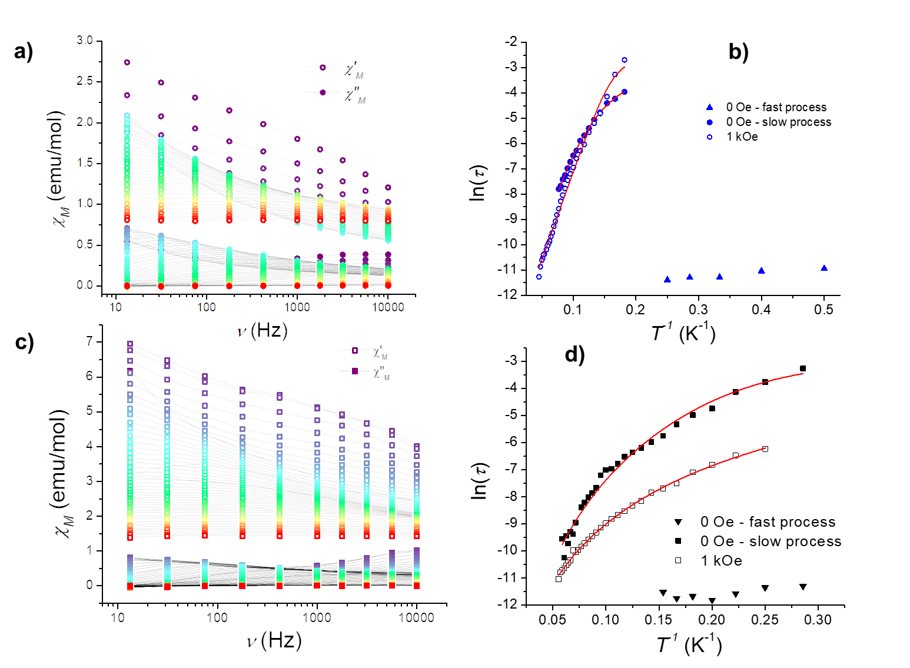
Figure 7. Frequency dependence of the molar in-phase (χ’_{M}) and out-of-phase (χ”_{M}) magnetic susceptibilities of compounds 6 (panel a) and 10 (panel c), measured with no static field applied. The temperature dependence of the relaxation times, measured with or without a 1 kOe applied field, is reported as Arrhenius plots in panels b (for compound 6) and d (for 10). The best fitting functions are discussed in the text.

Featuring the Dy(III) core found in compound 6, it is not surprising that the magnetization dynamics of compound 10 are related to the ones previously analyzed. At the lowest temperatures and without applied field, two sets of peaks in the out-of-phase magnetic susceptibility are present in this case as well. The relaxation rate of the faster process, again, displays a very feeble temperature dependence, and can be interpreted as a QTM with an estimated frequency of 17.1 kHz. The increase in the QTM frequency can be tentatively attributed to the increased dipolar field in the solid state by means of the external Dy(III) ions bound to the terpyridine moieties. Differently from what found in the case of 6, the temperature dependence of the slower process in zero field cannot be fitted with an Orbach/QTM model, which is unable to reproduce the low temperature data efficiently. Instead, the relaxation mechanism of 10 without applied field can be interpreted as a mixed Raman/QTM model (n = 4.5(2), see Table S4). The two peaks could arise from the two structurally inequivalent Dy(III) ions present in the asymmetric unit of the complex, but we believe can be traced back to the Dy₂ core, as previously seen for compound 6. With a static applied field of 1 kOe, we find an increase in the relaxation rate, similarly to what previously observed for 6. In this case, however, the two Arrhenius plots do not overlap, and are better reproduced with a mixed Raman/direct or Raman/QTM mixed relaxation model rather than with an Orbach/direct one, in agreement with zero-field relaxation data (see Table S4 for the parameters). Considering a mixed Raman/QTM approach, a low n Raman exponent is found (n = 3.25(6)), a behavior previously observed in Dy(III) slow relaxing species, and attributed to the presence of low-lying m_{J} magnetic states.⁶⁴ The observed increase of the tunneling frequency upon application of the static magnetic field has been considered to be the cause of the decrease of the relaxation times, and can be attributed to the effect of the magnetic bias that each Dy(III) is exerting on its magnetically coupled, symmetric equivalent, one. This bias has been previously shown to remove the zero-field quantum tunneling pathway of relaxation of the magnetic moment in Dy₂ centrosymmetric systems, shifting it to higher fields.⁴⁰

Photoluminescence study on 7 and 11.
Complexes 7 and 11 belong to the family of polynuclear β-diketonato compounds connected through N-oxide ligands that we recently started to study.^{35,36} Like the other members of the family, when excited in a wide spectral range that extends from ultraviolet to visible, they show the typical red emission, clearly visible to the naked eye, of Eu³⁺.

Figure 8. Photoluminescence Excitation spectra (PLE, continuous lines) and diffuse reflectance absorption spectra (dotted lines) for 7 and 11 monitored on the Eu³⁺ ⁵D₀  ⁷F₂ transition (615 nm).

The absorption and excitation spectra of 7 and 11 have very similar profiles (Figure 8), but the spectrum of 7 shows a bathochromic shift of about 10 nm. Since the two complexes have the same ligands, this small difference cannot be ascribed only to ligand-centered transitions. In a previous study, we have shown that the low-energy portion of absorption spectra of homometallic dimeric complexes, bearing bridging N-oxide ligands, have a charge transfer character (CT). In these compounds, CT transitions affect both the shape of the absorption spectra and modulate the thermometric properties.³⁶ By analogy, the differences observed between 7 and 11 are due to low-energy CT transitions.
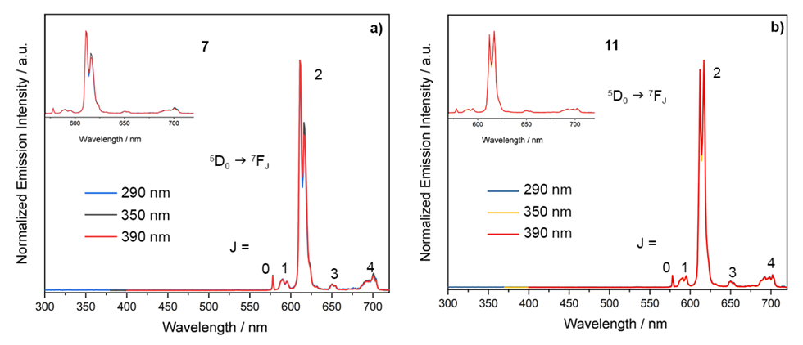Figure 9. Emission spectra of 7 (a) and 11 (b) obtained by exciting sample powders at different wavelengths. The inset of each panel shows the magnification of the region typical of Eu³⁺ emission.

Luminescence spectra (Figure 9) show only signals from Eu³⁺ 4f-4f intrashell transitions from the ⁵D₀ excited state, populated via ‘antenna effect’, to the ⁷F_{J} (J = 0,1,2,3,4) fundamental multiplet. The tuning of the excitation wavelength across PLE spectra does not affect the number and relative intensity of the different transitions.
While in 7 there are only two equivalent Eu³⁺ ions having coordination number 8, in 11 other 2 Eu³⁺ centers with CN = 9 are found. The general shape of the spectra is very similar and is predominantly determined by β-diketonato ligands.^{35,36} In this type of compound, the symmetry of the Eu³⁺ is very low, as evidenced by the presence of the transition ⁵D₀  ⁷F₀ in the spectra.⁶⁵
Figure 10. Emission spectra of 7 and 11, λ_{exc} = 370 nm.

Figure 10 shows the high-resolution spectra of 7 and 11 (λ_{exc} = 370 nm), i.e. close to the PLE and absorption maxima for both complexes. The ⁵D₀  ⁷F₂ and ⁵D₀  ⁷F₄ transitions show the most evident differences. In 7, octa-coordinated Eu³⁺ ions display a triangular dodecahedral geometry as in Figure 11 on the left while when CN is 9, Ln³⁺ ions have tricapped trigonal prism coordination.
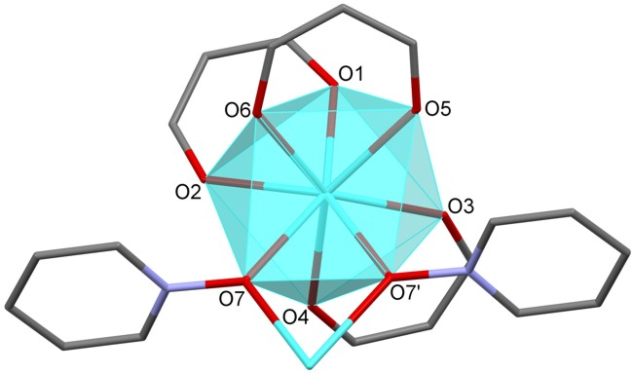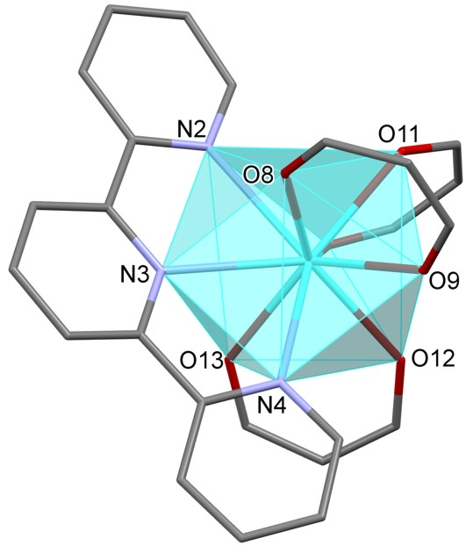
Figure 11. Coordination polyhedra of Dy in 10 for octa-coordinated (left) or nona-coordinated ions (right).
The different coordination geometry affects the shape of the Eu³⁺ emission spectra, and in particular, the crystal field component of ⁵D₀  ⁷F₂ multiplet at 617 nm, arrowed in the figure, seems to be peculiar for Eu³⁺ having coordination number 9, and hence it could be used as a sort of fingerprint for these sites.

Conclusions
The heterotopic divergent pyterpyNO ligand shows a high preference for the O-coordination mode towards rare-earth ions. Complexes having hypodentate terpyridine units, RE₂(tta)₆(pyterpyNO)₂, (RE = Y, 5; Dy, 6; Eu, 7) can be easily prepared controlling the stoichiometry of the reaction between pyterpyNO and the air stable diketonato mononuclear metal precursor RE(tta)₃dme. For lanthanum, 8, having a larger ionic radius, three pyterpyNO ligands can bridge two metal ions. Compounds 5, 6, 7 and 8, are expected to have a rich chemistry and to be useful in the mild synthesis of heterometallic complexes coordination polymers or metal-organic frameworks. Studies are ongoing in our laboratories.
Reactions with a different stoichiometry (a molar ratio RE(tta)₃dme/pyterpyNO = 2 for RE = Y, Dy, Eu) afford tetranuclear compounds with the pyterpyNO ligands in a bridging coordination mode and two non-equivalent metal centers for their coordination geometry. Octa-coordinated ions in an approximately triangular dodecahedral geometry are only O-coordinated, while nona-coordinated ions in a three-capped trigonal prism geometry have a terpyridine unit in their coordination sphere. Tetranuclear compounds have been obtained not only in a single step but also by addition of a second equivalent of the metal precursor to the dinuclear complexes. This sequential procedure opens the way to the synthesis of heterolanthanide complexes, an issue presently under study in our laboratories.
From the magnetic point of view, the Dy-O-Dy dinuclear core, present in compounds 6 and 10, features an antiferromagnetic interaction between the two Dy(III) ions. Such an interaction is weakly sensitive to the presence of two additional Dy(III) ions in the outer terpyridine binding sites, and it is likely to be responsible for the onset of a Single Molecular Magnet behavior in the absence of an applied static field for both complexes. Quite interestingly, while the relaxation mechanism of 6 can be described as an Orbach one, the temperature dependence of the magnetic relaxation times of 10 cannot be reproduced with this model but is properly fitted with a Raman mechanism. This suggests that the slow relaxing magnetization is related with the central, antiferromagnetically coupled, Dy2 pair. As a confirmation, the relaxation dynamics of compounds 6 and 10 speed up upon application of a magnetic field, supporting the previous conclusion.
Europium derivatives 7 and 11 displayed a bright red emission that is perceived by the naked eye even when only a few tiny grains of sample powder are shined with visible or near-ultraviolet light. Emission spectra of 7 and 11 have a similar shape, reflecting the presence of Eu(tta)₃ moieties on both octa- and nona-coordinated sites, but the relative intensity of the crystal field component at 612 and 617 nm of the ⁵D₀  ⁷F₂ transition can provide indication about the occupancy of CN 9 sites.

Experimental
Materials and instrumentation.
Anhydrous solvents were purchased from Merck and used as received. 4’-(4-pyridil)-2,2’:6’,2”-terpyridine N-oxide (pyterpyNO) was synthesized according to the literature.⁵⁶ FTIR spectra on solid samples were recorded with a Perkin–Elmer ‘‘Spectrum One’’ spectrometer, equipped with an ATR accessory. ¹H-, ¹³C-, ¹⁹F-,⁸⁹Y NMR spectra were recorded with a Bruker ‘‘Avance DRX400’’ spectrometer. Chemical shifts were measured in ppm (δ) from TMS by residual solvent peaks for ¹H and ¹³C, from CFCl₃ for ¹⁹F and YCl₃ (0.5 M in D₂O) for ⁸⁹Y. Elemental analysis (C, H, N) was performed at the Dipartimento di Chimica e Chimica Industriale, Università di Pisa (Italy).
Absorption spectra of powder samples were recorded using a Cary 5000 UV-Vis-Spectrometer equipped with an integrating sphere. The spectra were normalized and plotted as F(R) vs wavelength. F(R) is the Kubelka-Munk function. A full description can be found elsewhere.⁶⁶
Room temperature luminescence spectra of sample powders were recorded with a Horiba Jobin Yvon Fluorolog-3 spectrofluorimeter. A full description of the employed set-up can be found in a previous paper.³⁶
Magnetization measurements. Samples employed for DC (direct current) and AC (alternating current) measurements consisted of microcrystalline powders of products 6 and 10, which were wrapped in Teflon tape and pressed as pellets. The DC magnetic characterization was performed on Quantum Design MPMS (Magnetic Properties Measurement System) equipment provided with a 5 T magnet. The magnetization (M) dependence with the absolute temperature was investigated between 300 and 45 K using a magnetic field (B) of 1 T, and between 45 and 2 K with a field of 0.1 T to prevent magnetic saturation. Magnetic susceptibility per mole (χ_{M}) was then evaluated as χ_{M} = M_{M}/B. Alternating current magnetic susceptibility analyses were performed with a PPMS (Physical Properties Measurement System) platform, also from Quantum Design, with oscillating field frequencies ranging from 10 to 10⁴ Hz, and using static magnetic fields of zero and 1 kOe. The resulting magnetic data were corrected for the diamagnetic contributions of the ligands calculated from Pascal constants,⁶⁷ together with those measured for the sample container and the wrapping Teflon tape. The simultaneous fit of the 2 – 15 K region of the χ_{M}T plots and of the isothermal magnetizations of compounds 6 and 10 has been carried out with the program PHI.⁶⁸ For this, each Dy(III) ion has been treated as a purely uniaxial, Ising, ½ effective spin, and the only magnetic interaction assumed to be active is the one between the two Dy(III) ions connected through N-oxide bridges. On the basis of the structural properties, only one (two) set of magnetically equivalent Dy(III) ions have been considered for compound 6 (10).
The ac susceptibility data were analysed within the extended Debye model^{69,70}, in which a maximum in the out-of-phase component χ_{M}'' of the complex susceptibility is observed when the relaxation time τ equals (2πν)⁻¹. The adopted model includes two different relaxation processes to reproduce a non-zero χ_{M}'' in the low frequency region of the plots; the corresponding relaxation times extracted from this low frequency component were however not described due to the huge uncertainty associated to them. The frequency dependence of χ_{M}'' at constant temperature was thus fitted using equation (1):
χ_{M}'' (ω) = χ_{M}''_{LF} (ω) + χ_{M}''_{FIT} (ω) (1)

where each process corresponds to the function reported in equation (2):

χ_{M}'' (ω) = (χ_{T} − χ_{S})[(ωτ)^{1-α}cos(απ/2)]/[1 + 2(ωτ)^{1-α}sin(απ/2) + (ωτ)^{2-2α}] (2)

where ω = 2πν, χ_{T} and χ_{S} are the isothermal and adiabatic susceptibilities, i.e., the susceptibilities observed in the two limiting cases ν → 0 and ν → ∞, respectively, and α is a parameter which accounts for a distribution of relaxation times.
The temperature dependence of the magnetic relaxation times τ has been fitted using equation (3):

$τ_{}^{-1}\left(T\right)=τ_{0}^{-1}e^{\frac{∆}{kT}}+CT^{n}+BT+QTM$ (3)

where the terms represent an Orbach, Raman, direct and quantum relaxation mechanisms. To avoid overparametrization, in the fitting procedures Raman and Orbach mechanisms have been used alternatively.

Synthesis of RE₂(tta)₆(pyterpyNO)₂, (RE = Y, 5; Dy, 6; Eu, 7). The yttrium case is described at length.
5 (Y). PyterpyNO (0.14 g; 0.43 mmol) was added to a solution of Y(tta)₃(dme) (0.35 g; 0.42 mmol) in toluene (15 mL) under vigorous stirring. The resulting suspension was mildly heated (T = 70 °C) until the suspended ligand disappeared, then the solution was cooled to RT. Upon adding heptane (45 mL) a colourless solid precipitated, which was filtered and dried under vacuum for 4 h. (0.33 g; 0.15 mmol, 71.9 % yield). El. Anal. Calcd for Y₂(tta)₆(pyterpyNO)₂ (C₈₈H₅₂F₁₈N₈O₁₄S₆Y₂), %: Teor: C, 49.0; H, 2.4; N, 5.2; S, 8.9. Found: C, 48.7; H, 2.4; N, 4.9; S, 9.1. IR (range 1700 - 1100 cm⁻¹): 1624 (m), 1601 (s), 1586 (m), 1538 (s), 1503 (s), 1478 (m), 1441 (w), 1412 (s), 1393 (w), 1357 (m), 1306 (s), 1293 (s), 1244 (m), 1230 (m), 1182 (s), 1127 (s). Slow evaporation of a chloroform solution yielded well-shaped, single crystals, suitable for X-ray analysis.
¹H-NMR (400MHz, C₆D₆, ppm, Scheme 2): 9.37 (br s, H⁵, 4H), 8.78 (s, H⁷, 4H), 8.71 (d, H¹¹, 4H, ³J_{H11-H10}=7.9 Hz), 8.56 (d, H⁸, 4H, ³J_{H8-H9}=4.3 Hz), 7.50 (br s, H⁶, 4H), 7.38 (ddd, H¹⁰, 4H, ³J_{H10-H9}=8.7 Hz, ³J_{H10-H11}=7.9 Hz, ⁴J_{H10-H8} =1.2 Hz), 7.05 (d, H⁴, 6H, ³J_{H4-H3}=3.0 Hz), 6.83 (m, H² and H⁹, 10H), 6.45 (br s, H³, 6H), 6.31 (s, H¹, 6H).
¹⁹F-NMR (400MHz, C₆D₆, ppm): -75.1 (s, 18F).
¹³C-NMR (400MHz, C₆D₆, ppm): 182.0 (s), 171.1 (q, ²J_{C-F}=33 Hz), 157.0 (s), 156.0 (s), 149.6 (s), 146.1 (s), 145.5 (s), 136.7 (s), 132.6 (s), 131.4 (s), 130.4 (s), 129.4 (s), 125.7 (s), 124.3 (s), 123.9 (s), 121.4 (s), 120.6 (q, ¹J_{C-F}=286 Hz), 119.7 (s), 92.3 (s).
⁸⁹Y-NMR (400MHz, C₆D₆, ppm): 30.5 (s, 2Y).
Scheme 2. Numbering for NMR assignment in 5.

6 (Dy). Starting from 0.16 g of Dy(tta)₃(dme) (0.17 mmol), 0.06 g of pyterpyNO (0.18 mmol), 10 mL of toluene and 45 mL of heptane we obtained 0.13 g of Dy₂(tta)₆(pyterpyNO)₂ (0.06 mmol, yield 66.3%). IR (range 1700 - 1100 cm⁻¹): 1623 (m), 1601 (s), 1587 (m), 1538 (s), 1504 (s), 1471 (m), 1442 (w), 1412 (s), 1393 (w), 1356 (m), 1306 (s), 1292 (s), 1245 (m), 1230 (m), 1183 (s), 1131 (s). El. Anal. calculated for Dy₂(tta)₆(pyterpyNO)₂ (C₈₈H₅₂Dy₂F₁₈N₈O₁₄S₆), %: Teor: C, 45.9; H, 2.3; N, 4.9; S, 8.4. Found: C, 45.6; H, 2.1; N 4.7; S, 8.5.

7 (Eu). Starting from 0.41 g of Eu(tta)₃(dme) (0.45 mmol), 0.15 g of pyterpyNO (0.46 mmol), 25 mL of toluene, 0.32 g of Eu₂(tta)₆(pyterpyNO)₂ (0.14 mmol, 62.3 % yield) were obtained. IR (range 1700 - 1100 cm⁻¹): 1600 s, 1537 m, 1502 m, 1469 m, 1440 w, 1412 m, 1390 w, 1355 m, 1301 s, 1244 m, 1229 m, 1182 s, 1130 s. El. Anal. calculated for Eu₂(tta)₆(pyterpyNO)₂ (C₈₈H₅₂Eu₂F₁₈N₈O₁₄S₆), %: Teor: C, 46.3; H, 2.3; N, 4.9; S, 8.4. Found: C, 46.0; H, 2.3; N, 4.6; S, 8.6.

La₂(tta)₆(pyterpyNO)₃, 8. In an NMR-tube pyterpyNO (12.4 mg; 3.8·10⁻⁵ mol) and La(tta)₃(dme) (22.7 mg; 2.5·10⁻⁵ mol) were suspended in anhydrous C₆D₆ (1 mL). Upon sonicating and mildly heating the tube a solution was obtained. NMR data clearly showed that we had afforded the desired product. After removal of the volatile phases, a colourless solid was recovered and dried under vacuum for 2 h (18.3 mg of La₂(tta)₆(pyterpyNO)₃; 56.7% yield). IR (range 1700 - 1100 cm⁻¹): 1625 (m), 1603 (s), 1586 (m), 1569 (w), 1533 (s), 1500 (s), 1467 (m), 1442 (w), 1412 (s), 1393 (w), 1355 (m), 1291 (s), 1242 (m), 1228 (s), 1180 (s), 1128 (s). El. Anal. calculated for La₂(tta)₆(pyterpyNO)₃ (C₁₀₈H₆₆F₁₈La₂N₁₂O₁₅S₆), %: Teor: C, 50.2; H, 2.6; N, 6.5; S, 7.5. Found: C, 49.9; H, 2.8; N, 6.3; S, 7.7.
¹H-NMR (400MHz, C₆D₆, ppm, Scheme 3): 9.10 (br s, H⁵, 6H), 8.70 (d, H¹¹, 6H, ³J_{H11-H10}=8.3 Hz), 8.67 (s, H⁷, 6H), 8.53 (d, H⁸, 6H, ³J_{H8-H9}=4.2 Hz), 7.37 (ddd, H¹⁰, 6H, ³J_{H10-H11}=8.3 Hz, ³J_{H10-H9}=6.6 Hz, ⁴J_{H10-H8}=1.4 Hz), 7.29 (br s, H⁶, 6H), 7.06 (d, H⁴, 6H, ³J_{H4-H3}=2.7 Hz), 6.82 (d, H², 6H, ³J_{H2-H3}=5.1 Hz), 6.79 (t, H⁹, 6H, ³J_{H9-H10}=6.6 Hz, ³J_{H9-H8}=4.2 Hz), 6.41 (dd, H³, 6H, ³J_{H3-H2}=5.1 Hz, ³J_{H3-H4}=2.7 Hz), 6.29 (s, H¹, 6H).
¹⁹F-NMR (400MHz, C₆D₆, ppm): -74:8 (s, F¹, 18F).
¹³C-NMR (400MHz, C₆D₆, ppm): 180.7 (s), 169.7 (q, ²J_{C-F}=32 Hz), 156.4 (s), 155.7 (s), 149.2 (s), 145.8 (s), 145.4 (s), 141.9 (s), 136.3 (s), 132.7 (s), 131.6(s), 131.5 (s), 129.3 (s), 123.7 (s), 123.4 (s), 120.9 (s), 120.0 (q, ¹J_{C-F}=287 Hz), 119.0 (s), 91.6 (s).
Scheme 3. Numbering for NMR assignment in 8.

Synthesis of RE₄(tta)₁₂(pyterpyNO)₂, (RE = Y, 9; Dy, 10; Eu, 11). The yttrium case is described at length.
9 (Y). In a Schlenk flask 0.52 g of Y(tta)₃(dme) (0.62 mmol) and 0.10 g of pyterpyNO (0.31 mmol) were dissolved in dce (20 mL). The solution was stirred for two days; upon adding heptane (8 mL) a brown oil precipitated. The solution was therefore evaporated to dryness under vacuum and we obtained a colourless solid, which was recrystallized with 4 mL of toluene and 4 mL of heptane. This solid was recovered by filtration and dried under vacuum for 8 h. IR (range 1700 - 1100 cm⁻¹): 1603 (s), 1580 (w), 1538 (s), 1506 (m), 1475 (w), 1412 (s), 1354 (w), 1305 (s), 1247 (m), 1230 (s), 1183 (s), 1131 (s). Upon cooling at -20 °C the liquid phase from the filtration, precipitation of a colourless solid occurred. The latter solid had the same IR spectrum of the former. We recovered overall 0.34 g of Y₄(tta)₁₂(pyterpyNO)₂ (0.09 mmol, yield 59.9%). El. Anal. calculated for Y₄(tta)₁₂(pyterpyNO)₂ (C₁₃₆H₇₆F₃₆N₈O₂₆S₁₂Y₄), %: Teor: C, 44.6; H, 2.1; N, 3.1; S, 10.5. Found: C, 44.2; H, 2.3; N, 2.9; S, 10.7.
¹H-NMR (400MHz, C₆D₆, ppm, Scheme 4): 9.67 (d, H¹¹, 4H, ³J_{H11-H10}=4.6 Hz), 9.55 (d, H⁵, 4H, ³J_{H5-H6}=5.7 Hz), 7.63 (s, H⁷, 4H), 7.50 (m, H⁶ and H⁸, 8H), 7.17 (m, H¹⁵, 6H), 7.13 (m, H⁹, 4H), 7.07 (m, H⁴, 6H), 6.88 (d, H¹⁰, 4H, ³J_{H10-H11}=4.6 Hz), 6.85 (d, H¹³, 6H, ³J_{H13-H14}=4.4 Hz), 6.81 (d, H², 6H, ³J_{H2-H3}=4.6 Hz), 6.52 (s, H¹², 6H), 6.49 (dd, H¹⁴, 6H, ³J_{H14-H15}=5.5 Hz, ³J_{H14-H13}=4.4 Hz), 6.42 (d, H³, 6H), 6.34 (s, H¹, 6H).
¹⁹F-NMR (400MHz, C₆D₆, ppm, Scheme 4): -75.1 (s, F¹ 18F), -75.6 (s, F² 18F).
¹³C-NMR (400MHz, C₆D₆, ppm): 182.2 (s), 181.0 (s), 170.9 (q, ²J_{C-F}=30 Hz), 170.6 (q, ²J_{C-F}=31 Hz), 156.1 (s), 153.0 (s), 151.9 (s), 147.4 (s), 146.9 (s), 145.8 (s), 145.4 (s), 144.2 (s), 138.3 (s), 137.9 (s), 132.9 (s), 131.5 (s), 130.7 (s), 129.4 (s), 125.4 (s), 123.8 (s), 121.6 (s), 120.1 (q, 2C, ¹J_{C-F}=286 Hz), 120.0 (s), 118.8 (s), 92.4 (s), 91.8 (s).
⁸⁹Y-NMR (400MHz, C₆D₆, ppm, Scheme 4): 31.4 (s, Y¹, 2Y), 13.9 (s, Y², 2Y).
Scheme 4. Numbering for NMR assignment in 9.

10 (Dy). PyterpyNO (0.07 g; 0.21 mmol) and Dy(tta)₃(dme) (0.39 g; 0.43 mmol) were dissolved in toluene (10 mL) under vigorous stirring. The solution was stirred for 2 d, then upon adding heptane (40 mL) precipitation of a colourless solid occurred. This solid was filtered and dried under vacuum for 8 h. We obtained 0.29 g of Dy₄(tta)₁₂(pyterpyNO)₂ (0.07 mmol, yield 69.8%). IR (range 1700 - 1100 cm⁻¹): 1604 (s), 1577 (w), 1537 (s), 1504 (m), 1474 (w), 1413 (s), 1354 (w), 1305 (s), 1245 (m), 1229 (s), 1184 (s), 1135 (s). Slow evaporation of a toluene solution yielded well-shaped, single crystals, suitable for X-ray analysis. El. Anal. calculated for Dy₄(tta)₁₂(pyterpyNO)₂ (C₁₃₆H₇₆Dy₄F₃₆N₈O₂₆S₁₂), %: Teor: C, 41.3; H, 1.9; N, 2.8; S, 9.7. Found: C, 41.7; H, 2.1; N, 2.8; S, 9.9.

11 (Eu). PyterpyNO (0.09 g; 0.28 mmol) and Eu(tta)₃(dme) (0.51 g; 0.56 mmol) were dissolved in toluene (20 mL) under vigorous stirring. The solution was stirred for 2 d, then upon adding heptane (40 mL) precipitation of a light yellow solid occurred. This solid was filtered and dried under vacuum for 8 h. We obtained 0.38 g of Eu₄(tta)₁₂(pyterpyNO)₂ (0.10 mmol, yield 69.2%). IR (range 1700 – 1100 cm⁻¹): 1600 s, 1536 m, 1504 m, 1471 m, 1411 m, 1355 w, 1298 s, 1244 m, 1229 m, 1181 m, 1133 s. El. Anal. calculated for Eu₄(tta)₁₂(pyterpyNO)₂ (C₁₃₆H₇₆Eu₄F₃₆N₈O₂₆S₁₂), %: Teor: C, 41.7; H, 2.0; N, 2.9; S, 9.8. Found: C, 42.0; H, 2.0; N 2.9; S, 9.8.

La₅(tta)₁₅(pyterpyNO)₃, 12. In a NMR-tube pyterpyNO (6.5 mg; 2.0·10⁻⁵ mol) and La(tta)₃(dme) (29.2 mg; 3.3·10⁻⁵ mol) were suspended in anhydrous C₆D₆ (1 mL). Upon sonicating and mildly heating the tube we obtained a solution.
¹H-NMR (400MHz, C₆D₆, ppm, Scheme 5): 9.59 (br s, H⁵, 6H), 9.43 (d, H¹¹, 6H, ³J_{H11-H10}=4.9 Hz), 7.37 (d, H⁶, 6H, ³J_{H6-H5}=6.0 Hz), 7.34 (s, H⁷, 6H), 7.31 (d, H⁸, 6H, ³J_{H8-H9}=8.2 Hz), 7.21 (br s, H¹⁵, 9H), from 7.11 to 6.98 (m, H⁴ and H⁹, 12H), 6.84 (d, H¹³, 9H, ³J_{H13-H14}=4.2 Hz), 6.77 (d, H¹⁰, 6H, ³J_{H10-H11}=4.9 Hz), 6.76 (d, H², 6H, ³J_{H2-H3}=5.5 Hz), 6.51 (s, H¹², 9H), 6.49 (m, H¹⁴, 9H), 6.37 (br s, H¹ and H³, 12H).
¹⁹F-NMR (400MHz, C₆D₆, ppm, Scheme 5): -74:7 (s, F¹, 18F), -75:5 (s, F², 27F).
Scheme 5. Numbering for NMR assignment in 12.

X-ray Diffraction studies. Crystals of 5 and 10 were selected at room temperature (293 K), sealed in glass capillaries and analyzed with a Bruker Smart Breeze CCD diffractometer equipped with Mo Kα radiation. The lattice parameters and some collection details are summarized in Table 1. After correction for Lorentz and polarization effects and for absorption, structures were solved with the ShelXT⁷¹ program by intrinsic phasing and refined with the ShelXL⁷² package using least squares minimisation⁷³. All the four structures present disorder in some CF₃ groups, and those of 5 and 10 also in the orientation of thiophene groups, which were refined as distributed in two limit positions distinguished by different rotations about the C−C bond. The crystal structure of 5 is completed by two molecules of solvent chloroform for each complex molecule. Some solvent molecules (toluene) are also present in the crystal structure of 10. Four of them for each complex molecule were localized in the difference Fourier map, but the remaining ones, probably two, could not be located due to the excessive disorder. In this way a relevant cavity remained in the final structural model. To obtain a model that met CheckCIF's requirements, the localized solvent was removed and the entire contribution of the disordered solvent was subtracted with the SQUEEZE procedure contained in the PLATON program.⁷⁴ It is quite relevant to note that the program reports that it has found 551 electrons in the solvent accessible voids, a number quite close to the 600 electrons present in twelve molecules of toluene, six for each molecule of the complex. The final reliability factors for the reported structures are listed in Table 1.
Other control calculations were performed with the programs contained in the suite WINGX⁷⁵. X-ray crystallographic data CIF format (CCDC 2088701; 2088703) can be obtained free of charge from the Cambridge Crystallographic Data Center, 12 Union Road, Cambridge CB2 1EZ, UK; fax: +44 1223 336 033; or e-mail: deposit@ccdc.cam.ac.uk.

Table 1. Crystal data and refinement summaries for 5 and 10.
Identification code | 5⋅2 CDCl₃ | 10 [+solvent]
CCDC number | 2088701 | 2088703
Empirical formula | C₉₀H₅₄Cl₆F₁₈N₈O₁₄S₆Y₂ | C₁₃₆H₇₆Dy₄F₃₆N₈O₂₆S₁₂[+solvent]
Formula weight | 2396.29 | 3956.76
Crystal system | Monoclinic | Monoclinic
Space group | C 2/c | P 2₁/n
a (Å) | 23.6382(6) | 13.7999(4)
b (Å) | 16.0069(4) | 38.7002(11)
c (Å) | 27.4222(6) | 18.5473(6)
β (°) | 101.9140(10) | 103.7490(10)
Volume (Å³) | 10152.3(4) | 9621.5(5)
Z | 4 | 2
ρ_{calc} (g cm⁻¹) | 1.568 | 1.366
μ (mm⁻¹) | 1.516 | 1.755
F(000) | 4800 | 3872
θ range (°) | 1.64 to 26.5 | 2.39 to 26.4
Reflections collected | 49343 | 93532
Independent reflections | 10396 | 19621
Goodness-of-fit on F² | 1.026 | 0.894
Final R₁ [I ≥ 2σ(I )] | 0.0539 | 0.0406
Final wR₂ [I ≥ 2σ(I )] | 0.1592 | 0.1139
Final R₁ [all data] | 0.0651 | 0.0586
Final wR₂ [all data] | 0.1692 | 0.1271
Largest peak/hole (e Å⁻³) | 0.900, −0.963 | 0.930, − 0.606

ASSOCIATED CONTENT
Supporting Information
The syntheses of RE(tta)₃dme (RE = Y, 1; La, 2; Dy, 3; Eu, 4, crystallographic data for 3 and 4, and additional magnetic studies can be found in the Supplementary Information.

Notes
The authors declare no competing financial interest.

Acknowledgements
Thanks are due to Dr. Lorenzo Bonaldi for preliminary studies. G.P. gratefully acknowledges FAPERJ for financial support through grants E-26/202.912/2019, SEI-260003/001167/2020 and E-26/010.000978/2019. F.P. acknowledges Prof. Roberta Sessoli (University of Florence, Italy) for granting access to the magnetic characterization platforms.

References
(1) Zhao, X.-Q.; Zhao, B.; Ma, Y.; Shi, W.; Cheng, P.; Jiang, Z.-H.; Liao, D.-Z.; Yan, S.-P. Lanthanide(III)−Cobalt(II) Heterometallic Coordination Polymers with Radical Adsorption Properties. Inorg. Chem. 2007, 46 (15), 5832–5834. https://doi.org/10.1021/ic7007446.
(2) K. Farha, O.; M. Spokoyny, A.; L. Mulfort, K.; Frederick Hawthorne, M.; A. Mirkin, C.; T. Hupp, J. Synthesis and Hydrogen Sorption Properties of Carborane Based Metal−Organic Framework Materials. J. Am. Chem. Soc. 2007, 129 (42), 12680–12681. https://doi.org/10.1021/ja076167a.
(3) Ward, M. D. Transition-Metal Sensitised near-Infrared Luminescence from Lanthanides in d–f Heteronuclear Arrays. Coord. Chem. Rev. 2007, 251 (13–14), 1663–1677. https://doi.org/10.1016/J.CCR.2006.10.005.
(4) Cui, Y.; Yue, Y.; Qian, G.; Chen, B. Luminescent Functional Metal–Organic Frameworks. Chem. Rev. 2011, 112 (2), 1126–1162. https://doi.org/10.1021/cr200101d.
(5) Pan, M.; Liao, W. M.; Yin, S. Y.; Sun, S. S.; Su, C. Y. Single-Phase White-Light-Emitting and Photoluminescent Color-Tuning Coordination Assemblies. Chem. Rev. 2018, 118 (18), 8889–8935. https://doi.org/10.1021/acs.chemrev.8b00222.
(6) Rath, A.; Aceves, E.; Mitome, J.; Liu, J.; Ozkan, U. S.; Shore, S. G. Application of {(DMF)₁₀Ln₂[Pd(CN)₄]₃}∞ (Ln = Yb, Sm) as Lanthanide–Palladium Catalyst Precursors Dispersed on Sol–Gel–TiO₂ in the Reduction of NO by Methane in the Presence of Oxygen. J. Mol. Catal. A Chem. 2001, 165 (1–2), 103–111. https://doi.org/10.1016/S1381-1169(00)00447-7.
(7) Shore, S. G.; Ding, E.; Park, C.; Keane, M. A. Vapor Phase Hydrogenation of Phenol over Silica Supported Pd and Pd-Yb Catalysts. Catal. Commun. 2002, 3 (2), 77–84. https://doi.org/10.1016/S1566-7367(02)00052-3.
(8) Tanase, S.; Reedijk, J. Chemistry and Magnetism of Cyanido-Bridged d–f Assemblies. Coord. Chem. Rev. 2006, 250 (19–20), 2501–2510. https://doi.org/10.1016/J.CCR.2006.03.021.
(9) Wang, J.; Feng, M.; Akhtar, M. N.; Tong, M. L. Recent Advance in Heterometallic Nanomagnets Based on TM_{x}Ln_{4−x} Cubane Subunits. Coord. Chem. Rev. 2019, 387, 129–153. https://doi.org/10.1016/J.CCR.2019.02.008.
(10) Niu, Z.; Ma, J.-G.; Shi, W.; Cheng, P. Water Molecule-Driven Reversible Single-Crystal to Single-Crystal Transformation of a Multi-Metallic Coordination Polymer with Controllable Metal Ion Movement. Chem. Commun 2014, 50, 1839. https://doi.org/10.1039/c3cc47559j.
(11) Merkens, C.; Englert, U. Cite This: Dalton Trans. 2012, 41, 4664. https://doi.org/10.1039/c2dt11772j.
(12) Srivastava, S.; Gupta, R. From Chip-in-a-Lab to Lab-on-a-Chip: Towards a Single Handheld Electronic System for Multiple Application-Specific Lab-on-a-Chip (ASLOC). 2014, 18, 9185. https://doi.org/10.1039/c6ce01869f.
(13) Garibay, S. J.; Stork, J. R.; Cohen, S. M. The Use of Metalloligands in Metal-Organic Frameworks. In Progress in Inorganic Chemistry; John Wiley & Sons, Ltd, 2009; pp 335–378. https://doi.org/https://doi.org/10.1002/9780470440124.ch4.
(14) Das, M. C.; Xiang, S.; Zhang, Z.; Chen, B. Metal-Organic Frameworks Functional Mixed Metal-Organic Frameworks with Metalloligands. Angew. Chemie Int. Ed. 2011, 50, 10510–10520. https://doi.org/10.1002/anie.201101534.
(15) Kumar, G.; Gupta, R. Molecularly Designed Architectures-the Metalloligand Way. Chem. Soc. Rev 2013, 42, 9403. https://doi.org/10.1039/c3cs60255a.
(16) Gatteschi, D.; Sessoli, R.; Villain, J. Molecular Nanomagnets. In Mesoscopic Physics and Nanotechnology Molecular Nanomagnets; Oxford University Press, Ed.; 2006; p 395.
(17) Miller, J. S.; Gatteschi, D. Molecule-Based Magnets. Chem. Soc. Rev. 2011, 40 (6), 3065–3066. https://doi.org/10.1039/c1cs90019f.
(18) Woodruff, D. N.; Winpenny, R. E. P.; Layfield, R. A. Lanthanide Single-Molecule Magnets. Chem. Rev. 2013, 113 (7), 5110–5148. https://doi.org/10.1021/cr400018q.
(19) Caneschi, A.; Gatteschi, D.; Lalioti, N.; Sangregorio, C.; Sessoli, R.; Venturi, G.; Vindigni, A.; Rettori, A.; Pini, M. G.; Novak, M. A. Cobalt(II)-Nitronyl Nitroxide Chains as Molecular Magnetic Nanowires. Angew. Chemie - Int. Ed. 2001, 40 (9), 1760–1763. https://doi.org/10.1002/1521-3773(20010504)40:9<1760::AID-ANIE17600>3.0.CO;2-U.
(20) Jeon, I. R.; Clérac, R. Controlled Association of Single-Molecule Magnets (SMMs) into Coordination Networks: Towards a New Generation of Magnetic Materials. Dalt. Trans. 2012, 41 (32), 9569–9586. https://doi.org/10.1039/c2dt30906h.
(21) Liu, K.; Zhang, X.; Meng, X.; Shi, W.; Cheng, P.; Powell, A. K. Constraining the Coordination Geometries of Lanthanide Centers and Magnetic Building Blocks in Frameworks: A New Strategy for Molecular Nanomagnets. Chem. Soc. Rev. 2016, 45 (9), 2423–2439. https://doi.org/10.1039/c5cs00770d.
(22) Rigamonti, L.; Vaccari, M.; Roncaglia, F.; Baschieri, C.; Forni, A. New Silver(I) Coordination Polymer with Fe₄ Single-Molecule Magnets as Long Spacer. Magnetochemistry 2018, 4 (4), 1–15. https://doi.org/10.3390/magnetochemistry4040043.
(23) Armelao, L.; Belli Dell’Amico, D.; Bottaro, G.; Bellucci, L.; Labella, L.; Marchetti, F.; Mattei, C. A.; Mian, F.; Pineider, F.; Poneti, G.; Samaritani, S. 1D Hetero-Bimetallic Regularly Alternated 4f-3d Coordination Polymers Based on: N -Oxide-4,4′-Bipyridine (BipyMO) as a Linker: Photoluminescence and Magnetic Properties. Dalt. Trans. 2018, 47 (25), 8337–8345. https://doi.org/10.1039/c8dt00880a.
(24) Bellucci, L.; Labella, L.; Marchetti, F.; Pineider, F.; Poneti, G.; Samaritani, S. Magnetic Relaxation in Dysprosium and Terbium 1D-Zigzag Coordination Chains Having Only 4,4′-Bipyridine as Connector. Inorganica Chim. Acta 2021, 516 (December 2020), 120165. https://doi.org/10.1016/j.ica.2020.120165.
(25) Rigamonti, L.; Cotton, C.; Nava, A.; Lang, H.; Rüffer, T.; Perfetti, M.; Sorace, L.; Barra, A. L.; Lan, Y.; Wernsdorfer, W.; Sessoli, R.; Cornia, A. Diamondoid Structure in a Metal–Organic Framework of Fe₄ Single-Molecule Magnets. Chem. - A Eur. J. 2016, 22 (38), 13705–13714. https://doi.org/10.1002/chem.201601383.
(26) Poneti, G.; Bernot, K.; Bogani, L.; Caneschi, A.; Sessoli, R.; Wernsdorfer, W.; Gatteschi, D. A Rational Approach to the Modulation of the Dynamics of the Magnetisation in a Dysprosium-Nitronyl-Nitroxide Radical Complex. Chem. Commun. 2007, No. 18, 1807–1809. https://doi.org/10.1039/b617898g.
(27) Anwar, M. U.; Thompson, L. K.; Dawe, L. N.; Habib, F.; Murugesu, M. Predictable Self-Assembled [2 × 2] Ln(III)₄ Square Grids (Ln = Dy, Tb)—SMM Behaviour in a New Lanthanide Cluster Motif. Chem. Commun. 2012, 48 (38), 4576–4578. https://doi.org/10.1039/c2cc17546k.
(28) Atzori, M.; Chiesa, A.; Morra, E.; Chiesa, M.; Sorace, L.; Carretta, S.; Sessoli, R. A Two-Qubit Molecular Architecture for Electron-Mediated Nuclear Quantum Simulation. Chem. Sci. 2018, 9 (29), 6183–6192. https://doi.org/10.1039/c8sc01695j.
(29) Alley, K. G.; Poneti, G.; Robinson, P. S. D.; Nafady, A.; Moubaraki, B.; Aitken, J. B.; Drew, S. C.; Ritchie, C.; Abrahams, B. F.; Hocking, R. K.; Murray, K. S.; Bond, A. M.; Harris, H. H.; Sorace, L.; Boskovic, C. Redox Activity and Two-Step Valence Tautomerism in a Family of Dinuclear Cobalt Complexes with a Spiroconjugated Bis(Dioxolene) Ligand. J. Am. Chem. Soc. 2013, 135 (22), 8304–8323. https://doi.org/10.1021/ja4021155.
(30) Kerbellec, N.; Kustaryono, D.; Haquin, V.; Etienne, M.; Daiguebonne, C.; Guillou, O. An Unprecedented Family of Lanthanide-Containing Coordination Polymers with Highly Tunable Emission Properties. Inorg. Chem. 2009, 48, 2837–2843. https://doi.org/10.1021/ic801616y CCC:
(31) Tallant, D. R.; Seager, C. H.; Simpson, R. L. Energy Transfer and Relaxation in Europium-Activated Y₂O₃ after Excitation by Ultraviolet Photons. J. Appl. Phys. 2002, 91 (7), 4053–4064. https://doi.org/10.1063/1.1452770.
(32) Osborn Popp, T. M.; Yaghi, O. M. Sequence-Dependent Materials. Acc. Chem. Res. 2017, 50 (3), 532–534. https://doi.org/10.1021/acs.accounts.6b00529.
(33) Bellucci, L.; Bottaro, G.; Labella, L.; Marchetti, F.; Samaritani, S.; Belli Dell’Amico, D.; Armelao, L. Luminescent Sequence-Dependent Materials through a Step by Step Assembly of RE¹-1,4-Benzendicarboxylate-RE² (RE^{x} = Y³⁺ , Eu³⁺ and Tb³⁺ ) Architectures on a Silica Surface. J. Mater. Chem. C 2019, 7 (15), 4415–4423. https://doi.org/10.1039/c9tc00181f.
(34) Bellucci, L.; Bottaro, G.; Labella, L.; Marchetti, F.; Samaritani, S.; Belli Dell’Amico, D.; Armelao, L. 1D-Zigzag Eu³⁺/Tb³⁺ Coordination Chains as Luminescent Ratiometric Thermometers Endowed with Multicolor Emission. Materials (Basel). 2021, 14 (21), 6445–6459. https://doi.org/10.3390/ma14216445.
(35) Armelao, L.; Belli Dell’Amico, D.; Bellucci, L.; Bottaro, G.; Ciattini, S.; Labella, L.; Manfroni, G.; Marchetti, F.; Mattei, C. A.; Samaritani, S. Homodinuclear Lanthanide Complexes with the Divergent Heterotopic 4,4′-Bipyridine N -Oxide (BipyMO) Ligand. Eur. J. Inorg. Chem. 2018, 2018 (40), 4421–4428. https://doi.org/10.1002/ejic.201800747.
(36) Bellucci, L.; Bottaro, G.; Labella, L.; Causin, V.; Marchetti, F.; Samaritani, S.; Belli Dell’Amico, D.; Armelao, L. Composition−thermometric Properties Correlations in Homodinuclear Eu³⁺ Luminescent Complexes. Inorg. Chem. 2020, 59 (24), 18156–18167. https://doi.org/10.1021/acs.inorgchem.0c02611.
(37) Belli Dell’Amico, D.; Ciattini, S.; Fioravanti, L.; Labella, L.; Marchetti, F.; Mattei, C. A.; Samaritani, S. The Heterotopic Divergent Ligand N-Oxide-4,4′-Bipyridine (BipyMO) as Directing-Agent in the Synthesis of Oligo- or Polynuclear Heterometallic Complexes. Polyhedron 2018, 139, 107–115. https://doi.org/10.1016/j.poly.2017.10.009.
(38) Wild, A.; Winter, A.; Schlütter, F.; Schubert, U. S. Advances in the Field of π-Conjugated 2,2′:6′,2″-Terpyridines. Chem. Soc. Rev. 2011, 40 (3), 1459–1511. https://doi.org/10.1039/C0CS00074D.
(39) Housecroft, C. E. From Chip-in-a-Lab to Lab-on-a-Chip: Towards a Single Handheld Electronic System for Multiple Application-Specific Lab-on-a-Chip (ASLOC). 2014, 17, 7461. https://doi.org/10.1039/c5ce01364j.
(40) Chandra Mondal, P.; Singh, V.; Zharnikov, M. Nanometric Assembly of Functional Terpyridyl Complexes on Transparent and Conductive Oxide Substrates: Structure, Properties, and Applications. Acc. Chem. Res. 2017, 50 (9), 2128–2138. https://doi.org/10.1021/acs.accounts.7b00166.
(41) Housecroft, C. E.; Constable, E. C. The Terpyridine Isomer Game: From Chelate to Coordination Network Building Block. Chem. Commun 2020, 56, 10786. https://doi.org/10.1039/d0cc04477f.
(42) Constable, E. C.; Housecroft, C. E. ‘Simple’ Oligopyridine Complexes – Sources of Unexpected Structural Diversity. Aust. J. Chem. 2020, 73 (6), 390–398. https://doi.org/10.1071/CH19621.
(43) Meheboob, S.; Onar, S.; Srinivasann, D. Terpyridine-Based 3D Metal-Organic-Frameworks:AStructure-Property Correlation Chemistry-A European Journal. Chem. Eur.J 2021, 27, 5858–5870. https://doi.org/10.1002/chem.202004651.
(44) Constable, E. C.; Housecroft, C. E. More Hydra than Janus – Non-Classical Coordination Modes in Complexes of Oligopyridine Ligands. Coord. Chem. Rev. 2017, 350, 84–104. https://doi.org/10.1016/J.CCR.2017.06.006.
(45) Habib, F.; Luca, O. R.; Vieru, V.; Shiddiq, M.; Korobkov, I.; Gorelsky, S. I.; Takase, M. K.; Chibotaru, L. F.; Hill, S.; Crabtree, R. H.; Murugesu, M. Influence of the Ligand Field on Slow Magnetization Relaxation versus Spin Crossover in Mononuclear Cobalt Complexes. Angew. Chemie - Int. Ed. 2013, 52 (43), 11290–11293. https://doi.org/10.1002/anie.201303005.
(46) Goodwin, H. A. Spin Crossover in Cobalt(II) Systems. In Spin Crossover in Transition Metal Compounds II; Springer Berlin Heidelberg: Berlin, Heidelberg, 2004; pp 23–47. https://doi.org/10.1007/b95411.
(47) Liu, J.-J.; Lin, Y.-J.; Jin, G.-X. Box-like Heterometallic Macrocycles Derived from Bis-Terpyridine Metalloligands. Organometallics 2014, 33 (5), 1283–1290. https://doi.org/10.1021/om500093p.
(48) Beves, J. E.; Constable, E. C.; Housecroft, C. E.; Neuburger, M.; Schaffner, S. A One-Dimensional Copper( ^{Ii}) Coordination Polymer Containing [Fe(Pytpy)₂]²⁺ (Pytpy = 4′-(4-Pyridyl)-2,2′:6′,2″-Terpyridine) as an Expanded 4,4′-Bipyridineligand: A Hydrogen-Bonded Network Penetrated by Rod-like Polymers. CrystEngComm 2008, 10 (3), 344–348. https://doi.org/10.1039/B713001E.
(49) Jacques, A.; Schott, O.; Robeyns, K.; Hanan, G. S.; Elias, B. Hydrogen Photoevolution from a Green-Absorbing Iridium(III)-Cobalt­(III) Dyad. Eur. J. Inorg. Chem. 2016, 2016 (12), 1779–1783. https://doi.org/10.1002/ejic.201501467.
(50) Huang, W.; Wei, H.; Qian, J.; Zhang, C. Ligand-Assisted Conformation of Three Interesting Ni-M (M = Ag, Cu) Heterobimetallic Coordination Polymers: Syntheses, Structures, Thermal and Luminescence Properties. J. Clust. Sci. 2016, 27, 1655–1669. https://doi.org/10.1007/s10876-016-1021.
(51) Kiskin, M.; Zorina-Tikhonova, E.; Kolotilov, S.; Goloveshkin, A.; Romanenko, G.; Efimov, N.; Eremenko, I. Synthesis, Structure, and Magnetic Properties of a Family of Complexes Containing a {Co^{II}₂Dy^{III}} Pivalate Core and a Pentanuclear Co^{II}₄Dy^{III} Derivative. Eur. J. Inorg. Chem. 2018, 2018 (12), 1334–1334. https://doi.org/10.1002/ejic.201800239.
(52) Hayami, S.; Hashiguchi, K.; Juhász, G.; Ohba, M.; Okawa, H.; Maeda, Y.; Kato, K.; Osaka, K.; Takata, M.; Inoue, K. 1-D Cobalt(II) Spin Transition Compound with Strong Interchain Interaction: [Co(Pyterpy)Cl₂]*X. Inorg. Chem. 2004, 43 (14), 4124–4126. https://doi.org/10.1021/ic049509b.
(53) Xie, J.; Shu, H. M.; Hu, H. M.; Han, Z. X.; Shen, S. S.; Yuan, F.; Yang, M. L.; Dong, F. X.; Xue, G. L. Syntheses, Structures, and Luminescence Properties of Lanthanide Coordination Polymers with a Polycarboxylic Terpyridyl Derivative Ligand. Chempluschem 2014, 79 (7), 985–994. https://doi.org/10.1002/cplu.201402030.
(54) Okawara, T.; Feng, J.; Abe, M.; Hisaeda, Y. Aquabis(1,1,1,5,5,5-Hexafluoroacetylacetonato)[4-(4-Pyridyl)-2,2’:6’,2’’ - Terpyridine]Ytterbium(III) Chloride Methanol Monosolvate Monohydrate. Acta Crystallogr. Sect. E Struct. Reports Online 2012, 68 (1). https://doi.org/10.1107/S1600536811052378.
(55) N. Carlson, C.; J. Kuehl, C.; E. Da Re, R.; M. Veauthier, J.; J. Schelter, E.; E. Milligan, A.; L. Scott, B.; D. Bauer, E.; D. Thompson, J.; E. Morris, D.; D. John, K. Ytterbocene Charge-Transfer Molecular Wire Complexes. J. Am. Chem. Soc. 2006, 128 (22), 7230–7241. https://doi.org/10.1021/ja058667e.
(56) Pitarch López, J.; Kraus, W.; Reck, G.; Thünemann, A.; Kurth, D. G. Synthesis, Structure and Reactivity of the Homoleptic Iron(II) Complex of the Novel 4′-(4‴-Pyridyl-N-Oxide)-2,2′:6′,2″-Terpyridine Ligand. Inorganica Chim. Acta 2005, 358 (12), 3384–3390. https://doi.org/10.1016/J.ICA.2005.04.034.
(57) Buch, C. D.; Hansen, S. H.; Mitcov, D.; Tram, C. M.; Nichol, G. S.; Brechin, E. K.; Piligkos, S. Design of Pure Heterodinuclear Lanthanoid Cryptate Complexes. Chem. Sci. 2021, 12 (20), 6983–6991. https://doi.org/10.1039/d1sc00987g.
(58) Malandrino, G.; Lo Nigro, R.; Fragalà, I. L.; Benelli, C. Yttrium β-Diketonate Glyme MOCVD Precursors: Effects of the Polyether Length on Stabilities, Mass Transport Properties and Coordination Spheres. https://doi.org/10.1002/ejic.200300354.
(59) Binnemans, K. Rare-Earth Beta-Diketonates. Handb. Phys. Chem. Rare Earths 2005, 225, 111–277.
(60) Sorace, L.; Gatteschi, D. Electronic Structure and Magnetic Properties of Lanthanide Molecular Complexes. In Lanthanides and Actinides in Molecular Magnetism; John Wiley & Sons, Ltd, 2015; pp 1–26. https://doi.org/https://doi.org/10.1002/9783527673476.ch1.
(61) Yi, X.; Bernot, K.; Pointillart, F.; Poneti, G.; Calvez, G.; Daiguebonne, C.; Guillou, O.; Sessoli, R. A Luminescent and Sublimable Dy III-Based Single-Molecule Magnet. https://doi.org/10.1002/chem.201201167.
(62) Long, J.; Habib, F.; Lin, P.-H.; Korobkov, I.; Enright, G.; Ungur, L.; Wernsdorfer, W.; F. Chibotaru, L.; Murugesu, M. Single-Molecule Magnet Behavior for an Antiferromagnetically Superexchange-Coupled Dinuclear Dysprosium(III) Complex. J. Am. Chem. Soc. 2011, 133 (14), 5319–5328. https://doi.org/10.1021/ja109706y.
(63) Jeletic, M.; Lin, P.-H.; J. Le Roy, J.; Korobkov, I.; I. Gorelsky, S.; Murugesu, M. An Organometallic Sandwich Lanthanide Single-Ion Magnet with an Unusual Multiple Relaxation Mechanism. J. Am. Chem. Soc. 2011, 133 (48), 19286–19289. https://doi.org/10.1021/ja207891y.
(64) Abragam, A.; Bleaney, B. Electron Paramagnetic Resonance of Transition Ions; Oxford University Press: Oxford, 1970.
(65) Binnemans, K. Interpretation of Europium(III) Spectra. Coord. Chem. Rev. 2015, 295, 1–45. https://doi.org/10.1016/j.ccr.2015.02.015.
(66) De Bellis, J.; Bellucci, L.; Bottaro, G.; Labella, L.; Marchetti, F.; Samaritani, S.; Belli Dell’Amico, D.; Armelao, L. Single-Crystal-to-Single-Crystal Post-Synthetic Modifications of Three-Dimensional LOFs (Ln = Gd, Eu): A Way to Modulate Their Luminescence and Thermometric Properties. Dalt. Trans. 2020, 49 (18), 6030–6042. https://doi.org/10.1039/D0DT00449A.
(67) Bain, G. A.; Berry, J. F. Diamagnetic Corrections and Pascal’s Constants. J. Chem. Educ. 2008, 85 (4), 532–534. https://doi.org/10.1021/ed085p532.
(68) Chilton, N. F.; Anderson, R. P.; Turner, L. D.; Soncini, A.; Murray, K. S. PHI: A Powerful New Program for the Analysis of Anisotropic Monomeric and Exchange-Coupled Polynuclear d- and f-Block Complexes. J. Comput. Chem. 2013, 34 (13), 1164–1175. https://doi.org/10.1002/jcc.23234.
(69) Cole, K. S.; Cole, R. H. Dispersion and Absorption in Dielectrics I. Alternating Current Characteristics. J. Chem. Phys. 1941, 9 (4). https://doi.org/10.1063/1.1750906.
(70) Dekker, C.; Arts, A. F. M.; de Wijn, H. W.; van Duyneveldt, A. J.; Mydosh, J. A. Activated Dynamics in a Two-Dimensional Ising Spin Glass: Rb₂Cu_{(1 − x)}Co_{x}F₄. Phys. Rev. B 1989, 40 (16). https://doi.org/10.1103/PhysRevB.40.11243.
(71) Sheldrick, G. M. SHELXT - Integrated Space-Group and Crystal-Structure Determination. Acta Crystallogr. Sect. A Found. Crystallogr. 2015, 71 (1), 3–8. https://doi.org/10.1107/S2053273314026370.
(72) Sheldrick, G. M. Crystal Structure Refinement with SHELXL. Acta Crystallogr. Sect. C Struct. Chem. 2015, 71, 3–8. https://doi.org/10.1107/S2053229614024218.
(73) Sheldrick, G. M. A Short History of SHELX. Acta Crystallogr. Sect. A Found. Crystallogr. 2008, 64 (1), 112–122. https://doi.org/10.1107/S0108767307043930.
(74) Spek, A. L. Single-Crystal Structure Validation with the Program PLATON. J. Appl. Cryst 2003, 36, 7–13. https://doi.org/10.1107/S0021889802022112.
(75) Farrugia, L. J. WinGX and ORTEP for Windows: An Update. J. Appl. Crystallogr. 2012, 45 (4), 849–854. https://doi.org/10.1107/S0021889812029111.

Inorganic Chemistry

Table of Contents Graphic

Coordination driven assembly of polynuclear (Ln, n = 2 or 4) complexes exploiting a divergent ligand able to show N-oxide coordination preference respect to terpyridine coordination. Structural, Magnetic and Photoluminescence studies.

