Vitrimers based on Bio-derived Chemicals: Overview and Future Prospects
Balaji Krishnakumar,^{a†} Andrea Pucci,^{b} Prakash P. Wadgaonkar,^{c} Indresh Kumar,^{d}
Wolfgang H. Binder ^{e}* and Sravendra Rana ª*
ªUniversity of Petroleum & Energy Studies (UPES), School of Engineering, Energy Acres, Bidholi, Dehradun, 248007, India
^{b}Department of Chemistry and Industrial Chemistry, University of Pisa Via Giuseppe Moruzzi, 3; Pisa, 56124, Italy
^{c}Polymer Science and Engineering Division, CSIR-National Chemical Laboratory, Dr. Homi Bhabha Road, Pune, 411008, India
^{d}Department of Chemistry, Birla Institute of Technology and Science, Pilani, 333031, India
^{e}Chair of Macromolecular Chemistry, Institute of Chemistry, Faculty of Natural Science II, Martin Luther University Halle-Wittenberg, Von-Danckelmann-Platz 4, Halle, 06120, Germany
† Present Address: The Florida A&M University-Florida State University College of Engineering, 2525 Pottsdamer St.Tallahassee, Florida 32310-6046, USA
E-mail: S. Rana- srana@ddn.upes.ac.in; Wolfgang H. Binder- wolfgang.binder@chemie.uni-halle.de
The perspective of using recyclable and biobased materials in the vitrimeric concept is attractive, as current polymers' regulations, their recyclabilities, together with the need to reduce CO₂-emission, is pressing. The expansion of viable bio-based polymeric materials is gaining increased attention to achieve sustainable development goals. Although durability, cost, and performance still limit their application. These interceptions can be resolved through state-of-the-art bio-vitrimeric materials displaying thermoset like mechanical and thermal properties as well as thermoplastic like malleable and thus recyclable properties. Bio-derived chemicals based vitrimers can be of advantage, where material design is made from scratch, allowing to plan material properties in line with their future life cycle from the very beginning. This article emphasizes the current needs of vitrimers based on bio-derived chemicals, including their recycling, reprocessing, and self-healing properties, along with their advantages and potential obstacles from todays’ perspective. The article also identifies potential bio-derivatives as attractive building blocks for vitrimers because of their potential for sustainability.
Keywords: Vitrimers • Sustainable material • Self-healing • Recycling
- Introduction
Thermoset polymers demonstrate desirable mechanical and thermal properties[1–4], although they generally lack recyclability and reusability. With a total production of ~ 40 to 50 MioTons[5], thermosets account for approximately 15 % of the total plastics produced worldwide. Apart from landfills and combustion, there is only little chance to reach a full chemical/physical recycling of these materials. This is of uttermost significance for those polymeric materials, already improved by introducing reprocessability and self-healable properties, where efficient healing is helpful to regain their structural properties and thus defer the waste by increasing the life cycle of the material. Whereas the self-healing of polymers can be designed in many practical ways, such as via (i) intrinsic[6–12] and (ii) extrinsic[13–16] concepts, the chemical recycling of thermoset systems still represents a challenge. As intrinsic self-healing is fascinating for many investigators[17–19] due to the absence of external agents (capsules and vascular networks) achievable via reversible physical[20–25](hydrogen, ionic, hydrophobic, etc.)[22,26–30] and chemical[31–33] (Diels-alder) principles, this does not represent the only principle to improve the sustainability of polymeric materials. Thus novel materials based on reversible chemical bonds have been developed, in general, termed vitrimers, materials identified as stable thermosets, up to a specific temperature, where reprocessing can be enabled, thus putting the thermoset back into reuse – a process unprecedented with conventional thermoset materials.
Starting from reversible covalent chemistry, such as Diels-Alder chemistry to introduce dissociative dynamic covalent adaptive network exchange (DDCAN) into thermoset materials with self-healing as an additional property, often, a loss in network integrity was observed[34–36], making these concepts not widely applicable. In contrast, the introduction of associative dynamic covalent adaptive network exchanges (ADCAN) was helpful to overcome the structural integrity issues, where materials can exhibit a fixed crosslink density along with self-healing[37,38]and reprocess ability[39–41], in turn leading to thermosets with excellent mechanical properties and the chance for thermal reprocessing.
This new generation of polymers was named “vitrimers”, introduced by Leibler et al. in 2011, where the authors have discussed transesterification promoted ADCAN exchanges[39]. These materials extend polymers with display dynamic properties by carefuly introducing additional chemistry, which adds reversibly breaking/reforming bonds into the material as an essential partner to form the dynamic covalent networks[42]. This introduction has extended the classification of polymers, where materials can demonstrate a thermoset polymer like mechanical and thermal property[1–4], combined with thermoplastic malleability and processability[43]. Due to their associative dynamic covalent adaptive networks, vitrimers can rapidly reform their cleaved bonds without failure. The vitrimeric chain exchanging temperature has denoted a topology transition temperature (T_{v}), where the material’s viscosity crosses 10¹² Pa·s[44,45]. The extrapolated vitrimeric temperature, T_{v} was described as an upper and lower temperature limit for service and recycling, respectively, where above T_{v}, a faster exchange reaction, and below T_{v} a slow exchange reaction of the underlying chemical exchange was observed[46]. The position of T_{v} (before or after the glass transition temperature (T_{g})) tends to follow the Arrhenius equation (equation (1)) (after T_{g}) or the Williams Landel Ferry (WLF) equation (before T_{g})[47]. Hence the observed activation energy (E_{a}) is the minimum energy required to start the exchange reaction[48].
τ* = τ₀ exp (E_{a}/RT) (1)
where, τ* = relaxation time; τ₀ = characteristic relaxation time; E_{a} = activation energy; R = gas constant; T = temperature.
A plethora of different chemistries, including transesterification[49,50], transalkylation[51], transamination[52], disufide[53,54], transcarbamoylation[55] and imine exchanges [56]have been used to prepare such processable and recyclable vitrimers [47,57–59]. Due to their ease of network exchanges at different environmental conditions, transesterification and disulfide mechanisms based on vitrimers have been studied extensively[47]. Furthermore, many vitrimers have been generated based on different materials and principles (epoxy, polycarbonate, polyhydroxy urethane, imines, and many others), demonstrating their diverse exchange kinetics and properties and their applications in various fields including coatings, adhesives, and automotive industries[60–62]. Recently, Xiong and co-workers have developed a self-healable high performance supercapacitor using smart porous lignin free wood and vitrimeric polymer supported flower-like NiS/Ni conjuction[63]. Tris (2-aminoethyl) amine and bicyclic carbonate precursor component based vitrimeric material demonstrates a good shape plasticity behavior, and thus was used as scaffold for the fabrication of [(CLFW)@Ni-NiS/Vitrimer] by means of vacuum filtration, carbonization and infiltration. Along with excellent volumetric specific capacitance, the hybrid material also displays a good power density (56 kW kg⁻¹, 202 mW cm⁻² and 39 kW L⁻¹). Besides the self-healing and shape memory properties, a better in life span of supercapacitors was observed, where due to cross-linked vitrimer polymer network a falling off the electrode material was also achieved. The authors have further used the synthesized carbonate vitrimer for the fabrication of cellulose paper based energy storage device consisting of high energy density, electromagnetic shielding, and self-healing properties[64]. A screen printing fabricating pattern was used to prepare a cellulose paper by coating a conductive ink@polyaniline-vitrimer (IP@PN-V) composite by combining dip coating, electropolymerization and screen printing methods.
The mechanisms mentioned above can also be applied to bio-derived monomers, with the so prepared vitrimers demonstrating similar properties compared to conventional, purely synthetic-based vitrimers. [65–69]. Fully bio-based vitrimers are advantageous, where material design is then made from scratch, and thus allows to design the desirable material from the very beginning[48,70,71]. Given many thermoset-materials in polymer technology, the perspective of using recyclable, biobased materials in the vitrimeric concept is attractive[5]. The screening of the Scopus database in October 2021 was used to find publications containing the words “recylable polymers” “self-healing polymers” “vitrimers” and “bio-based vitrimers” and reveals a growing interest for these materials, and thus has been studied extensively in last few years (Figure 1). Herein, vitrimers based on bio-derived chemicals/monomers, including their exchange mechanisms and prospect for future polymer science, has been covered.
- Current needs of bio-derived vitrimers
Due to their popularity, including desirable properties, polymeric materials play a crucial role in our daily lives[72]. The continuous demand for synthetic polymers is accelerating fossil fuel exhaustion; however, synthetic polymers' disposal causes severe damage to the environment[73]. Government/non-government organizations promote the utilization of natural resources-based polymer with the advantages of recyclability, reprocessability and reusability[74,75]. However, the total current consumption of bio-based polymers has been less than one percent globally (2016; 365 million tons)[76].
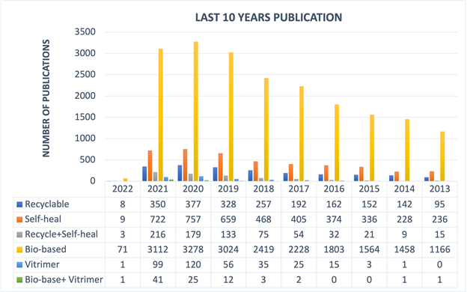
Figure 1. The number of publications containing the word “Recylable Polymers”, “Self-healing Polymers”, “Recylable + Self-healing Polymers” “Bio-based Polymers” “Vitrimers” “Bio-based Polymers + Vitrimers” in the title published in the period of 2013 -2022 (using Scopus database; date of search: October 2021).

The European bio-plastics industry reports the bio-polymers production capacity to increase from 2.11 million tons (in 2018) to nearly 2.61 million tons (in 2023)[73], opening an excellent perspective for the use of such materials in vitrimeric systems. About 65% of bio-based polymers have been utilized in packaging industries. There is a perfect opportunity for the rest of the bio-based materials involved in catering products, consumer electronics, automotive, agriculture/horticulture. [77] (see, e.g. the study of the NOVA Institute: http://bio-based.eu/market_study/media/files/13-06-21MSBiopolymersExcerpt.pdf)[66]. Lack of performance, durability, repair, reuse, and reprocess/recycle ability have restricted their use in many applications and limited their introduction into the commercial market. They are also hampered by variations in chemical composition when collected from different sources[66,67]. Especially in thermosets, the use of bioderived components is essential[60], although recycling issues in thermosets are largely unsolved when approaching nanocomposite-filled thermoset systems[78] or carbon-fiber based resins, as, e.g. commonly used in automotive/aeroplane materials. Therefore, the use of biobased vitrimers represents one of the most important contributions of modern polymer science to generate nanocomposite-filled thermosets with a significantly lowered carbon dioxide footprint by vitrimeric reuse. The existing drawbacks can be resolved by introducing an associative dynamic covalent adaptive network (ADCAN) containing bio-vitrimers[74]. The material can exhibit recycling/processability with improved thermal and mechanical properties,
- Different mechanisms involved bio-based vitrimers
The classification of vitrimers has been executed based on different chemistries/mechanism exchanges, including the used monomers extracted from the various natural resources (lignin, fructose, sucrose, cashew nuts, etc.). Table 1 condenses the chemistries and uses bio-monomers to design ADCAN based polymers, percentage of renewable biocarbon as well as their healing properties.

3.1 Transesterification exchanges
Ester groups offer flexibility, adhesion, water resistance to the resulting materials, wherefore vitrimers based on transesterification exchange have been one the most attractive choices for researchers[79]. Recently, transesterification promoted lignin-based vitrimers were developed with sebacic acid derived epoxy monomers and ozone crafted lignin (curing agent) in the presence of zinc catalyst[80]. An addition of lignin had enriched the presence of ester/hydroxyl groups in the crosslinked network, thus improving the thermal and mechanical properties of the vitrimers. These developed vitrimers exhibit self-healing and shape memory behaviour at 190 ⁰C for 5 min (healing efficiency = 70%) and at 80 ⁰C (recovery ratio = 87%- 97%), respectively, and demonstrates fast stress relaxation at above 160 ⁰C via transesterification chemistry. The reported epoxy vitrimers show good adhesive properties, where joint aluminium sheets exhibit sufficient strength (6.5 MPa), similar to commercially available adhesives (8 MPa) (Figure 2)[80].
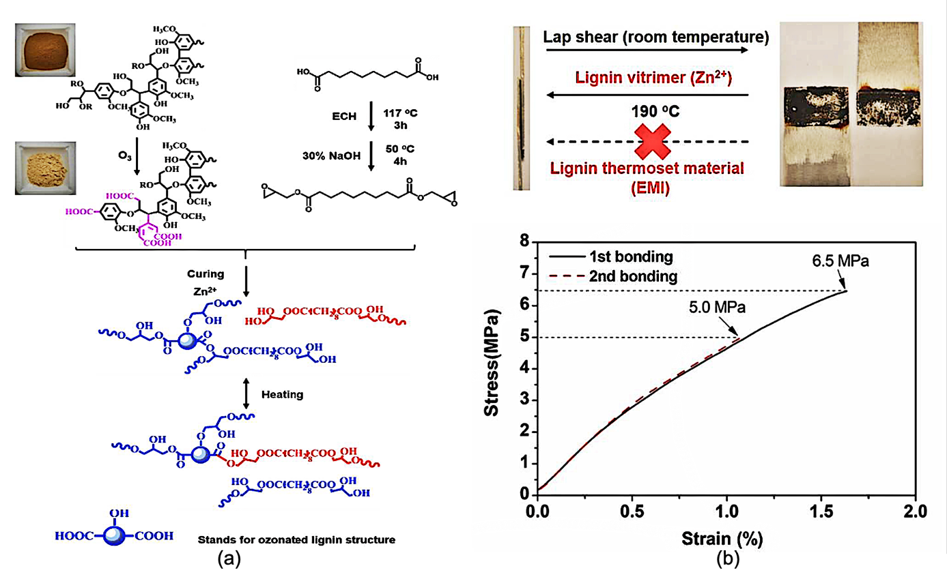
Figure 2. (a) Schematic preparation of the Se-EP/Oz-L vitrimer and its reconstruction through TERs. (b) Lap shear strength of vitrimer adhesive joint. Reproduced with permission[80].
Due to their abundant availability, Lignin-derived polymers have been studied for years, acting as a substitute for many purely synthetic poly(hydroxyl)polymers used in vitrimeric systems. Zhang and co-workers have developed vitrimeric materials based on lignin-derived polycarboxylic acid (L-COOH) and poly (ethylene glycol) diglycidyl ether (PEG-epoxy)). The produced vitrimers were used as a coating material, displaying thermal self-healing based on different percentages of PEG-epoxy/L-COOH (1:1, 1:1.5, 1:2)[81]. Stress relaxation analysis found a slow relaxation for 1:1.5 composition compared to samples with 1:1 and 1:2 composition. A vitrimer with a high hydroxyl- and carboxyl- containing epoxy content demonstrates self-healing efficiencies up to 100%. A similar trend of self-healing efficiency (with 10% reduction) was observed, identical to specimen, for reported vitrimers when coated in tin plates to determine the repairability and removability[53]. A bio-based epoxy/ cashew nutshell liquid vitrimer was treated with multi-walled carbon nanotubes (CNT), where shape memory and self-welding phenomenon were observed for both the thermal and photoinduced transesterification exchanges[82]. The thermally generated shape memory was achieved at 60 ⁰C. At the same time, the addition of CNT (till 0.5%) was also helpful to rapid up the shape recovery, ascribed due to the energy storage capacity of the carbon nanofillers[83]. The vitrimers also demonstrate shape recovery behaviour even after the fifth cycle (recovery ratio= 100%) under near-infrared (NIR)irradiation. A reduction in time for shape recovery was observed due to CNT’s, as these material converts light energy into thermal energy and thus helps to achieve a fast shape recovery. The addition of CNTs was also helpful to suppress stress relaxation and adhesive fracture energy[82].
Polymeric materials can be designed from vegetable oils due to their renewability and biodegradability. Liu and co-workers demonstrated a bio-based epoxy vitrimer, where the performed epoxy vitrimer was prepared from epoxidized soybean oil (ESO) and fumaropimaric acid (FPA) in the presence of zinc acetylacetonate as catalyst[84]. The FPA derived ESO-FPA_{1.0} based vitrimeric network displays a higher tensile strength (16.62 MPa) than the conventional citric acid cured ESO (0.6 MPa) networks. The higher crosslinking densities were observed due to a rigid hydrogenated phenanthrene ring and more reactive groups of FPA. The performed vitrimer material was degraded with ethanol at 120 ⁰C for 2h, where ethanol hydroxyl groups were reacted with the ESO-FPA ester groups, and curing was conducted in the absence of a catalyst. Still, the recycled vitrimer exhibits a reduction in T_{g} (65 ⁰C to 30 ⁰C) as well as in tensile strength (decreased from 16 MPa to 10.5 MPa)[84].
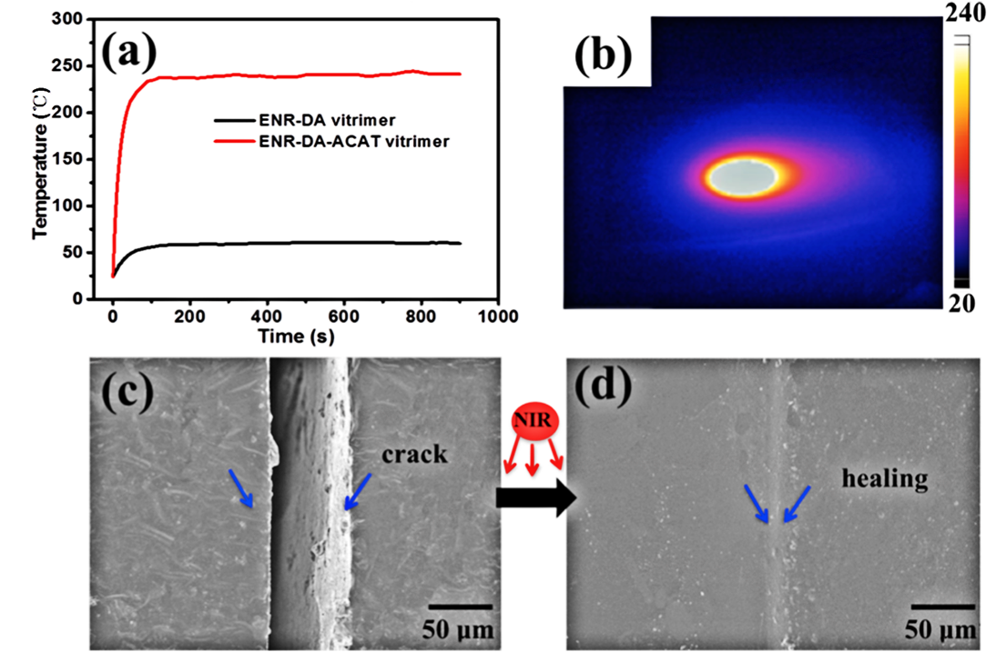
Figure 3. (a) Temperature curves of ENR-DA-ACAT vitrimer and the sample without ACAT (ENR-DA vitrimer) dependent on NIR light irradiation time. (b) The temperature of ENR-DA-ACAT vitrimer when irradiated for 900 s. NIR-light-triggered healing of ENR-DA-ACAT vitrimer with crack healed using local irradiation for (c) 0 min and (d) 15 min. Reproduced with permission[85].
Zhang and co-worker[86] developed lignin-derived eugenol based epoxy-vitrimers and further treated it with succinic anhydride (SA) in the presence of zinc catalyst. The reported epoxy vitrimer demonstrates self-healing at 190 ⁰C and shape memory and fast stress relaxation at 80 ⁰C and 200 ⁰C, respectively. The recycling of the material was achieved through physical and chemical principles, where the epoxy vitrimer was reprocessed at 160 ⁰C for one hour in a hot press to give a newly designed shape by direct physically induced reshaping. Under the addition of ethanol, the network can be chemically degraded as decomposition of the polymer took place at 160 ⁰C to regenerate monomers and, in turn, re-polymerize to achieve a novel epoxy-resin with similar properties as before[86]. Epoxidized natural rubbers containing dodecanedioic acids (DAs) and aniline trimer (ACAT, a kind of oligoaniline) were used to generate vitrimers allowing the recycling, displaying both self-healing and shape memory behaviour. While the introduction of ACAT accelerates this transesterification with an activation energy of ~ 58.5 kJ/mol, thus reaching the temperature for conventional reprocessing conditions. Self-healing and shape memory studies were performed at thermal and NIR-conditions (near-infrared) (Figure 3 a-d). Thus thermally-induced self-healing and shape memory were observed at 200 ⁰C for 30 mins (recovery tensile efficiency = 80%) and 80 ⁰C (shape recovery ratio = 95%), respectively, with recycling of the material accomplished at 200 ⁰C for 20 mins, 15 MPa. The recycled material efficiency was analyzed via tensile studies and reached about 88% recovery in efficiency after the third recycling [85].

β-activated ester (diethylmalonate [DEM]), extracted from fruit juices (blackberry, pineapple, guava) has also been explored to prepare a partially bio-based vitrimer polyesters [87]. A catalyst free ester exchange based vitrimer were prepared by the reaction of poly-(hydroxyethyl methacrylate) (PHEMA), a hydroxyl precursor with DEM. The material demonstrates reprocessing (150 ⁰C, 5h, compress under 40 kg load) and self-healing (150 ⁰C, 5h) properties without sacrificing the mechanical properties. Methacrylic ester, a derivative of natural oil is in use to lower the T_{g} as well as helpful to improve the flexibility of the resins[88]. Recently, Maric and co-workers reported a dynamic covalent boronic ester based methylacrylic vitrimer with moisture triggered self-healing functions[89]. The partially bio-based vitrimer was synthesized using C13 methacrylate (methacrylic ester 13.0, C13MA,76% bio carbon content) and isobornyl methacrylate (IBOMA, 71% bio carbon content-from pine sap), copolymerized with 4-vinylphenylboronic acid (VPBA) and glycerol monomethacrylate (GMMA). An ambient temperature scratch healing (under relative humidity) was observed for both the co-polymers. The polymers also demonstrate reprossing at 80 ⁰C (within 50 min) as well as a 87% recovery in stress at break. In addition, the study found that the addition of VPBA and GMMA significantly improve the heat resistance of polymers up to 121 ⁰C, compared to the IBOMA/C13MA copolymers (without GMMA and VPBA functional monomers)[90]. A naturally available glycyrrhizic acid (GL) consisting of hydrophilic diglucuronic unit and rigid hydrophobic triterpenoid is widely used in medicinal ingredients and food sweeteners, as well as it can easily be incorporated into the biocompatible self-assembled materials[91]. Glycyrrhizic acid and epoxidized soybean oil (ESO) based fully biobased vitrimer consisting of recyclable, weldable, and self-healing properties via transesterification exchange has been reported by Li and co-workers [92]. ESO/GL based Vitrimeric materials demonstate an excellent lap-shear strength of 3.42, 2.89, and 2.49 MPa for original, repaired and recycled samples, respectively, and thus, seems a promising recyclable adhesive. A similar kind of study was reported by Athanassiou and co-workers, where a biobased reprocessable thermoset was developed using diboronic ester dithiol and epoxidized soynean oil. The vitrimer polymer demonstrates a multiple time reprocessibility and recyclability along with room temperature healing without compromising its mechanical properties [93].
Overall, a temperature-induced dynamic reaction between the ester and –OH group can achieve shape-changing and repair properties. Primarily, metal catalyst promoted active transesterification reactions have been reported. However, to cope with this issue, the effect of neighbouring groups’ participation and internal catalysis could enhance the impact on exchange reactions. However, these approaches are sometimes only preliminary, in particular, for the vitrimers derived from bio-based chemicals.
3.2 Disulfide exchange
Disulfide bonds are known for their reversible behavior and have been involved in vulcanization of rubbers for a long time[94]. In 1946, Steven and co-workers discussed the reshuffling of these bonds to study the stress-relaxation in these materials[95]. Indeed, the thiol/disulfide exchanges, as well as self-healing, depends on the chosen stoichiometry of the disulfide containing polymers[96]. Guo and co-workers have reported a catalyst-free disulfide exchange promoted reprocessable and self-healable vitrimers based on vanillin-derived dialdehyde and amine monomers. The performed catalyst-free vanillin vitrimers were optimized with different hardener molar ratios of 4-AFD (4,4’-disulfanediyldianiline) and tris (2-aminoethyl) amine[97]. The catalyst-free, disulphide-promoted epoxidized soyabean oil (ESO) based vitrimers were generated from that place [98], with variable percentages of crosslinking density in these networks, including different curing times at 180 ⁰C. These epoxy vitrimeric (28h cured) specimens demonstrate outstanding tensile strength due to their high crosslinking density. All the performed samples displayed a catalyst-free disulfide exchange and could be reprocessed efficiently at 180 ⁰C for 10 min under a pressure of 20 MPa [98]. Li and co-workers[54] utilized isosorbide derived monomers and aromatic diamines (4,4’-disulfanediyldianiline (MDS)), to generate a catalyst-free disulphide vitrimer. The resulting material demonstrates better thermomechanical properties in comparison to the conventional epoxy using 4,4’-methylenedianiline (MDA)) as curing agents. Due to the disulfide exchanges, a faster stress relaxation time (197 s at 130 ⁰C to 12 s at 170 ⁰C) and a T_{v} (31.3 ⁰C) was observed via the Arrhenius equation (equation 1). The material exhibits a prominent reprocessing and self-healing at 100 ⁰C for 60 mins and shape memory behavior at 80 ⁰C for 1 min. It was owing to the presence of isosorbide (a water-soluble polymer) the degradation of specimens was observed in a 5 wt% NaOH aqueous solution. The recycled material efficiency reduced continuously on each responding cycle which could be due to the oxidation of sulfur radicals at high temperature or C-C bonds' scission by grinding[54].
Among dynamic exchange reactions, disulfide exchanges have been a good choice for researchers, where aromatic disulfides are mainly investigated, being catalyst-free. However, literature remains limited to discuss the effect of nitrogen and other activation groups on the activation energy and bond dissociation energy, effective for more radical generation, and thus a fast and easy exchange reaction.
3.3 Imine exchange
Since long ago, imine chemistry was attractive for its reversible bondings, now being a superior bond, in dynamic covalent networks, thus being widely explored in materials chemistry[48][99]. Imine exchange promoted bio-based vitrimers were prepared from fructose derived furan dialdehyde and di-/tri-amines derived from fatty acids. Due to the dynamic interaction of the imine reversible bonds, the reported vitrimers demonstrate a fast stress relaxation even at room temperature. The observed glass transition temperature (T_{g}= -10 ⁰C) of this bio-based polyimine vitrimer was higher than the extrapolated T_{v} (-60 ⁰C). Reprocessing of imine vitrimers was performed three times (at 120 ⁰C for 10 min) without any significant loss of the mechanical properties (Figure 4a-4b)[48].

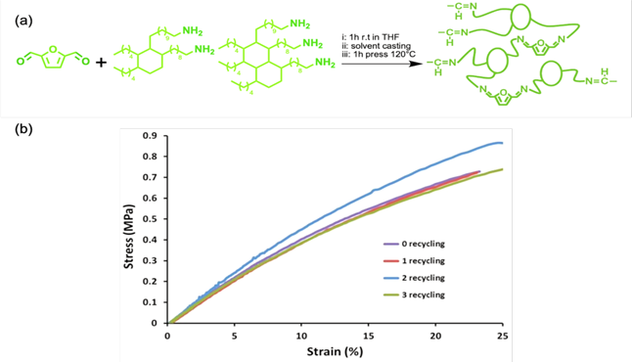
Figure 4. (a) Bio-based polyimine vitrimer reaction; (b) Stress-strain curves of vitrimer for different recycling cycles. Reproduced with permission[48].
In addition, lignin-derived vanillin based di-aldehyde monomers were treated with a conventional diamine to obtain bio-based vitrimers, where imine covalent exchange enables the reprocessing and recycling. The dynamic imine metathesis reaction promotes self-healing at 180 ⁰C for 1h (Figure 5a), where cut/damaged specimen shows optimal mechanical recovery after healing at 150 ⁰C for 1h (healing efficiency = 74.5%). The samples were reprocessed using hot pressing, where even after the third reprocess cycle, the specimens demonstrate a 71.2% tensile strength and a 72.8% elongation-at-break compared to the initial material. Chemical recycling was observed under an acidic environment at 50 ⁰C, and the obtained aldehyde monomer can be reused to prepare vitrimers (Figure 5b)[100].

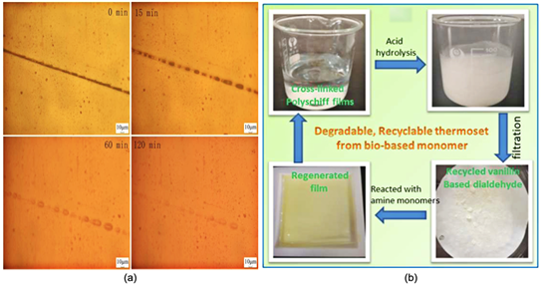
Figure 5. (a) Optical images of vitrimeric polymer scratch healing at 180 ⁰C for a different time; (b) Chemical recycling of crosslinked polyimine films (conditions: 50 ⁰C, pH =2, 24 h). Reproduced with permission[100].
In 2020, Zhao and co-workers reported a vitrimer based on a catalyst promoted epoxidized soybean oil (ESO) derived epoxy chemistry, which was cured with vanillin derived Schiff based hardener. In comparison to the ESO containing conventional polymers, the polymer produced shows better mechanical properties, including reprocessing ability. Due to the Schiff (imine) based exchanges, the material exhibits a reprocess- and self-healing behavior at 190 °C under 20 MPa for 5 mins and 150 ⁰C for 20 mins, respectively. In addition, the recovery was retained almost after reprocessing (92%), as evaluated via tensile studies[101]. In addition, vanillin based polyimine vitrimers were developed via condensation of vanillin-derived functionalized aldehydes and biobased amines [102]. The results indicated that the glass transition temperature (T_{g}) of vitrimer increases with the increase in cross-linking density. The vitrimers showed good malleability and recyclability even with high cross-linking density.
3.4 Other exchange reactions
Isocyanate-free polyester-hydroxy urethanes were prepared using sugar derived dimethyl-2,5-furan dicarboxylate (DMFD). The non-isocyanate polyester-urethane (NIPHEU) vitrimer exhibits a covalent exchange based on transcarbomylation chemistry[103]. With onset degradation temperatures ranging from 170 to 220 ⁰C, the reported polymers demonstrated good thermal stability with high melting temperatures from (93 to 110 ⁰C), including a striking thermal change in the NIPHEUs upon repetitive heating cycles[103]. Zhu and coworkers have developed castor oil-based vinylogous urethane vitrimers using aminate DL-limonene (AL). The performed catalyst-free vinylogous urethane vitrimer had demonstrated exchanges via transamination mechanism. The reported vitrimer also exhibits a low glass transition temperature (T_{g}= 39 ⁰C) and provides evidence for reprocessing and shape memory[Figure 6]. The amine exchanges in vinylogous urethane enable reprocessing at 160 ⁰C, 6 MPa for 30mins, and shape memory at 70 ⁰C for 1 min[104]. Indeed, such natural resource-based vitrimeric PUs would be an exciting material for industries.
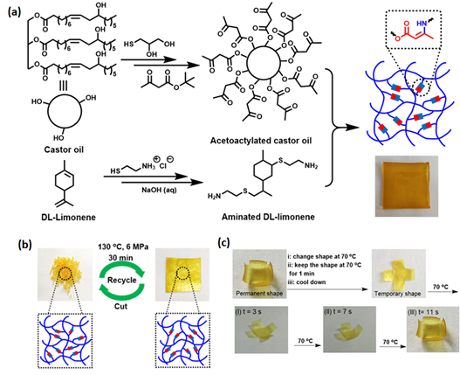
Figure 6. (a) Synthetic route of vinylogous urethane vitrimer from castor oil and DL-limonene; (b) Images of cut polymer pieces and remolded polymer film; (c) Shape memory properties of bio-based vinylogous urethane vitrimer. Reproduced with permission [94].

Maric and co-workers have explored a miniemulsion polymerization technique to prepare a heat activated transamination exchange based vitrimers[105]. The vitrimers were developed using commercially available (2-acetoacetoxy) ethyl methacrylate (AAEMA), a pine sap extracted isobornyl methacrylate (IBOMA), and vegetable oils derived priamine. The impact of different amount of POSS-NH₂ (0, 5, 10, 20 wt%) incorporation onto the vitrimer properties was also studies, where an improvement in tensile strength (from 2.5 to 5 MPa), tensile modulus (from 96 to 176 MPa) as well as a slow down in relaxation rate was observed with the incorporation of 20% POSS-NH₂ nanofillers. Interestingly, the vitrimer nanocomposites can be recycled by grinding and remolding at 125 ⁰C without any loss in mechanical properties as well as enable to un-crosslink by dissolving in monofunctional amines at 65 ⁰C.

 | Table 1. Different bio-based vitrimer recycling, self-healing and shape memory conditions
Mechanism |  | Bio-based derivatives | Material | Recycling/ Reprocessing | Self-healing | Shape memory |  | % of renewable bio-carbon | Ref
Trans-esterification |  | Lignin | Sebacic acid derived epoxy and ozone crafted lignin | ----------- | 190 ⁰C for 5mins, 70% ^{b@} |  | 80 ⁰C for less than minute, 87%-97% ^{c} | 100% | [80]
 |  | Lignin | Eugenol derived epoxy with succinic anhydride | 190 ⁰C for 1h,  Low efficiency ^{a#} | 190 ⁰C for 1h,  90% ^{b*} |  | 80 ⁰C for less than minute, 100% ^{c} | 47-48% | [86]
 |  | Soybean | Epoxidized soybean oil (ESO) and rosin derived Fumaropim-aric acid (FPA) | 120 ⁰C for 2h, 88% ^{a*} | 180 ⁰C for 60 mins,  Nearly 100%^{b^} |  | 80 ⁰C for 30 mins, 89% | 100% | [84]
 |  | Natural rubber | Epoxidized natural rubber with dodecanedioic acids (DAs) and aniline trimer (ACAT) | 200 ⁰C for 20 mins, 88% ^{a#} | NIR and 200 ⁰C for 30 mins, 80% ^{b*} |  | NIR and 80 ⁰C for less than a minute,  95% ^{c} | 100% | [85]
 |  | Cashew nut | Epoxy/ cashew nutshell liquid and multi-walled carbon nanotubes (CNT) | ---------- | ---------- |  | NIR and 60 ⁰C for less than a minute,  100% ^{c} | 32-33% | [82]
 |  | Plant tissue | Itaconic acid-based epoxy with phytic acid | 160 ⁰C under 5 MPa for 1.5 h | ------------ |  | ------------- | 100% | [106]
 |  | Fruit juice | Fruit juice derived Diethylmalonate based polyesters | 150 ⁰C, 5 h under 40 Kg load | 150 ⁰C, 5 h  100% ^{b*} |  | ---------- | 21% | [87]
 |  | Pine sap | Isobornyl methacrylate (IBOMA, 71% bio carbon content-from pine sap) and C13 methacrylate (C13MA,76% bio carbon content) | 80 ⁰C,  <1h, 6-13 metric tons | Room temperature (under relative humidity); 100%, ^{b*} |  | -------- | 72-76% | [89]
 |  | Soybean oil | Glycyrrhizic acid and epoxidized soybean oil based vitrimers | 200 ⁰C, 15 min | 200 ⁰C, 15 min (without pressure),^{@c} |  | 200 ⁰C, 10 min, 92% | 100% | [92]
 |  | Soybean oil | Epoxidized soybean oil acrylate derived boronic ester vitrimer | Hydrolysis in 9% ethanol | RT, 6h |  | ------ | 51% | [93]
 |  | Isosorbide | Isosorbide derived epoxy and aromatic diamines | 100 ⁰C for 1h, 82.6% ^{a*} | 100 ⁰C for 1h,  100% ^{b*} |  | 80 ⁰C for 1min  100% | 41% | [54]
Disulfide |  | Soybean | Epoxidized soybean oil (ESO) cured with 4, 4’-dithiodiphenylamine (APD) | 180 ⁰C for 10min under 20 MPa,  80%^{a~} | ------------ |  | ---------- | 56% | [98]
 |  | Lignin | Vanillin-derived dialdehyde and amine monomers | 60 ⁰C for 20min,  Maximum efficiency ^{a#} | 2 mL of ethylene diamine added with 200g weight for 30 min |  | ---------- | 82-100% | [97]
 |  | Fructose | Furan dialdehyde and fatty acid-based diamine/ triamine | 120 ⁰C for 10mins, Nearly 100% ^{a*} | ---------- |  | ---------- | 100% | [48]
Imine exchange |  | Lignin | Vanillin based dialdehyde monomer with conventional diamine | 150 ⁰C for 10 mins,  71.2% ^{a*} | 150 ⁰C for 1h,  74.5% ^{b*} |  | ---------- | 82-84% | [100]
 |  | Soybean | Epoxidized soybean oil (ESO) with vanillin derived Schiff base (VSB) dynamic hardener | 190 °C under 20 MPa for 5 mins,  85.0%~92.0%^{a*} | 150 ⁰C for 20 mins,  95.5% ^{b*#} |  | ---------- | 62-64% | [101]
 |  | Sugar | ﻿Dimethyl-2,5-furan dicarboxylate (DMFD) with polyhydroxyl-urethanes (PHUs) adducts | ------------- | ---------------- |  | --------- | 100% | [103]
Trans-carbomylation |  | Castor oil | Castor oil involved vinylogous urethane vitrimer was developed with aminate DL-limonene (AL) | 160 ⁰C, 6 MPa for 30mins | ---------------- |  | 70 ⁰C for 1 min, 100% | 43% | [104]
Trans-amination |  | Pine sap | Pine sap extracted isobornyl methacrylate (IBOMA), and vegetable oils derived priamine based polymethacrylate vitrimers | 125 ⁰C,  14 metric tons, 6 h | 125 ⁰C, 6h, 90% ^{b*} |  | ----- | 64-66% | [105]
[a]- recovery efficiency. [b]- healing efficiency. [c]- shape recovery ratio. [*]- tensile strength. [@]-Lap shear. [#]- stress-strain. [^]-scratch. [$]-cut and overlapped. [~]- elongation at break
4. Biomass derived green vitrimers
The green materials are recently getting attention from the researchers as the promising bio-based investigations are remarkably needed to produce economic and sustainable vitrimeric materials. The reusable and recyclable green vitrimeric blends and composites have been reported in recent times (Table 2), where the incorporation of cellulose, chitosan, chitin, etc., would not only helpful to reduce the cost but also provide a facile way to extend the applications of vitrimers in different fields. Zhao and co-workers reported a cellulose paper-based polycarbonate vitrimer (vitrimer-paper composites), prepared via in-situ polymerization of bis (6-membered cyclic carbonate) (BCC) and 1,3-Propanediol (PD) [107]. The transcarbonation exchange based materials demonstrate good mechanical properties and exhibit shape memory, self-healing and reprocessing behavior at optimal conditions (Table 2), which is helpful to attain recycling at mild conditions. Based on bis (6-membered cyclic carbonate) (BCC) and 1,3-propanediol (PD) ratio, the vitrimer’s tensile strength in a 1/0.5 ratio of BCC/PD results a high tensile strength (42.7 MPa)[107]. Shape memory and self-healing were achieved at 150 ⁰C (75% efficiency). Further, separately cut specimens were reconnected together at 170 ⁰C for 2 h, at 4 MPa, resulting in an 80% healing efficiency[107] (Figure 7). The material shows a full recycling under mild condition (IM HCl solution, 90 0C, 36h), where natural cellulose and polycarbonate can be recovered using simple filtration process.
Similarly, abundantly available chitin integrated vitrimer epoxy composites were fabricated via layer-by-layer fabrication method[108]. A chitin/epoxy film was prepared with different weight percentage of chitin (i.e. CF1, CF3, and CF5 contained 0.7%, 2.0% and 3.5% of chitin, respectively). Significantly, the addition of chitin has a high impact on tensile moduli (from 47.5 MPa (CF1, 1 layer) to 182.9 MPa (CF5, 5 layers), where compared to pristine vitrimer, a 412% improvement in tensile moduli was observd for the composite materials. In addition, the self healing (160 ⁰C, 100 KPa for 3h), shape memory (60 ⁰C for 90s) and recycling (180 ⁰C, 200 kPa for 90 mins) was obtained; however, in this case the recycled samples did not exhibit a prominent efficieny[108]. Furthermore, a polymer networks was induced to perform vitrimer like transesterification exchanges with the addition of bio-based carboxy methyl cellulose and glycerol/ bio polyol in the system, where the role of different mole percentage of glycerol and TBD was investigated effectively [109]. The best compositon sample demonstrates a 84% tensile recovery after two consecutive remolding at 140 °C under a pressure of 2.5 KPa; whereas, a quick self healing was observed at 100 ⁰C. In addition, cellulose-modified halloysite nanotube (HNT-C) were incorporated in vitrimer epoxy matrix, where a transesterification exchanges based recycling was observed for the prepared composites[110]. The performance of the material were enriched by the incorporation of HNT-C (0.3 wt%) and thus results self healing at ΔH_{ave}= 305- 551 J/g[110]. In addition to this, the cellulose nanocrystals had introduced with post consumer used epoxy material, prepared with ball milling (mechno-chemical) technique, and the obtained samples demonstrate vitrimer behaviour (via transesterification) with nanocrystals contains hydroxyl groups. The composites consisting of 15% of CNC exhibits excellent reprocessing at 220 °C (at 5 MPa for 60 min) and self-healing/ shape memory at different conditions (Table 2) [111]. Certainly, the green material establishment and involvement would enrich the vitrimeric material to a high performance reliable real-time application materials.
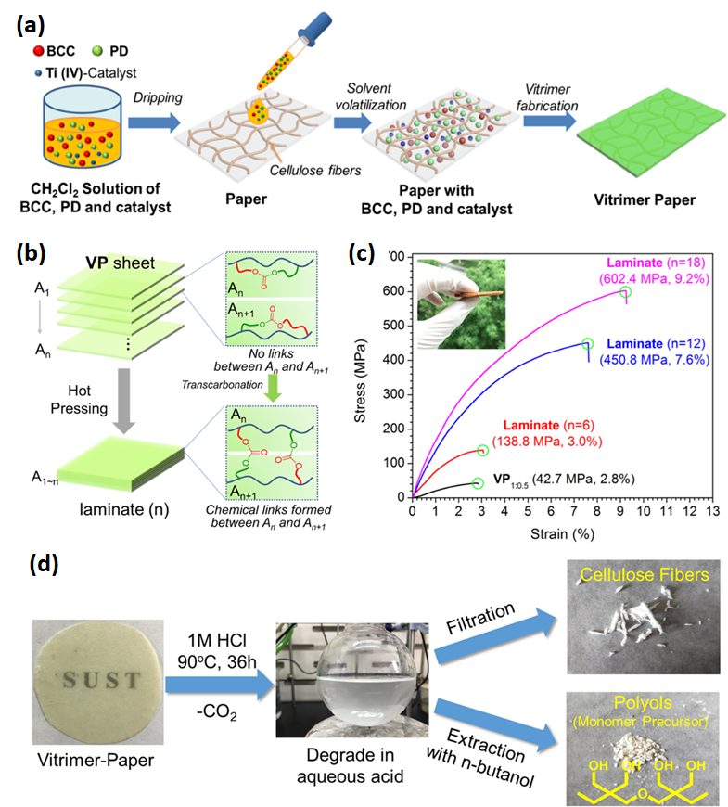
Figure 7. (a) Schematic Diagram of the Fabrication of Paper-Reinforced Polycarbonate Vitrimer; (b,c) Demonstration of the reprocessing ability of curved vitrimer-paper composites using VP sheets to prepare VP laminates via hot pressing, (b) diagram of laminate preparation; (c) tensile stress−strain curves of resultant laminates; (d) Chemical recycling of paper-reinforced vitrimer VP[107].

Table 2. Green Vitrimers
Polymer | Bio-based material | Chemistry | Material formation | Recycle/ Reprocess | Self- heal | Shape Memory | % of renewable bio-carbon |  | Ref
Bis (6-membered cyclic carbonate) (BCC) and 1,3-Propanediol (PD) | cellulose paper | Trans-carbonation | Infiltrated vitrimer into bio material | HCl at 90 ⁰C for 36h | 160 ⁰C for 10s, 75% ^{b*^}and 170 °C for 2h, 4 MPa, 80% ^{b*$} | 150 ⁰C for less than minute ^{c} |  | 14-16% |  | [107]
Epoxy/COOH/ Zn(ac)₂ | Chitin film | Trans-esterification | Multilayered | 180 ⁰C, 200 kPa for 90mins | 160 ⁰C, 100 KPa for 3h | 60 ⁰C for 90s |  | 0.3- 1.5% |  | [108]
Bisphenol A and epichlorohydrin with Cycloaliphatic Epikure | Cellulose-functionalized HNT (Halloysite nanotube) | Trans-esterification | Solvent exchange | ---------- | ΔH_{ave}= 305- 551 J/g | ---------- |  | 0.01-0.05% |  | [110]
Epon 828 and anhydrid mixed with catalyst methylimidazole | Cellulose nano crystals | Trans-esterification | Mechano- chemical (Ball milling) | 220 °C and 5 MPa for 60 min | 200 ⁰C for 30 mins | 200 ⁰C for 10 mins |  | Upto 7% |  | [111]
Bisphenol A digly- cidyl ether (DGEB), TBD and zinc acetate (Zn(Ac)₂) | Carboxy methyl cellulose (CMC) and glycerol/ biopolyol | Trans- esterification | Insitu polymerization | 140 °C under a pressure of 2.5 MPa for 1h, 84%^{a*} | -------- | 100 °C for few second |  | 20-22% |  | [109]
[a]- Reovery efficiency. [b]- healing efficiency. [*] Tensile. [@]-Lap shear.

The above reactions represents a notable toolbox to choose the desirable crosslinking chemistry based on the available bio-derived chemicals. However, selecting a low cost and effective catalyst, solvent, crosslinking chemistry, including the effect of neighbouring groups, provides significant room to explore new dynamic exchange reactions. Thus, some identical unexplored bio-derivatives are also identified, and these novel molecules could be interesting for researchers in the field of sustainable vitrimers (Table 3).

Table 3. Still unexplored bio-derivatives of potential use for vitrimers
Identical for | Bio resource | Derived monomer | Chemical Structure | Ref
Trans- esterification | Cardanol | Acid anhydride and carboxyl acid | 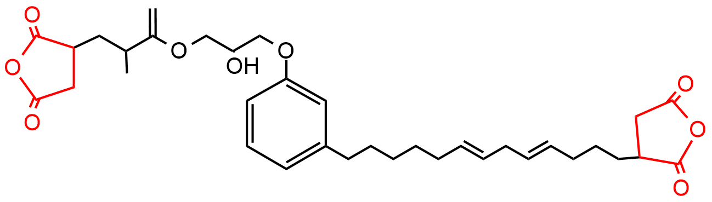 | [112]
Trans-esterification  and  Disulfide | Guaiacol | N-heterocyclic epoxy | 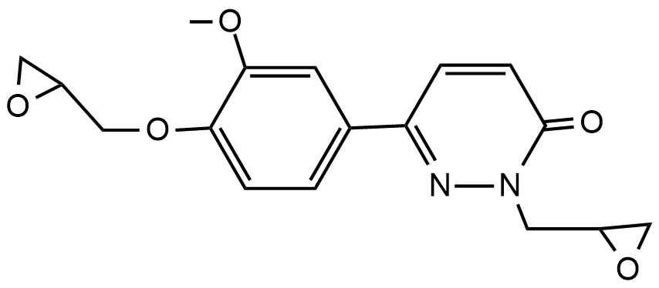 | [113]
Trans-esterification  and  Disulfide | Cardanol | Polyepoxide cardanol glycidyl ether | 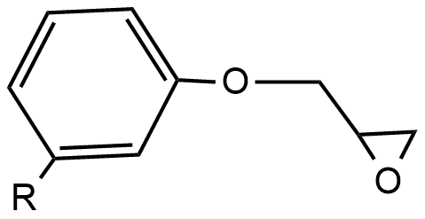 | [114]
Trans-esterification  and  Disulfide | Cardanol | cardanol novolac epoxy | 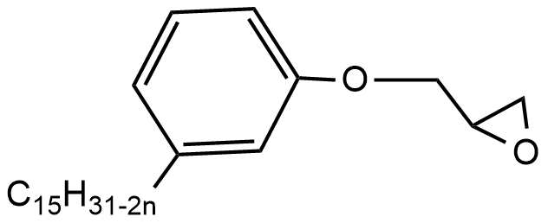 | [115]
Trans-esterification  and  Disulfide | Cardanol | Difunctional glycidyl ether epoxy | 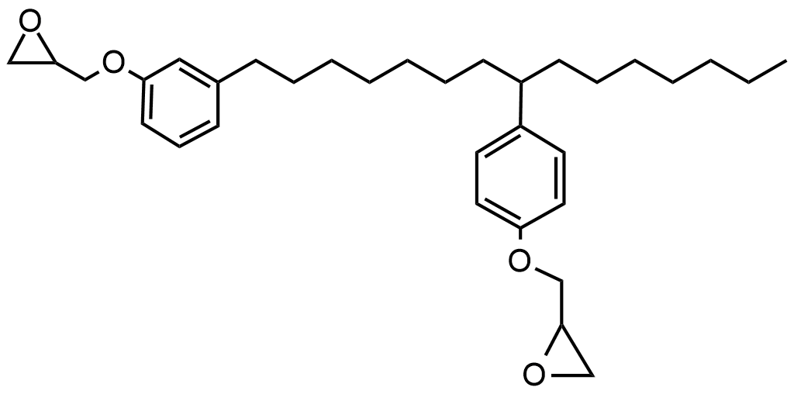 | [116]
Trans-esterification  and  Disulfide | Tannin | Tetra-glycidyl gallic acid | 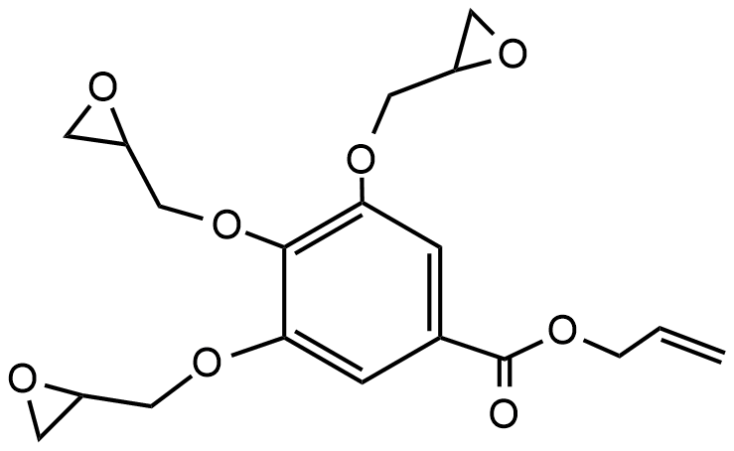 | [117]
Trans-esterification  and  Disulfide | Tannin | Sorbitol polyglycidyl ether | 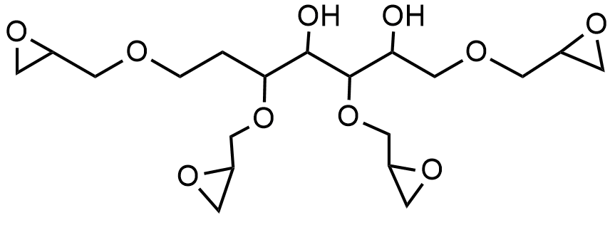 | [118]
Trans-esterification  and  Disulfide | Tannin | Phloroglucinol triglycidylether | 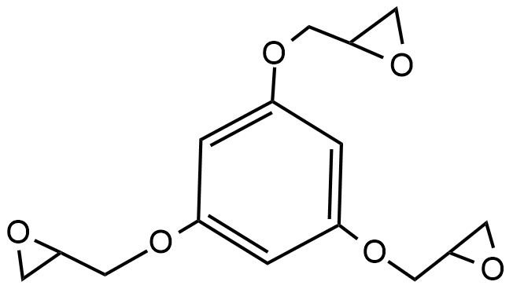 | [119]
Trans-esterification  and  Disulfide | Ferulic acid | Triglycidyl glyceroltriferulate | 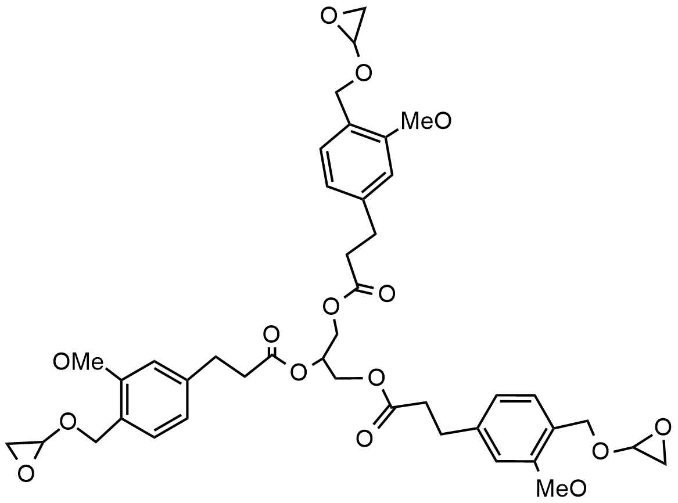 | [120]
Trans-esterification  and  Disulfide | Resveratrol | Triglycidyl ether | 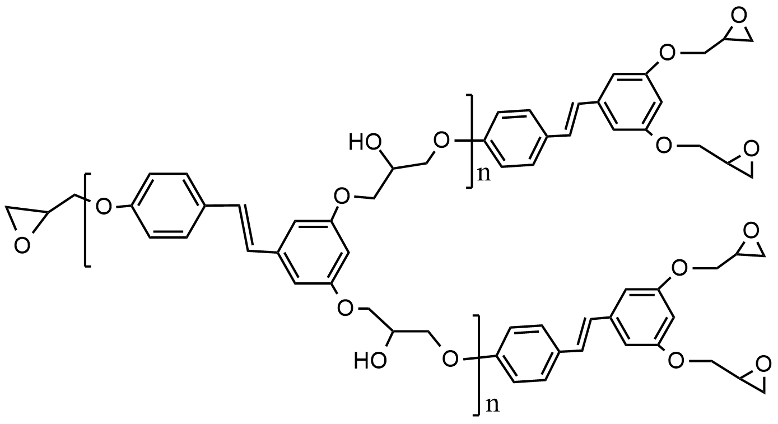 | [121]
Trans-esterification, Trans-amination, Transalkylation,Trans-carbamoylation, Disulfide and Imine exchanges | Cardanol | Phenalkamines | 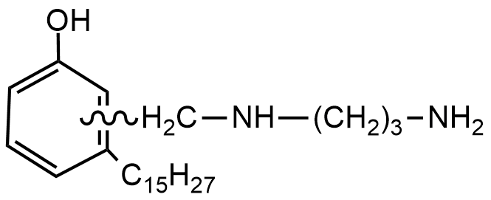 | [122]
 | Cardanol | Polyamine | 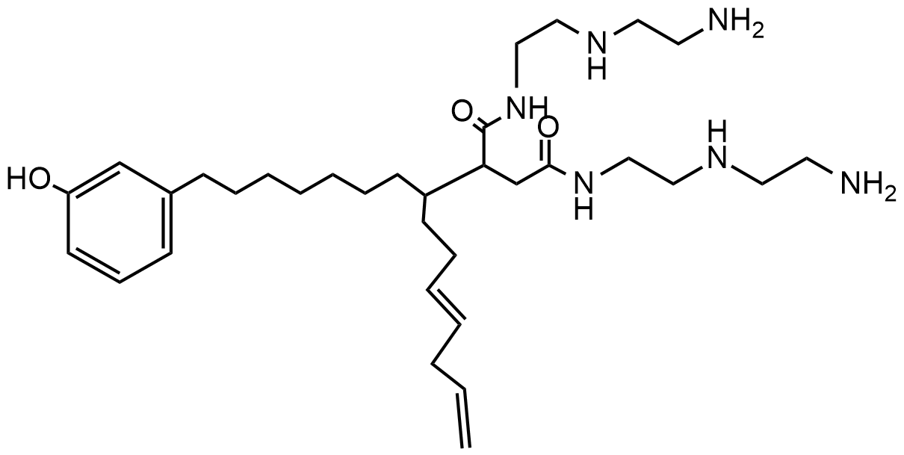 | [123]
 | p-cymene | 4,4’-methylenedianiline | 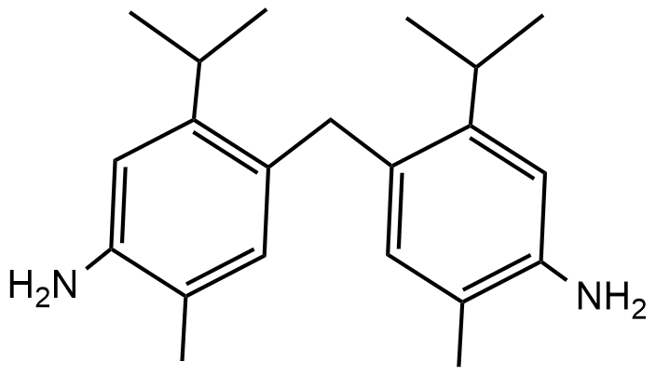 | [124]
- Summary and outlook
The use of bio-based materials mainly aims to reduce the number of synthetic polymers, often in the form of composites, where bio-based resources replace part of the synthetic materials. Keeping material performance similar to the unmodified product represents a significant challenge, as many physical parameters must be considered when adding novel components to already established materials.
An important point to be considered in biobased vitrimers is their overall stability upon thermal recycling and reprocessing, requiring the vitrimeriy temperature, Tv, being lower than decomposition temperatures of biobased materials used therein. The search for novel vitrimers with more satisfying reprocessing temperatures, also within several cycles, therefore represents a significant challenge, putting an effort not only to the choice of the biobased components but also to the catalyst/chemical system of choice to affect the vitrimeric behavior.
Overall, bio-based vitrimers can be advantageous when factors like the availability of the biobased additives and their true sustainability. In addition, the availability of new bio-molecules/monomers open the door for materials researchers as designing/synthesis of a few monomers/molecules form the petrol-chemicals is truly difficult. Along with this a bio-material design is made from scratch, allowing to plan material properties in line with their future life cycle from the very beginning. Thus, transesterification exchange reactions focus on this type of vitrimeric system has been developed and is primarily explored. Many of these materials from biobased resources, such as lignins and fatty acids, achieve a high self-healing efficiency with the vitrimeric behavior reaching extrapolated activation energies of 54.42 kJ/mol, allowing reprocessing at temperatures where conventional polyester materials are reprocessed. An equally attractive material is catalyst-free vitrimers, as they provide temperature-based recycling of many of the thermosetting polymers currently in use, given that the production of bio-based raw materials is equally developing. Although many bio-based polymers often demonstrate reduced mechanical properties, incorporating nanofillers and rigid rings based reactive molecules could result in higher tensile strength, helpful to suppress adhesive fracture energy and stress relaxation. Due to their reprocessability, malleability, and self-healing properties, vitrimers derived from bio-derived chemicals would be highly desirable for various applications, including coatings, adhesives, and automotive industries.
However, still limited literature is available for vitrimers based on bio-derived chemicals/ monomers, meriting this review as a first starter into the field. Given many thermoset-materials in polymer technology, the perspective of using recyclable, biobased materials in the vitrimeric concept is attractive. Moreover, as per current polymers' regulations, this could be one initiative to reduced CO₂ emissions. Therefore, apart from the aforementioned bio-based vitrimers, some more identical bio-derivatives are available to be explored, such as those shown in Table 3, like cardanol, tannin, phenolic adducts. Adjusting mechanical, chemical, and the required stress-relaxation properties of such materials with the proper knowledge of the underlying chemistry and physics is undoubtedly an exciting prospect for future polymer science.
Acknowledgements
We gratefully acknowledge the financial support from Science and Engineering Research Board (SERB-DST), Government of India (Grant No. ECR/2016/001355). WHB acknowledges the DFG-Graduate College GRK 2670 (German research foundation – project ID 43649874, TP B2, RTG 2670). This work was also done in the frame of the International Graduate School AGRIPOLY supported by the European Regional Development Fund (ERDF) and the Federal State Saxony-Anhalt.
Conflict of interest statement
No conflict of interest.
References
[1] A. Shiota, C.K. Ober, Rigid rod and liquid crystalline thermosets, Prog. Polym. Sci. 22 (1997) 975–1000. https://doi.org/https://doi.org/10.1016/S0079-6700(97)00014-2.
[2] J.-M. Raquez, M. Deléglise, M.-F. Lacrampe, P. Krawczak, Thermosetting (bio)materials derived from renewable resources: A critical review, Prog. Polym. Sci. 35 (2010) 487–509. https://doi.org/https://doi.org/10.1016/j.progpolymsci.2010.01.001.
[3] B.H. Rutz, J.C. Berg, A review of the feasibility of lightening structural polymeric composites with voids without compromising mechanical properties, Adv. Colloid Interface Sci. 160 (2010) 56–75. https://doi.org/https://doi.org/10.1016/j.cis.2010.07.005.
[4] T. Kaiser, Highly crosslinked polymers, Prog. Polym. Sci. 14 (1989) 373–450. https://doi.org/https://doi.org/10.1016/0079-6700(89)90007-5.
[5] W. Post, A. Susa, R. Blaauw, K. Molenveld, R.J.I. Knoop, A Review on the Potential and Limitations of Recyclable Thermosets for Structural Applications, Polym. Rev. 60 (2020) 359–388. https://doi.org/10.1080/15583724.2019.1673406.
[6] Y.C. Yuan, T. Yin, M.Z. Rong, M.Q. Zhang, Self healing in polymers and polymer composites. Concepts, realization and outlook: A review, Express Polym. Lett. 2 (2008) 238–250. https://doi.org/10.3144/expresspolymlett.2008.29.
[7] F. Sordo, V. Michaud, Processing and damage recovery of intrinsic self-healing glass fiber reinforced composites, Smart Mater. Struct. 25 (2016) 84012. https://doi.org/10.1088/0964-1726/25/8/084012.
[8] N.K. Guimard, K.K. Oehlenschlaeger, J. Zhou, S. Hilf, F.G. Schmidt, C. Barner-Kowollik, Current trends in the field of self-healing materials, Macromol. Chem. Phys. 213 (2012) 131–143. https://doi.org/10.1002/macp.201100442.
[9] M. Raimondo, E. Calabrese, W.H. Binder, P. Michael, S. Rana, L. Guadagno, Tunneling Atomic Force Microscopy Analysis of Supramolecular Self-Responsive Nanocomposites, Polym. . 13 (2021). https://doi.org/10.3390/polym13091401.
[10] A. Campanella, D. Döhler, W.H. Binder, Self-Healing in Supramolecular Polymers, Macromol. Rapid Commun. 39 (2018) 1700739. https://doi.org/10.1002/marc.201700739.
[11] T. Yan, K. Schröter, F. Herbst, W.H. Binder, T. Thurn-Albrecht, What Controls the Structure and the Linear and Nonlinear Rheological Properties of Dense, Dynamic Supramolecular Polymer Networks?, Macromolecules. 50 (2017) 2973–2985. https://doi.org/10.1021/acs.macromol.6b02507.
[12] T. Yan, K. Schröter, F. Herbst, W.H. Binder, T. Thurn-Albrecht, Unveiling the molecular mechanism of self-healing in a telechelic, supramolecular polymer network, Sci. Rep. 6 (2016) 32356. https://doi.org/10.1038/srep32356.
[13] D.Y. Zhu, M.Z. Rong, M.Q. Zhang, Self-healing polymeric materials based on microencapsulated healing agents: From design to preparation, Prog. Polym. Sci. 49–50 (2014) 175–220. https://doi.org/10.1016/j.progpolymsci.2015.07.002.
[14] V.K. Thakur, M.R. Kessler, Self-healing polymer nanocomposite materials: A review, Polymer (Guildf). 69 (2015) 369–383.
[15] B.J. Blaiszik, N.R. Sottos, S.R. White, Nanocapsules for self-healing materials, Compos. Sci. Technol. 68 (2008) 978–986. https://doi.org/10.1016/j.compscitech.2007.07.021.
[16] S. Rana, D. Döhler, A.S. Nia, M. Nasir, M. Beiner, W.H. Binder, “Click”-Triggered Self-Healing Graphene Nanocomposites, Macromol. Rapid Commun. 37 (2016). https://doi.org/10.1002/marc.201600466.
[17] F. Herbst, K. Schröter, I. Gunkel, S. Gröger, T. Thurn-Albrecht, J. Balbach, W.H. Binder, Aggregation and Chain Dynamics in Supramolecular Polymers by Dynamic Rheology: Cluster Formation and Self-Aggregation, Macromolecules. 43 (2010) 10006–10016. https://doi.org/10.1021/ma101962y.
[18] S. Chen, W.H. Binder, Dynamic Ordering and Phase Segregation in Hydrogen-Bonded Polymers, Acc. Chem. Res. 49 (2016) 1409–1420. https://doi.org/10.1021/acs.accounts.6b00174.
[19] S. Chen, N. Mahmood, M. Beiner, W.H. Binder, Self-Healing Materials from V- and H-Shaped Supramolecular Architectures, Angew. Chemie Int. Ed. 54 (2015) 10188–10192. https://doi.org/10.1002/anie.201504136.
[20] L. Brunsveld, B.J.B. Folmer, E.W. Meijer, R.P. Sijbesma, Supramolecular Polymers, Chem. Rev. 101 (2001) 4071–4098. https://doi.org/10.1021/cr990125q.
[21] P. Cordier, F. Tournilhac, C. Soulié-Ziakovic, L. Leibler, Self-healing and thermoreversible rubber from supramolecular assembly, Nature. 451 (2008) 977–980. https://doi.org/10.1038/nature06669.
[22] L. Guadagno, L. Vertuccio, C. Naddeo, E. Calabrese, G. Barra, M. Raimondo, A. Sorrentino, W.H. Binder, P. Michael, S. Rana, Self-healing epoxy nanocomposites via reversible hydrogen bonding, Compos. Part B Eng. 157 (2019). https://doi.org/10.1016/j.compositesb.2018.08.082.
[23] R. Tamate, K. Hashimoto, T. Horii, M. Hirasawa, X. Li, M. Shibayama, M. Watanabe, Self-Healing Micellar Ion Gels Based on Multiple Hydrogen Bonding, Adv. Mater. 30 (2018) 1802792. https://doi.org/10.1002/adma.201802792.
[24] K. Tian, J. Bae, Z. Suo, J.J. Vlassak, Adhesion between Hydrophobic Elastomer and Hydrogel through Hydrophilic Modification and Interfacial Segregation, ACS Appl. Mater. Interfaces. 10 (2018) 43252–43261. https://doi.org/10.1021/acsami.8b16445.
[25] H.-J. Schneider, A.K. Yatsimirsky, Selectivity in supramolecular host–guest complexes, Chem. Soc. Rev. 37 (2008) 263–277. https://doi.org/10.1039/B612543N.
[26] M. Raimondo, C. Naddeo, L. Vertuccio, L. Bonnaud, P. Dubois, W.H. Binder, A. Sorrentino, L. Guadagno, Multifunctionality of structural nanohybrids: the crucial role of carbon nanotube covalent and non-covalent functionalization in enabling high thermal, mechanical and self-healing performance, Nanotechnology. 31 (2020) 225708. https://doi.org/10.1088/1361-6528/ab7678.
[27] A. Mordvinkin, D. Döhler, W.H. Binder, R.H. Colby, K. Saalwächter, Terminal Flow of Cluster-Forming Supramolecular Polymer Networks: Single-Chain Relaxation or Micelle Reorganization?, Phys. Rev. Lett. 125 (2020) 127801. https://doi.org/10.1103/PhysRevLett.125.127801.
[28] D. Döhler, J. Kang, C.B. Cooper, J.B.-H. Tok, H. Rupp, W.H. Binder, Z. Bao, Tuning the Self-Healing Response of Poly(dimethylsiloxane)-Based Elastomers, ACS Appl. Polym. Mater. 2 (2020) 4127–4139. https://doi.org/10.1021/acsapm.0c00755.
[29] L. Guadagno, L. Vertuccio, C. Naddeo, E. Calabrese, G. Barra, M. Raimondo, A. Sorrentino, W.H. Binder, P. Michael, S. Rana, Reversible Self-Healing Carbon-Based Nanocomposites for Structural Applications, Polymers (Basel). 11 (2019) 903. https://doi.org/10.3390/polym11050903.
[30] L. Guadagno, C. Naddeo, M. Raimondo, G. Barra, L. Vertuccio, A. Sorrentino, W.H. Binder, M. Kadlec, Development of self-healing multifunctional materials, Compos. Part B Eng. 128 (2017) 30–38. https://doi.org/https://doi.org/10.1016/j.compositesb.2017.07.003.
[31] N.B. Pramanik, G.B. Nando, N.K. Singha, Self-healing polymeric gel via RAFT polymerization and Diels–Alder click chemistry, Polymer (Guildf). 69 (2015) 349–356. https://doi.org/10.1016/j.polymer.2015.01.023.
[32] R. Geitner, J. Ahner, M. Abend, S. Zechel, S. Hoeppener, B. Dietzek, M. Schmitt, Remendable polymers via reversible Diels – Alder cycloaddition of anthracene-containing copolymers with fullerenes, J. Appl. Polym. Sci. 135 (2018) 45916. https://doi.org/10.1002/app.45916.
[33] N.I. Khan, S. Halder, S.B. Gunjan, T. Prasad, A review on Diels-Alder based self-healing polymer composites, IOP Conf. Ser. Mater. Sci. Eng. 377 (2018) 12007.
[34] A. Fuhrmann, K. Broi, S. Hecht, Lowering the Healing Temperature of Photoswitchable Dynamic Covalent Polymer Networks, Macromol. Rapid Commun. 39 (2018) 1700376. https://doi.org/10.1002/marc.201700376.
[35] A. Jurowska, K. Jurowski, Vitrimers – the miracle polymer materials combining the properties of glass and plastic?, Chemik. 69 (2015) 389–394.
[36] W. Denissen, J.M. Winne, F.E. Du Prez, Vitrimers: Permanent organic networks with glass-like fluidity, Chem. Sci. 7 (2015) 30–38. https://doi.org/10.1039/c5sc02223a.
[37] C.J. Hansen, S.R. White, N.R. Sottos, J.A. Lewis, Accelerated self-healing via ternary interpenetrating microvascular networks, Adv. Funct. Mater. 21 (2011) 4320–4326. https://doi.org/10.1002/adfm.201101553.
[38] H. Zheng, Q. Liu, X. Lei, Y. Chen, B. Zhang, Q. Zhang, A conjugation polyimine vitrimer: Fabrication and performance, J. Polym. Sci. Part A Polym. Chem. 56 (2018) 2531–2538. https://doi.org/10.1002/pola.29232.
[39] M. Capelot, D. Montarnal, F. Tournilhac, L. Leibler, Metal-Catalyzed Transesterification for Healing and Assembling of Thermosets, J. Am. Chem. Soc. 134 (2012) 7664–7667. https://doi.org/10.1021/ja302894k.
[40] W. Denissen, J.M. Winne, F.E. Du Prez, Vitrimers: permanent organic networks with glass-like fluidity, Chem. Sci. 7 (2016) 30–38. https://doi.org/10.1039/C5SC02223A.
[41] P. Chakma, D. Konkolewicz, Dynamic Covalent Bonds in Polymeric Materials, Angew. Chemie Int. Ed. 58 (2019) 9682–9695. https://doi.org/10.1002/anie.201813525.
[42] N. Zheng, Y. Xu, Q. Zhao, T. Xie, Dynamic Covalent Polymer Networks: A Molecular Platform for Designing Functions beyond Chemical Recycling and Self-Healing, Chem. Rev. 121 (2021) 1716–1745. https://doi.org/10.1021/acs.chemrev.0c00938.
[43] J.D. Muzzy, A.O. Kays, Thermoplastic vs. thermosetting structural composites, Polym. Compos. 5 (1984) 169–172. https://doi.org/10.1002/pc.750050302.
[44] M.D. Ediger, C.A. Angell, S.R. Nagel, Supercooled Liquids and Glasses, J. Phys. Chem. 100 (1996) 13200–13212. https://doi.org/10.1021/jp953538d.
[45] J.C. Dyre, Colloquium: The glass transition and elastic models of glass-forming liquids, Rev. Mod. Phys. 78 (2006) 953–972. https://doi.org/10.1103/RevModPhys.78.953.
[46] Y. Yang, S. Zhang, X. Zhang, L. Gao, Y. Wei, Y. Ji, Detecting topology freezing transition temperature of vitrimers by AIE luminogens, Nat. Commun. 10 (2019) 1–8. https://doi.org/10.1038/s41467-019-11144-6.
[47] B. Krishnakumar, R.V.S.P. Sanka, W.H. Binder, V. Parthasarthy, S. Rana, N. Karak, Vitrimers: Associative Dynamic Covalent Adaptive Networks in Thermoset Polymers, Chem. Eng. J. (2019) 123820. https://doi.org/https://doi.org/10.1016/j.cej.2019.123820.
[48] S. Dhers, G. Vantomme, L. Avérous, A fully bio-based polyimine vitrimer derived from fructose, Green Chem. 21 (2019) 1596–1601. https://doi.org/10.1039/C9GC00540D.
[49] M. Capelot, D. Montarnal, F. Tournilhac, L. Leibler, Metal-Catalyzed Transesterification for Healing and Assembling of Thermosets, J. Am. Chem. Soc. 134 (2012) 7664–7667. https://doi.org/10.1021/ja302894k.
[50] L. Cao, J. Fan, J. Huang, Y. Chen, A robust and stretchable cross-linked rubber network with recyclable and self-healable capabilities based on dynamic covalent bonds, J. Mater. Chem. A. 7 (2019) 4922–4933. https://doi.org/10.1039/c8ta11587g.
[51] Benjamin Hendriks, Jelle Waelkens, Johan M. Winne, F.E. Du Prez*, Department, Poly(thioether) Vitrimers via Transalkylation of Trialkylsulfonium Salts, ACS Macro Lett. 6 (2017) 930–934.
[52] W. Denissen, G. Rivero, R. Nicolaÿ, L. Leibler, Vinylogous urethane vitrimers, Adv. Funct. Mater. 25 (2015) 2451–2457. https://doi.org/10.1002/adfm.201404553.
[53] B. Krishnakumar, M. Singh, V. Parthasarthy, C. Park, N.G. Sahoo, G.J. Yun, S. Rana, Disulfide exchange assisted self-healing epoxy/PDMS/graphene oxide nanocomposites, Nanoscale Adv. (2020). https://doi.org/10.1039/D0NA00282H.
[54] Z. Ma, Y. Wang, J. Zhu, J. Yu, Z. Hu, Bio-based epoxy vitrimers: Reprocessibility, controllable shape memory, and degradability, J. Polym. Sci. Part A Polym. Chem. 55 (2017) 1790–1799. https://doi.org/10.1002/pola.28544.
[55] D.J. Fortman, J.P. Brutman, C.J. Cramer, M.A. Hillmyer, W.R. Dichtel, Mechanically Activated, Catalyst-Free Polyhydroxyurethane Vitrimers, J. Am. Chem. Soc. 137 (2015) 14019–14022. https://doi.org/10.1021/jacs.5b08084.
[56] P. Taynton, K. Yu, R.K. Shoemaker, Y. Jin, H.J. Qi, W. Zhang, Heat- or water-driven malleability in a highly recyclable covalent network polymer, Adv. Mater. 26 (2014) 3938–3942. https://doi.org/10.1002/adma.201400317.
[57] A. Li, J. Fan, G. Li, Recyclable thermoset shape memory polymers with high stress and energy output: Via facile UV-curing, J. Mater. Chem. A. 6 (2018) 11479–11487. https://doi.org/10.1039/c8ta02644k.
[58] Z. Feng, B. Yu, J. Hu, H. Zuo, J. Li, H. Sun, N. Ning, M. Tian, L. Zhang, Multifunctional Vitrimer-Like Polydimethylsiloxane (PDMS): Recyclable, Self-Healable, and Water-Driven Malleable Covalent Networks Based on Dynamic Imine Bond, Ind. Eng. Chem. Res. 58 (2019) 1212–1221. https://doi.org/10.1021/acs.iecr.8b05309.
[59] B. Krishnakumar, R.V.S. Prasanna Sanka, W.H. Binder, C. Park, J. Jung, V. Parthasarthy, S. Rana, G.J. Yun, Catalyst free self-healable vitrimer/graphene oxide nanocomposites, Compos. Part B Eng. 184 (2020). https://doi.org/10.1016/j.compositesb.2019.107647.
[60] J. Zheng, Z.M. Png, S.H. Ng, G.X. Tham, E. Ye, S.S. Goh, X.J. Loh, Z. Li, Vitrimers: Current research trends and their emerging applications, Mater. Today. (2021). https://doi.org/https://doi.org/10.1016/j.mattod.2021.07.003.
[61] N.J. Van Zee, R. Nicolaÿ, Vitrimers: Permanently crosslinked polymers with dynamic network topology, Prog. Polym. Sci. 104 (2020) 101233. https://doi.org/https://doi.org/10.1016/j.progpolymsci.2020.101233.
[62] W. Alabiso, S. Schlögl, The Impact of Vitrimers on the Industry of the Future: Chemistry, Properties and Sustainable Forward-Looking Applications, Polym. . 12 (2020). https://doi.org/10.3390/polym12081660.
[63] C. Xiong, B. Li, H. Liu, W. Zhao, C. Duan, H. Wu, Y. Ni, A smart porous wood-supported flower-like NiS/Ni conjunction with vitrimer co-effect as a multifunctional material with reshaping, shape-memory, and self-healing properties for applications in high-performance supercapacitors, catalysts, and sensors, J. Mater. Chem. A. 8 (2020) 10898–10908. https://doi.org/10.1039/D0TA03664A.
[64] C. Xiong, M. Li, Q. Han, W. Zhao, L. Dai, Y. Ni, Screen printing fabricating patterned and customized full paper-based energy storage devices with excellent photothermal, self-healing, high energy density and good electromagnetic shielding performances, J. Mater. Sci. Technol. 97 (2022) 190–200. https://doi.org/https://doi.org/10.1016/j.jmst.2021.04.054.
[65] R.L. Quirino, K. Monroe, C.H. Fleischer, E. Biswas, M.R. Kessler, Thermosetting polymers from renewable sources, Polym. Int. (2020) pi.6132. https://doi.org/10.1002/pi.6132.
[66] R.P. Babu, K. O’Connor, R. Seeram, Current progress on bio-based polymers and their future trends, Prog. Biomater. 2 (2013) 8. https://doi.org/10.1186/2194-0517-2-8.
[67] A. Dotan, Biobased Thermosets, in: H. Dodiuk, S.H. Goodman (Eds.), Handb. Thermoset Plast., Third Edit, Elsevier, Boston, 2014: pp. 577–622. https://doi.org/10.1016/B978-1-4557-3107-7.00015-4.
[68] R. Auvergne, S. Caillol, G. David, B. Boutevin, J.-P. Pascault, Biobased Thermosetting Epoxy: Present and Future, Chem. Rev. 114 (2014) 1082–1115. https://doi.org/10.1021/cr3001274.
[69] S.K. Bobade, N.R. Paluvai, S. Mohanty, S.K. Nayak, Bio-Based Thermosetting Resins for Future Generation: A Review, Polym. Plast. Technol. Eng. 55 (2016) 1863–1896. https://doi.org/10.1080/03602559.2016.1185624.
[70] K.-K. Tremblay-Parrado, C. García-Astrain, L. Avérous, Click chemistry for the synthesis of biobased polymers and networks derived from vegetable oils, Green Chem. 23 (2021) 4296–4327. https://doi.org/10.1039/D1GC00445J.
[71] F. Chen, F. Gao, J. Zhong, L. Shen, Y. Lin, Fusion of biobased vinylogous urethane vitrimers with distinct mechanical properties, Mater. Chem. Front. 4 (2020) 2723–2730. https://doi.org/10.1039/D0QM00302F.
[72] Center for International Environmental Law, Fueling Plastics, (2017) 5.
[73] C. Zhang, P.-L. Show, S.-H. Ho, Progress and perspective on algal plastics – A critical review, Bioresour. Technol. 289 (2019) 121700. https://doi.org/10.1016/j.biortech.2019.121700.
[74] X. Zhang, M. Fevre, G.O. Jones, R.M. Waymouth, Catalysis as an Enabling Science for Sustainable Polymers, Chem. Rev. 118 (2018) 839–885. https://doi.org/10.1021/acs.chemrev.7b00329.
[75] M. Hong, E.Y.X. Chen, Future Directions for Sustainable Polymers, Trends Chem. 1 (2019) 148–151. https://doi.org/10.1016/j.trechm.2019.03.004.
[76] P. Carlozzi, M. Seggiani, P. Cinelli, N. Mallegni, A. Lazzeri, Photofermentative poly-3-hydroxybutyrate production by Rhodopseudomonas sp. S16-VOGS3 in a novel outdoor 70-L photobioreactor, Sustain. 10 (2018). https://doi.org/10.3390/su10093133.
[77] R. Rendón-Villalobos, A. Ortíz-Sánchez, E. Tovar-Sánchez, E. Flores-Huicochea, The Role of Biopolymers in Obtaining Environmentally Friendly Materials, Compos. from Renew. Sustain. Mater. (2016). https://doi.org/10.5772/65265.
[78] R. Hsissou, R. Seghiri, Z. Benzekri, M. Hilali, M. Rafik, A. Elharfi, Polymer composite materials: A comprehensive review, Compos. Struct. 262 (2021) 113640. https://doi.org/https://doi.org/10.1016/j.compstruct.2021.113640.
[79] F.I. Altuna, C.E. Hoppe, R.J.J. Williams, Epoxy vitrimers: The effect of transesterification reactions on the network structure, Polymers (Basel). 10 (2018). https://doi.org/10.3390/polym10010043.
[80] S. Zhang, T. Liu, C. Hao, L. Wang, J. Han, H. Liu, J. Zhang, Preparation of a lignin-based vitrimer material and its potential use for recoverable adhesives, Green Chem. 20 (2018) 2995–3000. https://doi.org/10.1039/c8gc01299g.
[81] C. Hao, T. Liu, S. Zhang, L. Brown, R. Li, J. Xin, T. Zhong, L. Jiang, J. Zhang, A High‐Lignin‐Content, Removable, and Glycol‐Assisted Repairable Coating Based on Dynamic Covalent Bonds, ChemSusChem. 12 (2019) 1049–1058. https://doi.org/10.1002/cssc.201802615.
[82] P. Kasemsiri, N. Lorwanishpaisarn, U. Pongsa, S. Ando, Reconfigurable Shape Memory and Self-Welding Properties of Epoxy Phenolic Novolac/Cashew Nut Shell Liquid Composites Reinforced with Carbon Nanotubes, Polymers (Basel). 10 (2018) 482. https://doi.org/10.3390/polym10050482.
[83] S. Rana, N. Karak, J.W. Cho, Y.H. Kim, Enhanced dispersion of carbon nanotubes in hyperbranched polyurethane and properties of nanocomposites, Nanotechnology. 19 (2008). https://doi.org/10.1088/0957-4484/19/49/495707.
[84] X. Yang, L. Guo, X. Xu, S. Shang, H. Liu, A fully bio-based epoxy vitrimer: Self-healing, triple-shape memory and reprocessing triggered by dynamic covalent bond exchange, Mater. Des. 186 (2020). https://doi.org/10.1016/j.matdes.2019.108248.
[85] Z. Feng, J. Hu, H. Zuo, N. Ning, L. Zhang, B. Yu, M. Tian, Photothermal-Induced Self-Healable and Reconfigurable Shape Memory Bio-Based Elastomer with Recyclable Ability, ACS Appl. Mater. Interfaces. 11 (2019) 1469–1479. https://doi.org/10.1021/acsami.8b18002.
[86] T. Liu, C. Hao, L. Wang, Y. Li, W. Liu, J. Xin, J. Zhang, Eugenol-Derived Biobased Epoxy: Shape Memory, Repairing, and Recyclability, Macromolecules. 50 (2017) 8588–8597. https://doi.org/10.1021/acs.macromol.7b01889.
[87] S. Debnath, S. Kaushal, U. Ojha, Catalyst-Free Partially Bio-Based Polyester Vitrimers, ACS Appl. Polym. Mater. 2 (2020) 1006–1013. https://doi.org/10.1021/acsapm.0c00016.
[88] M.A.R. Meier, J.O. Metzger, U.S. Schubert, Plant oil renewable resources as green alternatives in polymer science, Chem. Soc. Rev. 36 (2007) 1788–1802. https://doi.org/10.1039/B703294C.
[89] S. Tajbakhsh, F. Hajiali, K. Guinan, M. Marić, Highly reprocessable, room temperature self-healable bio-based materials with boronic-ester dynamic cross-linking, React. Funct. Polym. 158 (2021) 104794. https://doi.org/https://doi.org/10.1016/j.reactfunctpolym.2020.104794.
[90] S. Tajbakhsh, F. Hajiali, M. Marić, Recyclable Polymers with Boronic Ester Dynamic Bonds Prepared by Miniemulsion Polymerization, ACS Appl. Polym. Mater. 3 (2021) 3402–3415. https://doi.org/10.1021/acsapm.1c00368.
[91] A. Saha, J. Adamcik, S. Bolisetty, S. Handschin, R. Mezzenga, Fibrillar Networks of Glycyrrhizic Acid for Hybrid Nanomaterials with Catalytic Features, Angew. Chemie Int. Ed. 54 (2015) 5408–5412. https://doi.org/https://doi.org/10.1002/anie.201411875.
[92] J. Wu, X. Yu, H. Zhang, J. Guo, J. Hu, M.-H. Li, Fully Biobased Vitrimers from Glycyrrhizic Acid and Soybean Oil for Self-Healing, Shape Memory, Weldable, and Recyclable Materials, ACS Sustain. Chem. Eng. 8 (2020) 6479–6487. https://doi.org/10.1021/acssuschemeng.0c01047.
[93] A. Zych, J. Tellers, L. Bertolacci, L. Ceseracciu, L. Marini, G. Mancini, A. Athanassiou, Biobased, Biodegradable, Self-Healing Boronic Ester Vitrimers from Epoxidized Soybean Oil Acrylate, ACS Appl. Polym. Mater. 3 (2021) 1135–1144. https://doi.org/10.1021/acsapm.0c01335.
[94] J.J. Griebel, R.S. Glass, K. Char, J. Pyun, Polymerizations with elemental sulfur: A novel route to high sulfur content polymers for sustainability, energy and defense, Prog. Polym. Sci. 58 (2016) 90–125. https://doi.org/https://doi.org/10.1016/j.progpolymsci.2016.04.003.
[95] M.D. Stern, A. V Tobolsky, Stress‐Time‐Temperature Relations in Polysulfide Rubbers, J. Chem. Phys. 14 (1946) 93–100. https://doi.org/10.1063/1.1724110.
[96] I. Azcune, I. Odriozola, Aromatic disulfide crosslinks in polymer systems: Self-healing, reprocessability, recyclability and more, Eur. Polym. J. 84 (2016) 147–160. https://doi.org/https://doi.org/10.1016/j.eurpolymj.2016.09.023.
[97] Z. Guo, B. Liu, L. Zhou, L. Wang, K. Majeed, B. Zhang, F. Zhou, Q. Zhang, Preparation of environmentally friendly bio-based vitrimers from vanillin derivatives by introducing two types of dynamic covalent C N and S–S bonds, Polymer (Guildf). 197 (2020) 122483. https://doi.org/10.1016/j.polymer.2020.122483.
[98] Y.Y. Liu, J. He, Y.D. Li, X.L. Zhao, J.B. Zeng, Biobased, reprocessable and weldable epoxy vitrimers from epoxidized soybean oil, Ind. Crops Prod. 153 (2020) 112576. https://doi.org/10.1016/j.indcrop.2020.112576.
[99] Y. Liu, Z. Tang, Y. Chen, S. Wu, B. Guo, Programming dynamic imine bond into elastomer/graphene composite toward mechanically strong, malleable, and multi-stimuli responsive vitrimer, Compos. Sci. Technol. 168 (2018) 214–223. https://doi.org/https://doi.org/10.1016/j.compscitech.2018.10.005.
[100] H. Geng, Y. Wang, Q. Yu, S. Gu, Y. Zhou, W. Xu, X. Zhang, D. Ye, Vanillin-Based Polyschiff Vitrimers: Reprocessability and Chemical Recyclability, ACS Sustain. Chem. Eng. 6 (2018) 15463–15470. https://doi.org/10.1021/acssuschemeng.8b03925.
[101] X.-L. Zhao, Y.-Y. Liu, Y. Weng, Y.-D. Li, J.-B. Zeng, Sustainable Epoxy Vitrimers from Epoxidized Soybean Oil and Vanillin, ACS Sustain. Chem. Eng. 8 (2020) 15020–15029. https://doi.org/10.1021/acssuschemeng.0c05727.
[102] Z. Zhou, X. Su, J. Liu, R. Liu, Synthesis of Vanillin-Based Polyimine Vitrimers with Excellent Reprocessability, Fast Chemical Degradability, and Adhesion, ACS Appl. Polym. Mater. 2 (2020) 5716–5725. https://doi.org/10.1021/acsapm.0c01008.
[103] B. Quienne, N. Kasmi, R. Dieden, S. Caillol, Y. Habibi, Isocyanate-Free Fully Biobased Star Polyester-Urethanes: Synthesis and Thermal Properties, Biomacromolecules. 21 (2020) 1943–1951. https://doi.org/10.1021/acs.biomac.0c00156.
[104] Y. Zhu, F. Gao, J. Zhong, L. Shen, Y. Lin, Renewable castor oil and DL-limonene derived fully bio-based vinylogous urethane vitrimers, Eur. Polym. J. 135 (2020) 109865. https://doi.org/10.1016/j.eurpolymj.2020.109865.
[105] F. Hajiali, S. Tajbakhsh, M. Marić, Thermally reprocessable bio-based polymethacrylate vitrimers and nanocomposites, Polymer (Guildf). 212 (2021) 123126. https://doi.org/https://doi.org/10.1016/j.polymer.2020.123126.
[106] Y. Liu, B. Wang, S. Ma, X. Xu, J. Qiu, Q. Li, S. Wang, N. Lu, J. Ye, J. Zhu, Phosphate-based covalent adaptable networks with recyclability and flame retardancy from bioresources, Eur. Polym. J. 144 (2021). https://doi.org/10.1016/j.eurpolymj.2020.110236.
[107] W. Zhao, Z. Feng, Z. Liang, Y. Lv, F. Xiang, C. Xiong, C. Duan, L. Dai, Y. Ni, Vitrimer-Cellulose Paper Composites: A New Class of Strong, Smart, Green, and Sustainable Materials, ACS Appl. Mater. Interfaces. 11 (2019) 36090–36099. https://doi.org/10.1021/acsami.9b11991.
[108] Z. Chen, J. Wang, H.J. Qi, T. Wang, H.E. Naguib, Green and Sustainable Layered Chitin–Vitrimer Composite with Enhanced Modulus, Reprocessability, and Smart Actuator Function, ACS Sustain. Chem. Eng. 8 (2020) 15168–15178. https://doi.org/10.1021/acssuschemeng.0c04235.
[109] C. Li, B. Ju, S. Zhang, Construction of a new green vitrimer material: introducing dynamic covalent bond into carboxymethyl cellulose, Cellulose. 28 (2021) 2879–2888. https://doi.org/10.1007/s10570-021-03763-4.
[110] M. Jouyandeh, F. Tikhani, N. Hampp, D. Akbarzadeh Yazdi, P. Zarrintaj, M. Reza Ganjali, M. Reza Saeb, Highly curable self-healing vitrimer-like cellulose-modified halloysite nanotube/epoxy nanocomposite coatings, Chem. Eng. J. 396 (2020) 125196. https://doi.org/https://doi.org/10.1016/j.cej.2020.125196.
[111] L. Yue, M. Amirkhosravi, K. Ke, T.G. Gray, I. Manas-Zloczower, Cellulose Nanocrystals: Accelerator and Reinforcing Filler for Epoxy Vitrimerization, ACS Appl. Mater. Interfaces. 13 (2021) 3419–3425. https://doi.org/10.1021/acsami.0c19350.
[112] K. Wazarkar, A. Sabnis, Cardanol based anhydride curing agent for epoxy coatings, Prog. Org. Coatings. 118 (2018) 9–21. https://doi.org/10.1016/j.porgcoat.2018.01.018.
[113] Y. Qi, J. Wang, Y. Kou, H. Pang, S. Zhang, N. Li, C. Liu, Z. Weng, X. Jian, Synthesis of an aromatic N-heterocycle derived from biomass and its use as a polymer feedstock, Nat. Commun. 10 (2019) 2107. https://doi.org/10.1038/s41467-019-10178-0.
[114] J. Chen, X. Nie, Z. Liu, Z. Mi, Y. Zhou, Synthesis and Application of Polyepoxide Cardanol Glycidyl Ether as Biobased Polyepoxide Reactive Diluent for Epoxy Resin, ACS Sustain. Chem. Eng. 3 (2015) 1164–1171. https://doi.org/10.1021/acssuschemeng.5b00095.
[115] M. Natarajan, S.C. Murugavel, Cure kinetics of bio-based epoxy resin developed from epoxidized cardanol–formaldehyde and diglycidyl ether of bisphenol–A networks, J. Therm. Anal. Calorim. 125 (2016) 387–396. https://doi.org/10.1007/s10973-016-5417-7.
[116] M. Chrysanthos, J. Galy, J.-P. Pascault, Influence of the Bio-Based Epoxy Prepolymer Structure on Network Properties, Macromol. Mater. Eng. 298 (2013) 1209–1219. https://doi.org/10.1002/mame.201200405.
[117] A. Tarzia, J. Montanaro, M. Casiello, C. Annese, A. Nacci, A. Maffezzoli, Synthesis, Curing, and Properties of an Epoxy Resin Derived from Gallic Acid, BioResources. 13 (2017) 9–21. https://doi.org/10.15376/biores.13.1.632-645.
[118] M. Shibata, N. Teramoto, S. Yoshihara, Y. Itakura, Preparation and properties of biocomposites composed of sorbitol-based epoxy resin, tung oil-pyrogallol resin, and wood flour, J. Appl. Polym. Sci. 129 (2013) 282–288. https://doi.org/10.1002/app.38739.
[119] R. Ménard, C. Negrell, M. Fache, L. Ferry, R. Sonnier, G. David, From a bio-based phosphorus-containing epoxy monomer to fully bio-based flame-retardant thermosets, RSC Adv. 5 (2015) 70856–70867. https://doi.org/10.1039/C5RA12859E.
[120] R. Ménard, S. Caillol, F. Allais, Ferulic acid-based renewable esters and amides-containing epoxy thermosets from wheat bran and beetroot pulp: Chemo-enzymatic synthesis and thermo-mechanical properties characterization, Ind. Crops Prod. 95 (2017) 83–95. https://doi.org/10.1016/j.indcrop.2016.10.016.
[121] L. Shang, X. Zhang, M. Zhang, L. Jin, L. Liu, L. Xiao, M. Li, Y. Ao, A highly active bio-based epoxy resin with multi-functional group: synthesis, characterization, curing and properties, J. Mater. Sci. 53 (2018) 5402–5417. https://doi.org/10.1007/s10853-017-1797-8.
[122] Y. Liu, J. Wang, S. Xu, Synthesis and curing kinetics of cardanol-based curing agents for epoxy resin by in situ depolymerization of paraformaldehyde, J. Polym. Sci. Part A Polym. Chem. 52 (2014) 472–480. https://doi.org/10.1002/pola.27018.
[123] D. Balgude, A. Sabnis, S.K. Ghosh, Synthesis and characterization of cardanol based reactive polyamide for epoxy coating application, Prog. Org. Coatings. 104 (2017) 250–262. https://doi.org/10.1016/j.porgcoat.2016.11.012.
[124] J. Wan, J. Zhao, X. Zhang, H. Fan, J. Zhang, D. Hu, P. Jin, D.-Y. Wang, Epoxy thermosets and materials derived from bio-based monomeric phenols: Transformations and performances, Prog. Polym. Sci. 108 (2020) 101287. https://doi.org/10.1016/j.progpolymsci.2020.101287.

