Research Paper
Received: , Accepted: , Published online:
DOI: 10.21625/essd.
Urban Regeneration for the Resilient City: Implementation of Sustainable Urban Drainage Solutions in Pisa's High Flash Flood Risk Areas
Luisa Santini¹ , Greta Frosini², Cinelli Fabrizio³
1 Associate Professor of Integrated Laboratory of Urban Analysis and Planning at Department of Energy, Systems, Territory, and Construction Engineering, University of Pisa, Italy
2 Research Fellow at the Department of Energy, Systems, Territory, and Construction Engineering, University of Pisa, Italy
3 University Researcher of General Arboriculture and Tree Cultivation at Department of Energy, Systems, Territory, and Construction Engineering University of Pisa, Italy

Policies and international cooperation widely acknowledge the imperative to enhance the resilience of cities, ensuring effective multi-risk disaster management. Nature-Based Solutions (NBS) provide approaches aimed at conserving, sustainably managing, and preserving natural ecosystems.This research, funded by UNIPI PRA_2022_22, titled “Mitigating Risks in Urban Areas”, aims to develop a methodology to analyse and evaluate the benefits of increased resilience in urban contexts following the implementation of NBS. To control water runoff sources, improve soil infiltration, retain, or detain water volume, and filter contaminants, we designed small-scale sustainable urban drainage interventions in 4 areas of the city of Pisa prone to high hydraulic and flash flood risk. To verify their impact on stormwater management, the i-tree Hydro Plus was used. We tested the software using input data that simulate generic interventions, such as green roofs, permeable pavements, and rain gardens. The application showed promising results, but several challenges were encountered in data acquisition, as much of the data was not readily available, requiring the use of default values in some cases. Additionally, the complexity of the i-Tree Hydro Plus software limited its practical application to those with specialized expertise and, in its current state, unfortunately, it is not an accessible tool for local authorities.
© 2024 The Authors. Published by IEREK Press. This is an open-access article under the CC BY license (https://creativecommons.org/licenses/by/4.0/). Peer review under the responsibility of ESSD’s International Scientific Committee of Reviewers.

Nature-Based Solutions, Urban Resilience; i-Tree toolset;
1. Introduction
The escalating frequency and intensity of extreme weather events driven by climate change underscore the critical need to strengthen urban resilience. Global frameworks such as the 2030 Agenda for Sustainable Development and the Sendai Framework for Disaster Risk Reduction (2015-2030) emphasize multi-hazard disaster management and the enhancement of resilience in urban areas.. As governments and researchers increasingly focus on prevention, mitigation, and risk management strategies, Nature-Based Solutions (NBS) have emerged as a promising approach (Chen et al., 2021). With this term, the European Commission conceptualizes “solutions that are inspired and supported by nature, which are cost-effective, simultaneously provide environmental, social, and economic benefits, and help build resilience”. Such solutions bring more nature and a greater diversity of natural features and processes into cities, landscapes, and seascapes through locally adapted, resource-efficient, and systemic interventions (European Commission: Directorate-General for Research and Innovation, 2015). NBS involves implementing strategies and policies that identify natural capital and ecosystem services as fundamental elements of new urban models. Key components of this approach, such as Green Infrastructure (GI) and Sustainable Urban Drainage Systems (SUDS), play a crucial role in building urban resilience, SUDS, for instance, introduce natural elements to urban water management systems, reducing surface runoff velocity, enhancing water infiltration, and retaining water for gradual release (Zölch et al. 2017). These systems provide additional benefits, such as recharging groundwater, improving urban vegetation, creating favorable microclimates, and adding aesthetic and environmental value (Veerkamp et al., 2021; Biswal et al., 2022; Johnson et al., 2022).
NBS, especially SUDS-based approaches, offer effective methods to address these challenges through:
- slowing down surface water runoff;
- attenuation and infiltration through the soil towards the shallow and deep aquifers;
- retention in depressions and volumes specifically designed for gradual water release over time;
- storage of water resources for subsequent use.
For a definition and classification of NBS, refer to the report by the International Union for Conservation of Nature (IUCN), one of the largest and most diverse environmental networks in the world (Cohen-Shacham et al., 2016). For a detailed examination of various NBS solutions and applications, consult the extensive scientific literature (Jones et al, 2022).
The effectiveness of green and sustainable systems for water flow control (NBS, GI, and SUDS) has now been demonstrated in numerous scientific studies and research that address their application in various contexts. Among these, with the aim of simulating the effects of NBS on the hydrological system, the i-Tree Hydro software has been developed. i-Tree Hydro Plus is part of the i-Tree suite, developed by USDA Forest Service and available online at https://www.itreetools.org/. The suite is a collection of tools for assessing and managing urban greenery and ecosystem services. It includes modules for tree canopy assessment, carbon storage, and hydrological modeling. i-Tree Hydro Plus is a module specialized in urban hydrological modeling, which allows for simulating water movement based on land cover, soil type, vegetation, and precipitation patterns.
Within the studies that apply i-Tree Hydro, we can mention the research by Song (Song et al., 2020), which involves the application of i-Tree Hydro to evaluate the impact of urban green space in regulating runoff in the city of Luohe (China). Among the applications in the European context are the research by Csete & Gulyás (2021), which focused on the districts of Szeged (Hungary), the application of i-Tree Hydro in the Green Plan of Padua (Italy) (available in full on the municipality's website at the link https://www.padovanet.it/informazione/piano-del-verde-comunale) (Bortolini & Brasola, 2022 and Semenzato & Bortolini, 2023) and the application of i-Tree Hydro in "Le Vallere" Park, Turin (Italy) by Busca & Revelli (2022)
Given that NBS are key solutions for enhancing urban resilience, it is crucial to implement policies and incentives at national, regional, and local levels to promote their integration into urban infrastructure development (Štrbac et al., 2023). Despite this, NBS are still not widely adopted in urban resilience strategies and are rarely integrated into urban planning (Cortinovis & Geneletti, 2018). Although research has investigated the implementation of NBS, comprehensive quantitative analyses of their effects on urban hydrology are lacking. This deficiency affects the ability of policymakers and urban planners to make informed decisions about adopting NBS to enhance resilience.To address this challenge, this study uses the i-Tree Hydro Plus modeling tool in the city of Pisa, Tuscany, Italy.
Tuscany is located in the so-called Mediterranean hotspot, an area identified by the Italian National Climate Change Adaptation Plan (approved in 2023 and accessible at https://www.mase.gov.it/sites/default/files/PNACC_DOCUMENTO_DI_PIANO.pdf) as highly vulnerable to climate change. Additionally, the latest ISPRA report, titled 'Hydrogeological Instability in Italy: Hazard and Risk Indicators' (ISPRA, 2021), identifies Tuscany as one of the regions with the highest population living in landslide and flood risk areas. According to meteorological data collected by the Intergovernmental Panel on Climate Change, a United Nations body operating from 1981 to 2020, Pisa is located in homogeneous climate macro-region 1 and belongs to cluster C (Ministero dell'Ambiente e della tutela del Territorio e del Mare, n.d.). For this cluster, projections for 2021–2050 indicate an overall increase in both ordinary and extreme precipitation events (short-duration, high-intensity concentrated rains). These factors, combined with extensive soil impermeabilization, artificialized watercourses, and inadequate drainage systems, exacerbate the risk of pluvial flooding and emphasize the importance of sustainable water management strategies in Pisa, making it an ideal case study for the implementation of NBS.
The present study aims to provide a localized assessment of NBS’ impact on urban water systems in Pisa. The research methodology involves five key phases: 1) Conducting a territorial analysis to identify the study area; 2) Performing a GIS-based analysis to quantify key model inputs;; 3) Developing NBS intervention scenarios by modifying model inputs; 4) Applying i-Tree Hydro Plus to simulate both current and future scenarios ; 5) Comparing results to evaluate the effectiveness of NBS interventions .
2. Materials and Methods
Study Area
The study focused on four distinct ueban zones within Pisa, Italy, selected based on land use, vegetation cover, and hydrological characteristics. The zones represent a range of urban typologies, including parks, residential neighborhoods, commercial districts, and industrial areas.
The macro-area of interest was delineated used GIS-based analysis, incorporating base data provided by the Northern Apennine Basin Authority. The analysis involved overlayng Flood Hazard and Flash Flood Propensity maps focusing on hazards levels P3 and P2 combined with Very High and High propensities. This revealed areas with simultaneous susceptibility to flooding events with return periods (TR) of up to 200 years and flash flood phenomena. Such risks are exacerbated by climate change and urban expansion.
The highest-risk area, identified as a “red zone”, lies to the north of the Arno River (Fig. 1). The macro-area boundary was defined by analysing the urban fabric of the most affected blocks, while agricultural areas were excluded due to their lower risk. Conversely, the commercial district within San Giuliano Terme (a municipality bordering Pisa) was included due to its higher flood susceptibility. The macro-area was further subdivided into four zones (Z1-Z4) based on the urban configuration, building density and hydrogeological data (Fig. 2).

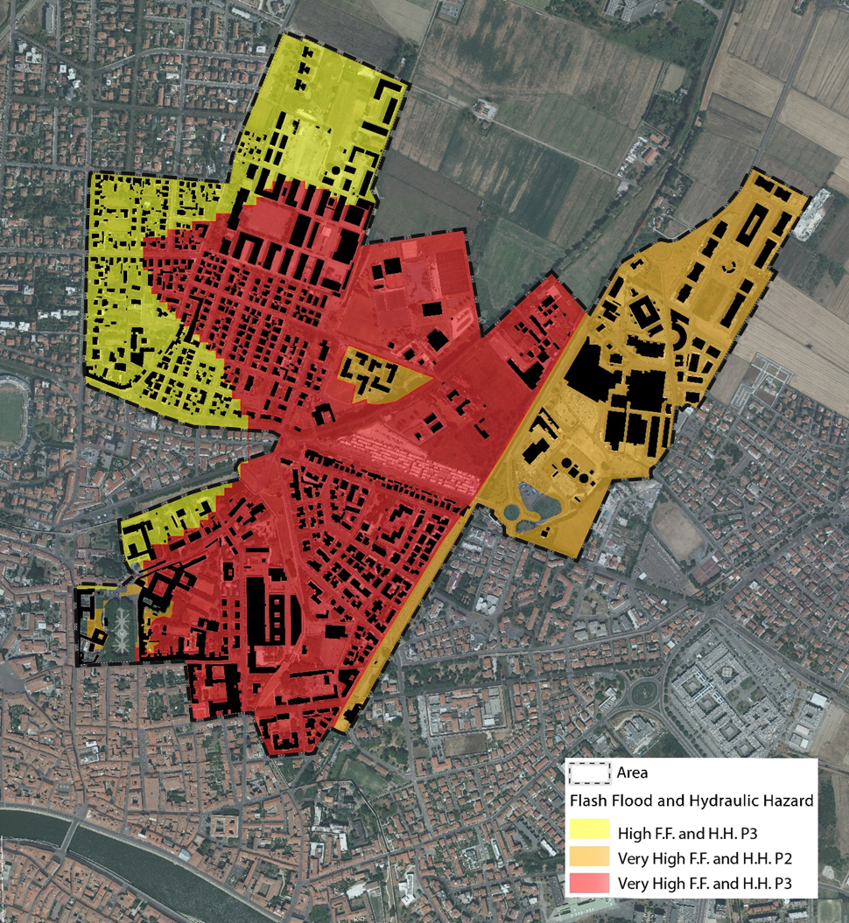
Figure 1 Map of the areas where flood hazard (P3 andP2) overlaps with a high propensity to flash flood phenomena (very high and high), identifying the study macro-areas. (Data source: Northern Apennine District Basin Authority; image by the authors)
Input Data
The data collected and utilized for this research encompasses various aspects crucial for the comprehensive analysis of NBS interventions and their potential impacts on urban hydrology. Key input data categories include:
- Methereological Data: Hourly weather data were sourced from Pisa Weather Station (#TOS01000544, Facoltà di. Agraria), The data set includes hourly precipitation, temperatures, humidity, wind speed and direction.
- Land Use and Cover Data: Land cover data were derived from satellite imagery, supplemented by on-site inspections for classification accuracy. These data informed the assessement of NBS feasibility. The land cover distribution is presented in Figure 3 and Tables 1 and 2
- Subsoil Characteristics: Urban subsoils, influenced by anthropogenic factors, were mapped using geotechnical data from the 2019 Structural Plan of Pisa, GEOscopio portal and the National Archive of Subsoil Surveys (accessible at https://sgi2.isprambiente.it/mapviewer/). Soil permeability was calculated based on technical guidelines (Soil Science Division Staff. 2017).
- Digital Terrain Model (DTM): A high-resolution Digital Terrain Model (DTM), with a 1m × 1m grid, was obtained from the Regional Mapping Portal for topographic analyses
- Digital Terrain Model (DTM): A high-resolution Digital Terrain Model (DTM), with a 1m × 1m grid, was obtained from the Regional Mapping Portal for topographic analyses.
- Directly Connected Impervious Area (DCIA): The DCIA, a critical factor for surface runoff, was estimated as a percentage of impervious surfaces based on land use and EPA guidelines (Soil Science Division Staff, 2017).
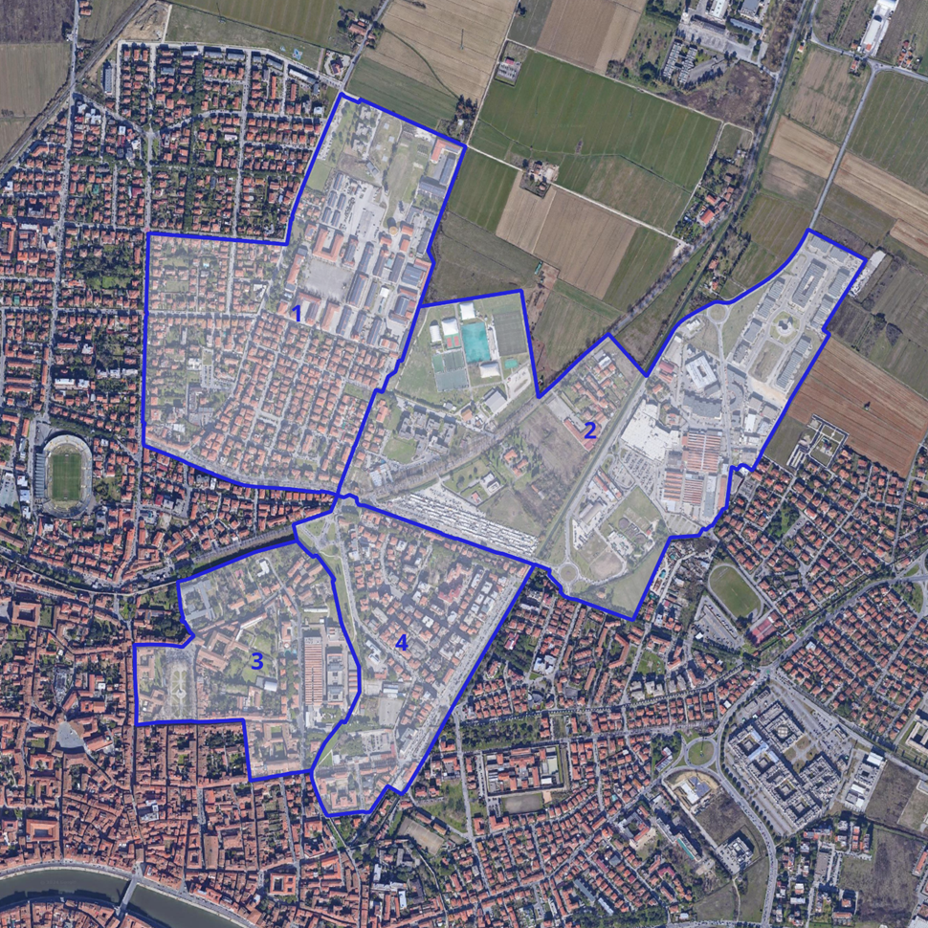
Figure 2 Map of the study areas (image by the authors)

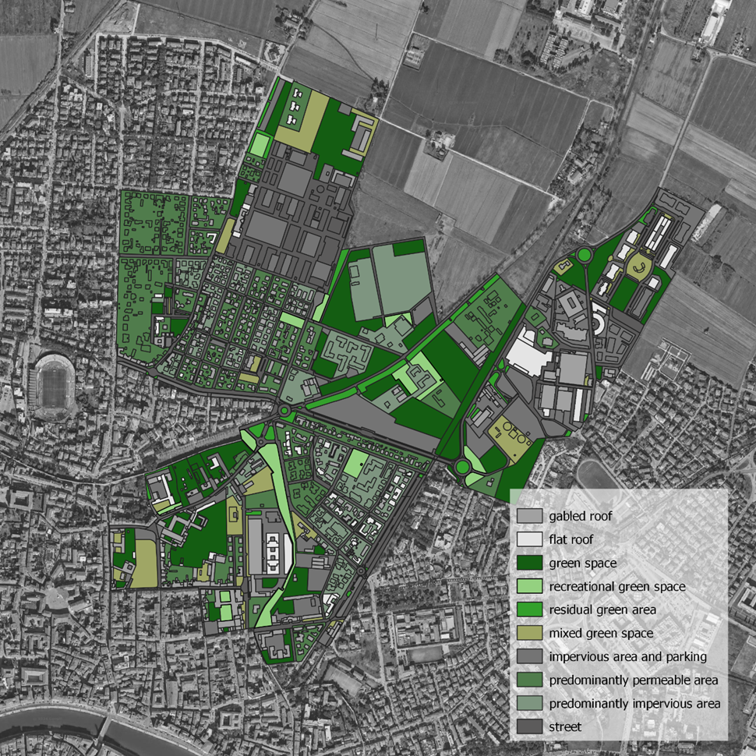Figure 3 Land cover of the study area (image by the authors))
i-Tree Hydro Plus
To model hydrological impacts, the study employed i-Tree Hydro Plus, a module within the i-Tree suite developed by the USDA Forest Service. This tool simulates urban water movement by accounting for land cover, soil properties, vegetation, and precipitation patterns. It integrates the UFORE-Hydro model and features statistical tools derived from the EPA SWMM model for evaluating green infrastructure.
Key input datasets include the Digital Elevation Model, meteorological data, land cover characteristics, and soil properties. The software outputs detailed hydrological metrics, including runoff, water quality, vegetation-related impacts, and subsurface hydrology. While the tool provides precise results, its complexity and intensive data requirements make it most suitable for expert use.
Scenarios
Four scenarios were modeled to assess the hydrological impacts of NBS interventions (Tab. 3). The baseline scenario represents 2022 conditions. In the Green Roof (GR) scenario, 75% of flat roofs are converted into vegetated surfaces. The Permeable Pavements (PP) scenario assumes 50% of public parking areas and 10% of private parking surfaces are replaced with permeable materials.
Table 1 Description of land cover in the four areas
 | Z1 |  | Z2 |  | Z3 |  | Z4
 | km² | Z1 area distribution | km² | Z2 area distribution | km² | Z3 area distribution | km² | Z4 area distribution
Impervious Cover | 0,362 | 69% | 0,429 | 65% | 0,128 | 60% | 0,171 | 70%
Pervious Cover | 0,161 | 31% | 0,230 | 35% | 0,087 | 40% | 0,074 | 30%
Total | 0,523 |  | 0,659 |  | 0,215 |  | 0,245
Table 2 Components of Impervious Cover area distribution divided by areas
 |  | Z1 |  | Z2 |  | Z3 |  | Z4
 |  | km² | Z1 Impervious Cover area distribu  tion | km² | Z2 Impervious Cover area distribu  tion | km² | Z3 Impervious Cover area distribu  tion | km² | Z4 Impervious Cover area distribu  tion
 | flat roof | 0,042 | 8% | 0,013 | 2% | 0,014 | 6,5% | 0,014 | 6%
 | parking | 0,060 | 11% | 0,009 | 1% | 0,014 | 6,5% | 0,014 | 6%
 | other | 0,260 | 50% | 0,407 | 62% | 0,100 | 47% | 0,143 | 58%
Total |  | 0,362 | 69% | 0,429 | 65% | 0,128 | 60% | 0,171 | 70%
Table 3 Description of scenarios
Scenario | Strategy | Description
Base | - | Current state
GR | Green Roof | Transform 75% of flat roofs into green roofs
PP | Permeable Pavement | Convert 50% of the areas currently designated for parking and 10% of the predominantly pervious private areas into Permeable Pavements
RG | Rain Garden | Creation of rain gardens within existing green areas
The Base scenario refers to the input data from 2022, while the other scenarios hypothesize the implementation of NBS systems.
In the GR scenario, it was assumed that 75% of flat roofs would be converted to green roofs.
The PP scenario involves the installation of permeable pavements on 50% of public parking surfaces and 10% of private parking areas.
In the RG scenario, the implementation of rain gardens was evaluated for an area equivalent to 10% of green spaces and residual green areas in zones Z1, Z3, and Z4, while in zone Z2, it was evaluated at 50%. This difference in distribution is related to the characteristics and extent of green areas in the various zones: Z2 is a peripheral and much less urbanised area compared to the other three and is characterised by large tracts of abandoned land.
The land cover distributions for each scenario and the baseline condition are outlined in Table 4
Table 4 Description of land cover in the four scenarios
 | Z1
 | Base |  | GR |  | PP |  | RG
 | km2 | % | km2 | % | km2 | % | km2 | %
Tree Cover | 0,007 | 1,32% | 0,007 | 1,32% | 0,008 | 1,50% | 0,007 | 1,32%
Pervious Cover | 0,158 | 30,27% | 0,161 | 30,84% | 0,163 | 31,10% | 0,158 | 30,27%
Impervious Cover | 0,358 | 68,41% | 0,355 | 67,84% | 0,353 | 67,41% | 0,358 | 68,41%
 | Z2
 | Base |  | GR |  | PP |  | RG
 | km2 | % | km2 | % | km2 | % | km2 | %
Tree Cover | 0,014 | 2,13% | 0,014 | 2,69% | 0,015 | 2,27% | 0,014 | 2,13%
Pervious Cover | 0,226 | 34,35% | 0,250 | 47,74% | 0,234 | 35,50% | 0,226 | 34,35%
Impervious Cover | 0,419 | 63,52% | 0,395 | 75,56% | 0,410 | 62,23% | 0,419 | 63,52%
 | Z3
 | Base |  | GR |  | PP |  | RG
 | km2 | % | km2 | % | km2 | % | km2 | %
Tree Cover | 0,004 | 1,70% | 0,004 | 0,70% | 0,005 | 2,12% | 0,004 | 1,70%
Pervious Cover | 0,084 | 38,98% | 0,091 | 17,38% | 0,085 | 39,50% | 0,084 | 38,98%
Impervious Cover | 0,127 | 59,32% | 0,120 | 22,97% | 0,125 | 58,38% | 0,127 | 59,32%
 | Z4
 | Base |  | GR |  | PP |  | RG
 | km2 | % | km2 | % | km2 | % | km2 | %
Tree Cover | 0,010 | 4,24% | 0,010 | 1,98% | 0,011 | 4,60% | 0,010 | 4,24%
Pervious Cover | 0,069 | 28,08% | 0,077 | 14,67% | 0,070 | 28,78% | 0,069 | 28,08%
Impervious Cover | 0,166 | 67,69% | 0,158 | 30,13% | 0,163 | 66,62% | 0,166 | 67,69%
3. Results
The analyses carried out using the UFORE-Hydro model provide an assessment of the total surface runoff, dividing it into: Pervious Area Runoff, flow generated when the intensity of rain on a permeable surface exceeds the soil's infiltration capacity or when the soil is saturated; Impervious Area Runoff, when the amount of rain exceeds the retention capacity of impermeable surfaces; and Subsurface Runoff, flow generated by water filtering through the soil, influenced by soil transmissivity, slope, and soil water content
In the following figures (Figs. 4, 5, 6, and 7), the results for each area can be seen.
In area Z1 (Fig. 4), characterised half by a predominantly residential fabric with numerous green and/or equipped areas and the other half by a military area, the PP scenario significantly reduces total runoff, demonstrating greater effectiveness in stormwater management compared to other configurations.
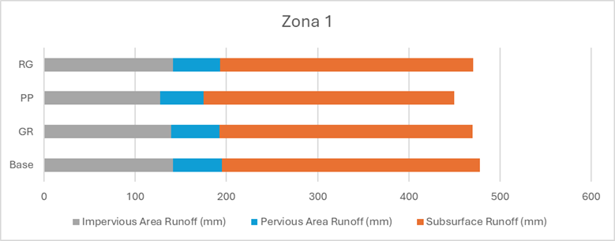
Figure 4 Results for zone 4
Z2 (Fig. 5), on the other hand, is a peripheral area predominantly commercial with many unorganized green areas. In this case, the PP scenario is particularly effective in reducing runoff from both impervious and pervious areas. However, the RG configuration stands out for the greater reduction in subsurface runoff, suggesting excellent infiltration management. Overall, RG reduces total runoff by about 64.78 mm compared to the current situation, making it the most effective for overall water management.
Z3 (Fig. 6) falls within the historic centre of the city of Pisa and differs from the other areas due to the marked presence of school buildings and public green areas. The GR scenario significantly reduces the total runoff in Z3, showing greater effectiveness in stormwater management compared to other configurations.
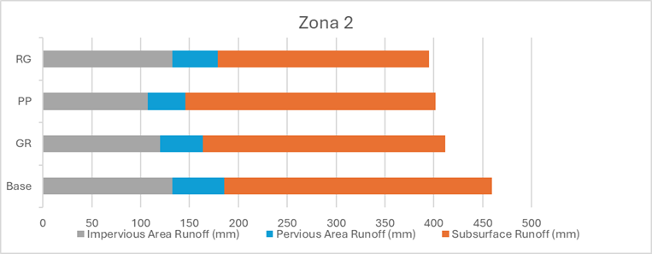
Figure 5 Results for zone 2
In Z4 (Fig. 7), an area closer to the historic centre characterised by a dense residential fabric, the GR and PP scenarios similarly reduce runoff from impervious areas. However, GR is the most effective in reducing total runoff compared to the current situation, making it the best in stormwater management.
The results obtained show that, in general, the installation of permeable pavements (PP scenario) is effective in reducing runoff from both impervious and pervious areas, particularly suitable for Z1 and Z2, while the installation of green roofs (GR scenario) seems effective in reducing subsurface and total runoff and is particularly suitable for Z3 and Z4 areas. The creation of rain gardens (RG scenario) has variable effects, sometimes reducing runoff more than other configurations (Z2) and sometimes less (Z3 and Z4).
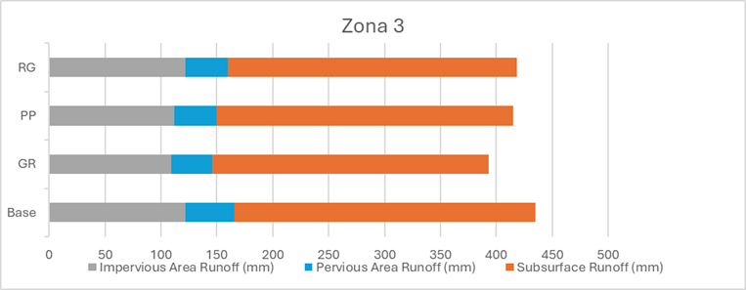
Figure 6 Results for zone 3
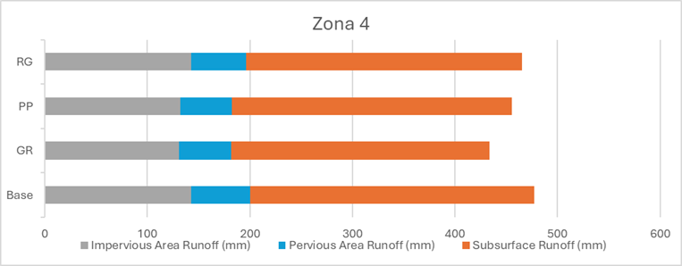
Figure 7 Results for zone 4
4. Discussion
This study evaluated the potential of NBS, specifically green roofs, permeable pavements, and rain gardens, for improving stormwater management and mitigating flood risks in urban areas. Using i-Tree Hydro Plus, the research focused on four zones in Pisa, Italy, and demonstrated that NBS can significantly reduce surface runoff, thereby enhancing urban resilience to flooding and contributing to sustainable development. However, the study also underscored substantial challenges associated with hydrological modeling and the practical implementation of NBS in urban contexts.
The hydrological benefits observed in Pisa align with findings from other cities. For example, research by Song (Song et al., 2020) has shown that although increasing urban green spaces has a positive impact on stormwater management, particularly influencing runoff, their mitigation remains limited unless accompanied by other NBS solutions, such as green roofs and significant reductions in impervious surfaces. Bortolini and Brasola (2022) reported that rain gardens in Padua reduced runoff by 34–41%, while our study highlighted complementary effects from combining green roofs and permeable pavements. Similarly, Busca and Revelli (2022) demonstrated significant runoff reductions in "Le Vallere" Park, Turin, emphasizing the role of urban green spaces in improving water management. In Szeged, Hungary, Csete & Gulyás (2021) found that districts with higher vegetation and pervious surfaces achieved better hydrological outcomes, echoing our findings that Pisa's zones with higher impervious surfaces experienced more runoff. Collectively, these results confirm that targeted, context-specific interventions are critical for maximizing the benefits of NBS.
Despite these promising outcomes, the study identified key barriers. Accurate modeling using i-Tree Hydro Plus requires detailed input data, such as meteorological variables, land cover, soil properties, and pollutant levels. Many of these datasets were either unavailable or insufficiently detailed, necessitating reliance on default values that may compromise model accuracy. This issue mirrors challenges reported in studies from Turin and Szeged, where data scarcity similarly limited the precision of simulations. Additionally, the complexity of i-Tree Hydro Plus presents a significant hurdle. Its steep learning curve and non-intuitive interface make it difficult for non-specialists to use, restricting its broader application in public planning contexts. Effective implementation also requires interdisciplinary collaboration among hydrologists, urban planners, geologists, and agronomists, resources often unavailable to public entities.
The challenges associated with maintaining and implementing NBS are particularly relevant in urbanized and historic settings. Similar to Padua, where Bortolini and Brasola (2022) emphasized the need for ongoing maintenance to ensure the functionality of NBS, Pisa will also require consistent upkeep to sustain these systems. Historical preservation regulations may further constrain large-scale interventions in Pisa’s historic zones, adding an additional layer of complexity to their implementation.
Overall, this study highlights both the potential and limitations of i-Tree Hydro Plus as a tool for evaluating NBS systems. While it provides valuable insights into the hydrological benefits of these solutions, its operational challenges, including data requirements, technical complexity, and reliance on multidisciplinary expertise, limit its accessibility beyond research contexts. Addressing these barriers is critical to scaling up the application of NBS and bridging the gap between research and real-world implementation.
Future efforts should prioritize the development of user-friendly modeling tools with streamlined interfaces and automated data integration, reducing reliance on technical expertise. Enhanced access to comprehensive, up-to-date environmental datasets would also improve modeling accuracy and simplify data collection processes. Furthermore, fostering interdisciplinary training programs and collaborations among urban planners, hydrologists, and environmental scientists is essential for effectively integrating NBS into urban planning. Finally, future research should expand on this study by exploring the long-term impacts of NBS on water quality, pollutant removal, and urban ecosystem health, ensuring that these solutions are fully optimized for diverse urban contexts
5. Conclusion
This study explored the potential of NBS, such as green roofs, permeable pavements, and rain gardens, to enhance stormwater management and mitigate flood risks in four zones of Pisa, Italy. Using i-Tree Hydro Plus software, the findings revealed that NBS can significantly reduce surface runoff, contributing to urban resilience and sustainable development. These results align with similar studies in Padua, Turin, Szeged and Luha, confirming the capacity of NBS to address urban hydrological challenges and adapt to climate change.
While the hydrological benefits of NBS are evident, the study also revealed substantial challenges that limit their practical application. The lack of detailed, localized data, reliance on default software inputs, and the technical complexity of tools like i-Tree Hydro Plus hinder accessibility for non-specialists and public entities. Moreover, the requirement for interdisciplinary expertise, spanning hydrology, agronomy, and urban design, creates additional barriers for widespread adoption, particularly in resource-constrained contexts. These findings are consistent with prior research, underscoring systemic obstacles that must be addressed to integrate NBS into urban planning.
To overcome these challenges, several key actions are necessary. The development of user-friendly software that automates data integration and simplifies hydrological modeling would make these tools more accessible to practitioners. Improved availability of detailed and updated environmental datasets would enhance the accuracy of NBS simulations, while fostering interdisciplinary collaboration through training and policy support would help bridge the gap between research and implementation.
This study reaffirms the critical role of NBS as effective, sustainable solutions for managing urban stormwater and reducing flood risks. By addressing the operational and technical barriers identified, policymakers and urban planners can unlock the full potential of NBS, advancing climate resilience and sustainable urban development. Future research should expand on this work, focusing on the long-term impacts of NBS on water quality, pollutant removal, and urban ecosystem health, ensuring their benefits are fully realized in diverse contexts.

Not applicable

Funding declaration:
This research was funded by UNIPI PRA_2022 (Mitigating Risks in Urban Areas). The funding body had no role in the design of the study, the collection, analysis, and interpretation of data, nor in the writing of the manuscript.
Ethics approval:
- Not applicable.
Conflict of interest:
- The author(s) declare that there is no competing interest

European Commission: Directorate-General for Research and Innovation. (2015). Towards an EU research and innovation policy agenda for nature-based solutions & re-naturing cities : final report of the Horizon 2020 expert group on 'Nature-based solutions and re-naturing cities' : (full version). Publications Office. https://data.europa.eu/doi/10.2777/479582.
Biswal, B. K., Bolan, N., Zhu, Y. G., & Balasubramanian, R. (2022). Nature-based Systems (NbS) for mitigation of stormwater and air pollution in urban areas: A review. Resources, Conservation and Recycling, 186, 106578.
Bortolini, L. & Brasola, V. (2022). Simulating the impact of nature-based solutions on runoff control by using i-Tree Hydro: a case study in Padua (Italy). Acta Hortic. 1345, 351-358 DOI: 10.17660/ActaHortic.2022.1345.47 https://doi.org/10.17660/ActaHortic.2022.1345.47
Busca, F., & Revelli, R. (2022). Green Areas and Climate Change Adaptation in a Urban Environment: The Case Study of “Le Vallere” Park (Turin, Italy). Sustainability, 14(13), 8091.Chen, W. Y., Davies, C., Sanesi, G., & Lafortezza, R. (2021). The European Union roadmap for implementing nature-based solutions: A review. Environmental Science & Policy, 121, pp. 49-67. https://doi.org/10.1016/j.envsci.2021.03.018
Csete, Á. K., & Gulyás, Á. (2021). Green infrastructure-based hydrological modelling, a comparison between different urban districts, through the case of Szeged, Hungary. Hungarian Geographical Bulletin, 70(4), pp. 353-368. https://doi.org/10.15201/hungeobull.70.4.5
Chen, W. Y., Davies, C., Sanesi, G., & Lafortezza, R. (2021). The European Union roadmap for implementing nature-based solutions: A review. Environmental Science & Policy, 121, pp. 49-67. https://doi.org/10.1016/j.envsci.2021.03.018
Cohen-Shacham, E., Walters, G., Janzen, C., & Maginnis, S. (Eds.). (2016). Nature-based Solutions to address global societal challenges. Gland, Switzerland: IUCN. http://dx.doi.org/10.2305/IUCN.CH.2016.13.en
Cortinovis, C., & Geneletti, D. (2018). Ecosystem services in urban plans: What is there, and what is still needed for better decisions. Land use policy, 70, 298-312.
Csete, Á. K., & Gulyás, Á. (2021). Green infrastructure-based hydrological modelling, a comparison between different urban districts, through the case of Szeged, Hungary. Hungarian Geographical Bulletin, 70(4), pp. 353-368. https://doi.org/10.15201/hungeobull.70.4.5
Johnson, B. A., Kumar, P., Okano, N., Dasgupta, R., & Shivakoti, B. R. (2022). Nature-based solutions for climate change adaptation: A systematic review of systematic reviews. Nature-Based Solutions, 2, 100042.
ISPRA. (2021). Rapporto sul dissesto idrogeologico in Italia (Rapporto n. 356/2021). Available online at: https://www.isprambiente.gov.it/files2022/pubblicazioni/rapporti/rapporto_dissesto_idrogeologico_italia_ispra_356_2021_finale_web.pdf
Jones, L., Anderson, S., Læssøe, J., Banzhaf, E., Jensen, A., Bird, D. N., Miller, J., Hutchins, M. G., Yang, J., Garrett, J., Taylor, T., Wheeler, B. W., Lovell, R., Fletcher, D., Qu, Y., Vieno, M., & Zandersen, M. (2022). A typology for urban Green Infrastructure to guide multifunctional planning of nature-based solutions. Nature-Based Solutions, 2, 100041. https://doi.org/10.1016/j.nbsj.2022.100041
Ministero dell’Ambiente e della tutela del Territorio e del Mare. (n.d.). Piano Nazionale di Adattamento ai Cambiamenti Climatici. Available online at: https://www.mase.gov.it/notizie/clima-approvato-il-piano-nazionale-di-adattamento-ai-cambiamenti-climatici
Semenzato, P., & Bortolini, L. (2023). Urban Heat Island Mitigation and Urban Green Spaces: Testing a Model in the City of Padova (Italy). Land, 12(2), 476. https://doi.org/10.3390/land12020476
Soil Science Division Staff. (2017). Soil survey manual. C. Ditzler, K. Scheffe, & H.C. Monger (Eds.). USDA Handbook 18. Government Printing Office.
Song, P., Kim, G., Mayer, A., He, R., & Tian, G. Assessing the ecosystem services of various types of urban green spaces based on i-Tree Eco. Sustainability 2020, 12(4), 1630.
Štrbac, S., Kašanin-Grubin, M., Pezo, L., Stojić, N., Lončar, B., Ćurčić, L., & Pucarević, M. (2023). Green Infrastructure Designed through Nature-Based Solutions for Sustainable Urban Development. International Journal of Environmental Research and Public Health, 20(2), 1102. https://doi.org/10.3390/ijerph20021102
Veerkamp, C. J., Schipper, A. M., Hedlund, K., Lazarova, T., Nordin, A., & Hanson, H. I. (2021). A review of studies assessing ecosystem services provided by urban green and blue infrastructure. Ecosystem Services, 52, 101367.
Zölch, T., Henze, L., Keilholz, P., & Pauleit, S. (2017). Regulating urban surface runoff through nature-based solutions – An assessment at the micro-scale. Environmental Research, 157, pp. 135–144.http://dx.doi.org/10.1016/j.envres.2017.05.023

