Novel experience in hybrid tracers: clinical evaluation of feasibility and efficacy in using ICG–TC-99m Nanotop® for sentinel node procedure in breast cancer patients

Gianpiero Manca MD, PhD *, Ludovico Maria Garau, MD *, Mazzarri Sara, MD *, Mazzuca Laura, MD †, Simona Muccioli, MD *, Matteo Ghilli, MD ‡, Giuseppe Naccarato, MD §, Patrick M Colletti, MD §§, Domenico Rubello, MD ††, Manuela Roncella, MD ‡, Duccio Volterrani, MD *, Ielizza Desideri, MD †

* Regional Center of Nuclear Medicine, Hospital University of Pisa, Pisa, Italy
† Pharmaceutical Operative Unit, Drug Policies, Hospital University of Pisa, Pisa, Italy
‡ Breast Surgery, Breast Cancer Center, Hospital University of Pisa, Pisa, Italy,
§ Pathology Unit, Hospital University of Pisa, Pisa, Italy
§§ Department of Radiology, Keck School of Medicine of USC, Los Angeles, CA
†† Nuclear Medicine Department, Santa Maria della Misericordia Hospital, Rovigo, Italy

Corresponding Author
Gianpiero Manca,
Regional Center of Nuclear Medicine, Hospital University of Pisa,
Via Roma 67, 56126 Pisa, Italy
Email: giamanca@gmail.com

Abstract
Purpose. The aim of the study was to evaluate the first-in-human use of ICG–Tc-99m Nanotop® hybrid tracer for the sentinel lymph node biopsy (SLNB) technique in breast cancer patients.

Methods. From January 2017 to March 2017, patients with breast cancer scheduled for SLNB were enrolled. The day before surgery, ICG–Tc-99m Nanotop® was injected periareolarly. Subsequently, planar lymphoscintigraphic (PL) and single photo emission computed tomography/computed tomography (SPECT/CT) images were acquired. Intraoperative sentinel lymph node (SLN) detection was performed by an opto-nuclear probe (Eurorad S.A., Eckbolsheim, France), which allowed us to trace both gamma and fluorescent signals. The harvested SLNs were examined using haematoxylin-eosin staining and patients were clinically evaluated one month after surgery.

Results. Twenty-one consecutive patients were enrolled in the trial. The PL and SPECT/CT techniques identified at least one SLN in all patients, for a preoperative sentinel detection rate of 100%. SPECT/CT was helpful to reveal 3 additional lymph nodes in the same nodal basin that had not been visualized on conventional PL (k = 0.747; P < 0.005). All 30 preoperative SLNs were localized and excised using combined radio- and fluorescence guidance up to 16 hours after injection. The counts measured via gamma tracing showed a very strong correlation with those measured via near-infrared fluorescent tracing (P < 0.005, r = 0.964). No adverse reactions associated with the use of ICG–Tc-99m Nanotop® were observed at one month follow-up.

Conclusions. The SLNB technique used with the ICG–Tc-99m Nanotop® tracer resulted to be feasible, reliable and safe. This hybrid compound allowed us to obtain excellent performance in terms of both preoperative lymphatic mapping and intra-operative SLN detection in breast cancer patients.

Keywords: Radioguided surgery, Fluorescence, Sentinel node, Multimodal, Hybrid imaging, Gamma probe

Introduction

The axillary lymph node status has consistently shown to be the most significant prognostic factor in patients with breast cancer [1]. Based on the concept of sequential tumour drain taking place in an orderly manner through the lymphatic system, biopsy of the sentinel lymph node (SLN) – the first lymph node to be affected by metastasis if the tumour has spread – is the standard of care for evaluating axillary node status in patients with clinically N0 breast cancer [2].
Denatured human serum albumin particles radiolabelled with the Tc-99m (Tc-99m nanocolloid) and blue dye (BD) are currently the most widely used methods to detect SLN in breast cancer [3]. The Tc-99m nanocolloid based method permits surgical planning by taking advantage of pre-operative imaging. The identification of SLN relies on acoustic signals generated by gamma-probe and takes advantage of Tc-99m nanocolloid reliability in terms of persistent retention and intraoperative penetrance through the tissues. The additional intraoperative use of BD can provide optical visualization of the SLNs within the operative field. According to the American Society of Clinical Oncology, the employment of the dual tracer of Tc-99m nanocolloid and BD during sentinel lymph node biopsy (SLNB) could help achieve a much higher SLN identification rate (>90%) and lower false-negative rate (<5%) than either tracer used alone [1,4]. However, the intraoperative gamma-probe has a limited spatial resolution and BD is associated with possible anaphylactic shock and lack of staining, which result in extensive and demanding axillary exploration.
Optical imaging by near-infrared fluorescence has been tested for SLNB in breast cancer to address the drawbacks of SLN detection based on Tc-99m nanocolloid and BD methods. The fluorescent tracer employed was indocyanine green (ICG, Pulsion®); after intraoperative injection, it is characterized by rapid kinetics [5]. This feature enables real-time optical detection of the SLN with high-target-to-background (surrounding anatomy) ratio within the operative field and with no adverse events compared to BD. However, several disadvantages have been reported, including: i) lack of pre-operative planning based on imaging; ii) failure to detect SLN for high body mass index patients because of tissue attenuation; iii) ICG leakage into the axillary adipose tissue, making it impossible to distinguish between fluorescent-positive SLNs and fluorescent-positive adipose tissue [6-8].
Recently, a hybrid tracer has been developed by combining fluorescent ICG and Tc-99m (ICG–Tc-99m) nanocolloid agent within the same particle, so as to exploit the beneficial properties of the two agents in a single drug. Initial experience has been reported in breast cancer, where the radiopharmaceutical kit containing denatured human serum albumin was Nanocoll® (GE Healthcare Ltd, Milan, Italy) [9,10].
In 2013, a new radiopharmaceutical kit containing denatured human serum albumin was authorized for marketing in Europe with the brand name Nanotop® (ROTOP Pharmaka AG, Dresden, Germany). However, no clinical data are available about hybrid tracers composed by ICG and Tc-99m Nanotop®.
The aim of our study was to evaluate, for the first time, the clinical feasibility and efficacy of ICG–Tc-99m Nanotop® in patients with breast cancer and to report any adverse events.

- Materials and methods

This clinical trial was approved by the local Ethical Committee (Eudract registration N° 2016-002978-13) and performed in accordance with the ethical standards of the Declaration of Helsinki. All patients gave written informed consent and the acquired data was anonymized.

  - Patients

All consecutive patients with breast cancer scheduled for SLNB from January 2017 to March 2017 were eligible for participation in this prospective study. Inclusion criteria were: age from 18 to 80 years, proven breast cancer on preoperative biopsy, image-guided tumour diameter ≤5 cm (cT1-T2) and clinically negative axillary nodes confirmed by palpation and ultrasound. Exclusion criteria were: clinically positive lymph nodes, previous breast surgery, multicentric breast cancer, presence of inflammatory process at the site of radiopharmaceutical administration, pregnancy or breast-feeding, other tumours concurrently with breast cancer, patient’s inability to cooperate with the procedure, hypersensitivity to products containing human albumin and/or ICG or excipients used in these pharmacological formulations, concomitant use of medicinal products that can reduce or increase ICG absorption.

  - Hybrid Tracer Preparation

All procedures were performed on the basis of the Good Drug Preparation Rules defined by the Italian Pharmacopoeia of the Institution’s pharmacist. Firstly, Tc-99m generator (Drytec®, GE Healthcare, Amersham, UK) provided sterile, crystal clear, pyrogen-free solution of Sodium Tc-99m Pertechnetate (740 Megabecquerels) injection in sodium chloride (0.4mL). Subsequently, this eluate was added to the commercial vial containing Nanotop® albumin colloid (0.5 mg) to obtain Tc-99m Nanotop®. Radiochemical purity was then assessed by using thin layer chromatography to verify that the ready-to-use suspension did not contain more than 5% of free Tc-99m pertechnetate, as Nanotop® instruction quality control. Gas nitrogen was eliminated from the Tc-99m Nanotop® vial by using a suitable medical device equipped with a 0.2 micrometer hydrophobic filter. Thus, the internal environment of the vial was balanced with the outside filtered air environment. Consecutively, 5 ml of water was added to a 25 mg ICG Pulsion® vial obtaining a final concentration solution of 5 mg/ml. Finally, 0.05 ml of reconstituted ICG Pulsion® (0.25 mg) was added to the Tc-99m Nanotop® vial using a 0.3 ml syringe and was gently swirled.
After 5 minutes incubation, the organoleptic characteristics of the solution, which had to be those of a homogeneous solution with bright green coloration, were examined. In the same way as with Tc-99m Nanotop®, thin layer chromatography verified that the ready-to-use suspension for injection (which should be used within 6 hours) did not contain more than 5% of free Tc-99m pertechnetate.

  - Study design

2.3.1 Preoperative procedure and image analysis. At the Nuclear Medicine Department and approximately 16-18 h prior surgery, the enrolled patients were intracutaneously injected with 37 MBq (in 0.3 ml saline) of ICG–Tc-99m Nanotop® in the peri-areolar area of the quadrant in which the tumour was localized [11-13]. Immediately after injection, all patients underwent lymphoscintigraphic imaging using a dual-head detector gamma camera equipped with CT (Discovery NM/CT 670 GE Healthcare®, Milwaukee, WI). Dynamic (1 frame/minute for 30 minutes), planar anterior-oblique, lateral and anterior scintigraphic scans (low energy high resolution collimator; matrix acquisition: 128x128; zoom factor; x1.33; preset time: 300 seconds) of the breast and axilla were sequentially acquired. In the same session, single photo-emission computed tomography/computed tomography (SPECT/CT) was performed (low energy high resolution collimator; orbit: circular; angle steps: 3°; views: 60x2 dual-head camera; pixel matrix: 128x128; time per view: 20 seconds). At lymphoscintigraphic images, the lymph nodes draining directly from the injection were defined as SLNs and cutaneously marked with indelible ink using a point-to-point radioactive source of ⁵⁷Co (Fig. 1). Finally, gamma and fluorescent tracing were performed by using a dual opto-nuclear probe (Eurorad S.A., Eckbolsheim, France), with 10-second count rate measured and presented to the nuclear physician via an acoustic output [14]. The gamma signal was traced. After switching the setting to fluorescent mode, fluorescent tracing was performed with the photomultiplier tube (PMT) voltage (V) set at 0.7 V (1.0×10⁵: low sensitivity mode). In the event that a non-fluorescent traced node was gamma-traced instead, PMT was increased to 0.9 V (1.0×10⁶: high-sensitivity mode) and the measurement was repeated [14].

2.3.2 Intraoperative Procedure. At the surgery room and in the same way as in the preoperative procedure, gamma and fluorescent tracing were repeated by the nuclear physician before surgery incision. During surgical exploration, the intra-operative definition of SLN was based on the presence of significant radioactivity, or fluorescence, or combined significant radioactivity and fluorescence.
Firstly, the 3-standard deviations (σ) rule was applied providing 99.7 % certainty that the detection of the ‘‘hot’’ node did not take place by chance [15]. In particular, radioactivity of the lymph nodes was quantified with the opto-nuclear probe by a single 10-second duration count. Next, the radioactivity background was recorded on the hand contralateral to the side of injection. Thus, lymph nodes with radioactivity counts exceeding 3σ above the mean count of normal tissue background were considered SLNs. Accordingly, any lymph node gamma count not fulfilling the 3σ rule was deemed a non-localized finding [16]. Finally, having switched the setting to fluorescence mode, all fluorescent lymph nodes (either radioactive or not) were also defined as SLNs. Here, PMT was initially set at 0.9 V and the fluorescence count-rate was evaluated by the nuclear physician. When a signal was obtained, the PMT voltage was reduced to 0.7 V.
Therefore, according to the intraoperative definitions used, all SLNs were harvested by the surgeon. The bed resection was considered ended when both the significant gamma (by using the 3σ rule) and the fluorescent signals were not detected by opto-nuclear probe.

2.3.3 Ex-Vivo Analysis and Histopathological Examination. After excision of the SLNs, gamma and fluorescent tracing at ex-vivo SLNs were repeated under similar geometric conditions by placing the tip of the opto-nuclear probe on the surface of the SLNs. Here, PMT voltage was set at 0.7 V and again both signals were detected with 10-second count rate measured and presented to the nuclear physician via an acoustic output [14]. Moreover, from one patient (B.C.) only, a near-infrared fluorescence imaging device (Fluobeam®, Grenoble, France) provided the additional real-time optic visualization of three gamma and fluorescent ex-vivo traced SLNs (Fig. 2).
Finally, the SLNs were analyzed in accordance to traditional histopathological procedures involving Hematoxylin-Eosin (H&E) staining for the identification of macrometastases (>2 mm), micrometastases (0.2-2 mm) or isolated tumour cells (or aggregates of neoplastic cells smaller than 0.2 mm).

  - Endpoints

The primary end-point of the study was to assess the feasibility of ICG–Tc-99m Nanotop®. Secondary endpoints were as follows: I) ratio between the number of procedures in which at least 1 SLN was detected and the number of total procedures, defined as sentinel lymph node detection rate (SDR); II) difference in number of pre-operatively detected SLNs between planar lymphoscintigraphy (PL) and planar lymphoscintigraphy with the additional contribution of SPECT/CT (PL+SPECT/CT); III) difference in the number of SLNs detected between the 2 imaging modalities (PL and/or PL+SPECT/CT) and surgically removed; IV) relationship between the counts measured via gamma tracing and those measured via near-infrared fluorescent tracing with the opto-nuclear probe in all harvested SLNs.
Finally, adverse events with one-month follow-up after SLNB were reported.

  - Statistical Analysis

All statistical analyses were performed by using R Software for Statistical Computing, version 3.6.3 (Foundation for Statistical Computing, Vienna, Austria) [17]. The collected data were evaluated by means of descriptive statistics (absolute and relative frequencies).
Fleiss’ Kappa was used to evaluate the inter-rater agreement for SLNs pre-operatively detected among PL, PL+SPECT/CT and the number of SLNs surgically removed. Cohen’s Kappa (k) was used for inter-rater agreement between any two of these. According to Altman’s guidelines, kappa is poor when it scores ≤0.20, fair when it is 0.210.40, moderate when it is 0.41-0.60, good when it is 0.61-0.80, and very good when it is ≥0.80 [18].
Since the data were not normally distributed (Shapiro-Wilk test, P < 0.001), Spearman’s Rho correlation (r) was used to analyze the relationship between the counts measured via gamma tracing and near-infrared fluorescent tracing. It is poor when r scores is ≤ 0.20, fair when r is 0.21-0.50, moderate when r is 0.51-0.70, very strong when r is 0.71-0.90, and perfect when r = 1 [18]. A P value < 0.05 was considered significant.

- Results

Twenty-one consecutive breast cancer patients undergoing SLNB were enrolled in this study. They were 20 females and 1 male, with an average age of 64 (range 40-80) years. Tumour site and clinical staging are specified in Table 1.

  - Preoperative sentinel lymph node detection
The PL and PL+SPECT/CT techniques identified at least one SLN in all 21 patients, for a preoperative SDR of 100 %. While PL detected 27 SLNs in the axillary lymph node station (median of 1.28; range 1-2), SPECT/CT was helpful to reveal 3 additional lymph nodes in the same nodal basin (1.42; range 1-3) that were not visualized on conventional PL (k = 0.747; P < 0.005).

  - Intraoperative sentinel lymph node detection
All preoperatively 30 depicted SLNs were localized and excised using combined radio- and fluorescence guidance for a SDR of 100 %. In addition to the SLNs detected by the PL+SPECT/CT technique, three additional (fluorescent and radioactive) lymph nodes were intraoperatively considered as SLNs and excised, with a median of 1.57 (range 1-3) harvested SLNs per patient (Fig. 3). This corresponded to a very good agreement, as quantified by Cohen’s kappa of 0.821 (P < 0.005). Five SLNs out of 33 were metastatic at histological analysis (Table 2).

  - Ex-vivo correlation between radioactive and fluorescence count-rate
The counts measured via gamma tracing showed a very strong/near-perfect correlation with those measured via near-infrared fluorescent tracing (P < 0.005, r = 0.964). The scatter plot showing the linear regression line between the counts measured via gamma tracing and near-infrared fluorescence tracing was reported (Fig. 4).

  - Adverse events
Finally, no adverse reactions associated with the use of ICG–Tc-99m Nanotop® were observed with one month follow-up.

- Discussion

To the best of our knowledge, Nanotop® has never been used so far to develop hybrid tracers. Thus, this is the first pilot study demonstrating the feasibility and clinical efficacy of SLNB based on the hybrid tracer ICG–Tc-99m nanocolloid, where the nanocolloid compound is attributed to the Tc-99m Nanotop® kit.

In vivo biodistribution of the ICG–Tc-99m Nanotop® mainly depends on Tc-99m nanocolloid particle sizes, while the number of Tc-99m atoms per nanocolloid particle affects the signal delivery from the SLNs. In this regard, at least 95% of the colloidal particles derived from the Nanotop® kit have a diameter ≤80 nm. These sizes are considered adequate to combine a rapid transport towards lymphatic vessels with appropriate retention time at the SLN node level, thus enabling the SLN to be identified intraoperatively. Most of the radioactivity favours a particle range of 30-50 nm, which is believed to be a good compromise between the rapid kinetic demand of the radiopharmaceutical and the appropriate retention time at the SLN level [19]. Indeed, the smaller particles can escape the lymphatic transport or easily pass through the lymphonodal filter. On the other hand, the radiocolloid particles have been reported to be cleared by lymphatic drainage to SLN, by passive diffusion, with a speed that is inversely proportional to the particle size [20,21]. In this respect, the addition of ICG to the radiotracer, associated with an increase in particle size, must not affect Tc-99m nanocolloid kinetic behaviour.

In this study, the kinetic behaviour of the ICG–Nanotop® compound allowed us to apply procedural guidelines for sentinel lymph node detection [11]. Dynamic (flow) and static planar imaging demonstrated the ability of ICG–Tc-99m Nanotop® to rapidly drain from the injection site to the lymphatic vessel and to map the nodes on the tumour drainage pathway for a 100 % preoperative SDR. Furthermore, the additional contribution of SPECT/CT provided the anatomical localization within an anatomical landscape of all the SLNs already visualized on planar images and a valuable road-map for surgery. By using the images and skin markings as guides, all the preoperatively detected thirty SLNs were intraoperatively identified and then excised. Moreover, three additional fluorescent and radioactive SLNs (equal to 9 % of total SLNs excised) were intraoperatively localized and harvested. However, despite the limitation related to the reduced sample size of enrolled patients, this greater number was not found to be statistically meaningful compared to the preoperative PL and/or PL+SPECT/CT techniques. The preoperatively observed drainage patterns and performances were similar to the results of studies in which the Tc-99m nanocolloid alone was used for SLNB, suggesting that the hybrid tracer behaved like the radiocolloid [9,22].

Schaafsma et al. are the only authors who have published a study evaluating the feasibility of the hybrid ICG–Tc-99m nanocolloid tracer for SLNB in breast cancer [23]. In agreement with our results, the authors intraoperatively identified at least one SLN (from 32 consecutive enrolled patients), which resulted to be both radioactive and fluorescent. However, unlike the current study conducted with the Nanotop® kit, Schaafsma et al. used the Nanocoll® kit. Unfortunately, only a few data are available in the literature to compare radiopharmaceutical characterization of the Nanocoll® or Nanotop® kit. However, the European Medicine Agency published a statement on the equivalence of Nanotop® and Nanocoll® [24]. Accordingly, Persico et al. demonstrated that the two nanocolloidal kits were not statistically different for the maximum of radioactivity (~50%) bound to particles with a diameter between 30 and 50 nm [19].

We used the opto-nuclear probe as one modality technique to trace both gamma and near-infrared fluorescence signals [25]. The opto-nuclear probe derived directly from the existing gamma probe technology [26]. A derivative of conventional gamma probe technology designed for fluorescence tracing allowed the integration of two optical fibers for excitation and emission signal collection [14]. The integration of the fluorescence tracing option into an existing modality offered the following advantages: i) a more intuitive use of the fluorescence tracing option of the opto-nuclear probe (the acoustic read-out is similar to that of the conventional gamma probe routinely used for SLN identification); ii) fluorescence tracing was performed in a luminous ambience and a valuable space in the operation theatre, thus making it possible to minimize the logistics; iii) additional investments were not necessary.
Recently, Van den Berg et al. have supported our findings by describing the first-in-human use of a prototype opto-nuclear probe during SLNB in a heterogeneous cohort of cancer patients using ICG–Tc-99m nanocolloid [14].

Dual opto-nuclear probe technology allowed us to verify whether the ICG–Tc-99m Nanotop® tracer could preserve the property of being gamma and fluorescent traced in both the preoperative and intraoperative phases. In particular, at 16-18 hours post-injection, we observed a statistically very strong/near-perfect correlation between the ex-vivo counts measured via gamma tracing and those measured via near-infrared fluorescent tracing (P< 0.005, r = 0.964). This condition evidenced prolonged stability of the hybrid tracer, making it possible to inject the radiopharmaceutical the day before surgery (thus avoiding the ICG injection directly prior to surgery) and to benefit from pre-operative planning based on PL and SPECT/CT imaging.
The preserved beneficial property of being fluorescent helps enhance the intraoperative identification of the SLN, permitting its optical visualization with-high target to background-ratio within the operative field. The intraoperatively observed fluorescent pattern was similar to the results of studies in which the ICG tracer alone was used for SLNB, suggesting that this hybrid pharmaceutical formulation did not impair fluorescent property [27]. Furthermore, the high tissue penetration of concurrent gamma-emission guided the identification of the SLN regardless of any possible ICG drawbacks such as tissue attenuation and ICG leakage into the axillary adipose tissue. These faults can make it impossible to distinguish between fluorescent-positive SLNs and fluorescent-positive adipose tissue [28,29].

The stability of the hybrid tracer and the successfully mapped SLN proportion may serve as reasonable quality indicators for this procedure and strong predictors of the false-negative rate (FNR) [30]. In particular, the contemporary use of fluorescent and radioactive signals could potentially improve the SDR (thus reducing the FNR) under those clinical circumstances (prior breast or axillary surgery, multiple breast cancer and neo-adjuvant chemotherapy) in which SLNB remained controversial.
Patients with unsuccessful axillary mapping may have an increased risk of positive axillary involvement [31]. Accordingly, current standards of care recommend axillary lymph node dissection to maintain regional control when intraoperative SLN identification is not achieved, but with a significant risk of complications such as lymphedema, numbness, axillary web syndrome, and decreased upper-extremity range of motion [32]. Therefore, the identification of otherwise unacknowledged SLNs could save patients with early breast cancer from the complications of axillary lymph node dissection. Moreover, the high diagnostic accuracy provided by a quality hybrid tracer could help clinicians to select early breast cancer women eligible for axillary lymph node dissection, namely women with nodal metastases found in SNB specimens who will receive mastectomy and women with more than two positive SLNs [33]. On the other hand, the high SDR provided by the hybrid tracer could help to accurately select women without SLN metastases, for whom axillary lymph node dissection is not recommended [34].

The feasibility and safety evidence provided by our experience could open the way to the use of ICG-^{99m}TC-Nanotop® in patients with different malignancies where complex lymphatic drainage could affect the possibility of high SDR [9,10,35–37]. In particular, in the head-and-neck region the fluorescent extension provided by ICG to ^{99m}Tc-nanocolloid could improve intraoperative SDR in the following circumstances. Firstly, the difficulty in detecting SLNs included within a cluster of radioactive lymph nodes; secondly, the “shine-through phenomenon” (in which the radioactivity of SLNs is masked because of the high tracer accumulation in the injection depots); thirdly, low-radioactive SLN at the SLN site owing to the problem of “scatter” (in which the direction of radioactivity from SLN is changed by the tissues).

Performance maximization could be achieved by the combined use of real-time visualization systems, for example the near-infrared fluorescence imaging device combined with the free-hand SPECT/CT, which offers intraoperative 3D radioactivity distribution and SLN detection. Recently, the near-infrared fluorescence imaging system in robotic-assisted surgery has provided intraoperative ICG near-infrared fluorescence. The application of these innovations in breast cancer could result in improved functional outcomes, decreased blood loss, and shorter hospital stays.

- Conclusions

The SLNB technique with the use of ICG–Tc-99m Nanotop® has resulted to be feasible, reliable and safe. This hybrid compound allowed us to obtain excellent performance in terms of both preoperative lymphatic mapping and intra-operative SLN detection up to 16 h post-injection. The incorporation of fluorescence in the daily use of radioguidance technologies can pave the way for new lines of research, trials and clinical applications.

Funding
This work was supported by the Association against Melanoma Onlus (Hospital University of Pisa, Pisa, Italy).

Acknowledgments
We appreciate the help from Fluobeam® (Grenoble, France), which supplied us with the device for real-time optic visualization of fluorescent lymph nodes.

References

1. Lyman GH, Giuliano AE, Somerfield MR, et al. American Society of Clinical Oncology guideline recommendations for sentinel lymph node biopsy in early-stage breast cancer. J Clin Oncol. 2005;23:7703–7720.
2. Manca G, Rubello D, Tardelli E, et al. Sentinel Lymph Node Biopsy in Breast Cancer: Indications, Contraindications, and Controversies. Clin Nucl Med 2016.
3. Sorrentino L, Sartani A, Pietropaolo G, et al. A Novel Indocyanine Green Fluorescence-Guided Video-Assisted Technique for Sentinel Node Biopsy in Breast Cancer. World J Surg. Springer New York LLC. 2018;42:2815–2824.
4. Yuan L, Qi X, Zhang Y, et al. Comparison of sentinel lymph node detection performances using blue dye in conjunction with indocyanine green or radioisotope in breast cancer patients: a prospective singlecenter randomized study. Cancer Biol Med. 2018;15:452–460.
5. Namikawa T, Sato T, Hanazaki K. Recent advances in near-infrared fluorescence-guided imaging surgery using indocyanine green. Surg. Today. 2015;45:1467-1474.
6. Bredell MG. Sentinel lymph node mapping by indocyanin green fluorescence imaging in oropharyngeal cancer - Preliminary experience. Head Neck Oncol. 2010;30:2:31.
7. Rietbergen DDD, Van Den Berg NS, Van Leeuwen FWB, et al. Hybrid techniques for intraoperative sentinel lymph node imaging: Early experiences and future prospects. Imaging Med. 2013;5:147–159.
8. Niebling MG, Pleijhuis RG, Bastiaannet E, et al. A systematic review and meta-analyses of sentinel lymph node identification in breast cancer and melanoma, a plea for tracer mapping. Eur J Surg Oncol. 2016;42:466–473.
9. Brouwer OR, Buckle T, Vermeeren L, et al. Comparing the hybrid fluorescent-radioactive tracer indocyanine green- 99mTc-Nanocolloid with 99mTc-nanocolloid for sentinel node identification: A validation study using lymphoscintigraphy and SPECT/CT. J Nucl Med. 2012;53:1034–1040.
10. Schaafsma BE, Mieog JSD, Hutteman M, et al. The clinical use of indocyanine green as a near-infrared fluorescent contrast agent for image-guided oncologic surgery. J Surg Oncol 2011.
11. Giammarile F, Alazraki N, Aarsvold JN, et al. The EANM and SNMMI practice guideline for lymphoscintigraphy and sentinel node localization in breast cancer. Eur J Nucl Med Mol Imaging. 2013;40:1932–1947.
12. Lyman GH, Temin S, Edge SB, et al. Sentinel lymph node biopsy for patients with early-stage breast cancer: American Society of Clinical Oncology clinical practice guideline update. J Clin Oncol. 2014;32:1365–1383.
13. Manca G, Vaggelli L, Mazzucca N. AIMN practice guideline for lymphoscintigraphy and sentinel node localization in breast cancer. 2018. Available from: https://www.aimn.it/documenti/lineeguida/chirurgia_radioguidata/LG_Mammella_2018.pdf
14. Van Den Berg NS, Simon H, Kleinjan GH, et al. First-in-human evaluation of a hybrid modality that allows combined radio- and (near-infrared) fluorescence tracing during surgery. Eur J Nucl Med Mol Imaging. 2015;42:1639–1647.
15. Wallace AM, Han LK, Povoski SP, et al. Comparative evaluation of [99mTc]tilmanocept for sentinel lymph node mapping in breast cancer patients: Results of two phase 3 trials. Ann Surg Oncol. 2013;20:2590–2599.
16. Marcinow AM, Hall N, Byrum E, et al. Use of a novel receptor-targeted (CD206) radiotracer, 99mTc-tilmanocept, and SPECT/CT for sentinel lymph node detection in oral cavity squamous cell carcinoma: initial institutional report in an ongoing phase 3 study. JAMA Otolaryngol Head Neck Surg 2013;139:895–902.
17. R Core Team. R: A language and environment for statistical computing. R Found Stat Comput. Vienna, Austria. 2014. Available from: http://www.r-project.org/
18. Akoglu H. User’s guide to correlation coefficients. Turkish J Emerg Med. 2018;18:91–93.
19. Persico MG, Lodola L, Buroni FE, et al. 99mTc-human serum albumin nanocolloids: Particle sizing and radioactivity distribution. J Label Compd Radiopharm. 2015;58:376–382.
20. Linehan DC, Eberlein TJ. Mechanisms of radiocolloid localization in sentinel node biopsy. Ann Surg Oncol. 2000;7:77.
21. Núñez EGF, Faintuch BL, Teodoro R, et al. Influence of colloid particle profile on sentinel lymph node uptake. Nucl Med Biol. Elsevier Inc.; 2009;36:741–747.
22. Van Den Berg NS, Brouwer OR, Klop WMC, et al. Concomitant radio- and fluorescence-guided sentinel lymph node biopsy in squamous cell carcinoma of the oral cavity using ICG-99mTc- nanocolloid. Eur J Nucl Med Mol Imaging. 2012;39:1128–1136.
23. Schaafsma BE, Verbeek FPR, Rietbergen DDD, et al. Clinical trial of combined radio-and fluorescence-guided sentinel lymph node biopsy in breast cancer. Br J Surg. 2013;100:1037–1044.
24. European Medicines Agency. Nanotop and associated names. Available from: https://www.ema.europa.eu/en/medicines/human/referrals/nanotop-associated-names.
25. Vidal-Sicart S, Seva A, Campos F, et al. Clinical use of an opto-nuclear probe for hybrid sentinel node biopsy guidance: first results. Int J Comput Assist Radiol Surg. 2019;14:409–416.
26. Tellier F, Ravelo R, Simon H, et al. Sentinel lymph node detection by an optical method using scattered photons. Biomed Opt Express. 2010;1:902–910.
27. Grischke E-M, Röhm C, Hahn M, et al. ICG Fluorescence Technique for the Detection of Sentinel Lymph Nodes in Breast Cancer: Results of a Prospective Open-label Clinical Trial. Geburtshilfe Frauenheilkd. 2015;75:935–940.
28. Liu J, Huang L, Wang N, et al. Indocyanine green detects sentinel lymph nodes in early breast cancer. J Int Med Res. 2017;45:514–524.
29. Lin J, Lin LS, Chen DR, et al. Indocyanine green fluorescence method for sentinel lymph node biopsy in breast cancer. Asian J Surg; 2020;3:S1015-9584(20)30045-2.
30. Kim T, Giuliano AE, Lyman GH. Lymphatic mapping and sentinel lymph node biopsy in early-stage breast carcinoma: A meta analysis. Cancer. 2006;4–16.
31. Brenot-Rossi I, Houvenaeghel G, Jacquemier J, et al. Nonvisualization of axillary sentinel node during lymphoscintigraphy: Is there a pathologic significance in breast cancer? J Nucl Med. 2003;44:1232–1237.
32. Lucci A, McCall LM, Beitsch PD, et al. Surgical complications associated with sentinel lymph node dissection (SLND) plus axillary lymph node dissection compared with SLND alone in the American College of Surgeons Oncology Group trial Z0011. J Clin Oncol. 2007;25:3657–3663.
33. Lyman GH, Somer MR, Bosserman LD, et al. Sentinel lymph node biopsy for patients with early-stage breast cancer: American Society of Clinical Oncology clinical practice guideline update. J Clin Oncol. 2017;35:561–564.
34. Giuliano AE, Ballman K V., McCall L, et al. Effect of axillary dissection vs no axillary dissection on 10-year overall survival among women with invasive breast cancer and sentinel node metastasis: The ACOSOG Z0011 (Alliance) randomized clinical trial. JAMA - J Am Med Assoc. 2017;318:918–926.
35. Van Der Poel HG, Buckle T, Brouwer OR, et al. Intraoperative laparoscopic fluorescence guidance to the sentinel lymph node in prostate cancer patients: Clinical proof of concept of an integrated functional imaging approach using a multimodal tracer. Eur Urol. 2011;60:826–833.
36. Brouwer OR, Klop WMC, Buckle T, et al. Feasibility of Sentinel Node Biopsy in Head and Neck Melanoma Using a Hybrid Radioactive and Fluorescent Tracer. Ann Surg Oncol. 2012;19:1988–1994.
37. KleinJan GH, van Werkhoven E, van den Berg NS, et al. The best of both worlds: a hybrid approach for optimal pre- and intraoperative identification of sentinel lymph nodes. Eur J Nucl Med Mol Imaging. 2018;45:1915–1925.

Table 1. Demographics of patients receiving ICG–Tc-99m Nanotop®

Characteristics | Value  No. (%)
Sex
Male | 1 (5)
Female | 20 (95)
Age
Median age  Years range | 64  40-80
Tumour site
Upper outer quadrant | 18 (86)
Lower outer quadrant | 0 (0)
Lower inner quadrant | 2 (9)
Upper inner quadrant | 1 (5)
Central Portion | 0 (0)
Tumour staging
Tis | 0 (0)
T1mic | 0 (0)
T1a | 1 (5)
T1b | 10 (48)
T1c | 6 (28)
T2 | 4 (19)

Table 2. Mapping results

Measurement | Pooled analysis  No. (%)
Preoperative identification rate
Patients with ≥1 SLN | 21 (100)
SLN | 30
Planar imaging | 27 (90)
SPECT/CT | 30 (100)
Intraoperative sentinel detection rate
Patients with ≥1 SLN | 21 (100)
SLN | 33
Radioactive and fluorescent | 33 (100)
Radioactive node, average count, range | 1427, 40-18139
Fluorescent node, average count, range | 5552, 87-65535
Fluorescent/Radioactivity, average count, range | 3.8, 2.2-7.2
Pathologically positive SLN
SLN | 5
Radioactive node, average count, range | 475, 100-1347
Fluorescent node, average count, range | 1784, 327-5000
Pathologically negative lymph node
SLN | 27
Radioactive node, average count, range | 1596, 40-18139
Fluorescent node, average count, range | 5796, 87-65535

SLN, Sentinel lymph node

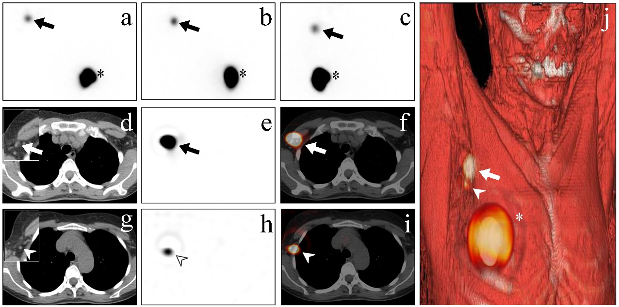
Fig. 1 A 50-year-old woman with breast cancer (cT1) located in the upper inner quadrant of the right breast underwent planar lymphoscintigraphy and SPECT/CT for preoperative sentinel lymph node (SLN) localization. On planar lymphoscintigraphy, the left anterior-oblique, lateral, and anterior views showed intracutaneous injection of ICG–99mTc Nanotop® (asterisks in a, b, and c) and a “hot” focal area projecting itself in the right axilla (arrows in a, b, and c). Subsequently, the patient underwent SPECT/CT. Axial CT image showed a first-tier SLN of the right axilla (arrow in d) where the “hot” focal area, previously detected on planar imaging and now presented on SPECT and fused images, were localized (arrow in e and f). Axial CT image showed a further right first-tier lymph node located very close to the previous one (arrowhead in g), showing milder “hot” focal areas on SPECT and fused images (arrowhead in h and i), which were diagnosed as further SLNs. Finally, on the image generated with 3D volume rendering, the injection site (asterisk in j) and the localized SLNs appeared in an anatomic three-dimensional landscape for better anatomical identification (arrow and arrowhead in j). Both SLNs, which preserved the property of being pre- and intraoperatively gamma- and fluorescent-traced, were excised. However, only the hottest one resulted to be micrometastatic at histopathological analysis.

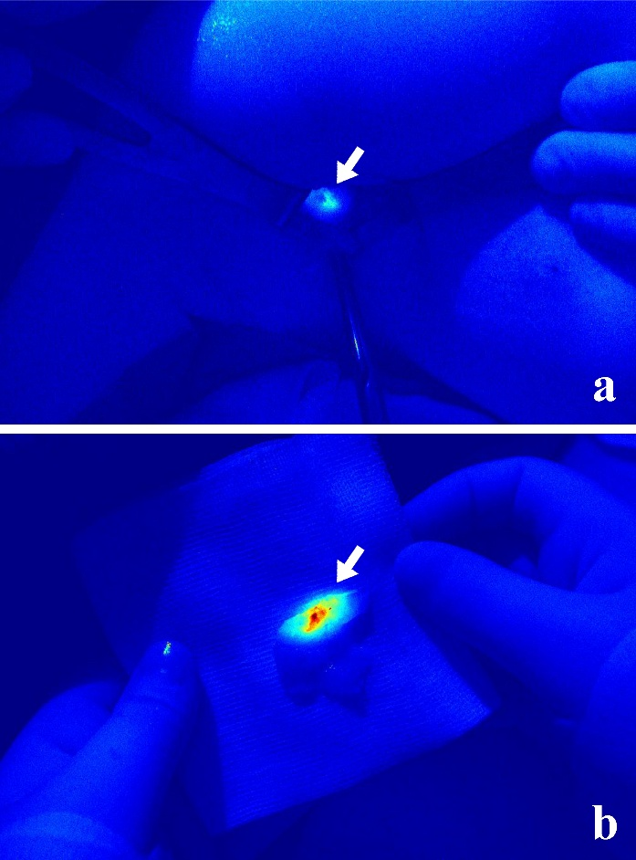
Fig. 2 A fluorescent sentinel lymph node inside the surgical field by the near-infrared fluorescence imaging device (Fluobeam®, Grenoble, France) in colour mode, before and after removal (white arrow in a and b, respectively) from the right axilla.

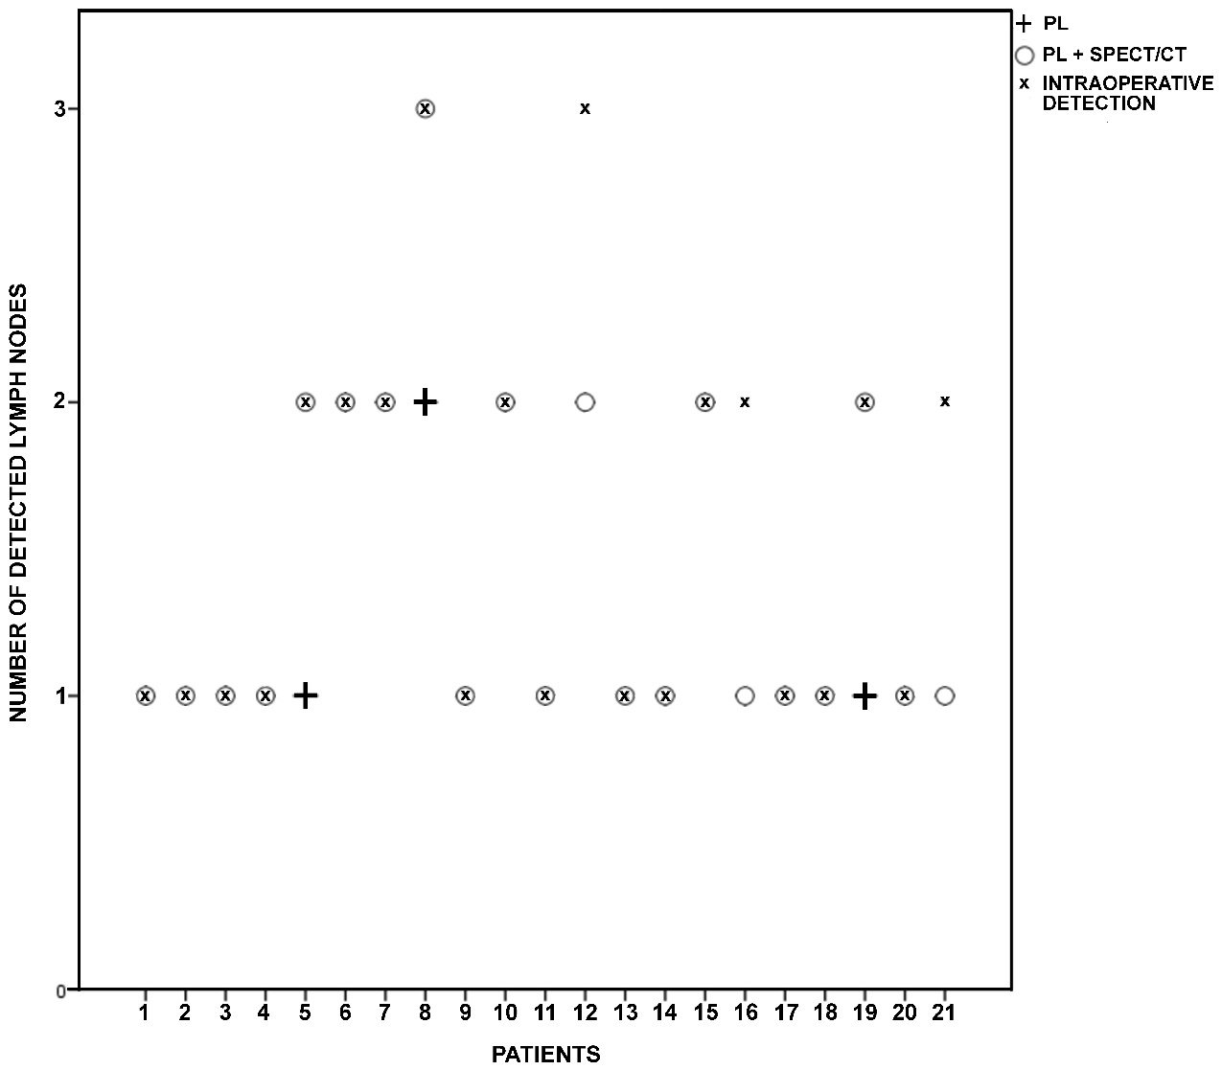
Fig. 3 Number of lymph nodes detected with planar lymphoscintigraphy (PL), PL with the additional contribution of SPECT/CT (PL+SPECT/CT) and intraoperatively using the dual opto nuclear probe.

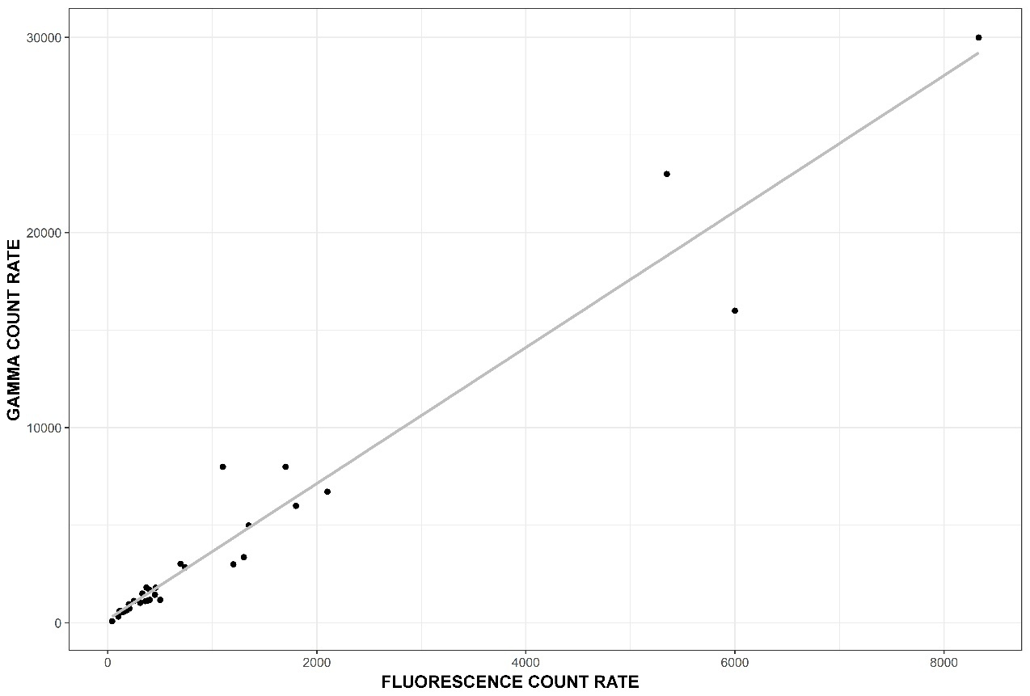
Fig. 4 Correlation between the counts measured via gamma tracing (y-axis) and near-infrared fluorescence tracing (x-axis). For near-infrared fluorescence tracing, 10-second count rate was measured with PMT set at 0.7 V.

