PRACTICES AND STRUCTURES FOR SKELETONISATION AND MUMMIFICATION OF BODIES IN SOUTHERN ITALY OF LATE MODERN AGE
Antonio Fornaciari*°, Valentina Giuffra*
*Divisione di Paleopatologia, Dipartimento di Ricerca Traslazionale e delle Nuove Tecnologie in Medicina e Chirurgia, Università di Pisa.
°Dipartimento di Storia, Scienze dell'Uomo e della Formazione, Insegnamento di Archeologia Funeraria, Università di Sassari.

In 2005 and 2006 a paleopathology team of the University of Pisa carried out a survey in north-eastern Sicily to investigate the funerary structures of Late Modern Age for the treatment of the bodies, still largely ignored or misinterpreted from the anthropological and paleopathological point of view. The survey allowed to create a first inventory of mummified remains still in situ in the crypts of north-eastern Sicily and to identify two types of surviving architectural structures for the control of bodies decay, preserved in the hypogea rooms under the churches: the ʻsitting colatoioʼ, aimed at favoring the skeletonization, and the ʻhorizontal colatoioʼ, used to obtain natural mummification by dehydration. The sitting colatoio consists in a masonry seat with a hole at the center of the sitting plane, used for desiccation-release of bones through the down flow of the cadaveric fluids (Fig.1). The horizontal colatoio are very small rooms provided with a horizontal grill, made of wood or pottery tubules, on which the corpse was placed. The body, lying on the grill, would slowly lose its fluids through the skin (Fig. 2). The survey, together with another archaeological research in Campania region in southern Italy and an accurate archival research about the ʻterrasanteʼ, the funerary crypts reserved to the members of Confraternities of Naples (fig. 3), allowed us to propose an new interpretation about use and destination of “colatoi”, with a reflection about the concept of death in terms of duration and of secondary burial, first developed by cultural anthropologists Robert Hertz and Arnold Van Gennep. Both these structures controlled the corpse’s decay and transformed the body in stable and durable simulacra of the dead. The ancient concepts of death as duration and the practices of secondary burial, first analyzed by Robert Hertz in the past century, still survive in many areas of southern Italy. According to these ancestral beliefs, death was perceived not as a sudden event, but as a long-lasting process, during which the dead had to go through a transitory phase, passing from one state of existence to another. The present study demonstrates that these archaic concepts, which seemed to have been uprooted by the Catholic Church, tenaciously resisted in the heart of Modern Mediterranean Europe until Contemporary Age.
Bibliography:
FORNACIARI A., GIUFFRA V., PEZZINI F., Processi di tanatometamorfosi: pratiche di scolatura deicorpi e mummificazione nel regno delle Due Sicilie. Arch. Post Med. 2007; 11: 11-49.
FORNACIARI A., GIUFFRA V., PEZZINI F., Secondary burial and mummification practices in the Kingdom of the Two Sicilies, Mortality 2010; 15/ 3: 223-249.
FORNACIARI A., Skeleton or mummy: practices and structures for secondary burial in southern Italy in modern and contemporary age. Med. Secoli 2013; 25/1: 205-38.
HERTZ R., Contribution à l’étude sur la représentation collective de la mort. Année Sociologique 1907; 10: 48-137.
PARDO I., L’elaborazione del lutto in un quartiere tradizionale di Napoli. Rassegna italiana di Sociologia 1982, 4: 335-369.
PEZZINI F., Doppie esequie e scolatura dei corpi, Med. Secoli 2006; 18/3: 897-924.

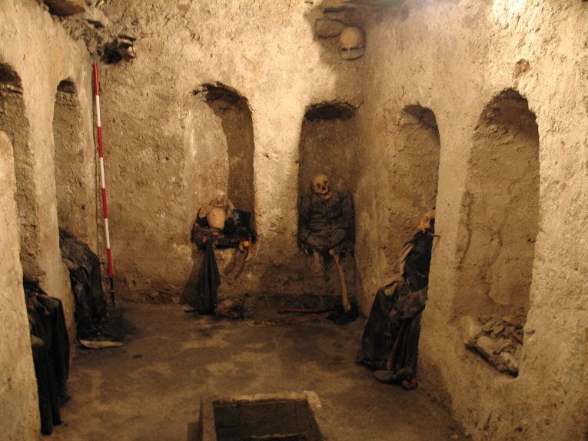
Fig. 1. The ʻsitting colatoioʼ, Chiesa Madre of Fiumedinisi (ME).
Fig.2. The ʻhorizontal colatoioʼ, Convento dei Cappuccini of Palermo.
Fig. 3. The ʻterrasantaʼ of Santa Maria delle Anime del Purgatorio ad Arco, Napoli.

