Solar Collectors based on luminescent 2,5-diarylimidazoles

Giulia Marianetti,ª Marco Lessi,^{b} Vincenzo Barone,ª Fabio Bellina,^{b,c,*} Andrea Pucci,^{b,c,*} Pierpaolo Minei^{b}

(a) Scuola Normale Superiore, Piazza dei Cavalieri 7, 56126 Pisa (Italy)
(b) Dipartimento di Chimica e Chimica Industriale, Università di Pisa, Via Moruzzi 13, 56124 Pisa, Italy
(c) INSTM, UdR Pisa, Via Moruzzi 13, 56124 Pisa, Italy

* Corresponding authors: fabio.bellina@unipi.it; andrea.pucci@unipi.it;

Abstract
We report on the synthesis of new fluorescent symmetrical 2,5-diaryl-1-methylimidazoles obtained in good yields by using direct C-H arylation synthetic strategies. Spectroscopic investigations in THF solution evidenced that the 2,5-diarylimidazole bearing the strong electron-withdrawing cyanoacrylate groups achieved the best trade-off between fluorescence maximum (518 nm), Stokes shift (115 nm) and a quantum yield of 25%. Highly homogeneous dispersions of the selected fluorophore in poly(methyl methacrylate) (PMMA) thin films (25±5 μm of thickness) perfectly maintained the optical features in solution, thus providing a brilliant green emission and a markedly enhanced quantum yield of 55%. Photocurrent measurements of the PMMA collectors supported the use of 2,5-diaryl-1-methylimidazoles as accessible alternatives to perylene backbones for the development of LSC with optical efficiencies close to 7%.

Keywords
push-pull azole-based fluorophores, 2,5-diaryl-substituted imidazoles, poly(methyl methacrylate), dye dispersion, luminescent solar concentrators

1. Introduction
Over the last three decades lot of interest has been devoted to light harvesting technologies. Recent findings on global warming and energy non-renewable resources push us to alternative means of storing energy.[1, 2] Sunlight stands indeed as an ideal asset to take advantage of. In this insight luminescent solar concentrators (LSCs) represent a way to decrease the cost of solar photovoltaics.[3, 4] LSC devices usually consist in a thin slab of transparent material (glass or amorphous polymer) doped with a fluorescent inorganic or organic dyes.[5-8] Upon solar irradiation, a fraction of the emitted light, through means of internal reflection, is collected at the edges of the device where photovoltaic cells are located.[9-13] Compared to traditional concentrators, which make use of mirrors and lenses, these devices show numerous advantages, such as theoretical higher concentration factors, the ability to work with both diffuse and incident light and no need for tracking devices or cooling apparatuses. Organic fluorescent dyes bearing π-conjugated electron-donor and -acceptor moieties exhibit intramolecular charge-transfer (ICT) properties, that can endow optical properties required by LSCs such as high quantum yield (Φ_{f}) and high Stokes shift.[14-22] Although the topic has started in the ‘80s, LSC-PV systems have only recently received great impulse thanks to the development of new materials in the modern building-integrated PV market and triggered by the EU Energy Performance of Buildings Directive 2010/31/EU.[4, 23, 24]
However, LSCs are plagued by critical processes and issues that hinder their ability to deliver light to PV cells, including fluorophores optical features, performances, and their prices.[25-27] For example, the perylene bisimide Lumogen F Red 305 (Basf) is considered the state-of-the-art for LSCs[26] due to its red emission with very high Φ_{f}, photo- and thermostability, but its high cost could definitely affect LSCs technology. In this context, aimed at identifying effective substitutes of perylene-based fluorophores in LSCs, we found push-pull organic fluorophores based on heteroaromatic rings as accessible alternatives.[28, 29] Such compounds are, in fact, attainable through simple and scalable synthetic procedures and their optical features can be tuned according to easy modifications of the molecular backbone or peripheral functionalities. Very recently, during the development of new synthetic procedures for the preparation of symmetrical 2,5-diaryl-substituted imidazoles of general formula 1, we discovered that 2,5-diaryl-1-methylimidazole 1a displayed a very bright yellow-green fluorescence with a maximum at 448 nm, a Stokes shift of 97 nm, and good Φ_{f} values.[30] Interestingly, their fluorescence was retained in the solid state too.
Intrigued by the fluorescence properties exhibited by this small-sized symmetrical pull-push-pull heteroaromatic fluorophore, we decided to evaluate their possible application in LSCs with optical efficiencies larger than 6%, comparable to those of the state-of-the-art.
In this paper, we report the results of our studies, which started from a comparison of the optical properties of 2,5-diaryl-substituted imidazole 1a, thiazole 2a, and oxazole 3a to examine the possible influence of the heteroatom (N, S, or O) on their fluorescence emission wavelength, Stokes shift, and Φ_{f}.
This preliminary study allowed us to establish that imidazole represents the best 1,3-azole core for this class of fluorophores in terms of Φ_{f}, but none of them displayed a fluorescence emission higher than 450 nm. We then decided to introduce more powerful electron-withdrawing groups able to widen the π-conjugation, which should result in a shift of the fluorescence emission towards the red region of the UV-Vis spectrum in respect to 1a but preserving large Stokes shifts and good Φ_{f}. Hence, the three novel imidazoles 1b-d, bearing respectively dicyanovinyl, cyanoacrylate, and indandione as strong electron-withdrawing functional groups, were synthesized in good chemical yields by Knoevenagel condensations starting from 1a.
After an evaluation of their UV-Vis properties in solution, compound 1c bearing cyanoacrylate functional group was selected due to its emission higher than 500 nm paired with the highest Φ_{f} and large Stokes shift being mandatory for high efficiency LSCs. Thin-film LSC device was then prepared by dispersing 1c in poly(methyl methacrylate) (PMMA) films coated over high optical quality glass slab. The LSCs optical efficiency is discussed and compared to that measured for an LSC with the same geometry but containing Lumogen F Red 305.

2. Experimental part
2.1 Materials
Unless otherwise stated, all reactions were performed under argon by standard syringe, cannula and septa techniques. 4,4'-(1-Methyl-1H-imidazole-2,5-diyl)dibenzaldehyde (1a), 4,4'-(thiazole-2,5-diyl)dibenzaldehyde (2a), 4,4'-(oxazole-2,5-diyl)dibenzaldehyde (3a) were prepared as previously described by us.[30] All the other commercially available reagents and solvents were used as received. Poly(methyl methacrylate) (PMMA, Aldrich, Mw = 350,000 g/mol, acid number <1 mg KOH/g).
2.2. 2,2'-(((1-Methyl-1H-imidazole-2,5-diyl)bis(4,1-phenylene))bis(methaneylylidene))-dimalononitrile (1b)
According to a previously reported procedure,[31] a reaction vessel was charged with 2,5-diarylated imidazole 1a (0.100 g, 0.33 mmol). The reaction vessel was fitted with a silicon septum, then evacuated and back- filled with argon for three times. Then, CH₂Cl₂ (24 mL), malononitrile (46 mg, 0.7 mmol), and Et₃N (4 drops) were added and the reaction mixture was stirred at room temperature overnight. The orange crude product was worked-up by diluting with CH₂Cl₂, and the solvent was evaporated in vacuo giving compound 1b as a red powder (87 mg, 68%), m.p. 165-167°C. ¹H NMR (400 MHz, DMSO-d₆) δ 8.65 (m, 2H), 8.19 (s, 1H), 8.17 (s, 1H), 8.16 (m, 2H), 8.09 (m, 2H), 7.92 (m, 2H), 7.61 (s, 1H), 3.90 ppm (s, 3H). ¹³C NMR (100 MHz, DMSO-d₆) δ 161.0; 160.9; 149.21; 135.6 (2C); 135.33; 131.7 (2C); 131.64; 131.3 (2C); 131.0; 130.8; 129.6 (2C); 128.8 (2C); 114.85; 114.76; 113.9; 113.7 82.1; 81.4; 35.2 ppm. ESI (m/z) = [M+H]⁺ 387. Anal. Calcd for C₂₄H₁₄N₆: C, 74.60; H, 3.65. Found: C, 74.67; H, 3.64.
2.3. Diethyl 3,3'-((1-methyl-1H-imidazole-2,5-diyl)bis(4,1-phenylene))(2E,2'E)-bis(2-cyano-acrylate) (1c)
According to a previously reported procedure[32] a reaction vessel was charged with 2,5-diarylated imidazole 1a (0.100 g, 0.33 mmol) and imidazole (0.68 mg, 1.0 mmol). The reaction vessel was fitted with a silicon septum, then evacuated and back- filled with argon for three times. Then, CH₂Cl₂ (5 mL) and ethyl cyanoacetate (0.1 mL, 1.0 mmol) were added and the reaction mixture was heated to reflux for 36 h. The yellow crude product was worked-up by diluting with CH₂Cl₂ and washing with water three times. The organic layer was dried over Na₂SO₄, the solvent was evaporated giving compound 1c as a bright orange fluorescent powder (94 mg, 58%), m.p. 230-232 °C. ¹H NMR (400 MHz, CDCl₃) d 8.65 (m, 2H), 8.19 (s, 1H), 8.17 (s, 1H), 8.16 (m, 2H), 8.09 (m, 2H), 7.92 (m, 2H), 7.61 (s, 1H), 3.90 (s, 3H). ¹³C NMR (100 MHz, CDCl₃) δ 162.5; 162.4; 153.93; 153.90; 149.42; 135.5; 134.7; 134.4; 131.8 (2C); 131.5 (2C); 131.0; 130.2; 129.3 (2C); 129.0; 128.7 (2C); 115.7; 115.6; 103.7; 103.3; 63.0 (2C); 34.7; 14.29 ppm (2C). ESI (m/z) = [M+H]⁺ 481. Anal. Calcd for C₂₈H₂₄N₄O₄: C, 69.99; H, 5.03. Found: C, 70.05; H, 5.04.
2.4. 2,2'-(((1-Methyl-1H-imidazole-2,5-diyl)bis(4,1-phenylene))bis(methanylylidene))bis(1H- indene-1,3(2H)-dione) (5e)
According to a previously reported procedure,[33] to a solution of 2,5-diarylimidazole 1a (86 mg, 0.29 mmol) in 3 mL of MeOH and 3 mL of CH₂Cl₂, 1,3-indanedione (146 mg, 1.0 mmol), and L-proline (12 mg, 0,1 mmol) were added. The resulting reaction mixture was then stirred at room temperature for 24 h. The crude product 1d was recovered by filtration as a bright red fluorescent powder (156 mg, 96%), m.p. 170-171 °C. ¹H NMR (400 MHz, DMSO-d₆) d 8.65 (m, 2H), 8.19 (s, 1H), 8.17 (s, 1H), 8.16 (m, 2H), 8.09 (m, 2H), 7.92 (m, 2H), 7.61 (s, 1H), 3.90 (s, 3H). ¹³C NMR spectrum of 1d could not be recorded due to its low solubility in the most common deuterated solvents. ESI (m/z) = [M+H]⁺ 547. Anal. Calcd for C₂₈H₂₄N₄O₄: C, 69.99; H, 5.03. Found: C, 70.05; H, 5.04.

2.5 Preparation of polymer films for optical studies
Different fluorophore/PMMA thin films were prepared by drop casting, i.e. pouring 0.8 mL chloroform solution containing 30.5 mg of the polymer and the proper amount of fluorophore to obtain concentrations in the range 0.1–2.0 wt.% on 35x50 mm area over a glass surface. The glass slides were cleaned with chloroform and immerged in 6 M HCl for at least 12 h, then they were rinsed with water, acetone and isopropanol and dried for 8 h at 120 °C. Solvent evaporation was performed on a warm hot plate (about 30 °C) and in a closed environment. The film thickness was measured by a Starrett micrometer to be 25±5 μm. The PMMA films were easily removed with a spatula after immersion in water so that they can be stored for successive measurements and comparison by attaching them on 50x50x3 mm optically pure glass substrate (Edmund Optics Ltd BOROFLOAT window 50x50 TS) with a high-purity silicone oil with a refractive index comparable to PMMA and glass (i.e., poly(methylphenyl siloxane), 710 fluid, Aldrich, refractive index n = 1.5365). Absorption and emission properties of such devices showed negligible differences with the freshly prepared ones.
2.6 Apparatus and Methods
Melting points were recorded on a hot-stage microscope (Reichert Thermovar). NMR spectra were recorded at room temperature at 400 MHz (¹H) and 100 MHz (¹³C), and were referred to TMS or to the residual protons of deuterated solvents. The ESI spectra were acquired on a Acquity QDa Water spectrometer (Temperature Probe: 600 °C; ESI capillary voltage 1.5 V; Cone voltage 15 V; mass range 200-1000) coupled with a Acquity H UPLC Water equipped with a column Acquity UPLC 2.1x100 mm, BEH C18, 1.7 μm.
Thermogravimetric analysis (TGA) was carried out by a Mettler Toledo Starc System (TGA/SDTA851e). Samples were heated from 25 °C to 600 °C at 10 °C/min under a nitrogen flow.
Absorption spectra were recorded at room temperature on a Perkin-Elmer Lambda 650 spectrometer. Fluorescence spectra were measured at room temperature on a Horiba Jobin-Yvon Fluorolog®-3 spectrofluorometer and equipped with a 450 W xenon arc lamp, double-grating excitation and single-grating emission monochromators. The fluorescence of fluorophore/PMMA films were recorded by using the Solid-Sample Holder and collecting the front-face emission at 30°.
The fluorescence quantum yield (Φ_{f}) in CHCl₃ was determined at room temperature relative to quinine sulphate (Φ^{s}_{f} = 0.54 in 0.1 M H₂SO₄) using the following relation:[34]
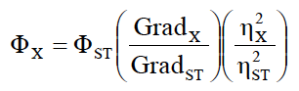
Where the subscripts ST and X are standard and dye respectively, Grad the gradient from the plot of integrated fluorescence intensity vs absorbance for different solutions of standard and dyes. In order to minimise re-absorption effects, absorbances never exceed 0.1 at and above the excitation wavelength. η is the refractive index of the solvent, i.e. 1.45 for CHCl₃ and 1.333 for water.[35]
The Φ_{f} of the solid samples were obtained by means of a 152 mm diameter "Quanta-phi" integrating sphere, coated with Spectralon®, using as excitation source the 450 W Xenon lamp coupled with a double-grating monochromator for selecting wavelengths.
2.7 Photocurrent measurements
A proper apparatus was build and composed by a plywood wooden box 15x15x30 cm with walls 1.5 cm thick. A removable cover hosting a housing for a solar lamp is present at the top. During the measurement a solar lamp TRUE-LIGHT® ESl E27 20W was used (Figure S1). The lamp is characterised by an energy efficiency of 48 lm/W and a power density of 10 μW/cm² measured at 365 nm. Two 50x3 mm slits were carved out at 5 cm from the bottom of the box to exactly fit the LSC systems (dimensions 50x50x3 mm) so that the minimum amount of light would come out during the measurement conditions. On the outer side of the slit, a set of three 1x1 cm photodiodes (THORLABS FDS1010 Si photodiode, with an active area of 9.7 x 9.7 mm and high responsivity (A/W) in the spectral range of 400–1100 nm, Figure S2) connected in parallel fashion was placed and coupled to a multimeter (KEITHLEY Mod. 2700) for photocurrent measuring. In order to collect a more intense and stable output signal, both the photodiodes and the multimeter are connected to an amplifier, realized in laboratory, following the specifications given by THORLABS. The measurement procedure comprehends a 20 minutes warm-up for the lamp, in order to reach its maximum power output. After this time, the current intensity can be measured every minute, for a total of five minutes.
2.8 Efficiency measurement using a PV-cell
A different set of LSC samples was prepared to measure the concentration efficiency attaching a Si-PV cell (IXYS SLMD121H08L mono solar cell 86x14 mm, with a solar cell efficiency of 22% and a fill factor > 70%, Figure S3) to one edge of the sample. This set of samples was made covering the full 50x50 area of the previously introduced optically pure glass slabs with a 25±5 μm fluorophore/PMMA thick film. One edge of the LSC was connected to a Si–based PV cell masked to cover just the LSC edge (50x3 mm) using silicone grease while the remaining edges were covered with an aluminum tape. These devices where then placed over a white poly(ethylene terephthalate) scattering sheet (Microcellular® MCPET reflective sheet, ERGA TAPES Srl) and placed about 20 cm under a solar lamp (TRUELIGHT® ESL E27 20W, with a correlated colour temperature of 5500 K, Figure S1). The efficiency is reported as η_{opt}, which is the ratio between the short circuit current of the PV cell attached the LSC edges under illumination of a light source (I_{LSC}) and the short circuit current of the bare cell put perpendicular to the light source (I_{SC}).
2.9 Computational methods
Quantum mechanical (QM) calculations on fluorophores have been performed at the density functional theory (DFT) and its time-dependent extension (TD-DFT) levels of theory.[36] Due to the likely presence of long-distance charge transfers, the CAM-B3LYP functional[37] has been chosen, together with the SNSD basis set,[38] which was developed for spectroscopic studies of medium-to- large molecular systems. The SNSD basis set allows cost-effective predictions for a broad range of spectroscopic properties, including electronic absorption and emission spectra.[39] Vertical excitation energies (VE) and excited state equilibrium geometries have been calculated with TD-DFT.[40] As a matter of fact, the TD-CAM-B3LYP computations have already shown very good performance for a broad range of excited electronic states,[41] and in conjunction with the SNSD basis set they have been extensively tested for spectroscopic properties of different π-conjugated chromophores.[42]
In order to match experimental conditions, environmental effects simulating solvent (THF) has been accounted for with the polarizable continuum model (PCM)[43] and more precisely its Conductor-like (C-PCM) variant.[44] The molecule-shaped cavity surrounding the solute molecule has been built by interlocking spheres centered on heavy atoms, exploiting the default set of sphere radii implemented in Gaussian.[45] Non-equilibrium solvent effects on the vertical excitation energies have been computed with the linear response LR-PCM/TD-DFT approach,[40] where the excitation energies are directly determined without computing the exact excited electron density. This solvation model provides reliable results at a relatively low computational cost and can be extended to several spectroscopic properties,[46] with further consideration of spectral line shapes.[46, 47]
All computations were performed using a locally modified version of the Gaussian package.[45]

3. Results and discussion
3.1 Synthesis of 2,5-bis-(4-formylphenyl)azoles 1a, 2a, 3a, and of 2,5-diarylimidazoles 1b-d
The three 2,5-bis(4-formylphenyl) substituted 1,3-azoles 1a, 2a, and 3a were prepared starting from the corresponding azole 4, 5, or 6 according to the one-pot two-step reaction sequence depicted in Scheme 1, as already described by us.[30]

Scheme 1. Synthesis of 2,5-diaryl substituted 1,3-azoles 1a, 2a and 3a

In detail, the required 1,3-azole 4, 5, or 6 was reacted with 3.0 equiv of 4-bromobenzaldehyde (7a) in the presence of 5 mol% Pd(OAc)₂ as the catalyst precursor and 2.0 equiv of CsOAc as the base in N,N-dimethylacetamide (DMA) at 110 °C for 24 h. Then, to the reaction mixture were added 2.0 equiv of CuI, and the reaction temperature was raised to 140 °C in order to drive the reaction to completion. Compounds 1a, 2a, and 3a were obtained in 77%, 76%, and 62% isolated yield, respectively.
3.2 Synthesis of 2,5-bis-diarylimidazoles 1b, 1c, and 1d.
As already mentioned in the introduction, with the aim of inducing a bathochromic shift of the fluorescence in respect to compound 1a without significantly affect both Stokes shift and fluorescence quantum yield, electron-withdrawing functional groups stronger than the aldehyde moiety were introduced at the periphery of the fluorophore 1. In this way, imidazoles 1b, 1c, and 1d were obtained in 68%, 58%, and 96% isolated yield, respectively, by known Knoevenagel condensations involving the bis-formyl derivative 1a and the appropriate active methylene reactant 8-10 (Scheme 2).

Scheme 2. Synthesis of compounds 1b-d by Knoevenagel condensations starting from 1a

3.3 Optical properties in THF solutions
All the optical features of compounds 1b-d are summarized in Table 1.
Table 1 Spectroscopic properties of fluorophores 1a-d dissolved in THF
 | λ_{abs} [nm] | ε [M⁻¹cm⁻¹] | λ_{em} [nm] | SS [nm] | Φ_{f}ª
1a | 351 | 32,400 | 448 | 97 | 0.20
1b | 410 | 15,000 | 536 | 125 | 0.15
1c | 403 | 39,800 | 518 | 115 | 0.25
1d | 448 | 30,100 | 576 | 128 | 0.04

ªFluorescence quantum yield (Φ) was determined relative to quinine sulphate in 0.1M H₂SO₄ (Φ = 0.54).

The introduction of powerful electron withdrawing groups was able to widen the π-conjugation of 1a, thus resulting in a shift of the absorption features towards the red region of the UV-Vis spectrum, i.e. from about 350 nm up to 448 nm (Figure 1a). This characteristic was also reflected in fluorescence since the spectrum becomes progressively red-shifted in the order 1c, 1b, 1d, and the Stokes shift (SS) thus increased in the same direction (Table 1 and Figure 1b) up to a maximum of 128 nm in the case of 1d.

(a)
(b)

Figure 1. Normalized absorption (a) and emission (b) spectra of 10⁻⁵ M THF solutions of 1a-d (λ_{exc.}= 363, 373, 373, and 450 nm, respectively)
On the other hand, Φ_{f} resulted inversely proportional to the fluorescent wavelength, as evidenced in table 1. Notably, the highest Φ_{f} is observed for compound 1c, whereas 1d appeared poorly emissive possibly due to its highest red-shifted fluorescence. This is not surprising since de-excitation by internal conversion is more efficient when the energy difference between the ground and excited states is small,[48] as also evidenced in many red-emitting organic fluorophores both in solution and in condensed phases.[49]
Compound 1c was then utilized to achieve a trade-off between longer emission wavelengths (around 520 nm) and highest Φ (0.25), in order to comply with the requirements of fluorophores in LSCs.[26] Notably, 1c was demonstrated to be thermally stable up to 220 °C (Figure S1), above which experienced a 15-20% of weight loss possibly due to the peripheral electron-withdrawing groups. Therefore, it was considered suitable for LSC applications.

A theoretical explanation of the optical features of imidazoles of general structure 1
2,5-Diarylimidazoles of general structure 1 display interesting fluorescence features despite their small size. This aspect could be due to a ICT phenomenon upon excitation. To elucidate this aspect, we conducted QM calculations to analyze the difference in the molecular orbital distribution in HOMOs and LUMOs. In these calculations compound 1a and 1c were taken into account, and in the case of chromophore 1c the peripheral ethyl chains were neglected and replaced with hydrogen atoms to simplify the structure, and its analogue 1c’ was considered in the calculations.
Figure 2, where HOMOs and LUMOs are reported for both 1a and 1c’ chosen as examples, evidences that the electron density moves from the central electron rich imidazole to the peripheral electron-withdrawing functionalities. HOMOs are alike for 1a and 1c’, and the electron density is mainly located on the three central (hetero)aromatic rings. The situation is different for LUMOs: both compounds show a displacement of the electron density toward the electron withdrawing groups, but this behavior is much more remarkable in the case of 1c’.
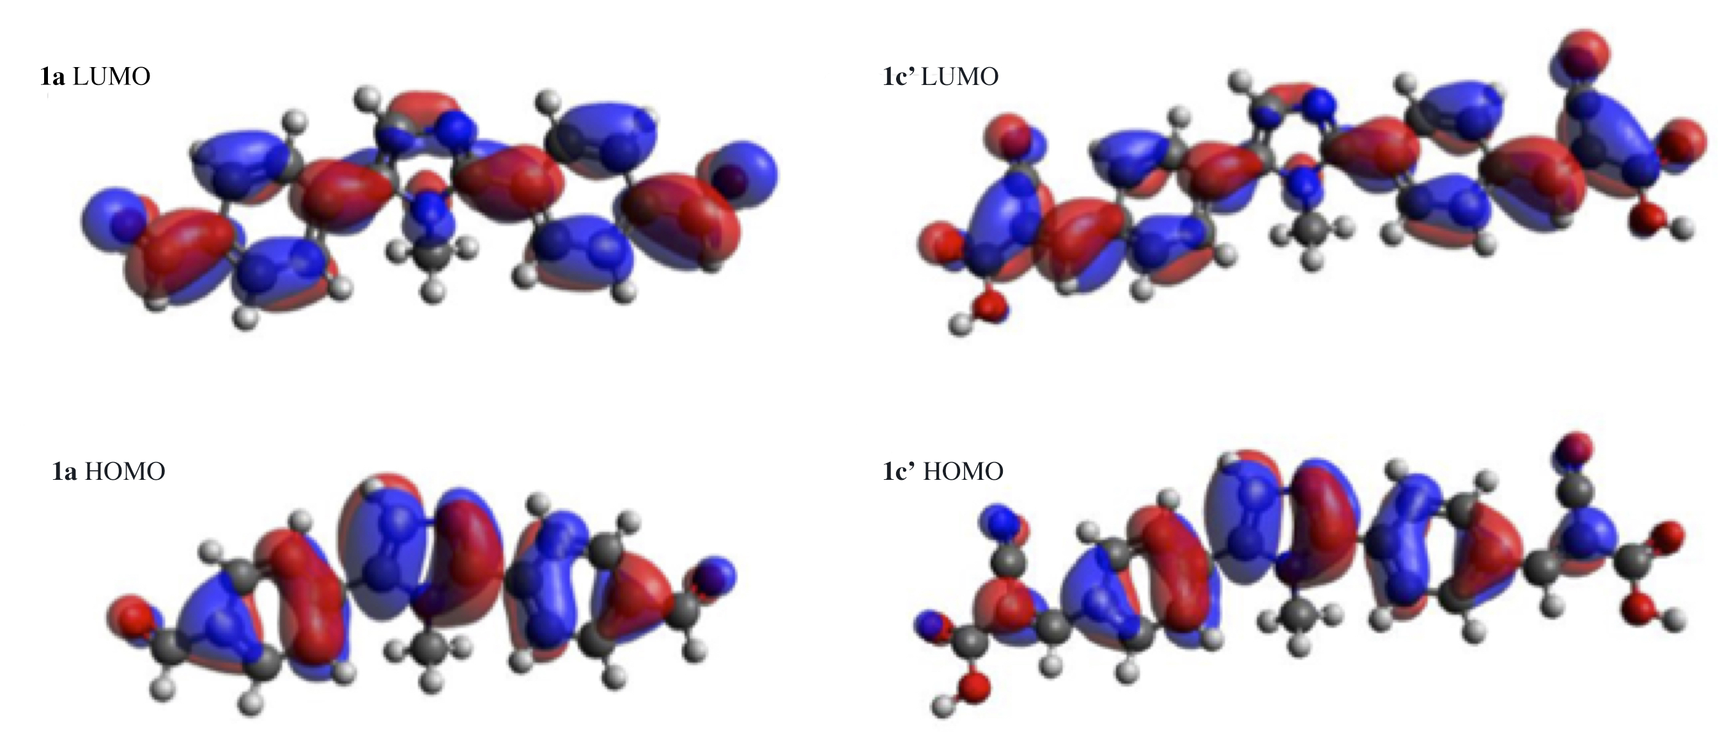
Figure 2. Molecular orbitals HOMO and LUMO for compounds 1a and 1c’.
Through the natural bond orbital analysis, we can indeed quantify the strength of the EWG effect, taking 1c’ as example (Figure 3). The decrease in the electron density in the heteroaromatic core passing from the ground state (S0) to the first excited state (S1) is mainly highlightened by atomic charge on carbon C4 (in red in Figure 3) whereas the increase in the peripheral moiety is well displayed by the terminal alkenyl carbon of the cyanoacrilic functionality (in green in Figure 3).
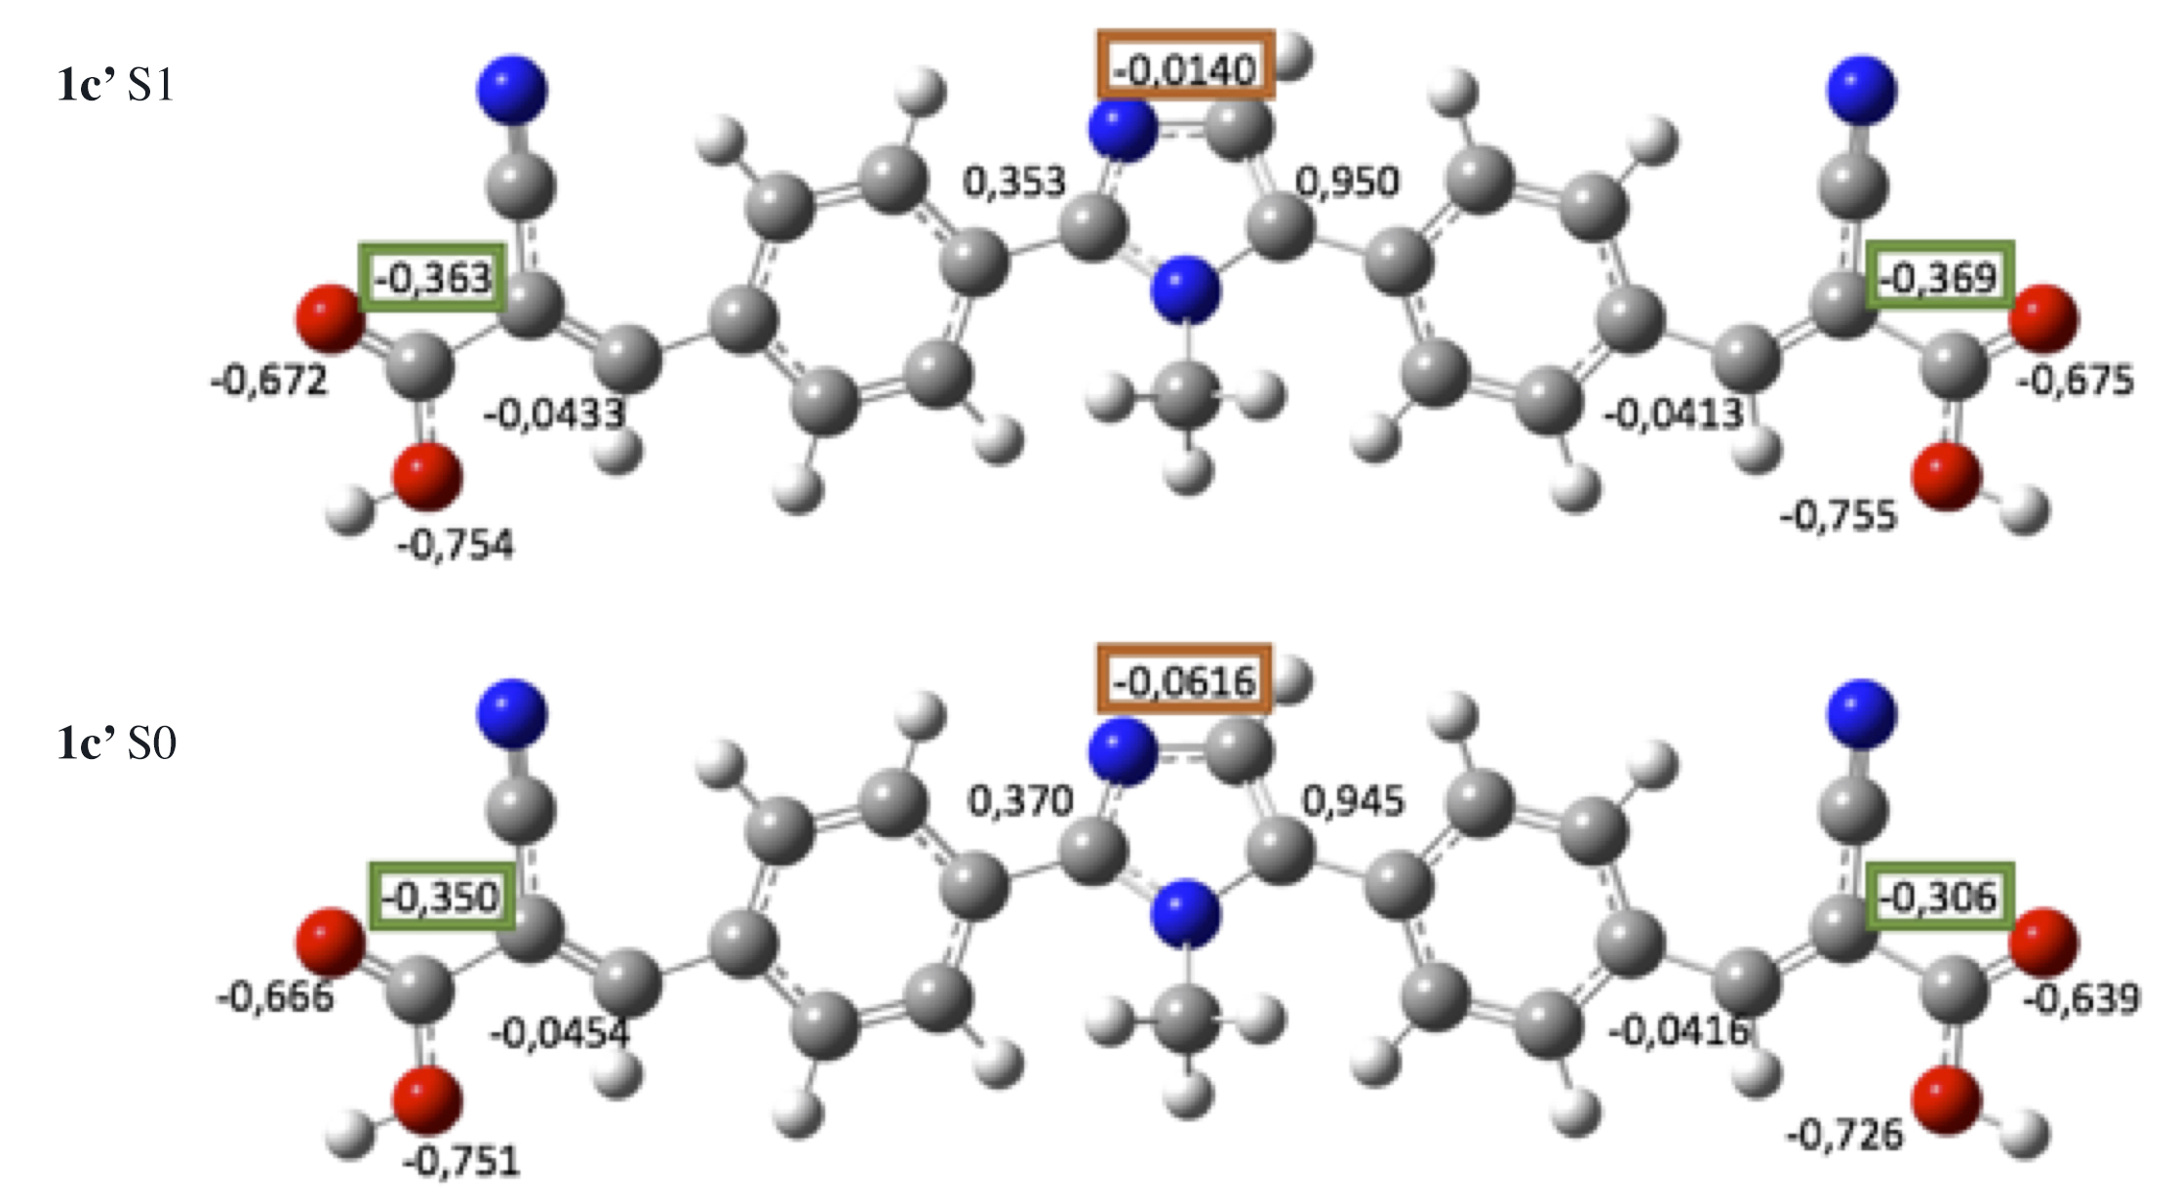
Figure 3. Selected atomic charges from natural bond orbital analysis for 1c’. Values were computed at CAM-B3LYP/SNSD/PCM(THF) level of theory for ground state (S0) and first excited state (S1).

Optical characterization of the 1c/PMMA films
Owing to the aforementioned optical properties, 1c was selected and dispersed by solution processing in the transparent and totally amorphous polymer matrix of poly(methyl methacrylate) (PMMA). PMMA is 100% amorphous, transparent, cheap and commercially available, characteristics that make this polymer a perfect candidate for large-scale LSC applications.[50]
The optical characteristics of 0.6 wt.% of 1c in PMMA films were reported in figure 4 with maximum absorption and emission bands found at 404 nm and 519 nm, respectively, with a SS of 115 nm, and without an evident influence of fluorophore concentration.
Figure 4. Absorption (black solid line) and emission spectra (green solid line, λ_{exc.}= 400 nm) of a 0.6 wt.% 1c/PMMA film with a thickness of 25±5 μm.

It is worth nothing that the optical features of 1c observed in THF solution were fully preserved after its dispersion in the polymeric matrix with absorption and fluorescence peaked at 404 and 519 nm, respectively. Notably, SS of 115 nm strongly limited any adverse auto-absorption phenomena among 1c fluorophores and contributed to a brilliant green emission from the PMMA film (Figure 5).
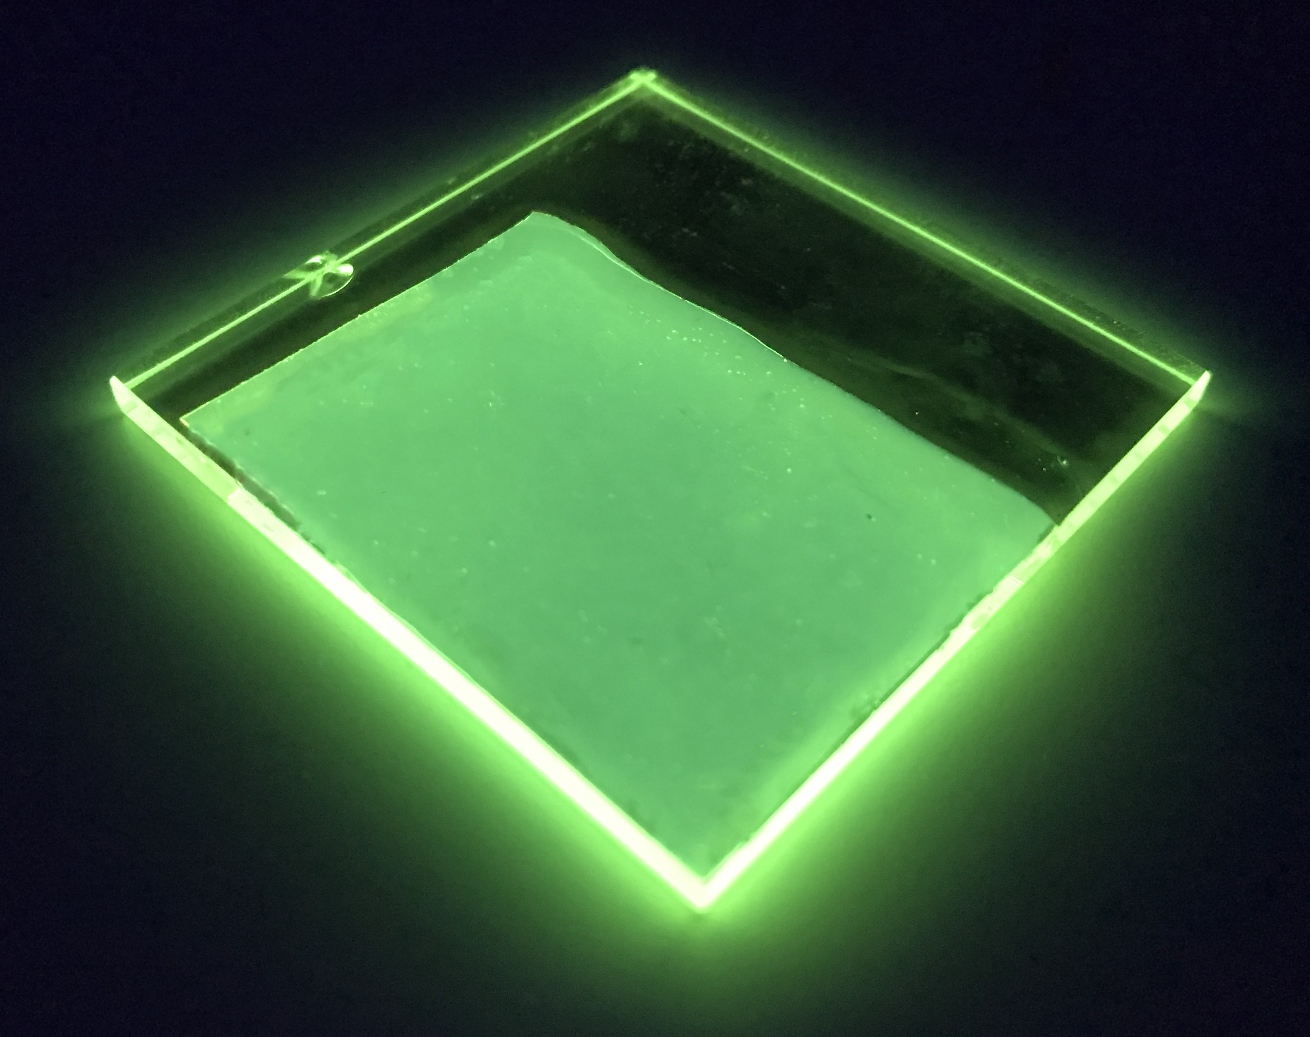

Figure 5. Picture of a 0.6 wt.% 1c/PMMA film with a thickness of 25±5 μm coated over an optically pure 50x50x3 mm glass under the excitation of a long-range UV lamp at 366 nm

The unaltered position of the emission peak in the solid state also demonstrates the poor tendency of 1c to promote significant intermolecular interactions within PMMA,[29, 51] thus suggesting the dispersion of the fluorophores at a molecular level, for the range of concentration investigated. This characteristic is quite desired for LSC application since aggregation caused quenching phenomena strongly affect the solar harvesting features. The measured absolute Φ_{f} of 1c in PMMA was around 55% that is a value markedly higher than that of THF solution (25%). This is not surprising because distinct enhancement of the emission in the solid matrix is often reported and possibly addressed to the reduced internal conversion caused by the limited vibrational relaxation.[49]
The optical characteristics of 1c/PMMA films as LSC were then gathered on optically pure 50x50x3 mm glass. Notably, the wave-guiding features of the 1c/PMMA system to the glass edge due to the internal fluorescence reflection appears apparent (Figure 5). Photocurrent measurements (Figure 6) were accomplished with a home-built apparatus[52] by using a set of three 1x1 cm photodiodes assembled in parallel fashion. Photodiodes are ideal for measuring light sources in LSC emission range by converting the optical power to an electrical current, allowing for a fast, precise and reproducible response even with different sets of samples.

Figure 6. Photocurrent of 1c/PMMA films of a thickness of 25±5 μm with increasing fluorophore concentration (wt.%). Photocurrents were fitted with eq. 1 (dotted curve) with parameters listed in Table 2 (see below)

The data followed a peculiar trend, i.e. photocurrent increasing with 1c content and levelling off at the highest concentration investigated (1.6 wt.%). In detail, photocurrent was found to increase steadily with 1c concentration up to 1.3 wt.% of fluorophore, thus suggesting a negligible effect of self-quenching on fluorescence efficiency. Conversely, when the concentration was further increased adverse dissipative phenomena prevailed.
Notably, the photocurrent behaviour fits quite well with eq. 1:
$η_{opt}=ε'∙c∙e^{-μ_{opt}∙c}+D$ (eq.1)
where η_{opt} is the optical efficiency a term proportional to the current generated by photodiodes, c is the concentration of the dye in wt.%, and ε' and μ_{opt} are two empirical constants defined as:
$ε'∝h∙e^{-\overline{l}}$ (eq. 2)
$μ_{opt}∝μ''(QY,p)∙\overline{l}$ (eq. 3)
where h is the thickness of the thin film, $\overline{l}$ is the mean path length of the radiation in the optical system and $μ''$ is a term depending on both Φ_{f} and the probability of fluorescence re-absorption (p), being greater at high p and low Φ_{f}. D is an empirical constant added since even an empty system of transparent material (c = 0) is capable of trapping some light by means of surface and bulk defects due to scattering phenomena.
Eq. 1 was recently determined inspired by the work of Goezberger[25] who proposed in 1977 an effective method to evaluate LSC efficiency. Both ε’ and µ_{opt} must be considered as completely empirical since even the most accurate estimations require strong approximations. In particular, ε’ is a coefficient related to the absorption properties of the dye/polymer system, whereas μ_{opt} combines all the fluorescence quenching mechanisms due to the dye. An optimal dye/polymer system should therefore present a high ε’ and a small µ_{opt} so that the maximum efficiency is shifted to higher concentrations and the curve steadily rises under the influence of the linear part (eq. 1).[52]
The fitting parameters, reported in Table 1, were compared to those recently gathered for PMMA films with the same thickness of 25±5 μm but containing Lumogen Red F305 (LR),[8, 52] selected being benchmark for LSC applications.[26]
Table 2. Fitting parameters of the photocurrent data measured for 1c/PMMA and LR/PMMA[52] films. For both systems, the film thickness was 25±5 μm

Entry | ε' | μ_{opt} | D
1c/PMMA | 47 | 0.45 | 35
LR/PMMA | 140 | 0.45 | 20

The fitting parameters of 1d/PMMA films were found to be different from those of LR/PMMA only for ε’. The smaller ε’ is a result of the lesser absorption window of 1c compared to that of LR in PMMA, being ε’ related to the light absorption properties of the system. Nevertheless, the higher transmittance makes the device suitable for integration in the modern buildings architecture as transparent windows or panels.[28] Conversely, it is worth noting that the fluorophores showed identical µ_{opt} values, notwithstanding the lower Φ_{f} of 1c compared to that of LR (55% against about 1, respectively).[52] This phenomenon was addressed to the limited fluorescence quenching mechanisms experienced by 1c at high concentration, possibly due to the high compatibility of the fluorophore with the PMMA matrix as evidenced by fluorescence studies.
Notably, D values resulted to be quite similar for all the dye/PMMA systems, thus suggesting that the contribution of non–fluorescent trapping is more or less the same for samples with the same thickness.
The 1c/PMMA films with the highest photocurrent, that is those containing the 1.3 and 1.6 wt.% of 1c, were investigated as LSC by using a Si-based PV cell attached to one edge of the concentrator, as described in the experimental section. The optical efficiency η_{opt} (Table 3) was evaluated from the concentration factor C, which is the ratio between the short circuit current measured in the case of the cell over the LSC edge (I_{LSC}) and short circuit current of the bare cell when perpendicular to the light source (I_{SC}) (eq. 4):
${\text{η}}_{\text{opt}}\text{=}\frac{{\text{I}}_{\text{LSC}}}{{\text{I}}_{\text{SC}}\text{∙G}}$ (eq. 4)
where G is the geometrical factor (in our case, G = 13.3), which is the ratio between the area exposed to the light source and the collecting area.

Table 2. Optical efficiencies (η_{opt}) calculated for 1c/PMMA LSC and compared to those of LR/PMMA LSC with similar geometrical factor[19, 52]

Entry | wt.% | η_{opt} (%)
1c/PMMA | 1.3 | 6.2
1c/PMMA | 1.6 | 6.9
LR/PMMA | 1.5-1.8 | ∼8.0

The calculated η_{opt} for the 1c/PMMA system with the highest photocurrents was not surprisingly found lower than that gathered from LSC containing LR in the same range of fluorophore content and geometrical factor. The difference of 1% in light collection is a result of the poor visible light absorption by 1c fluorophores compared to the perylene derivative. Nevertheless, η_{opt} of around 7% is the highest ever recorded in our laboratory for fluorophores with the same emission range, possibly thanks to the effective combination of large SS (115 nm) and favourable Φ_{f} (55%). This definitely contributed in fluorescence trapping, thus fostering LSC concentration efficiency. The present outcome is worthwhile if also considering the recent result gathered from push-pull imidazole-benzothiazole and thiazole-benzothiazole fluorophores by our group.[28] These molecules notwithstanding the similar emission range and larger SS (137 against 115 nm) than that of 1c provided LSCs with worse optical efficiencies of 5.9. It seems therefore that the 17% gained in optical efficiency could be only provided by the more red-shifted absorption band of 1c, i.e. 404 nm against 359 nm, that possibly contributed in harvesting more visible light by the LSC.

Conclusions
We have shown that the dispersion of symmetric 2,5-diaryl-1-methylimidazoles functionalized with cyanoacrylate as strong electron-withdrawing peripheral moieties in PMMA allowed the preparation of LSC with a brilliant green emission and optical efficiencies close to 7, were synthesized with brilliant green emission in PMMA.
Notably, different fluorophores characterized by the 2,5-diaryl-1-methylimidazole backbone were synthesized in good chemical yields by Knoevenagel condensations aimed at obtaining favourable combinations of optical properties in terms of Stokes shift fluorescence quantum yield. Among them, the fluorophore bearing electron-withdrawing cyanoacrylate groups was found the best candidate and was selected as highly compatible green emitting dopant in PMMA. Photocurrent experiments of the derived LSC revealed optical efficiencies expectedly lower than those evaluated by the state-of-the-art collectors (i.e. 6.9 against 8) due to the limited absorption in the visible region. Nevertheless, the trapping efficiency was maximized thanks to the favourable combination of Φ_{f} (55%) and very large SS (115 nm). Overall, the results here reported consistently support the use of the prepared symmetric 2,5-diaryl-1-methylimidazoles as accessible alternatives to perylene backbones for the preparation of efficient solar collectors.

Acknowledgements
This work was supported by the Regione Toscana under POR-CREO 2014-2020 (project “COOLSUN”); the Università di Pisa under PRA 2017 (project No. PRA_2017_28).

References

[1] Armaroli N, Balzani V. Solar Electricity and Solar Fuels: Status and Perspectives in the Context of the Energy Transition. Chemistry – A European Journal. 2016;22(1):32-57.
[2] Rogelj J, den Elzen M, Höhne N, Fransen T, Fekete H, Winkler H, et al. Paris Agreement climate proposals need a boost to keep warming well below 2 °C. Nature. 2016;534(7609):631-9.
[3] McKenna B, Evans RC. Towards Efficient Spectral Converters through Materials Design for Luminescent Solar Devices. Advanced Materials. 2017;10.1002/adma.201606491.
[4] Debije M. Renewable energy Better luminescent solar panels in prospect. Nature. 2015;519(7543):298-9.
[5] Banal JL, Zhang B, Jones DJ, Ghiggino KP, Wong WWH. Emissive Molecular Aggregates and Energy Migration in Luminescent Solar Concentrators. Accounts of Chemical Research. 2017;50(1):49-57.
[6] Beverina L, Sanguineti A. Organic fluorophores for luminescent solar concentrators. Solar Cell Nanotechnology. 2014:317-55.
[7] Rondao R, Frias AR, Correia SFH, Fu L, de Zea Bermudez V, Andre PS, et al. High-Performance Near-Infrared Luminescent Solar Concentrators. ACS Appl Mater Interfaces. 2017;9(14):12540-6.
[8] Pucci A, Pavone M, Minei P, Munoz-Garcia AB, Fanizza E, Cimino P, et al. Cost-effective Solar Concentrators based on Red Fluorescent Zn(II)-Salicylaldiminato Complex. RSC Advances. 2016;6:17474-82.
[9] Gombert A, Miñano JC, Benitez P, Hornung T. Concentrator Optics for Photovoltaic Systems. Photon Management in Solar Cells: Wiley-VCH Verlag GmbH & Co. KGaA; 2015. p. 153-82.
[10] Goldschmidt JC, Prönneke L, Büchtemann A, Gutmann J, Steidl L, Dyrba M, et al. Fluorescent Concentrators for Photovoltaic Applications. Photon Management in Solar Cells: Wiley-VCH Verlag GmbH & Co. KGaA; 2015. p. 283-321.
[11] Tonezzer M, Gutierrez D, Vincenzi D. Luminescent solar concentrators - state of the art and future perspectives. Solar Cell Nanotechnology. 2014:293-315.
[12] van Sark WGJHM. Luminescent solar concentrators - A low cost photovoltaics alternative. Renewable Energy. 2013;49(0):207-10.
[13] Sark WGJHMv, Barnham KWJ, Slooff LH, Chatten AJ, B¸chtemann A, Meyer A, et al. Luminescent Solar Concentrators - A review of recent results. Opt Express. 2008;16(26):21773-92.
[14] Gianfaldoni F, De Nisi F, Iasilli G, Panniello A, Fanizza E, Striccoli M, et al. A push-pull silafluorene fluorophore for highly efficient luminescent solar concentrators. RSC Advances. 2017;7(59):37302-9.
[15] De Nisi F, Francischello R, Battisti A, Panniello A, Fanizza E, Striccoli M, et al. Red-emitting AIEgen for luminescent solar concentrators. Materials Chemistry Frontiers. 2017;1(7):1406-12.
[16] Lucarelli J, Lessi M, Manzini C, Minei P, Bellina F, Pucci A. N-alkyl diketopyrrolopyrrole-based fluorophores for luminescent solar concentrators: Effect of the alkyl chain on dye efficiency. Dyes and Pigments. 2016;135:154-62.
[17] Turrisi R, Sanguineti A, Sassi M, Savoie B, Takai A, Patriarca GE, et al. Stokes shift/emission efficiency trade-off in donor-acceptor perylenemonoimides for luminescent solar concentrators. Journal of Materials Chemistry A: Materials for Energy and Sustainability. 2015;3(15):8045-54.
[18] Meinardi F, McDaniel H, Carulli F, Colombo A, Velizhanin KA, Makarov NS, et al. Highly efficient large-area colourless luminescent solar concentrators using heavy-metal-free colloidal quantum dots. Nat Nano. 2015;10(10):878-85.
[19] Griffini G, Levi M, Turri S. Thin-film luminescent solar concentrators: A device study towards rational design. Renewable Energy. 2015;78:288-94.
[20] Meinardi F, Colombo A, Velizhanin KA, Simonutti R, Lorenzon M, Beverina L, et al. Large-area luminescent solar concentrators based on 'Stokes-shift-engineered' nanocrystals in a mass-polymerized PMMA matrix. Nature Photonics. 2014;8(5):392-9.
[21] Buffa M, Debije MG. Dye-Doped Polysiloxane Rubbers for Luminescent Solar Concentrator Systems. Springer Series in Materials Science. 2014;190(High-Efficiency Solar Cells):247-66.
[22] Sanguineti A, Sassi M, Turrisi R, Ruffo R, Vaccaro G, Meinardi F, et al. High Stokes shift perylene dyes for luminescent solar concentrators. Chemical Communications. 2013;49(16):1618-20.
[23] Sawin JL. Renewables Global Status Report. Renewable Energy Policy Network for the 21th Century. Renewable Energy Policy Network for the 21th Century ed. Paris: Renewable Energy Policy Network for the 21th Century; 2014.
[24] BIPV Technologies and Markets 2015-2022. Dublin, Ireland2015.
[25] Goetzberger A, Greube W. Solar energy conversion with fluorescent collectors. Appl Phys. 1977;14(2):123-39.
[26] Debije MG, Verbunt PPC. Thirty Years of Luminescent Solar Concentrator Research: Solar Energy for the Built Environment. Advanced Energy Materials. 2012;2(1):12-35.
[27] Tummeltshammer C, Taylor A, Kenyon AJ, Papakonstantinou I. Losses in luminescent solar concentrators unveiled. Solar Energy Materials and Solar Cells. 2016;144:40-7.
[28] Bellina F, Manzini C, Marianetti G, Pezzetta C, Fanizza E, Lessi M, et al. Colourless p-phenylene-spaced bis-azoles for luminescent concentrators. Dyes and Pigments. 2016;134:118-28.
[29] Lessi M, Manzini C, Minei P, Perego LA, Bloino J, Egidi F, et al. Synthesis and Optical Properties of Imidazole-Based Fluorophores having High Quantum Yields. ChemPlusChem. 2014;79:366-70.
[30] Lessi M, Panzetta G, Marianetti G, Bellina F. Improved Synthesis of Symmetrical 2,5-Diarylimidazoles by One-Pot Palladium-Catalyzed Direct Arylation Tailored on the Electronic Features of the Aryl Halide. Synthesis. 2017;49(20):4676-86.
[31] Zheng W, He X, Chen H, Gao Y, Li H. Colorimetric fluorescent cyanide chemodosimeter based on triphenylimidazole derivative. Spectrochimica Acta Part A: Molecular and Biomolecular Spectroscopy. 2014;124:97-101.
[32] Heravi MM, Tehrani MH, Bakhtiari K, Oskooie HA. A practical Knoevenagel condensation catalysed by imidazole. Journal of Chemical Research. 2006;2006(9):561-2.
[33] Lee C-J, Sheu C-N, Tsai C-C, Wu Z-Z, Lin W. Direct [small beta]-acylation of 2-arylidene-1,3-indandiones with acyl chlorides catalyzed by organophosphanes. Chemical Communications. 2014;50(40):5304-6.
[34] Brouwer AM. Standards for photoluminescence quantum yield measurements in solution (IUPAC Technical Report). Pure and Applied Chemistry. 2011;83(12):2213-28.
[35] Lide D, Haynes W. CRC handbook of chemistry and physics: a ready-reference book of chemical and physical data-/editor-in-chief, David R. Lide; ass. ed. WM" Mickey" Haunes: Boca Raton, Fla: CRC, 2009.
[36] Casida ME, Chermette H, Jacquemin D. Time-dependent density-functional theory for molecules and molecular solids. Journal of Molecular Structure: THEOCHEM. 2009;914(1):1-2.
[37] Yanai T, Tew DP, Handy NC. A new hybrid exchange–correlation functional using the Coulomb-attenuating method (CAM-B3LYP). Chemical Physics Letters. 2004;393(1):51-7.
[38] Barone V, Biczysko M, Bloino J. Fully anharmonic IR and Raman spectra of medium-size molecular systems: accuracy and interpretation. Physical Chemistry Chemical Physics. 2014;16(5):1759-87.
[39] Bloino J, Biczysko M, Santoro F, Barone V. General Approach to Compute Vibrationally Resolved One-Photon Electronic Spectra. Journal of Chemical Theory and Computation. 2010;6(4):1256-74.
[40] Scalmani G, Frisch MJ, Mennucci B, Tomasi J, Cammi R, Barone V. Geometries and properties of excited states in the gas phase and in solution: Theory and application of a time-dependent density functional theory polarizable continuum model. The Journal of Chemical Physics. 2006;124(9):094107.
[41] Peach MJG, Helgaker T, Salek P, Keal TW, Lutnaes OB, Tozer DJ, et al. Assessment of a Coulomb-attenuated exchange-correlation energy functional. Physical Chemistry Chemical Physics. 2006;8(5):558-62.
[42] Barone V, Biczysko M, Borkowska-Panek M, Bloino J. A Multifrequency Virtual Spectrometer for Complex Bio-Organic Systems: Vibronic and Environmental Effects on the UV/Vis Spectrum of Chlorophyll a. ChemPhysChem. 2014;15(15):3355-64.
[43] Tomasi J, Mennucci B, Cammi R. Quantum Mechanical Continuum Solvation Models. Chemical Reviews. 2005;105(8):2999-3094.
[44] Cossi M, Rega N, Scalmani G, Barone V. Energies, structures, and electronic properties of molecules in solution with the C-PCM solvation model. Journal of Computational Chemistry. 2003;24(6):669-81.
[45] Frisch MJ, Trucks GW, Schlegel HB, Scuseria GE, Robb MA, Cheeseman JR, et al. Gaussian 16. Wallingford, CT2016.
[46] Marenich AV, Cramer CJ, Truhlar DG, Guido CA, Mennucci B, Scalmani G, et al. Practical computation of electronic excitation in solution: vertical excitation model. Chemical Science. 2011;2(11):2143-61.
[47] Prampolini G, Bellina F, Biczysko M, Cappelli C, Carta L, Lessi M, et al. Computational Design, Synthesis, and Mechanochromic Properties of New Thiophene-Based p-Conjugated Chromophores. Chemistry--A European Journal. 2013;19(6):1996-2004.
[48] Zastrow A. The physics and applications of fluorescent concentrators: a review. 2255:534–547. In: Wittwer V, Granqvist CG, Lampert CM, editors. Optical Materials Technology for Energy Efficiency and SolarEnergyConversionXIII, Proceedings of the SPIE. Freiburg1994. p. 534-47.
[49] Valeur B, Berberan-Santos MN. Molecular Fluorescence: Principles and Applications. second ed. Weinheim (Germany): Wiley-VCH, 2013.
[50] Sperling LH. Introduction to Physical Polymer Science. 4th ed. Hoboken, New Jersey: John Wiley & Sons, Inc., 2006.
[51] Barone V, Bellina F, Biczysko M, Bloino J, Fornaro T, Latouche C, et al. Toward the design of alkynylimidazole fluorophores: computational and experimental characterization of spectroscopic features in solution and in poly(methyl methacrylate). Phys Chem Chem Phys. 2015;17(40):26710-23.
[52] Carlotti M, Panniello A, Fanizza E, Pucci A. A Fast and Effective Procedure for the Optical Efficiency Determination of Luminescent Solar Concentrators. Solar Energy. 2015;119:452-60.

Graphical abstract

