INFANT HANDLING INCREASES GROOMING TOWARDS MOTHERS IN WILD GELADAS (Theropithecus gelada)

Marta Caselliª, Anna Zanoliª, Elisabetta Palagi^{b,c*}, Ivan Norscia^{a,b*}

ª Department of Life Sciences and Systems Biology, University of Torino, Via Accademia Albertina 13, 10123 Torino (Italy)
^{b} Natural History Museum, University of Pisa, Via Roma 79, 56011 Calci (Pisa, Italy)
^{c} Unit of Ethology, Department of Biology, University of Pisa, Via Alessandro Volta 6, 56126 Pisa (Italy)

* Ivan Norscia and Elisabetta Palagi share the senior authorship

Corresponding authors: ivan.norscia@unito.it; elisabetta.palagi@unipi.it

Ivan Norscia ORCID: 0000-0002-1618-7717
Elisabetta Palagi ORCID: 0000-0002-2038-4596

Declarations of interests: none

ABSTRACT
Infant handling - involving affiliative behavior from non-mothers to infants – is a phenomenon that is variably present in Old World monkeys and can be granted by mothers to obtain social services, such as grooming. Here we investigated for the first time whether infant handling could influence grooming exchange in wild geladas. We gathered data on the population of Kundi highland (Ethiopia) in 2019/2020. Via sampling on 15 focal mothers from eight different One-Male Units, we video-recorded 55 grooming sessions between focal mothers and non-focal females (mothers or non-mothers). We also recorded the possible occurrence of infant handling performed by non-focal females. We found that grooming sessions were longest between mother and non-mothers and in the presence than in the absence of infant handling. Hence, our results show that infant handling can influence the grooming exchange between wild gelada females. Because grooming is used to establish and reinforce social bonds in primates, infant handling may act as a ‘social bridge’ in a female bonded society. From an evolutionary perspective, infant handling strategies might represent the stepping stone to more complex forms of infant care, such as allomaternal care and cooperative breeding.

Key Words:
Female bonded societies; grooming exchange; infant manipulation; infant handling; Theropithecus gelada

- Introduction

In primates, social interactions between dependent infants and non-mother subjects might be a precursor of advanced shared offspring care, such as allomaternal care (Hrdy, 2009; Preston, 2013). In its most complex form (cooperative breeding), allomaternal care consists of prolonged and/or regular affiliative interactions between the infant and non-mothers that are beneficial to the infant (e.g., increased survival; Burkart et al., 2009; Hrdy, 2009; Rosenbaum and Gettler, 2018; Solomon and French, 1997; Tecot and Baden, 2015). Such interactions can include babysitting, protective carrying, nursing, crèching, or huddling for thermoregulation (Dunayer and Berman, 2018; Tecot and Baden, 2015). While infant care from the father is related to direct fitness benefits as it increases the chance of infant’s survival (Fernandez-Duque et al., 2009), several hypotheses have been put forth to explain allomaternal care from others, which may produce indirect fitness benefits. Allomaternal behavior may: i) be a consequence of the selection for high responsiveness to infants (by-product hypothesis; Quiatt, 1979); ii) provide indirect fitness benefits when the care-taker is related to the mother (kin selection hypothesis: Hrdy, 2009); iii) allow the acquisition of competence in maternal behavior (learning-to-mother hypothesis: Lancaster, 1971); iv) enhance agonistic support (alliance formation hypothesis: Maestripieri, 1994); v) lead to future care for own infants (the reciprocity hypothesis: Hrdy, 1976). An important consequence of allomaternal care is that it influences social dynamics as a result of increased tolerance, social attention, food sharing and other cooperative tasks (Burkart and van Schaik, 2010, 2016; Guerreiro Martins et al., 2019; Kramer, 2010; Snowdon and Cronin, 2007).
New World Monkeys (Callitrichidae and Pitheciidae species) and modern humans show complex forms of allomaternal care (involving different helpers participating in the process; Garber, 1997; Hrdy, 2009), whereas other primates may show more basic interactions between infants and non-mothers, such as infant handling. Although the literature is not always clear on the distinction between infant handling and allomaternal care, compared to proper and regular allomaternal care, infant handling involves occasional affiliative behaviors such as nuzzling, play, a brief embracing, grooming, carrying and holding, and it does not provide discernible benefits to either the mother or the infant (Dunayer and Berman, 2018). Another difference between allomaternal care and infant handling can be that in the former, the care itself (rather than grooming) represents the payoff for infant access by non-mothers (Hrdy, 2009).
Great apes infrequently show infant handling (Mitani and Watts, 1997), which involves infrequent affiliative behaviors such as grooming, carrying and holding mainly performed by related females (Boose et al., 2018; Grueter et al., 2019). In Old World monkeys, infant handling is a variable phenomenon that can be performed by both females and males (Maestripieri, 1994; Paul et al., 2000). As regards male-infant interactions, several hypotheses have been proposed to explain infant handling, such as the infanticide protection hypothesis (with the male protecting their putative offspring from being killed by other males; Paul et al., 2000), and the agonistic buffering hypothesis (where males use infants as a shield to protect themselves against the attacks from high-ranking males; geladas, Theropithecus gelada: Dunbar, 1984; hamadryas baboons, Papio hamadryas: Kummer, 1967; Papio spp.: Smith and Whitten, 1988). The expression of infant handling by non-mother females is related to the species-typical social structure, with particular reference to social relationships among females (Maestripieri, 1994). Compared to more despotic species (e.g. Japanese macaques, Macaca fuscata: Schino et al., 2003; chacma baboons, Papio ursinus: Henzi and Barrett, 2002), mothers living in tolerant societies are more permissive and inclined to allow other females to manipulate their own offspring (Ciani et al., 2012; Maestripieri, 1994). Within biological markets (sensu Noë and Hammerstein 1994, 1995), infant access can be granted by mothers in exchange for social services (e.g., for sex in snub-nosed monkeys, Rhinopitecus roxellana: Yu et al., 2013; for embracing in spider monkeys, Ateles geoffroyi: Slater et al., 2007; for grooming in tufted capuchins monkeys, Sapajus apella; Tiddi et al., 2010; in macaques, Macaca spp.: Gumert, 2007; Jiang et al., 2019), with mothers and non-mothers being considered as two trading classes exchanging different commodities (Henzi and Barrett, 2002; Tiddi et al., 2010). Such exchange follows the supply-demand law (Noë et al., 2001). Within the infant-handling domain, the ratio between supply and demand is determined by the number of available infants. For example, in spider monkeys (Slater et al., 2007), the number of infants can be positively correlated with the proportion of embraces followed by infant handling. In long-tailed macaques (Gumert, 2007) and chacma baboons (Henzi and Barrett, 2002), the amount of grooming received by the mothers can be negatively affected by the increased number of available infants. Grooming is a valuable commodity that in non-human primates is used to establish, maintain, and restore social relationships (Dunbar, 1991). Non-mother females are attracted to newborn infants (Altmann, 1980; Maestripieri, 1994) and try to manipulate them around grooming sessions with the mothers (Frank and Silk, 2009; Gumer, 2007; Henzi and Barrett, 2002; Jiang et al., 2019; Muroyama, 1994). Hence, in female-bonded societies, the grooming exchanged between females can largely determine their social dynamics, and infant handling can influence the exchange of grooming, especially between mothers and non-mothers (e.g. Frank and Silk, 2009; Henzi and Barrett, 1999; Jiang et al., 2019). Consequently, infant handling could be a tool to maintain and improve female-female cooperative relationships, as it occurs in capuchin monkeys (Cebus capucinus), where females were found to handle the infants of mothers with which they exchanged grooming and formed coalitions more frequently (Manson, 1999).
The aim of the present study is to investigate for the first time the possible linkage between infant handling and grooming in wild gelada females (Theropithecus gelada), a tolerant monkey species endemic to Ethiopian highlands (Dunbar and Dunbar, 1975). Geladas live in a multi-level society whose basic unit is represented by the One-Male Unit (OMU), usually composed of one adult male, several adult females with offspring and characterized by female philopatry and male dispersal (Kawai et al., 1983; Le Roux et al., 2011; Snyder-Mackler et al., 2012). Due to the female philopatry, gelada females are strictly related and show maternally inherited dominance status, even though overt aggressions are rare, and hierarchy is less steep than that observed in the baboon species (Le Roux et al., 2011). The female social cohesion is maintained via several positive interactions (social play: Mancini and Palagi, 2009; Gallo et al., 2021; agonistic support: Pallante et al., 2016; embracing: Pallante et al., 2019), including a large amount of grooming, exchanged only between females belonging to the same OMU (Dunbar, 1983, 2014; Dunbar and Dunbar 1975). Thus, geladas are a good species to be considered to expand the existing literature on infant handling and its relation to grooming dynamics between females to geladas. Based on the above framework, we formulated the following predictions:
Prediction 1 - Females of different primate species can be interested in others’ infants (Altmann, 1980; Nicolson, 1987), making mothers more attractive than non-mothers (Hrdy, 1976; Maestripieri, 1994). Non-mothers can be particularly motivated to groom females when they have an infant (patas monkeys, Erythrocebus patas: Muroyama, 1994; Tibetan macaques: Jiang et al., 2019; snubbed nosed monkeys: Yu et al., 2013; olive baboons: Frank and Silk, 2009). Hence, we predicted that mothers would receive more grooming than non-mothers (Prediction 1a).
However, grooming sessions can be shorter in the presence than in the absence of infant handling because non-mothers may stop grooming mothers as they obtain access to the infant (Henzi and Barrett, 2002). Thus, we predicted that grooming sessions could be shorter in the presence than in the absence of infant handling (Prediction 1b). Still, previous literature indicates that mothers can receive more grooming than they give when they allow the infant manipulation to non-mothers (e.g., Tibetan macaques: Jiang et al., 2019; olive baboons: Frank and Silk, 2009). Consequently, we predicted that mothers would receive a larger amount of grooming by non-mothers in presence rather than in the absence of infant handling (Prediction 1c).
Prediction 2 – In other monkey species, according to the supply-demand law, the amount of grooming received by mothers decreases as the number of infants in the group increases (e.g. chacma baboons: Henzi and Barrett, 2002; long-tail macaques: Gumert, 2007). If a similar situation also applies to geladas, we expect to find a significant effect of the availability of infants on the grooming received by the mothers from the non-mothers (Prediction 2a). Moreover, when infants are used as a ‘commodity’ their age can make a difference because newborns are more attractive to other females and elicit more grooming than less dependent infants (Nicolson, 1987). Thus, if also in geladas infants are used as a ‘commodity’, we expect that newborns, more than older infants, could enhance grooming between mothers and non-mothers (Prediction 2b).
Prediction 3 – With exceptions (Jiang et al., 2019; Muroyama, 1994), previous studies showed that grooming is usually given to mothers by non-mothers before they are allowed to access the infant (e.g., chacma baboons: Henzi and Barrett, 2002; snub-nosed monkeys, Yu et al., 2013; tufted capuchin monkeys, Tiddi et al., 2010). Thus, we expected that mothers would obtain grooming preferentially before (rather than after) infant handling.

- Methods

2.1 Study site, subjects and data collection

This study was conducted from January to May 2019 and from December 2019 to February 2020 on a wild gelada population (Theropithecus gelada) frequenting the Kundi plateau (Wof-Washa area, Amhara region, Ethiopia, N9°40.402’ E39°45.060’). Daily observations occurred from around 9:30 to 17:00 when the animals, which came from the cliffs in the early morning and left the cliffs in the evening, frequented the highland for grazing. During the first month of fieldwork, four observers (two authors and two field assistants) were able to count 21 groups based on size, sex- and age-ratio of each group and to particular signs of some subjects (Caselli et al., 2021). For this study, we focused on the seven most frequently seen OMUs, in which all adult females were identified. For each OMU, the number of infants was also known (Table 1). The infants’ age-classes were defined as follows: black infants (from 0 to 6 months: the fur is black or dark brown), early infants (from 6 months to 1 year: the fur is brown, carried dorsally by the mother) and late infant (from 1 to 2 years: the fur is brown as an adult) (Kawai et al., 1983).
Females were identified on the basis of OMU identity, presence of dependent offspring and long-lasting distinctive features (size, permanent scars, alopecia, abnormal swelling of body parts, shapes of the red chest area). Owing to the presence of infants, lactating females (hereafter, ‘mothers’) were easier to identify than other females, and the identification was possible during field data collection. Non-lactating females (hereafter, ‘non-mothers’) were identified either on the field or via videos.
Data gathering was carried out using focal animal sampling (Altmann, 1974) on the identified mothers when visible. The mothers were video recorded (via Panasonic HC-V180 Full HD optic-zoom 50x, 2csec accuracy), and focal videos lasted around 10-min. In the end, for subsequent analyses, we selected 15 mothers (hereafter ‘focal mothers’) with at least two grooming sessions involving another identified female (hereafter, ‘non-focal female’). From the total dataset of 120 video hours collected, we were able to analyze 7.21 video hours due to the proper visibility requirements. The selected video included 55 grooming sessions that involved the 15 focal mothers and 36 non-focal females interacting with the focal mothers (31 adult and subadult/juvenile non-mothers and 5 mothers; Ngrooming_session_focal_mother/another_mother=10; N grooming_session_focal_mother/non-mother=45).

2.2 Video analysis and operational definitions

The video analysis was carried out via BORIS 7.9.24 (Friard and Gamba, 2016; https://www.boris.unito.it/), a free, open‐source and multiplatform program that allows a user‐specific coding environment to be set for a computer‐based review of previously recorded videos. Once established the behavioral set (grooming given/received and infant handling), the coding was performed by MC using previously assigned keys. Subsequently, we extracted the exact duration of grooming (total and given/received by the focal mothers), of infant handling and the behavioral sequence string for each grooming session. The strings consisted of the code of different behaviors separated by a break symbol in the order as they occurred.
For each grooming session, we recorded: i) identity of the focal mother and the other interacting female; ii) OMU identity; iii) the status of the non-focal interacting female (mother/non-mother); iii) total duration; iv) duration of the grooming received and given by the focal mother; v) presence/absence of infant manipulation by the non-focal female (hereafter ‘infant handling’). We could not consider the dominance relationship between females because aggressive events were rare (only 12 aggressive events between females of the same OMU occurred during the entire study period, including threat displays). Due to their philopatry, the females within each OMU are highly related (Le Roux et al., 2011), even though their exact kinship relations are unknown.
Although infant handling can include aggressive behaviors (e.g. biting, pulling, hitting; Boose et al., 2018), we never observed aggressive behaviors toward infants during the study period. Moreover, infant carrying by non-mother subjects was never observed. We, therefore, considered only the following affiliative patterns as part of infant handling, occurring when the infant was in contact or proximity (within arm’s reach) with the mother: embrace, lift and nuzzle infant rear, play, retrieve and grooming (Dunbar and Dunbar, 1975; Table 2; infant handling via grooming and retrieve is shown in Video S1). In only 1% of cases, we observed infant handling occurring outside the grooming context.
To calculate the grooming duration, we considered a grooming session as initiated when one of the two individuals (individual A: the groomer) began cleaning the fur of the other (individual B: the groomee), and as finished when grooming was interrupted for at least 13s. We considered this time window, which is larger than the mean duration of infant handling (12.292 seconds ± 4.827 SE), to reduce the probability to consider one grooming session as two separated sessions interrupted by an infant handling event. We associated infant handling events with a specific grooming session when non-focal females handled the infant within 10s before the onset and/or after the grooming session. If infant handling occurred during the grooming session, we excluded the duration of infant handling from the duration of the grooming session. We collected N=17 grooming sessions with infant handling and N=38 grooming sessions without infant handling.
We calculated the proportion of grooming received by the focal mother per session as the duration (in seconds) of the grooming received by the focal mother normalized over the grooming session’s total duration. We calculated the proportion of grooming received by the focal mother across sessions by summing up the duration of the grooming received by the focal mother in all sessions normalized over the total time that the focal mother spent grooming.

2.3 Statistics

We ran a Linear Mixed Model (LMM) to test if the duration of a grooming session between females was influenced by the type of grooming dyad (grooming between the focal mother and another mother or between the focal mother and a non-mother), the presence of infant handling performed by the non-focal female, the number of in-group infants and the age class of the infant. In the model, we included the log₁₀-transformed duration of the grooming session as a dependent variable (the transformation allowed the achievement of the homogeneity and the normal distribution of the residual looking at the qqplot and plotting the fitted values against the residuals; Estienne et al., 2017). We included as fixed factors the grooming dyad type (binomial: dyad “focal mother/non-focal mother” or dyad “focal mother/non-mother”), presence/absence of infant handling (binomial), the number of in-group infants (numeric) and the age class of the infant (trinomial). The dyad identity and the OMU identity were included as random factors. We fit the LMMs in R (R Core Team, 2018; version 3.5.1) using the function “lmer” of the R-package lme4 (Bates et al., 2015). We established the significance of the full model by comparison to a null model comprising only the random effects (Forstmeier and Schielzeth, 2011). We used a likelihood ratio test (Dobson, 2002) to test this significance (ANOVA with argument ‘Chisq’). We calculated the p values for the individual predictors based on likelihood ratio tests between the full and the null model by using the R-function “drop1” (Barr et al., 2013). We used a multiple contrast package (multcomp) to perform all pairwise comparisons for each bonding level with the Tukey test, when a multinomial predictor had a significant main effect (Bretz et al. 2010). The level of probability reported was adjusted according to the Bonferroni correction. The effect size was calculated via the R-package “effects”.
In addition, we used the behavioral strings extracted via BORIS 7.9.24 (see above) from each grooming session (N_{behavioral_strings}=N_{grooming_sessions}=55) to carry out a sequential analysis at the session level to assess the probability of temporal association between infant handling performed by the non-focal female and the grooming given and received by the focal mother. Via the freeware Behatrix 0.9.11 (Friard and Gamba, 2020), we ran a permutation test on the behavioral transition counts (‘Run random permutation test’ Behatrix function, 10,000 permutation test). Based on this, we generated a flow diagram of behavior-to-behavior transitions (including only the significant transitions).
In the subsequent analysis, we focused on the dyads composed by the focal mother and a non-mother.
We compared the proportion of grooming received/session (seconds) between focal mothers and non-mothers (non-normal distribution; Kolmogorov-Smirnov test: N_{grooming_sessions}=45; p<0.001) via the non-parametric, paired Wilcoxon Signed Rank test (Siegel and Castellan, 1988). Because the same female could be involved in more than one session, to account for data pseudoreplicaton we applied a Monte Carlo randomization (Bros and Cowell, 1987). To verify the presence of a possible correlation between the grooming received by the mothers from the non-mothers and the number of in-group infants, we ran a correlation via randomization test. The correlation test was employed with a number of 10,000 permutations by using the software Resampling Procedures 1.3 (David C. Howell, freeware).
Then, we focused on the focal mothers (N_{focal_mothers}=8) that had been involved in at least one grooming session with infant handling and one grooming session without infant handling (N_{grooming_session}=11; N_{grooming_session}=21 considered for this analysis). Due to the small sample size (N_{focal_mothers}=8; not testable for normality because N<10), we employed a non-parametric Wilcoxon Signed Rank test to compare the proportion of grooming received by focal mothers across sessions in presence and in absence of infant handling performed by non-mothers. The eight females excluded from this analysis were involved in 6 grooming sessions with infant handling and 17 grooming sessions without infant handling.
Non-parametric tests and randomization procedures were carried out via SPSS 26.0. The threshold of statistical significance for all tests was set at α=0.05.

- Results

3.1 Prediction 1 and Prediction 2

Via LMM we tested whether grooming duration (target variable) was influenced by the type of the dyad involved (focal mother/another mother or focal mother/non-mother), the presence/absence of infant handling performed by non-focal females, the number of in-group infants and their age class. The full model significantly differed from the null model (likelihood ratio test: N_{grooming_sessions}=55, χ²=14.452, df=5, p=0.013).
Prediction 1a - According to the LMM results (Table 3), grooming sessions were significantly longer when they involved the focal mother and a non-mother (p=0.014) compared to the other condition (grooming between mothers, Figure 1; effect size>1). Moreover, when considering the grooming sessions that occurred between the focal mother and a non-mother, the proportion of grooming received/session was higher in the focal mother than in the non-mother (Wilcoxon Signed Rank via Monte Carlo randomization; N_{grooming_sessions}=45; Z=-2.978; p=0.002; Figure 3).
Prediction 1b - According to the LMM results (Table 3) the grooming sessions were longer in presence than in absence of infant handling (p=0.033; Figure 2; effect size>1).
Prediction 1c - The proportion of grooming received by the focal mother was higher in presence than in absence of infant handling (Wilcoxon Signed Rank test; N_{focal_mothers}=8; Z=-2.028; p=0.043; Figure 4). In this analysis, we included only those focal mothers that had been involved in at least one grooming session with infant handling and one grooming session without infant handling.
Prediction 2a – The correlation via randomization test did not reveal any significant effect of the number of in-group infants on the amount of grooming received by the mother within a single session (r=-0.103, N_{grooming_sessions}=45; p=0.504).
Prediction 2b – Because there was a trend of significance in the effect of the infant age class on grooming duration (p=0.054, Table 3), we ran the Tukey test. The comparison between the three age classes did not show any significant difference (Tukey test; black infants vs. early infants, Est=0.097; SE=0.176; p=0.846; black infants vs. late infants, Est=0.274; SE=0.139; p=0.118; early infants vs. black infants, Est=0.177; SE=0.145; p=0.432)

3.2 Prediction 3

The behavioral sequence analysis carried out on the total grooming sessions (N_{grooming_sessions}=55) showed significant transitions from the grooming given to the grooming received by the focal mother (grooming given grooming received: p<0.001), from grooming received to grooming given by the focal mother (grooming received grooming given: p=0.022), from infant handling to grooming received by the focal mother (infant handling grooming received: p=0.006) and from grooming received by the focal mother to infant handling (grooming received infant handling: p=0.004) (Figure 5).

- Discussion
Our results show that infant handling in wild geladas is not only present but can also influence the grooming exchange between mothers and other females.
In line with prediction 1a, in our study groups grooming lasted longer when it involved a mother and a non-mother (Figure 1, Table 3), with mothers receiving more grooming than non-mothers (Figure 3) even though the grooming sessions between mothers (N=10) were fewer than the grooming sessions between mothers and non-mothers (N=47). This result – although preliminary - is in line with previous literature showing that primate mothers can be very attractive to the other females of the group (Hrdy, 1976; Maestripieri, 1994). Consistently, in different Old Word monkey species, non-mothers can groom mothers longer than other females even when infants become more independent (sooty mangabeys, Cercocebus atys and vervet monkeys, Chlorocebus pygerythrus: Fruteau et al., 2011; Tibetan macaques, Macaca thibetana: Jiang et al., 2019). Similarly, in moor macaques (Macaca maurus) Matsumura (1997) found that non-mothers groomed mothers significantly longer after than before birth, thus suggesting a possible linkage between grooming provided by the non-mothers and the presence of a newborn (Nicolson, 1987).
In contrast with prediction 1b, in our geladas the grooming sessions between females were longer in presence than in absence of infant handling (Figure 2; Table 3). To our knowledge, Henzi and Barrett (2002) provided the only study addressing grooming duration in relation to the presence of infant handling and they found that in chacma baboons grooming sessions were shorter in presence of infant handling, possibly because non-mothers groomed mothers only the time that was necessary to obtain infant access. The divergence between chacma baboons (Henzi and Barrett, 2002) and geladas (present study) could be explained in the light of the different tolerance level of the two species.
In chacma baboons, females show strict hierarchical relationships (Engh et al., 2006) and can be not so much tolerant with other females (Barrett et al., 2002). Thus, grooming can be necessary to obtain infant access. Geladas are characterized by high levels of tolerance and grooming exchange between females (Dunbar and Dunbar, 1975). In this respect, infant handling may further enhance female bonding via grooming, thus acting as a social bridge.
In agreement with prediction 1c, we found that mothers received more grooming when allowing their female grooming partners to manipulate their infants (Figure 4). This result is in line with previous studies on other Old World monkey species. For example, in Tibetan macaques (Jiang et al., 2019), mothers allowing infant handling can receive a higher amount of grooming from other females compared to more protective mothers. Consistently, in olive baboons, Frank and Silk (2009) found that females preferentially groomed mothers, especially when infant handling was allowed. Similarly, in geladas the grooming exchange between mothers and non-mothers can be influenced by the presence of infant handling.
The number of available in-group infants did not correlate with the amount of grooming received by the mothers (prediction 2a not supported). Moreover, the infant age class did not affect the total duration of grooming sessions (prediction 2b not supported, Table 3). Thus, in geladas the exchange of infant handling and grooming does not seem to follow the supply/demand law. Two non-mutually exclusive explanations can account for this result. The first explanation relies upon the breeding period. In seasonally breeding primates, infants represent a variable and volatile commodity (Dunayer and Berman, 2016). For example, in vervet monkeys and sooty mangabeys (Henzi and Lucas, 1980; Mielke et al., 2020), Fruteau et al. (2011) found that mothers received less grooming by other females as the number of available infants and their age increased. In non-seasonal breeders such as geladas (Tinsley Johnson et al., 2018), black, early and late infants are available all year round, which results in very low fluctuations in the ratio between supply and demand. The second explanation could rely upon the tolerant nature of the species. In chacma baboons, characterized by low tolerance levels (Faraut et al., 2019), mothers are stressed by the attempts of others to access the infants and such stress increases when the number of infants is reduced (Henzi and Barrett, 2002). In this respect, non-mothers could provide a high amount of grooming to calm mothers and obtain infant access. In rather tolerant species (olive baboons: Frank and Silk, 2009; tufted capuchins monkeys: Tiddi et al., 2010) mothers are more relaxed and the number of infants does not appear to affect the amount of grooming provided by non-mothers, although the age of infants may have an effect depending on the species considered (Frank and Silk, 2009). In geladas, the high tolerance of females combined with the non-seasonal reproduction may explain why a biological market involving infants may not be necessary in geladas. Indeed, biological markets are unlikely to emerge in the presence of inter-individual relaxed relationships and when the level of permissiveness is high (Barrett et al., 1999).
Further analyses on larger datasets are necessary to verify if infant age could influence the amount of grooming received by mothers and confirm that infants may not represent a ‘commodity’ in geladas.
Contrary to prediction 3, our sequential analysis revealed that infant handling either preceded or followed the grooming received by mothers (but not the grooming given by mothers) in a significant amount of transitions (Figure 5). Thus, mothers could receive grooming regardless of whether the non-mothers had already handled the infant or not. A similar situation was found in patas monkeys (Muroyama, 1994) and olive baboons (Frank and Silk, 2009) where grooming could either precede or follow infant handling at comparable levels. In other case studies, a specific temporal association was found between the grooming received by mothers and infant-handling although with mixed results (Henzi and Barrett, 2002; Jiang et al., 2019; Tiddi et al., 2010; Yu et al., 2013). Specifically, in Tibetan macaques, the authors found that the grooming received by mothers followed infant handling (Jiang et al., 2019). Conversely, in chacma baboons (Henzi and Barrett, 2002), snub-nosed monkeys (Yu et al., 2013) and tufted capuchin monkeys (Tiddi et al., 2010) infant handling was found to precede the grooming received by mothers.
Such differences in the time sequence between grooming received by mothers and infant handling may apply to the different social organization, female-female bonding, and tolerance levels that characterize the different species. Geladas live in very tolerant, female bonded social groups and non-mothers do not need to provide grooming to mothers to access their infants.
Instead, as discussed above, infant handling per se seems to enhance the grooming that females exchange and that mothers receive by non-mothers (regardless of whether it occurs before or after infant handling). Very few studies have so far addressed the temporal link between grooming and infant handling. Therefore, at this stage it is not possible to draw any convincing picture on what social features can produce the association between affiliation and infant access.
In conclusion, in geladas infant handling appears to be tolerated by mothers and works as a grooming enhancer. In this species, tolerance is so pronounced that the infants from different OMUs are left to play together by mothers (Dunbar and Dunbar, 1975; for the population of this study: Gallo et al., 2021). Although this study has to be considered as a preliminary investigation owing to the small sample size, our results show that in a tolerant species, such as geladas, infant handling may act as a “social bridge” that puts in contact mothers and non-mothers through grooming. In an evolutionary perspective, such a strategy might represent one of the stepping-stones to more complex forms of infant care, such as allomaternal care and cooperative breeding.

Ethical Statement

This study was approved by the Ethiopian Wildlife Conservation Authority (EWCA). Since the study was purely observational and was conducted with no manipulation of animals, no further permit was needed.

Funding

The University of Turin provided the PhD grant of M. C. from the Italian Ministry of Education (879705), University and Research (MIUR), the PhD grant of A. Z. from Compagnia di San Paolo (879660) and local research funds to I.N. (NORI_RILO_2018_01). Additional funding for this research was provided by the and by the zoos of the European Association of Zoo and Aquaria (EAZA) via Natural History Museum of the University of Pisa (N° Protocol 0000384/2018): the Animal Research Conservation in Action Onlus of Parco Natura Viva (Bussolengo, Italy), the Bronx Zoo (Bronx, United State of America), the Colchester Zoo (Colchester, Great Britain), the Diergaarde Blijdorp Rotterdam zoo (Rotterdam, Netherlands), the Dudley Zoological Gardens (Dudley, Great Britain), the Espace Zoologique de La Boissière-du-Doré (La Boissière, France), the Giardino Zoologico di Pistoia (Pistoia, Italy), the Jardin Zoologique de la Citadelle de Besançon (Besançon, France), the NatureZoo Rheine (Rheine, Germany), the Parc des Félins (Lumigny-Nesles-Ormeaux, France), the Parco Natura Viva (Bussolengo, Italy), the Parco Zoo Falconara (Falconara, Italy), the Wilhelma Zoologisch-Botanischer Garten Stuttgart (Stuttgart, Germany), the Zoo Veszprém (Veszprém, Humgary) and the Zoo Zürich (Zürich, Switzerland), the Associazione Italiana Guardiani di Zoo (AIGZOO).

Declarations of interests

The authors declare that there are no conflicts of interest.

Data Availability Statement

The raw data supporting the conclusions of this article will be made available by the authors, without undue reservation.
Acknowledgments

A special thanks to the coordinator of the European Endangered Species Programme, Achim Johann for helping in fundraising. We also acknowledge the Ethiopian Wildlife Conservation Authority (EWCA) for granting us the permission to conduct this research. Moreover, we thank Daniel Sebhatu, Elijah Nevers and Elias Kahsay for field support. We wish to thank Alessandro Gallo, Chiara De Gregorio and Carlo Dagradi for their invaluable help in the field data collection.
References
Altmann, J., 1974. Observational study of behaviour sampling methods. Behaviour. 49, 227-265. https://doi.org/10.1163/156853974X00534
Altmann, J., 1980. Baboon mothers and infants. University of Chicago Press.
Barr, D.J., Levy, R., Scheepers, C., Tily, H.J., 2013. Random effects structure for confirmatory hypothesis testing: keep it maximal. J. Mem. Lang. 68, 255–278. https://doi.org/10.1016/j.jml.2012.11.001
Barrett, L., Henzi, S.P., Weingrill, T., Lycett, J.E., Hill, R.A., 1999. Market forces predict grooming reciprocity in female baboons. Proc. Royal Soc. B. 266(1420), 665-670. https://doi.org/10.1098/rspb.1999.0687
Barrett, L., Gaynor, D., Henzi, S.P., 2002. A dynamic interaction between aggression and grooming reciprocity among female chacma baboons. Anim. Behav. 63(6), 1047-1053. https://doi.org/10.1006/anbe.2002.3008
Bates, D., Mächler, M., Bolker, B., Walker, S., 2015. Fitting Linear Mixed- Effects Models using lme4. J. Stat. Softw. 67, 1–48. https://doi.org/10.18637/jss.v067.i01.
Boose, K., White, F., Brand, C., Meinelt, A., Snodgrass, J., 2018. Infant handling in bonobos (Pan paniscus): Exploring functional hypotheses and the relationship to oxytocin. Physiol. Behav. 193, 154-166. https://doi.org/10.1016/j.physbeh.2018.04.012
Bretz, F., Hothorn, T., Westfall, P., 2010. Multiple Comparisons Using R, eds. Chapman & Hall, Boca Raton, Florida.
Bros, W.E., Cowell, B.C., 1987. A technique for optimizing sample size (replication). J. Exp. Mar. Biol. Ecol. 114(1), 63-71. https://doi.org/10.1016/0022-0981(87)90140-7
Bulger, J., Hamilton, W.J., 1987. Rank and density correlates of inclusive fitness measures in a natural chacma baboon (Papio ursinus) troop. Int. J. Primatol. 8(6), 635-650. https://doi.org/10.1007/BF02735781
Burkart, J.M., Hrdy, S.B., Van Schaik, C.P., 2009. Cooperative breeding and human cognitive evolution. Evol. Anthropol. 18(5), 175-186. https://doi.org/10.1002/evan.20222
Burkart, J.M., Van Schaik, C.P., 2010. Cognitive consequences of cooperative breeding in primates?. Anim. Cogn. 13(1), 1-19. https://doi.org/ 10.1007/s10071-009-0263-7
Burkart, J.M., van Schaik, C.P., 2016. Revisiting the consequences of cooperative breeding. J. Zool. 299(2), 77-83. https://doi.org/10.1111/jzo.12322
Caselli, M., Zanoli, A., Dagradi, C., Gallo, A., Yazezew, D., Tadesse, A., ... Norscia, I., 2021. Wild geladas (Theropithecus gelada) in crops—more than in pasture areas—reduce aggression and affiliation. Primates, 1-14. https://doi.org/10.1007/s10329-021-00916-8
Ciani, F., Dall'Olio, S., Stanyon, R., Palagi, E., 2012. Social tolerance and adult play in macaque societies: a comparison with different human cultures. Anim. Behav. 84, 1313-1322. https://doi.org/10.1016/j.anbehav.2012.09.002
Dobson, A.J., 2002. An Introduction to Generalized Linear Models, second ed. Chapman and Hall/CRC Press, Boca Raton .
Dunayer, E.S., Berman, C.M., 2016. Biological markets: theory, interpretation, and proximate perspectives. A response to Sánchez-Amaro and Amici (2015). Anim. Behav. 121(13), 1e136. https://doi.org/10.1016/j.anbehav.2016.08.018
Dunayer, E.S., Berman, C.M., 2018. Infant handling among primates. Int. J. Comp. Psychol. 31.
Dunbar, R.I.M., 1983. Structure of gelada baboon reproductive units. II. Social relationships between reproductive females. Anim. Behav. 31(2), 556-564. https://doi.org/10.1016/S0003-3472(83)80079-7
Dunbar, R.I.M., 1984. Infant-use by male gelada in agonistic contexts: agonistic buffering, progeny protection or soliciting support?. Primates. 25(1), 28-35. https://doi.org/10.1007/BF02382293
Dunbar, R.I.M., 1991. Functional significance of social grooming in primates Folia Primatol. 57(3), 121-131. https://doi.org/10.1159/000156574
Dunbar, R.I.M., 2014. Reproductive decisions: an economic analysis of gelada baboon social strategies, Princeton University Press, Princeton.
Dunbar, R.I.M., Dunbar, P., 1975. Social dynamics of gelada baboons, in Kuhn, H., Luckett, W.P., Noback, C.R., Schultz, A.H., Starck, D., Szalay, F.S. (Eds.) Contributions to Primatology. S. Karger, Basel, pp. 1-157.
Engh, A.L., Beehner, J.C., Bergman, T.J., Whitten, P.L., Hoffmeier, R.R., Seyfarth, R.M., Cheney, D.L., 2006. Female hierarchy instability, male immigration and infanticide increase glucocorticoid levels in female chacma baboons. Anim. Behav. 71(5), 1227-1237. https://doi.org/10.1016/j.anbehav.2005.11.009
Estienne, V., Mundry, R., Kühl, H.S., Boesch, C., 2017. Exploitation of underground bee nests by three sympatric consumers in Loango National Park, Gabon. Biotropica, 49(1), 101-109. https://doi.org/10.1111/btp.12354
Faraut, L., Siviter, H., Dal Pesco, F., Fischer, J., 2019. How life in a tolerant society affects the usage of grunts: evidence from female and male Guinea baboons. Anim. Behav. 153, 83-93. https://doi.org/10.1016/j.anbehav.2019.05.003
Fernandez-Duque, E., Valeggia, C.R., Mendoza, S.P., 2009. The biology of paternal care in human and nonhuman primates. Ann. Rev. Anthropol. 38, 115-130. https://doi.org/10.1146/annurev-anthro-091908-164334
Forstmeier, W., Schielzeth, H., 2011. Cryptic multiple hypotheses testing in linear models: overestimated effect sizes and the winner’s curse. Behav. Ecol. Sociobiol., 65(1), 47-55. https://doi.org/10.1007/s00265-010-1038-5
Frank, R., Silk, J., 2009. Grooming exchange between mothers and non-mothers: the price of natal attraction in wild baboons (Papio anubis). Behaviour. 146(7), 889-906. https://doi.org/10.1163/156853908X396656
Friard, O., Gamba, M., 2016. BORIS: a free, versatile open‐source event‐logging software for video/audio coding and live observations. Methods Ecol. Evol. 7(11), 1325-1330. https://doi.org/10.1111/2041‐210X.12584
Friard, O., Gamba, M., 2020. Behatrix: Behavioral sequences analysis with permutations test. Retrieved from http://www.boris.unito.it/pages/behatrix. Accessed January 04, 2021.
Fruteau, C., van de Waal, E., van Damme, E., Noë, R., 2011. Infant access and handling in sooty mangabeys and vervet monkeys. Anim. Behav. 81(1), 153-161. https://doi.org/10.1016/j.anbehav.2010.09.028
Gallo, A., Caselli, M., Norscia, I., Palagi, E., 2021. Let’s unite in play! Play modality and group membership in wild geladas. Behav. Processes. 184, 104338. https://doi.org/10.1016/j.beproc.2021.104338
Garber, P.A., 1997. One for all and breeding for one: cooperation and competition as a tamarin reproductive strategy. Evol. Anthropol. 5(6), 187-199. https://doi.org/10.1002/(SICI)1520-6505(1997)5:6<187::AID-EVAN1>3.0.CO;2-A
Grueter, C.C., Hale, J., Jin, R., Judge, D., Stoinski, T., 2019. Infant handling by female mountain gorillas: Establishing its frequency, function, and (ir)relevance for life-history evolution. Am. J. Phys. Anthropol. 168(4), 744-749. https://doi.org/10.1002/ajpa.23791
Guerreiro Martins, E.M., Moura, A.C.D.A., Finkenwirth, C., Griesser, M., Burkart, J.M., 2019. Food sharing patterns in three species of callitrichid monkeys (Callithrix jacchus, Leontopithecus chrysomelas, Saguinus midas): Individual and species differences. J. Comp. Psychol. 133(4), 474. https://doi.org/10.1037/com0000169
Gumert, M.D., 2007. Grooming and infant handling interchange in Macaca fascicularis: the relationship between infant supply and grooming payment. Int. J. Primatol. 28(5), 1059-1074. https://doi.org/10.1007/s10764-007-9202-0
Henzi, S.P., Barrett, L., 1999. The value of grooming to female primates. Primates. 40(1), 47-59. https://doi.org/10.1007/BF02557701
Henzi, S.P., Barrett, L., 2002. Infants as a commodity in a baboon market. Anim. Behav., 63(5), 915-921. https://doi.org/10.1006/anbe.2001.1986
Henzi, S.P., Lucas, J.W., 1980. Observations on the inter-troop movement of adult vervet monkeys (Cercopithecus aethiops). Fol. Primatolog., 33(3), 220-235. https://doi.org/10.1159/000155936
Hrdy, S.B., 1976. Care and exploitation of non-human primate infants by conspecifics other than the mother, in: Rosenblatt, J.S., Hinde, R.A., Shaw, E., Beer, C. (Eds.), Advances in the Study of Behavior: Vol. 6. Academic Press, Cambridge, pp.101-158. https://doi.org/10.1016/S0065-3454(08)60083-2
Hrdy, S.B., 2009. Mothers and others. the evolutionary origins of mutual understanding, Harvard University Press, Cambridge.
Jiang, Q., Xia, D.P., Wang, X., Zhang, D., Sun, B.H., Li, J.H., 2019. Interchange between grooming and infant handling in female Tibetan macaques (Macaca thibetana). Zool. Res. 40(2), 139. https://doi.org/10.24272/j.issn.2095-8137.2018.049
Kawai, M., Ohsawa, H., Mori, U., Dunbar, R.I.M., 1983. Social organization of gelada baboons: social units and definitions. Primates. 24(1), 13-24. https://doi.org/10.1007/BF02381450
Kramer, K.L., 2010. Cooperative breeding and its significance to the demographic success of humans. Annu. Rev. Anthropol. 39, 417-436. https://doi.org/10.1146/annurev.anthro.012809.105054
Kummer, H., 1967. Tripartite relations in Hamadryas baboons, in: Altmann, S. (ed.), Social communication among primates. University of Chicago, Chicago, pp. 63–71.
Lancaster, J.B., 1971. Play-mothering: the relations between juvenile females and young infants among free-ranging vervet monkeys (Cevcopithecus aethiops). Folia Primatol. 15(3-4), 161-182. https://doi.org/10.1159/000155377
Le Roux, A., Beehner, J.C., Bergman, T.J., 2011. Female philopatry and dominance patterns in wild geladas. Am. J. Primatol. 73(5), 422-430. https://doi.org/10.1002/ajp.20916
Maestripieri, D., 1994. Social structure, infant handling, and mothering styles in group-living Old World monkeys. Int. J. Primatol. 15(4), 531-553. https://doi.org/10.1007/BF02735970
Mancini, G., Palagi, E., 2009. Play and social dynamics in a captive herd of gelada baboons (Theropithecus gelada). Behav. Process. 82(3), 286– 292. https://doi.org/10.1016/j.beproc.2009.07.007
Manson, J.H., 1999. Infant handling in wild Cebus capucinus: testing bonds between females?. Anim Behav, 57(4), 911-921. https://doi.org/10.1006/anbe.1998.1052
Matsumura, S., 1997. Mothers in a wild group of moor macaques (Macaca maurus) are more attractive to other group members when holding their infants. Folia Primatol. 68(2), 77-85. https://doi.org/10.1159/000157234
Mielke, A., Crockford, C., Wittig, R.M., 2020. Predictability and variability of association patterns in sooty mangabeys. Behav. Ecol. Sociobiol, 74(4), 1-13. https://doi.org/10.1007/s00265-020-2829-y
Mitani, J.C., Watts, D., 1997. The evolution of non-maternal caretaking among anthropoid primates: do helpers help?. Behav. Ecol. Sociobiol. 40(4), 213-220. https://doi.org/10.1007/s002650050335
Muroyama, Y., 1994. Exchange of grooming for allomothering in female patas monkeys. Behaviour. 128(1-2), 103-119. https://doi.org/10.1163/156853994X00064
Nicolson, N.A., 1987. Infants, mothers, and other females, in: Smuts, B., Cheney, D., Seyfarth, R., Wrangham, R., Struhsaker, T. (Eds.), Primate Societies. Chicago University Press, Chicago, pp. 330-342.
Noë, R., 2001. Biological markets: Partner choice as the driving force behind the evolution of mutualisms, in: Noë, R., Van Hooff, J., Hammerstein, P. (Eds.), Economics in Nature: Social Dilemmas, Mate Choice and Biological Markets. Cambridge University Press, Cambridge, pp. 93-118. doi:10.1017/CBO9780511752421.008
Noë, R., Hammerstein, P., 1994. Biological markets: supply and demand determine the effect of partner choice in cooperation, mutualism and mating. Behav Ecol Sociobiol, 35(1), 1-11. https://doi.org/10.1007/BF00167053
Noë, R., Hammerstein, P., 1995. Biological markets. Trends Ecol Evol, 10(8), 336-339. https://doi.org/10.1016/S0169-5347(00)89123-5
Pallante, V., Ferrari, P.F., Gamba, M., Palagi, E., 2019. Embracing in a female-bonded monkey species (Theropithecus gelada). J. Comp. Psychol. 133(4), 442. https://doi.org/10.1037/com0000173
Pallante, V., Stanyon, R., Palagi, E., 2016. Agonistic support towards victims buffers aggression in geladas (Theropithecus gelada). Behaviour. 153(9-11), 1217-1243. https://doi.org/10.1163/1568539X-00003369
Paul, A., Preuschoft, S., Van Schaik, C., 2000. The other side of the coin: Infanticide and the evolution of affiliative male–infant interactions in Old World primates, in: Van Schaik, C., Janson, C. (Eds.), Infanticide by Males and its Implications. Cambridge University Press, Cambridge, pp. 269-292. https://doi.org/10.1017/CBO9780511542312.014
Preston, S.D., 2013. The origins of altruism in offspring care. Psychol. Bull. 139(6), 1305. https://doi.org/10.1037/a0031755
Quiatt, D., 1979. Aunts and mothers: adaptive implications of allomaternal behavior of non-human primates. Am. Anthropol. 81(2), 310-319. https://doi.org/10.1525/aa.1979.81.2.02a00040
R Core Team, 2018. R: a language and environment for statistical computing. R Foundation for Statistical Computing, Vienna. http s. www. R-proje ct. org.
Rosenbaum, S., Gettler, L.T., 2018. With a little help from her friends (and family) part II: non-maternal caregiving behavior and physiology in mammals. Physiol. Behav. 193, 12-24. https://doi.org/10.1016/j.physbeh.2017.12.027
Schino, G., Speranza, L., Ventura, R., Troisi, A., 2003. Infant handling and maternal response in Japanese macaques. Int J Primatol, 24(3), 627-638. https://doi.org/10.1023/A:1023796531972
Siegel, S., Castellan, N.J., 1988. Nonparametric statistics for the behavioral sciences, second ed., Mcgraw-Hill Book Company, New York. https://doi.org/10.1177/014662168901300212
Slater, K.Y., Schaffner, C.M., Aureli, F., 2007. Embraces for infant handling in spider monkeys: evidence for a biological market?. Anim. Behav. 74(3), 455-461. https://doi.org/10.1016/j.anbehav.2006.11.026
Smith, E.O., Whitten, P.L., 1988. Triadic interactions in savanna-dwelling baboons. Int. J. Primatol. 9(5), 409-424. https://doi.org/10.1007/BF02736217
Snowdon, C.T., Cronin, K.A., 2007. Cooperative breeders do cooperate. Behav. Process. 76(2), 138. https://doi.org/10.1016/j.beproc.2007.01.016
Snyder-Mackler, N., Beehner, J.C., Bergman, T.J., 2012. Defining higher levels in the multi-level societies of geladas (Theropithecus gelada). Int. J. Primatol. 33(5), 1054-1068. https://doi:10.1007/s10764-012-9584-5.
Solomon, N.G., French, J.A., 1997. Cooperative breeding in mammals, Cambridge University Press, Cambridge.
Tecot, S., Baden, A.L., 2015. Primate allomaternal care. Emerging trends in the social and behavioral sciences: an interdisciplinary, searchable, and linkable resource, 1-16. https://doi.org/10.1002/9781118900772.etrds0263
Tiddi, B., Aureli, F., Schino, G., 2010. Grooming for infant handling in tufted capuchin monkeys: a reappraisal of the primate infant market. Anim. Behav. 79(5), 1115-1123. https://doi.org/10.1016/j.anbehav.2010.02.008
Tinsley Johnson, E., Snyder-Mackler, N., Lu, A., Bergman, T. J., Beehner, J. C., 2018. Social and ecological drivers of reproductive seasonality in geladas. Behav. Ecol. 29(3), 574-588. https://doi.org/10.1093/beheco/ary008
Yu, Y., Xiang, Z.F., Yao, H., Grueter, C.C., Li, M., 2013. Female snub-nosed monkeys exchange grooming for sex and infant handling. PLoS One. 8(9), e74822. https://doi.org/10.1371/journal.pone.0074822

Fig. 1
Bar plot combined with a density plot showing that duration of grooming sessions (log₁₀ transformed data) is higher in focal mother/non-focal mother (orange bars) than focal mother/non-mother (grey bars) dyads (LMM: N_{grooming_sessions}=55, p=0.036). The distribution of the duration of grooming sessions in focal mother/non-focal mother dyads and in focal mother/non-mother dyads is represented by the orange and grey density curves, respectively. Dashed line indicates the mean grooming duration. Each bar indicates a grooming session.

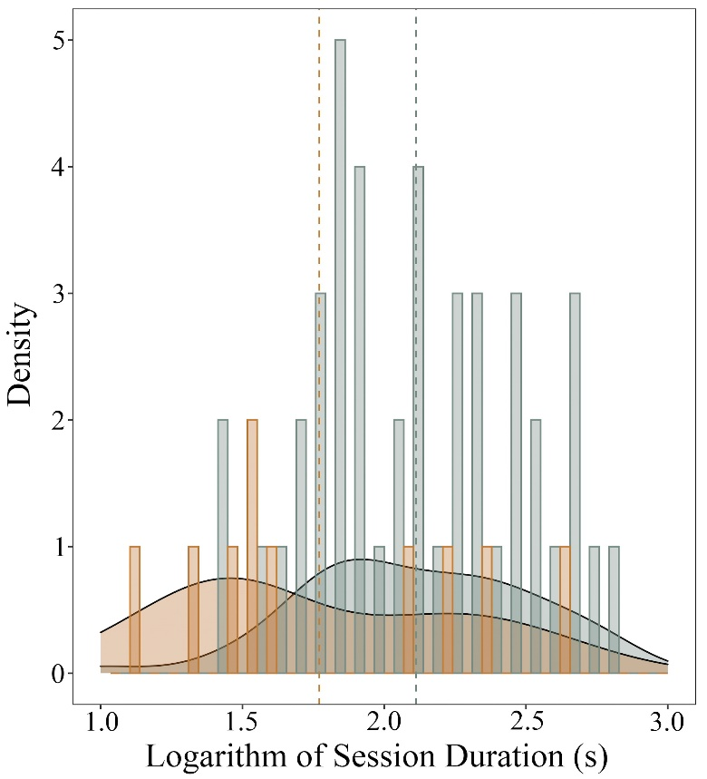

Fig. 2
Bar plot combined with a density plot showing that the duration of grooming sessions (log₁₀ transformed data) is higher in presence (yellow bars) than in absence (blue bars) of infant handling (LMM: N_{grooming_sessions}=55, p=0.021). The distribution of the duration of grooming sessions in presence and absence of infant handling is represented by the yellow and blue density curves, respectively. Dashed line indicates the mean grooming duration. Each bar indicates a grooming session.
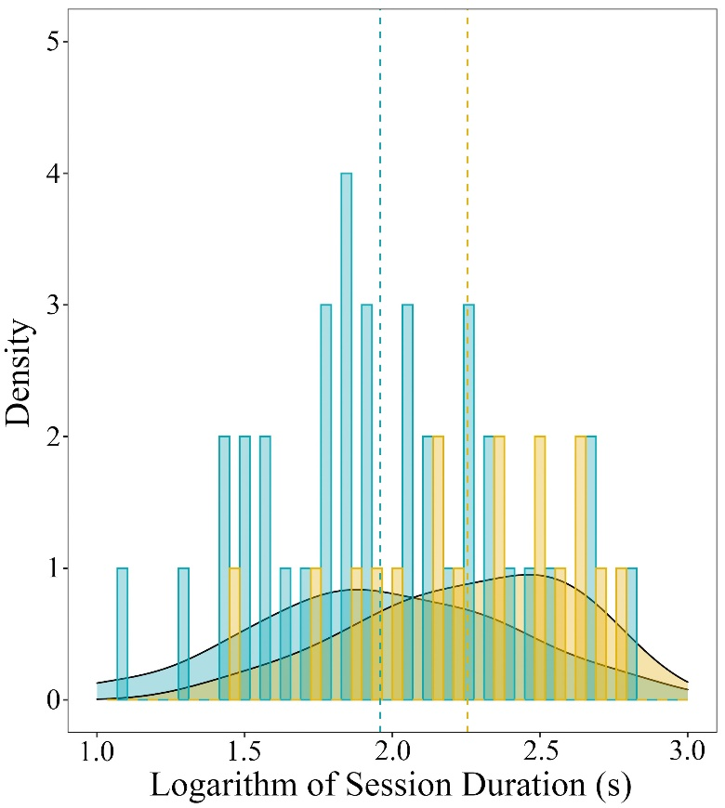

Fig. 3
Bar plot showing that the proportion of grooming received in each grooming session by mothers (yellow bars) is higher than the proportion of grooming received by non-mothers (green bars) (Wilcoxon’s test via Monte Carlo randomization: N_{grooming_sessions}=45; Z= -2.978; p=0.002). The exact proportion of grooming received is shown on each line next to the reference bar.

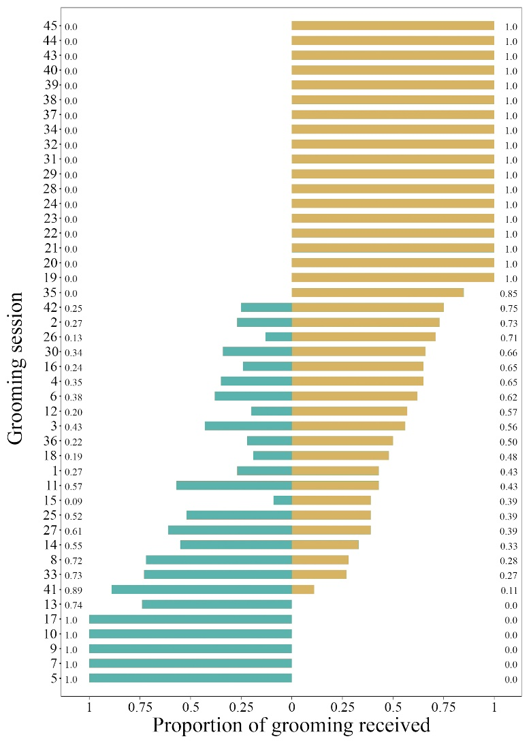

Fig. 4
Alluvial plot (R package “ggalluvial”) showing that the average proportion of grooming received by mothers is higher in presence (yellow bars) than absence of infant handling (blue bars) (Wilcoxon’s test: N_{focal_mothers}=8, Z=-2.028, p=0.043).
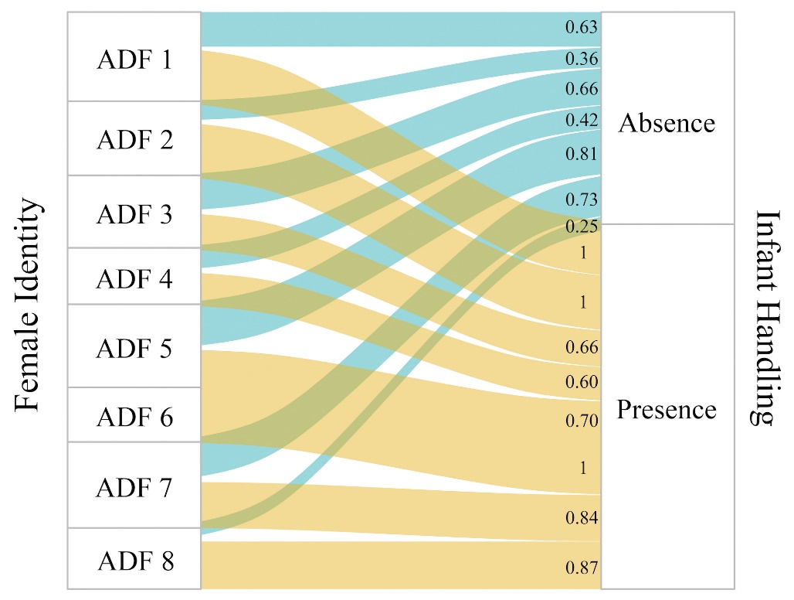

Fig. 5
Flow diagram generated by Behatrix 0.9.11 representing the transitions and the percentage of occurrence between each behavior and the proceeding one. Thick arrows indicate significant transitions (grooming given grooming received: p<0.001; grooming received grooming given: p=0.022; infant handling grooming received: p=0.006; grooming received infant handling: p=0.004). 10 focal mothers were involved in 13 grooming session in which the grooming that they received followed infant handling.

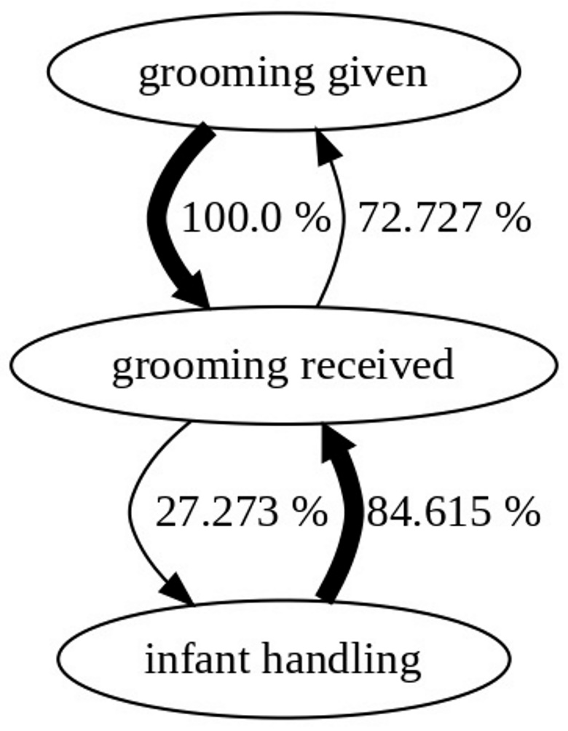

Tables
Table 1
Composition of the 7 OMUs involved in the study, including adult females (8.000 ± 0.690 mean ± SE), subadult females (1.71± 0.522 mean ± SE), juvenile females (0.857 ± 0.404 mean ± SE), late infants (2.143 ± 0.459 mean ± SE), early infants (1.000 ± 0.488), and black infants (1.286 ± 0.359 mean ± SE).
OMU | Adult females | Subadult females | Juvenile females | Infants | Late infants | Early infants | Black infants
OMU 1 | 11 | 1 | 2 | 6 | 3 | 2 | 1
OMU 2 | 6 | 3 | 0 | 5 | 0 | 2 | 3
OMU 3 | 8 | 1 | 2 | 4 | 3 | 0 | 1
OMU 4 | 9 | 1 | 0 | 6 | 3 | 3 | 0
OMU 5 | 6 | 0 | 0 | 3 | 2 | 0 | 1
OMU 6 | 7 | 4 | 2 | 3 | 1 | 0 | 2
OMU 7 | 9 | 2 | 0 | 4 | 3 | 0 | 1

Table 2
Description of the behaviors considered as infant handling during the study. The behavioral items were extracted from the ethogram of Dunbar & Dunbar (1975).
BEHAVIOUR | DESCRIPTION
Embrace | The handler embraces the infant with one or both arms
Lift and nuzzle infant rear | The handler lifts and smells the rear of the infant
Play | The handler performs some playful actions with the infant
Retrieve | The handler blocks the infant to avoid its flight
Grooming | The handler inspects and cleans the fur of the infant
Table 3
Full results of the LMM on the log₁₀ transformed duration of grooming sessions (N_{grooming_sessions}=55). Fixed factors: infant handling (presence or absence), dyad type (focal mother/non-focal mother or focal mother/non-mother), number of in-group infants and age class of infant (black infant, early infant and late infant). Identity and OMU membership were included as random factors.
LMM on log₁₀ transformed grooming duration
Predictors | Estimates |  | SEM | Chi-squared | P
(Intercept)ª |  | 2.288 | 0.292 | a | a
Infant handling (yes) |  | 0.232 | 0.106 | 2.187 | 0.033
Dyad type (focal mother/non-focal mother) |  | -0.343 | 0.135 | -2.543 | 0.014
Number of in-group infant |  | -0.076 | 0.067 | -1.148 | 0.276
Infant age-class (early) |  | 0.097 | 0.176 | 0.547 | 0.587
Infant age-class (late) |  | 0.274 | 0.139 | 1.968 | 0.054
ª Not shown as not having a meaningful interpretation.

