Evaporation Thermodynamics of the Tetraoctylphosphonium Bis(trifluoromethylsulfonyl)imide([P₈₈₈₈]NTf₂) and Tetraoctylphosphonium Nonafluorobutane-1-Sulfonate ([P₈₈₈₈]NFBS) Ionic Liquids

Lorenzo Barulli,ª Andrea Mezzetta,^{b,*} Bruno Brunetti,^{c} Lorenzo Guazzelli,^{b} Stefano Vecchio Ciprioti,^{d} Andrea Ciccioli^{a,*}
ªDipartimento di Chimica, Sapienza Università di Roma, P.le A. Moro 5, I-00185 Rome, Italy
^{b}Dipartimento di Farmacia, Università di Pisa, via Bonanno 33, 56126 Pisa, Italy
^{c} Istituto per i Materiali Nanostrutturati, Consiglio Nazionale delle Ricerche, c/o
Dipartimento di Chimica, Sapienza Università di Roma, P.le A. Moro 5, I-00185 Rome, Italy
^{d}Dipartimento di Scienze di Base ed Applicate per l’Ingegneria, Sapienza Università di Roma,
Via del Castro Laurenziano 7, I-00161 Rome, Italy

* Corresponding author
E-mail addresses:
andrea.mezzetta@unipi.it (A. Mezzetta)
andrea.ciccioli@uniroma1.it (A. Ciccioli)

Abstract
The evaporation/thermal decomposition behaviour of two ionic liquids with phosphonium cation (Phosphonium Ionic Liquids, PhosphoniumILs,), namely tetraoctylphosphonium bis(trifluoromethylsulfonyl)imide ([P₈₈₈₈]NTf₂) and tetraoctylphosphonium perfluorobutylphosphonate ([P₈₈₈₈]NFBS) was studied by thermogravimetry and by the effusion-based techniques Knudsen Effusion Mass Spectrometry (KEMS) and Knudsen Effusioni Mass Loss (KEML). KEMS spectra show that no appreciable release of decomposition products occurs up to the highest temperature reached in the experiments (225 °C for [P₈₈₈₈]NTf₂ and 262 °C [P₈₈₈₈]NFBS). Evaporation by loss of intact ion pair was detected at temperatures as low as 174 and 188 °C for the two compounds, much lower than the onset temperatures evaluated by the TG traces (383 °C for [P₈₈₈₈]NTf₂ and 407 °C [P₈₈₈₈]NFBS). In the explored temperature intervals (185 °C – 242 °C for [P₈₈₈₈]NTf₂ and 180 °C – 230 °C for [P₈₈₈₈]NFBS) the vapor pressures measured by KEML are very similar for the two compounds, falling in the ranges 1.8 10^{–3} – 0.19 Pa and 1.1 10^{–3} – 0.096 Pa. By monitoring the vapor pressure as a function of temperature, the following values of the evaporation enthalpies were determined at the average experimental temperature (227 °C):158.1 ± 2.0 kJ/mol ([P₈₈₈₈]NTf₂) and 161.2 ± 2.2 kJ/mol ([P₈₈₈₈]NFBS), which confirm the very similar volatility of the two compounds under equilibrium conditions.

1. Introduction
Ionic liquids (ILs) are organic salts composed by an organic cation paired with either an organic or an inorganic anion with a melting point below an arbitrarily set value (100 °C) [1,2]. The enormous interest gained by ILs in the last twenty years stems from their greener and higher safety profiles when compared to those of traditional organic solvents and from their unique physico-chemical properties (e.g. chemical stability[3], wide electrochemical window[4], non-flammability, negligible vapour pressure[5]).Furthermore, these properties can be tailored on a given application combining suitable ions from the almost unlimited choice of those available nowadays. Therefore, ILs found application in several different areas of research as for instance organic reactions[6,7], development of drug delivery systems[8,9], energy storage[10,11], biomass dissolution and transformation[12,13].
Among ILs, alkylphosphonium-based ILs (Phosphonium ILs) are known to possess some advantageous physico-chemical properties compared to more common ionic liquids such as those with N-alkylimidazolium or pyrrolidinium cations[14].Valuable properties of Phosphonium ILs include higher thermal and chemical stability, low density and low cost. The absence of acidic protons in Phosphonium IL cations has been claimed as an important factor enhancing their stability. On this basis, the use of Phosphonium ILs has been suggested in several technological applications, such as extraction and chemical synthesis solvents, electrolytes in electrochemical devices, corrosion protection, sulfur removal and neat lubricants[15,16]. Despite these appreciable features, the available experimental information about volatility, evaporation enthalpies and other thermodynamic properties of this class of ILs is very limited to date compared to nitrogen-based counterparts.
To the best of our knowledge, the first paper reporting vapor pressure data for a Phosphonium IL was presented in 2017[17]. In that work, the vapor pressure of tetraoctylphosphonium bis(2-ethylhexyl) phosphate was measured under both Knudsen and Langmuir conditions. In a subsequent work by the Verevkin’s group, vapor pressures and evaporation enthalpies were determined by QCM (Quartz Crystal Microbalance) and, to a lesser extent, by isothermal thermogravimetry (TG) for a number of Phosphonium IL containing several typical anions (PF₆–, NTf₂–, BF₄–, Br–, Cl–) and selected tetralkylphosphonium cations[18].
In order to better explore the technological potential of Phosphonium ILs, experimental information on crucial properties such as volatility, thermal stability, and evaporation enthalpy need to be expanded to assess the effect of chemical modifications of both cation and anion. In this work, we present the results of Knudsen Effusion Mass Spectrometry (KEMS) [19,20] and Knudsen Effusion Mass Loss (KEML) experiments[21,22] on two tetralkylphosphonium ionic liquids, namely tetraoctylphosphonium bis(trifluoromethanesulfonyl)imide ([P₈₈₈₈]NTf₂) and tetraoctylphosphonium nonafluorobutane-1-sulfonate ([P₈₈₈₈]C₄F₉SO₃ or [P₈₈₈₈]NFBS). TG measurements were also carried out on the two selected compounds.
The rationale for the selection of these Phosphonium ILs was mainly to test the effect of a symmetrical cation on the volatility and intermolecular forces and to compare the behaviour of two Phosphonium ILs whose anions are expected to give a remarkable thermal stability to the liquid. While the higher sensitivity of the QCM technique allows for performing vapor pressure measurements in a considerably lower temperature range compared to classic techniques, effusion conditions such as those used in our study have the advantage to permit to the system to reach a condition close to thermodynamic equilibrium. Furthermore, the use of mass spectrometry enables us to monitor the composition of the vapor phase, so investigating the possible release of volatile species as a result of thermal decomposition.

2. Experimental
2.1 Synthesis of ionic liquids
Tetraoctylphosphonium bis(trifluoromethanesulfonyl)imide ([P₈₈₈₈]NTf₂) was obtained following a well-known metathesis reaction[23]. To an aqueous solution of [P₈₈₈₈]Br, an aqueous solution of lithium bis(trifluoromethanesulfonyl)imide LiNTf₂ (80 wt.%, 5.5mmol, 1.1 equiv.) was added and the resulting second phase was recovered with dichloromethane (15 mL).The organic phase was washed with water (4 × 20 mL) until the aqueous phase tested negative for halide using a 0.1 M AgNO₃water solution. The dichloromethane was evaporated, and the remaining liquid was dried under high vacuum at 60 °C for at least 6 h to give a colourless liquid (yield 97%). The obtained product was analyzed by ¹H and ¹³C NMR.
Tetraoctylphosphonium nonafluorobutane-1-sulfonate ([P₈₈₈₈]NFBS) was synthetized following a similar procedure as [P₈₈₈₈]NTf₂. At a water solution of [P₈₈₈₈]Br, a proper amount of potassium nonafluorobutane-1-sulfonate (KNFBS, 3 mmol, 1,1 equiv.) was added. The resulting second phase was recovered with dichloromethane (15 mL) and then washed with water (4 × 20 mL) until the aqueous phase tested negative for halide using a 0.1 M AgNO₃ water solution. The dichloromethane was evaporated, and the remaining liquid was dried under high vacuum at 60 °C for at least 6 h to give a colorless liquid (yield 96%). The obtained product was analyzed by ¹H and ¹³C NMR (see Figs. S1-S4).

2.2. Thermogravimetry (TG)
Prior to TG measurement, all samples were dried in high vacuum at 40 °C for 12 hours, to remove moisture and any volatile materials. The thermal stability of the synthesized ILs was investigated by thermal gravimetric analysis (TGA), conducted in a TA Instruments Q500 TGA. The temperature calibration was performed using nickel standard and for weight calibration weight standards were used (1 g, 500 mg and 100 mg). All the standards were supplied by TA Instruments Inc. IL (11-15 mg) was heated in a platinum crucible as sample holder. First, the heating mode was set to isothermal at 40°C in N₂ (80 mL/min) for 30 min. Then, IL was heated from 40 to 900 °C at a heating rate of 10 °C/min under nitrogen (80 mL/min) and maintained at 900 °C for 3 min. Mass change was recorded as a function of temperature and time. TGA experiments were carried out in duplicate.

2.3 Knudsen Effusion Mass Spectrometry (KEMS)
KEMS is a classic technique combining the effusion of vapours from a Knudsen cell with mass spectrometric detection, that allows the composition of the vapor to be investigated. In a typical experiment, the IL sample is placed in a crucible whose lid has a small hole (1 mm diameter) allowing the vapor to escape and to enter the ion source of the mass spectrometer. Vapor species are ionized by electron impact and then accelerated by high voltage to a magnetic sector where they are separated on the basis of mass-to-charge ratio. Detection is then accomplished by an electron multiplier. The cell is heated by irradiation from a coil-shaped tungsten resistor surrounding it. Further details of our apparatus are reported in previous papers[24]. In all experiments, a graphite Knudsen cell was used, in turn inserted in an outer tantalum container. The energy of the ionizing electron beam was set at 20 eV. The vacuum in the ion source region of the apparatus was of the order of 5 10^{–7} – 2 10^{–6} mbar. The ion intensity measured for a given isotope i $\left(I_{i}^{+}\right)$is converted into the partial pressure p in the cell of the corresponding neutral precursor by the equation [24]
$p=k\frac{1}{a_{i}σ_{i}γ_{i}}I_{i}^{+}T$ (1)
where k is a calibration constant, and a, σ, γ are the isotope abundance, the electron impact ionization cross section and the detector gain for the species whose intensity is monitored. T is the absolute temperature, that was measured by an iron-constantan thermocouple (Type J) inserted in an hole made at the bottom of the outer tantalum crucible so as to make it to touch the bottom of the graphite cell.
Two KEMS experiments were carried out for each IL. As detailed in Section 3, the by far strongest peak in the mass spectra was that at m/e = 483.5, corresponding to the [P₈₈₈₈]⁺ cation. As usual in mass spectrometric studies of aprotic ionic liquids using “hard” ion sources, no peak was detected at the mass of the intact ion pair C⁺A–(g), which is most probably the only or largely dominant species released by evaporation. The accepted interpretation is that the gaseous ion pair is fragmented under electron impact leading to the formation of the observed C⁺ cation. The intensity vs electron energy curves were registered for the [P₈₈₈₈]⁺ species in order to derive an estimate of the appearance potential, i.e. the minimum energy required to form the ion. The values obtained were 9.5 ± 0.2 eV for [P₈₈₈₈]NTf₂ (consistent with that observed for imidazolium ionic liquids with the same anion [21]) and 8.5 ± 0.2 eV for [P₈₈₈₈]NFBS.
The calibration constant in equation 1 was derived by vaporizing pure cadmium from the same graphite cell used in experiments on Phosphonium ILs.

2.4 Knudsen Effusion Mass Loss (KEML)
The KEML technique is the most classic effusion-based method. In KEML, the mass of a sample placed in a Knudsen cell is monitored as a function of temperature and the (total) pressure in the cell at each temperature is evaluated from the measured mass loss rate dm/dt from the usual equation

$p=κ\frac{dm}{dt}\sqrt{\frac{T}{M}}$ (2)

where $κ$ is a calibration constant that in the present study was derived by vaporizing known substances such as cadmium or benzoic acid, and M is the (average) molecular weight of the vapor at the given temperature. In the present work, M is the mass of the intact ion pair which is the only (or overwhelmingly dominant) species in the vapor. It should be noted that eq 2 assumes that the vaporization coefficient α is unity. Such an assumption is usually valid for liquids and melts and it was invariably considered valid in previous effusion studies on ionic liquids, although it was recently questioned [17]. In order to test the attainment of proper equilibrium conditions, we performed a prolonged isothermal evaporation of a [P₈₈₈₈]NTf₂ sample that did not show any time-dependent drift of the signal.
The apparatus used here is an Ugine-Eyraud B60 model by Setaram, whose effusion source was previously modified in our laboratory. Details of the instrument were reported elsewhere[21]. Briefly, the cell is inserted into a capped copper cylinder to improve temperature homogeneity and measurement. The latter is done by a Pt100 platinum resistance inserted directly into the copper cylinder. The temperature control and the measurements of the mass loss were driven by a LabVIEW software that permits remote control and continuous operation. All IL samples were kept at about 120 °C, under vacuum for 24 hours. Mass losses were observed primarily in the first two hours of treatment. The total mass losses during the treatment were equal to about 8% for [P₈₈₈₈]NTf₂ and 4% for [P₈₈₈₈]NFBS.

3. Results and Discussion
3.1 Vapor pressures
The KEMS measurements were performed in the overall temperature ranges 174 °C – 225 °C for [P₈₈₈₈]NTf₂ and 188 °C – 262 °C for [P₈₈₈₈]NFBS. The main aim of KEMS experiments was to investigate the composition of the vapor phase–information that cannot be obtained by classic KEML. To this end, two relatively short experiments were performed for each IL, rather than one prolonged run as done for KEML measurements.
In Figure 1 we report the mass spectra of the vapor phase released under effusion conditions by the two Phosphonium ILs. The spectra show clear dominance of the peak at m/e = 483.5, easily assigned to the [P₈₈₈₈]⁺ cation. Minor signals surrounding the main peak are due to the ¹³C isotopes (M+1, M+2) and to species where one or two H atoms were lost.

Figure 1. Background-subtracted KEMS spectra recorded for [P₈₈₈₈]NTf₂ and [P₈₈₈₈]NFBS.

The other peaks in the spectra are due to fragments of the cation with one (m/e =370) or two (m/e = 257) alkyl chain(s) lost, most probably formed by electron impact. According to previous findings[21, 25], this result is explained by assuming that the IL evaporates in the form of intact ion pairs which are then fragmented by electron impact so as to form the free cation:

CA(l) = CA(g) (3)
CA(g) + 1 e– = C⁺(g) + A(g) + 2 e–

Based on the spectra in Figure 1, any thermal degradation with release of volatile decomposition products can be ruled out up to the highest temperatures reached in the experiments. This result confirms the relatively high stability of Phosphonium ILs. TG experiments (Figure 2) are consistent with this conclusion. The onset decomposition temperatures derived from TG traces provide values of 383 °C and 407 °C for [P₈₈₈₈]NTf₂ and [P₈₈₈₈]NFBS, respectively. It should be noted that, due to the higher sensitivity of KEMS/KEML and to the close-to-equilibrium conditions attained in the effusion cell, the evaporation of the two Phosphonium ILs has been observed at temperatures significantly lower than the onset TG values. This confirms previous results[21], leading to the conclusion that the onset temperatures accessible by thermogravimetric experiments tend to overestimate the temperature where decomposition begins to occur. This is an important point in assessing the long-term stability of ionic liquids.

Figure 2. TG and DTG curves for [P₈₈₈₈]NTf₂ (upper figure) and [P₈₈₈₈]NFBS

The intensity of the [P₈₈₈₈]⁺ peak was monitored as a function of temperature and converted to the corresponding partial pressure of the intact ion pair in the vapor by equation 1. The resulting values are reported in Table 1. In order to calculate the corresponding cell pressures, the value of σ is needed. Apparently, no experimental values of the electron impact ionization cross sections of ionic liquid isolated pairs are available to date but the tentative estimate of 35 ± 15 Å² reported by our group for the prototypical IL BMImNTf₂[21]. In lack of information, we adopted this value for both the Phosphonium ILs under exam. Note that this assumption may be affected by a larger error for the Phosphonium ILs with the NFBS anion. This approximation is considered to bring about an uncertainty in the calculated partial pressures up to a factor 2. For this reason, as well as for possible uncertainties in the sensitivity constant, we deem the pressures obtained by KEML more reliable in terms of absolute values.

Table 1. Vapor pressures of the P₈₈₈₈NTf₂ and P₈₈₈₈NFBS ionic liquids derived from KEMS and KEML measurements.

The vapor pressures derived from KEML experiments are also reported in Table 1. The temperature ranges covered in the experiments were 185 °C – 242 °C for [P₈₈₈₈]NTf₂ and 180 °C – 230 °C for [P₈₈₈₈]NFBS, and the corresponding vapor pressure ranges were 1.8 10^{–3} – 0.19 Pa and 1.1 10^{–3} – 0.096 Pa.

Figure 3. Clausius-Clapeyron plot of the vapor pressures measured for [P₈₈₈₈]NTf₂ (red symbols) and [P₈₈₈₈]NFBS (black symbols) by KEMS (run 1 and run 2) and KEML. For sake of comparison, the well-assessed vapor pressure of a typical imidazolium IL (BMImNTf₂) is also reported (solid line).

The KEMS and KEML vapor pressures are plotted in Figure 3 together with the values of a typical imidazolium IL, [BMIm]NTf₂, which are well-assessed[21]. In view of the uncertainty of the cross section values used in converting KEMS intensities into pressures, the agreement between the two techniques is satisfactory. In any case, as mentioned, the KEML values are to be considered more accurate. The results indicate that the vapor pressures of the two Phosphonium ILs here studied are very similar and are 1-2 orders of magnitude lower than [BMIm]NTf₂. No data are available for a comparison with imidazolium ILs having alkyl chains as long as those of the [P₈₈₈₈] cation, which are expected to be much less volatile than [BMIm]NTf₂.[26] In Figure 4 we compare the vapor pressures measured by KEML for the two compounds with those of a few related Phosphonium ILs for which tensimetric measurements were reported in the literature [18], namely the tetralkyl Phosphonium ILs with the NTf₂ anion and the only Phosphonium ILs with the [P₈₈₈₈] cation ([P₈₈₈₈]Cl). Although a systematic comparison is not feasible due to the scarcity of the available data, we note (Figure 4A) that the volatility of the Phosphonium ILs here investigated is substantially higher in comparison to the only compound with the same total number of C atoms ([P_{666,14}]NTf₂) and is very similar to that of [P_{444,14}]NTf₂, which has a lower total number of carbon atoms with three short and one long alkyl chain. Interplay between the chain length and the degree of symmetry of the cation is likely to be at work in the observed trend. With regard to Figure 4B, the lower volatility of the chloride IL is expected on the basis of the trend observed for imidazolium compounds [27] and is in part accounted for by the larger enthalpy of evaporation (see below, Table 3).

Figure 4. The vapor pressures of [P₈₈₈₈]NTf₂ and [P₈₈₈₈]NFBS measured in this work by KEML compared with values retrieved from literature for related compounds: tetraalkylphosphonium ionic liquids with the NTf₂ anion (A) and the only ionic liquid with the [P₈₈₈₈] cation (B) for which data are available ([P₈₈₈₈]Cl).

3.2 Enthalpy of evaporation
The enthalpy change of process (3) ($∆_{l}^{g}H_{m}^{°}$) can be derived as usual from the slope of the ln p vs 1/T plot (see Figure 3). Note that, unlike the pressure values, the KEMS-derived $∆_{l}^{g}H_{m}^{°}$values are not affected from systematic inaccuracies in the estimate of the cross section or sensitivity constant in eq 1. The resulting $∆_{l}^{g}H_{m}^{°}$ obtained for each experiment at the pertinent mean temperature are reported in Table 2 along with the corresponding temperature ranges, mean temperatures, and number of datapoints. Note that a much larger number of data was collected in the KEML experiments compared to KEMS ones.

Table 2. Results of the Clausius-Clapeyron regression for all the experiments

In view of the different mean temperatures of the various experiments, a proper comparison between the results obtained in different experiments may be done only after reducing all $∆_{l}^{g}H_{m}^{°}$to a common reference temperature. This implies to know the heat capacities of the liquid and gaseous phase of the ionic liquid or at least their difference (Δ_{ev}C_{p}) from the experimental temperatures to the reference temperature. To the best of our knowledge, the only available C_{p} data for Phosphonium ILs are those reported in [28], which do not include the two compounds under exam. Moreover, very little information is known about the heat capacities of IL gaseous ion pairs, which requests to calculate the partition functions from molecular parameters, and no information of this kind is available on Phosphonium ILs. To overcome the lack of data, various empirical methods were devised. In particular, Zaitsau et al.[18] proposed the following equation relating Δ_{ev}C_{p} to the heat capacity of the liquid phase:

Δ_{ev}C_{p} = k C_{p}(liquid) + m (4)

and found empirical values of the constants k and m for several anions including the NTf₂ on the basis of available experimental data. Thus, we applied the above equation to [P₈₈₈₈]NTf₂ by using for C_{p}(liquid) the value of the [P_{666,14}]NTf₂ Phosphonium IL (having the same number of carbon atoms) measured in [28]. For [P₈₈₈₈]NFBS we used the same approach, but the lack of assessed values of k and m for the nonafluorobutante-1-sulfonate anion and the lack of any experimental C_{p} Phosphonium ILs with this anion added further uncertainties to the procedure. The C_{p} of [P₈₈₈₈]NFBS was thus estimated by a group contribution method proposed in [29] and the empirical constants were evaluated from an overall fitting of the data reported in [18].
In order to minimize the effect of the approximate estimate of heat capacities, we choose T_{ref} = 227 °C (500 K) as the reference temperature, which is close to experimental temperatures. Adopting the more common room temperature of 25 °C (298 K) would imply much larger heat content differences, with higher associated errors that could affect the analysis.
By translating the $∆_{l}^{g}H_{m}^{°}$values to 227 °C (500 K) by the approximate procedure detailed above we obtained the results reported in the last column of Table 2. On this basis, we concluded that the results display an overall acceptable to satisfactory agreement, with a somehow larger discrepancy between the KEML and KEMS results for [P₈₈₈₈]NFBS. It seems reasonable to propose as the recommended value of $∆_{l}^{g}H_{m}^{°}$for the two compounds under study the mean of the different runs weighted for the number of data. The values so obtained at 227 °C (500 K) are 158.1 ± 2.0 kJ/mol for [P₈₈₈₈]NTf₂ and 161.2 ± 2.2 kJ/mol for [P₈₈₈₈]NFBS. Not surprisingly (see Figs 3 and 4), the evaporation enthalpies of the two compounds are very similar, partially overlapping in the uncertainty range.
As mentioned in the introduction, the information on evaporation enthalpies for Phosphonium ILs presently available in the literature is limited. In Table 3 we report a list of literature data for related compounds, all translated to the common reference temperature by the above reported procedure. Our value for [P₈₈₈₈]NFBS is apparently the first determination of $∆_{l}^{g}H_{m}^{°}$for ILs (not only Phosphonium ILs) with this anion, so no comparison with literature is possible. With regard to [P₈₈₈₈]NTf₂, our value is close to that reported for the only Phosphonium ILs with the same number of carbon atoms, P_{666,14} NTf₂. The slightly lower enthalpy of evaporation of the symmetric-cation compound [P₈₈₈₈]NTf₂ compared to [P_{666,14}]NTf₂ is in line with the trend recently observed for imidazolium ILs[30,31]. However, in view of the small difference between the two values, any conclusion in this regard should be supported by experimental determinations on a larger series of compounds.

Table 3. Enthalpies of evaporation of alkyl phosphonium ionic liquids from literature and from the present work at 227 °C (500 K)

4. Conclusions
Evaporation properties of tetraoctylphosphonium bis(trifluoromethanesulfonyl)imide ([P₈₈₈₈]NTf₂) and tetraoctylphosphonium nonafluorobutane-1-sulfonate ([P₈₈₈₈]NFBS) were studied by the effusion technique KEML and KEMS and by thermogravimetry. The two Phosphonium ILs evaporated with no significant simultaneous decomposition in the temperature ranges 174 – 242 °C for [P₈₈₈₈]NTf₂ and 180 – 262 °C for [P₈₈₈₈]NFBS. The two compounds displayed very similar volatilities, with vapor pressures falling in the ranges 4 10^{–3} – 0.2 Pa and 1 10^{–3} – 0.6 Pa, respectively, in the above mentioned temperature intervals. Such values are 1-2 orders of magnitude lower than those of a typical imidazolium ionic liquid with short alkyl chains, such as [BMIm]NTf₂, for which the vapor pressure was assessed in various studies. The evaporation enthalpies were 158.1 ± 2.0 kJ/mol for [P₈₈₈₈]NTf₂ and 161.2 ± 2.2 kJ/mol for [P₈₈₈₈]NFBS at the mean experimental temperature of 227 °C (500 K). These results confirm that phosphonium cation provides the system with both higher thermal stability toward decomposition and lower volatility compared to ionic liquids featuring more common cations.

References
[1] T. Welton, Ionic liquids: a brief history, Biophys. Rev. 10 (2018) 691–706.
[2] S.K. Singh, A.W. Savoy, Ionic liquids synthesis and applications: An overview, J. Mol. Liq. 297 (2020) 112038. https://doi.org/10.1016/j.molliq.2019.112038.
[3] B. Wang, L. Qin, T. Mu, Z. Xue, G. Gao, Are Ionic Liquids Chemically Stable?, Chem. Rev. 117 (2017) 7113–7131.
[4] M. Hayyan, F.S. Mjalli, M. Ali, I.M. Alnashef, T. Xue, Journal of Industrial and Engineering Chemistry Investigating the electrochemical windows of ionic liquids, J. Ind. Eng. Chem. 19 (2013) 106–112.
[5] H.B. Wu, B. Zhang, S.H. Liu, C.C. Chen, Flammability estimation of 1-hexyl-3-methylimidazolium bis(trifluoromethylsulfonyl)imide, J. Loss Prev. Process Ind. 66 (2020) 104196.
[6] S. Muhammad, F. I. Ali, M. N.Javed, A. A. Wasima, A. Bari, F. Rafique, M. A. Ilyas, K. Riaz, S. J. Mahmood,A. Ahmed, I. Ali Hashmi.Effect of supramolecular polymeric aggregation in room temperature ionic liquids (RTILs) on catalytic activity in the synthesis of 4H-chromene derivatives and Knoevenagel condensation. J. Mol. Liq. (2020) in press.
[7] L. Guglielmero, A. Mezzetta, C.S. Pomelli, C. Chiappe, L. Guazzelli. Evaluation of the effect of the dicationic ionic liquid structure on the cycloaddition of CO₂ to epoxides. J. CO₂ Util. 34 (2019) 437–445.
[8] M. M. Santos, C. Alves, J. Silva, C. Florindo, A. Costa, Ž. Petrovski, I. M. Marrucho, Rui Pedrosa, and L. C. Branco. Antimicrobial Activities of Highly Bioavailable Organic Salts and Ionic Liquids from Fluoroquinolones. Pharmaceutics, 12 (2020) 694.
[9] S. Tampucci, L. Guazzelli, S. Burgalassi, S. Carpi, P. Chetoni, A. Mezzetta, P. Nieri, B. Polini, C.S. Pomelli, E. Terreni, D. Monti, pH-Responsive Nanostructures Based on Surface Active Fatty Acid-Protic Ionic Liquids for Imiquimod Delivery in Skin Cancer Topical Therapy, Pharmaceutics. 12 (2020) 1078.
[10] C.F.J. Francis, I.L. Kyratzis, A.S. Best. Lithium-Ion Battery Separators for Ionic-Liquid Electrolytes: A Review. Adv. Mater. 32 (2020) 1904205.
[11] E. Jonsson, Ionic liquids as electrolytes for energy storage applications – A modelling perspective, Energy Storage Mater. 25 (2020) 827–835.
[12] A. Mehmood Asim, M. Uroos, S. Naz, M. Sultan, G. Griffin, N. Muhammad, A. S. Khan. Acidic ionic liquids: Promising and cost-effective solvents for processing of lignocellulosic biomass. J. Mol. Liq. 287 (2019) 110943.
[13] S. Becherini, A. Mezzetta, C. Chiappe, L. Guazzelli. Levulinate amidinium protic ionic liquids (PILs) as suitable media for the dissolution and levulination of cellulose. New J. Chem., 43 (2019) 4554-4561.
[14] K.J. Fraser, D.R. MacFarlane, Phosphonium-based ionic liquids: an overview, Aust. J. Chem. 62 (2009) 309-321.
[15] L. Macarie, V. Simulescu, G. Ilia, Phosphonium-based ionic liquids used as reagents or catalysts, ChemistrySelect 4 (2019) 9285-9299.
[16] S. Khazalpour, M. Yarie, E. Kianpour, et al., Applications of phosphosnium-based ionic liquids in chemical processes, J. Iran. Chem. Soc. 17 (2020) 1775-1917.
[17] J.W. McMurray, Y. Zhou, H.M. Luo, et al., Vaporization behavior of tetraoctylphosphonium bis(2-ethylexyl)phosphate ionic liquid, Chem. Phys. Lett. 667 (2017) 55-61.
[18] D.H. Zaitsau, N. Plechkova, S.P. Verevkin, Vaporization thermodynamics of ionic liquids with tetraalkylphosphonium cations, J. Chem. Thermodynamics 130 (2019) 204-212.
[19] V. Volpe, B. Brunetti, G. Gigli, et al., Toward the elucidation of the competing role of evaporation and thermal decomposition in ionic liquids: a multitechnique study of the vaporization behaviour of 1-butyl-3-methylimidazolium hexafluorophosphate under effusion conditions, J. Phys. Chem. B 121 (2017) 10382-10393.

[20] A.M.Dunaev, V.B.Motalov, L.S.Kudin, M.F.Butman Thermodynamic properties of the ionic vapor species over EMImNTf₂ ionic liquid studied by Knudsen effusion mass spectrometry, J. Mol. Liq. 223 (2016) 407-411.
[21] B. Brunetti, A. Ciccioli, G. Gigli et al., Vaporization of the prototyipical ionic liquid BMimNTf₂ under equilibrium conditions: a multitechnique stud, Phys. Chem. Chem. Phys. 16 (2014) 15653-15661.
[22] A. Ciccioli, R. Panetta, A.Luongo et al. Stabilizing lead halide perovskites with quaternary ammonium cations: the case of tetramethylammonium lead iodide,Phys. Chem. Chem. Phys., 21 (2019) 24768-24777.
[23] A. Mezzetta, V. Perillo, L. Guazzelli, C. Chiappe. Thermal Behavior Analysis as a Valuable Tool for Comparing Ionic Liquids of Different Classes. J. Therm. Anal. Calorim. 138 (2019) 3335–3345.
[24] A. Ciccioli, G. Gigli. The Uncertain Bond Energy of the NaAu Molecule: Experimental Redetermination and Coupled Cluster Calculations, J. Phys. Chem. A 117 (2013) 4956-4962.
[25] A.M.Dunaev, V.B.Motalov, L.S. Kudin, M.F.Butman. Molecular and ionic composition of saturated vapor over EMImNTf₂ ionic liquid, J. Mol. Liq. 219 (2016) 599-601.
[26] S. P Verevkin, D. H. Zaitsau, V. N Emel’yanenko et al.. Making Sense of Enthalpy of Vaporization Trends for Ionic Liquids: New Experimental and Simulation Data Show a Simple Linear Relationship and Help Reconcile Previous Data, J. Phys. Chem. B 117 (2013) 6473-6486.
[27] D. H. Zaitsau, R. Siewert, A. A. Pimerzin et al. From volatility to solubility: Thermodynamics of imidazolium-based ionic liquids containing chloride and bromide anions, J. Mol. Liq. 323 (2021) 114998.
[28] A.F. Ferreira, P.N. Simões, A.G.M. Ferreira, Quaternary phosphonium-based ionic liquids: thermal stability and heat capacity of the liquid phase, J. Chem. Thermodynamics 45 (2012) 16-27.
[29] A. Ahmadi, R. Haghbakhsh, S. Raeissi, et al. A simple group contribution correlation for the prediction of ionic liquid heat capacities at different temperatures, Fluid phase Equilibria 403 (2015) 95-103.
[30] A. V. Yermalayeu, D. H. Zaitsau, M.Loor, et al. Imidazolium Based Ionic Liquids: Impact of the Cation Symmetry and Alkyl Chain Length on the Enthalpy of Vaporization, Z. Anorg. Allg. Chemie, 643 (2017) 81-86.
[31] M. A. A. Rocha, J. A. P. Coutinho, L.M.N.B.F Santos, Cation symmetry effect on the volatility of ionic liquids, J. Phys. Chem. B 116 (2012) 10922-10927.

Table 1. Vapor pressures of the P₈₈₈₈NTf₂ and P₈₈₈₈NFBS ionic liquids derived from KEMS and KEML measurements.
P₈₈₈₈NTf₂ |  |  |  | P₈₈₈₈NFBS
KEMS |  | KEML |  | KEMS |  | KEML
T/°C | pª/Pa | T/°C | p^{b}/Pa | T/°C | pª/Pa | T/°C | p^{b}/Pa
Run 1 |  | 242.1 | 0.19 | Run 1
174 | 0.00037 | 237.1 | 0.13 | 251 | 0.14 | 202.0 | 0.0083
193 | 0.0018 | 232.2 | 0.079 | 224 | 0.023 | 199.4 | 0.0056
206 | 0.0062 | 227.1 | 0.051 | 238 | 0.093 | 194.4 | 0.086
218 | 0.019 | 222.2 | 0.033 | 221 | 0.023 | 229.3 | 0.059
231 | 0.053 | 217.4 | 0.025 | 249 | 0.14 | 224.3 | 0.032
 |  | 212.4 | 0.018 | 261 | 0.33 | 219.4 | 0.026
Run 2 |  | 207.2 | 0.0099 | 204 | 0.0049 | 214,3 | 0.018
200 | 0.0076 | 202.2 | 0.0064 | 188 | 0.0012 | 209.4 | 0.012
225 | 0.069 | 197.2 | 0.0045 | 224 | 0.018 | 204.5 | 0.0077
 |  | 192.4 | 0.0030 | 252 | 0.13 | 199.5 | 0.0040
 |  | 187.5 | 0.0022 | 268 | 0.37 | 194.6 | 0.0036
 |  | 234.2 | 0.092 |  |  | 189.7 | 0.0022
 |  | 229.3 | 0.070 | Run 2 |  | 184,8 | 0.0015
 |  | 224.5 | 0.046 | 239 | 0.18 | 179.9 | 0.084
 |  | 219.6 | 0.031 | 210 | 0.017 | 229.3 | 0.056
 |  | 214.6 | 0.020 | 224 | 0.049 | 224.6 | 0.035
 |  | 209.6 | 0.011 | 249 | 0.26 | 219.5 | 0.022
 |  | 204.5 | 0.0076 | 262 | 0.60 | 214.5 | 0.015
 |  | 199.8 | 0.0052 | 202 | 0.0074 | 209.5 | 0.0087
 |  | 194.8 | 0.0040 |  |  | 204.5 | 0.0070
 |  | 189.9 | 0.0027 |  |  | 199.4 | 0.0041
 |  | 185.0 | 0.0018 |  |  | 194.5 | 0.0034
 |  | 234.3 | 0.10 |  |  | 189.6 | 0.0024
 |  | 229.4 | 0.061 |  |  | 184.7 | 0.0011
 |  | 224.4 | 0.043 |  |  | 179.8 | 0.096
 |  | 219.4 | 0.029 |  |  | 230.0 | 0.057
 |  |  |  |  |  | 224.7 | 0.037
 |  |  |  |  |  | 219.4 | 0.023
 |  |  |  |  |  | 214.5 | 0.014
 |  |  |  |  |  | 209.6 | 0.010
 |  |  |  |  |  | 204.6 | 0.0070
 |  |  |  |  |  | 199.7 | 0.0046
 |  |  |  |  |  | 194.9 | 0.0027
 |  |  |  |  |  | 189.8 | 0.0023
 |  |  |  |  |  | 185 | 0.0014
 |  |  |  |  |  | 180 | 0.091
 |  |  |  |  |  | 229.4 | 0.059
 |  |  |  |  |  | 224.5 | 0.036
 |  |  |  |  |  | 219.6 | 0.024
 |  |  |  |  |  | 214.5 | 0.017
 |  |  |  |  |  | 209.7 | 0.0099
 |  |  |  |  |  | 204.7 | 0.0072
ª Obtained by eq 1from the intensity of MS peak m/e = 483.5
^{b} Obtained from measured mass loss rate by eq 2 using the molar mass M of the gaseous ion pair

Table 2. Results of the Clausius-Clapeyron regression for all the experiments
Sample | Experiment | Data  points | T range  (T_{mean})/°C | ln (p/Pa) = A – B/10^{–4} T(K) | $$∆_{l}^{g}H_{m}^{°}$$  (T_{mean})  (kJ/mol) | $∆_{l}^{g}H_{m}^{°}$(227 °C, 500 K)  (kJ/mol)
P₈₈₈₈NTf₂
 | KEMS 1 | 5 | 174-231  (203.6) | (36.489 ± 1.049) – (1.9887 ± 0.04995) | 165.4 ± 4.2 | 159.0 ± 4.2
 | KEMS 2 | 2 | 200-225  (212.2) | – | (172.6) | (168.6)ª
 | KEML | 27 | 185-242  (213.9) | (35.776 ± 0.5002) – (1.9349 ± 0.02434) | 161.5 ± 2.0 | 157.9 ± 2.0
 |  |  |  |  | Mean 158.1 ± 2.0
P₈₈₈₈NFBS
 | KEMS 1 | 11 | 188-268  (233.4) | (32.745 ± 1.444) – (1.8146 ± 0.07305) | 150.9 ± 6.1 | 153.0 ± 6.1
 | KEMS 2 | 6 | 202-262  (230.1) | (34.293 ± 1.443) – (1.85619 ± 0.07252) | 154.3 ± 6.0 | 155.3 ± 6.0
 | KEML | 42 | 180-230  (205.4) | (35.081 ± 0.5472) – (1.8900 ± 0.02617) | 157.1 ± 2.2 | 164.2 ± 2.2
 |  |  |  |  | Mean161.2 ± 2.2
a Not included in the mean (2 datapoints)

Table 3. Enthalpies of evaporation of alkyl phosphonium ionic liquids from literature and from the present work at 227 °C (500 K)

Anion | Cation | Total C atoms in the cation | $∆_{l}^{g}H_{m}^{°}$(227 °C or 500 K) kJ/mol | Method [ref.]
[PF₆] | [P6[P6665] 665] | 23 | 154.5 ± 3.0 | QCM [18]
 | [P6666] | 24 | 160.2 ± 3.1 | QCM [18]
 | [P6667] | 25 | 159.1 ± 3.3 | QCM [18]
 | [P6668] | 26 | 161.5 ± 3.5 | QCM [18]
[NTf₂] | [P6667] | 25 | 154.5 ± 5.7 | QCM [18]
 | [P444,14] | 26 | 146.7 ± 5.4 | QCM [18]
 | [P666,14] | 32 | 160.3 ± 7.2 | QCM [18]
 | [P8888] | 32 | 158.1 ± 2.0 | KEMS/KEML (this work)
[Cl] | [P8888] | 32 | 167.1 ± 6.6 | QCM [18]
[Br] | [P6666] | 24 | 146.8 ± 5.7 | QCM [18]
 | [P8888] | 32 | 144.2 (estimate) | QCM [18]
[DEHP] (bis-2-ethylhexylphosphate) | [P8888] | 32 | 86.5 ± 13.3 | KEML [17]
[NFBS] | [P8888] | 32 | 161.2 ± 2.2 | KEMS/KEML (this work)

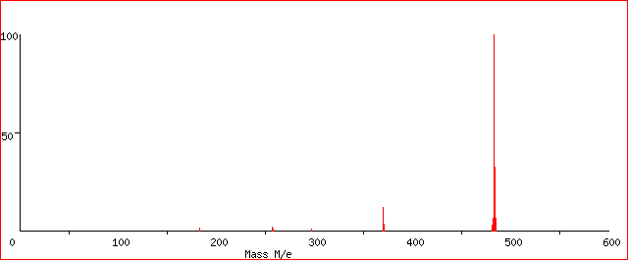
[P₈₈₈₈]⁺
483.5
370
257
[P₈₈₈₈][NTf₂]
T = 169 °C

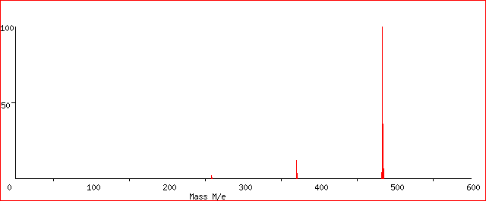
483.5
370
257
[P₈₈₈₈][NFBS]
[P₈₈₈₈]⁺
T = 218 °C
Figure 1. Background-subtracted KEMS spectra recorded for [P₈₈₈₈]NTf₂ and [P₈₈₈₈]NFBS.

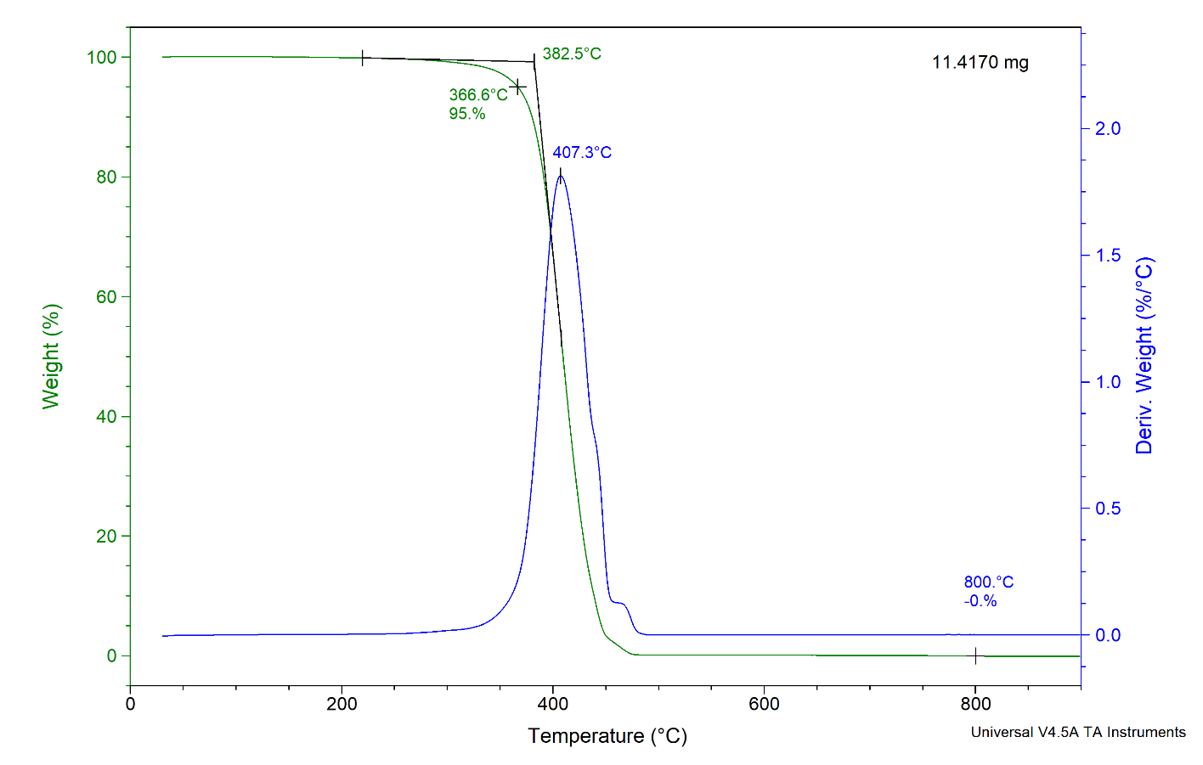
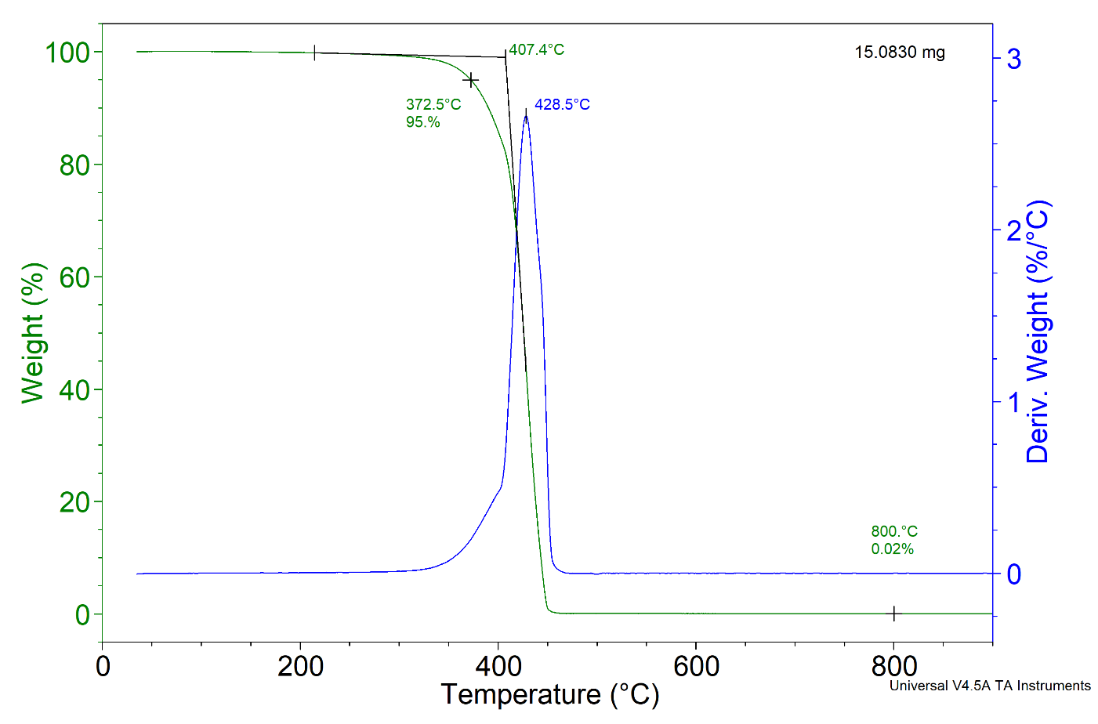
Figure 2. TG and DTG curves for [P₈₈₈₈]NTf₂ (upper figure) and [P₈₈₈₈]NFBS
Figure 3. Clausius-Clapeyron plot of the vapor pressures measured for [P₈₈₈₈]NTf₂ (red symbols) and [P₈₈₈₈]NFBS (black symbols) by KEMS (run 1 and run 2) and KEML. For sake of comparison, the well-assessed vapor pressure of a typical imidazolium IL (BMImNTf₂) is also reported (solid line).
(A)
(B)
Figure 4. The vapor pressures of [P₈₈₈₈]NTf₂ and [P₈₈₈₈]NFBS measured in this work by KEML compared with values retrieved from literature for related compounds: tetraalkylphosphonium ionic liquids with the NTf₂ anion (A) and the only ionic liquid with the [P₈₈₈₈] cation (B) for which data are available ([P₈₈₈₈]Cl).

