An interfacial self-assembling bioink for supramolecular and hierarchical bioprinting

Yuanhao Wu^{1,2,3}, Gabriele Maria Fortunato⁴, Babatunde O. Okesola^{5,6}, Francesco Luigi Pellerej di Brocchetti⁴, Ratima Suntornnond⁷, John Connelly⁷, Carmelo De Maria⁴, Jose Carlos Rodriguez-Cabello⁸, Giovanni Vozzi⁴, Wen Wang^{5,6}, Alvaro Mata^{1,2,3,5,6*}

- School of Pharmacy, University of Nottingham, NG7 2RD Nottingham, UK.
- Department of Chemical and Environmental Engineering, University of Nottingham, NG7 2RD Nottingham, UK.
- Biodiscovery Institute, University of Nottingham, NG7 2RD Nottingham, UK.
- Research Center ‘E. Piaggio’ & Dipartimento di Ingegneria dell’Informazione, University of Pisa, Largo Lucio Lazzarino, 1 - 56122 Pisa, Italy.
- Institute of Bioengineering, Queen Mary University of London, London E1 4NS, UK.
- School of Engineering and Materials Science, Queen Mary University of London, London E1 4NS, UK.
- CREATE LAB, Blizard Institute, Barts and the London School of Medicine and Dentistry, Queen Mary University of London, 4 Newark St London, E1 2AT.
- BIOFORGE Group, University of Valladolid, CIBER-BBN, 47011 Valladolid, Spain.

*Corresponding author: Alvaro Mata, a.mata@nottingham.ac.uk

Abstract
Self-assembling bioinks offer the possibility to biofabricate with unprecedented molecular precision, hierarchical control, and biofunctionality. However, for these benefits to become widespread reality, it is essential to engineer these ink systems ensuring reproducibility and providing suitable standardization. Here, we report on the characterization, optimization, and validation of a bioink based on the non-covalent, yet high affinity, interactions and organization of a disordered protein (ELR) with graphene oxide (GO). Co-assembly and hierarchical organization of the components is triggered and guided upon liquid-on-liquid printing of an ELR solution inside a GO solution, enabling the fabrication of macroscopic tubular structures with resolutions down to ~10 m in diameter and ~2 m thick tube walls. Both experiments and finite element analysis were performed to characterize and optimize the printing conditions, underlying interfacial diffusion-reaction mechanism of assembly, fidelity of the prints, and resulting material porosity and permeability. By systematic modification of printing conditions, we demonstrate the capacity to modulate the pore size of the printed material between 0.5 - 4 µm, resulting in permeability constants to 20 kDa dextran between 2x10⁻⁶ - 58x10⁻⁶ cm/s and to fluorescein sodium salt between 1x10⁻⁵ - 5x10⁻⁵ cm/s. Taking advantage of the biocompatibility of the bioink, human umbilical vascular endothelial cells (hUVECs) were then grown on the material and used to further affect structure permeability. Finally, the potential of the ELR-GO bioink was also demonstrated by printing tubes exhibiting walls with progressively different concentrations of the components, resulting in anisotropic permeabilities with a gradient profile.

Introduction
Bioinks are increasingly playing a leading role in our quest for recreating the structures and subsequent functions of biological systems^{[1]}. In combination with techniques such as extrusion and inkjet printing, new bioinks are pushing the boundaries of biofabrication enabling the development of thick vascularized structures^{[2]}, soft high-resolution constructs^{[3]}, multicellular environments^{[4]}, and higher levels of biomimecry^{[5,6]}. Inspite of these exciting advances, replication of the molecular diversity, structural hierarchy from the nanoscale, and ultimate functionality of tissues and organs remains a major challenge^{[7,8]}. Consequently, it is essential to develop innovative ways to fabricate using molecular and nanoscale building blocks in a rational manner while enabling communication between cellular and extracellular components across size scales^{[9]}.

Self-assembly is the process by which multiple components come together to create higher-ordered structures in a reproducible manner^{[10]}. Nature has evolved to grow and regenerate tissues and organs using these processes in order to organize molecular building-blocks such as proteins, lipids, and carbohydrates^{[11]}. Inspired by this, a wide variety of self-assembling materials have been developed based on molecules such as peptide amphiphiles^{[12]}, dipeptides^{[13]}, and multi-domain peptides^{[14]} as well as approaches such as peptide libraries^{[15]} or machine learning^{[16]}. These materials offer a unique opportunity to recreate features of the extracellular matrix (ECM) such as the nanofibrous architecture of macromolecules^{[17]} and the capacity to selectively communicate with cells by controllably displaying molecular signals^{[18]}. Examples include materials capable of promoting cell adhesion^{[19]}, differentiation^{[20]}, and mineralization^{[21]}; regeneration of tissues such as bone^{[22]}, cartilage^{[23]}, and vasculature^{[24]}; and in vitro recreation of complex in vivo environments such as bone-like constructs^{[25]} and ovarian cancer spheroids^{[26]}.

Bioinks based on molecular self-assembly offer the opportunity to immediately present cells with rationally designed ECM-like milieus^{[27]}. Pioneering work by Raphael et al and Loo et al demonstrated the possibility to integrate top-down printing with bottom-up molecular self-assembly^{[28][29]}. However, the widespread use of self-assembling materials in additive manufacturing has been limited primarily due to inadequate structural integrity and speed of setting as well as limited capacity to control their assembly beyond the nanoscale^{[30]}. Multicomponent self-assembly offers an opportunity to not only enhance some of these crucial physical characteristics^{[31]} but also enrich the molecular diversity^{[32]} and functionality^{[33]} of these synthetic matrixes. Furthermore, this approach takes advantage of the properties of the individual components as well as emergence of new ones as a result of their interaction^{[34]} such as structural hierarchy^{[35]}, enhancement of mechanical properties^{[36]}, access to non-equilibrium^{[37]}, or tuneability of bioactivity^{[38]}. In addition, multicomponent self-assembling bioinks offer the possibility of printing soft and weak components into sufficiently robust structures^{[39]}. For example, peptides conjugated with a lysine and assembling with phosphate-buffered saline were used to print 3D hydrogel structures displaying stiffnesses up to ~40 kPa and the capacity to stimulate stem cell differentiation to create gastrointestinal and skin-like structures^{[29]}. In another example, glycosaminoglycans and pure poly(ethyleneglycol) enabled printing of hydrogel structures with resolutions down to 50 μm and tuneable mechanical properties^{[40]}.

Multicomponent self-assembling bioinks can also be used to generate solid structures upon printing one low viscosity liquid phase into another^{[29]}. For example, taking advantage of the interface between oil and water, nanoclay-polymer surfactants were self-assembled into semi-permeable membranes and perfusable capillaries^{[41]}. Also, printing a dextran water solution into a polyethylene oxide water solution enabled rapid fabrication of biocompatible tissue-like 3D architectures such as capillary networks and cardiac structures^{[42]}.

Liquid-on-liquid printing not only exploits multicomponent self-assembly but also control of emerging supramolecular phenomena such as compartmentalization^{[43]} and diffusion-reaction processes^{[37]}. These events are ubiquitous in nature and play a key role in the functionality of biological systems such as in cell division and motility, the key compartmentalization exhibited by cells and organelles^{[44]}, and the regulation of molecular transport exhibited cross simple organisms such as prokaryotes^{[45]}. In this way, liquid-on-liquid printing offers an opportunity to fabricate by simulatenous assembly taking place from both the top-down and bottom-up, bridging size-scales and facilitating communication with biology at subcellular, cellular, and multicellular levels^{[46]}. Taking advantage of these opportunities, we have recently reported on a multicomponent material emerging from the co-assembly of elastin-like recombinamers (ELRs) with graphene oxide (GO)^{[47]}. This system utilizes disorder-to-order transitions of the ELR molecule to spontaneously interact with and conform to GO through electrostatic and hydrophobic forces. The material can be assembled through ELR-on-GO printing and controlled interfacial growth to fabricate perfusable fluidic devices exhibiting physiological properties.

In this study, we standardize key bioprinting parameters and expand the capabilities of our ELR-GO co-assembling system to serve as a liquid-on-liquid bioink (Figure 1a) for the fabrication of hierarchical structures (Figure 1b) with resolutions down to ~10 m luminal structure (Figure 1c and e) with ~2 m feature (Figure 1d) and exhibiting a spectrum of structural and biofunctional properties. Through experiments and cross-platform finite element analysis (COMSOL Multiphysics v5.5, COMSOL Group, Sweden), we demonstrate the possibility to bioprint perfusable tubular structures with various degrees of permeability, including permeability gradients within a single structure. The system enables bioprinting of tubes with endothelial cells, which rapidly endothelialize and further modulate permeability.

Results and discussion
Rationale of the study
The ELR (ELK1) is a 51.9 kDa recombinant molecule consisting of 24 repeats of a single block made of four hydrophobic pentapeptides (VPGIG) and a positively charged one (VPGKG), while GO comprises of a hydrophobic middle area and negatively charged edges. Upon printing a solution of the ELK1 into the GO solution (Figure 1a), hydrophobic and electrostatic interactions define ELK1-GO co-assembly and trigger an interfacial diffusion-reaction process that gives rise to a multi-layered membrane (Figure 1b). By modulating the way in which both solutions are mixed, it is possible to spatially control this process to easily generate hierarchical tubular structures (Figure 1a). In this manner, while the printing nozzle determines the diameter of the tubular structures, it is the bioink that defines the wall thickness and consequently the ultimate resolution of the printing process. Futhermore, the resulting tube wall can be designed to exhibit a variety of physiologically-relevant properties such as the capacity to pulsate (Figure 1f and Supplenmentary Movie 1) and tuneable thickness, stiffness, and permeability. Consequently, we first conducted experiments and simulations to characterize, standardize, and optimize the printing parameters. We then focused on further controlling the printing fidelity and material properties by modulating the concentration of GO. Given the potential use of the bioink to biofabricate fluidic devices and perfusable structures, we then conducted a thorough characterization of tube wall permeability with and without cells as well as developed ways to fabricate structures with tuneable and anisotropic permeability.

Optimization of the printing process
ELK1-GO diffusion-reaction process and printing fidelity
We conducted experiments and simulations to characterize bioink shape fidelity as determined by the diffusion-reaction mechanism triggered upon ELK1-in-GO printing. First, an 18 µL ELK1 water solution (2 wt%) was manually injected into 100 µL GO water suspension (0.10 wt%) in a 96-well plate to generate a standard tube. The process was video recorded (Supplementary Figure 1) and imaged at different time-points to investigate the kinetics of tube wall formation (Figure 2a and Supplenmentary Movie 2). Separately, a “transport of diluted species” COMSOL model simulating similar experimental conditions was generated and used to validate the experimental results. Both experimental and simulation results (Supplementary figure 5) were in agreement and revealed that (1) the ELK1-GO tube wall thickness did not increase after ~80 s of interaction (Figure 2a), (2) the tube wall thickness increased from inside the tube to the outside as the ELK1 diffussed towards the GO (Figure 2a, simulated images), and (3) the ELK1-GO tube exhibited a similar diameter as that of the starting ELK1 injected drop (Figure 2a). The results demonstrated that the initial volume of the ELK1 injection determined the outside dimension of the final printed structure (Figure 2a) and that this dimension was not affected by the growth of the ELK1-GO interfacial tube wall as a result of its diffusion-reaction process.

Tuneable geometry by varying printing parameters and GO concentration
The printability of the ELK1-GO bioink was characterized using a commercially available 3D printer (3D Discovery™ Evolution, RegenHU, Switzerland) with adjustable nozzle heights and diameters, dispensing pressures, and printing speeds^{[48]}. By fixing nozzle height and diameter, we assessed the relation between dispensing pressure and printing speed. The fidelity of fabricated ELK1-GO tubes was assessed by optically and systematically measuring tube diameters at different locations, which revealed increased printing fidelity with increasing printing speed (Figure 2b and Figure 2c). Larger diameter differences within a single tube led to larger variances, which resulted in rugged tube walls (Figure 2b, printing speed: 10 mm/s). By varying the dispensing pressure of the ELK1 solution between 0.02 - 0.10 MPa and the printing speed between 10 - 100 mm/s (nozzle height and diameter were fixed and shown in the Figure 2b, table), we found that tubes were able to be generated when the dispensing pressure was between 0.04 - 0.08 MPa. When printing within this pressure range and printing speeds above 30 mm/s, variances in tube wall geometry within a single tube were under 5%, which reflected high fidelity tubes with smooth walls (Figure 2b).

Printing fidelity was also characterized by varying the concentration of the GO suspension (Figure 2c). In this case, lower concentrations of GO (0.05 wt%) generated tubes with lower printing fidelity and thinner tube walls (~40 µm), while higher GO concentrations (0.10 and 0.15 wt%) resulted in tubes with higher printing fidelity and thicker walls (~60 µm) (Figure 2d and 2e). We speculate that this difference in wall thickness results from interfacial membranes forming with varying levels of permeability as a result of having different concentrations of GO. We have demonstrated that upon initial ELK1-GO co-assembly, a diffusion barrier is formed, which defines its downstream diffusion-reaction mechanism that generates the distinctive multilayer membrane^{[47]}. We reason that lower concentration of GO leads to a more permeable diffusion barrier, which allows for higher and faster ELK1 diffusion and consequently thinner multi-layered membranes. In contrast, higher concentration of GO upon co-assembly results in the formation of a less permeable diffusion barrier, which results in thicker membranes.

Optimization of the printed structure
Tuneable porosity by varying the concentration of GO suspension
Having characterized printing reproducibility and fidelity, we then focused on exploiting the co-assembling nature of the bioink to control ELK1-GO tube wall porosity by varying the concentration of GO. Tubes were first co-assembled with varying GO concentrations (0.05, 0.10, and 0.15 wt%) and cut to extract flat membranes (the tube wall) (Supplementary Figure 1a). The luminal (inner) and abluminal (outer) sides of these membranes were then examined by scanning electron microscopy (SEM) following standard preparation protocols^{[47]}. As expected, increased GO concentrations led to decreased porosity, which was easily noticeable on both inner and outer surfaces of the membranes (Figure 3a). Upon closer inspection, significant differences in porosity between the inner and outer surfaces were observed on all membranes, independently of GO concentration (Figure 3b), which was also confirmed by histological sectioning (Figure 3d). These results demonstrated the possibility to modulate the ELK1-GO tube wall pore sizes from 0.5 - 1.2 µm on the inner surface and 1.6 - 4.0 µm on the outer one by modifying GO concentrations (Figure 3c).

Together with the previous results of printing fidelity and tuneability of geometry and porosity, we can conclude that higher GO concentration and printing speed (50 mm/s < PS < 70 mm/s) can be used to fabricate higher fidelity tubes with smooth and thicker (~60 µm) fully formed tube walls but less porosity after 60 s of co-assembly. By contrast, lower GO concentration and printing speed (30 mm/s < PS <50 mm/s) would generate lower fidelity tubes with rugged and thinner (~40 µm) tube walls exhibiting higher levels of porosity. Importantly, upon ELK1-GO co-assembly, the thickness of the resulting interfacial structures depends on the time-dependent diffusion-reaction process of formation (Figure 2a). Consequently, given the high ELK1-GO affinity, it is possible to stop the co-assembly process at different time points, resulting in interfacial membranes of different thicknesses. We found that it was possible to stop the co-assembly process after just 15 s by removing the fabricated tube from the GO suspension, resulting in tube wall thicknesses down to ~2 µm when printing at > 70 mm/s. Furthermore, tube wall thicknesses were observed to reach a maximum of ~20 µm in thickness (Figure 2c) after ~80 s of co-assembly, which did not seem to change after longer periods of time. We speculate that these thin tube walls result from the low ELK1 volumes released upon printing at fast printing speeds (> 70 mm/s), offering an opportunity to reproducibly biofabricate with resolutions down to a few microns in size (Figure 1c,d). In summary, these results demonstrate how bioprinting fidelity and resolution can be tuned through both printing parameters from the top-down and self-assembling events taking place from the bottom-up.

Assessment of applicability
Tuneable permeability by varying porosity
The possibility to control tube wall porosity opens an opportunity to fabricate membranes, capillaries, and other structures with tuneable permeability that could be designed to recreate that of biological tissues. For example, vascular permeability is fundamental in biological processes such as regulating diffusion of nutrients and waste products, serving as a semipermeable barrier between blood contents and tissues to screen toxic molecules, and regulating the microenvironment of the ECM^{[49]}. Furthermore, diffusion across vascular and lymphatic tissues is vital to enable appropriate filtration, protection, and delivery of key solutes, cells, and factors.

The capacity to develop vascular structures or fluidic devices with tuneable permeability is critical to recreate and optimize biofunctionality. To assess the effect of tube wall porosity on its permeability, we designed a simple capillary-based permeability testing device where the membrane (cut from the ELK1-GO tube) can be positioned in the middle, leaving two free chambers on either side. (Supplementary Figure 2a). The chambers can be filled with any solution, enabling diffusion of solutes from one side to the other (Supplementary Figure 2a).We tested the permeability of the membrane to fluorescein sodium salt and 20 kDa FITC-dextran in water solution to recreate physiological charge and size barriers, respectively. These two functions are normally observed in vascular tissue^{[49]}. Using epifluorescence microscopy imaging, permeability constants were calculated based on the fluorescence intensity profiles recorded on the chamber where the solutes diffused to (Figure 4a). Specifically, exponential curves describing the trend of the average intensity within the chamber as a function of time were calculated for each ELK1-GO membrane and the permeability constant measured using a fitting plot (Figure 4b). To confirm these results, we established a “transport of diluted species” COMSOL model to predict the permeability of sodium salt through the membrane (Figure 4a). Similarly to the experimental setup, sodium salt exhibited faster diffusion than 20 kDa FITC-dextran (Figure 4c) and a permeability constant of ~5x10⁻⁵ cm/s. Furthermore, as expected, we found that the permeability constants decreased with increasing concentration of GO for both fluorescein sodium salt (from 1x10⁻⁵ cm/s to 5x10⁻⁵ cm/s) and 20 kDa FITC-dextran (from 2x10⁻⁶ cm/s to 58x10⁻⁶ cm/s) (Figure 4c).

These results demonstrate the potential of the ELK1-GO bioink to fabricate complex membranous and tubular structures while enabling regulation of permeability. By simply modulating GO concentration, it is possible to fabricate complex structures made from thin membranes with permeabily constants comparable to those of the native retina (~2x10⁻⁵ cm/s)^{[50]}, a hUVEC-containing Transwell (~5x10⁻⁶ cm/s)^{[51]}, organ-on-chip devices of the blood-brain-barrier (~5x10⁻⁵ cm/s)^{[52]} and lymphatic-vessels (~6.4x10⁻⁶ cm/s)^{[53]}.

Tuneable permeability after endothelialization
To further assess the functionality and biological relevance of the bioink, we conducted similar permeability tests but after endothelialisation of the lumen of the ELK1-GO tubes. Different densities (5x10³, 1x10⁴, 5x10⁴, or 1x10⁵ /mL) of hUVECs were seeded on the luminal side of the membranes (cut from ELK1-GO tubes) (0.10 wt% GO) placed on Petri dishes (Supplementary Figure 2b, top) in order to develop membranes comprising numbers of cells. As expected, after 48 hrs of culture, membranes exhibited different hUVEC densities including ~30%, 50%, 80%, and > 95%, as measured by confocal microscopy imaging (Figure 5a, confocal images). Then, these membranes were inserted into the permeability test device with hUVECs facing one of the chambers (Supplementary Figure 2b, bottom). Then, 40 kDa FITC-Dextran^{[54]} in phosphate-buffered saline (PBS) was flown into the chamber facing the cells while PBS alone was flown into the other. Here, we used 40 kDa FITC-Dextran instead of the 20 kDa FITC-Dextran as it is widely used to test biomaterial permeability^{[54]}. The results demonstrated that membrane permeability tended to decrease with increased cell density, with membranes without cells (control) exhibiting the highest permeability contant (2.2x10⁻⁶ cm/s) while those with the highest cell density exhibited the lowest permeability constant (6.5x10⁻⁷ cm/s) (Figure 5b and 5c). In conclusion, the presence of hUVECs growing on the ELK1-GO tube wall significantly influenced the transport of solutes in a way that is dependent on the level of hUVEC confluency. We speculate that lower cell densities led to lower number of endothelial cell junctions, which in turn led to higher permeabilities. These results further support the possibility to tune structure permeability and, in particular, to do it through the presence of cells. For example, the permeability constant of ELK1-GO-hUVEC membranes (~1x10⁻⁶ cm/s) with confluence levels above 50% were comparable with that of tumor micro vessels (1.8x10⁻⁶ cm/s)^{[55]}.

Fabrication of tubular structure with anisotropic porosity and permeability
To further demonstrate the potential of the ELK1-GO bioink for the biofabrication of compled structures with innovative properties, we printed tubes exhibiting different porosities and corresponding permeabilities within the same structure along the tube axis (Figure 6c, illustrator). We first designed an experimental setup that enabled the formation of a MilliQ water solution made with different concentrations of GO contiguously increasing from 0.15 wt% on the left side, 0.10 wt% on the middle, and 0.05 wt% on the right side (Figure 6a). The GO was stained with Rhodamin B prior to printing of the ELK1 to enable GO visualization in the tube wall. In this setup, we found that the gradient of the GO in solution was maintained for at least 3 hrs, which was confirmed by a “transport of diluted species” COMSOL model (Figure 6a) and facilitated the printing process. Upon extrusion of the ELK1 solution into the GO solution from the lower to the higher concentration of GO, the tube formed immediately at the interface of both liquids with the tube wall progressively assembling with increasing concentrations of GO (Figure 6b). The resulting tubular structure was then characterized via epifluorescence microscopy, which revealed a tube wall with increasing content of GO and consequently a porosity gradient (Figure 6c, red). To test the effect of this porosity gradient on the permeability of the overall tube, 20 kDa FITC-Dextran solution was perfused through and, as expected, its diffusion progressively decrease along the tube direction as the GO concentration increased (Figure 6c, green and 6d). These kinds of anisotropic structures are prevalent in biological systems such as in renal tubules^{[56]} and arteriovenous networks^{[57]}. Our bioink enables the fabrication of such anisotropic vascular structures in a simple manner.

Conclusion
We have standardized and optimized the ELK1-GO bioink and demonstrated its potential to enable biofabrication by integrating top-down and bottom-up. Through experimental work and simulations, we have confirmed the possibility to use the ELK1-GO bioink to fabricate complex tubular structures with hierarchical organization and resolutions down to ~10 m luminal structure with ~2 m. These structures enable immediate perfusion after assembly and exhibit physical properties such as stiffnesses^{[47]} and the capacity to pulsate that resemble physiological structures. In addition, the bioink permits printing fidelity and control over structure porosity and permeability by modulating the concentration of GO and the possibility to guide this process to fabricate structures with permeability grandients. Furthermore, the bioink is biocompatible and facilitates hUVEC bioprinting, growth, and proper function, enabling futher control of permeability. In this way, it is possible to biofabricate complex structures that can be designed to recreate the permeability properties of native tissues or other engineered devices.

Acknowledgement
The work was supported by the ERC Starting Grant (STROFUNSCAFF), the UK Regenerative Medicine Platform (UKRMP2) Acellular/Smart Materials, the AO Foundation (3D Printed Osteogenic & Hierarchal Bio Mineralizing Scaffold), and the AO Foundation AOCMF-17-19M grant. We thank Dr. J. Rafael Castrejón-Pita from from the School of Engineering and Materials Science at Queen Mary University of London for offering devices to record optical images of diffusion reaction. We thank Mr. Jingyu Feng from Department of Chemical Engineering at Imperial College London for helping design illustrator of capillary-based permeability testing device.

References
[1] T. J. Hinton, Q. Jallerat, R. N. Palchesko, J. H. Park, M. S. Grodzicki, H. J. Shue, M. H. Ramadan, A. R. Hudson, A. W. Feinberg, Sci. Adv. 2015, 1.
[2] D. B. Kolesky, K. A. Homan, M. A. Skylar-Scott, J. A. Lewis, Proc. Natl. Acad. Sci. U. S. A. 2016, 113, 3179.
[3] T. Tylek, C. Blum, A. Hrynevich, K. Schlegelmilch, T. Schilling, P. D. Dalton, J. Groll, Biofabrication 2020, 12, 025007.
[4] N. Ashammakhi, S. Ahadian, C. Xu, H. Montazerian, H. Ko, R. Nasiri, N. Barros, A. Khademhosseini, Bioinks and bioprinting technologies to make heterogeneous and biomimetic tissue constructs. Mater. Today Bio 2019, 1, 100008.
[5] F. P. W. Melchels, M. A. N. Domingos, T. J. Klein, J. Malda, P. J. Bartolo, D. W. Hutmacher, Additive manufacturing of tissues and organs. Prog. Polym. Sci. 2012, 37, 1079–1104.
[6] T. Jungst, W. Smolan, K. Schacht, T. Scheibel, J. Groll, Strategies and Molecular Design Criteria for 3D Printable Hydrogels. Chem. Rev. 2016, 116, 1496–1539.
[7] Hedegaard C and Mata A, Integrating self-assembly and biofabrication for the development of structures with enhanced complexity and hierarchical control. Biofabrication 2020, In Press.
[8] S. V. Murphy, A. Atala, 3D biorinting of tissues and organs. Nat. Biotechnol. 2014, 32, 773–785.
[9] P. S. Gungor-Ozkerim, I. Inci, Y. S. Zhang, A. Khademhosseini, M. R. Dokmeci, Bioinks for 3D bioprinting: An overview. Biomater. Sci. 2018, 6, 915–946.
[10] G. M. Whitesides, M. Boncheva, Proc. Natl. Acad. Sci. U. S. A. 2002, 99, 4769.
[11] A. H. Gröschel, F. H. Schacher, H. Schmalz, O. V. Borisov, E. B. Zhulina, A. Walther, A. H. E. Müller, Nat. Commun. 2012, 3, 1.
[12] R. Freeman, M. Han, Z. Álvarez, J. A. Lewis, J. R. Wester, N. Stephanopoulos, M. T. McClendon, C. Lynsky, J. M. Godbe, H. Sangji, E. Luijten, S. I. Stupp, Science (80-. ). 2018, 362, 808.
[13] E. Gazit, Peptide nanostructures: Aromatic dipeptides light up. Nat. Nanotechnol. 2016, 11, 309–310.
[14] T. L. Lopez-Silva, D. G. Leach, I. C. Li, X. Wang, J. D. Hartgerink, ACS Biomater. Sci. Eng. 2019, 5, 977.
[15] C. G. Pappas, R. Shafi, I. R. Sasselli, H. Siccardi, T. Wang, V. Narang, R. Abzalimov, N. Wijerathne, R. V. Ulijn, Nat. Nanotechnol. 2016, 11, 960.
[16] F. Li, J. Han, T. Cao, W. Lam, B. Fan, W. Tang, S. Chen, K. L. Fok, L. Li, Proc. Natl. Acad. Sci. U. S. A. 2019, 166, 11259.
[17] J. D. Hartgerink, E. Beniash, S. I. Stupp, Science (80-. ). 2001, 294, 1684.
[18] M. P. Lutolf, J. A. Hubbell, Synthetic biomaterials as instructive extracellular microenvironments for morphogenesis in tissue engineering. Nat. Biotechnol. 2005, 23, 47–55.
[19] J. R. Brennan, D. C. Hocking, Acta Biomater. 2016, 32, 198.
[20] K. S. Hellmund, B. Koksch, Self-assembling peptides as extracellular matrix mimics to influence stem cell’s fate. Front. Chem. 2019, 7.
[21] S. Elsharkawy, M. Al-Jawad, M. F. Pantano, E. Tejeda-Montes, K. Mehta, H. Jamal, S. Agarwal, K. Shuturminska, A. Rice, N. V. Tarakina, R. M. Wilson, A. J. Bushby, M. Alonso, J. C. Rodriguez-Cabello, E. Barbieri, A. Del Río Hernández, M. M. Stevens, N. M. Pugno, P. Anderson, A. Mata, Nat. Commun. 2018, 9, 1.
[22] A. Mata, Y. Geng, K. J. Henrikson, C. Aparicio, S. R. Stock, R. L. Satcher, S. I. Stupp, Biomaterials 2010, 31, 6004.
[23] J. Kisiday, M. Jin, B. Kurz, H. Hung, C. Semino, S. Zhang, A. J. Grodzinsky, Proc. Natl. Acad. Sci. U. S. A. 2002, 99, 9996.
[24] M. E. Davis, J. P. M. Motion, D. A. Narmoneva, T. Takahashi, D. Hakuno, R. D. Kamm, S. Zhang, R. T. Lee, Circulation 2005, 111, 442.
[25] B. Derkus, B. O. Okesola, D. W. Barrett, M. D’Este, T. T. Chowdhury, D. Eglin, A. Mata, Acta Biomater. 2020, 109, 82.
[26] M. A. Hedegaard CL, Redondo-Gomez C, Tan BY, Ng KW, Loessner D, Under Rev.
[27] J. H. Collier, J. S. Rudra, J. Z. Gasiorowski, J. P. Jung, Chem. Soc. Rev. 2010, 39, 3413.
[28] B. Raphael, T. Khalil, V. L. Workman, A. Smith, C. P. Brown, C. Streuli, A. Saiani, M. Domingos, Mater. Lett. 2017, 190, 103.
[29] Y. Loo, A. Lakshmanan, M. Ni, L. L. Toh, S. Wang, C. A. E. Hauser, Nano Lett. 2015, 15, 6919.
[30] M. Guvendiren, J. Molde, R. M. D. Soares, J. Kohn, Designing Biomaterials for 3D Printing. ACS Biomater. Sci. Eng. 2016, 2, 1679–1693.
[31] B. O. Okesola, H. K. Lau, B. Derkus, D. K. Boccorh, Y. Wu, A. W. Wark, K. L. Kiick, A. Mata, Biomater. Sci. 2020, 8, 846.
[32] A. M. Fuentes-Caparrós, F. De Paula Gómez-Franco, B. Dietrich, C. Wilson, C. Brasnett, A. Seddon, D. J. Adams, Nanoscale 2019, 11, 3281.
[33] B. O. Okesola, S. Ni, B. Derkus, C. C. Galeano, A. Hasan, Y. Wu, J. Ramis, L. Buttery, J. I. Dawson, M. D’Este, R. O. C. Oreffo, D. Eglin, H. Sun, A. Mata, Adv. Funct. Mater. 2020, 1906205.
[34] B. O. Okesola, A. Mata, Multicomponent self-assembly as a tool to harness new properties from peptides and proteins in material design. Chem. Soc. Rev. 2018, 47, 3721–3736.
[35] D. M. Raymond, B. L. Nilsson, Multicomponent peptide assemblies. Chem. Soc. Rev. 2018, 47, 3659–3720.
[36] G. Ochbaum, M. Davidovich-Pinhas, R. Bitton, Soft Matter 2018, 14, 4364.
[37] K. E. Inostroza-Brito, E. Collin, O. Siton-Mendelson, K. H. Smith, A. Monge-Marcet, D. S. Ferreira, R. P. Rodríguez, M. Alonso, J. C. Rodríguez-Cabello, R. L. Reis, F. Sagués, L. Botto, R. Bitton, H. S. Azevedo, A. Mata, Nat. Chem. 2015, 7, 897.
[38] A. Scelsi, B. Bochicchio, A. Smith, V. L. Workman, L. A. Castillo Diaz, A. Saiani, A. Pepe, J. Biomed. Mater. Res. - Part A 2019, 107, 535.
[39] D. E. Clarke, C. D. J. Parmenter, O. A. Scherman, Angew. Chemie - Int. Ed. 2018, 57, 7709.
[40] R. Zimmermann, C. Hentschel, F. Schrön, D. Moedder, T. Büttner, P. Atallah, T. Wegener, T. Gehring, S. Howitz, U. Freudenberg, C. Werner, Biofabrication 2019, 11, 045008.
[41] W. Feng, Y. Chai, J. Forth, P. D. Ashby, T. P. Russell, B. A. Helms, Nat. Commun. 2019, 10, 1.
[42] G. Luo, Y. Yu, Y. Yuan, X. Chen, Z. Liu, T. Kong, Adv. Mater. 2019, 31, 1904631.
[43] A. H. Chen, P. A. Silver, Designing biological compartmentalization. Trends Cell Biol. 2012, 22, 662–670.
[44] R. Roodbeen, J. C. M. Van Hest, Synthetic cells and organelles: Compartmentalization strategies. BioEssays 2009, 31, 1299–1308.
[45] S. Soh, M. Byrska, K. Kandere-Grzybowska, B. A. Grzybowski, Reaction-diffusion systems in intracellular molecular transport and control. Angew. Chemie - Int. Ed. 2010, 49, 4170–4198.
[46] C. L. Hedegaard, E. C. Collin, C. Redondo-Gómez, L. T. H. Nguyen, K. W. Ng, A. A. Castrejón-Pita, J. R. Castrejón-Pita, A. Mata, Adv. Funct. Mater. 2018, 28, 1703716.
[47] Y. Wu, B. O. Okesola, J. Xu, I. Korotkin, A. Berardo, I. Corridori, F. L. P. di Brocchetti, J. Kanczler, J. Feng, W. Li, Y. Shi, V. Farafonov, Y. Wang, R. F. Thompson, M.-M. Titirici, D. Nerukh, S. Karabasov, R. O. C. Oreffo, J. Carlos Rodriguez-Cabello, G. Vozzi, H. S. Azevedo, N. M. Pugno, W. Wang, A. Mata, Nat. Commun. 2020, 11, 1182.
[48] J. Yin, D. Zhao, J. Liu, Bio-Design Manuf. 2019, 2, 50.
[49] S. Ono, G. Egawa, K. Kabashima, Inflamm. Regen. 2017, 37, 11.
[50] S. Tsuboi, T. Fujimoto, Y. Uchihori, K. Emi, S. Iizuka, K. Kishida, R. Manabe, Investig. Ophthalmol. Vis. Sci. 1984, 25, 1146.
[51] J. Glod, D. Kobiler, M. Noel, R. Koneru, S. Lehrer, D. Medina, D. Maric, H. A. Fine, Blood 2006, 107, 940.
[52] P. J. Gaillard, A. G. De Boer, Eur. J. Pharm. Sci. 2000, 12, 95.
[53] M. Sato, N. Sasaki, M. Ato, S. Hirakawa, K. Sato, K. Sato, PLoS One 2015.
[54] N. Kirschner, R. Rosenthal, M. Furuse, I. Moll, M. Fromm, J. M. Brandner, J. Invest. Dermatol. 2013, 133, 1161.
[55] N. K. Reitan, M. Thuen, P. E. Goa, C. de Lange Davies, J. Biomed. Opt. 2010, 15, 036004.
[56] A. S. Verkman, Mechanisms and regulation of water permeability in renal epithelia. Am. J. Physiol. - Cell Physiol. 1989, 257.
[57] J. E. Fish, J. D. Wythe, The molecular regulation of arteriovenous specification and maintenance. Dev. Dyn. 2015, 244, 391–409.

Figure legends

Figure1. Rationale, assembly, and structure of the ELK1-GO bioink. a. Artist vision of the potential of the ELK1-GO bioink to be combined with extrusion-based printing to fabricate tube and capillary-based fluidic structures. The bioink assembles upon liquid-on-liquid printing of an ELK1 (brown) solution comprising cells (blue) into a solution of GO flakes (red), spontaneously triggering a diffusion-reaction process at the solution interface and leading to the formation of a multilayered membrane. The process enables trapping of cells within the membrane and immediate localization within the lumen of the resulting tubular structures. b. Scanning electron microscope (SEM) image of the cross-section of an ELK1-GO tubular structure depicting the resulting multi-layered architecture. c-e. SEM images of an ELK1-GO capillary with an internal diameter of ~10 μm and a tube wall thickness of ~2 μm. f. Time-lapse imaging of an ~800 mm diameter tube being perfused with a pulsatile flow at 12 mL/min depicting the change in tube diameter (white arrow) as a result of the material’s resilient properties.

Figure 2. Diffusion-reaction process and printing fidelity. a. Time-lapse optical images of a co-assembling tube upon immersion of a solution of ELK1 into a solution of GO depicting a growing tube wall (shown between white arrows) reaching a maximum of ~150 µm in thickness after ~80 s. In the bottom row, corresponding images of tube wall thickness from “transport of diluted species” COMSOL model simulations (rainbow colour) confirming the increasing thickness of the tube wall as a result of the time-dependent diffusion-reaction process of formation. b. The graph on the left reports on the relationship between printing speed, releasing pressure, and fabricated tube diameters. Error bars represent ±s.d. for n = 10. *p < 0.05. t test. The images on the right illustrate the printing fidelity of the ELK1-GO bioink in relation to different printing parameters. c. Confocal image of a longitudinal-section of an ELK1-GO depicting the tube walls (between white arrows) (green = ELK1, red = GO) demonstrating a high-fidelity tubular structure. d. Graphs and e. corresponding confocal images of unilateral longitudinal-sections of the wall of ELK1-GO tubes revealing the relationship between the concentration of the GO suspension prior to co-assembly and the resulting tube wall thickness. ±s.d. for n = 5. *p < 0.05. t test.

Figure 3. Control of tube wall porosity by varying the concentration of GO. a. SEM images and b, c corresponding quantifications of porosity (b) and pore size, (c) demonstrating significant differences in porosity between the inner and outer surfaces on all membranes (tube walls) and pore sizes by modifying GO concentration. d. Histological slide of tube wall cross-section demonstrating the decrease in porosity from the inner side of the tube wall to the outer side of the tube wall. ±s.d. for n = 3. *p < 0.05. t test.

Figure 4. Control of tube wall permeability by varying the concentration of GO. a. Confocal images and corresponding “transport of diluted species” COMSOL model simulations of a perfused ELK1-GO membrane (cut from an ELK1-GO tube) positioned in the middle of a capillary-based permeability testing device. Upon injection of fluorescein sodium salt solution in the right chamber, progressive diffusion across the membrane is observed at different time points in the left chamber. In the bottom, red colour indicating high fluorescein sodium salt concentration while green colour indicating low concentration. b. Graphs depicting the time-dependent fluorescein density change of FITC-Dextran 20 kDa (left) and fluorescein sodium salt (right) in the left chamber of the permeability testing device with fitting lines. c. Permeability constants calculated based on the data reported in b revealing the permeabilities of ELK1-GO membranes for FITC-Dextran 20 kDa and fluorescein sodium salt decrease with the increasing concentration of GO suspension.

Figure 5. Modification of permeability after endothelialisation. a. Confocal images of hUVECs (green) grown at different confluency levels (left to right: 30%, 50%, 80%, >95%) on the inner side of ELK1-GO membranes. b. Graphs recording the fluorescein density change of FITC-Dextran 40 kDa with time in the left chamber with fitting lines and c. permeability constants calculated based on the data reported in b for FITC-Dextran 40 kDa permeability through ELK1-GO-hUVECs membranes. Membrane permeability tended to decrease with increased cell density, with membranes without cells (control) exhibiting the highest permeability constant while those with the highest cell density exhibiting the lowest one. ±s.d. for n = 3. *p < 0.05. t test.

Figure 6. Fabrication of tubular structures with anisotropic porosity and permeability. a. Images of “transport of diluted species” COMSOL model simulations and corresponding graphs demonstrating the maintained gradient of increasing GO concentration in solution for at least 3 hr. b. Illustration of the mechanism of fabricating the tubular structures with progressively decreasing porosity and permeability by printing the ELK1 solution from right to left into the GO solutions. c. Schematic of the fabrication process and mechanism of assembly of a tubular structure with progressively increasing concentration of GO. GO was stained with Rhodamin B (red, middle image) prior to printing of the ELK1 solution to enable GO visualization within the tube wall. After ELK1-GO tube fabrication, FITC-Dextran 20 kDa (green, bottom image) was perfused through the tube and was observed to diffuse in time through the tube wall with higher levels of diffusion in the areas of the tube with lower concentration of GO (qualitatively increasing diffusion from left to right). d. Optical microscope image and time-lapse confocal images of the perfused tube with FITC-Dextran 20 kDa (green) at different times points. A fluorescent intensity analysis on the permeated area outside the tube (X axis = parallel to the tube axis, Y axis = perpendicular to the tube axis) confirming the anisotropic permeability variance at different time points.

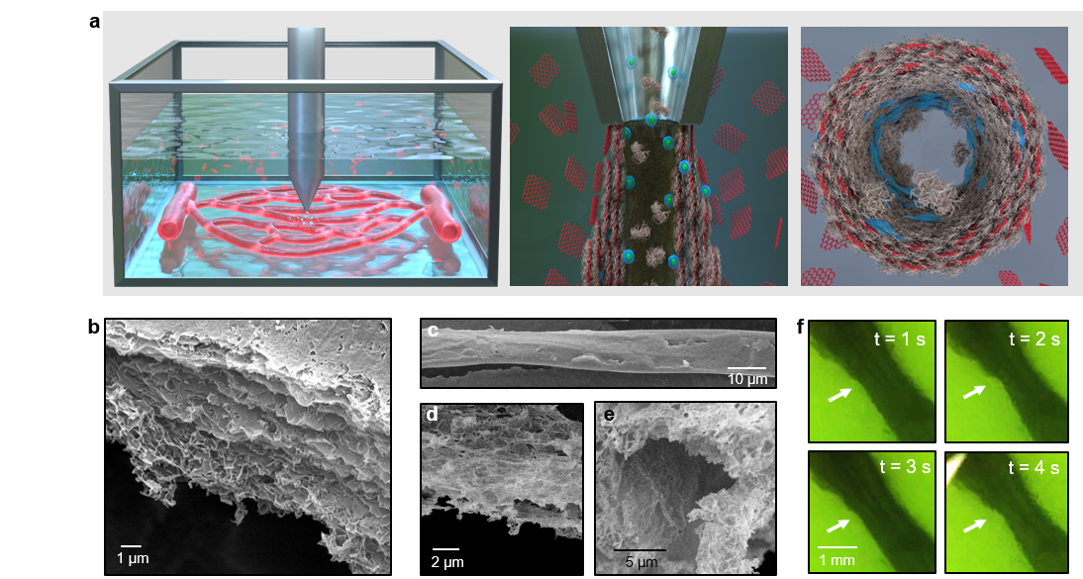

Figure 1

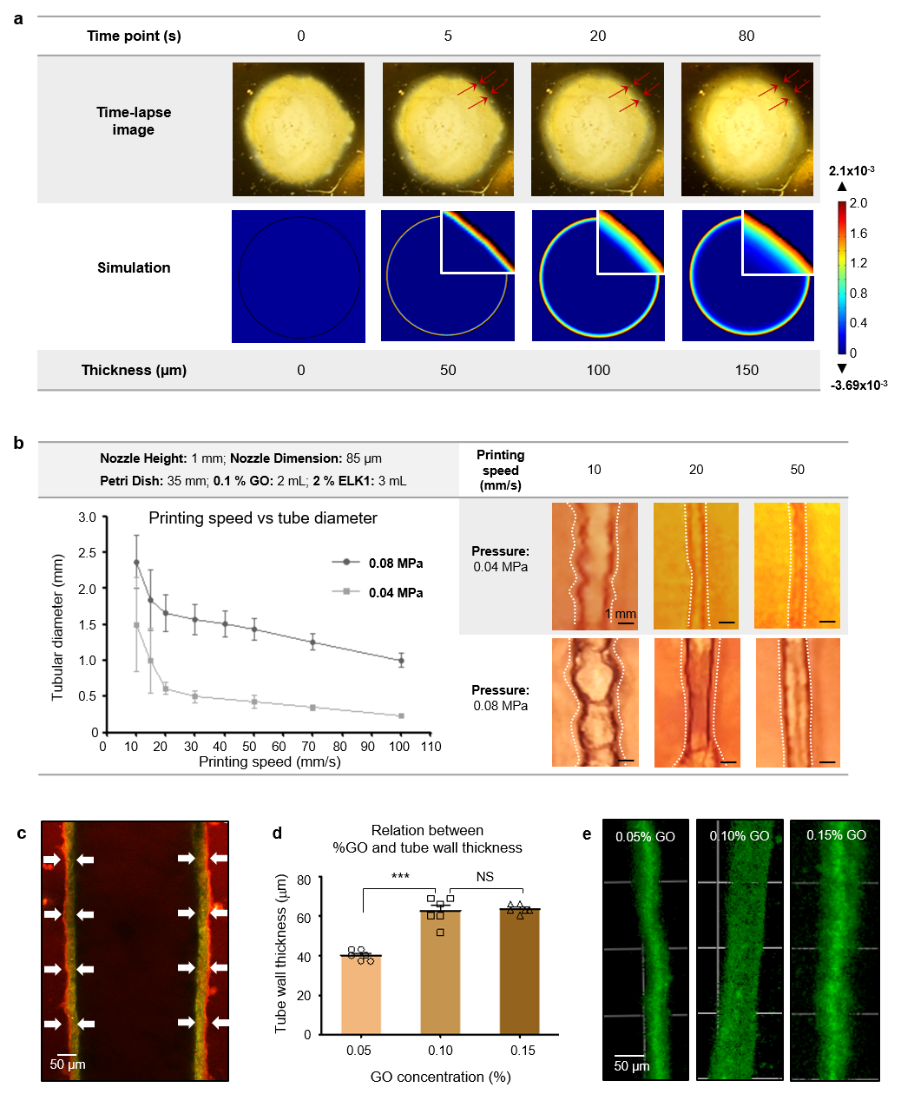

Figure 2

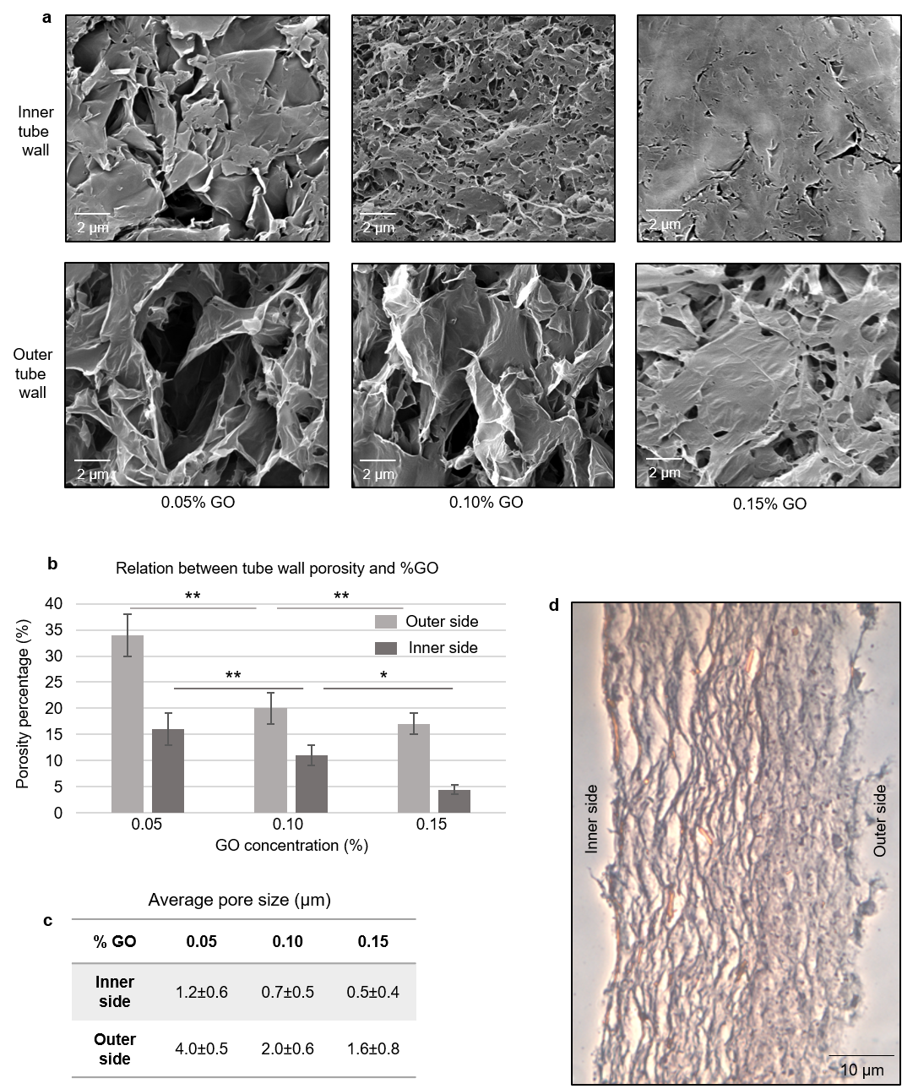

Figure 3

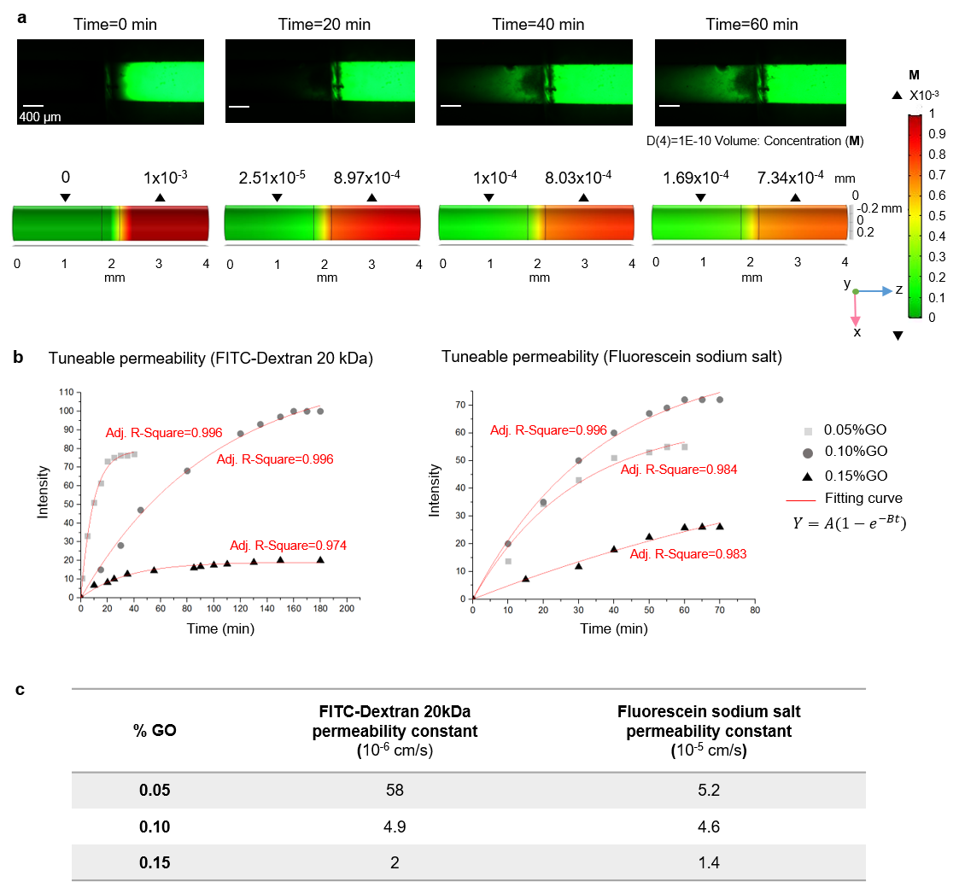

Figure 4

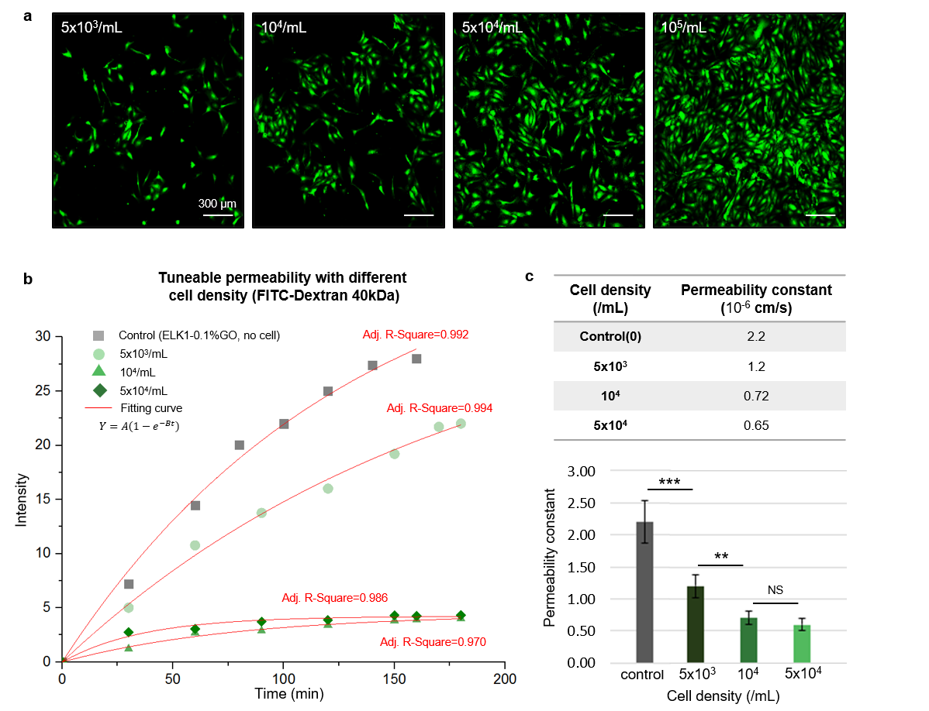

Figure 5

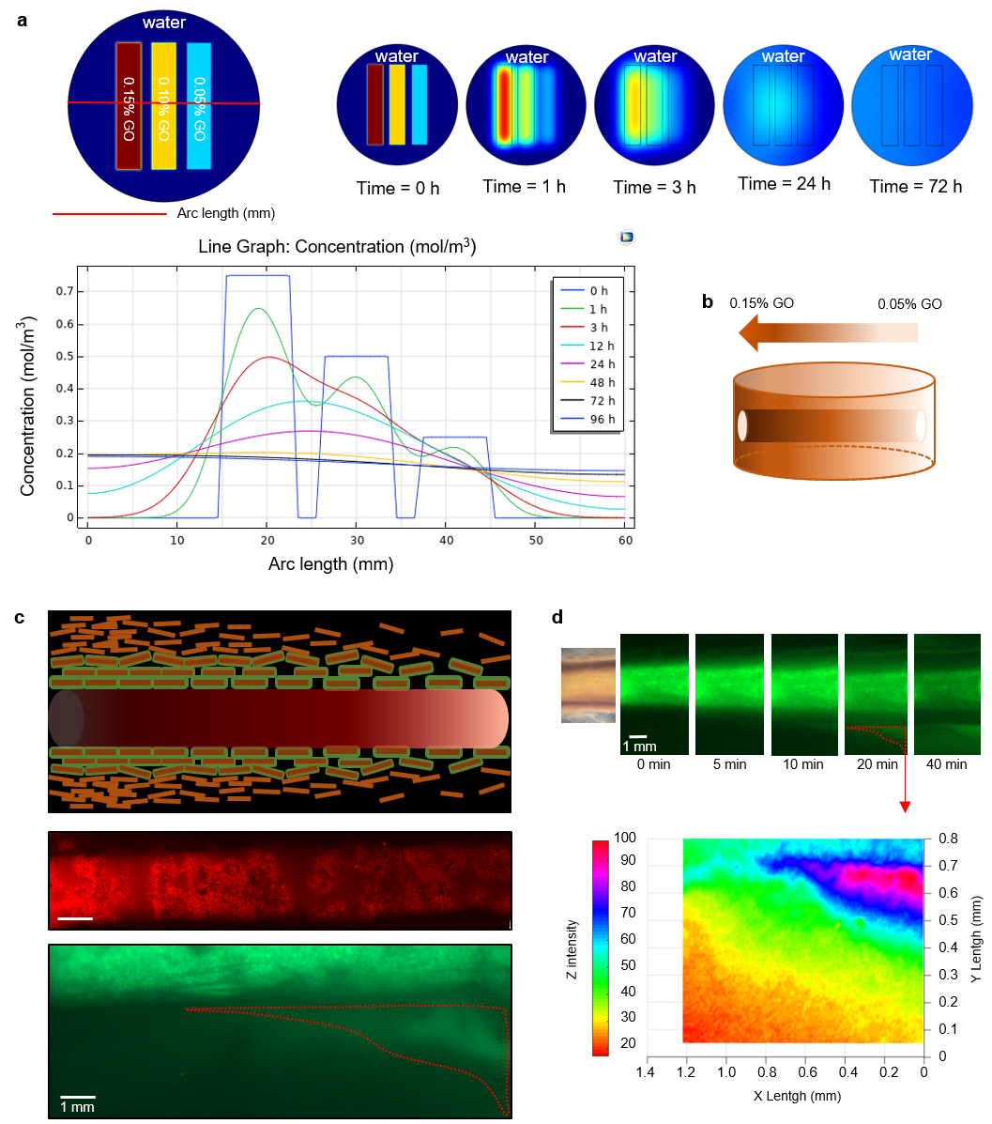

Figure 6

