Open-source CAD-CAM simulator of the extrusion-based bioprinting process
Amedeo Franco Bonatti ^{1, +}, Irene Chiesa ^{1, +}, Giovanni Vozzi¹, Carmelo De Maria^{1*}
¹ Department of Information Engineering and Research Center “Enrico Piaggio”, University of Pisa, Pisa
+ shared first authorship
* corresponding author: Carmelo De Maria; e-mail: carmelo.demaria@unipi.it; address: Largo L. Lazzarino 1, 56122 Pisa, Italy; Tel. +39 050 2217073

Abstract
Extrusion-based Bioprinting (EBB) represents one of the most used Bioprinting technologies among researchers, thanks to its ease of use, wide variety of available materials, and affordable cost. Even though the technique has successfully been applied in bioprinting constructs for Tissue Engineering applications, there is still no consensus on which parameters have more influence of the accuracy of bioprinted scaffolds. Moreover, the literature lacks a rapid and robust method to consistently set the printing parameters before the actual printing phase, thus minimizing the trial-and-error process. In this context, we present a mathematical model for understanding the printability of a defined structure by depositing a given biomaterial ink through a specific EBB apparatus. The model takes into account different steps of the printing process, including extrusion, line formation and scaffold stabilization over time. The model was experimentally validated and implemented in an open-source software to guide the user in setting the correct printing parameters (i.e., printing speed, layer height and flow) based on scaffold dimensions, material properties (including rheological and mechanical ones) and printer set-up. To encourage the model use, we also propose a set of experiments to extract the relevant material properties for our model, and the software is available both as a stand-alone program (available at https://github.com/CentroEPiaggio/Rheology-GUI), as well as a webpage (available at https://www.prin-vision.it/printability-assessment).

Keywords: extrusion-based bioprinting, printability, rheological properties, open-source GUI, extrudability, shape fidelity.

Highlights
- Development and validation of a mathematical model of extrusion-based Bioprinting
- Selection of printing parameters on the basis of geometry, material and printer properties
- Model equations implemented both as open-source standalone software and webpage
- Definition of rheological experiments to identify the material properties for the model

Introduction
In the last decades, additive manufacturing (AM) technologies evolved from rapid prototyping tools to essential fabrication methodologies extensively used in many biomedical applications, including tissue engineering (TE) [1]–[3]. In the TE field, the application of AM processes to the fabrication of three-dimensional (3D) bio-engineered constructs, made of living and non-living materials that interact with physiological systems at cellular level, has been referred as bioprinting [1]. Among the many different bioprinting technologies, extrusion based bioprinting (EBB) is the most efficient and used approach to fabricate well-defined 3D scaffolds, i.e. a 3D structure onto and into which cells adhere and differentiate toward a mature tissue, with clinically relevant size and within a realistic time frame [4]–[6]. The typical EBB apparatus consists of an extrusion system, which can be either mechanical (i.e., screw- or piston-driven) or pneumatical (i.e., air pressure- driven), attached to a three-axis micro-positioner. Thanks to this arrangement, the desired material, usually a hydrogel (generally stored in a syringe) is deposited on the built plate through microscale needles in continuous strands, thus creating the desired 3D structures in a layer-by-layer fashion. The reason behind the wide-spread diffusion of EBB mainly lies in the following key advantages: i) the ability to extrude a variety of materials, with viscosities ranging from 10⁻³ up to 10⁴ Pa*s [7]; ii) the possibility to deposit biomaterial inks including living cells (referred to as bioinks [8]) with a high cell concentration and viability; iii) reasonable costs; iv) simple hardware, which can be customized based on the researchers’ needs [6], [9], [10].
Although highly used, one of the current major challenges in EBB is to a priori and quickly pinpoint if a given biomaterial ink is printable into a predefined geometry through a specific EEB apparatus, as well as to find the optimal set of printing parameters, specific for a defined material-extrusion system-geometry combination. In addition, even though the concept of printability has been extensively studied for other bioprinting techniques (e.g., drop formation for inkjet bioprinting [11]), there is still a lack of consensus on the definition of printability for EBB and on which factors affect it. As a matter of a fact, the term printability in EBB has been used to refer to a series of properties that can determine if the printing process is favorable or not, including extrudability, filament formation, shape fidelity and structure collapse [12]–[14]. In the last years, qualitative and quantitative assays have been proposed to evaluate these aspects [13], [15], [16]. For example, Paxton et al. proposed a two-step test to investigate the material printability through EBB by firstly screening the materials through fiber formation, and then evaluating the ability of each the biomaterial ink to create a stable printed construct [17]. Taking a step forward, Ribeiro et al. also quantitatively investigated the behavior of the printed material after deposition, by analyzing both the filament collapse on overhanging structures as well as the fusion of adjacent printed strands [16]. Although the approaches described above are interesting screening tools for investigating the printability of a material, they have some limitations as they evaluate necessary but not sufficient conditions. In fact, they do not take into account the entire EBB process, i.e. from the generation of the driving force necessary for the material extrusion through the needle, to the line formation upon deposition, and the structure stability under its own weight. Furthermore, they are characterized by a trial-and-error process that imply a waste of time and material.
Trying to overcome these limitations, in a previous work our group developed finite element (FE) models to investigate two different aspects of printability, namely the extrudability of a biomaterial ink and the scaffold collapse over-time. Simulation results guided us in selecting the most appropriate biomaterial ink and in tuning the printing parameters to successfully fabricate a 3D ear-shaped scaffold made of a novel self-assembling peptide hydrogel, thus minimizing the trial-and-error attempts [6]. However, FE models are computationally demanding tools, that are not able to guide the user quickly and easily in the EBB process optimization [18]–[20].
To the best of our knowledge there is a lack in literature of a robust, simple, and predictive analytical a priori model able to identify the printability of a given 3D structure starting from the properties of the biomaterial ink, the features of the EBB apparatus, and the printing parameters.
In this context, we propose a solid analytical model of the EBB process which, for the first time, simultaneously considers different steps of the printing process, from the extrusion of the biomaterial ink through the needle, to its deposition on the building plate and the long-term stability of the printed structure. This model will define the printability and the correct set of printing parameters for achieving specific geometrical features using a biomaterial ink with a defined EBB apparatus. This work also proposes a set of rheological experiments, based on recognized standards [7], to identify the material properties, required by the model, in a robust way. These results will enable the evolution of the EBB process to an integrated computer aided design – computer aided manufacturing (CAD-CAM) technology, since not only the scaffold design will be performed digitally, but also the printing parameter setting and optimization will be guided by a solid and user-friendly digital tool.
The following sections will describe the model and its validation through printing tests. To facilitate and spread its use, model equations were implemented in both in a python code featuring a graphical user interface (GUI) (available on https://github.com/CentroEPiaggio/Rheology-GUI with a CC-BY license) as well as a web-page, available at the link https://www.prin-vision.it/printability-assessment/.
Therefore, in this way, we created a user-friendly digital tool able to predict the printability of a defined structure by depositing a given biomaterial ink through a precise EBB apparatus and exploiting a definite printing parameter set. This tool will be immediately usable by researchers for free, thus facilitating the EBB process optimization.

Materials and Methods

Model description and rationale
EBB is a complex process in which the interaction of different elements (i.e., extrudability, line formation, shape fidelity) determines the success of the print. Here, we propose a model able to predict the printability of a given geometrical structure with a given biomaterial ink through a specific EBB apparatus and exploiting a defined set of printing parameters. As a reference geometry, we consider a woodpile lattice structure, given its extensive use in EBB applications [21], [22], characterized by a connected and tunable porosity. More complex, patient-based geometry could be obtained by repeating in space an elementary lattice element [23].
To achieve this goal, we divide the EBB process into three main stages (Figure 1): i) Stage 1: material extrusion through the needle, ii) Stage 2: strand formation upon extrusion; iii) Stage 3: scaffold stabilization/collapse under its own weight once extruded.
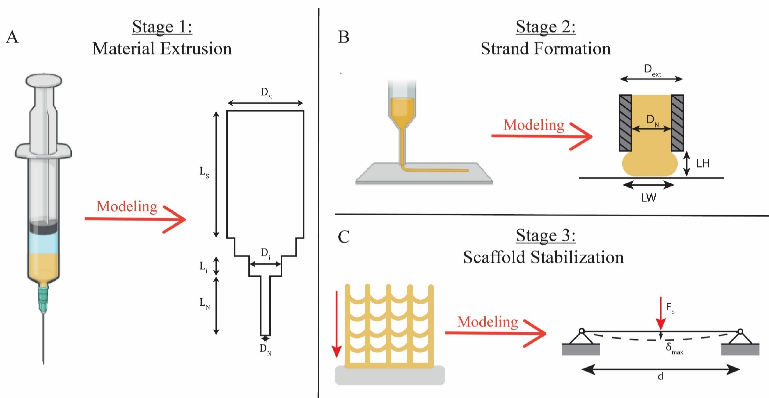
Figure 1: the three main steps that constitute the EBB. (A) Stage 1: Material Extrusion through the syringe needle; (B) Stage 2: Strand Formation upon deposition for the first layer; (C) Stage 3: Strand Stabilization over time.
More in detail, the Stage 1 model evaluates the extrudability, i.e. the easiness at which the material leaves the extruder by applying a pressure/driving force to it. As a reference geometry, a syringe-based extruder is considered, due its widespread use in several EBB apparatus (Figure 1A) [5],[6],[9],[10], [14-17]. The outputs of Stage 1 are the minimum pressure gradient ΔP_{min} required to extrude the given biomaterial ink, and the pressure gradient ΔP required to extrude the given biomaterial ink at the specific flow rate Q.
The Stage 2 model evaluates the line formation during material deposition, by investigating how printing parameters and material parameters can affect the final line width (LW). The Stage 2 output is a printability window, namely a graph on the Layer Height-Extrusion Multiplier (LH-EM) plane that can used by the user to properly select the LH and EM combination that yields a good quality line. The LH is the distance between the needle and the previously printed layer (or printing plate for the first layer). EM, also usually referred as “flow”, is a printing parameter representing a modifier of the amount of material that is being extruded, calculated as a percentage of a standard flow for extruding cylindrical strands on free air with a diameter equal to the nozzle diameter D_{N} [24]. It is important to note that during the printing process the shape of the strands printed on a surface is assumed as in Figure 1B. Furthermore, immediately after deposition, the printed line could break or spread due to surface tension or gravity forces.
The Stage 3 model evaluates the shape fidelity of the scaffold after printing, by computing: i) the displacement along the z-axis of the suspended printed line over time, as well as ii) the deformation of the first layer due to all the above printed layers. Regarding the first point, the displacement should be small compared to LH since this would imply the decrease of the size of the scaffold lateral pores. For the second point, the model verifies the mechanical strength of the structure, by analyzing if the first layer (the most stressed section) can support the weight of the above ones. As output, the Stage 3 model will provide the user with the minimum infill density (S_{infill}), i.e. the amount of macroscopic porosity of the printed scaffold that will not result in the collapse of the lateral pores and bottom layers of the scaffold.
Table 1 reports the main symbol names for the inputs used in the different stage models, alongside their unit of measurement. Each input will be described in the following sections.
Group Name | Parameter | Description | Unit of Measurement | Stage(s)
EBB system (geometry, performance) | D_{s} | Syringe main body internal diameter | [m] | 1
EBB system (geometry, performance) | L_{s} | Syringe main body length | [m] | 1
EBB system (geometry, performance) | D_{i} | Diameter of the syringe i-th section | [m] | 1
EBB system (geometry, performance) | L_{i} | Length of the syringe i-th section | [m] | 1
EBB system (geometry, performance) | D_{N} | Needle internal diameter | [m] | 1-2-3
EBB system (geometry, performance) | L_{N} | Needle length | [m] | 1
EBB system (geometry, performance) | D_{ext} | Needle external diameter | [m] | 2
EBB system (geometry, performance) | P_{max} | Maximum pressure that can be applied by the extrusion system | [Pa] | 1
Material | ρ | Material density | [kg/m³] | 2-3
Material | E | Elastic modulus | [Pa] | 3
Material | G’ | Shear modulus | [Pa] | 2
Material | η₀ | Viscosity at rest | [Pa∙s] | 2
Material | K | Flow Consistency Index | [Pa∙s^{n}] | 1
Material | n | Flow Behavior Index | - | 1
Material | τ_{y} | Critical yield stress | [Pa] | 1-2
Material | ν | Poisson’s Ratio | - | 3
Printing Parameters | LH | Layer Height | [m] | 2
Printing Parameters | LW | Line Width | [m] | 2
Printing Parameters | U_{T} | Deposition speed | [m/s] | 1-2
Printing Parameters | EM | Extrusion Multiplier | - | 1-2-3
Printing Parameters | S_{infill} | Infill density | - | 3
Printing Parameters | W | Scaffold width | [m] | 3
Printing Parameters | L | Scaffold depth | [m] | 3
Printing Parameters | T | Scaffold height | [m] | 3
Table 1: summary of the parameters used as inputs of the three region models, alongside their unit of measurement.

Material constitutive equations
In the EBB process, the biomaterial ink is usually in form of hydrogel, i.e. a water swollen network of polymer chains, or other water-based paste mixture. During the EBB steps, the biomaterial ink behavior strongly varies depending on the stage where we observe the material. Specifically, during its extrusion through the needle (Stage 1), the strong shear stresses break up its structure and the material flows under the applied pressure (liquid-like behavior). On the other hand, after the material deposition onto the printing plate (Stage 2 and 3), it behaves like a solid (solid-like behavior). To model this complexity, different material constitutive equations were considered in the models.
When the material shows a liquid-like behavior, its properties are described by rheological parameters. The Newtonian model is the simplest rheological description, and applies to ideal liquid materials (also referred as Newtonian fluids) whose constitutive equation can be written as follows (Eq. 1):
$$\begin{aligned}τ=η\dot{γ} \#\left(1\right)\end{aligned}$$
where τ represents the shear stress [Pa], $\dot{γ}=\frac{dv}{dy}$ the shear rate [s⁻¹], and η the Newtonian viscosity [Pa•s]. Increasing the complexity, a non-Newtonian material can be described by the power law of Ostwald-de Waele, as in Eq. 2:
$$\begin{aligned}τ=K{\dot{γ}}^{n} \#\left(2\right)\end{aligned}$$
Here, K is referred as flow consistency index, and n is referred as the flow behavior index. The exponent n indicates the class of the fluid: if n > 1 the material is shear-thickening: (i.e., its viscosity increases when the shear rate increases), whereas if n < 1 the material is shear-thinning (i.e., its viscosity decreases when the shear rate increases).
Furthermore, some materials may also present a yield phenomenon (i.e., the material does not flow until a critical yield stress (τ_{y}) is reached inside it) in combination with a non-Newtonian behavior (i.e., shear-thinning or shear-thickening). For this class of materials, the Herschel-Bulkley (HB) model can be used (Eq. 3):
$$\begin{aligned}τ=τ_{y}+K{\dot{γ}}^{n} \#\left(3\right)\end{aligned}$$
On the other hand, for the solid-like behavior, the Kelvin-Voigt lumped parameter model (i.e. an elastic element and a viscous one arranged in parallel [25]) can be used to describe the viscoelastic properties of the material. The relation between the stress (σ) and strain (ε) inside the material can be written as follows (Eq. 4):
$$\begin{aligned}σ=Eε+η_{0}\dot{ε}\#\left(4\right)\end{aligned}$$
where both σ [Pa] and ε (dimensionless) are both time dependent. E [Pa] is the elastic modulus, η₀ [Pa∙s] is the viscosity at rest and $\dot{ε}$ [s⁻¹] is the deformation rate.
The Kelvin-Voigt lumped parameter model can be used to model the creep response of a viscoelastic material, i.e. a deformation under a constant load σ₀, in our case due to the gravity (Eq. 5):
$$\begin{aligned}ε\left(t\right)=\frac{σ_{0}}{E}\left(1-e^{-t/t_{r}}\right)\#\left(5\right)\end{aligned}$$
here, the term $t_{r}=η_{0}/E$, expressed in [s], represents the retardation time of the model.

Model equations

Stage 1 model
In the Stage 1 model, the extrudability of the given biomaterial ink is evaluated.
The extrusion of a material from a reservoir can be viewed as a fluid-dynamic problem through a series of circular channels corresponding to the different reservoir sections. As already stated, a syringe-like geometry is considered in the model, as depicted in Figure 1A.
In Stage 1 model only the syringe needle was considered since it represents the smallest diameter section and, therefore, the highest contribution to viscous pressure losses ΔP. However, the analysis is general and can be extended to the whole case of N number of sections, and for this reason we use the extended case notation throughout the model.
By applying Stokes equation to the outlet section, the pressure gradient is as in Eq. 6:
$$\begin{aligned}ΔP=\frac{4L_{N}τ_{w}}{D_{N}} \#\left(6\right)\end{aligned}$$
where τ_{w} is the shear stress at the wall of the needle, D_{N} is internal diameter of the needle and L_{N} its length. Then, computing the generalized Bernoulli equation between the inlet and outlet sections of the syringe and neglecting the differences in the kinetic and in the potential energy between these two sections (see Supplementary Materials - S1), the final expression of the pressure gradients depends on the viscous pressure losses h_{f} [Pa∙m³/kg], as can be seen in Eq. 7:
$$\begin{aligned}ΔP≈{ρh}_{f} \#\left(7\right)\end{aligned}$$
where ρ is the material density. The term h_{f} can be further divided in two contributions, the distributed pressure losses $h_{f}^{d}$ due to the viscous losses inside each tube section, and the localized ones $h_{f}^{l}$, which depend on the change of section in the geometry. $h_{f}^{d}$ can be expressed as the sum of the viscous pressure losses through each section of the syringe (Eq. 8):
$$\begin{aligned}h_{f}^{d}=\frac{1}{ρ}⋅\sum_{i=1}^{N}{ΔP_{i}} \#\left(8\right)\end{aligned}$$
Each contribution ΔP_{i} can be found by applying the Stokes equation (Eq. 6) to the i-th section, where τ_{w} is computed as described in Supplementary Materials - S2 using the mean speed of the material in the needle v_{n}, the material properties (τ_{y,} n, K) and section diameter.
The localized pressure drops $h_{f}^{l}$can be calculated through analytical expressions in the case of a Newtonian or power-law material [25], while for the HB model only numerical approximations and FE simulations are available [26], [27]. For simplicity, we consider its contribution through a safety factor SF, as in Eq. 9:
$$\begin{aligned}ΔP≈SF⋅ρh_{f}^{d}\#\left(9\right)\end{aligned}$$
For the purpose of Stage 1 model, the SF is considered equal to 1.3, calculated starting from previously published paper of our group [6].

Stage 2 model
In the Stage 2 model, the line deposition and its stability are evaluated.
The theorical LW (LW_{t}) can be calculated on the basis of the flow rate conservation by supposing that the material is flowing once extruded. This is a common solution that is used in open-source slicing software like Slic3r [24]. Under this assumption, we can suppose that the cross-section of the printed strand can be approximated as in Figure 1B.
In this context, the flow rate conservation equation can be written as follows (Eq. 10):
$\begin{aligned}A⋅U_{T}=\frac{πD_{N}^{2}}{4}⋅v_{N} \#\left(10\right)\end{aligned}$where U_{T} is the deposition speed (i.e. the relative velocity between the extruder and the deposition plate) and $A=\left({LW}_{t}-LH_{t}\right)⋅LH_{t}+π{\left(\frac{LH_{t}}{2}\right)}^{2}$ is the strand cross-section area. Here, LH_{t} represents the theorical layer height, i.e. the layer height that we set in the slicing software. It is referred to as theorical since the line may spread after being printed.
Since $v_{N}=U_{T}⋅EM$, Eq. 10 can be simplified and rearranged in terms of the LW_{t} as follows (Eq. 11):
$$\begin{aligned}{LW}_{t}=LH_{t}\left(1-\frac{π}{4}\right)+\frac{πD_{N}^{2}}{4LH}⋅EM \#\left(11\right)\end{aligned}$$
Note that, since Eq. 11 is derived from flow rate conservation, the LW_{t} does not explicitly depend on the material properties, even though the formation of the lateral menisci depends on the interaction between the material and the substrate. This interaction will be taken into account later for this Stage.
In the context of this work, a deposited line has a good quality when its LW do not exceed the needle external diameter (D_{ext}), since this would result in material accumulation around the needle. Furthermore, LW should not be smaller than D_{N} to avoid line break-up due to the stress induced in the material and to insufficient deposited material. For reaching a smaller LW, the deposition speed U_{T} must be higher than the velocity estimated with Eq. 10, causing a reduction of the cross-sectional area due to the mass conservation [28], [29]; however, considering a visco-elastic material, this action induces also an internal stress in the deposited strand a consequence of the imposed strain in the same direction of U_{T}.
As a result, by rearranging Eq. 11 in terms of EM, we can identify two limiting values for it as in Eq. 12a and Eq. 12b:
$$\begin{aligned}EM_{min}=\frac{4LH_{t}}{πD_{N}^{2}}⋅\left[D_{N}-LH_{t}\left(1-\frac{π}{4}\right)\right] \#(12a)\end{aligned}$$
$$\begin{aligned}EM_{max}=\frac{4LH_{t}}{πD_{N}^{2}}⋅\left[D_{ext}-LH_{t}\left(1-\frac{π}{4}\right)\right] \#(12b)\end{aligned}$$
After the deposition of the strand, the biomaterial ink interacts with the deposition plate, in case of the first layer, or with the previously deposited layers for the other ones.
In order to analyze the interaction between the biomaterial ink and the deposition plate material, it is convenient to compare the viscous forces, which opposes the material movements on the surface, and surface tension, which tends to minimize the surface energy of the system promoting changes in the shape of the strand, causing a spread or a contraction. This comparison is provided by the dimensionless Ohnesorge number (Eq. 13):
$$Oh= \frac{η}{\sqrt{ρs_{t}L}} (13)$$
where s_{t} is the surface tension and L is the system characteristic length scale, that for the purpose of this model can be assumed equal to the LW. Viscoelastic hydrogel, that represents the most used material in bioprinting application [13], [30], are characterized by a high viscosity as well as by a low surface tension (high Oh numbers regime). Therefore, in this model, the surface tension force can be neglected compared to viscous force. This implies that during EBB the Plateau-Rayleigh instability, i.e. the breakup of a continuous column/strand in a droplet stream/array due to surface tension, can be neglected. However, at smaller scales (e.g. L = 1μm), and with low viscous materials (e.g.η = 0.01 Pa•s), this effect must be taken into account [20].
Besides surface tension effects, gravity force interacts with the structures. More in details, due to gravity forces, the deposited line may tend to spread laterally increasing its LW_{t} and decreasing its LH (due to volume conservation). This phenomenon happens if the stress inside the material due to gravity forces σ_{g} exceeds its yield stress, and in this case the material will behave like a fluid. We can define a condition for this to happen as follows (Eq. 14), derived as described in Supplementary Materials - S3:
$$\begin{aligned}σ_{g}=ρgLH≫τ_{y} \#\left(14\right)\end{aligned}$$
Taking a conservative approach, we can suppose that this condition is satisfied when the ratio of the two stresses $σ_{g}/τ_{y}$ is greater than constant factor$φ$. For the purpose of this model, $φ$ was set equal to two order of magnitudes (φ = 0.04). If the condition in Eq. 14 is not verified, then the material behaves like a solid and the theorical LW_{t} computed by Eq. 11 closely relates to the actual LW (LW_{f}). On the other, if the condition in Eq. (14) is valid the material starts to spread under its own weight, until this tendence is compensated by viscous force and, in to lower extent, surface tension. In light of this considerations, until Eq. 14 is verified the line will spread, thus increasing its LW and decreasing its LH (see Supplementary Materials - S4). As a consequence, a new value for LH can be obtained (LH_{f}), from which the LW_{f} can be estimated by volume conservation (Eq. 15).
$$\begin{aligned}LW_{f}=\frac{LH_{t}ρg}{τ_{y}φ}⋅LW_{t} \#\left(15\right)\end{aligned}$$

Stage 3 model
The Stage 3 model analyzes the shape fidelity of the scaffold by calculating the deformation of the printed strands under gravity forces after that multiple layers (at least two) have been printed.
The problem can be viewed at two different levels: i) deformation of the scaffold lateral pore (as can be seen in Figure 1C), and ii) level of the stress in the bottom layer due to the other layers printed above it.
Regarding the first aspect, we can view the lateral pore strand as a viscoelastic beam with a circular cross-section, pinned at both ends and under creep due to its own weight (Figure 1C) [31].
The viscoelastic nature of the material introduces a retardation to the beam deformation, with a time constant equal to t_{r}, as in Eq. 5. The maximum displacement $δ_{max}$ that the beam will reach after a sufficiently long time (greater than the t_{r}) can be expressed from the elastic beam theory as follows (Eq. 16):
$$\begin{aligned}δ_{max}=\frac{F_{p}⋅d^{3}}{48E⋅J} \#\left(16\right)\end{aligned}$$
Here, $F_{p}=mg=ρV_{s}g$ represents the weight of the printed strand (with m its mass, V_{s} its volume), d represents the length of the beam, E is its elastic modulus, and J is the strand moment of inertia ([m⁴]). Since we are extruding in air, J can be calculated by considering a strand circular cross-section with a diameter equal to D₀ and is equal to $\frac{πD_{0}^{4}}{64}$. D₀ is correlated to D_{N} through EM as $D_{0}=D_{N}⋅\sqrt{EM}$ (see Supplementary Materials – S5). Eq. 16 can be rearranged to yield the following expression (Eq. 17):
$$\begin{aligned}δ_{max}=\frac{ρd^{4}g}{3E⋅D_{N}^{2}⋅EM} \#\left(17\right)\end{aligned}$$
Regarding the second aspect, the global deformation of a lattice structure under its own weight or under external load is a complex problem, usually solved through numerical simulations or experimental analysis [32], [33]. This is due to a reduced contact area between two overlapping layers, leading to a stress concentration and thus possible local failure.
In this context, we analyze the stress acting on the areas of the first layer in contact with the second one, considering the weight of all the other layers above.
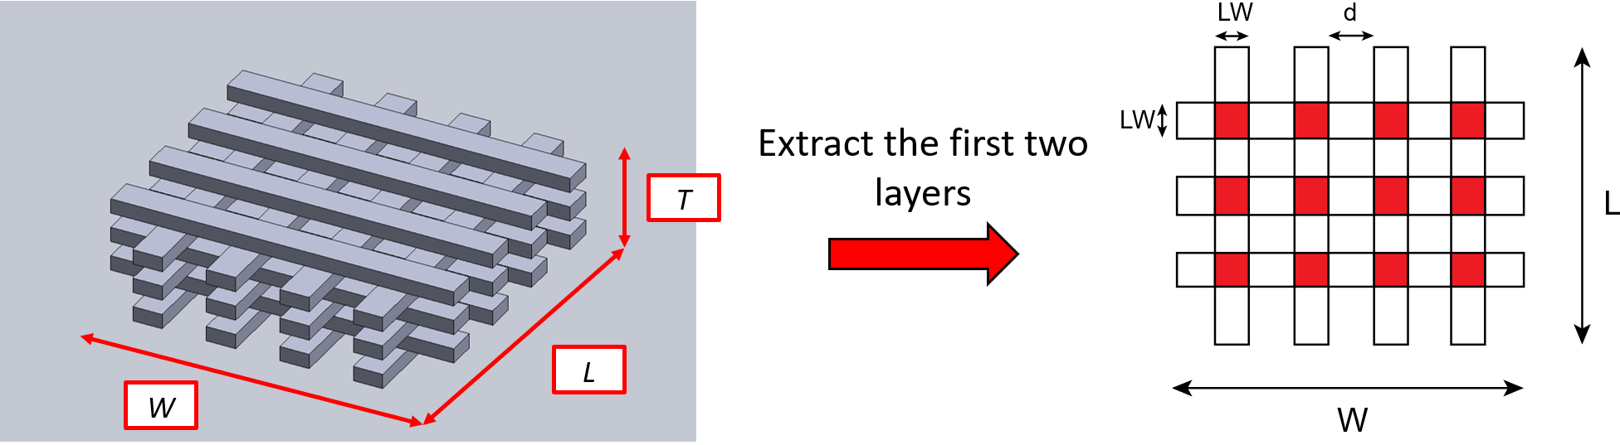
Figure 2: example of a typical woodpile scaffold geometry, with highlighted its dimensions (W: scaffold width, L: scaffold length, T: scaffold thickness). On the right, the extracted two layers, one of top of the other, where the red areas represent the areas of intersection between the two layers.
The total number of layers can be expressed easily calculated from Eq. 18:
$$\begin{aligned}n_{layers}=\frac{T}{LH} \#\left(18\right)\end{aligned}$$where T [m] is the total scaffold height. Considering a woodpile geometry, the total printed volume of all layers (i.e., actual scaffold volume), excluded the “k” first layers, is thus Eq. 19:
$$\begin{aligned}V=\left(n_{layers}-k\right)⋅L∙W∙LH∙S_{infill} \#\left(19\right)\end{aligned}$$
where L [m] and W [m] are the external dimensions of the scaffold (Figure 2), and k is equal to 1 in case of the first layer. Knowing the material density ρ, the weight load acting on the first layer can then be expressed as $F_{p}=V⋅ρ⋅g$. This mass force is acting on the first layer on an area A_{eff} which corresponds to the areas of intersections with the second layer (the red area in Figure 2). This area is proportional to the squared value of S_{infill} (see Supplementary Material – S6 for the demonstration), according to Eq. 20:
$$\begin{aligned}A_{eff}=L∙W∙S_{infill}^{2} \#\left(20\right)\end{aligned}$$
Finally, the total stress acting on the k-th layer will then be given by Eq. 21:
$$\begin{aligned}σ_{g}=\frac{F_{p}}{A_{eff}} \#\left(21\right)\end{aligned}$$
As for the Stage 2, we can compare this stress with the yield stress of the material to verify if the layer can sustain the applied stress.

Model Flowchart

Stage 1
The goal of the Stage 1 model is to check if, for a given EBB apparatus and printing parameters, the biomaterial ink is extrudable or not. The problem can be divided into two aspects: i) check the minimum pressure required for the material to be extruded, and ii) check if for the specific flow rate required by the user the material is achievable or not.
For the first check, if the material has a yielding behavior, to start the extrusion the wall shear stress τ_{w} needs to be just above the yield stress τ_{y} of the material. Therefore, the Stokes equation (Eq. 6) can be rearranged as Eq. 22:
$$\begin{aligned}ΔP_{min}=SF⋅\frac{4L_{N}τ_{y}}{D_{N}} \#\left(22\right)\end{aligned}$$
Here, the same SF as in Eq. 9 is considered. At this specific pressure gradient, the fluid is not moving inside the needle, but a small increase of the force applied will enable extrusion. ΔP_{min} value needs to be computed only for materials with a yield stress, since if a material does not present a yield stress, it will be extruded independently from the applied pressure. Moreover, ΔP_{min} can be used for pneumatic extrusion systems as a starting point to calibrate the pressure needed to extrude the material. The model compares the value in Eq. 22 with P_{max} of the printer. In Supplementary Materials – S7 a methodology to estimate P_{max} for piston-driven EBB systems is provided.
If ΔP_{min} > P_{max}, the material is not extrudable. The analysis of Eq. 22 suggests the selection of a different needle, shorter and/or with a larger internal diameter, as a possible solution for reducing the required ΔP_{min}. On the other hand, if ΔP_{min} < P_{max}, the material is extrudable with the given configuration.
Then the model checks if the material is extrudable at the specific flow rate Q, that can be expressed as a function of the printing parameters U_{T} and EM as in Eq. 23:
$$\begin{aligned}Q=\frac{πD_{N}^{2}}{4}⋅v_{N}=\frac{πD_{N}^{2}}{4}⋅U_{T}⋅EM \#\left(23\right)\end{aligned}$$
To perform the required check, the model compares P_{max} with the Q-associated ΔP, that is calculated as in Eq. 9. ΔP is compared to P_{max}; if ΔP > P_{max}, a possible solution is to decrease the printing speed or increase the needle diameter. Differently, if ΔP < P_{max} the material is extrudable with the desired configuration and flow rate. Note that for a pneumatic extrusion system, the value of ΔP can be used to regulate the air pressure so that the chosen Q is achieved.

Stage 2
The Stage 2 model has two aims: i) to identify a printability window inside which the user can select the combinations of EM and LH that allow a good quality of the extruded line; ii) to provide an estimation of the LW_{f} for the first layer after the line deformation due to its own weight. Thus, for a given needle geometry, the Eq. 12a and 12b define the printability window in the plane EM-LH, as can be seen in Figure 3. The shaded area between the two lines identifies the correct combination of EM and LH to obtain a ‘good’ quality line. A minimum value for the LH can be chosen by considering that if the LH is too narrow (i.e., lower than 20% the D_{N}), the needle may crash against the deposition plate, if the printer is not properly calibrated or if the plate has a poor planarity tolerance. On the other hand, an upper limit for LH is also introduced by considering that values higher than 80% the D_{N} can cause uneven deposition during printing.
Then, the model will estimate the LW_{f,} considering an eventual line deformation due to its own weight. More in detail, the model will use the value for EM and LH to evaluate the respective LW_{t,} as in Eq 11. Then, it will compare the yield stress with the gravity force as in Eq. 14. If the condition is verified the model will calculate the LW_{f} as in Eq. 15, otherwise the LW_{f} will be equal to LW_{t} because no collapse will occur.
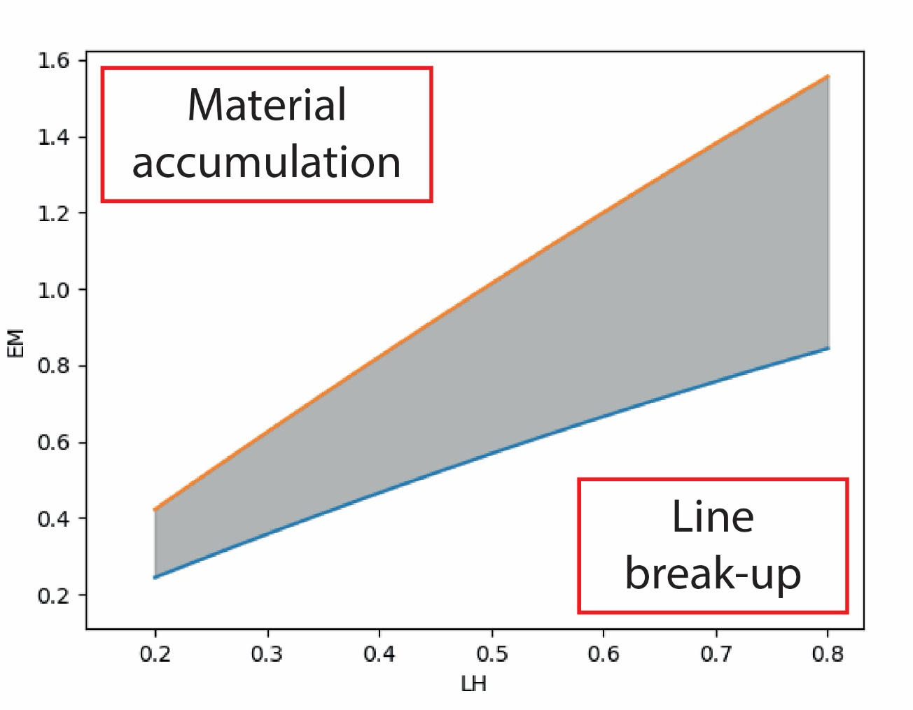
Figure 3: an example of printability window. The grey zone indicates the combination of EM and LH that allow the formation of a good printed line for the first layer. If EM is too high in respect to LH, the material will accumulate on the needle; whereas if the LH is too high with respect to the EM the deposited line will break-up due to under-extrusion.

Stage 3
The goal of Stage 3 model is to identify the minimum S_{infill} that is associated with an acceptable strands and whole structure deformation. To achieve this goal, the model first computes the maximum displacement of the strands due to bending (Eq. 17) and compares it to a safety displacement $\tilde{δ}$, which is a percentage α of the LH (i.e., α = 0.1), and will not alter the final lateral pores of the scaffold. This condition can be written as $\tilde{δ}=α⋅LH ≥ δ_{max}$. By rearranging the Eq. 17, we can find a critical beam length d_{c}, when $δ_{max}= \tilde{δ}$ (Eq. 24):
$$\begin{aligned}d_{c}={\left[\frac{3E⋅α⋅LH⋅D_{N}^{2}⋅EM}{ρg}\right]}^{\frac{1}{4}} \#\left(24\right)\end{aligned}$$
If the beam length is greater than d_{c}, then the maximum displacement is too high, and the scaffold loses the desired shape. Thus, using d_{c}, the model finally outputs an optimized S_{infill}, which can be used as an indicator of the minimum fill density that can be used inside the scaffold to maintain an acceptable lateral pore height.
In this work, the infill density corresponding to d_{c} is computed using the Slic3r model. In particular, the minimum distance between two printed lines S_{solid} represents the ‘spacing’ in a solid layer (i.e., a layer with 100% infill) and can be approximated as $S_{solid}=LW$. Then, the critical infill percentage will be given by the ratio Eq. 25:
$$\begin{aligned}S_{infill, c}=\frac{S_{solid}}{d_{c}}=\frac{LW}{d_{c}} \#\left(25\right)\end{aligned}$$
This value represents the lower limit for the infill density, since lower values (and so higher porosities) will give a greater beam length d and so an increased displacement due to gravity.
Then, the model uses this specific infill density, alongside the other printing parameters, to compute the mechanical strength of the structure. Specifically, if the stress on the first layer is greater than the yield stress, a warning is generated. Moreover, the model estimates how many layers can be affected by this exceeding stress using Eq. 21.

Software implementation
The model described above was implemented in a standalone software code featuring a GUI and in a web page to help the user decide the correct printing parameters.
The standalone software was written in Python, using the PyQt5 bindings, while the webpage was implemented in Node.js. Both software are structured into two stages. Firstly, the user can input the settings related to the printer (i.e., U_{T}, P_{max}, D_{N}), to the scaffold bounding box dimensions (i.e., thickness, width, and height), and to the other to the material properties. Regarding the latter, the user can choose between three material models (i.e., Newtonian, power-law, and HB) and the related parameters (i.e., n, K, τ_{y}), as well as other physical (i.e., ρ, γ) and the Kelvin-Voigt model properties (i.e., E and η₀).
Thus, if the user will choose the most complex fluid behavior (i.e., HB) seven parameters are needed to describe it: i) elastic modulus; ii) viscosity at rest; iii) density, iv) surface tension; v) flow behavior index; vi) flow consistency index; vii) critical yield stress. In the experimental validation part, we will point out a set of experiments to obtain these relevant parameters, using only rheological measurements.
In the third and last tab, the user can choose different optimization behavior keeping, if required, some specific parameters as constant (i.e., LW, LH, EM). Table 2 reports the possible combinations and relative output.
LH | EM | LW | Output
NC | NC | NC | At least one input must be selected. An error message is displayed to the user.
C | NC | NC | A range of EM is given to the user based on the LH input. A vertical line is showed in the printability window.
NC | C | NC | A range of LH is given to the user based on the EM input. A horizontal line is showed in the printability window.
NC | NC | C | A line is shown in the printability window, which represents all the EM-LH combinations that can give the specified LW.
C | C | NC | Since both EM and LH have been specified, the corresponding LW is computed and sent to the user. A point is shown on the printability window. The user has visual feedback on the parameter choice, since the point should be in the shaded area.
C | NC | C | In this case, the optimized EM is computed from the specified LH and LW values. A point is shown on the printability window, which gives visual feedback on the parameter choice.
NC | C | C | As in the previous two cases, an optimized LH values is returned to the user and shown on the printability window as a point based on the specified EM and LW values.
C | C | C | In the final case, all inputs are required. The program outputs the LW corresponding to the EM and LH combination, which is represented as a point on the printability window. Then, the error between the computed LW and the specified LW is found. This error represents how much the effective printed line will differ from the requested LW if the specified combination of EM and LH is used.
Table 2: summary of the main optimization checks that can be selected in the third tab of the software, as well as the related output. Here, NC stands for non-constrained, while C for constrained.
Then, in the second phase, a new window presents the results based on the properties and optimization checks selected in the first stage. All stage results are supported by a brief description of main results, and which parameters may be varied to obtain better results. Error handling at different stages of the application is implemented. All inputs are validated, in terms of data format (e.g., positive integer, positive float number) and range. Further information on the software implementation can be found in Supplementary Materials – S8.

Model validation

Material preparation
Poloxamer 407 (commercial name Pluronic acid F127) and a poly(vinyl alcohol)–poly(vinyl pyrrolidone) (PVA-PVP) copolymer were used for all the model validation experiments. PVA-PVP copolymer (ratio 1:1) was used as purchased [6]. A solution of Pluronic acid F127 (Sigma-Aldrich) at 25% w/v in deionized water was prepared as previously described [22].

Rheological tests
Rheological measurements of the selected materials were performed at 25°C using a HAAKE RheoStress 6000 rheometer (Thermo Scientific) equipped with a cone-plate (1° angle) measuring tool.
Samples (200 μl each) were prepared by pipetting the materials onto the rheometer stage before lowering the upper head.
Here, we propose a set of rheological experiments that can help the user properly define the necessary material properties, consisting in a flow curve, an amplitude sweep and a frequency sweep.
Firstly, to assess the viscosity behavior under shear stress, steady state flow curve in control shear rate-mode was performed in the shear rate range of 0.01–2000 1/s. To find τ_{y}, different methods have been proposed [7]. Here, we used the tangent cross-over method, which consists in plotting the data point in a log-log plot of γ vs. τ. For materials with a distinct yielding behavior, the plot clearly shows two lines with different slopes where the intersection between the two gives the yield stress.
The K and n parameters were found by fitting the power-law equation to the linear of the flow curve in a log-log plot of η vs. $\dot{γ}$. From the η vs. $\dot{γ}$ curve the value for η₀ was found by taking the order of magnitude of the first registered value of the viscosity curve. Since for a yield material the viscosity tends to infinity for shear rates towards 0, this approach can be used as a practical approximation in the computation of the retardation time.
Regarding the oscillatory tests, here we consider 0.1 Hz as frequency at rest [7]. Firstly, an amplitude sweep was performed at this frequency to find the limit for the linear viscoelastic region (LVE). The limit value of the LVE in terms of the limiting stress τ_{l} was found by fitting the plateau region for G’ with a horizontal line and visually identifying the stress value at which the G’ curve starts to deviate significantly from the fitted line. Then, the corresponding limiting deformation γ_{l} was identified. The analysis was conducted for both tested materials and, in order to keep the same testing conditions, a common γ_{l} value for the LVE was chosen by taking the lowest between the two materials.
The γ_{l} value was then used as the deformation amplitude for the frequency sweep tests, so that the deformation was in the LVE region for all tested frequencies. A frequency sweep between 0.1 Hz and 14 Hz (over two decades) was performed, and linear regression was used for the G’ plateau region to extrapolate the intersect with the Y-axis (i.e., the G’ at rest). This value was then used to compute the elastic component of the Kelvin-Voigt model. To convert the shear modulus to the Young modulus, assuming isotropy for the mechanical properties of the materials, we used the formula $E=2G^{'}\left(1+ν\right)$, where ν is the Poisson’s ratio. Since both materials tested have a high water content, we will assume the Poisson’s ratio equal to 0.49 [6].

Printing experiments
Printing tests were performed to validate the analytical model. All tests were performed at room temperature with a custom-made extrusion-based 3D printer, equipped with a piston driven extruder [6], [10], [22]. In all the experiments, the biomaterial inks were contained in a plastic syringe with a diameter equal to 12 mm and a length equal to 30 mm.

Stage 1 model experimental validation
To validate Stage 1 model the materials were loaded into the piston-actuated syringe extruder equipped with a force sensing resistor (FSR, Ohmite), which was used to measure the applied pressure during extrusion. The sensor was positioned on the bottom surface of the extruder piston, in direct contact with the syringe plunger. Before performing the validation tests, the sensor was calibrated using a dynamic calibration procedure, in which the sensor resistance was measured by applying a force ramp to the sensor. After calibration, each material was extruded in open air using three different flow rates (Q = 0.15 ml/min, Q = 0.23 ml/min, Q = 0.31 ml/min). For the PVA-PVP a needle with a D_{N} of 0.41 mm was chosen, whereas for the Pluronic 25% a larger needle of 1.2 mm D_{N} was preferred. This choice was guided by the results from the theorical model, which for these specific flow rates predicted a too high pressure that could not be read by the sensor for the Pluronic acid. Each extrusion test was started with the syringe plunger at 1 mm from the sensor, so that the full pressure build-up behavior could be captured.
The pressure values were read using an Arduino Uno board and was filtered using a moving average filter (window dimension of 5) to smooth out the sensor reading. Briefly, the sensed total pressure will be given by a contribution of two terms: the viscous pressure losses and the pressure due to the elastic element of the material inside the syringe main body. The overall behavior will be an initial rapid pressure rising, followed by a plateau region due to the viscous pressure losses. In order to compute the viscous pressure drop, two lines were fitted to the two regions with different slopes, and the intersection was taken as the target value (Figure 4).
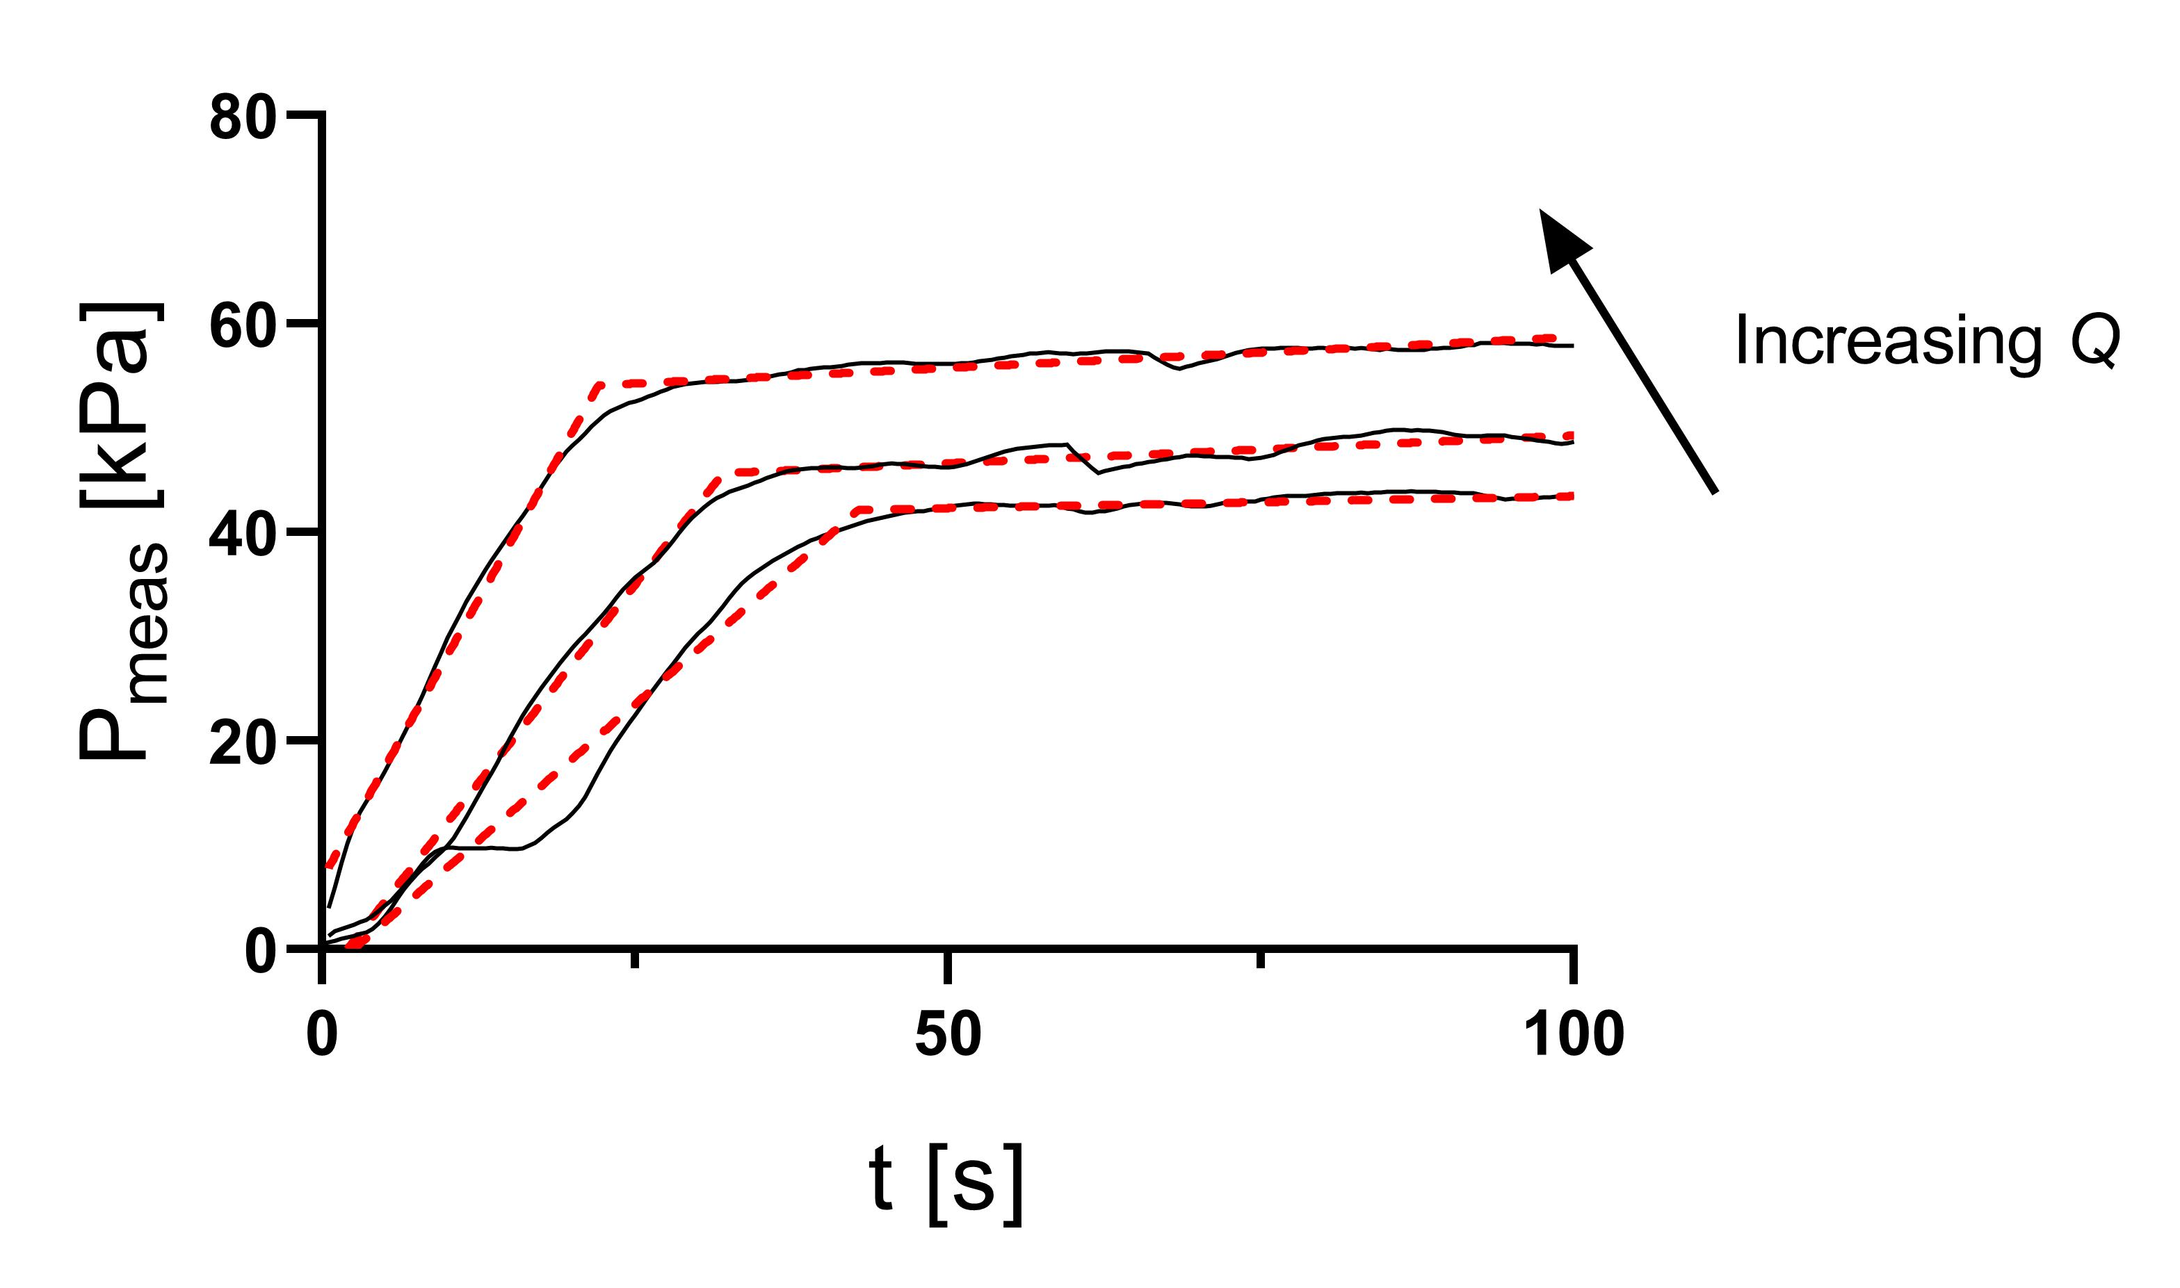
Figure 4: example of a pressure reading over time for the PVA-PVP gel at increasing flow rates. The red dashed lines represent the segmental linear fitting used to extrapolate the viscous pressure drop.
The measured pressure drop was compared to the pressure drop calculated from the model using the same flow rate and needle diameter and the model deviation MD₁ was computed as follows (Eq. 26a):
$$\begin{aligned}MD_{1}=\frac{ΔP_{meas}-ΔP_{mod}}{ΔP_{mod}} ×100\#\left(26a\right)\end{aligned}$$

Stage 2 model experimental validation
To validate Stage 2 model, serpentine-like shapes were printed on glass slides using the PVA-PVP and the Pluronic 25%. A D_{N} of 0.41 mm was used, and all prints were performed with U_{T} equal to 1 mm/s. To obtain the correct stability of the flow, a skirt was added to the serpentine-like shape (Figure 5A). Different serpentine patters were printed, each representing a different combination of the EM and LH parameters. Specifically, for the EM parameters the values 0.7, 1 and 1.3 were used, while for the LH 40%, 60% and 80% (referred to the D_{N}).
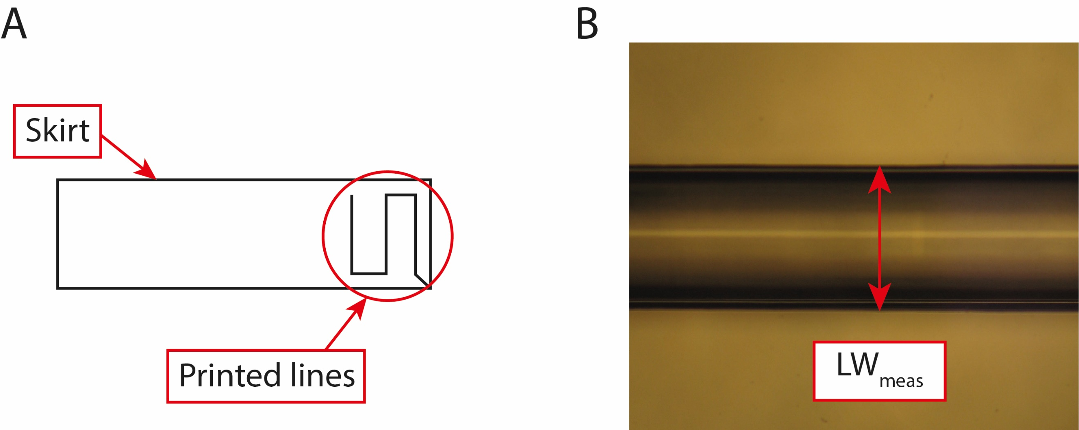
Figure 5: in (A) a schematic representation of the serpentine shape, while in (B) an example of measuring LW (material: Pluronic 25%, LH = 40%, EM = 0.7).
The serpentine shapes were analyzed at an optical microscope (Olympus AX70), and the images were processed in ImageJ to extract the experimental LW (Figure 5B). Then, the values of the measured LW_{meas} were compared to the model LW_{f,mod} for the same parameter combination. The model LW was computed considering the gravity spreading correction from Eq. 14 and Eq. 15. The two values were then compared by computing the model deviation MD₂ as Eq. 26b:
$$\begin{aligned}MD_{2}=\frac{LW_{meas}-LW_{f,mod}}{LW_{f,mod}} ×100\#\left(26b\right)\end{aligned}$$

Stage 3 model experimental validation
Finally, to validate Stage 3 model, we followed the protocol developed by Ribeiro et al. [16]. Briefly, a supporting structure was designed in Fusion360 and printed using a Fused Deposition Modeling printer (Figure 6A). The structure is composed of a series of parallel comb tooth spaced with increasing distances d (i.e., 5, 6, and 7 mm) (Figure 6B).
The materials were printed at 6 mm/s using a 0.41 mm D_{N}, which was placed at 0.4 mm from the top surface of the support. Photos of the filaments were taken after at least the time specified by the t_{r} parameter (see Table 4 for the values) so that the deformation could reach its maximum value, and were later analyzed in ImageJ. To validate the model, the displacement was estimated as illustrated in Figure 6C, and the results were compared with the theorical displacement of Eq. 17, in which D₀ was directly taken from the photos by measuring the strand diameter.
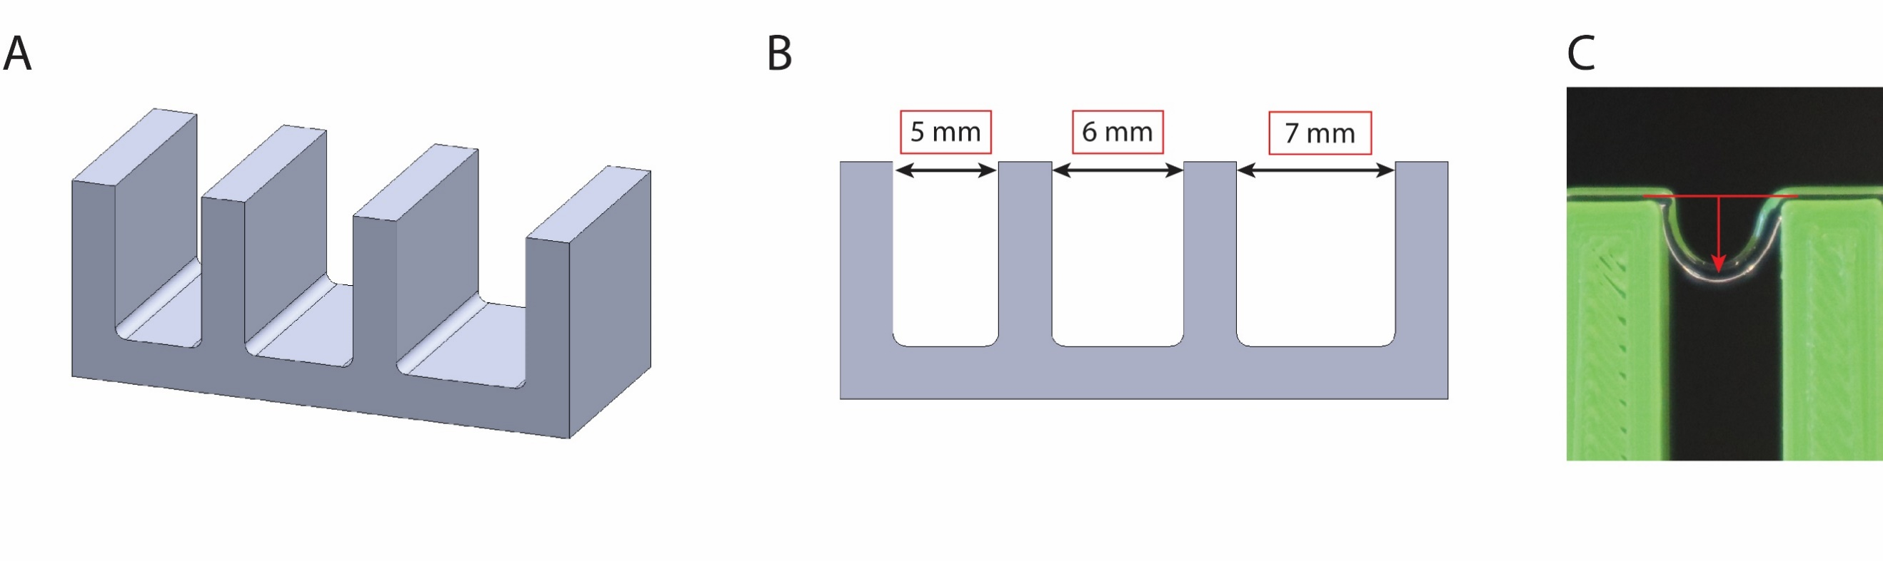
Figure 6: in (A) and (B) visualization of the comb structure used for the Stage 3 model validation, while in (C) how the deformation of the printed line was measured.
It is important to highlight that the stage 3 model validity depends on two main hypothesis which need to be verified if we want to compare the experimental and model data. Firstly, the model is based on elastic beam theory with small deformations. This condition defines a maximum tooth spacing L_{max} (corresponding to the beam length, modelled as one-dimensional object) which sets an upper boundary for the model validity (see Supplementary materials – S9 for the demonstration). Furthermore, in order to apply the beam theory, the minimum spacing of the tooth L_{min} should be much longer than diameter [34]. In the context of these experiments, we considered a spacing of at least four times the diameter of the printed strand. The intersection of these two intervals provides the range of the tooth spacing in which we can compare the model with the experimental observation and was computed for both materials.
After doing this model validity check, as was previously done for the other two Stages, the model deviation was computed as follows (Eq. 26c):
$$\begin{aligned}MD_{3}=\frac{δ_{meas}-δ_{mod}}{δ_{mod}}×100 \#\left(26c\right)\end{aligned}$$

Statistical analysis
All statistical tests were performed using Graphpad Prism considering a significance α = 0.05. Regarding the Stage 1 validation, since each material was tested at the same flow rates but with different D_{N}, a one-way ANOVA test was performed on these values for each material to compare the flow rate effects on the printing pressure. Three measurements (n = 3) were considered for each flow rate and material combination. For the Stage 2 validation, a two-way ANOVA statistical test with Tukey’s post-hoc multiple comparisons was conducted on the measured LW data. The test was performed to investigate if there was any statistical influence on the LW by the LH and EM parameters for each tested material. For each LH and EM combination a single serpentine-like shape structure was printed, and 5 measurements were taken on each structure (n = 5). Finally, for the Stage 3 validation a one-way ANOVA was performed on the measured deformation for the three tooth spacings to highlight if the spacing of the comb tooths had a significant influence on it. Four different tests were performed for each material (n = 4).

Final scaffold printing
Finally, as a proof-of-concept of the proposed model, a 3D scaffold-like structure with dimensions 10 x 10 x 3 mm was printed using Pluronic 25%, that turned out to be the best performing material in the previous printing tests. The model was used to decide an optimal set of parameters for the specific material and printer. In particular, the printer settings and scaffold dimensions were used as inputs in the first tab of the model. Regarding the first group of settings, since the maximum pressure that could be applied with our extrusion system is around 1 MPa, the chosen parameters allowed the extrusion of the Pluronic 25%. To keep the values consistent with the previous printing experiments, we used a print speed of 1 mm/s, while for the D_{N} we chose a value of 0.61 mm to avoid a too high extrusion pression.
In the second tab, the material properties were inputted according with the results from the material characterization (see Table 4). To describe the complex behavior of the Pluronic solution, a complete HB model was chosen. Since the hydrogel is mainly composed of water, here we estimate the density of the material to be similar to that of water (≈ 1000 kg/m³) and the Poisson modulus to be ≈ 0.49.
For the third tab, we chose to constrain the LH parameter to be 60% of the D_{N}. This choice was guided by the results from the Stage 2 model validation, in which this specific LH gave better accuracy to the model.
Finally, from the results window we verified that the pressure drop (around 120 kPa) was lower than the maximum pressure that the extrusion system could output, so that the material could be extruded at the given flow rate. Moreover, we obtained a range for the EM and infill density parameters, that were optimized based on the inputs we gave to the model. A summary of all parameters used is reported in Table 3.
Parameter | Input value | Output value | Final value chosen
P_{max} | 1 MPa | - | 1 MPa
U_{T} | 1 mm/s | - | 1 mm/s
D_{N} | 0.61 mm | - | 0.61 mm
LH | 0.6*D_{N} | - | 0.6*D_{N}
EM | - | 0.67-1.2 | 1.1
Infill density | - | > 18.6% | 50%
Table 3: main parameters chosen for printing the proof-of-concept scaffold, alongside the optimized range for the specific parameter given by the GUI.

Results and discussion

Rheological measurements
The flow curves (i.e., viscosity η vs. shear rate $\dot{γ}$) for both materials are shown in Figure 7A Both tested materials show a linear region in which the viscosity decreases with an increase in shear rate, highlighting their non-Newtonian shear-thinning behavior. As previously stated, this is an essential requirement for a material to be printable using EBB [16]. The K and n parameters (found by linear regression using Eq. 2) are reported in Table 4, alongside with the η₀ value.
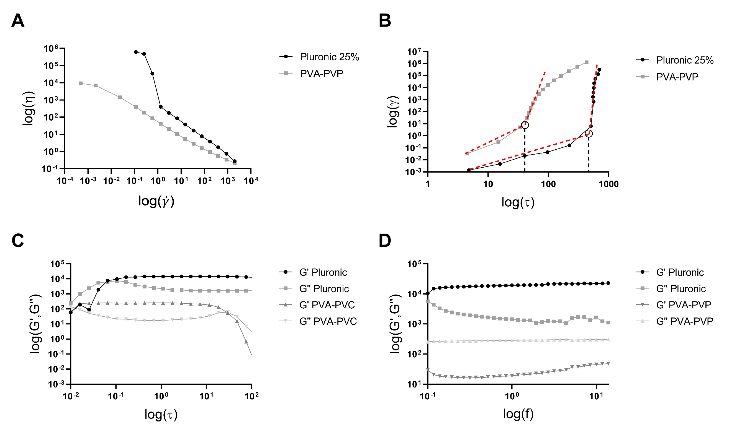
Figure 7: results from the rheological measurements. In (A) the flow curves for the two materials, and in (B) the log-log γ vs. τ plot to extrapolate the yield stress value. On the lower row, in (C) the results from the amplitude sweeps alongside the frequency sweep in (D).
Plotting the shear deformation γ vs. the shear stress τ in a log-log plot (Figure 7B), a clear indication on the yielding behavior of both materials can be seen. Indeed, the graph highlights how there is a clear increase in deformation when the applied stress is greater than a threshold value, and two distinct regions can be identified at low and high deformations. By using linear regression to fit a line to each region, the yield stress is given by the stress at the intersection between the two lines [7]. The extrapolated values are reported for both materials in Table 4. The clear presence of a yield stress for both materials confirms their suitability for EBB, since yielding behavior is a key property to obtain a self-sustaining structure over time [17].
Regarding the oscillatory tests, as can be seen from the amplitude sweep in Figure 7C the Pluronic 25% does not show a significant decrease of G’ after the plateau for the tested τ values. Differently, the PVA-PVP gel showed a clear decrease of G’ at higher values for τ. As a result, the PVA-PVP gel was used as reference to compute the limiting stress τ_{l} and the limiting deformation γ_{l}. Considering a safety margin, the value for γ_{l} was set to 0.25% for both materials. The results for the frequency sweep tests are presented in Figure 7D. As can be seen from the graph, both materials show a clear plateau in the G’ values. The extrapolated value is reported in Table 4.
Test type | Parameter | Unit of measurement | Pluronic 25% | Fitting R² – Pluronic 25% | PVA-PVP | Fitting R² – PVA-PVP
Flow curve | K | [Pa*s^{n}] | 525 | 0.9995 | 50 | 0.9987
Flow curve | n | - | 0.04 | 0.9995 | 0.20 | 0.9987
Flow curve | τ_{y} | [Pa] | 535 | 0.9388 | 39 | 0.9619
Flow curve | η₀ | [Pa*s] | ≈ 6*10⁶ | - | ≈ 10⁴ | -
Frequency sweep | G’ | [Pa] | 18793 | 0.9738 | 286 | 0.9538
Frequency sweep | E | [Pa] | 56003 | - | 852 | -
Frequency sweep | t_{r} | [s] | ≈ 110 | - | ≈ 12 | -
Table 4: material parameters derived from the rheological tests, alongside the R² values for indicating the goodness of the fitting.
As can be seen from Table 4, the two materials show rheological and mechanical behaviors at two different extremes: high yield stress, viscosity, and elastic modulus values for the Pluronic 25% and low for the PVA-PVP copolymer. This opposite behavior makes the two materials good candidates to validate the analytical model.

Stage 1 validation
Figure 8 reports the measured pressure recorded during extrusion of Pluronic 25% and PVA-PVP copolymer at different flow rates.
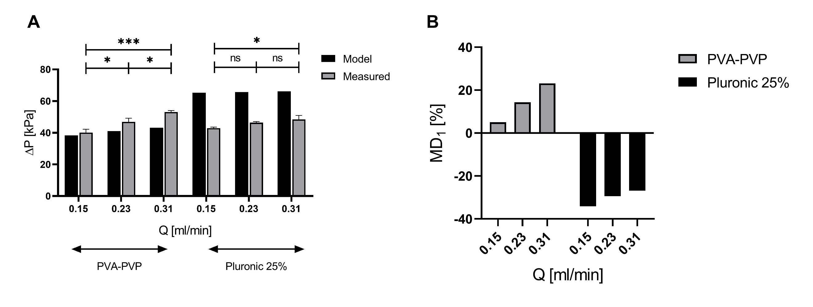
Figure 8: results from the Stage 1 model validation. In (A), the pressure gradient from the model alongside the measured one for three different flow rates and for the two materials. In (B), bar plot for the MD₁ ratio. Note that the two materials were extruded at the same flow rates but with different D_{N} (0.41 mm for the PVA-PVP, 1.2 mm for the Pluronic 25%). In the graphs, ns: not significant (p ≥ 0.05), *: p ≤ 0.05, ***: p ≤ 0.001.
In accordance with the theoretical model, the one-way ANOVA highlighted that an increase of flow rate results in an increase of the applied pressure for the PVA-PVP gel (p=0.0005). For the Pluronic 25% gel, however, there was no statistically significant influence of the flow rate on the pressure (p=0.0143). This result is still in accordance with the theorical model: by looking at the P_{mod} values for the Pluronic 25% gel, the difference between the pressure values at different flow rates is neglectable (0.15 ml/min vs. 0.23 ml/min difference of 550 Pa, 0.23 ml/min vs. 0.31 ml/min difference of 428 Pa) and can be difficult to sense with the FSR sensor.
The MD₁ values show a correspondence between the theorical and measured pressures, with the highest MD₁ for the case of the Pluronic 25% at the lowest flow rate (MD₁ = -34%). This result confirms that the model can be considered as a good approximation of the material behavior during extrusion.

Stage 2 validation
To validate Stage 2 model, serpentine-like shapes were printed with a D_{N} of 0.41 mm, and a U_{T} equal to 1 mm/s. Increasing values of EM and LH were used (9 combination in total). Then, the LW of the lines were measured from optical images of the printed structure. The model values are reported in Figure 9A, while the measured value of LW is reported in Figure 9B for the PVA-PVP copolymer and in Figure 9C for the Pluronic gel, alongside the corresponding values for MD₂. The model values have been found considering the spreading due to gravity, that was relevant only for the PVA-PVP biomaterial ink.
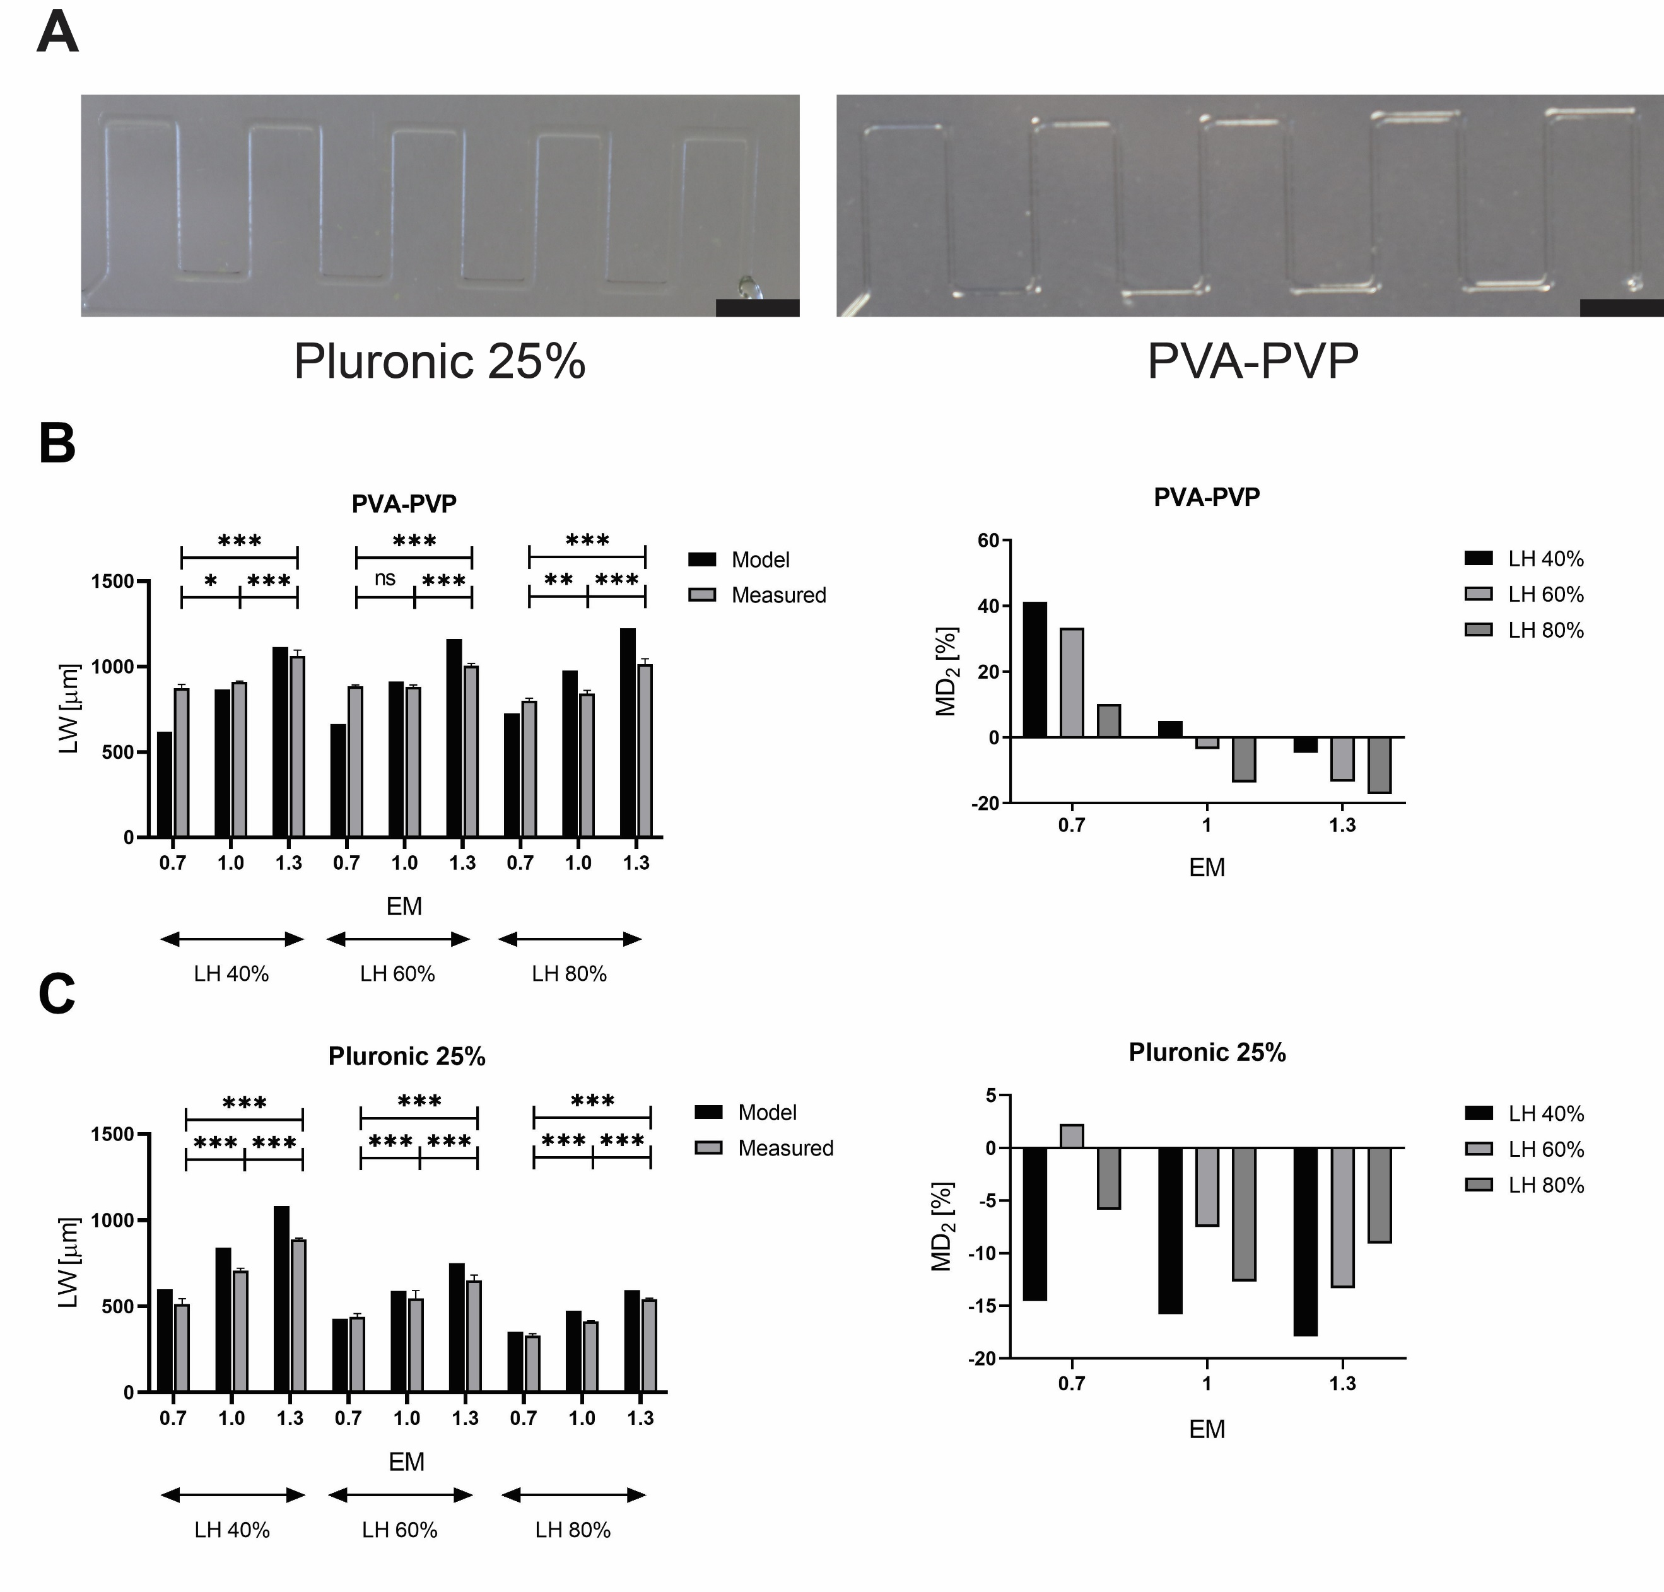
Figure 9: summary of the results from the Stage 2 validation. In (A), photos of the printed serpentine-like shape for the two materials (printing parameters: LH 60%, EM 1). In the first row (B), the results for the PVA-PVP gel from the analytical model and the measured LW, alongside the relative values for the MD₂ ratio. In the second row (C) the results for the Pluronic 25% gel. In the graphs, ns: not significant (p ≥ 0.05), *: p ≤ 0.05, ***: p ≤ 0.001. Scale bars equal to 5 mm.
For both materials the two-way ANOVA showed a statistically significant effect of both EM and LH on the LW (p<0.0001 for the effect of both parameters), in accordance with the theoretical model. Furthermore, the Tukey’s post-hoc comparisons showed that, in each LH of the Pluronic 25%, there was a statistically significant difference in the means by varying the EM parameter for all combinations (p<0.0001 for all values). The same applies for the PVA-PVP, except for the combinations LH 40%, EM 0.7 vs 1 (p=0.0181) and LH 60%, EM 0.7 vs. 1 (p=0.9257) which show a non-significant difference between the means.

Stage 3 validation
To validate Stage 3 model the deformation of printed line over increasing gaps was evaluated and compared with the deformation with the deformation given in output by the model.
For both materials, we first evaluated the limit on beam length and of small deformations by computing the two limiting values for the tooth spacing L_{min} and L_{max}. The experimental values are reported in Table 5.
Material | L_{min} [mm] | L_{max} [mm]
PVA-PVP | ≈ 3.2 | ≈ 1.9
Pluronic 25% | ≈ 3.2 | ≈ 7.5
Table 5: the two extreme tooth spacings to satisfy the small deformation and beam hypothesis for the Stage 3 model.
As can be seen from Table 5, for the PVA-PVP there is no intersecting range, as confirmed by no successful experimental results (data not shown). Figure 10A and Figure 10B show the model displacement δ_{mod}, measured displacement δ_{meas} and model deviation MD₃ for the case of Pluronic 25% (Figure 10C).
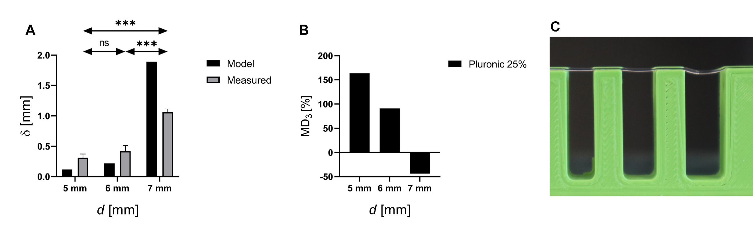
Figure 10: results from the Stage 3 model validation for the Pluronic 25% gel. In (A) the measured and modelled displacement alongside the MD₃ in (B). In (C) an example image of the gel deformation. In the graphs, ns: not significant (p ≥ 0.05), ***: p ≤ 0.001.
According to the analytical model, the one-way ANOVA results (Figure 10A) showed a statistically significant effect of the comb tooth distance on the measured deformation for the Pluronic 25% (p<0.0001). Furthermore, the results for the Pluronic 25% are in line with the theorical model, since the predicted mean deformation has the same order of magnitude as the experimental one. The high MD₃ values are mainly related to the micrometric dimensions to be measured, which are difficult to capture from the acquired images.

Scaffold printing
Even though the Pluronic 25% gel required a higher pressure to be extruded when compared to the PVA-PVP one (Stage 1 results), it also shows more predictable line width (Stage 2 results) and deformation under its own weight (Stage 3 results). Thus, it was used to print a scaffold-like structure as proof-of-concept of the developed GUI. The printing parameters are reported in Table 3 and were chosen in accordance with the GUI output, as described in 2.3.3. As can be seen from Figure 11, the printing process was successful in creating a scaffold using this specific combination of parameters.
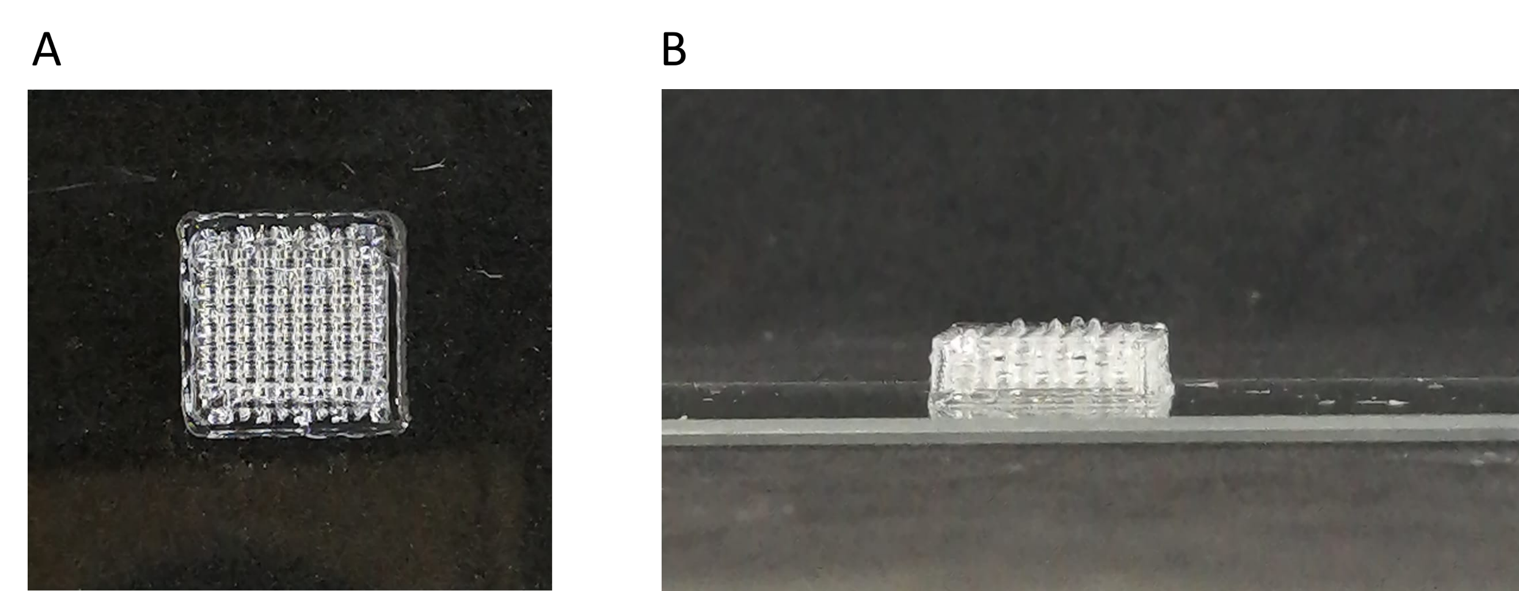
Figure 11: proof-of-concept of a scaffold-like structure, using the optimized parameters from the analytical models.

Conclusions
In this work, for the first time, we proposed a theoretical model that considers all the main aspects of EBB, thus developing a rapid, user-friendly and open-source tool able to guide the user in the identification of the printing parameters necessary for a successful print. As a matter of a fact, the model is able to predict the printability of a given material using a specific EBB equipment and a printing parameter set for the fabrication of a defined geometry.
Herein, we have defined “printability” as a combination of different aspects of the EBB process (material, geometry, printer) that determines a priori if the printing process will be successful of not.
Extrudability, strand formation, and long-term stability concur equally to determine the EBB printability of a certain geometry, using a given biomaterial ink with a specific EBB apparatus
To help in the use of the developed model, it was implemented in both in a python code featuring a graphical user interface (GUI) (available on https://github.com/CentroEPiaggio/Rheology-GUI with a CC-BY license) as well as a web-page, available at the link https://www.prin-vision.it/printability-assessment/, so that it can be used by researchers and industries as a tool to guide printing parameters choice in EBB.
This model is a robust tool for optimizing EBB, that can already support the user in the process, thus reducing the trial-and-error preliminary tests. However, some further features can be added into the model in the future to improve its performance. For example, in Stage 1 the equations may be modified to take into account other needle geometries (i.e., conical, co-axial). Furthermore, no cross-linking reactions were considered in the proposed model. Although it is possible to include as input the final elastic modulus (i.e., after a complete crosslinking) to evaluate the long term stability of the scaffold, a comparison between the relaxation and cross-linking times is necessary. More in detail, if the former is much greater than the latter, the material will not collapse significantly due to the rapid cross-linking and so it will maintain its printed shape. On the other hand, if the cross-linking time greatly exceeds the relaxation one, there may be a loss in shape fidelity due to the material relaxation.
Moreover, a tool to predict cell viability during the extrusion process can be introduced in the Stage 1 model, or alternatively the study of bridges formation (i.e., open-air extrusions without a support) using soft materials can be added to Stage 3 model. Thus, thanks to the modularity of the proposed model, it can be upgraded to provide the scientific community with an increasingly accurate tool for EBB optimization.

Acknowledgements
All the authors acknowledge the support of the Crosslab Additive Manufacturing of the Department of Information Engineering of the University of Pisa. All the authors like to thank Francesco Biagini, Gabriele Maria Fortunato, Anna Lapomarda, and Simone Micalizzi, University of Pisa, for their essential contribute to the initial discussion.

Fundings
This work was supported by the Italian Ministry of Education, University and Research (MIUR) under the PRIN Project VISION “Development and promotion of the Levulinic acid and Carboxylate platforms by the formulation of novel and advanced PHA-based biomaterials and their exploitation for 3D printed green-electronics applications”; grant 2017FWC3WC, by the European Union’s Horizon 2020 research and innovation program under the project GIOTTO: “Giotto: Active ageing and osteoporosis: The next challenge for smart nanobiomaterials and 3D technologies”; grant agreement No 814410, and by Regione Toscana’s Bando Ricerca Salute 2018 under the project TRITONE:“Smart bioactive personalised and implatable 3d printed scaffold for tendon regeneration”

References
[1] L. Moroni, T. Boland, J. A. Burdick, C. De Maria, B. Derby, G. Forgcas, J. Groll, Q. Li, J. Malda, V. A. Mironov, C. Mota, M. Nakamura, W. Shu, S. Takeuchi, T. B. F. Woodfield, T. Xu, J. J. Yoo, G. Vozzi, “Biofabrication: A Guide to Technology and Terminology,” Trends in Biotechnology, vol. 36(4), pp. 384–402, 2018. https://doi.org/10.1016/j.tibtech.2017.10.015
[2] R. T. Shafranek, S. C. Millik, P. T. Smith, C. Lee, A. J. Boydston, A. Nelson, “Stimuli-responsive materials in additive manufacturing,” Progress in Polymer Science, vol. 93, pp. 36–67, 2019. https://doi.org/10.1016/j.progpolymsci.2019.03.002
[3] S. A. M. Tofail, E. P. Koumoulos, A. Bandyopadhyay, S. Bose, L. O’Donoghue, C. Charitidis, “Additive manufacturing: scientific and technological challenges, market uptake and opportunities,” Materials Today, vol. 21(1), pp. 22–37, 2018. https://doi.org/10.1016/j.mattod.2017.07.001
[4] I. T. Ozbolat, M. Hospodiuk, “Current advances and future perspectives in extrusion-based bioprinting,” Biomaterials, vol. 76, pp. 321–343, 2016. https://doi.org/10.1016/j.biomaterials.2015.10.076
[5] F. Pati, J. Jang, J. W. Lee, D. Cho, Extrusion bioprinting, in: A. Atala, J. J. Yoo (Eds), Essentials of 3D Biofabrication and Translation, Academic Press, 2015, pp 123-152.
[6] I. Chiesa, C. Ligorio, A. F. Bonatti, A. De Acutis, A. M. Smith, A. Saiani, G. Vozzi, C. De Maria, “Modeling the Three-Dimensional Bioprinting Process of β-Sheet Self-Assembling Peptide Hydrogel Scaffolds,” Frontiers in Medical Technology, vol. 2(October), pp. 1–16, 2020. https://doi.org/10.3389/fmedt.2020.571626
[7] T. G. Mezger, The Rheology Handbook, 4th Edition. Vincentz Network, Hannover, Germany, 2020.
[8] J. Groll, J A Burdick, D-W Cho, B Derby, M Gelinsky, S C Heilshorn, T Jüngst, J Malda, V A Mironov, K Nakayama, A Ovsianikov, W Sun, S Takeuchi, J J Yoo and T B F Woodfield “A definition of bioinks and their distinction from biomaterial inks,” Biofabrication, vol. 11(1), 2019. https://doi.org/10.1088/1758-5090/aaec52
[9] I. T. Ozbolat, K. K. Moncal, H. Gudapati, “Evaluation of bioprinter technologies,” Additive Manufacturing, vol. 13, pp. 179–200, 2017. https://doi.org/10.1016/j.addma.2016.10.003
[10] I. Chiesa, G. M. Fortunato, A. Lapomarda, L. Di Pietro, F. Biagini, A. De Acutis, L. Bernazzani, M. R. Tinè, C. De Maria, G. Vozzi, “Ultrasonic mixing chamber as an effective tool for the biofabrication of fully graded scaffolds for interface tissue engineering,” International Journal of Artificial Organs, vol. 42(10), 2019. https://doi.org/10.1177/0391398819852960
[11] M. Singh, H. M. Haverinen, P. Dhagat, G. E. Jabbour, “Inkjet printing-process and its applications,” Advanced Materials, vol. 22(6), pp. 673–685, 2010. https://doi.org/10.1002/adma.200901141
[12] R. Levato, T. Jungst, R. G. Scheuring, T. Blunk, J. Groll, J. Malda, “From Shape to Function: The Next Step in Bioprinting,” Advanced Materials, vol. 32(12), 2020. https://doi.org/10.1002/adma.201906423
[13] A. Schwab, R. Levato, M. D’Este, S. Piluso, D. Eglin, J. Malda, “Printability and Shape Fidelity of Bioinks in 3D Bioprinting,” Chemical Reviews, vol. 120(19), pp. 11028–11055, 2020. https://doi.org/10.1021/acs.chemrev.0c00084
[14] S. Naghieh, D. Chen, “Printability – a Key Issue in Extrusion-based Bioprinting,” Journal of Pharmaceutical Analysis, 2021. https://doi.org/10.1016/j.jpha.2021.02.001
[15] A. Tirella, A. Orsini, G. Vozzi, A. Ahluwalia,“A phase diagram for microfabrication of geometrically controlled hydrogel scaffolds,” Biofabrication, vol. 1(4), 2009. https://doi.org/10.1088/1758-5082/1/4/045002
[16] A. Ribeiro, m. M. Blokzujl, R. Levato, C. W. Visser, M. Castilho, W. E. Hennink, T. Vermonden, J. Malda, “Assessing bioink shape fidelity to aid material development in 3D bioprinting,” Biofabrication, vol. 10(1), 2018. https://doi.org/10.1088/1758-5090/aa90e2
[17] N. Paxton, W. Smolan, T. Bock, F. Melchels, J. Groll, T. Jungst, “Proposal to assess printability of bioinks for extrusion-based bioprinting and evaluation of rheological properties governing bioprintability,” Biofabrication, vol. 9(4), 2017. https://doi.org/10.1088/1758-5090/aa8dd8
[18] J. Göhl, K. Markstedt, A. Mark, K. Hakansson, P. Gatenholm, F. Edelvik, “Simulations of 3D bioprinting: Predicting bioprintability of nanofibrillar inks,” Biofabrication, vol. 10(3), 2018. https://doi.org/10.1088/1758-5090/aac872
[19] A. Gleadall, I. Ashcroft, J. Segal, “VOLCO: A predictive model for 3D printed microarchitecture,” Additive Manufacturing, vol. 21(April), pp. 605–618, 2018. https://doi.org/10.1016/j.addma.2018.04.004
[20] E. N. Udofia, W. Zhou, “A Guiding Framework for Microextrusion Additive Manufacturing,” Journal of Manufacturing Science and Engineering, Transactions of the ASME, vol. 141(5), 2019. https://doi.org/10.1115/1.4042607
[21] A. Lapomarda, E. Pulidori, G. Cerqueni, I. Chiesa, M. De Blasi, M. A. Geven, F. Montemurro, C. Duce, M. Mattioli-Belmonte, M. R. Tinè, G. Vozzi, C. De Maria, “Pectin as Rheology Modifier of a Gelatin-Based Biomaterial Ink,” 2021. https://doi.org/10.3390/ma14113109
[22] I. Chiesa, C. De Maria, A. Lapomarda, G. M. Fortunato, F. Montemurro, R. Di Gesù, R. S. Tuan, G. Vozzi, R. Gottardi, “Endothelial cells support osteogenesis in an in vitro vascularized bone model developed by 3D bioprinting,” Biofabrication, vol. 12(1), 2020. https://doi.org/10.1088/1758-5090/ab6a1d
[23] A. Lapomarda, A. De Acutis, I. Chiesa, G. M. Fortunato, F. Montemurro, C. De Maria, M. Mattioli-Belmonte, R. Gottardi, G. Vozzi, “Pectin-GPTMS-Based Biomaterial: Toward a Sustainable Bioprinting of 3D scaffolds for Tissue Engineering Application,” Biomacromolecules, vol. 21(2), pp. 319–327, 2020. https://doi.org/10.1021/acs.biomac.9b01332
[24] Slic3r manual. https://manual.slic3r.org/, (accessed 3 July 2021)
[25] R. P. Chhabra, J. F. Richardson, “Non-Newtonian Flow and Applied Rheology,” Foreign Affairs, vol. 91(5), pp. 1689–1699, 2012.
[26] P. K. Swamee, N. Aggarwal, “Explicit equations for laminar flow of herschel-bulkley fluids,” Canadian Journal of Chemical Engineering, vol. 89(6), pp. 1426–1433, 2011. https://doi.org/10.1002/cjce.20484
[27] P. Saramito, A. Wahcs, “Progress in numerical simulation of yield stress fluid flows,” Rheologica Acta, vol. 56(3), pp. 211–230, 2017. https://doi.org/10.1007/s00397-016-0985-9
[28] M. Mattioli-Belmonte, C. De Maria, C. Vitale-Brovarone, F. Baino, M. Dicarlo, G. Vozzi, “Pressure-activated microsyringe (PAM) fabrication of bioactive glass–poly(lactic-co-glycolic acid) composite scaffolds for bone tissue regeneration,” Journal of Tissue Engineering and Regenerative Medicine, vol. 11(7), pp. 1986–1997, 2015. https://doi.org/10.1002/term.2095
[29] G. Vozzi, A. Previti, D. De Rossi, A. Ahluwalia, “Microsyringe-based deposition of two-dimensional and three-dimensional polymer scaffolds with a well-defined geometry for application to tissue engineering,” Tissue Engineering, vol. 8(6), pp. 1089–1098, 2002. https://doi.org/10.1089/107632702320934182
[30] L. Li, Q. Lin, M. Tang, A. J. E. Duncan, C. Ke, “Advanced Polymer Designs for Direct-Ink-Write 3D Printing,” Chemistry - A European Journal, vol. 25(46), pp. 10768–10781, 2019. https://doi.org/10.1002/chem.201900975
[31] C. Duty, C. Ajinjeru, V. Kishore, B. Compton, N. Hmeidat, X. Chen, P. Liu, A. A. Hassen, J. Lindahl, V. Kunc, “What makes a material printable? A viscoelastic model for extrusion-based 3D printing of polymers,” Journal of Manufacturing Processes, vol. 35(August 2017), pp. 526–537, 2018. https://doi.org/10.1016/j.jmapro.2018.08.008
[32] E. Cuan-Urquizo, S. Yang, A. Bhaskar, “Mechanical characterization of additively manufactured material having lattice microstructure,” IOP Conference Series: Materials Science and Engineering, vol. 74(1), 2015. https://doi.org/10.1088/1757-899X/74/1/012004
[33] A. M’Barki, L. Bocquet, A. Stevenson, “Linking Rheology and Printability for Dense and Strong Ceramics by Direct Ink Writing,” Scientific Reports, vol. 7(1), pp. 1–10, 2017. https://doi.org/10.1038/s41598-017-06115-0
[34] R. C. Juvinall, "Fundamentals of machine component design.", 2007.

