Supplementary information

Yuanhao Wu^{1,2,3}, Gabriele Maria Fortunato⁴, Babatunde O. Okesola^{5,6}, Francesco Luigi Pellerej di Brocchetti⁴, Ratima Suntornnond⁷, John Connelly⁷, Carmelo De Maria⁴, Jose Carlos Rodriguez-Cabello⁸, Giovanni Vozzi⁴, Wen Wang^{5,6}, Alvaro Mata^{1,2,3,5,6*}

- School of Pharmacy, University of Nottingham, NG7 2RD Nottingham, UK.
- Department of Chemical and Environmental Engineering, University of Nottingham, NG7 2RD Nottingham, UK.
- Biodiscovery Institute, University of Nottingham, NG7 2RD Nottingham, UK.
- Research Center ‘E. Piaggio’ & Dipartimento di Ingegneria dell’Informazione, University of Pisa, Largo Lucio Lazzarino, 1 - 56122 Pisa, Italy.
- Institute of Bioengineering, Queen Mary University of London, London E1 4NS, UK.
- School of Engineering and Materials Science, Queen Mary University of London, London E1 4NS, UK.
- CREATE LAB, Blizard Institute, Barts and the London School of Medicine and Dentistry, Queen Mary University of London, 4 Newark St London, E1 2AT.
- BIOFORGE Group, University of Valladolid, CIBER-BBN, 47011 Valladolid, Spain.

*Corresponding author: Alvaro Mata, a.mata@nottingham.ac.uk

Materials and methods
Chemicals
Rhodamine B (>=95%, HPLC grade) and paraformaldehyde (95%) were obtained from Sigma-Aldrich. Graphene oxide (product number-777676) was obtained from Sigma-Aldrich. Alexa Fluor™ 488 NHS Ester (product number-A20000) was obtained from Thermo Fisher Scientific. FITC-Dextran 40kDa (product number-FD40), 20kDa (product number-FD20s), and Fluorescein sodium salt (product number- 518-47-8) were obtained from Sigma-Aldrich.

Synthesis and characterization of elastin-like recombinamers (ELRs)
ELR [ELK1: MESLLP-(VPGIG VPGIG VPGKG VPGIG VPGIG)₂₄] molecule was provided by TP Nanobiotechnology (Valladolid, Spain), synthesised and purified by E. coli recombinant expression system. The sequence and molecular weights of the polymers were verified using amino acid analysis. SDS-PAGE and MALDI-TOF SIMS were used to carry out the ELK1 characterisation.

Sample preparation (ELK1-GO system)
Aqueous suspension of GO (0.1 wt%, 100 µL) was added to a well of 96-well TCP and aqueous solution of the ELK1 (2 wt%, 18 µL) was slowly injected into the suspension of GO. The tip of the pipette was
allowed to contact the bottom of the well before releasing the ELK1 solution vertically at a constant speed. All samples were prepared in MilliQ water.

Diffusion-reaction of ELK1-GO tube wall formation
The diffusion-reaction of ELK1-GO tube wall formation is critical and determine the increase of tube wall thickness over time. An imaging system was used to observe tube formation and its behaviour over time. The system consisted of a Nikon camera with a 1:1 macro lens, a mirror to reflect the image on the lens of the camera and a light source powered at 30 Volts (Supplementary Figure 1). A time lapse was used to observe the membrane self-assembly.

Confocal microscopy
The interaction and localization of ELK1 and GO was probed using laser scanning confocal and multiphoton microscopy (TCS SP2, Leica Microsystems, Germany). ELK1 (2 wt%) was dissolved in an aqueous solution of Alexa Fluor™ 488 NHS Ester (10⁻⁶ wt%) and GO were diluted to 0.1 wt% with an aqueous solution of Rhodamine (10⁻⁶ wt%). All solutions were incubated for 20 min at 30 °C and protected from light. Images were acquired at laser wavelengths of 488 and 543 nm which correspond to the excitation wavelength of Alexa Fluor and rhodamine, respectively. Images were further processed using ImageJ.

Scanning electron microscopy (SEM)
The microstructures of ELK1–GO membranes were examined by SEM. ELK1–GO membranes were dehydrated directly using increasing concentrations of ethanol (20, 50, 70, 90, 96, and 100%). All samples were subjected to critical point drying (K850, Quorum Technologies, UK) prior imaging. The SEM micrographs were captured on Inspect F50 (FEI Comp, the Netherlands) after sputter-coating with gold (10 nm thick). All samples consisting only ELRs or GO were prepared for SEM imaging without a prior cross-linking process.

3D printing of ELK1-GO materials, perfusing, and pulsating
A commercially available 3D printer (3D DISCOVERY™ EVOLUTION, RegenHU, Switzerland) was applied for the 3D printing of ELK1–GO materials. An 85 μm diameter nozzle was used to release the solution of the ELK1 (2 wt%) under 0.02 - 0.10 MPa pressure at a range of speed between 10 and 100 mm/s. The printing nozzle was merged in a container with 0.1% GO MilliQ water suspension. A peristaltic pulsatile pump was used to perfuse 1 v/v green food dye in MilliQ water. The perfusion speed was 12 mL/min and the pulse frequency was 1 Hz.

Fabrication of capillary-based permeability testing device
The device was produced by pouring a first base layer of Polydimethylsiloxane (PDMS) (1mm thickness) in a Petri dish. After curing at 60 °C for 1 hr, a metal needle of 0.8 mm outer diameter was placed on the first layer and two pins for subsequent alignment of the device. A second layer of PDMS was then poured and cured in the Petri dish. The level of PDMS in the second layer had to cover the needle. Petri dish was then placed in an oven at 60 °C for 2 hr to thoroughly cure both PDMS layers. Removal of tube with forceps leaves a cylindrical cavity with a diameter of 0.8mm. The PDMS with cavity was cut from centre and divided into two chambers. A flat membrane from an ELK1-GO tubular structure was inserted into the middle of the device and divided the channels of the left and right chambers. A test solution was injected into the right chamber, while the same solvent of the test solution was injected into the left chamber (Supplementary Figure 2a).

Permeability measurement
Two substances were used to measure permeability: Fluorescein sodium salt and FITC-dextran. These two solutions were used to measure, respectively, the permeability of sodium ions and of macro molecules (20kDa and 40kDa). MilliQ water (Phosphate-buffered saline) was injected into the left chamber and a water solution of FITC-dextran or Fluorescein sodium salt was added to the right chamber. The concentration of GO for the formation of ELK1-GO membranes was changed to observe the variations of the permeability across the membrane. The GO concentrations considered were:0.05%,0.10%and0.15%(Fig.2.11). An epi fluorescence microscope (Leica DMI 4000B, Epifluorescence Microscope with a LEICA DFC 300FXCCD camera) was used to determine the passage of molecules from one chamber of the device to another one. Data collected from the intensity analysis were described through following model^{[1]}:
$C2=\frac{V1C1}{V1+V2}(1-e^{\frac{{-DA\left(V1V2\right)}^{t}}{L\left(V1+V2\right)}})$ (eq 1)
Where V1 was the volume of the left chamber, C1 was the concentration of molecules inside the left chamber, V2 was the volume of the right chamber, C2 was the concentration of molecules inside the right chamber; L and A were the membrane thickness and area respectively and D was the permeability constant.
Then to determine the permeability constant D, the experimental data were fitted with an exponential equation (eq 2) with Matlab.
$Y=A(1-e^{-Bt})$ (eq 2)
Once the permeability constant of the equation (eq 2) was determined, it was compared with the argument of the exponential in model (eq 1).
$B=\frac{DA(V1V2)}{L(V1+V2)}$ (eq 3)

Cell culture
GFP-Human umbilical vein endothelial cells (GFP-hUVECs) (Fisher scientific, Angio Proteomie GFP-hUVECs, NC0601093, USA) were cultured in EGM™-2 Media (Lonza, CC-3156 and CC-4176). The medium was changed every 3 days until the cells reached 80% confluency. GFP-hUVECs between passage 2 and 4 were used for experiments. The tubes were first washed three times with PBS 8 h after assembly and sterilized with UV for 45 min. Then each tube was placed in a well of 48-well cell culture plate with inner or outer side facing up. The EGM™-2 Media (500 µL) containing different cell densities (5x10³, 1x10⁴, 5x10⁴, and 1x10⁵ /mL) were added to each well containing ELK1–GO membranes. The coated wells were incubated for 8 h prior to cell seeding. The cells were incubated at 37 °C and 5% CO2 for 48 hr for permeability test (Supplementary Figure 2b).

Finite elements analysis
Finite elements method simulations were carried out using Comsol MultiPhysics® v5.5 software. All the presented models were developed using the Transfer of diluted species module.

Permeability model
The aim of the first model was to identify the diffusion coefficient of the membrane to Dextran and Sodium salt starting from experimental data. A 2D axial symmetric transient model was used. Different time points were set for Dextran (0-1-3-5 h) and Sodium (0-20-40-60 min) according to experimental data previously acquired. The model consists of 3 domains (Supplementary Figure 3a). In each domain, transport properties are governed by the following balance equations (eq. 4 and 5):
$\frac{∂C_{i}}{∂t}+∇∙J_{i}=R_{i}$ (eq. 4)
$J_{i}=-D_{i}∇C_{i}$ (eq. 5)
where Ci is the concentration (mol/m3), Di the diffusion coefficient and Ri the reaction rate. $D_{i}=1×{10}^{-9}{m^{2}}/s$ for domains 1 and 3 (same as water) while it was considered as a parameter to be estimated in the membrane (domain 2, parametric sweep study). On the right side of the membrane (domain 1) the initial concentration (t=0 h/min) of salt was 1M and 0.001M for Dextran and Sodium respectively (C=0 M for other domains). A transient study allowed the evaluation of concentration profile in the whole chamber across the membrane. All external boundaries were set to No flux condition (eq. 6).

$-n∙\left(J_{i}+uC_{i}\right)=0$ (eq. 6)

For each image (acquired by epifluorescence microscope), a normalized plot profile was obtained on the centre line using ImageJ® software. The comparison between the model and the real images was carried out considering a single point in the left chamber (1 mm from the left side) (Supplementary Figure 3b and 3c). The normalized value of the grey level from the image was compared with the normalized value of the concentration in the same point of the model at different diffusion constants for each time point. Best fitting was evaluated by calculating the adjusted R-squared parameter discarding values corresponding to the membrane in both profiles (from 2 to 2.5 mm). Results are shown in Supplementary figure 4.

Reaction model
The aim of this model was to identify the time of reaction between two species (aqueous solutions of 2 wt% ELK1 in 0.1 wt% GO). A 1.6 mm radius ELK1 drop in GO solution was simulated with a 1D axial symmetric transient model. The model consists of 2 domains: the first represents the ELK1 drop (initial value C2=0.4 mol/m3), while the second is the GO solution (C1=0.5 mol/m3) (Supplementary Figure 3d). The two species will react creating a third C3 species. The transport properties of the species are characterised by their diffusion constant in the different domains. We made two hypotheses:
1) diffusion constant of ELK1 (C2) and GO (C1) decreases linearly as C3 is formed according to eq. 7 :

$D=D_{f}+D_{0}×\left(1-c/{c_{f}}\right) {m^{2}}/s$ (eq. 7)
where $D$ is the diffusion at generic instant t, $D_{f}$ is the final value of diffusion constant with a stable membrane, $D_{0}$ is the starting diffusion constant before the membrane formation, $c$ is the concentration of species C3 at generic instant t, $c_{f}$ is the concentration of the stable membrane. According to permeability model for Dextran, the presence of the membrane causes a diffusivity drop of at least 3 orders of magnitude. We need to estimate concentration at which the membrane can be considered stable. Considering 1.5% ELK1, the protein is totally consumed (reference paper Nature communications) forming a stable membrane, with a resulting concentration $c_{f}=$0.3 mol/ m3. The starting diffusion coefficient ($D_{0}$) for proteins is about ${10}^{-9}$ ${m^{2}}/s$, the final will be similar to that of Dextran ($D_{f}=1×{10}^{-12}{m^{2}}/s)$. The final value of GO diffusion coefficient was estimated with a parametric simulation ($D_{f}=1×{10}^{-13},$ $1×{10}^{-15},1×{10}^{-17}{m^{2}}/s$; starting $D_{0}$ for GO was considered as typical values for large molecules → 57×10-11). On the basis of these considerations, diffusion constant was modeled on Comsol Multiphysics® with the following relation:

$D={max⁡(D}_{f}+D_{0}×\left(1-{c3}/{0.3}\right), D_{f})$ (eq. 8)
Using max (x, y), if $\left(1-{c3}/{0.3}\right)<0$, reference diffusion constant is $D_{f}.$
2) diffusion of C3 is negligible (very low diffusion constant $D_{C_{3}}=1×{10}^{-17}{m^{2}}/s$).
A reaction was introduced in this model in both domains. Reaction conditions were set as follows:
$${dC_{1}}/{dt}=R_{c1}=-A\left(C_{1}*C_{2}\right)$$
$${dC_{2}}/{dt}=R_{c2}=-B\left[A\left(C_{1}*C_{2}\right)\right]$$
$${dC_{3}}/{dt}=R_{c3}=A\left(C_{1}*C_{2}\right)$$
where A=reaction rate [${m^{3}}/{(mol∙s)}$], B=stoichiometric ratio ELK1:GO.
The previous equations assume that:
1) reaction rate is 200 ${m^{3}}/{(mol∙s)}$;
2) since stoichiometric ratio is ELK1:GO = 20:1, C2 decreases 20 times faster than C1;
3) C3 increases as fast as C1 is consumed.
On the basis of these assumptions, the reactions were modelled in Comsol MultyPhysics® with the following equations:
$$R_{C_{1}}=-200*C_{1}*C_{2}{*(C}_{1}>0){*(C}_{2}>0)$$
$$R_{C_{2}}=-20*(200*C_{1}*C_{2}{*(C}_{1}>0){*(C}_{2}>0))$$
$$R_{C_{3}}=200*C_{1}*C_{2}{*(C}_{1}>0){*(C}_{2}>0)$$
Where the expression $[*{(C}_{1}>0){*(C}_{2}>0)]$means that the reaction happens only if C1 and C2 are present at the same time.
A transient study was computed over 800 s time evaluating how C3 is formed at the interface between C1 and C2 domains. In order to obtain a more accurate solution a user-controlled mesh was introduced by setting the maximum element size to 0.005 mm. Results are shown in Supplementary figure 5.

Gradient model
The aim of this model was to identify the gradient concentration trend over time of three different GO solutions placed in a 6 cm diameter Petri dish. The three solution were 0.05%, 0.10% and 0.15% GO w/v respectively, corresponding to 0.25, 0.5 and 0.75 mol/m3 (MW of GO is 2043.8 g/mol). A 2D transient model consisting of 4 domains was developed: domain 1 corresponds to water, while 2, 3 and 4 are the 3 different GO solutions placed with increasing concentration value (Supplementary Figure 3e). Diffusion constant was set to $D_{i}=1×{10}^{-9}{m^{2}}/s$ (same as water). Concentration trend over a 96-hr time was evaluated on a cut line placed in the middle of the Petri dish (red line in Supplementary Figure 3e).

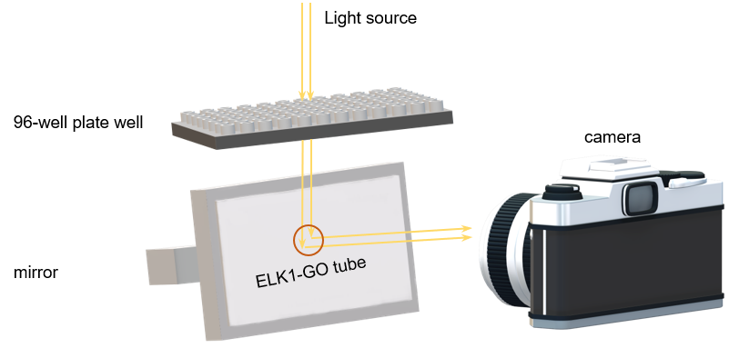
Supplementary Figure 1. System used for observing and recording the ELK1-GO diffusion reaction and tube formation.

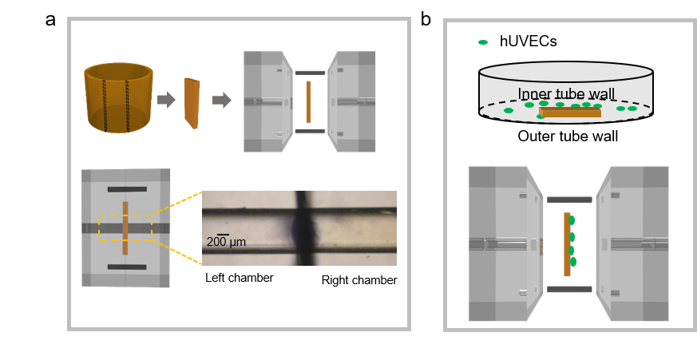
Supplementary Figure 2. Set-up of capillary-based permeability testing device. a. A membrane was cut from an ELK1-GO tube and was inserted in the device, dividing the central channel into two chambers. b. Membrane with hUVECs was inserted into the permeability test device with hUVECs facing to the right chamber.

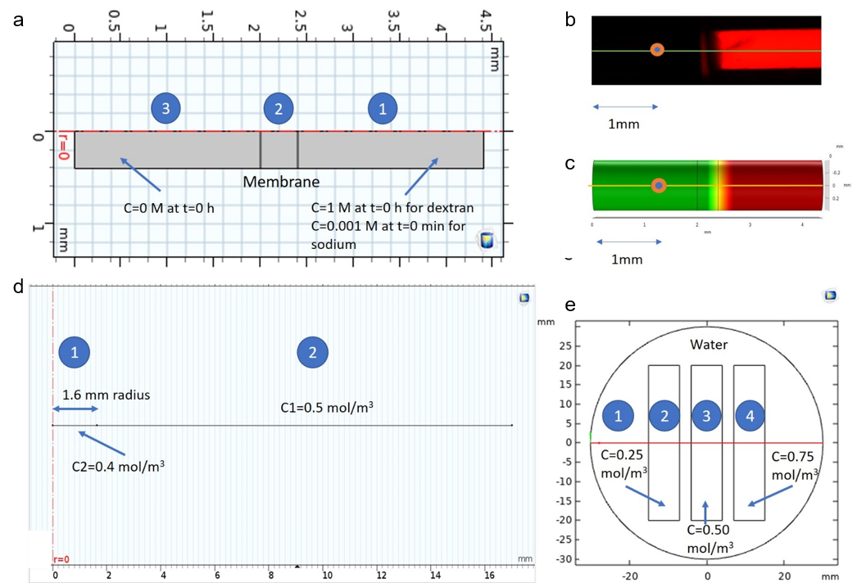
Supplementary Figure 3. Permeability model. a. 2D axial symmetric model. The model consists of three domains. Initial values for each domain are shown. b. Experimental image for Dextran (t=0 h). Grey profile was evaluated on the green line, while normalized grey value on the orange point. c. Modelled chamber (t=0 h). Concentration plot was evaluated on the yellow line, while normalized concentration value on the orange point. d. Reaction model: 1D axial symmetric model. Domain 1 represents ELK1 solution drop, domain 2 is the GO solution. e. Gradient model: 2D model. Domain 1 represents water in a 6 cm Petri dish. Domains 2, 3 and 4 correspond to three different GO solutions: 0.05%, 0.10% and 0.15% w/v respectively.

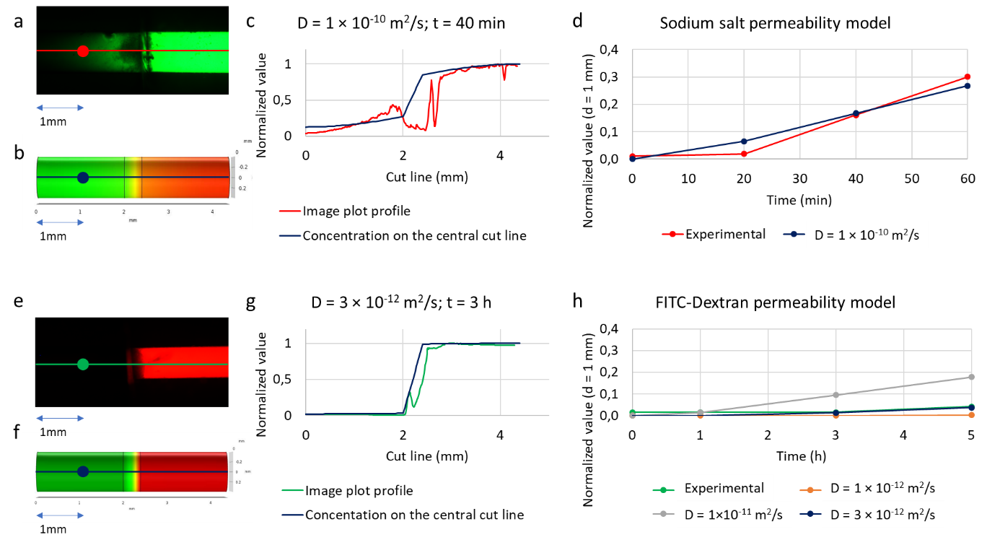
Supplementary Figure 4. Permeability model results. a-b. Experimental image and model for sodium salt permeability model at t=40 min. c. Example of normalized plot profile evaluated on the red line (a) against normalized concentration evaluated on the blue cut line (b) at t=40 min. d. Comparison between normalized grey level and concentration evaluated on a single point in the left chamber for experimental setup and model. Best fitting results with a diffusion constant $D=1×{10}^{-10} {m^{2}}/s$. e-f. Experimental image and model for FITC-Dextran permeability model at t=3 h. c. Example of normalized plot profile evaluated on the green line (e) against normalized concentration evaluated on the blue cut line (f) at t=3 h. d. Comparison between normalized grey level and concentration evaluated on a single point in the left chamber for experimental setup and model. Best fitting results with a diffusion constant $D=$3×10-12 m2s.

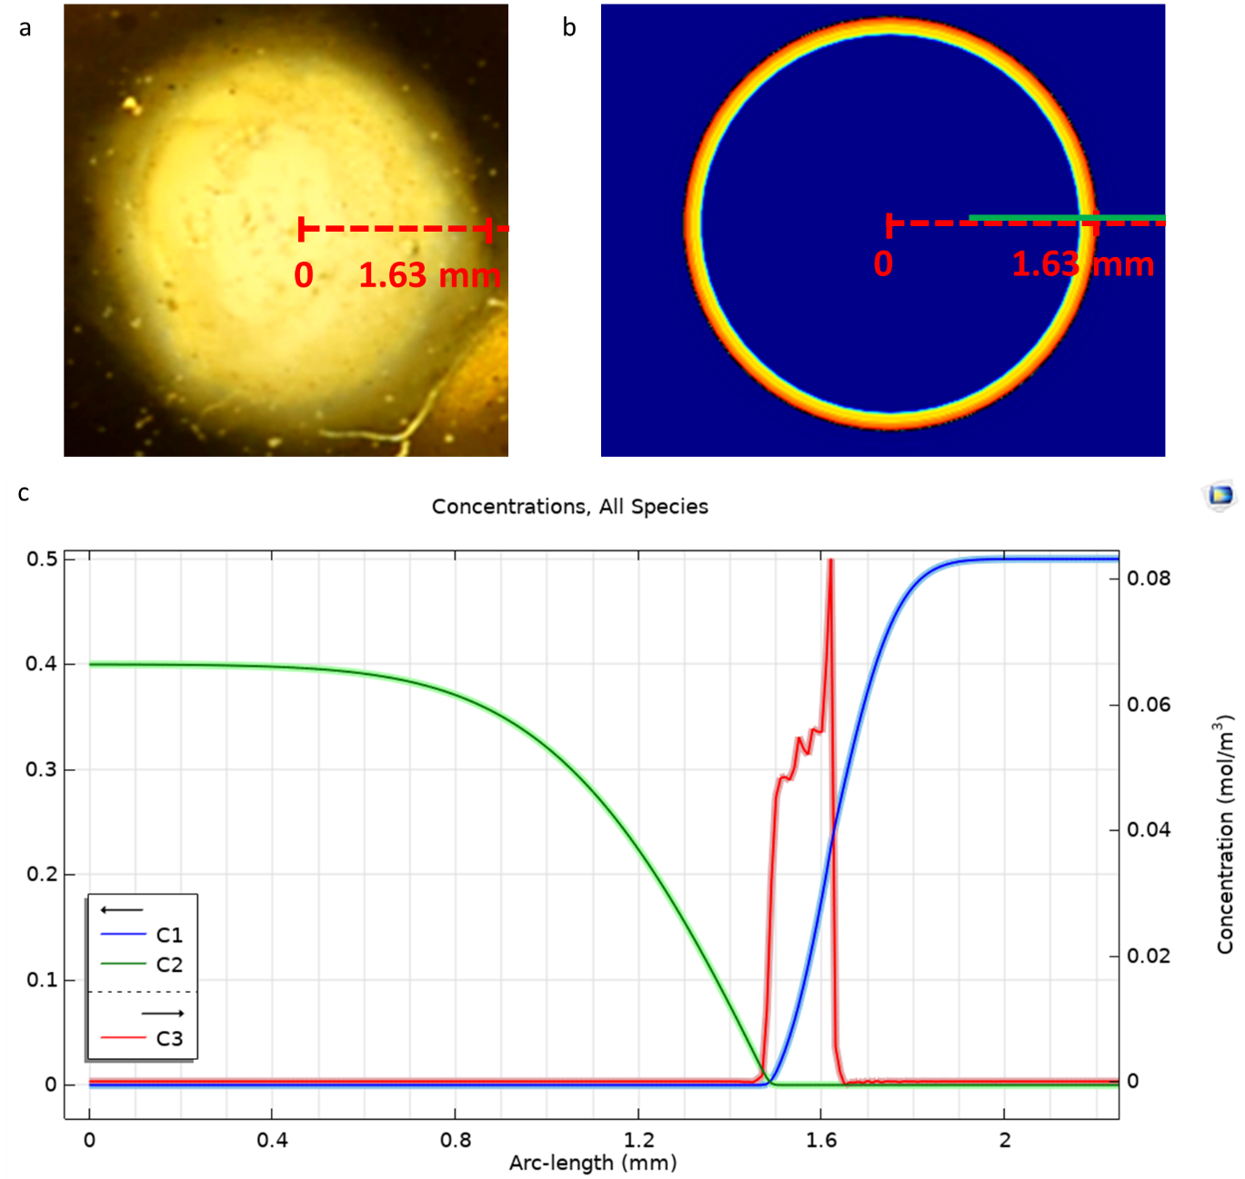
Supplementary Figure 5. Reaction model results. a-b. Experimental image and model of the membrane formation after 80 s. Red-dashed line represents the 1D axial symmetry used for the analysis. c. Concentration trend of 3 species C1 (GO), C2 (ELK1) and C3 (membrane) at the interface GO/ELK1 [green line (b)] at t=80 s with a $D_{f}=1×{10}^{-15} {m^{2}}/s$. Membrane is growing inwards (external radius same as starting drop R=1.63 mm) and has a thickness of ∼150 μm. ELK1 remains inside the tube and GO does not enter. The thicker, lighter coloured line (for all species) corresponds to the range of values obtained by varying $D_{f}$. The lower limit of the range for GO (C1, blue) and ELK1 (C2, green) corresponds to $D_{f}=1×{10}^{-13} {m^{2}}/s$. , the upper to $D_{f}=1×{10}^{-17} {m^{2}}/s$. Considering C3, the membrane thickness is higher with higher $D_{f}$ (upper limit of the range). If $D_{f}$ is higher GO diffusion is higher, reaction with ELK1 is faster and consequently their concentration decreases faster and the membrane thickness increases. As shown by this narrow region the model is robust even if the accurate final value of GO diffusion coefficient is unknown.

