TAMDAKHT: A MOROCCAN ORDINARY CHONDRITE FALL WITH AN UNPRECEDENTED FUSION CRUST
Larbi ZENNOURI¹, *, Hasnaa CHENNAOUI AOUDJEHANE^{1,2}, Luigi FOLCO^{3,4}, Taha SHISSEH¹, Abderrazak EL ALBANI⁵, Arnaud MAZURIER⁵, Mohamed Hassan LEILI¹

¹ GAIA Laboratory, Faculty of Sciences Ain Chock, Hassan II University of Casablanca, km 8 Route d’El Jadida, 20150 Casablanca, Morocco
² ATTARIK Foundation for Meteoritics and Planetary Science, Faculty of Sciences Ain Chock, Hassan II University of Casablanca, km 8 Route d’El Jadida, 20150 Casablanca, Morocco
³ Dipartimento di Scienze della Terra, Università di Pisa, V. S. Maria 53, 56126 Pisa, Italy
⁴ Centro per la Integrazione della Strumentazione della Università di Pisa, CISUP, Lungarno Pacinotti 43/44, 56126 Pisa, Italy
⁵ Université de Poitiers, CNRS, IC2MP, Poitiers, France.

*Corresponding author. E-mail: l.zennouri@gmail.com

ABSTRACT
Tamdakht meteorite is the most massive observed fall in Morocco with a total recovered mass of ~500 kg. Most of the specimens investigated in this study are covered by a well-developed primary fusion crust with thickness that reaches up to 1.2 cm. Macroscopic investigations of this crust suggest complex atmospheric entry conditions. In some specimens, the primary fusion crust broke off and was replaced by a thin secondary crust, suggesting its removal during the late stages of the meteoroid’s flight. Meteorite fragments are enclosed in the primary fusion crust implying a potential inter-shower debris transfer prior to the dark flight, or that the broken pieces were retained by the viscous fusion crust. X-ray tomographic and backscattered electron imaging shows that the primary fusion is irregular in thickness and consists of three layers. The outer layer is mainly composed of magnetite that formed as a result of the reaction of atmospheric oxygen with Fe in the melt produced by heating. The middle layer consists of zoned olivine phenocrysts, large vesicles, metal and sulfide grains. The innermost layer displays a lower degree of melting and contains tiny vesicles, as well as metal and iron sulfides in the form of blebs and veins invading the substrate. The textural, mineralogy, and the compositional variation of Tamdakht’s fusion crust implies a change in the degassing degree, temperature, and reaction with atmospheric oxygen from the surface inward.

INTRODUCTION
Ordinary chondrite meteorites are silicate-rich meteorites composed mostly of olivine and low-Ca pyroxene (Zolensky et al. 2018). They are the most abundant meteorites on Earth (80% of all falls; Russell et al. 2018). To date (May 3, 2024), 62878 ordinary chondrites are recovered, including 974 falls and 61904 finds according to the Meteoritical Society bulletin database (www.lpi.usra.edu/meteor/metbull.php).
Fresh meteorite falls are covered by a fusion crust that forms during the atmospheric entry due to heating by hypervelocity collisions with air molecules (Krinov 1960). For meteorites that have been on Earth for a long time, weathering may affect the fusion crust making it no longer visible. This crust provides valuable information on the conditions (temperature, pressure, orientation) of the meteoroid’s atmospheric entry. Two main types of fusion crusts are distinguished: (1) a primary fusion crust that forms from the beginning of the entry until the total deceleration of the meteoroid (i.e., dark flight); (2) a secondary fusion crust that forms on freshly exposed surfaces after the fragmentation of the meteoroid during its entry (Sears 1975). Fusion crusts differ based on meteorite types (Thaisen and Taylor 2009). Chondrites have a dark matt fusion crust due to the presence of iron and sulfides (Genge and Grady 1999). In iron meteorites, the fusion crust is thick due to the conductive nature of metal (El Goresy and Fechtig 1967).
Since 2000, numerous meteorite falls have been documented in Morocco (with 80% of them being ordinary chondrites. These falls have total recovered masses ranging from 79 grams (Izarzar meteorite fall) to up to ~500 kg (Tamdakht meteorite fall).
Tamdakht is classified as an H (high iron, high metal) ordinary chondrite, displaying a petrologic type of 5 (moderately equilibrated) (www.lpi.usra.edu/meteor/metbull.php).
In this paper, we provide a detailed description of Tamdakht’s strewnfield, petrography, and mineralogy. The fusion crust is investigated in detail to gain insight into the processes that occurred during Tamdakht’s meteoroid atmospheric entry. We eventually suggest a formation mechanism for this unusual fusion crust.

SAMPLES AND METHODS

FIELDWORK
Five weeks after the initial reports of a fireball sighting, a field mission was organized by Hasnaa Chennaoui (Hassan II University of Casablanca), accompanied by Mohamed Aid, and Mohamed Aoudjehane to the fall area close to Ouarzazate province, Ait Benhaddou Ksar and Tamdakht village.

SAMPLES
In this study, we investigate numerous Tamdakht meteorite fragments that exhibit a variety of fusion crust features. For macroscopic studies, we examined three Tamdakht specimens. For microtomographic investigations, we used one centimetric fragment of Tamdakht covered by a fusion crust. For mineralogical and compositional analysis, we studied two thin sections and four thick sections.

X-RAY TOMOGRAPHY
X-ray tomographic analysis was performed at the Institut de Chimie des Milieux et Matériaux de Poitiers (IC2MP, France), using an EasyTom XL Duo device (RX-solutions, France) with a microfocus x-ray source (Hamamatsu L12161) coupled to a flat panel detector (Varian PaxScan 2520DX), following these parameters: 110 kV (tube voltage), 90 µA (target current), 1440 projections (1840x1456 pixels; 16 bits), 3 frames per second (imager readout speed), 10 frames averaging, beam filtration with a 1.2 mm Al filter, source-to-object and source-to-detector distances of 67 mm and 589 mm respectively, and voxel resolution of 14.42 µm. Slice reconstructions were constructed using an XAct software (RX-Solutions) with a filtered back projection algorithm, attenuation of beam hardening artefact, corrections of x-ray spot drift and ring artifacts. In order to understand the internal evolution of the fusion crust without cutting the sample, cross-section images and a three-dimensional model were performed with Avizo v. 2019 (Thermo Fisher Scientific-FEI).

OPTICAL AND SEM MICROSCOPY
For optical microscopic observations, we used a Zeiss-Axio Imager polarizing microscope in transmitted light, coupled with a digital camera AxioCam-105-color at the Dipartimento di Scienze della Terra, Università di Pisa, Italy. To obtain backscattered electron images of the fusion crust and the interior of Tamdakht, we used a scanning electron microscope (SEM) FEI Quanta 450 ESEM FEG equipped with microanalytical energy dispersive system (EDS) Bruker QUANTAX XFlash Detector 6/10 at Centro per la Integrazione della Strumentazione dell’Università di Pisa (CISUP, Italy) in backscattered electron mode at an accelerating voltage of 15 kV.

ELECTRON MICROPROBE ANALYSIS
Electron probe micro-analysis (EPMA) was carried out using a Cameca SX100 and a Cameca SX50 microprobes equipped with wavelength-dispersion spectrometers at the Université Pierre et Marie Curie of Paris, France. Standards are: Orthose (Al, K), albite (Na), apatite (P), pyrite (Fe), NiO (Ni), ZrSi (Zr), Cr2O3 (Cr), albite (Na), diopside (Mg, Si, Ca), MnTiO3 (Ti, Mn).

RESULTS

STREWN FIELD
On December 20, 2008, around 10:37 pm, Tamdakht’s meteoroid entered the atmosphere following a southwest to northeast direction and disintegrated mid-flight causing a series of explosions. The bolide was big and was witnessed by people from the regions of Agadir, Marrakech, Tizin’ Tichka pass in the High Atlas Mountains and Ouarzazate which allowed a detailed description of the event. No records from cameras were reported as there were no cameras installed at this time in Morocco. Hunting began immediately after the fireball report in the High Atlas Mountains, which were covered by snow since it was wintertime. The first sample was discovered five weeks later near the village of Tamdakht by the Moroccan hunter Mohamed Azeroual. The most massive, recovered piece weighs about 82 kg. The largest impact crater, with a diameter of 1.1 m and a depth of 70 cm (C1; Table 1), was reported near the area of Oued Aachir located northeast of Tamdakht.
We constructed the strewn field using the GPS coordinates obtained from a total of twelve recovered Tamdakht pieces and two craters, including coordinates provided by the two meteorite collectors S. Buhl and P. Thomas. During the authors’ field expedition, additional small pieces were recovered and mapped. Recovery location coordinates are listed in Table 1, and the strewn field is shown on the map in Fig. 1. Tamdakht specimens were recovered between 5 to 30 km northwest, north, and northeast of the village of Tamdakht. The strewn field spans at least 35 km in length and approximately 5 km in diameter, following a WSW to ENE direction. The strewn field is consistent with the eyewitnesses reports regarding the fireball direction.

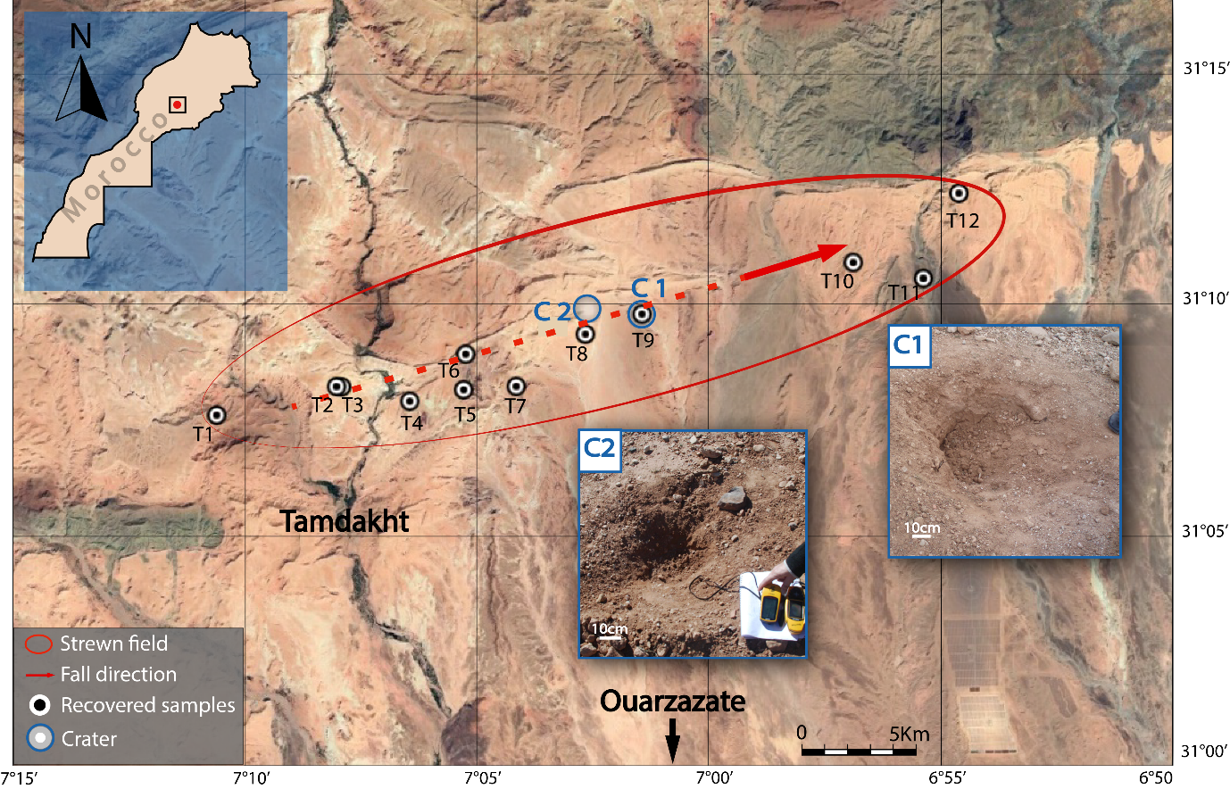
Fig. 1. Distribution of Tamdakht meteorite fragments in the strewn field, which has a length of 35 km and a diameter of 5 km. The direction of the fall is WSW to ENE. T = Tamdakht specimen; C = Crater. Google Maps (2023).

MACROSCOPIC FEATURES
Most of Tamdakht meteorite fragments are completely covered by an outer black fusion crust that varies in thickness. Two types of fusion crusts are identified. A primary fusion crust that is thick and matt (Fig. 2a, b, c, d, e), and a secondary fusion crust that is thin and shiny (Fig. 2c, d; Fig. S1a, b). Regmaglypts up to 3 centimeters in diameter (Fig. 2a, b), and flow lines are observed in some oriented samples radiating from the center of their front side (Fig. 2b). The surface of the fusion crust of some specimens shows impact marks (i.e., skid marks), due to the collision with ground rocks when these fragments landed (Fig. 2a; Fig. S1c).
The fusion crust observed on the surface of one specimen has a thickness of up to 12 millimeters (Fig. 2c, 2d). It contains abundant vesicles, small fragments of the meteorite, millimetric chondrules, abundant metal, and iron sulfides visible to the naked eye. We note that a part of the thick primary fusion crust is missing, and the remaining area of the meteorite’s surface is covered by a thinner secondary fusion crust. A gap between the substrate and the primary fusion is observed (Fig. 2d). We suspect that the fragment shown in Fig. 2e is likely a fusion crust fragment that was detached from the surface of the meteorite during the atmospheric entry. Its thickness is about 1.2 cm, and it displays an irregular surface with fragments of the meteorite embedded in it (Fig. S1e, f). The back side of the same sample displays an uncommon shape and texture and has pieces of the meteorite (up to 1 cm in size) and chondrules sticking beneath it (Fig. 2f).

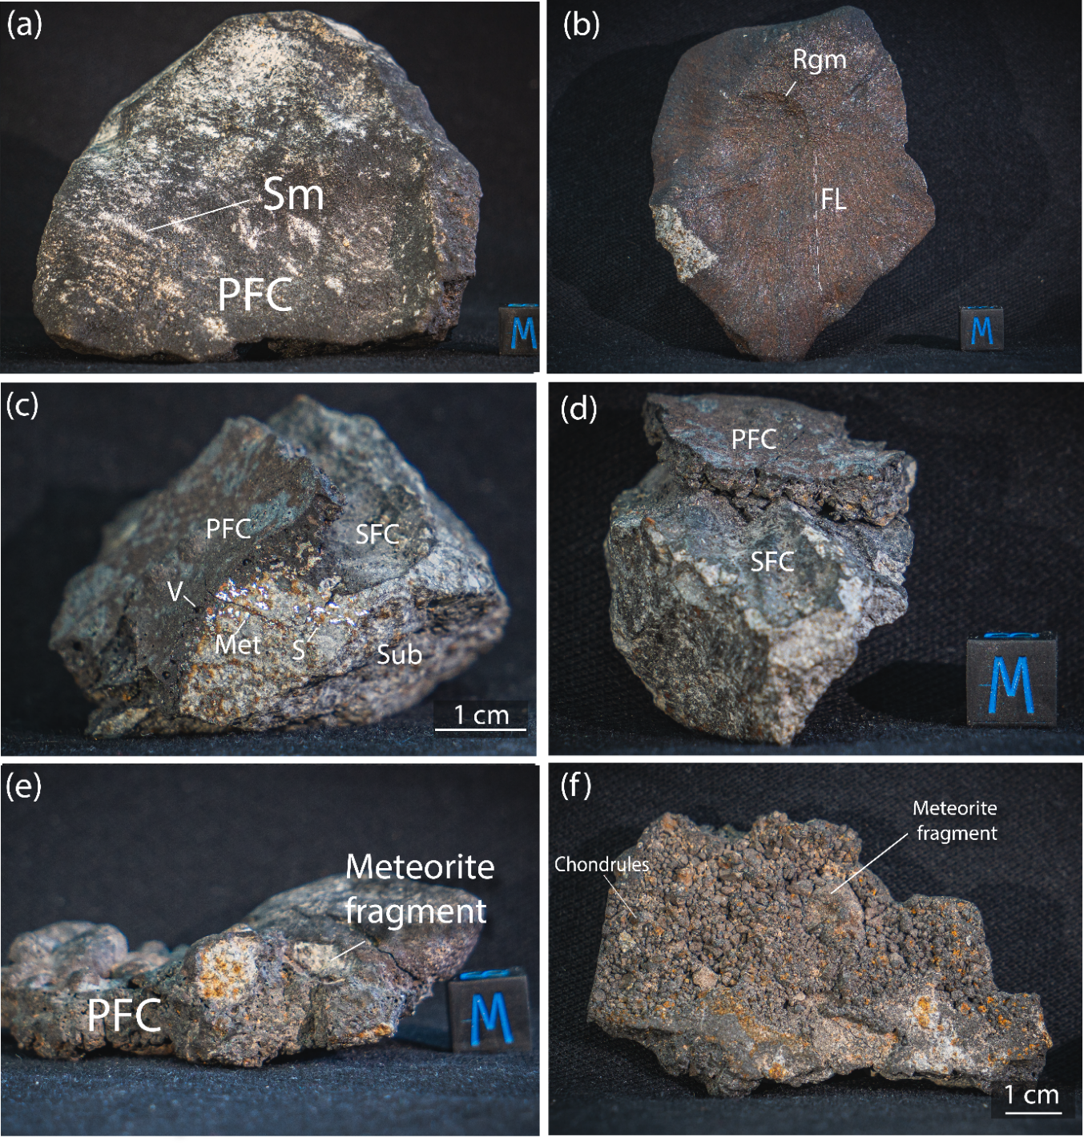
Fig. 2. Photographs of hand specimens of Tamdakht. (a) 814 g specimen covered by primary fusion crusts showing skid marks. (b) 313 g oriented specimen covered by a brownish and matt fusion crust. Note the presence of flow lines and a 1-cm-sized regmaglypt at the center of the specimen. (c, d) Photographs of a specimen from various angles. Primary and secondary fusion crusts are present. A cut surface (c) shows the occurrence of vesicles, metal, and iron sulfides. Note the gap between the substrate and the bottom of the primary fusion crust in (d). (e) photograph of a specimen of Tamdakht covered with a fusion crust enclosing pieces of the meteorite’s interior and chondrules. (f) chondrules and fragments from the meteorite’s interior found beneath the specimen. PFC = primary fusion crusts; SFC = secondary fusion crust; SM = skid marks; Rgm = regmaglypts; Fl = flow lines; V = vesicles; Met = metal; S = iron sulfides; Sub = substrate; Cube= 1cm.

TEXTURAL AND MINERALOGICAL CHARACTERISTICS OF TAMDAKHT’S FUSION CRUST
The three-dimensional (3D) reconstruction of a piece of Tamdakht meteorite by X-ray microtomography confirms the macroscopic observations regarding the fusion crust’s thickness, which reaches up to 6 millimeters in some areas (Fig. 3). Based on the two-dimensional (2D) images obtained during the examination, we detected a variation in the physical and compositional characteristics of the fusion crust, indicated by the presence of vesicles with various sizes and shapes, as well as silicate and metallic phases, and fragments from the meteorite’s interior.
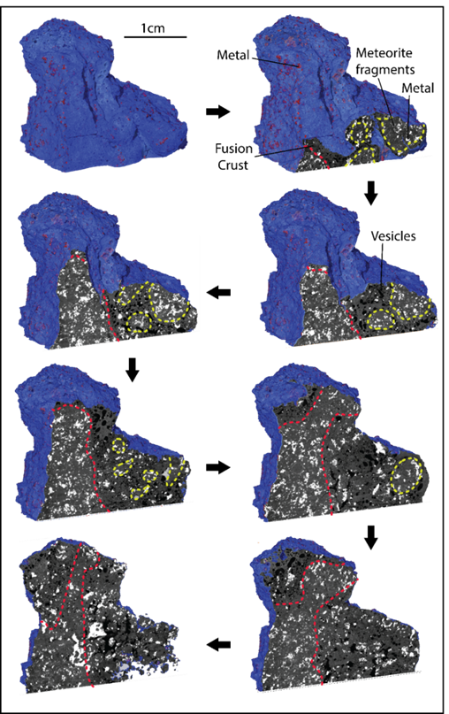
Fig. 3. X-ray microtomography scan showing the evolution of the fusion crust of Tamdakht. The red dashed line shows the limit between the substrate and the fusion crust. The yellow dashed line shows fragments from the interior of the meteorite enclosed in the fusion crust. The fusion crust contains vesicles of various sizes and shapes.

Backscattered electron (BSE) image of the fusion crust of Tamdakht is consistent with X-ray microtomographic observations. BSE images show that the primary fusion crust exhibits a strong variation in thickness, which ranges from 400 µm to 6 mm (Fig. 4a). Vesicles are frequently present in glass, around silicates, and in opaque mineral phases. The abundance of these vesicles decreases from the substrate outward (Fig. 4c). Their size decreases inward, with the largest ones being up to 1.6 mm in diameter, whereas the tiniest ones have a diameter ranging from ~5 µm to ~10 µm (Fig. 4a, c). The shape of vesicles also varies outward. Vesicles in the outer region are elongated or subspherical, whereas the ones in the inner parts of the fusion crust are spherical. Unlike the meteorite’s interior, the distribution of metal and iron sulfides in the primary fusion crust is heterogenous, as they occur as single large grains up to 2 mm in size (Fig. 4a). Three layers of the primary fusion crust are distinguished:
- a discontinuous iron-oxide-rich outermost layer that reaches a maximum thickness of 200 µm. This layer mainly consists of magnetite (Fig. 4d). It is also composed of iron sulfides with a mottled texture in the form of anhedral to euhedral 2-µm-sized grains with intergranular spaces, associated with magnetite in some cases (Fig. 5). In the areas where this layer is at minimum thickness, skeletal magnetite occurs as individual grains up to 5 µm in size on the external surface (Fig. 4e).
- a second middle layer characterized by less magnetite, and an increase in euhedral and skeletal olivine with a low Z -contrast Mg-rich core and a high Z -contrast Fe-rich rim, set in a glassy matrix or a microcrystalline groundmass (Fig. 4d, e; Fig. 5). The Fe-rich rim of olivine in close vicinity of the outermost layer extends to up to 5 µm toward the Mg-core and gradually decreases in thickness to up to 1 µm in olivine toward the interior of the crust. Some olivine phenocrysts contain iron oxides in their cores (Fig. 2d). In this layer, we found large grains of an assemblage of metal and iron sulfides characterized by a heterogenous distribution (Fig. 4a; Fig. 5c). A relict anhedral grain of olivine up to 300 µm with digested margins, invaded by glassy veins and vesicles with a diameter of 3 µm is shown in Fig. 4d, e.
- an innermost layer ranging from 3 to 4 mm in thickness. This layer experienced a lower degree of melting and encloses chondrules surrounded by vesicles (Fig. 4e), and pieces from the meteorite’s interior. It also contains blebs up to 15 µm in size and a network of metal and sulfide veins filling the fractures (Fig. 4e).
In addition to the primary fusion crust, we detected a secondary fusion crust in the same thick section (Fig. 4f). This crust is characterized by a thickness of about 150 µm, exhibits a different texture, and consists of different components than the primary one. Contrarily to the primary fusion crust, the limit between the substrate and this secondary crust is easily discerned (Fig. 4f). Vesicles are scarce and have diameters ranging from 1 to 90 µm. Olivine occurs as 60-µm-long microlites embedded in a glassy matrix (see close-up view in Fig. 5d). Metal and iron sulfides are mostly found as rounded blebs with a diameter of 7 µm or less. These phases also occur as single grains up to 120 µm on the surface. In a different polished section, the secondary fusion crust exhibits similar features (Fig. 4g). The substrate beneath the fusion crust is invaded with fractures often filled with metal and sulfide veins (Fig 4g), in a similar way as the outermost part of the substrate in the primary fusion crust (Fig. 4a).
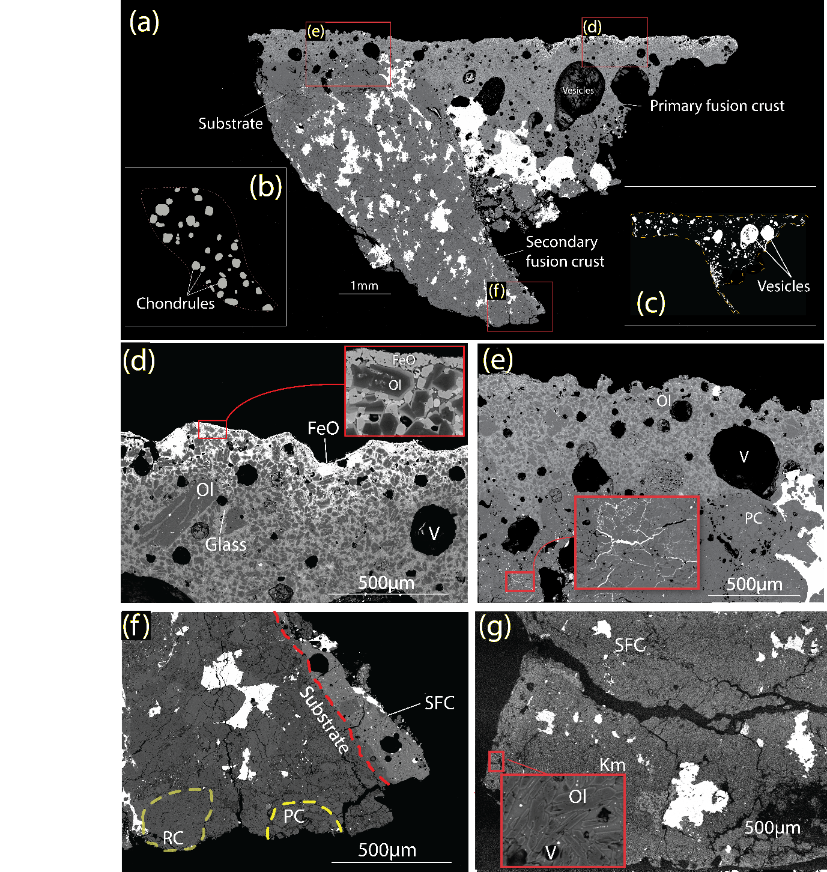
Fig. 4. BSE and processed images of the primary and secondary fusion crusts of Tamdakht. (a) BSE mosaic map of a polished section of Tamdakht. (b) Processed image (with ImageJ) showing the distribution of chondrules in (a). (c) Processed image (with ImageJ) showing the distribution of vesicles in (a). (d) Fusion crust layer rich in iron oxide and zoned olivine with Mg-rich cores and Fe-rich rims. Fe-rich rims are thick in olivine near the surface of the fusion crust as shown in the close-up view outlined by the red rectangle. Minor oscillatory zoning is also observed in the olivine crystal shown in the close-up view. Note the presence of partially melted and digested olivine grain in the center left of the image. (e) A slightly melted silicate-rich layer that contains vesicles and a porphyritic chondrule surrounded by vesicles. The red rectangle shows a close-up view of the substrate invaded by veins of metal and iron sulfides. (f) A secondary fusion crust containing olivine microlites, silicate fragments, and vesicles displaying various sizes and forms. (g) BSE image of a secondary fusion crust from a polished section prepared from a different Tamdakht fragment. Note the presence of olivine microlites embedded in the glassy matrix. Ol = olivine; FeO = iron oxide; V = vesicles; PC = porphyritic chondrules; RC = radial chondrules; Km = kamacite; Tr = troilite; SFC = secondary fusion crust.
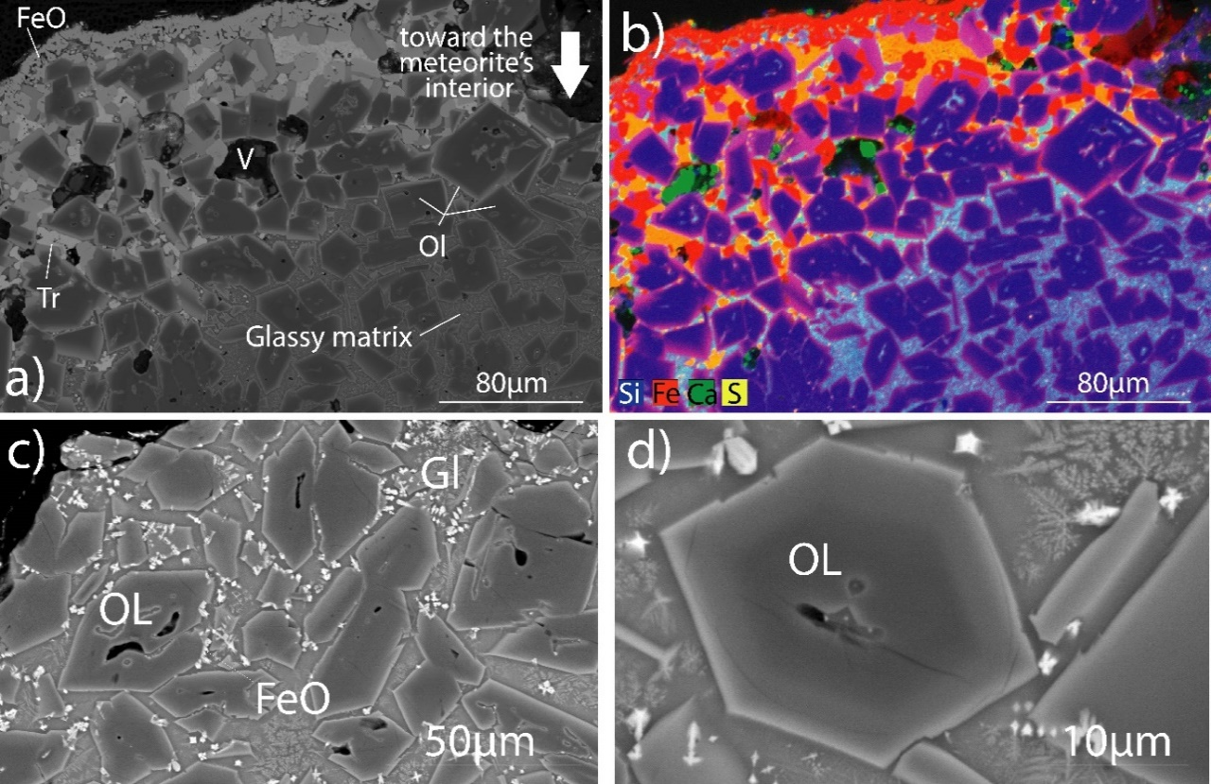
Fig. 5. Backscattered electron image and corresponding X-ray elemental map of the outermost layer of the primary fusion crust. (a) BSE image of the external layer that constitutes the primary fusion crust of Tamdakht. The layer mainly contains iron oxides and skeletal olivine. The thickness of the Fe-rich rim in olivine decreases inward. (b) X-ray elemental map (Si, Fe, Ca and S) showing compositional zoning of olivine. Note the presence of abundant troilite in the upper layer. An increase of glass abundance between olivine grains toward the interior of the meteorite is also observed, marking the limit between the outermost and the middle layers. (c) close-up view of the outer layer of the primary fusion crust in Tamdakht. This layer contains skeletal olivine phenocrysts and skeletal magnetite grains, embedded in a glassy matrix. (d) Single olivine phenocrysts in the primary fusion crust of Tamdakht. Minor oscillatory zoning is observed. The BSE-white crystals are skeletal magnetite. Dendritic crystals are present in the glassy matrix FeO = iron oxide; V = vesicles; Ol = Olivine; Tr = troilite.

DISCUSSION

-The formation mechanism of Tamdakht’s fusion crust
The majority of recovered Tamdakht specimens are covered by a primary thick fusion crust that reaches a thickness of 1.2 cm in some areas (Fig. 2; Fig. S1). Generally, fusion crusts do not exceed a few millimeters in thickness (Genge and Grady 1999; Pittarello et al. 2019; Genge et al. 2023). This makes Tamdakht’s fusion crust unprecedented, with evidence of complex atmospheric entry conditions. The presence of a very thick primary crust in some areas of the samples but not on others likely implies a rotation of the meteoroid during entry (Fig. 2), which led to a local accumulation of the melt on some of its sides (Ramsdohr, 1967). It also consistent with the eyewitnesses’ report of seeing a fireball that lasted for several seconds, which could be due to low entry angle and/or low velocity atmospheric entry of the meteoroid. This extended entry time could also explain the presence of the innermost layer (Fig. 4), given that a correlation exists between the atmospheric entry duration and the distance to which the temperatures can penetrate the surface of the meteoroid (Sears 1975).
During the atmospheric entry, Tamdakht meteoroid was subjected to many fragmentation events after the formation of the primary fusion crust and during the late stages of the ablative flight. The fragmentation of a meteoroid exposes new surfaces to the atmospheric environment, leading to the formation of secondary fusion crusts. Each fragment experiences distinct conditions in terms of rotation, angle, and velocity, affecting the development and characteristics of these secondary fusion crusts. We noted the removal of the thick primary fusion crust in some specimens, and its replacement with a very thin secondary fusion crust (Fig. 2c, d). The presence of this secondary crust is compelling evidence that the primary fusion crust broke off from the specimen during the atmospheric entry. And not after it hit the ground. Separation of the primary fusion crust from the substrate is likely due to the accumulation of vesicles, which form when volatiles in the material vaporize during rapid heating. These gas bubbles create a gap between the crust and the underlying substrate, weakening the bond and making separation more probably. (Fig. 2d. 6a). Also, the high viscosity due to the high iron content likely played a crucial role in both stabilizing the primary fusion crust and contributing to the fragmentation by generating internal stresses during the atmospheric entry. The characteristics of the fragment shown in Fig. 2e, f are consistent with this explanation, as it seems to be a piece of a primary fusion that was removed from the surface of a Tamdakht’s meteoroid fragment during late stages of atmospheric deceleration. This fusion crust piece has a thickness reaching up to 1.2 cm, and encloses numerous meteorite fragments (Fig. 2e; Fig. S1e, f). These debris are most likely small pieces separated from the parent meteoroid during fragmentation, which subsequently impacted the surface and were glued to the melted, well-developed portions of the fusion crust. Transfer of material in the same shower has been previously reported in the fusion crust of the CM2 Winchcombe meteorite (Genge et al. 2023).
The intershower material transfer in this meteorite is indicated by the presence of silicate warts enclosed in the fusion crust. These particles were liquid droplets removed from the surface of the outer layers of the fusion crust by ablation (Genge et al. 2023). Pittarello et al. (2019) reported a spherule trapped in the fusion crust of Asuka 09368 ureilite, which could be formed by the same process as silicate warts in Winchcombe. The fragments of the meteorite enclosed in the fusion crust of Tamdakht (Fig. 2e, f; Fig. S1e) could have been incorporated during an intershower debris transfer during a late stage of the atmospheric flight.
The microscopic characteristics of Tamdakht’s primary fusion crust are comparable to those of other chondritic meteorites (Genge and Grady 1999; Pittarello et al., 2019; Maksimova et al. 2019; Scott et al., 2023).
Vesicles in Tamdakht’s fusion crust decrease in size and increase in abundance toward the interior of the meteorite, with the largest ones being in the middle layer (Fig. 4a, c). The presence of vesicles in the fusion crust of meteorites suggests volatile loss and degassing during the atmospheric passage (Genge and Grady 1999). The presence of tiny vesicles near the substrate and large vesicles in the middle layer of the fusion crust of Tamdakht implies their migration outward and coalescence as they move through the melt, leading to the formation of larger vesicles as degassing progresses. When rapidly cooled, these vesicles ceased to migrate and were trapped inside the middle layer (Pittarello et al., 2019).
The occurrence of magnetite in the outer layer of fusion crusts has been previously reported in stony meteorites. Genge and Grady (1999) documented skeletal or lattice-like dendritic magnetite in many carbonaceous and enstatite chondrites, which decreases in abundance and size toward the interior. They also identified similar textures in ordinary chondrites, although these show little variation throughout. In the CM2 Winchcombe meteorite, magnetite occurs alongside olivine phenocrysts and as monolayers formed by the incorporation of surface magnetite, and its characteristics become less detectable with depth in the fusion crust (Genge et al. 2023). H5 chondrites Asuka 09004 and Asuka 09502 also contain small skeletal magnetite grains, primarily associated with olivine (Pittarello et al. 2019). In Tamdakht, magnetite forms a thin, discontinuous surface layer due to atmospheric oxygen reacting with melts during entry (Genge and Grady 1999). A slight reduction in magnetite content toward the interior, similar to Winchcombe, may be due to varying oxidation states. The absence of magnetite in some areas of Tamdakht fusion crust may result from surface erosion during ablation or changes in the oxidation state caused by the local presence of large metal grains, which worked as sink for oxygen (Genge and Grady 1999).
Olivine is among the major components of chondritic meteorites’ fusion crust (Genge and Grady 1999; Pittarello et al., 2019; Scott et al., 2023; Genge et al. 2023). Within the primary fusion crust of Tamdakht, euhedral to subhedral olivine phenocrysts are present, embedded in a glassy or microcrystalline matrix. Their abundance, shapes, and sizes are correlated with the fusion crust’s depth as they decrease towards the interior (Fig. 4). This suggests a variation in cooling rates within the layers of the fusion crust (Pittarello et al., 2019). Olivine in Tamdakht is zoned, with Mg-rich cores and Fe-rims (Fig. 4a, d, e). We noted that the Fe-rich rims are thicker in olivine phenocrysts associated with magnetite in the outer layer of the fusion crust (Fig. 4a, d, e). The crystallization of olivine in the fusion crust of Tamdakht and the observed zoning in olivine phenocrysts are primarily controlled by the oxidation state of the melt. This oxidation state is determined by the interaction between the meteoroid’s surface and atmospheric oxygen during entry, significantly influencing the mineralogical characteristics and textural features of the fusion crust (Pittarello et al., 2019).
Metal and iron sulfides occur as blebs and veins filling the fractures in the substrate or as large grains in the middle layer of the fusion crust (Fig. 4a, e). Similar features are reported in chondritic meteorites (Genge and Grady 1999; Pittarello et al., 2019; Genge et al. 2023). During the atmospheric entry, the heating of preexisting metal and sulfide phases leads to the formation of immiscible liquids, which circulate in the fractures to form veins in the substrate and migrate outwards to form large grains in the fusion crust (Genge and Grady 1999).
In summary, the physical, mineralogical, and compositional characteristics of the primary and secondary fusion crusts of Tamdakht indicate complex atmospheric entry conditions for the pieces investigated in this study (Fig. 6). Tamdakht meteoroid most likely entered Earth’s atmosphere at low velocity and/or low entry angle, which led to a long atmospheric entry duration resulting in the formation of an unprecedented, well-developed primary fusion crust. It also experienced multiple fragmentation events during the late stages of the ablative flight, as evidenced by the wide array of primary fusion crust features observed, and also by the presence of secondary fusion crusts in a few specimens.
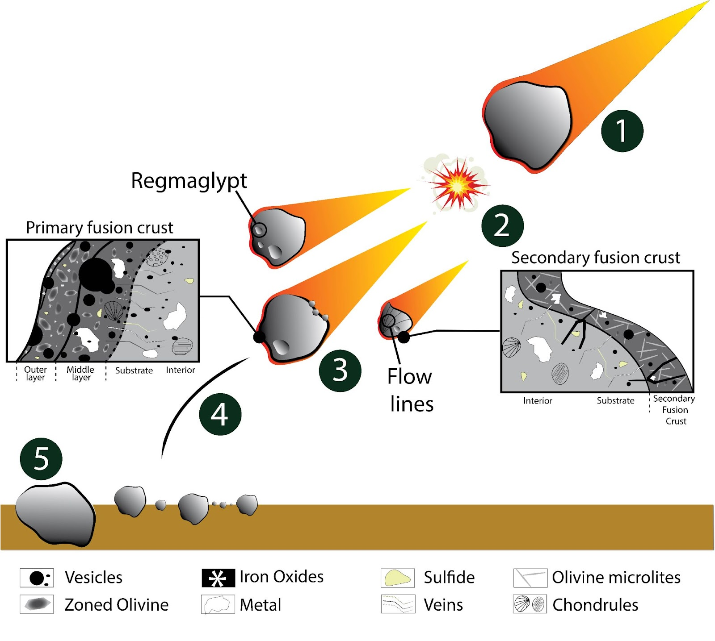
Fig. 6. The mechanisms responsible for the formation of the primary and secondary fusion crusts in Tamdakht. (1) entry of the meteoroid. (2) primary fragmentation leading to debris with various entry conditions. (3) development of the primary fusion crust as degassing and melting proceeds as well as flow lines and regmaglypts. More fragmentation events occurred during the late stages of the flight, leading to formation of secondary fusion crusts. An intershower debris transfer may have occurred, and could have caused incorporation of meteoroid fragments in the well-developed primary fusion crusts. (4) final stages of deceleration and dark flight. (5) fall of the meteorite on the fall area surface.

CONCLUSION

We investigated numerous Tamdakht specimens covered by primary and secondary fusion crusts to shed light on the meteoroid’s atmospheric entry conditions. The primary fusion crust is matt, thick, and often contains regmaglypts and flow lines. The secondary fusion crust is thin and less matt. The primary fusion crust of some specimens was removed during late stages of the ablative flight and was replaced by a thin secondary fusion crust. The presence of fusion crust pieces is evidence for such a process. X-ray tomographic and BSE imaging show that Tamdakht’s primary fusion crust has a wide range of thicknesses. Three layers are identified: (1) an outer layer consisting of magnetite and minor olivine phenocrysts; (2) a middle layer that mainly contains large vesicles and zoned olivine phenocrysts embedded in a glassy matrix, and; (3) an inner layer containing smaller vesicles, as well as blebs and metal and sulfide veins filling the fractures of the substrate. The secondary fusion crust is present as a single layer, consisting of tiny vesicles, olivine microlites, and blebs of metal and sulfides. The wide diversity of Tamdakht’s fusion crust features makes it unprecedented, with a record of complex atmospheric entry conditions, such as repeated explosive fragmentations prior to dark flight, multiple generation of fusion crusts, and exchange and trapping of debris during the meteoroid ablative deceleration in the atmosphere.

ACKNOWLEDGEMENTS
We would like to thank the anonymous reviewer and the associate editor Gopalan Srinivasan for their time and effort to review this manuscript. We genuinely appreciate your suggestions and comments, which greatly improved the quality of this work. We also appreciate the efforts of A. J. Timothy Jull for the editorial handling. This work was funded by the ERASMUS+ KA-107 Program at the University of Pisa, Italy, which provided essential support for this research project. We extend our gratitude to Maurizio Gemelli and Randa Ishak of the “Centro per la Integrazione della Strumentazione del l’Università di Pisa” (CISUP, Italy) for their invaluable assistance. We also acknowledge the Platina platform (IC2MP), financial support from the European Union (ERDF), and La Region Nouvelle Aquitaine. Special thanks to Camille Cartier, Svend Buhl, and Philippe Thomas for providing coordinates of many pieces they found in Tamdakht’s strewnfield. Special thanks to Mohamed Aoudjehane, Mohamed Aid, Ahmed Bouragaa, and Mohamed Zeroual for the fieldwork. This study is part of the research work of the ATTARIK Foundation for Meteoritics and Planetary Sciences.

REFERENCES

www.lpi.usra.edu/meteor/metbull.php

El Goresy. A. and Fechtig, H 1967. Fusion crust of iron meteorites and mesosiderites and production of cosmic spherules. Smithsonian Contr. Astrophys., vol.11, pp. 391-397.

Genge, M. J.; Alesbrook, L.; Almeida, N.V.; Bates, H. C.; Bland, P.A.; Boyd, M. R.; Burchell, M.J.; Collins, G. S.; Cornwell, L. T.; Daly, L.; Devillepoix, H. A. R.; van Ginneken, M.; Greshake, A.; Hallatt, D.; Hamann, C.; Hecht, L.; Jenkins, L. E.; Johnson, D.; Jones, R.; King, A. J.; Mansour, H.; McMullan, S.; Mitchell, J. T.; Rollinson, G.; Russell, S. S.; Schröder, C.; Stephen, N. R.; Suttle, M. D.; Tandy, J. D.; Trimby, P.; Sansom, E. K.; Spathis, V.; Willcocks, F. M. and Wozniakiewicz, P. J. (2023). The fusion crust of the Winchcombe meteorite: A preserved record of atmospheric entry processes. Meteoritics & Planetary Science, 59(5) pp. 948–972.

Genge, M. J., and Grady, M. M. 1999b. Unequilibrated Assemblages of sulfide, Metal and Oxide in the Fusion Crusts of the Enstatite Chondrite Meteorites. Mineralogical Magazine 63: 473–88.

Genge, M. J., and Grady, M. M. 1999a. The Fusion Crusts of Stony Meteorites: Implications for the Atmospheric Reprocessing of Extraterrestrial Materials. Meteoritics & Planetary Science 34: 341–56.

Krinov, E. L. 1960. Principles of Meteoritics. New York: Permagon Press.

Maksimova, A.A., Petrova, E.A., Chukin, A.V., Karabanalov, M.S., Felner, I., Gritsevichi, M. and Oshtrakh, M.I. 2020. Characterization of the matrix and fusion crust of the recent meteorite fall Ozerki L6. Meteoritics & Planetary Science 55: 233–241.

Pittarello, L., Yamaguchi, A., Roszjar, J., Debaille, V., Koeberl, C., and Claeys, P. 2019. To Be or Not to Be Oxidized: A Case Study of Olivine Behavior in the Fusion Crust of Ureilite A 09368 and H Chondrites A 09004 and A 09502. Meteoritics & Planetary Science 54: 1563–78.

Ramsdohr, P. 1967. Die schmelzkruste der meteorite. Earth and Planetary Science Letters 2: 593–8.
Russell S.S., Connolly H.C., and Krot A.N. (2018) Chondrules: Records of Protoplanetary Disk Processes. Cambridge, UK: Cambridge University Press, 450 pp.

Sears, D. W (1975). Temperature gradients in meteorites produced by heating during atmospheric passage. Mod. Geol. 5, 155–164.

Thaisen K.G., and Taylor L.A. 2009. Meteorite Fusion Crust Variability. Meteoritics & Planetary Science 44: 871–8.

Scott, J.M.; Negri, M.; Faure, K.; Palmet, M.C.; Knaack, D.R.; Leybourne, M.I. Multi-zone fusion crust formation and classification of the 2004 Auckland meteorite (L6, S5, and W0). Meteorit. Planet. Sci. 2023, 58, 328–340.

Zolensky M.E., Abreu N.M., Velbel M.A., Rubin A., Chaumard N., Noguchi T., Michikami T. 2018. Chapter2 Physical, Chemical, and Petrological Characteristics of Chondritic Materials and Their Relationships to Small Solar System Bodies. Primitive Meteorites and Asteroids, Elsevier, 59-204.

TABLES

Table 1. Masses and locations of recovered Tamdakht meteorite pieces. Coordinates collected by the author's team, Svend Buhl, Mohamed Aid, and Philippe Thomas are reported.
Sample N° | Mass (g) | X | Y
T1 | 1490 | 07° 12.033‘W | 31° 07.533'N
T2 | 3690 | 07° 08.900‘W | 31° 08.183'N
T3 | 288 | 07° 08.770‘W | 31° 08.176'N
T4 | 2007 | 07° 06.971‘W | 31° 07.855'N
T5 | Unknown | 07° 05' 33.0"W | 31° 08' 06.8"N
T8 | 120 | 07° 02.355W | 31° 09.364'N
T9 | 399 | 07° 00.867‘W | 31° 09.817'N
T10 | 2400 | 06° 55.311‘W | 31° 10.979'N
T11 | 1015 | 06° 53.464‘W | 31° 10.622'N
T12 | 5100 | 06° 52.549‘W | 31° 12.521'N
C1 | 80000 | 7°00.9’W | 31°09.8’N
C2 | 500 | 07°02.3’W | 31°09.9’N
T: recovered samples. C: Crater.

CLEAN MANUSCRIPT

TAMDAKHT: A MOROCCAN ORDINARY CHONDRITE FALL WITH AN UNPRECEDENTED FUSION CRUST
Larbi ZENNOURI¹, *, Hasnaa CHENNAOUI AOUDJEHANE^{1,2}, Luigi FOLCO^{3,4}, Taha SHISSEH¹, Abderrazak EL ALBANI⁵, Arnaud MAZURIER⁵, Mohamed Hassan LEILI¹

¹ GAIA Laboratory, Faculty of Sciences Ain Chock, Hassan II University of Casablanca, km 8 Route d’El Jadida, 20150 Casablanca, Morocco
² ATTARIK Foundation for Meteoritics and Planetary Science, Faculty of Sciences Ain Chock, Hassan II University of Casablanca, km 8 Route d’El Jadida, 20150 Casablanca, Morocco
³ Dipartimento di Scienze della Terra, Università di Pisa, V. S. Maria 53, 56126 Pisa, Italy
⁴ Centro per la Integrazione della Strumentazione della Università di Pisa, CISUP, Lungarno Pacinotti 43/44, 56126 Pisa, Italy
⁵ Université de Poitiers, CNRS, IC2MP, Poitiers, France.

*Corresponding author. E-mail: l.zennouri@gmail.com

ABSTRACT
Tamdakht meteorite is the most massive observed fall in Morocco with a total recovered mass of ~500 kg. Most of the specimens investigated in this study are covered by a well-developed primary fusion crust with thickness that reaches up to 1.2 cm. Macroscopic investigations of this crust suggest complex atmospheric entry conditions. In some specimens, the primary fusion crust broke off and was replaced by a thin secondary crust, suggesting its removal during the late stages of the meteoroid’s flight. Meteorite fragments are enclosed in the primary fusion crust implying a potential inter-shower debris transfer prior to the dark flight, or that the broken pieces were retained by the viscous fusion crust. X-ray tomographic and backscattered electron imaging shows that the primary fusion is irregular in thickness and consists of three layers. The outer layer is mainly composed of magnetite that formed as a result of the reaction of atmospheric oxygen with Fe in the melt produced by heating. The middle layer consists of zoned olivine phenocrysts, large vesicles, metal and sulfide grains. The innermost layer displays a lower degree of melting and contains tiny vesicles, as well as metal and iron sulfides in the form of blebs and veins invading the substrate. The textural, mineralogy, and the compositional variation of Tamdakht’s fusion crust implies a change in the degassing degree, temperature, and reaction with atmospheric oxygen from the surface inward.
INTRODUCTION
Ordinary chondrite meteorites are silicate-rich meteorites composed mostly of olivine and low-Ca pyroxene (Zolensky et al. 2018). They are the most abundant meteorites on Earth (80% of all falls; Russell et al. 2018). To date (May 3, 2024), 62878 ordinary chondrites are recovered, including 974 falls and 61904 finds according to the Meteoritical Society bulletin database (www.lpi.usra.edu/meteor/metbull.php).
Fresh meteorite falls are covered by a fusion crust that forms during the atmospheric entry due to heating by hypervelocity collisions with air molecules (Krinov 1960). For meteorites that have been on Earth for a long time, weathering may affect the fusion crust making it no longer visible. This crust provides valuable information on the conditions (temperature, pressure, orientation) of the meteoroid’s atmospheric entry. Two main types of fusion crusts are distinguished: (1) a primary fusion crust that forms from the beginning of the entry until the total deceleration of the meteoroid (i.e., dark flight); (2) a secondary fusion crust that forms on freshly exposed surfaces after the fragmentation of the meteoroid during its entry (Sears 1975). Fusion crusts differ based on meteorite types (Thaisen and Taylor 2009). Chondrites have a dark matt fusion crust due to the presence of iron and sulfides (Genge and Grady 1999). In iron meteorites, the fusion crust is thick due to the conductive nature of metal (El Goresy and Fechtig 1967).
Since 2000, numerous meteorite falls have been documented in Morocco (with 80% of them being ordinary chondrites. These falls have total recovered masses ranging from 79 grams (Izarzar meteorite fall) to up to ~500 kg (Tamdakht meteorite fall). Tamdakht is classified as an H (high iron, high metal) ordinary chondrite, displaying a petrologic type of 5 (moderately equilibrated) (www.lpi.usra.edu/meteor/metbull.php).
In this paper, we provide a detailed description of Tamdakht’s strewnfield, petrography, and mineralogy. The fusion crust is investigated in detail to gain insight into the processes that occurred during Tamdakht’s meteoroid atmospheric entry. We eventually suggest a formation mechanism for this unusual fusion crust.

SAMPLES AND METHODS

FIELDWORK
Five weeks after the initial reports of a fireball sighting, a field mission was organized by Hasnaa Chennaoui (Hassan II University of Casablanca), accompanied by Mohamed Aid, and Mohamed Aoudjehane to the fall area close to Ouarzazate province, Ait Benhaddou Ksar and Tamdakht village.

SAMPLES
In this study, we investigate numerous Tamdakht meteorite fragments that exhibit a variety of fusion crust features. For macroscopic studies, we examined three Tamdakht specimens. For microtomographic investigations, we used one centimetric fragment of Tamdakht covered by a fusion crust. For mineralogical and compositional analysis, we studied two thin sections and four thick sections.

X-RAY TOMOGRAPHY
X-ray tomographic analysis was performed at the Institut de Chimie des Milieux et Matériaux de Poitiers (IC2MP, France), using an EasyTom XL Duo device (RX-solutions, France) with a microfocus x-ray source (Hamamatsu L12161) coupled to a flat panel detector (Varian PaxScan 2520DX), following these parameters: 110 kV (tube voltage), 90 µA (target current), 1440 projections (1840x1456 pixels; 16 bits), 3 frames per second (imager readout speed), 10 frames averaging, beam filtration with a 1.2 mm Al filter, source-to-object and source-to-detector distances of 67 mm and 589 mm respectively, and voxel resolution of 14.42 µm. Slice reconstructions were constructed using an XAct software (RX-Solutions) with a filtered back projection algorithm, attenuation of beam hardening artefact, corrections of x-ray spot drift and ring artifacts. In order to understand the internal evolution of the fusion crust without cutting the sample, cross-section images and a three-dimensional model were performed with Avizo v. 2019 (Thermo Fisher Scientific-FEI).

OPTICAL AND SEM MICROSCOPY
For optical microscopic observations, we used a Zeiss-Axio Imager polarizing microscope in transmitted light, coupled with a digital camera AxioCam-105-color at the Dipartimento di Scienze della Terra, Università di Pisa, Italy. To obtain backscattered electron images of the fusion crust and the interior of Tamdakht, we used a scanning electron microscope (SEM) FEI Quanta 450 ESEM FEG equipped with microanalytical energy dispersive system (EDS) Bruker QUANTAX XFlash Detector 6/10 at Centro per la Integrazione della Strumentazione dell’Università di Pisa (CISUP, Italy) in backscattered electron mode at an accelerating voltage of 15 kV.

ELECTRON MICROPROBE ANALYSIS
Electron probe micro-analysis (EPMA) was carried out using a Cameca SX100 and a Cameca SX50 microprobes equipped with wavelength-dispersion spectrometers at the Université Pierre et Marie Curie of Paris, France. Standards are: Orthose (Al, K), albite (Na), apatite (P), pyrite (Fe), NiO (Ni), ZrSi (Zr), Cr2O3 (Cr), albite (Na), diopside (Mg, Si, Ca), MnTiO3 (Ti, Mn).

RESULTS

STREWN FIELD
On December 20, 2008, around 10:37 pm, Tamdakht’s meteoroid entered the atmosphere following a southwest to northeast direction and disintegrated mid-flight causing a series of explosions. The bolide was big and was witnessed by people from the regions of Agadir, Marrakech, Tizin’ Tichka pass in the High Atlas Mountains and Ouarzazate which allowed a detailed description of the event. No records from cameras were reported as there were no cameras installed at this time in Morocco. Hunting began immediately after the fireball report in the High Atlas Mountains, which were covered by snow since it was wintertime. The first sample was discovered five weeks later near the village of Tamdakht by the Moroccan hunter Mohamed Azeroual. The most massive, recovered piece weighs about 82 kg. The largest impact crater, with a diameter of 1.1 m and a depth of 70 cm (C1; Table 1), was reported near the area of Oued Aachir located northeast of Tamdakht.
We constructed the strewn field using the GPS coordinates obtained from a total of twelve recovered Tamdakht pieces and two craters, including coordinates provided by the two meteorite collectors S. Buhl and P. Thomas. During the authors’ field expedition, additional small pieces were recovered and mapped. Recovery location coordinates are listed in Table 1, and the strewn field is shown on the map in Fig. 1. Tamdakht specimens were recovered between 5 to 30 km northwest, north, and northeast of the village of Tamdakht. The strewn field spans at least 35 km in length and approximately 5 km in diameter, following a WSW to ENE direction. The strewn field is consistent with the eyewitnesses reports regarding the fireball direction.

Fig. 1. Distribution of Tamdakht meteorite fragments in the strewn field, which has a length of 35 km and a diameter of 5 km. The direction of the fall is WSW to ENE. T = Tamdakht specimen; C = Crater. Google Maps (2023).

MACROSCOPIC FEATURES
Most of Tamdakht meteorite fragments are completely covered by an outer black fusion crust that varies in thickness. Two types of fusion crusts are identified. A primary fusion crust that is thick and matt (Fig. 2a, b, c, d, e), and a secondary fusion crust that is thin and shiny (Fig. 2c, d; Fig. S1a, b). Regmaglypts up to 3 centimeters in diameter (Fig. 2a, b), and flow lines are observed in some oriented samples radiating from the center of their front side (Fig. 2b). The surface of the fusion crust of some specimens shows impact marks (i.e., skid marks), due to the collision with ground rocks when these fragments landed (Fig. 2a; Fig. S1c).
The fusion crust observed on the surface of one specimen has a thickness of up to 12 millimeters (Fig. 2c, 2d). It contains abundant vesicles, small fragments of the meteorite, millimetric chondrules, abundant metal, and iron sulfides visible to the naked eye. We note that a part of the thick primary fusion crust is missing, and the remaining area of the meteorite’s surface is covered by a thinner secondary fusion crust. A gap between the substrate and the primary fusion is observed (Fig. 2d). We suspect that the fragment shown in Fig. 2e is likely a fusion crust fragment that was detached from the surface of the meteorite during the atmospheric entry. Its thickness is about 1.2 cm, and it displays an irregular surface with fragments of the meteorite embedded in it (Fig. S1e, f). The back side of the same sample displays an uncommon shape and texture and has pieces of the meteorite (up to 1 cm in size) and chondrules sticking beneath it (Fig. 2f).

Fig. 2. Photographs of hand specimens of Tamdakht. (a) 814 g specimen covered by primary fusion crusts showing skid marks. (b) 313 g oriented specimen covered by a brownish and matt fusion crust. Note the presence of flow lines and a 1-cm-sized regmaglypt at the center of the specimen. (c, d) Photographs of a specimen from various angles. Primary and secondary fusion crusts are present. A cut surface (c) shows the occurrence of vesicles, metal, and iron sulfides. Note the gap between the substrate and the bottom of the primary fusion crust in (d). (e) photograph of a specimen of Tamdakht covered with a fusion crust enclosing pieces of the meteorite’s interior and chondrules. (f) chondrules and fragments from the meteorite’s interior found beneath the specimen. PFC = primary fusion crusts; SFC = secondary fusion crust; SM = skid marks; Rgm = regmaglypts; Fl = flow lines; V = vesicles; Met = metal; S = iron sulfides; Sub = substrate; Cube= 1cm.

TEXTURAL AND MINERALOGICAL CHARACTERISTICS OF TAMDAKHT’S FUSION CRUST
The three-dimensional (3D) reconstruction of a piece of Tamdakht meteorite by X-ray microtomography confirms the macroscopic observations regarding the fusion crust’s thickness, which reaches up to 6 millimeters in some areas (Fig. 3). Based on the two-dimensional (2D) images obtained during the examination, we detected a variation in the physical and compositional characteristics of the fusion crust, indicated by the presence of vesicles with various sizes and shapes, as well as silicate and metallic phases, and fragments from the meteorite’s interior.
Fig. 3. X-ray microtomography scan showing the evolution of the fusion crust of Tamdakht. The red dashed line shows the limit between the substrate and the fusion crust. The yellow dashed line shows fragments from the interior of the meteorite enclosed in the fusion crust. The fusion crust contains vesicles of various sizes and shapes.

Backscattered electron (BSE) image of the fusion crust of Tamdakht is consistent with X-ray microtomographic observations. BSE images show that the primary fusion crust exhibits a strong variation in thickness, which ranges from 400 µm to 6 mm (Fig. 4a). Vesicles are frequently present in glass, around silicates, and in opaque mineral phases. The abundance of these vesicles decreases from the substrate outward (Fig. 4c). Their size decreases inward, with the largest ones being up to 1.6 mm in diameter, whereas the tiniest ones have a diameter ranging from ~5 µm to ~10 µm (Fig. 4a, c). The shape of vesicles also varies outward. Vesicles in the outer region are elongated or subspherical, whereas the ones in the inner parts of the fusion crust are spherical. Unlike the meteorite’s interior, the distribution of metal and iron sulfides in the primary fusion crust is heterogenous, as they occur as single large grains up to 2 mm in size (Fig. 4a). Three layers of the primary fusion crust are distinguished:
- a discontinuous iron-oxide-rich outermost layer that reaches a maximum thickness of 200 µm. This layer mainly consists of magnetite (Fig. 4d). It is also composed of iron sulfides with a mottled texture in the form of anhedral to euhedral 2-µm-sized grains with intergranular spaces, associated with magnetite in some cases (Fig. 5). In the areas where this layer is at minimum thickness, skeletal magnetite occurs as individual grains up to 5 µm in size on the external surface (Fig. 4e).
- a second middle layer characterized by less magnetite, and an increase in euhedral and skeletal olivine with a low Z -contrast Mg-rich core and a high Z -contrast Fe-rich rim, set in a glassy matrix or a microcrystalline groundmass (Fig. 4d, e; Fig. 5). The Fe-rich rim of olivine in close vicinity of the outermost layer extends to up to 5 µm toward the Mg-core and gradually decreases in thickness to up to 1 µm in olivine toward the interior of the crust. Some olivine phenocrysts contain iron oxides in their cores (Fig. 2d). In this layer, we found large grains of an assemblage of metal and iron sulfides characterized by a heterogenous distribution (Fig. 4a; Fig. 5c). A relict anhedral grain of olivine up to 300 µm with digested margins, invaded by glassy veins and vesicles with a diameter of 3 µm is shown in Fig. 4d, e.
- an innermost layer ranging from 3 to 4 mm in thickness. This layer experienced a lower degree of melting and encloses chondrules surrounded by vesicles (Fig. 4e), and pieces from the meteorite’s interior. It also contains blebs up to 15 µm in size and a network of metal and sulfide veins filling the fractures (Fig. 4e).
In addition to the primary fusion crust, we detected a secondary fusion crust in the same thick section (Fig. 4f). This crust is characterized by a thickness of about 150 µm, exhibits a different texture, and consists of different components than the primary one. Contrarily to the primary fusion crust, the limit between the substrate and this secondary crust is easily discerned (Fig. 4f). Vesicles are scarce and have diameters ranging from 1 to 90 µm. Olivine occurs as 60-µm-long microlites embedded in a glassy matrix (see close-up view in Fig. 5d). Metal and iron sulfides are mostly found as rounded blebs with a diameter of 7 µm or less. These phases also occur as single grains up to 120 µm on the surface. In a different polished section, the secondary fusion crust exhibits similar features (Fig. 4g). The substrate beneath the fusion crust is invaded with fractures often filled with metal and sulfide veins (Fig 4g), in a similar way as the outermost part of the substrate in the primary fusion crust (Fig. 4a).
Fig. 4. BSE and processed images of the primary and secondary fusion crusts of Tamdakht. (a) BSE mosaic map of a polished section of Tamdakht. (b) Processed image (with ImageJ) showing the distribution of chondrules in (a). (c) Processed image (with ImageJ) showing the distribution of vesicles in (a). (d) Fusion crust layer rich in iron oxide and zoned olivine with Mg-rich cores and Fe-rich rims. Fe-rich rims are thick in olivine near the surface of the fusion crust as shown in the close-up view outlined by the red rectangle. Minor oscillatory zoning is also observed in the olivine crystal shown in the close-up view. Note the presence of partially melted and digested olivine grain in the center left of the image. (e) A slightly melted silicate-rich layer that contains vesicles and a porphyritic chondrule surrounded by vesicles. The red rectangle shows a close-up view of the substrate invaded by veins of metal and iron sulfides. (f) A secondary fusion crust containing olivine microlites, silicate fragments, and vesicles displaying various sizes and forms. (g) BSE image of a secondary fusion crust from a polished section prepared from a different Tamdakht fragment. Note the presence of olivine microlites embedded in the glassy matrix. Ol = olivine; FeO = iron oxide; V = vesicles; PC = porphyritic chondrules; RC = radial chondrules; Km = kamacite; Tr = troilite; SFC = secondary fusion crust.
Fig. 5. Backscattered electron image and corresponding X-ray elemental map of the outermost layer of the primary fusion crust. (a) BSE image of the external layer that constitutes the primary fusion crust of Tamdakht. The layer mainly contains iron oxides and skeletal olivine. The thickness of the Fe-rich rim in olivine decreases inward. (b) X-ray elemental map (Si, Fe, Ca and S) showing compositional zoning of olivine. Note the presence of abundant troilite in the upper layer. An increase of glass abundance between olivine grains toward the interior of the meteorite is also observed, marking the limit between the outermost and the middle layers. (c) close-up view of the outer layer of the primary fusion crust in Tamdakht. This layer contains skeletal olivine phenocrysts and skeletal magnetite grains, embedded in a glassy matrix. (d) Single olivine phenocrysts in the primary fusion crust of Tamdakht. Minor oscillatory zoning is observed. The BSE-white crystals are skeletal magnetite. Dendritic crystals are present in the glassy matrix FeO = iron oxide; V = vesicles; Ol = Olivine; Tr = troilite.

DISCUSSION

-The formation mechanism of Tamdakht’s fusion crust
The majority of recovered Tamdakht specimens are covered by a primary thick fusion crust that reaches a thickness of 1.2 cm in some areas (Fig. 2; Fig. S1). Generally, fusion crusts do not exceed a few millimeters in thickness (Genge and Grady 1999; Pittarello et al. 2019; Genge et al. 2023). This makes Tamdakht’s fusion crust unprecedented, with evidence of complex atmospheric entry conditions. The presence of a very thick primary crust in some areas of the samples but not on others likely implies a rotation of the meteoroid during entry (Fig. 2), which led to a local accumulation of the melt on some of its sides (Ramsdohr, 1967). It also consistent with the eyewitnesses’ report of seeing a fireball that lasted for several seconds, which could be due to low entry angle and/or low velocity atmospheric entry of the meteoroid. This extended entry time could also explain the presence of the innermost layer (Fig. 4), given that a correlation exists between the atmospheric entry duration and the distance to which the temperatures can penetrate the surface of the meteoroid (Sears 1975).
During the atmospheric entry, Tamdakht meteoroid was subjected to many fragmentation events after the formation of the primary fusion crust and during the late stages of the ablative flight. The fragmentation of a meteoroid exposes new surfaces to the atmospheric environment, leading to the formation of secondary fusion crusts. Each fragment experiences distinct conditions in terms of rotation, angle, and velocity, affecting the development and characteristics of these secondary fusion crusts. We noted the removal of the thick primary fusion crust in some specimens, and its replacement with a very thin secondary fusion crust (Fig. 2c, d). The presence of this secondary crust is compelling evidence that the primary fusion crust broke off from the specimen during the atmospheric entry. And not after it hit the ground. Separation of the primary fusion crust from the substrate is likely due to the accumulation of vesicles, which form when volatiles in the material vaporize during rapid heating. These gas bubbles create a gap between the crust and the underlying substrate, weakening the bond and making separation more probably. (Fig. 2d. 6a). Also, the high viscosity due to the high iron content likely played a crucial role in both stabilizing the primary fusion crust and contributing to the fragmentation by generating internal stresses during the atmospheric entry. The characteristics of the fragment shown in Fig. 2e, f are consistent with this explanation, as it seems to be a piece of a primary fusion that was removed from the surface of a Tamdakht’s meteoroid fragment during late stages of atmospheric deceleration. This fusion crust piece has a thickness reaching up to 1.2 cm, and encloses numerous meteorite fragments (Fig. 2e; Fig. S1e, f). These debris are most likely small pieces separated from the parent meteoroid during fragmentation, which subsequently impacted the surface and were glued to the melted, well-developed portions of the fusion crust. Transfer of material in the same shower has been previously reported in the fusion crust of the CM2 Winchcombe meteorite (Genge et al. 2023).
The intershower material transfer in this meteorite is indicated by the presence of silicate warts enclosed in the fusion crust. These particles were liquid droplets removed from the surface of the outer layers of the fusion crust by ablation (Genge et al. 2023). Pittarello et al. (2019) reported a spherule trapped in the fusion crust of Asuka 09368 ureilite, which could be formed by the same process as silicate warts in Winchcombe. The fragments of the meteorite enclosed in the fusion crust of Tamdakht (Fig. 2e, f; Fig. S1e) could have been incorporated during an intershower debris transfer during a late stage of the atmospheric flight.
The microscopic characteristics of Tamdakht’s primary fusion crust are comparable to those of other chondritic meteorites (Genge and Grady 1999; Pittarello et al., 2019; Maksimova et al. 2019; Scott et al., 2023).
Vesicles in Tamdakht’s fusion crust decrease in size and increase in abundance toward the interior of the meteorite, with the largest ones being in the middle layer (Fig. 4a, c). The presence of vesicles in the fusion crust of meteorites suggests volatile loss and degassing during the atmospheric passage (Genge and Grady 1999). The presence of tiny vesicles near the substrate and large vesicles in the middle layer of the fusion crust of Tamdakht implies their migration outward and coalescence as they move through the melt, leading to the formation of larger vesicles as degassing progresses. When rapidly cooled, these vesicles ceased to migrate and were trapped inside the middle layer (Pittarello et al., 2019).
The occurrence of magnetite in the outer layer of fusion crusts has been previously reported in stony meteorites. Genge and Grady (1999) documented skeletal or lattice-like dendritic magnetite in many carbonaceous and enstatite chondrites, which decreases in abundance and size toward the interior. They also identified similar textures in ordinary chondrites, although these show little variation throughout. In the CM2 Winchcombe meteorite, magnetite occurs alongside olivine phenocrysts and as monolayers formed by the incorporation of surface magnetite, and its characteristics become less detectable with depth in the fusion crust (Genge et al. 2023). H5 chondrites Asuka 09004 and Asuka 09502 also contain small skeletal magnetite grains, primarily associated with olivine (Pittarello et al. 2019). In Tamdakht, magnetite forms a thin, discontinuous surface layer due to atmospheric oxygen reacting with melts during entry (Genge and Grady 1999). A slight reduction in magnetite content toward the interior, similar to Winchcombe, may be due to varying oxidation states. The absence of magnetite in some areas of Tamdakht fusion crust may result from surface erosion during ablation or changes in the oxidation state caused by the local presence of large metal grains, which worked as sink for oxygen (Genge and Grady 1999).
Olivine is among the major components of chondritic meteorites’ fusion crust (Genge and Grady 1999; Pittarello et al., 2019; Scott et al., 2023; Genge et al. 2023). Within the primary fusion crust of Tamdakht, euhedral to subhedral olivine phenocrysts are present, embedded in a glassy or microcrystalline matrix. Their abundance, shapes, and sizes are correlated with the fusion crust’s depth as they decrease towards the interior (Fig. 4). This suggests a variation in cooling rates within the layers of the fusion crust (Pittarello et al., 2019). Olivine in Tamdakht is zoned, with Mg-rich cores and Fe-rims (Fig. 4a, d, e). We noted that the Fe-rich rims are thicker in olivine phenocrysts associated with magnetite in the outer layer of the fusion crust (Fig. 4a, d, e). The crystallization of olivine in the fusion crust of Tamdakht and the observed zoning in olivine phenocrysts are primarily controlled by the oxidation state of the melt. This oxidation state is determined by the interaction between the meteoroid’s surface and atmospheric oxygen during entry, significantly influencing the mineralogical characteristics and textural features of the fusion crust (Pittarello et al., 2019).
Metal and iron sulfides occur as blebs and veins filling the fractures in the substrate or as large grains in the middle layer of the fusion crust (Fig. 4a, e). Similar features are reported in chondritic meteorites (Genge and Grady 1999; Pittarello et al., 2019; Genge et al. 2023). During the atmospheric entry, the heating of preexisting metal and sulfide phases leads to the formation of immiscible liquids, which circulate in the fractures to form veins in the substrate and migrate outwards to form large grains in the fusion crust (Genge and Grady 1999).
In summary, the physical, mineralogical, and compositional characteristics of the primary and secondary fusion crusts of Tamdakht indicate complex atmospheric entry conditions for the pieces investigated in this study (Fig. 6). Tamdakht meteoroid most likely entered Earth’s atmosphere at low velocity and/or low entry angle, which led to a long atmospheric entry duration resulting in the formation of an unprecedented, well-developed primary fusion crust. It also experienced multiple fragmentation events during the late stages of the ablative flight, as evidenced by the wide array of primary fusion crust features observed, and also by the presence of secondary fusion crusts in a few specimens.
Fig. 6. The mechanisms responsible for the formation of the primary and secondary fusion crusts in Tamdakht. (1) entry of the meteoroid. (2) primary fragmentation leading to debris with various entry conditions. (3) development of the primary fusion crust as degassing and melting proceeds as well as flow lines and regmaglypts. More fragmentation events occurred during the late stages of the flight, leading to formation of secondary fusion crusts. An intershower debris transfer may have occurred, and could have caused incorporation of meteoroid fragments in the well-developed primary fusion crusts. (4) final stages of deceleration and dark flight. (5) fall of the meteorite on the fall area surface.

CONCLUSION

We investigated numerous Tamdakht specimens covered by primary and secondary fusion crusts to shed light on the meteoroid’s atmospheric entry conditions. The primary fusion crust is matt, thick, and often contains regmaglypts and flow lines. The secondary fusion crust is thin and less matt. The primary fusion crust of some specimens was removed during late stages of the ablative flight and was replaced by a thin secondary fusion crust. The presence of fusion crust pieces is evidence for such a process. X-ray tomographic and BSE imaging show that Tamdakht’s primary fusion crust has a wide range of thicknesses. Three layers are identified: (1) an outer layer consisting of magnetite and minor olivine phenocrysts; (2) a middle layer that mainly contains large vesicles and zoned olivine phenocrysts embedded in a glassy matrix, and; (3) an inner layer containing smaller vesicles, as well as blebs and metal and sulfide veins filling the fractures of the substrate. The secondary fusion crust is present as a single layer, consisting of tiny vesicles, olivine microlites, and blebs of metal and sulfides. The wide diversity of Tamdakht’s fusion crust features makes it unprecedented, with a record of complex atmospheric entry conditions, such as repeated explosive fragmentations prior to dark flight, multiple generation of fusion crusts, and exchange and trapping of debris during the meteoroid ablative deceleration in the atmosphere.

ACKNOWLEDGEMENTS
We would like to thank the anonymous reviewer and the associate editor Gopalan Srinivasan for their time and effort to review this manuscript. We genuinely appreciate your suggestions and comments, which greatly improved the quality of this work. We also appreciate the efforts of A. J. Timothy Jull for the editorial handling. This work was funded by the ERASMUS+ KA-107 Program at the University of Pisa, Italy, which provided essential support for this research project. We extend our gratitude to Maurizio Gemelli and Randa Ishak of the “Centro per la Integrazione della Strumentazione del l’Università di Pisa” (CISUP, Italy) for their invaluable assistance. We also acknowledge the Platina platform (IC2MP), financial support from the European Union (ERDF), and La Region Nouvelle Aquitaine. Special thanks to Camille Cartier, Svend Buhl, and Philippe Thomas for providing coordinates of many pieces they found in Tamdakht’s strewnfield. Special thanks to Mohamed Aoudjehane, Mohamed Aid, Ahmed Bouragaa, and Mohamed Zeroual for the fieldwork. This study is part of the research work of the ATTARIK Foundation for Meteoritics and Planetary Sciences.

REFERENCES

www.lpi.usra.edu/meteor/metbull.php

El Goresy. A. and Fechtig, H 1967. Fusion crust of iron meteorites and mesosiderites and production of cosmic spherules. Smithsonian Contr. Astrophys., vol.11, pp. 391-397.

Genge, M. J.; Alesbrook, L.; Almeida, N.V.; Bates, H. C.; Bland, P.A.; Boyd, M. R.; Burchell, M.J.; Collins, G. S.; Cornwell, L. T.; Daly, L.; Devillepoix, H. A. R.; van Ginneken, M.; Greshake, A.; Hallatt, D.; Hamann, C.; Hecht, L.; Jenkins, L. E.; Johnson, D.; Jones, R.; King, A. J.; Mansour, H.; McMullan, S.; Mitchell, J. T.; Rollinson, G.; Russell, S. S.; Schröder, C.; Stephen, N. R.; Suttle, M. D.; Tandy, J. D.; Trimby, P.; Sansom, E. K.; Spathis, V.; Willcocks, F. M. and Wozniakiewicz, P. J. (2023). The fusion crust of the Winchcombe meteorite: A preserved record of atmospheric entry processes. Meteoritics & Planetary Science, 59(5) pp. 948–972.

Genge, M. J., and Grady, M. M. 1999b. Unequilibrated Assemblages of sulfide, Metal and Oxide in the Fusion Crusts of the Enstatite Chondrite Meteorites. Mineralogical Magazine 63: 473–88.

Genge, M. J., and Grady, M. M. 1999a. The Fusion Crusts of Stony Meteorites: Implications for the Atmospheric Reprocessing of Extraterrestrial Materials. Meteoritics & Planetary Science 34: 341–56.

Krinov, E. L. 1960. Principles of Meteoritics. New York: Permagon Press.

Maksimova, A.A., Petrova, E.A., Chukin, A.V., Karabanalov, M.S., Felner, I., Gritsevichi, M. and Oshtrakh, M.I. 2020. Characterization of the matrix and fusion crust of the recent meteorite fall Ozerki L6. Meteoritics & Planetary Science 55: 233–241.

Pittarello, L., Yamaguchi, A., Roszjar, J., Debaille, V., Koeberl, C., and Claeys, P. 2019. To Be or Not to Be Oxidized: A Case Study of Olivine Behavior in the Fusion Crust of Ureilite A 09368 and H Chondrites A 09004 and A 09502. Meteoritics & Planetary Science 54: 1563–78.

Ramsdohr, P. 1967. Die schmelzkruste der meteorite. Earth and Planetary Science Letters 2: 593–8.
Russell S.S., Connolly H.C., and Krot A.N. (2018) Chondrules: Records of Protoplanetary Disk Processes. Cambridge, UK: Cambridge University Press, 450 pp.

Sears, D. W (1975). Temperature gradients in meteorites produced by heating during atmospheric passage. Mod. Geol. 5, 155–164.

Thaisen K.G., and Taylor L.A. 2009. Meteorite Fusion Crust Variability. Meteoritics & Planetary Science 44: 871–8.

Scott, J.M.; Negri, M.; Faure, K.; Palmet, M.C.; Knaack, D.R.; Leybourne, M.I. Multi-zone fusion crust formation and classification of the 2004 Auckland meteorite (L6, S5, and W0). Meteorit. Planet. Sci. 2023, 58, 328–340.

Zolensky M.E., Abreu N.M., Velbel M.A., Rubin A., Chaumard N., Noguchi T., Michikami T. 2018. Chapter2 Physical, Chemical, and Petrological Characteristics of Chondritic Materials and Their Relationships to Small Solar System Bodies. Primitive Meteorites and Asteroids, Elsevier, 59-204.

TABLES

Table 1. Masses and locations of recovered Tamdakht meteorite pieces. Coordinates collected by the author's team, Svend Buhl, Mohamed Aid, and Philippe Thomas are reported.
Sample N° | Mass (g) | X | Y
T1 | 1490 | 07° 12.033‘W | 31° 07.533'N
T2 | 3690 | 07° 08.900‘W | 31° 08.183'N
T3 | 288 | 07° 08.770‘W | 31° 08.176'N
T4 | 2007 | 07° 06.971‘W | 31° 07.855'N
T5 | Unknown | 07° 05' 33.0"W | 31° 08' 06.8"N
T8 | 120 | 07° 02.355W | 31° 09.364'N
T9 | 399 | 07° 00.867‘W | 31° 09.817'N
T10 | 2400 | 06° 55.311‘W | 31° 10.979'N
T11 | 1015 | 06° 53.464‘W | 31° 10.622'N
T12 | 5100 | 06° 52.549‘W | 31° 12.521'N
C1 | 80000 | 7°00.9’W | 31°09.8’N
C2 | 500 | 07°02.3’W | 31°09.9’N
T: recovered samples. C: Crater.

